

Student name: Nadejda Canter
Student ID: 2324209

Module name: Independent Project
Module code: BMHP6020
Supervisor’s name: Jolly Nwankwo

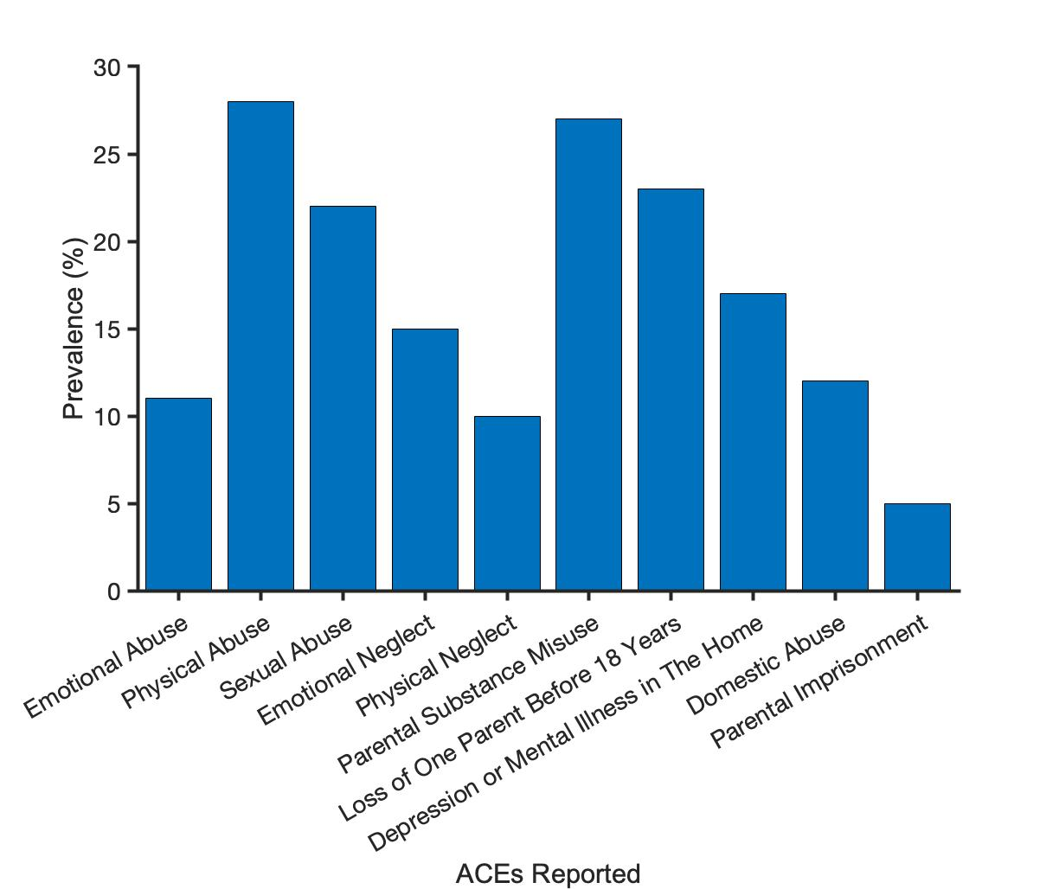  Source:dundee-cape.ac.uk (2018) |  | Investigating the Relationship Between Adverse Childhood Experiences and Physical Health Outcomes in Adulthood in the United Kingdom  Aim: To understand the relationship between adverse childhood experiences and physical health outcomes in adulthood in the United Kingdom.  Objectives:  - To find out the connection among adverse childhood experiences with physical health outcomes in adulthood in the UK.  - To analyse the problems which come from poor childhood experiences towards physical health during adulthood in the UK.  - To evaluate suitable strategies to overcome the problems of adverse childhood situations and gain better physical health results during adulthood in the UK. | 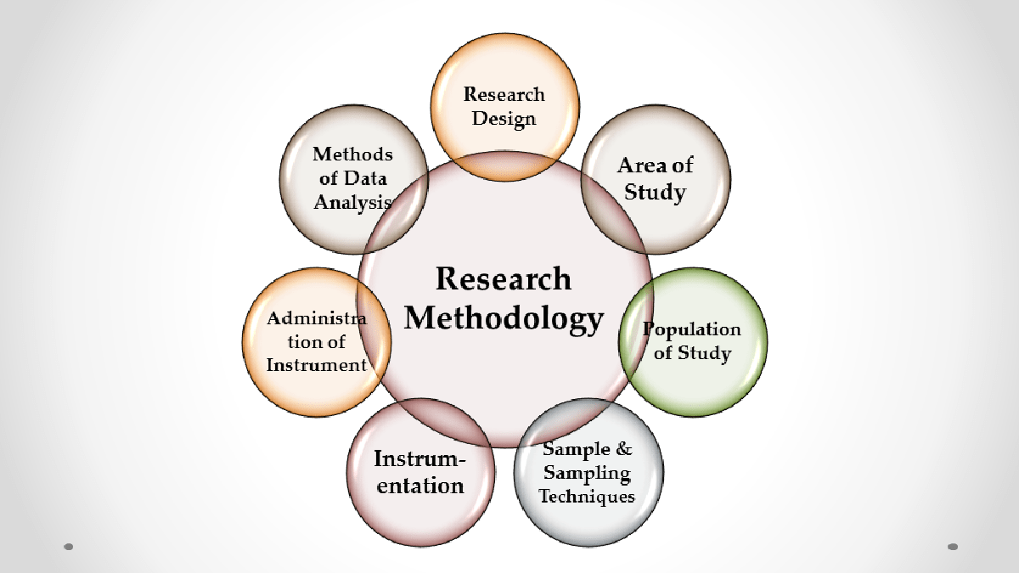 | 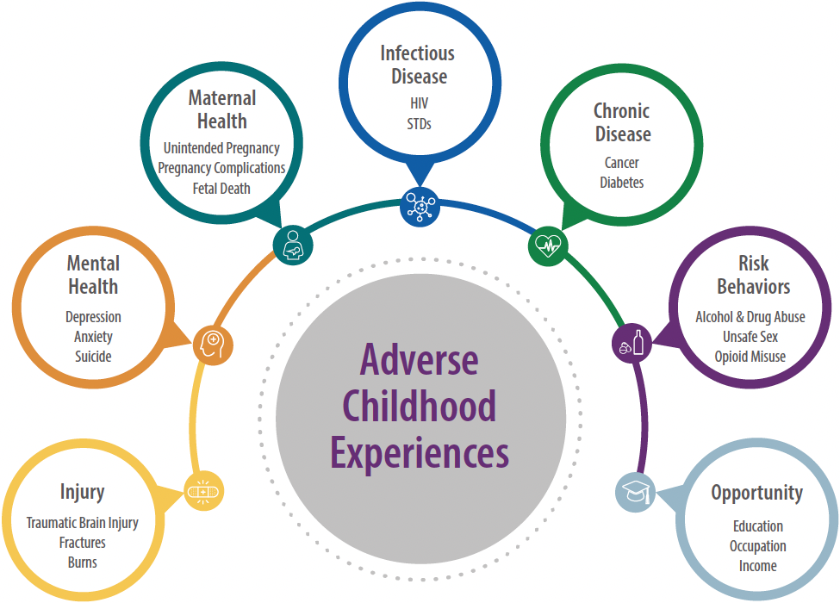
 |  |  |  | Source: Atrainceu.com. (2021)
Methodology  The study will focus on qualitative research design which will be based on secondary data. This design encompasses in-depth analysis of current research on ACEs and adult physical health, reports, and relevant publications. It is suitable as the study focuses on understanding relationships, experiences and patterns of recurrence (Schührer and Sandiford, 2025). |  |  |  | Data Analysis Method  The findings from the selected articles will be examined using thematic analysis. This approach will help organise the evidence into themes relating to the possible long-term effects of ACEs on physical health.  The analysis will focus on health outcomes discussed in the literature, including chronic diseases, cardiovascular conditions, diabetes and hypertension.  Each article will be reviewed to identify its main findings. These findings will then be compared to explore similarities, differences and recurring themes across the studies. The analysis will be informed by the approach described by Braun and Clarke (2006).  Ethical considerations  Ethical considerations are relevant despite having secondary data and there are no direct participants. References will be used appropriately to acknowledge the writing of original authors (Hole,2024). The study will also consider refraining from unnecessary personal information and respecting confidentiality in sources reviewed (Haaker,2024).
Data Collection Method
Data will be collected from existing academic publications rather than directly from participants. The literature search will focus on peer-reviewed studies published between 2016 and 2026 that investigate ACEs and adult physical health outcomes within the UnitedKingdom.
The searches will be carried out using ProQuest, Google Scholar, PubMed and the UWTSD Library. Keywords and predefined inclusion criteria will be used to identify studies relevant to the research question.
The selection process will be documented to make it clear how the articles were identified and chosen for the review (Tricco et al., 2018).

References
Adverse childhood experiences – CAPE consortium. Available at: https://dundee-cape.ac.uk/adverse-childhood-experiences/ (Accessed 13 Oct. 2026).
Adverse childhood experiences and trauma | ATrain education. Available at: https://www.atrainceu.com/content/11-adverse-childhood-experiences-and-trauma (Accessed 13 Oct. 2026).
Braun, V. and Clarke, V. (2006) ‘Using thematic analysis in psychology’, Qualitative Research in Psychology, 3(2), pp. 77–101.
Haaker, M., (2024). Research quality in through qualitative secondary analysis. The Sage handbook of qualitative research quality. Sage, pp.392-407.
Hole, L., (2024). Handle with care; considerations of Braun and Clarke's approach to thematic analysis. Qualitative research journal, 24(4), pp.371-383.
Morton, S., Curran, M. and Barry O’Gorman, M. (2022) Adverse Childhood Experiences, Domestic Violence and Substance Misuse: An Action Research Study on Routine Enquiry and Practice Responses’, Frontiers in Psychiatry, 13, 892849.
Tricco, A.C., Lillie, E., Zarin, W. et al. (2018) ‘PRISMA Extension for Scoping Reviews (PRISMA-ScR): Checklist and Explanation’, Annals of Internal Medicine, 169(7), pp. 467–473.
Schührer, S. and Sandiford, P.J., (2025). Business research in practice. In Exploring Research Methodology and Research Design (pp. 20-30). Edward Elgar Publishing.

