

LOCATION: Swansea | LLEOLIAD: abertawe
LEVEL 5 | LEFEL 5
EXAMINATION PERIOD | CYFNOD ARHOLIADAU
may 2022  34/60 = 56% | mai 2022

MODULE CODE: ACCA5032
OBJECT ORIENTED PROGRAMMING AND ALGORITHMS
TIME: 2 HOURS
answer THREE quESTIONs out of FOUR

Equipment or materials required – None
Adnoddau neu ddefnyddiau sydd eu hangen - Dim

ANSWER THREE QUESTIONS OUT OF FOUR

Q1
A program has been written for a small book shop to manage their sales and stock levels. Using syntax acceptable for C#, construct a class to represent the sales controller element of this program. You should assume that a “Customer” class exists within the system that can be used to manipulate customer details. In addition, it should also be assumed an “Order” class exists that may hold the values mentioned below. The created class should provide methods for the following functionalities:

- The creation of a new order, accepting values for Customer ID, Item Code, Item Quantity, Date of Order and Ship Status, an Order ID should be generated through this process.
(5 marks)
- Display the current sales list, accepting a parameter to filter based upon whether an item has been shipped.
(5 marks)
- The amendment of an order in form of change of quantity, accepting arguments for an Order Id and Quantity.
(5 marks)

Further marks will be given for demonstration of the correct use of attributes, constructors and methods within the class.
(5 marks)

[20 marks total]

Q2. The following code extract exhibits a small element of the controlling functionality for game elements with which a player may interact.

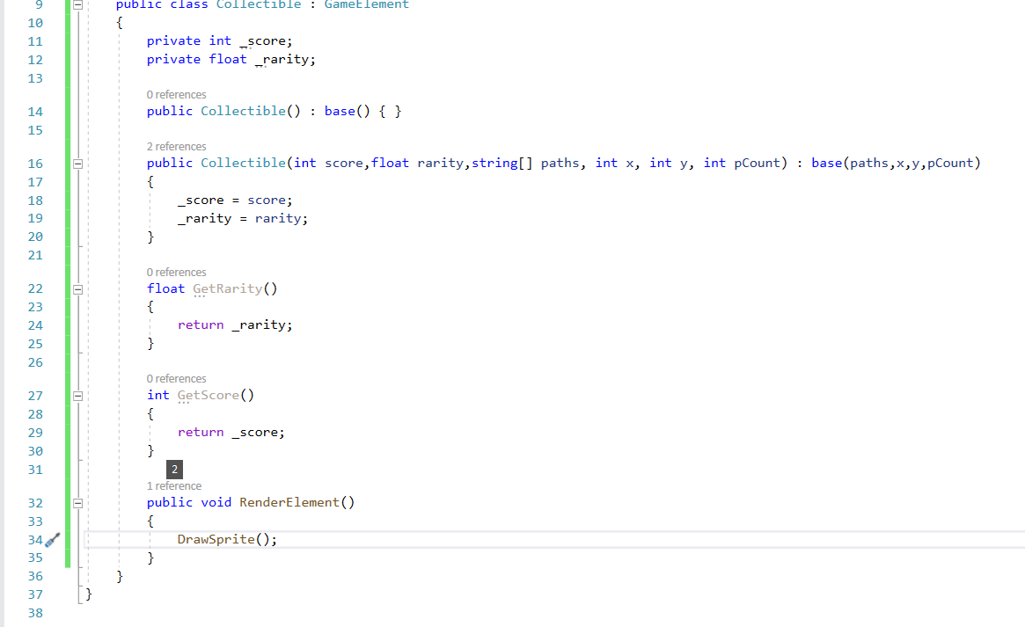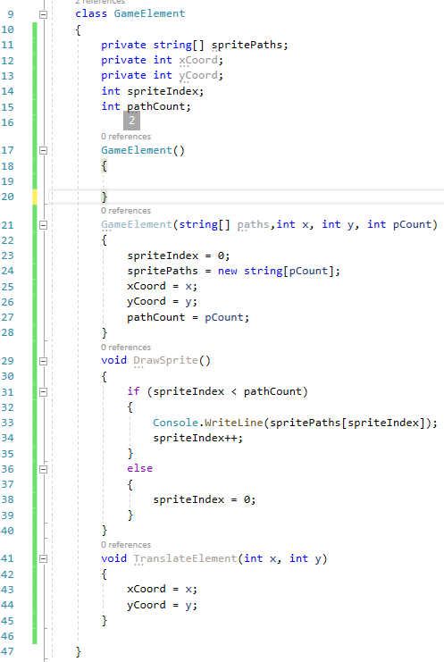
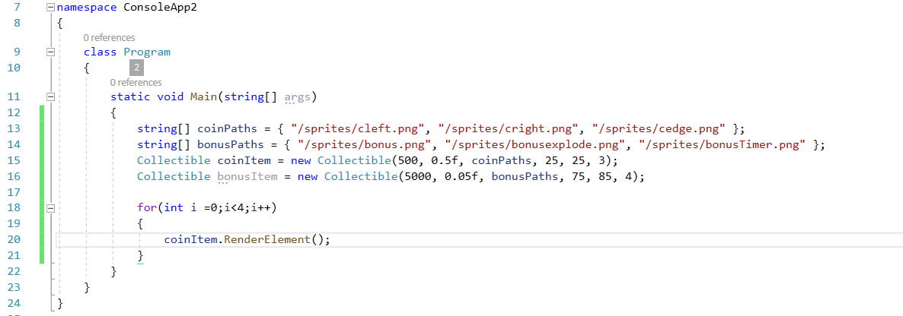

a) Analyse the operation of the code excerpt provided. Explain the features and operation of the code in detail.
(16 marks)
THE PROGRAM IS A GAME AND IN THIS PROGRAM THE FOLLOWING IS HAPPENING: -
FIRST PART OF THE CODE: -
THE GAME STARTS WITH A PUBLIC CLASS THAT A USER CAN ENTER DATA OR IN THIS CASE NUMBERS: COLLECTIBLE (GAMELEMENT) THE TWO MAIN PRIVATE VARIBLES ARE: INT_SCORE (INT VARIBLE IS USED FOR WHOLE NUMBERS) AND FLOATE _RARITY (FLOATE IS USED FOR NUMBERS WITH DECIMAL POINTS) SO THE USER CANT NOT ALTER OR CHANGE.

SECOND PART OF THE CODE: -
THIS PART IS DEFINING THE CLASS (GAMELEMENT) WHICH IS STATING THE OBJECTS IN THIS METHOD.
THE VARIBLES IN THIS CLASS ARE PRIVATE STRING[] (WHICH IS USED FOR CHARACTERS), PRIVATE INT (FOR X AND ONE FOR Y).
IN THIS PART IT IS DEFINING THE PARAMETERS OF THE FUNTION OF THIS CLASS, THE IF THEN STATEMENT IS ASKING: -
IF STRING VARIBULE SPRITEIDEX IS LESS THAN (<) PATHCOUNT THEN WRITE ON THE SCREEN. ELSE IS EQUAL (=) TO 0.
THE THIRD PART OF THE CODE: -
THE CLASS PROGRAM WILL DISPLAY 6 IMAGES ON THE SCREEN AND GIVE A SCORE DECIDED BY CLASS COLLECTIBLE. THE FOR LOOP IS GOING RUN THE PROGRAM 4 TIMES BEFORE IT STOPS.
b) Show the exact output of the provided code and explain your answer.
(4 marks)
[20 marks total]

Q3. There are several structures that can be used to contain collections of information that relate to one another. When we want to keep like structures together, we may use an array. If we need more complex means of storing data entities, we may use other forms of storage mechanisms

- List three alternatives to arrays outlining with comparison (5 marks)
- BUBBLE SORT: - IS A BASIC ALGOTHM USED IN A STRING OF NUMBERS AND OTHER ELEMENTS IN A ASSENDING ORDER.
- QUICK SORT: - IS FASTER THAN BUBBLE SORT BUT SLOWER THAN MERGE SORT BUT QUICK SORT HAS BETTER MEMORY.
- MERGE SORT: - DEVIDS THE ARRAY INTO TWO EQUAL PARTS AND SORTS THEM.
- What are benefits of the use of linked lists (5 marks)
- LINK LISTS HAVE ARE A STACK WHERE IT IS ONLY POSIBLE TO INSERT AND REMOVE DATA FROM THE TAIL ( PUSH AND POP), UNLESS IT IS A QUEUE LINK LIST WHERE IT CAN ONLY BE INSERTED FROM THE TOP (PUSH) AND TAKEN OUT OF THE TAIL (POP).
- Explain the binary tree structure and operation. (5 marks)
- A BINARY TREE IS A TREE DATA STURTURE WHERE EACH NODE HAS A T MOST TWO CHILDREN WHICH IS CALLED LEFT CHILD AND RIGHT CHILD.
- Give an example use case for implementing a binary tree (5 marks)
- A BINARY TREE COULD BE USED TO SORT OUT A LARGE AMOUNT OF NUMBERS INTO ONE SECTION OF LOW NUMBERS AND ONE FOR HIGH NUMBERS. (CAN’T THINK)
[20 marks total]

Q4. Computers have the capacity to house a vast collection of data in many different data structures. In many cases such data structures may need to provide capability for organising or finding specific information found within them

(a)
i) List two types of search algorithm with comparison (4 marks)
- LINEAR SEARCH LOOKS AT EVERY ITEM IN CONSETION WHICH IS VERY SLOW.
- BINARY SEARCH DIVIDES ALL THE ITEM UNTILL IT FINDS IT WHICH IS MUCH FASTER.
ii) Which of the search algorithms identified is the most efficient and why?
(4 marks)
- A BINARY SEARCH IS GOOD FOR FINDING ITEMS IN AN ALREADY SORTED LIST, IT DOES THIS BY REPEATEDLY DIVIDING THE LIST IN HALF UNTILL IT FINDS THE LOCATION OF THE ITEM ITS LOOKING FOR.
ii) In what circumstances would you use a binary search? (4 marks)
(12 marks)
- THIS WOULD BE USFULL TO USE IN A VERY LARGE AMOUNT OF NUBERS TO FIND THE ONE ITEM/NUMBER FAST.
(b) Outline the operation of a bubble sort and define its complexity
(8 marks)
- BUBBLE SORTS SORT OUT THE DATA IN ASSENDING ORDER AND WILL MOVE DATA FROM LEFT TO RIGHT.

[20 marks total]
Diwedd/End

