Salih Osman 1809711 Agile Exam
Q1
a)
User stories:
- As a store owner I wish to be able to easily access and identify each of the products I sell, their respective ranges, so that I can keep track of product types.
- As a store owner I wish to be able to easily access and view all discounts offered by the store, and the conditions under which they apply, so I can regulate purchasing power of customers.
- As a store clerk I wish to be told the current price of any particular range and product which I enter the details of, so that I can present customers with an accurate bill.
- As a store clerk I want to oversee the entry of details of which items have been purchased, including which particular range of product it is so that I can keep track of item popularity.
- As a factory floor manager I wish to be regularly updated on levels of stock for each range of each product, so that I can modify production needs accordingly.
- As a factory floor manager I wish to be told which ranges belong to which products, so that I can position all warehouse items in a well-structured and efficient manner.

b) Object oriented analysis of chair factory
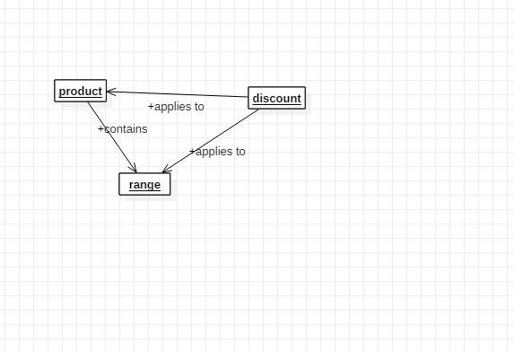
Q2
a)
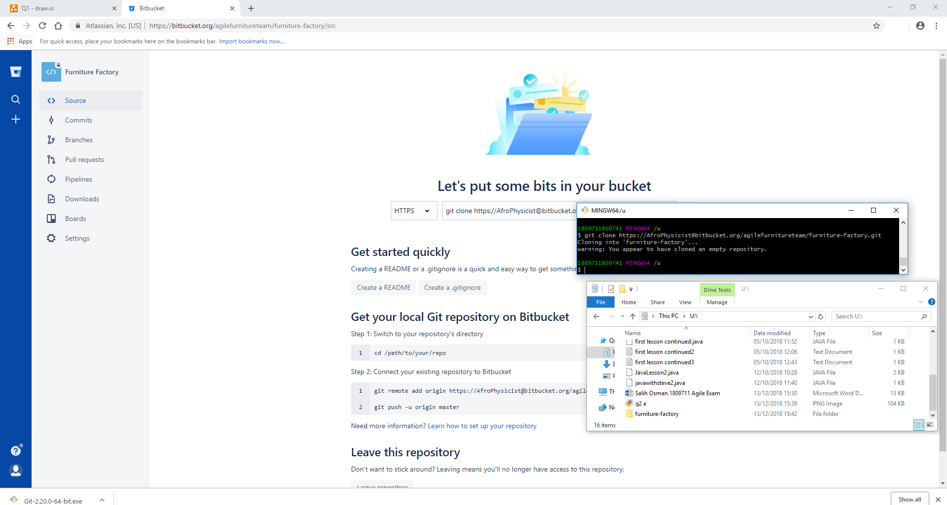

Above is evidence of having created a team on the bitbucket platform, and a subsequent empty workspace/repository for the access of that team.
This repository can then be cloned down by members of the team at will, as shown, so that they can work on their code.
b)
The use of the git distributed development tool would be extremely useful for this project.
Using Git would allow multiple members of the team to work on features of the source code in parallel. This puts it at an advantage compared with other collaborative software development systems such as svn. Where, if one developer wanted to work on a piece of code, the others would be blocked off from editing that section until it was resubmitted (leading to potential situations where the code would be deadlocked).
Part of the identity of git is that it every user can pull down an up to date copy of the source code onto their local machines at any point in time, i.e. the project is held in a distributed workspace rather than on one central server.
git clone would allow users to copy the repository on their local machine.
Meanwhile git branch allows them to create an editable copy of the code which they can work on, rather than moderating, and potentially damaging, the master branch, on which the true/ultimate version of the code is stored.
Once the developers had added or made changes to the code in their branch, they could use git add to stage the code to be committed to their local repository
It should be noted here that git status allows a developer to check how many changed files have not yet been tracked using add, how many are waiting to be committed etc, allowing good oversight of the branch or repository
They can then commit code via git commit, including a message. This adds the tracked or staged files, as well as creating all the associated meta-data files for the updated code.
Git push would then allow them to alert the public repository on bitbucket of the new branch and altered code within it. All fellow devs would then be able to access it
The dev could then create a pull request, even simply using the bitbucket GUI, to request fellow devs to approve his changes so they can then be merged to the master branch. This is keyin facilitating peer review of code. A senior dev can easily perform a git pull on the repo to get an updated version on their machine, including the new branch made by the initial developer.
Other features like git log, git blame and git show, respectively a) The full commit history, along with commit messages and associated dev and times etc, b) The developer responsible for a particular piece of code (often used after merge problems have come to light) and c) The commits along with the code committed line for line. These are very important for keeping track of how much work devs have been putting in, when problematic changes were made and by who etc etc.
c)
The agile SCRUM methodology would be useful here.
This would be well suited for a small dev team such as this, working on a project where it would be essential to maintain accuracy to the “spirit” of the requirements provided by the furniture company.
First it would be important to assign roles to the team members, in particular, a scrum master, responsible for motivating and managing the dev team, as well as removing blockers which prevent them from working on particular features. In addition, a product owner, who is essentially fulfilling the role of proxy for the customer, keeping track of high level design and requirements and maintaining the project backlog, the list of all user stories (requirement subsections) not yet completed.
Scrum is an iterative process, rather than purely being incremental. The team would look to emphasise implementation of features which would add value on a regular basis (working in sprints, where each sprint covers a different group of user stories (representing the requirements). In this way close contact could be kept with the customer, going back to him each new release to ensure the created software has not begun to deviate from his original vision. The idea is that eventually the dev team would build up the minimal viable product, a software system which, while not containing close to the full envisioned functionality, is essentially representative of the behaviour and appearance of the final system.

Q3)
a)
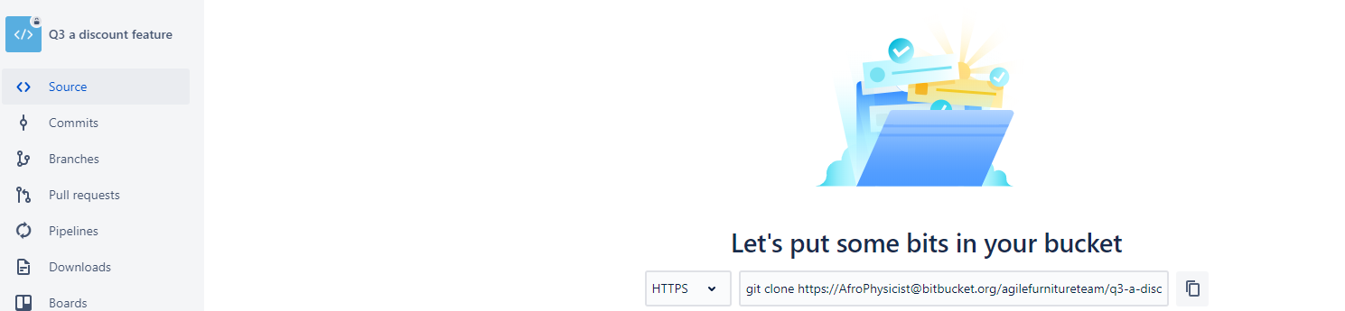
Public repository^
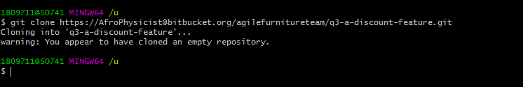
Evidence of created local version of public repository on machine.
b) See public repo
c) Git bash terminal showing process of adding to local repo and making public aware
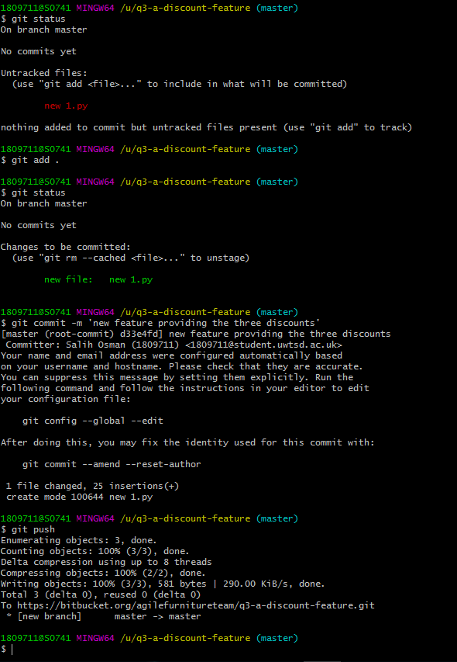
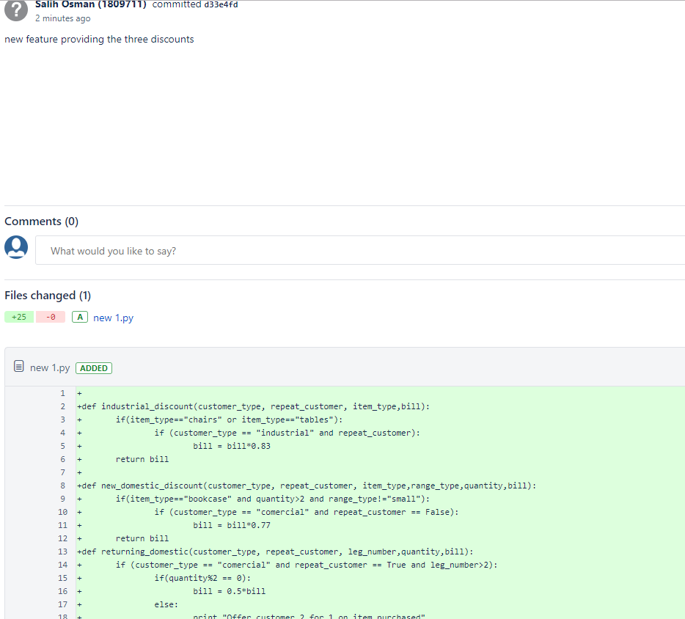
Evidence of file on public repo
Q4)
a)
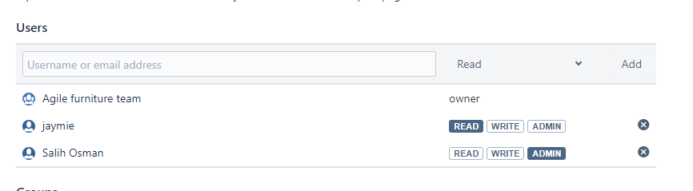
Evidence that Jaymie has been added to the repo
b) 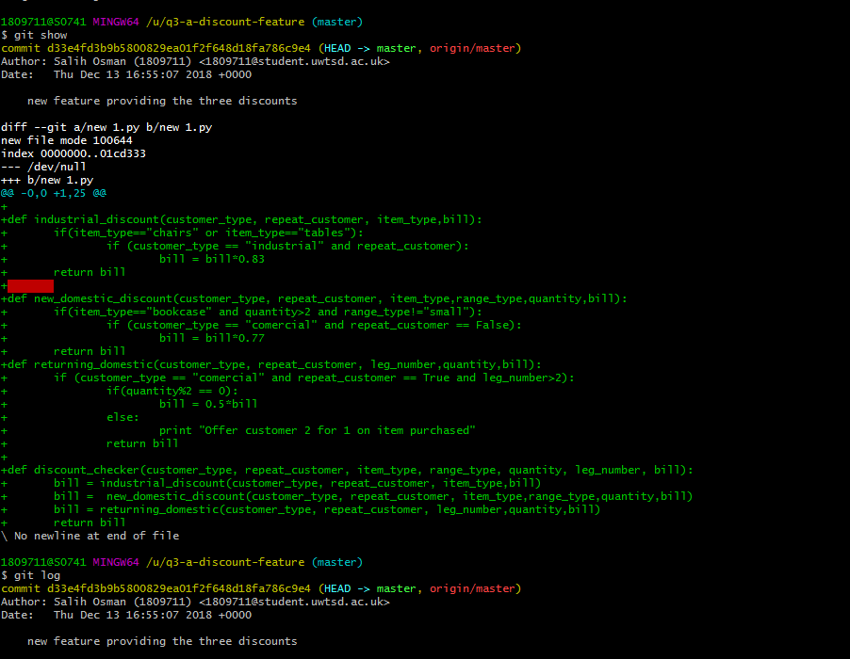
Evidence of changes made to the repo
c) compartmentalised testing, also known as unit testing, provides a white box approach to validating that the created code fulfils the user requirements, and doesn’t introduce unwanted features or bugs.
A common method for creating unit tests in java is via junit, with triple A tests following the arrange, action, assert format.
An example of such a test would be
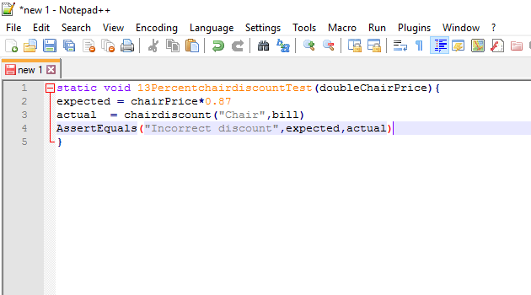
The use of doubles, mocks and stubs would help here
Mock is empty class
Doubles contain some data
Stub contains basic functionality

