

Student name: Teodor Katrandzhiev
Student ID number: 2124415
Programme: BA Business Management

Module: Entrepreneurship
Module code: LCBB5001
Module Leader: Vasilios Tavlaridis
Assignment Title: Assessment Component 1: Written Report/ Business Plan

Table of contents
Overview of the business idea 3
Legal format of the startup 3
Management of the company 4
Target market and market strategies 5
Use of social media and website 6
Evaluation of the business idea by using SWOT analysis 6
Cash flow forecast for the first 12 months 8
Reference list 9
Appendices 12

Business plan for a used motor vehicle dealership

Overview of the business idea

Used car dealership that provides excellent value-for-money vehicles. Focused on customer service and going the extra mile to deliver trouble-free motoring at an affordable price. The company will be based in Burton-on-Trent, where the United Kingdom`s information service shows another 90 companies registered with similar nature of business. GOV.UK (2023b) The dealership aims to achieve a solid online presence by advertising on most available platforms and offering nationwide delivery on all cars to expand the customer base.

Legal format of the startup

More than five and a half million businesses are currently in operation in the United Kingdom. (GOV.UK, 2023a) The two main legal forms that can suit a used vehicle dealership are Sole Trader and Private Limited Company. While Sole Trader is easier to set up and run, with the most straightforward possible accounting, there is also an inherited risk for the individual as the person and business are not separate, and we are liable for any business debts and unsettled contractual obligations. (GOV.UK, 2022) This business structure allows us to have employees other than the owner. Still, it is unlikely that it will suit the needs of a company that requires a substantial investment as it makes funding through borrowing and issuing shares extremely difficult. (GOV.UK, 2011)
As far as the majority of used motor vehicle dealerships go, the 90 local companies in Burton-on-Trent are all registered as Private Limited Companies due to the numerous benefits of this business structure over a sole trader. GOV.UK (2023b) Over 4 million businesses in the United Kingdom chose this business structure that represents a separate legal personality allowing it to sign contracts and agreements in its own name. (GOV.UK, 2022a). This separation between the individual and the business means that the owner is not personally liable for any legal issues that may arise with the business, and we are not obliged to settle company obligations with our funds. Some of the disadvantages we had to consider for the business were the more paperwork involved in running a limited company s and the numerous taxation rules that need to be followed. (GOV.UK, 2011)

Management of the company

The owner and director of the company will be Teodor Katrandzhiev, with over ten years of vehicle repair, maintenance and sales, at present completing his Batcheler education degree in business management. Proven track record of retiling cars for the last three years, steadily increasing the vehicles available in stock and the total sales. Currently keeping a regular stock of 6 cars on average and over 25 used motor vehicles sold yearly.
There will be a position available for a salesperson to represent the business in front of potential customers as well as offer thorough assistance along the way to purchasing a vehicle, including but not limited to maintenance and warranty plans, demonstrating vehicle features, taking customers for test drives and provide excellent customer service. Online presence is significant to our business as it will allow us to present our stock to more potential customers. For the initial stage of the company, we will use a website-building platform rather than a web designer, as it is much more cost-effective. We might not get quite the bespoke and unique feel of the website, but we won`t have to factor in payments for an experienced professional and will have better value-for-money results overall. Smith (2022), in her article for Forbes magazine, stated that the days when you needed inside knowledge to create stunning websites are long gone, and the available website builders are an excellent all-in-one package that includes hosting and domain name in the price. SquareSpace is our platform of choice, marked as number 4 in the Forbes top 10 list of website builders, as it provides modern designs and user-friendly software. (Smith, 2022)
The business will be registered as a private limited company, which can be operated without an accountant. However, as the Department for business innovation and skills guide (2011) suggests, the limited company is subject to stricter regulations than the sole trader option. Therefore, there is much more pressure on the person dealing with the business’s accounts and tax returns. (GOV.UK, 2011) We chose to use a professional accounting company, and according to Edwards (2022), the average monthly charge for a company with revenue up to £80 thousand is £79+VAT which will go up slightly depending on turnover.
Importance of relevant experience when starting a business
Considering the number of start-up companies registered every day in the United Kingdom, for our business to have a fighting chance at success, we have chosen a business path where our director has years of experience. We will be able to guide the company in the right direction quickly. As Morris (2008) states, it is challenging for a new business to persuade a bank to lend money. As a company, we will find the bar relatively high and must do our best to secure loans and funding. For a business plan to be worth considering, we will need to go the extra mile in every way possible, and what can tip the scales in our favour is the experience and background of the key employees in the business. Furthermore, Read et al. (2017) argue that investors and experienced entrepreneurs agree that implementing a business idea is the only way to test it. Test the business model at a smaller scale with relatively low investment and determine whether real customers are willing to purchase our products at a fair price. And this is precisely what our business has done; the business model has been tested for over two years, and there is a proven track record of actual sales and documents of generated revenue and a considerable profit.

Target market and market strategies
More and more companies are looking for more effective ways to come out in front of the competition. Kotler and Keller (2016) state that many implement target marketing. Rather than spreading their marketing efforts to a wide range of customers, they focus on the ones they have the best chance of satisfying. Market segmentation is the foundation of successful marketing (Mcdonald and Dunbar, 2012)
Kotler and Keller (2016) also give us the framework for effective marketing:
- Identify and define distinct segments of the market with unique requirements and preferences
- Choose one or more of those specific segments as the focus of your marketing efforts
- Create a distinctive benefit in the company`s products or services that appeals to each of the selected target groups.
The business’s target market will be new drivers, young people and families with income around the national average.The market segments are generally looking to spend up to five thousand pounds on a vehicle, and sometimes their budget can be as low as two thousand. As we target new drivers, we will aim to stock a variety of smaller vehicles, easier to drive and cheaper to insure to attract our target customers. The other segment we will customise our marketing efforts toward is young people and families looking for an affordable vehicle. We will attract those customers by having a mid-sized vehicle stock that represents excellent value for money. Special attention will be given to all these having the ISO-FIX system so that child seats can be securely installed in the vehicle.

Use of social media and website

The dealership will lean heavily on its online presence, including social media and our web page. All the vehicles in stock will also be advertised on two of the more established used car sales platforms, Autotrader and Ebay. Autotrader is the largest marketplace for used vehicles in the United Kingdom; with over 450 thousand cars available on the website at any moment, they dominate the used car market. Their data suggest that 70% of all the online time spent on used vehicle advertisements is done on their website, which will give our business the best chance to reach customers anywhere in the United Kingdom. (Auto Trader Group plc, 2016) There are, however, some limitations for most vehicle retailers that come from the wide variety available on Autotrader, it makes customers more aware of the vehicle’s worth, and the dealership must constantly remain aware of the used car market. As our business model is based on affordability and delivering great value for money for our customers, we will spend most of the time locating and purchasing the correct stock to satisfy our customers’ needs.

Evaluation of the business idea by using SWOT analysis
As a start-up company in such a competitive market, we will need all the help and resources we can get. Venugopal (2010) argues that the company can only capitalise on the opportunities provided by external forces if they have the knowledge and capabilities to do so. Therefore, every business must understand its capabilities and determine the opportunities and threats. To assess the current situation that our company is in, we have chosen to use a SWOT (Strengths, Weaknesses, Opportunities, and Threats) analysis. Plunkett and Allen (2016) state that SWOT is a wonderful tool that provides an understanding of where the business stands in the current business environment and can be especially useful in creating a marketing strategy for the company.
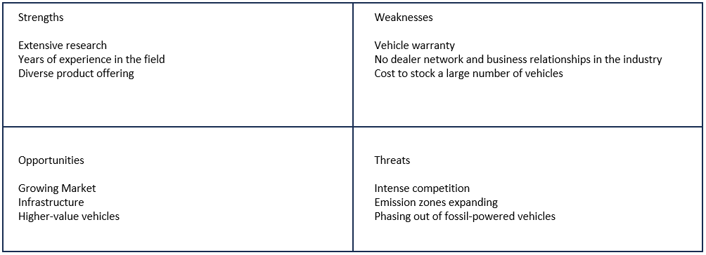
Strengths
Extensive research
We have conducted thorough research on the market and the main competitors in the area, what cars they have in stock, the value of the vehicles, where they advertise them and the number of monthly sales. Even further, we researched the number of employees, the salaries of the employees and the average price for rent on commercial buildings in the area.
Years of experience
The company director has over ten years of experience in motor vehicle maintenance and repair, allowing us to choose the best cars for our forecourt and, more recently, in the last three years, the focus has shifted to the used car trade.
Diverse offering
We also plan to offer our customers a diverse product range by constantly having different types of vehicles across a wide price range.

Weaknesses
The company will be registered as a motor vehicle dealer. As such, we will be required by law to supply customers with a 3-month warranty unless stated otherwise in the contract, which can potentially open us to high costs if any of the vehicles become faulty. (Car.co.uk, n.d.)
As a newly formed business, our limited funds will only allow us to have a small selection of vehicles in stock or a network of dealerships to support sales.

Opportunities
The market has been steadily growing since the initial drop in sales during the COVID-19 pandemic, and the first quarter of the year is the most promising yet. (SMMT, 2023)
There is also plenty of commercial real estate available for sale and rent. As a company relying heavily on our online presence, we can choose from many locations.
Including higher-value vehicles as part of our selection of cars will be a valuable option if we want to expand our target market and generate more sales.

Threats
The competition in the field is fierce, with many small private traders and, according to the Companies House register (2023), over 90 companies registered in Burton on Trent alone, some of which have over 20 years in the business and are currently stocking over 200 vehicles.
Green air zones are constantly expanding, and most diesel vehicles may need more time to sell.
The United Kingdom announced in November 2020 that they will end the sales of new petrol and diesel light goods vehicles by 2030, which will affect the used car market. (Gov.UK, 2020)

Cash flow forecast for the first 12 months
Lucy Tobin (2012) suggests that the three main options to fund a business are self-funding, equity financing from investors or taking out a loan. Our business model will require a relatively small investment, so we have chosen to finance it with £15 thousand of our funds and £10 thousand borrowed from a bank. Financing the business through debt will give us complete control over the company and a clear idea of the costs in advance. However, Barringer (2014) claims that a bank loan might be challenging to secure for a start-up company. This is the main reason we will finance most of the venture with our own funds.

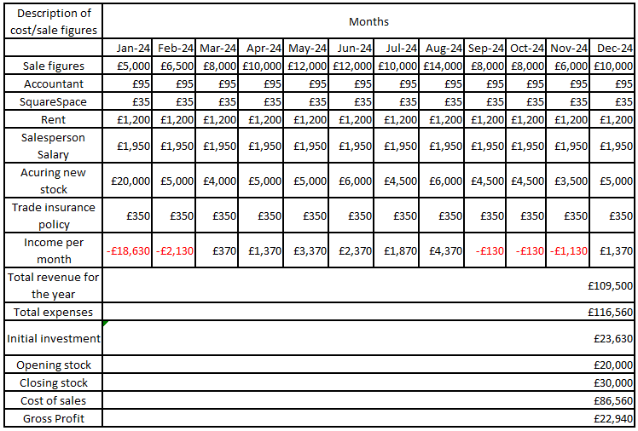

Reference list

Auto Trader Group plc (2016). Auto Trader Group plc Annual Report and Financial Statements 2016. [online] www.autotrader.co.uk. Available at: https://www.autotrader.co.uk/why/ebaymotorsgroup [Accessed 15 Jun. 2023].
Barringer, B.R. (2014). Preparing effective business plans: an entrepreneurial approach. Harlow: Pearson Education. [Accessed 15 Jun. 2023].
Car.co.uk (n.d.). Car Warranties: What is covered in a three-month car warranty? - Car.co.uk FAQs. [online] www.car.co.uk. Available at: https://www.car.co.uk/car-warranties/faqs/general/what-is-covered-in-a-three-month-car-warranty [Accessed 15 Jun. 2023].
Country Car Sales (2023). Country Car Sales [online] https://www.countrycarsales.co.uk/ Available at: https://www.countrycarsales.co.uk/dist/img/hero/hero-4-1920.jpg [Accessed 15 Jun. 2023].
Edwards, S. (2022). How much does an accountant cost/charge in the UK? Accounts for self-employed and limited companies (Part 1). [online] CTA Profit First Accountants. Available at: https://www.cheltenham-tax-accountants.co.uk/blog/how-much-does-an-accountant-cost-charge-in-the-uk-part-1-2022/#limitedcompany [Accessed 15 Jun. 2023].
GOV.UK (2011). A Guide to legal forms for Business. [online] Available at: https://assets.publishing.service.gov.uk/government/uploads/system/uploads/attachment_data/file/31676/11-1399-guide-legal-forms-for-business.pdf [Accessed 14 Jun. 2023].
GOV.UK (2022a). Business population estimates for the UK and regions 2022: statistical release. Available at: https://www.gov.uk/government/statistics/business-population-estimates-2022/business-population-estimates-for-the-uk-and-regions-2022-statistical-release-html#:~:text=Composition%20of%20the%202022%20business%20population,-The%20UK%20private&text=At%20the%20start%20of%202022%3A,4.1%20million%20had%20no%20employees. [Accessed 15 Jun. 2023].

GOV.UK (2022b). Set up as a Sole Trader. [online] GOV.UK. Available at: https://www.gov.uk/set-up-sole-trader. [Accessed 15 Jun. 2023].
GOV.UK (2023a). About Companies House - Companies House. [online] companieshouse.blog.gov.uk. Available at: https://companieshouse.blog.gov.uk/about-companies-house/.[Accessed 15 Jun. 2023].
GOV.UK (2023b). Advanced company search - Companies House Register. [online] Available at: https://find-and-update.company-information.service.gov.uk/advanced-search/get-results?companyNameIncludes=&companyNameExcludes=®isteredOfficeAddress=Burton-On-Trent&incorporationFromDay=&incorporationFromMonth=&incorporationFromYear=&incorporationToDay=&incorporationToMonth=&incorporationToYear=&status=active&status=open&sicCodes=45112&type=ltd&dissolvedFromDay=&dissolvedFromMonth=&dissolvedFromYear=&dissolvedToDay=&dissolvedToMonth=&dissolvedToYear=.[Accessed 15 Jun. 2023].

GOV.UK (2023c). Start a business. [online] Help to Grow. Available at: https://helptogrow.campaign.gov.uk/i-want-to-start-a-business/ [Accessed 15 Jun. 2023].
Gov.UK (2020). Government Takes Historic Step Towards net-zero with End of Sale of New Petrol and Diesel Cars by 2030. [online] GOV.UK. Available at: https://www.gov.uk/government/news/government-takes-historic-step-towards-net-zero-with-end-of-sale-of-new-petrol-and-diesel-cars-by-2030. [Accessed 15 Jun. 2023].
Kotler, P. and Keller, K.L. (2016). Marketing Management. 15th ed. Boston: Pearson.
Mcdonald, M. and Dunbar, I. (2012). Market Segmentation : How to Do It and How to Profit from It. 4th ed. Chichester: John Wiley & Sons.
Morris, M. (2008). Starting a successful business. London: Kogan Page.
Plunkett, W.R. and Allen, G.S. (2016). Management. Wessex Incorporated.
Read, S., Sarasvathy, S., Dew, N. and Wiltbank, R. (2017). Effectual entrepreneurship. Londonetc.: Routledge, Francis & Taylor Group, , Cop.
Smith, A.N. (2022). 10 Best Website Builders Of January 2022. [online] Forbes Advisor UK. Available at: https://www.forbes.com/uk/advisor/business/software/best-website-builder-for-small-business/.[Accessed 15 Jun. 2023].
SMMT (2023). New car market grows for ninth month running. [online] SMMT. Available at: https://www.smmt.co.uk/2023/05/new-car-market-grows-for-ninth-month-running/#:~:text=This%20has%20led%20to%20an [Accessed 15 Jun. 2023].
Tobin, L. (2012). Entrepreneur. John Wiley & Sons.
Venugopal, P. (2010). Marketing Management. SAGE Publishing India.

Appendices

Car dealership visualisation idea.


(Country Car Sales, 2023)

