The context of leadership in the 21st century and the evaluation of leadership approaches and skills


MARCH 2020

MODULE NAME: LEADERSHIP & MANAGEMENT THEORY & PRACTICE (M6X00882)
STUDENT NAME: PHILS MUOBIKE
STUDENT NUMBER: 1706873
LECTURER NAME: JULIE HAYWARD
WORD COUNT: 3170

Table of Contents
1. Executive Summary 3
2.Introduction 4
2.1 Context 4
3. Leadership approaches 5
3.1. Transformational 5
3.2. Servant 6
3.3. Authentic 7
3.4. Critical evaluation of the three leadership approaches 7
4. Leadership Skills in the 21st Century that foster innovation 8
4.1. Emotional intelligence and Social intelligence 8
4.2. Networks and Networking 9
4.3. Learning Agility 10
5. Conclusion 11
6. Recommendations 11
7. References 13

Table of Figures
Figure 2 Servant leadership attributes Source: Russell and Stone, 2002 6
Figure 3 Qualities of authentic leadership Source: George, 2003 7

Executive Summary
The aim of this report is to identify and evaluate leadership approaches and skills; discover the best leadership approach to nurture innovation, high performance and adaption. The author of the report has engaged as a consultant for a technology company and he will suggest the best leadership approach and skills to excel in the sector. The author of the report, will briefly explain the internal and external factors of context, discover and critically analyse his findings, identify three leadership approaches and three leadership skills to understand the most suitable to foster innovation. The benefits and some limitations of the leadership approaches and limitations will be mentioned in the document. The findings will be discussed, and the recommendations will be included in order to provide a solution to improve the leadership skills. Transformational, servant and authentic leadership are the three approaches chosen by the author, while, emotional intelligence, networking and learning agility are the three skills analysed. The conclusion is brief but summarises the main findings and recommendation on micro-experiments will be used to understand how small changes could make a significant difference and develop leadership skills.

2.Introduction
This report aims to critically evaluate and analyse leadership approaches and skills to foster innovation in the 21st century. There will be a section where the external and internal factors will be discussed, leadership approaches and skills will be included. A brief section with the conclusion will be incorporated to summarise the findings with by author through the research and recommendations will be also included.

2.1 Context
It is generally accepted that the 21st-century environment is complex, due to high demands of globalisation, advancements with technology, changing customers’ expectations and new approaches in the workplace, motivated by the management (CIPD,2020). Companies need to learn and be flexible to adapt to these new forms of complexity (Yukl, 2013). Clark (2013) defined the term complexity as the highest level of uncertainty, ambiguity, interdependencies and interrelations which determines the environment that the companies operate. In the past, complexity in business was considered as a negative factor that had to be overcome (Lowell, 2016). The development of complexity science introduced new opportunities to take advantage of the complexity in the external environment (Snowdon and Boone, 2007).
Stacey (2011) described that companies were seen as machine-like systems which could be controlled to be more effective and efficient by utilising principles that were developed to enhance the performance of the machines. In 21 century, scholars and managers understand that companies do not work as machine-like systems but are Complex Adaptive System, simply know as CAS, (Clarke, 2013; Snowden and Boone, 2007). Leaders in CAS have to find a rising wave of emerging situations, they also have to deal with a relentless pressure to do more with fewer resources (Stacey, 2011). Whenever a company as seen as CAS, the management from command and control changes to learning, creativeness and sensemaking (Griffiths and Inman, 2016; Richardson, 2011).
Many scholars and researchers believe that a leadership approach that could contain complexity and interrelationship is essential (Cameron and Green, 2017), with the ability to foster an environment which enables to create innovative solutions to understand resolve the dynamics of a CAS (Griffiths, and Inman, 2016; Uhl-Bien, Marion and McKelvey, 2011). However, researches also stated that there is a high quality of leadership in an organisation (Bawany, 2016), employees disappointed with their leaders in workplace and management losing their credibility Hagemann and Bawany, 2016). Only 33% of managers are believed to have exceptional leadership skills and competences (Deloitte, 2017).
VUCA is a concept utilised to describe the Volatility, Uncertainty, Complexity and Ambiguity in uncontrollable environments where modern companies’ leadership or strategies are not exempted from the VUCA world (Kovacs and Corrie, 2017). Leaders in the future will need to have Vision, Understanding, Clarity and Agility (Elkington, 2018). In the 21 century, business executives operate in VUCA world but most of them believe that they are not prepared enough to deal with the high levels of complexity they encounter (Kovacs and Corrie, 2017). Leadership deficit could be accredited to the absence of acknowledgement that different leadership approaches are necessary to adapt in a VUCA world (Lawrence, 2013).
Megatrends are driving forces impacting the foundations of the world, which were identified by Naisbitt (1982). Vielmetter and Sell (2014) identified Globalization 2.0, environmental crisis, individualization and value pluralism, the digital era, demographic change and technological convergence, six mega-trends which could develop considerably. Megatrends are continuously changing the way executives operate due to climate change, technological advancement and population getting older (PWC, 2020).
The author of the report will analyse to understand the most appropriate approaches of leadership to foster innovation and excellence in complex adaptive systems. Three leadership approaches and three skills will be analysed and evaluated in order to identify the most suitable leadership approach and skill to foster innovation in the 21st century.

3. Leadership approaches

3.1. Transformational
Downton introduced the term Transformational leadership (Hickman, 1998), while Burns developed the meaning of the term. Transformational leadership is recognised when the leaders and the followers enhance the motivation and the ethics of a company (Burns, 1978). Bass (1985) stated that transformational leadership arises when leaders increase and raise the interest of the employees while producing a better sense of understanding and acceptance for the common mission of the company is working to achieve. Transformational leadership consist of having a leader that motivates and empower the staff to have a long-term vision, instead of worrying for their personal interest (Rees and French, 2016).
The CEO of Netflix, Reed Hastings could be a perfect example, transformational leader. Hastings stated a good leader needs to make good decisions that will positively influence the employees and sometimes it is necessary for stepping back from making decisions as a leader and empower the followers (Grinapol, 2013). At Netflix, information is shared among all the followers in order to guide them to make the best decisions. Hastings-Netflix and DVD (2018) believe that when the workers are empowered, they are more likely to perform better and have successful results. Hastings introduced a new version of Human Resources system where formal reviews and personal rewards were eliminated and encourage the team to learn new skills and be involved in decision-making (McCord, 2014). Hastings is considered a transformational leader because he is able to foresee a need, create a plan and launch it to the marketplace.

3.2. Servant
In 1970, Greenleaf coined the term servant leadership in his essay (Greenleaf, 2008). Servant leadership is an approach, where focusing on personal interest is replaced by creating environments that generate results (Northouse, 2016). Servant leadership focuses on a future-focused plan and embracing leadership principles to perform efficiently. In the 21st century, the business environment has changed significantly, leaders must change so that they can expand customers value and delivery. Russell and Stone defined nine functional qualities and eleven accompanying attributes that servant leaders should have and that can also be developed (Russell and Stone, 2002). Servant leaders believe that achieving their organisational objectives is important but if their staffs are unhappy then the leaders have failed because the employees come first (Northouse, 2016).
Sir Richard Branson, the owner of Virgin Media has adopted the servant leadership. Branson (2020) stated having a leader that can motivate people is most likely to create a great working environment. If the leader is forced into his team and unable to motivate, the company is more likely to fail (Gandolfi and Stone, 2018). Branson is considered an effective leader because he shows attributes, such as appreciating others, vision, listening and influencing (Russell and Stone, 2002). A company has to be engaging, enjoyable and has to exercise people’s creative instincts (Branson, 2010). Branson also shows some qualities of emotional and social intelligence, as an example could be his ability to be unbiased and choosing not to listen to people’s opinion if it will prevent him from achieving his objectives (Higgs and Dulewicz, 2016).
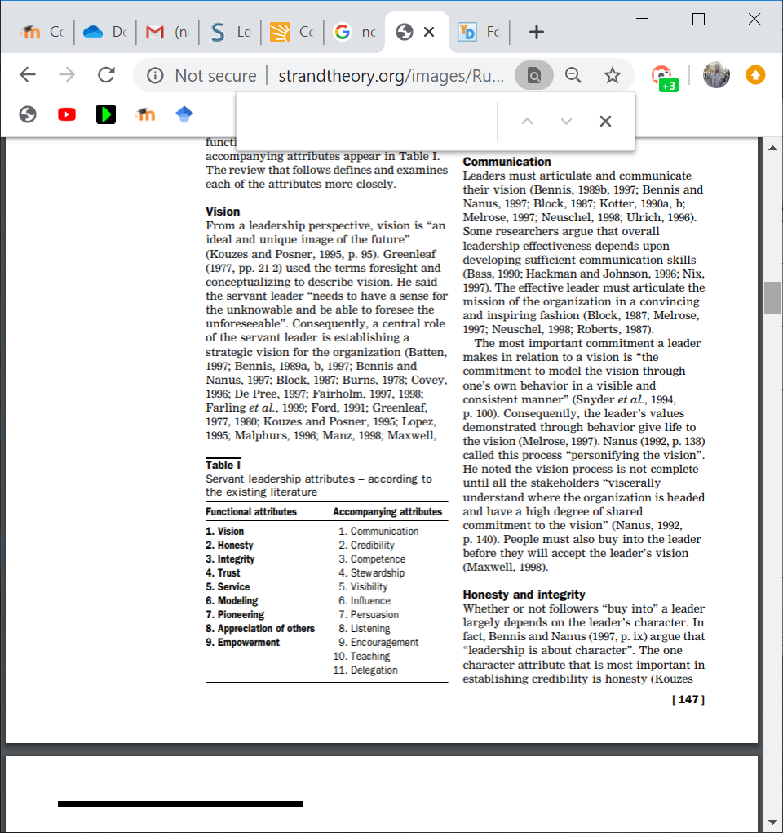
Figure 2 Servant leadership attributes Source: Russell and Stone, 2002

3.3. Authentic
Authentic leadership is when the leader is genuine and respects his beliefs. He also understands the role of a leader and they know how to create long-term relationships (George et al, 2007). Authentic leaders have personal self-discipline to provide exceptional outcomes from their teams (George, 2010). When leaders choose to act, instead of showing their real personality, there is a risk that the followers might not believe or trust them (Kruse, 2013). George (2010) stated that self-awareness, Genuity, result-oriented and task-drive, focused and empathetic are the five qualities of an authentic leader.
The former CEO of Tata Group, Ratan Tata is considered a man of principles and he managed the business with his beliefs. His philosophy involved encouraging independence, empowering potential leaders, develop the quality of the working environment and apply fair business practice (Cappelli et al, 2010). With his philosophy was able to give Tata Group a structure and a clear focus which enabled the company to succeed by creating a relationship and engaging with the stakeholders (Sakar and Sakar, 2016). Ratan Tata is undoubtedly an authentic leader due to the fact he showed he true-self and did not compromise his principles to please others (Cappelli et al, 2010). Ratan Tata has the five qualities that George mentioned that an authentic leader should own to be successful (George, 2010).

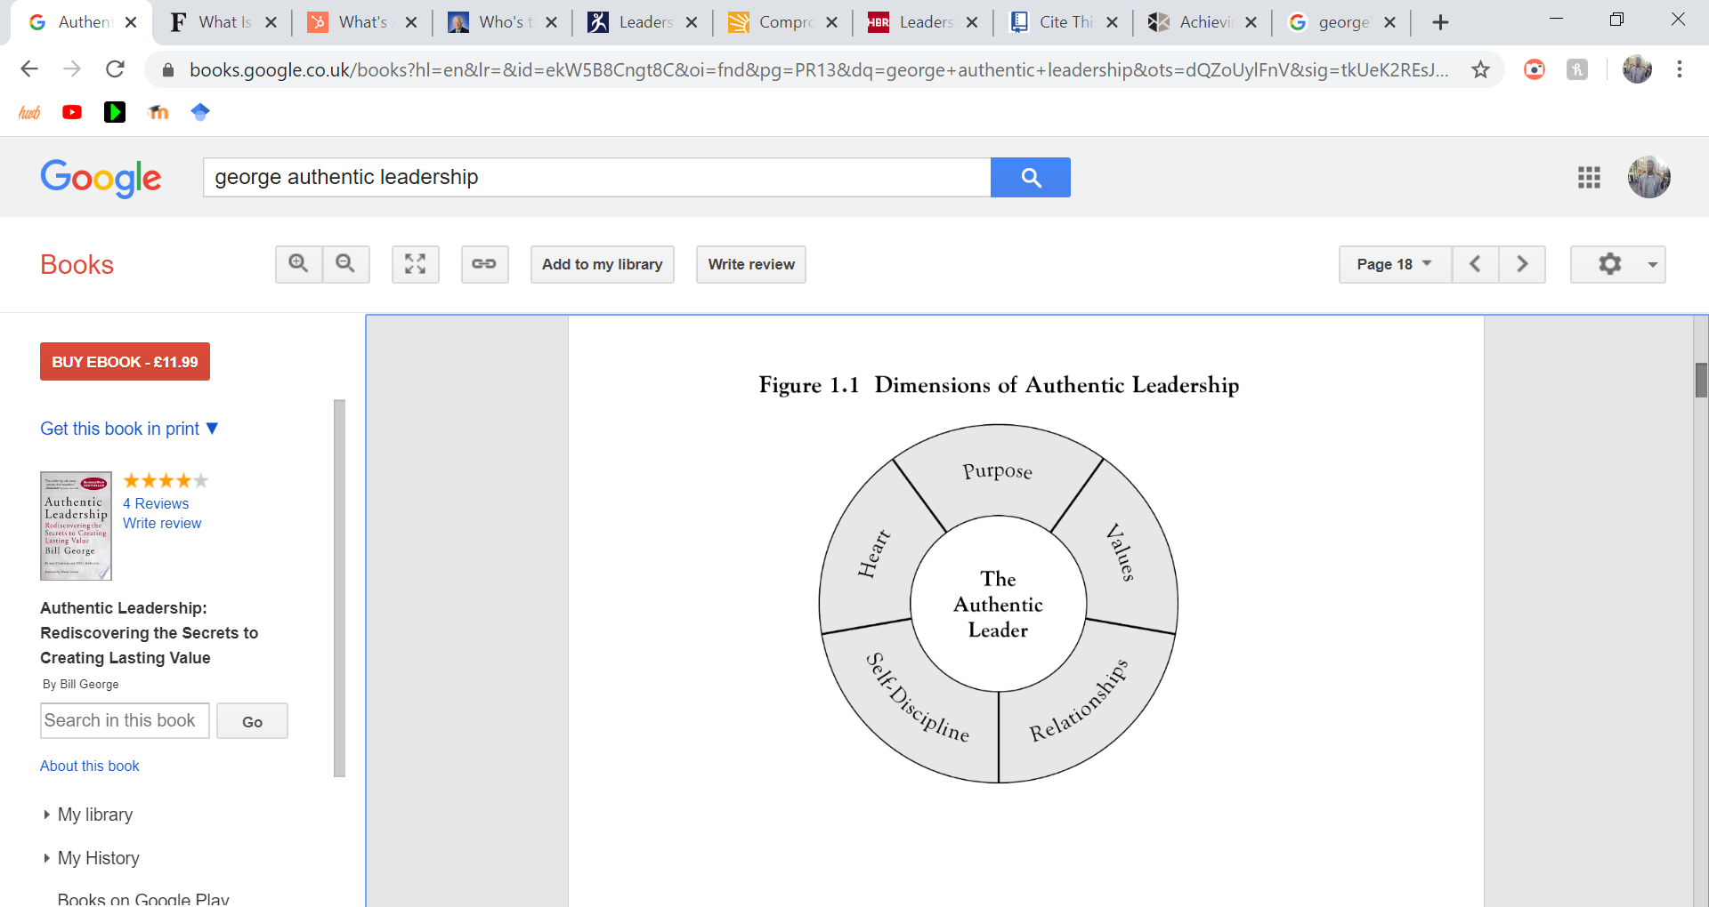
Figure 3 Qualities of authentic leadership Source: George, 2003

3.4. Critical evaluation of the three leadership approaches
Out of the three approaches analysed by the author of the report, it can be said that there no best approach to leadership. Servant leadership values its employees but treats them even better than their customers. When employees feel valued and satisfied with their job, there is a high chance that there will be more productive (Northouse, 2016). When the leader is seen serving someone, the whole company will follow that same culture. Servant leaders believe that achieving their organisational objectives is important but if their staffs are unhappy then the leaders have failed because the employees come first. Servant leadership might not be appropriate as a successful approach of leadership because it implies managers and employees to follow each rather than leading them (Yukl, 2013; Northouse, 2016).
Authentic leadership, employees are valued, and the relationship is also considered important. Authentic leaders do what they believe is right and best for their followers (Northouse, 2016). Authentic characteristics can be developed by leaders with time, so everyone can develop this quality. According to Northouse (2016), authentic leadership is still in development because there are various questions to be addressed and how this approach is effective enough to achieve the company's objectives. It is not always possible to be authentic and might not be considered as a beneficial leadership approach (Caza and Jackson, 2011).
Transformational leadership values the workforce and tries to motivate them to unlock their full potential to benefit the organisation. Transformational leadership is aimed to focus on the whole company, not only the employees (Bass et al, 2003). Transformational leaders believe that employees are essential for achieving their objectives- even if these objectives are organisational, personal or developmental (Rees and French, 2016). Transformational leaders are recognised as motivators and innovators but sometimes they ignore problems because they rely on the enthusiasm and believe that when there an effective team everything is possible (Stone et al, 2004). Transformational could be considered a bit more appropriate than a servant and authentic because the leaders are most likely to be in charge even though occasionally, they do not make decisions. Compared to servant leadership, where serving is essential and sometimes leaders might lose their role as a leader because they do not lead anymore. Authentic leadership is more about behaving based on your beliefs, while transformational leadership is based on empowering and motivating the followers (Novicevic et al, 2005). An authentic leader might be considered a bit close-minded because he acts based on beliefs and trying to give a good example.

4. Leadership Skills in the 21st Century that foster innovation

4.1. Emotional intelligence and Social intelligence
Emotional intelligence is considered as a form of social intelligence which encompasses the skill to monitor each other’s feelings, to separate them and utilise the information to have an unbiased way of thinking (Salovey and Mayer, 1990). Emotional intelligence is a set of interpersonal abilities created on specific neural circuits which helps to influence other people to be more effective (Goleman and Boyatzis, 2008). However, the complexity of organisational change and emotions have a significant impact such as eliminating jobs, global expansion, changes in leadership; the emotional and social intelligence of executives needs to be given attention whenever they interrelate with the stakeholders (Nath, 2013; Goleman and Boyatzis, 2008). In the past, the only thing motivating the workers were with pecuniary rewards, while, in the 21st century, companies have to attract their hearts and engage their minds, these can be achieved by including emotional and social intelligence (Njoroge and Yazdanifard, 2014). Various scholars and experts stated that emotions can be improved through specific development and training programs (Goleman and Boyatzis, 2008; Njoroge and Yazdanifard, 2014, Nath, 2013).
Emotional intelligence plays an important role in helping leaders to foster innovation. Companies are always facing a problem which requires innovation, most of the time these problems are presented as complex and hard to deal with (Serrat, 2017). Leaders should ensure that their working environment is psychologically safe, leaders should encourage the workers that when they make a mistake they will not get punished and it is acceptable to share their ideas and they should not feel intimidated. Psychological safety has a significant effect while creating emotional intelligence, the more the workers ask questions and share ideas with their employer, the more they learn and be more aware (George, Ibarra, Goffee, and Jones, 2017). Transformational leadership might be a suitable approach for creating an environment that is psychologically safe (Carmeli et al, 2017). Reed Hastings could be an example, he is making less decision and encouraging his staff to make decisions and be empowered. Reed's style of transformational leadership can be considered an effective way to foster innovation.

4.2. Networks and Networking
According to Clarke (2013), complexity leadership necessitates leaders to improve their skills effectively and develop networks. Ibarra and Hunter (2007) discovered networking is one of the most apparent and one the most feared developmental challenges which ambitious leaders have to face. As businesses attempt for effective cooperation across boundaries, executives are obliged to look at the invisible informal networks that support the company (Cross et al, 2013). Some research found out that when people collaborate across boundaries was the main barrier for collaboration in business activity (Kane et al, 2018). Boundary spanners are people who are capable of connecting interest and moving information from the disparate sector of the organisation (Cullen et al. 2014). In order to cross boundaries, leaders have to learn to widen their outlooks and create more ways of solving problems and fostering innovation (Ibarra and Hunter, 2007). A way to effectively identify and enhance boundary spanners within a company is utilising Organisational Network Analysis, simply known ONA (Cullen et al, 2014). An ONA identifies if leaders are isolated from the other people of the organisation and find the inequalities in the boundaries they are spanning (Cross et al, 2013).

4.3. Learning Agility
Learning agility is considered to be a mindset and a corresponding collection of methods that enables development, expansion and the use of new approaches to solving complex problems (Mitchinson and Morris, 2012). It is believed that that learning agility involves several qualities and attributes which enables someone to learn, adapt and put themselves in volatile environment conditions. Other scholars describe that in the 21 Century, who is unable to learn, unlearn and relearn will be considered an illiterate; giving up skills and believe that they are not useful anymore to learn new relevant things (Toffler, 1970; Flaum and Winkler, 2015; Mitchinson and Morris, 2012). As reported by Gravett and Caldwell (2016) an organisation that has a learning agility workforce will enable the company to have higher productivity and profitability, well-trained future workforce and productive workers. Researchers demonstrated that Learning agility is a reliable system of leadership because it enables learning agile people to outshine at assimilating the information from their experience and then analyse from others to had different experiences (De Meuse et al, 2012).
In the 21st century, businesses live in a VUCA world, uncertainty and changes are frequent, so it is necessary to be able to learn new skills, knowledge and behaviours to adapt and deal with future unforeseen or predicted challenges (De Meuse, 2019). Servant leaders are likely to be the right people to use learning agility. Sir Richard Branson personalises the term learning agility. He gets motivated by challenging himself. Branson takes time to mentor, value and guides his employees (Gochman, and Storfer, 2014) In order to create innovation, the employees should constantly challenge by their way of thinking and behaviour (Eichinger and Lombardo, 2004). Leaders such as Branson should keep encouraging himself and his employees to create more, innovate and predict what could happen in the future to adapt easily (Branson, 2010).
This kind of leadership approach and skills is linked with innovative leadership. Leaders are aware they need to change their working style and approach to get a result at a strategic level. According to Horth and Buchner (2014), an innovative leader might not always be the one that had an idea and they should create an organisational environment where employees apply innovative thinking to solve problems, develop new services and products. Innovative leaders adopt an alternative way of learning, it is seen as a competitive advantage that enables a high level of performance. Companies need to provide equipment such as software, reviews and debriefs to have effective learning agility (Mitchinson and Morris, 2012).
Emotional intelligence, networking, learning agility are important skills for leaders and their followers. There might not be the best skill to foster innovation, emotional intelligence, networking and learning agility might be appropriate and can still be developed; they are linked skills. An example could be that when someone meets greater people it enables them to improve their network and at the same time improve their emotional intelligence, (Kesting et al, 2015). Hastings has shown a high level of emotional intelligence with his transformational leadership style. Learning agility is another skill that might foster innovation and high performance; this skill is might be effective if the leaders are innovative (Clarke, 2013). There might not be the most suitable skills for foster innovation but emotional intelligence and learning agility might be appropriate, (Iordanoglou, 2018).

5. Conclusion
Leaders in the 21st century have been struggling to operate in a complex adaptive system. Identifying the right leadership approach to foster innovation, high performances and adaption were challenging for the author of the report. The author mentioned some benefits of each leadership approach and he believes that transformational leadership might be considered a bit appropriate to foster innovation. Leadership skills are essential for leaders, but it might hard to find to most suitable skill to foster innovation and provide high performance. Emotional intelligence and Learning agility might be considered vital for leaders, on the other hand, networks are also important and might be linked and improve the other skills. With this analysis it is possible to understand the leadership approaches and skills; finding the required leadership approach to nurture innovation might be a challenging because there is not an accurate approach but transformational leadership might be considered effective and emotional intelligence could be considered also effective with the necessary improvements. Due to the word count limitation, the author of this report could go in-depth with his analysis and conclusions. In the following section, there will recommendations on how to improve leadership skills.

6. Recommendations
Micro-experiments is small and informal research which helps to learn and improve. A leader to improve his leadership skills, he could introduce ‘job swapping’. When the employees that work in completely different departments exchange their jobs for a determined period of time. This could be seen as a cross-training strategy, it used mostly to develop the employees understanding and have a different perspective on how the company operates and increase relationships (Reid, 2005). This will enable the employees to develop their emotional intelligence with a simple experiment. ‘Job swapping' should be planned and prepared in order to avoid problems. For example, it should not be implemented when there is a crisis or something that could prevent the ‘’job swapping’ to be effective (flowers, 2014).

7. References
Bass, B.M., (1985). Leadership and performance beyond expectations.
Bass, B.M., Avolio, B.J., Jung, D.I. and Berson, Y., (2003). Predicting unit performance by assessing transformational and transactional leadership. Journal of applied psychology, 88(2), p.207.
Bawany, S., (2016). Leading in a VUCA business environment. Leadership Excellence Essentials, 7, pp.39-40.
Berkovich, I., 2016. School leaders and transformational leadership theory: time to part ways?. Journal of Educational Administration.
Branson, R. (2020). Look after your staff. [Online] Virgin. Available at: https://www.virgin.com/richard-branson/look-after-your-staff [Accessed: 24 Feb 2020].
Branson, R., (2010). Losing my virginity: how I've survived, had fun, and made a fortune doing business my way. Currency.
Burns, J.M., (1978). Transformational Leadership Theory. Leadership.
Cameron, E. and Green, M., (2017). Essential Leadership: Develop Your Leadership Qualities Through Theory and Practice. Kogan Page.
Cappelli, P., Singh, H., Singh, J. and Useem, M. (2010). Leadership Lessons from India. [online] Harvard Business Review. Available at: https://hbr.org/2010/03/leadership-lessons-from-india [Accessed 2 Mar. 2020].
Carmeli, A., Sheaffer, Z., Binyamin, G., Reiter‐Palmon, R. and Shimoni, T., (2014). Transformational leadership and creative problem‐solving: The mediating role of psychological safety and reflexivity. The Journal of Creative Behavior, 48(2), pp.115-135.
Caza, A. and Jackson, B., (2011). Authentic leadership. The SAGE handbook of leadership, pp.352-364.
CIPD. (2020). New Memorandum of Understanding between the CIPD, HPMA, PPMA and UHR set to promote development of 21st Century public service workforces | CIPD. [online] Available at: https://www.cipd.co.uk/about/media/press/090518-mou-public-service [Accessed 2 Mar. 2020].
Clarke, N., (2013). Model of complexity leadership development. Human Resource Development International, 16(2), pp.135-150.
Cross, R., Ernst, C. and Pasmore, B., (2013). A bridge too far? How boundary spanning networks drive organizational change and effectiveness. Organizational Dynamics, 42(2), pp.81-91.
Cullen, K.L., Palus, C.J. and Appaneal, C., (2014). Developing Network Perspective Understanding the Basics of Social Networks and their Role in Leadership. White paper, Center for Creative Leadership.
De Meuse, K.P., (2019). A Meta-Analysis of the Relationship between Learning Agility and Leader Success. Journal of Organizational Psychology, 19(1).
De Meuse, K.P., Dai, G., Swisher, V.V., Eichinger, R.W. and Lombardo, M.M., (2012). Leadership development: Exploring, clarifying, and expanding our understanding of learning agility. Industrial and Organizational Psychology, 5(3), pp.280-286.
Deloitte, (2017). 2017 Deloitte Global Human Capital Trends: Rewriting the Rules for the Digital Age.
Eichinger, R.W. and Lombardo, M.M., (2004). Learning agility as a prime indicator of potential. People and Strategy, 27(4), p.12.
Elkington, R., (2018). Leadership Decision‐Making Leveraging Big Data in Vuca Contexts. Journal of Leadership Studies, 12(3), pp.66-70.
Flaum, J.P. and Winkler, B., (2015). Improve your ability to learn. Harvard Business Review.
Flowers, L.K., Thomas-Squance, R., Brainin-Rodriguez, J.E. and Yancey, A.K., (2014). Interprofessional social and emotional intelligence skills training: study findings and key lessons. Journal of interprofessional care, 28(2), pp.157-159.
Gandolfi, F. and Stone, S., (2018) Leadership, leadership styles, and servant leadership. Journal of Management Research, 18(4), pp.261-269.
George, B., (2010). True north: Discover your authentic leadership (Vol. 143). John Wiley & Sons.
George, B., Ibarra, H., Goffee, R. and Jones, G., (2017). Authentic leadership (HBR Emotional Intelligence Series). Harvard Business Press.
George, B., Sims, P., McLean, A.N. and Mayer, D., 2007. Discovering your authentic leadership. Harvard business review, 85(2), p.129.
Gochman, I. and Storfer, P., (2014). Talent for tomorrow: Four secrets for HR agility in an uncertain world. People and Strategy, 37(2), p.24.
Goleman, D. and Boyatzis, R., (2008). Social intelligence and the biology of leadership. Harvard business review, 86(9), pp.74-81.
Gravett, L.S. and Caldwell, S.A., (2016). Learning agility: The impact on recruitment and retention. Springer.
Greenleaf, R.K., (2008). Who is the servant-leader?. The International Journal of Servant-Leadership, 4(1), pp.29-37.
Griffiths, D. and Inman, M. (2016) Hgh Performance Workplaces: A practical approach to managing complexity and coping with change. South Wales Business Review, 6(4), pp. 18-20.
Griffiths, D. and Inman, M. (2016) Hgh Performance Workplaces: A practical approach to managing complexity and coping with change. South Wales Business Review, 6(4), pp. 18-20.
Grinapol, C., (2013). Reed Hastings and Netflix. The Rosen Publishing Group, Inc.
Hagemann, B. and Bawany, S., (2016). Enhancing Leadership and Executive Development-Latest Trends & Best Practices in Leadership Excellence Essentials.
Hastings–Netflix, R. and From, D.V.D., (2018). Leadership and Management Styles and Approaches. Leadership.
Hickman, G.R., (1998). Leading organizations: Perspectives for a new era. Sage.
Higgs, M. and Dulewicz, V., (2016). Developments in leadership thinking. In Leading with emotional intelligence (pp. 75-103). Palgrave Macmillan, Cham.
Ibarra, H. and Hunter, M., (2007). How leaders create and use networks. Growth, 35(1), pp.101-103.
Iordanoglou, D., 2018. Future trends in leadership development practices and the crucial leadership skills. Journal of Leadership, Accountability and Ethics, 15(2).
Kane, G.C., Palmer, D., Phillips, A.N., Kiron, D. and Buckley, N., (2018). Coming of age digitally. MIT Sloan Management Review and Deloitte Insights, 5.
Kesting, P., Ulhøi, J.P., Song, L.J. and Niu, H., (2015). The impact of leadership styles on innovation-a review. Journal of Innovation Management, 3(4), pp.22-41.
Kovacs, L.C. and Corrie, S., (2017). Executive coaching in an era of complexity. Study 1. Does executive coaching work and if so how? A realist evaluation. International Coaching Psychology Review, 12(2), pp.74-89.
Kruse, K. (2013). What Is Authentic Leadership?. [Online] Forbes.com. Available from: https://www.forbes.com/sites/kevinkruse/2013/05/12/what-is-authentic-leadership/#163aa032def7 [Accessed 27 Feb. 2020].
Lawrence, K., (2013). Developing leaders in a VUCA environment. UNC Executive Development, pp.1-15.
Lowell, K.R., (2016). An application of complexity theory for guiding organizational change. The Psychologist-Manager Journal, 19(3-4), p.148.
McCord, P., (2014). How netflix reinvented HR. Harvard Business Review, 92(1), pp.71-76.
Mitchinson, A. and Morris, R., (2012). Learning about learning agility. A White Paper.
Naisbitt, J., (1982). Megatrends. New York, 17, p.1982.
Nath, B., (2013). An examination of the relationship between emotional intelligence, leadership styles and leadership effectiveness.
Njoroge, C.N. and Yazdanifard, R., (2014). The impact of social and emotional intelligence on employee motivation in a multigenerational workplace. Global Journal of Management and Business Research.
Northouse, P.G. (2016) Leadership Theory and Practice London: Sage Publications.
Novicevic, M.M., Davis, W., Dorn, F., Buckley, M.R. and Brown, J.A., (2005). Barnard on conflicts of responsibility: Implications for today's perspectives on transformational and authentic leadership. Management Decision, 43(10), pp.1396-1409.
PWC (2020) [Online] Megatrends. Available from: https://www.pwc.co.uk/issues/megatrends.html (Accessed: 3 Mar 2020).
Reed, B.J., (2012). Leader development, learning agility, and the army profession. COLUMBIA UNIV NEW YORK TEACHERS COLL.
Rees, G. and French, R. eds., (2016). Leading, managing and developing people. Kogan Page Publishers.
Reid, M., (2005). Applying succession management benefits for leadership continuity. Journal of Business & Economics Research (JBER), 3(6).
Richardson, K.A., (2011). Complexity and management: a pluralistic view. The SAGE handbook of complexity and management, pp.366-382.
Salovey, P. and Mayer, J.D., (1990). Emotional intelligence. Imagination, cognition and personality, 9(3), pp.185-211.
Sarkar, A. and Sarkar, A., (2016). We live in a VUCA World: the importance of responsible leadership. Development and Learning in Organizations: An International Journal, 30(3), pp.9-12.
Serrat, O., (2017). Understanding and developing emotional intelligence. In Knowledge solutions (pp. 329-339). Springer, Singapore.
Snowden, D.J. and Boone, M.E., (2007). A leader's framework for decision making. Harvard business review, 85(11), p.68.
Stacey, R.D., (2011). Strategic Management and Organisational Dynamics: The Challenge of Complexity.
Stone, A.G., Russell, R.F. and Patterson, K., (2004). Transformational versus servant leadership: A difference in leader focus. Leadership & Organization Development Journal.
Toffler, A., (1970). Future shock. Bantam.
Uhl-Bien, M., Marion, R. and McKelvey, B., (2011). Complexity Leadership Theory: Shifting Leadership from the Industrial Age to the Knowledge Era. Leadership, Gender, and Organization, pp.109-138.
Vielmetter, G. and Sell, Y., (2014). Leadership 2030: The six megatrends you need to understand to lead your company into the future. Amacom.
Yukl, G. (2013) Leadership in Organizations, 7th ed. Pearson

