 | Target assignment 7004 | What I have done in this assignment...
Target | Wider Reading to give more varies perspectives | I explored a diverse range of sources in my wider reading, and I gained varied perspectives that enriched both my understanding and the quality of my writing.
Title: How a school develops one aspect of its SDP: a report that critically reflects on the actions, impact, and evidence base.
Introduction
This assignment aims to explore how a school prioritizes a single aspect of its School Development Plan (SDP). Specifically, the assignment will engage in critical reflection upon a single action point identified from the school's priorities. To accomplish this, the Welsh government's school development plan cycle will be employed to illuminate how the target was identified, the action implemented, and the measures used to assess its impact. Through this approach, the effectiveness of the school's chosen strategies will be analysed and evaluated.
In line with BERA (2018) Guidelines, confidentiality and anonymity are crucial for research ethics. Researchers must respect the privacy rights of participants and institutions. Consequently, the participant's school will be referred to as School A and Assistant Headteacher Y.
School A is a mixed comprehensive school that serves pupils aged 11-16 and is situated on the eastern side of Swansea, with 1,058 pupils. School A is based in a deprived area with around 33.8% of pupils in receipt of free school meals which is higher than the national average of 22.4 and approximately 35% of the student are registered as having additional learning needs, of which 5% have specific statements of such requirements. These figures are notably higher than the national averages of roughly 23% and 2%, respectively. Therefore, the school has a special teaching facility to meet the student’s needs (Estyn, 2020).
School A focuses on six priorities in its SDP. This assignment will focus on one aspect of School A’s priorities: great behaviour. School A, primary objective is to provide an exceptional teaching experience that consistently encourages positive attitudes and behaviour. They firmly believe that every lesson, every day, should inspire students to strive for excellence in both their academic and personal growth.
Literature review
School Development Plan
SDP serves as a roadmap for school improvement and outlines the steps the school will take to improve learner outcomes. It is derived from regular self-evaluation of the school's performance and contextual data and outlines the school's priorities for improvement along with short- and long-term goals. Priorities may involve addressing national initiatives like improving literacy, and numeracy, and reducing poverty's effect on education. In addition to setting targets, the SDP outlines how the school will utilize resources and enhance the skills of its staff to achieve its objectives (Welsh Government,2014).
In contrast, the Welsh Government's recent publication of a new school improvement framework marks a significant shift in the way schools in Wales will be held accountable for their performance. It replaces the previous National Categorization system with a robust self-evaluation system, focusing on learner progression and well-being as the central drivers of high educational standards and aspirations. This new approach prioritizes collaboration between schools and transparency, with good practice being shared, and failure addressed promptly (Welsh Government, 2022a).
According to BERA guidance (2022) schools that are committed to self-improvement require a culture that recognizes the importance of self-evaluation for its own sake, rather than merely as a means to prepare for external inspection.
The SDP is a flexible document that covers three years and is periodically updated to reflect the school's progress in meeting its goals, considering the most recent performance data. Although it should provide sufficient details to enable immediate actions to address current priorities, it should also include high-level priorities and targets for the next two years (Welsh Government, 2014). One of the most significant changes under the new framework is the increased focus on providing up-to-date and detailed information about each school's improvement priorities and development plans, which will be made public and published. This change allows parents and stakeholders to gain better insights into the school's performance, facilitating more effective accountability (Welsh Government, 2022a).
The SDP should be easily accessible to staff and governors, who can use it as a common reference point to assess and enhance their work. Its contents need not be overly detailed and should focus on fulfilling its primary objective of facilitating improvement. The SDP's effectiveness should be measured by its impact on enhancing outcomes, rather than its level of detail (ibid).
Another crucial distinction is the separation of pupil assessment and school accountability in the new framework, which had become blurred in the past. The goal is to use assessment in the best interest of pupils, enabling teachers to adjust their teaching strategies, while accountability, led by Estyn, drives improvement through better transparency and performance evaluations. This approach is crucial since it emphasizes the importance of learner progression and well-being, rather than simply focusing on headline descriptions of school performance (Welsh Government, 2022b).
Furthermore, the new framework features an increased frequency of Estyn inspections, providing schools with more regular feedback for continuous improvement. The importance of regular feedback cannot be overemphasized, as it is one of the key drivers of continuous improvement in any system (Welsh Government, 2022a).
The school's vision is developed through a collaborative effort that includes learners, parents, external community members, and other partners who are invited to contribute (Welsh Government, 2018). While the governing body has the ultimate responsibility for the SDP, the headteacher will collaborate with the staff and governing body to create the SDP and will be accountable for executing the required actions and strategies to achieve improvement (Welsh Government,2014).
By incorporating input from various school partners and stakeholders, the plan becomes more comprehensive and accurately reflects each school's unique needs. Consequently, the success of such planning is primarily determined by its impact on learner outcomes (ibid).
In the new arrangements, the Welsh Government collaborates with educational stakeholders in schools and the middle tier to create new evaluation, improvement, and accountability measures. These aim to meet expectations for school improvement in the context of the Curriculum for Wales, ensuring performance is evaluated using contextualized evidence, focusing on learner progress and well-being as key factors (Welsh Government, 2022c).
Behaviour Management
According to Ingersoll and Smith (2003), the ability to effectively organize a classroom and manage student behaviour has a considerable impact on the likelihood of new teachers continuing in their teaching careers. Consequently, it is a crucial ability for educators to effectively manage students’ behaviours in the classroom as effective teaching demands substantial expertise in handling the diverse tasks and scenarios that arise daily in the classroom (Harris,1998).
Using Routine
Teachers foster student learning by implementing structured and organized teaching methods, clearly outlining learning objectives, and providing continuous feedback. Research has consistently demonstrated that higher learning outcomes are achieved when teachers utilize these approaches in the classroom (Harris, 1998).
Furthermore, effective teachers establish routines to set expectations and prevent misbehaviour in the classroom, creating an environment that is conducive to learning and academic success. Research has shown that developing well-defined expectations and routines in the classroom can decrease disruptive behaviour and promote a sense of security among students (Brophy, 2006).
By implementing consistent protocols for tasks such as entering and leaving the classroom, transitioning between activities, and handling materials, teachers can minimise interruptions and maintain a smooth learning environment (Epstein et al., 2008).
Using Rewards
In UK schools, behaviour management policies incorporating rewards and sanctions have been formally implemented. These systems, however, may conflict with current teaching and learning approaches due to their differing theoretical foundations. Moreover, inconsistencies may arise in their application, stemming from the lack of distinction between positive reinforcement and disciplinary actions, as well as between students' academic tasks and social behaviour (Payne, 2015).
It is crucial to address these concerns to ensure that the effectiveness of behaviour management policies is not compromised and that they align with contemporary educational practices while consistently addressing students' needs. Certain disciplinary measures for student conduct in the classroom may result in students becoming silent, which could negatively impact their participation in all educational tasks. Punishments like making students skip breaks or assigning detentions seem to hinder their motivation to put in the effort during class (ibid).
A study by Bear et al. (2018) investigates the impact of punitive discipline on student motivation, finding that exclusionary practices such as suspension and expulsion can result in lower levels of student engagement, academic achievement, and overall well-being.
The most successful approach for both behaviour and academic performance among secondary school students is providing positive feedback through home communication. This method not only encourages proper conduct and diligent work but also fosters a positive teacher-student relationship (Payne, 2015).
In brief, to foster a positive school climate, educators should adopt a balanced approach that merges positive and punitive techniques for managing student behaviour and developing their social-emotional skills. The primary focus should be on strategies that students view as beneficial for their social-emotional growth, rather than frequently using praise, rewards, or punishments (Bear et al.,2018).
These studies indicate that punitive disciplinary measures may not be the most effective approach for promoting positive student behaviour and engagement in the classroom. Instead, schools should consider alternative strategies such as school-wide positive behavioural interventions and supports (SWPBIS), which have been shown to foster a more positive and inclusive learning environment (McIntosh et al., 2016).
Developing an action point
This section will examine the process by which School A recognized behaviour management as a crucial focus and established the implementation of "Great Behaviour" as a high-level priority.
The SDP cycle relies on a clear vision for the school's goals, forming the basis for the SDP. To ensure lasting improvement, the school needs a unified purpose understood by all, taking its context into account, and adopting an achievable, motivating vision backed by practical strategies. The cycle has four main stages: (see Appendix A) self-evaluation, strategic planning, taking an action, and reviewing impact (Welsh Government, 2014).
Stage 1 - Self-Evaluation
Self-evaluation allows schools to analyse their performance and create plans for long-term enhancement. This method is crucial for fostering progress in school development, professional growth, and student achievements. As a yearly practice, self-evaluation helps schools measure their effectiveness, and strong areas, recognizing aspects needing enhancement, and deciding on steps to make those improvements. As part of their ongoing monitoring procedures, schools annually evaluate their progress regarding established objectives or benchmarks (Welsh Government, 2014).
The Assistant head teacher stated that School A has identified the behaviour as a priority, as they feel that great behaviour and routines are linked to excellent teaching and learning. School A aims on achieving an impeccable teaching experience, where every lesson, every day, challenges poor behaviour and attitudes towards learning within tight systems while creating a positive, respectful, resilient, and safe culture from the very beginning of the week on Monday to the end on Friday. School A aims to develop its SDP by focusing on three areas: ensuring consistent student success values and routines, improving attendance systems, and reducing exclusions (School A SDP,2022).
Welsh Government (2014) stated that schools can utilize various data sources to aid their development planning, such as information related to particular student groups like those eligible for FSMs or with ALN. Additionally, they have access to comparative data, enabling them to evaluate their performance against top-performing schools and those within their network.
School A believes that all students need to be explicitly taught routines and values, particularly given that students who receive FSM and those with ALN are overrepresented in poor attendance and exclusions. School A has compared exclusion rates locally and nationally, as well as analysed positive and negative points awarded in class charts. This data helped identify areas for improvement and set objectives related to behaviour management. However, it is essential to recognize the limitations of solely relying on exclusion rates and class charts data, as they may not capture the entire picture of student behaviour.
A key aspect of the self-evaluation system is the fundamental involvement of schools and professionals in assisting other schools, enabling the distribution of strengths throughout the system, and addressing areas needing improvement through cooperative efforts among peers (Welsh Government, 2022a). The subject mentor stated that the Assistant Headteacher, who leads the priority for Great behaviour in School A, visited schools in England and participated in a meeting with local leaders to exchange and discuss behaviour strategies. This can be advantageous as it fosters collaboration among schools and promotes the sharing of effective practices.
Stage 2: Strategic planning
All individuals associated with the school, including school partners, and stakeholders, will actively participate in recognizing strong points and pinpointing areas that require enhancement (Welsh Government,2014).
Headteacher Assistant highlighted that School A stakeholders, staff, students, and parents were consulted on the behaviour processes, with the Headteacher Assistant and the student achievement team leading the initiative. The process is monitored by area of learning and experience (AoLE) leads and learning leaders. According to Welsh government (2014) guidelines, it is vital to the SDP process that a sense of responsibility and collaboration is nurtured by including all stakeholders in the planning stages for continuous improvement.
The school's governing body, headteacher, and staff members should collaborate to determine SDP priorities and targets (Welsh Government, 2022a). School A set a target to ensure that most students' positive points outweigh their negative points, and to reduce the number of exclusions in line with the local authority. Robust routines for learning were introduced, and all staff were required to follow these to ensure consistency in behaviour management.
In addition to addressing behaviour, the school highlighted the importance of improving attendance and reducing exclusions, particularly for FSM and ALN students who are overrepresented in these areas.
Stage 3: Making improvements and action
During this phase of the planning cycle, the actions and strategies outlined in the SDP are implemented and executed.
To accomplish the school's improvement objectives, it is essential to address the professional development requirements of all staff members, including those in leadership roles. This support extends to teaching assistants and temporary staff, such as short- and long-term substitute teachers (Welsh Government, 2022a). Therefore, School A allocated inset days and twilight sessions to review and reinforce behaviour management strategies, including the use of class charts and providing guidance on recording students' positive or negative points systematically.
The school closely monitors attendance and behaviour, utilizing a range of efficient strategies to emphasize the importance of consistent attendance and behaving appropriately as noted in the Estyn report (2020). In parallel, School A emphasise the importance of celebrating the success of both great behaviour and attendance with all students at every opportunity via INSET with staff and assemblies and tutor time with students.
There are a variety of support systems available at School A that to the diverse needs of its pupils. These support systems are tailored to the unique requirements of each student. For instance, School A has a dedicated team known as 'PAWB' that works efficiently with identified pupils to ensure their engagement and commitment to school life.
In a conversation with Assistant Headteacher Y, he emphasized that establishing a positive relationship with young pupils is fundamental for a successful teaching experience. The foundation of effective teaching lies in fostering positive relationships with pupils, emphasizing the importance of routines for learning, and instilling values such as readiness, respect, resilience, and safety. Teachers should communicate expectations to minimise distractions during lessons and plan lessons strategically to prevent misbehaviour.
Furthermore, he said recognizing and reinforcing positive behaviour is a crucial step in addressing challenging behaviour. Even in situations where distractions occur, teachers should continue to acknowledge and reward good behaviour when students complete their tasks. School A believes this approach encourages students to maintain their positive behaviour and creates a supportive learning environment. Moreover, teachers need to emphasize the importance of respecting the unique culture of each learning space. By fostering an understanding of different cultural expectations within the classroom, students are more likely to engage in positive behaviour and contribute to a respectful, inclusive learning environment.
SDP should include explicit information regarding responsibilities, accountability measures, actions, and timelines. This clarity is crucial to prevent misunderstandings, and overlapping efforts, and to guarantee the optimal utilization of available resources (Welsh Government, 2014). Thus, in School A it is the responsibility of all staff to follow clear, coherent, and consistent routines for learning across all classrooms. To support that in 2022 School A implemented the use of three acronyms: STAR, SHAPE, and STEPS, (See Appendix B), (School A staff handbook, 2022).
Stage 4 Measuring impact:
SDPs should be treated as dynamic documents, monitored regularly, and reviewed at least annually. The governing body is responsible for updating the SDP after an Estyn inspection and it should reflect the current context of the school (Welsh Government,2014).
The Assistant Headteacher said that School A reviews behaviour half termly in line with local authority data and compares it to local and national data to measure the impact. They will also ensure consistency in the implementation of the student values for success and routines. However, it is important to recognize the limitations of using quantitative data alone to measure impact and consider using qualitative data from stakeholders to provide a more comprehensive understanding of the success of the behaviour management plan.

Reflection and evaluation
The prioritization of implementing consistent routines in School A is evident, as it promotes a cohesive learning environment throughout the school. By ensuring that all staff members follow established guidelines in every lesson, the school effectively promotes structure and unity in its educational approach.
The implementation of consistent routines in School A has led to positive outcomes, including reduced instances of negative behaviour recorded on class charts. This approach has effectively contributed to almost all students, including those receiving FSM, demonstrating behaviours that support progress in learning. Furthermore, the majority of students, and nearly all FSM students, are purposefully engaged during lessons (School A Improvement Toolkit, 2022).
School A utilizes the “School Way,” employing STAR, SHAPE, and STEPS to promote a respectful environment (see Appendix B). This approach not only teaches social skills to students, which can help prevent and address behavioural challenges by providing them with strategies for effectively interacting with peers and adults (Hemmeter et al., 2011); but also encourages positive relationships among students and staff (Cohen et al., 2009).
Students at School A who accumulate high positive points on the class charts are rewarded with trips. This practice aligns with Payne's (2015) research findings that offering incentives such as school trips has proven to be highly effective in schools.
Poulou and Norwich (2000) revealed a connection between poor behaviour and teacher stress, while Langford et al. (2014) established a link between student well-being and their outcomes which supports the notion that there is a robust link between health and education: children in good health tend to perform better academically. Consequently, it might be worthwhile that School A to consider evaluating both staff and student well-being as a means of assessing the impact of implemented strategies.
It is crucial to provide suitable training and additional support to ensure that teachers have access to professional development opportunities that address the unique needs of both teachers and schools (EWC,2002). In alignment with this regulation, School A could consider providing ongoing professional development opportunities, such as conferences, workshops, and online courses, which can empower teachers to enhance their skills, and knowledge in behaviour management strategies, ultimately improving student outcomes.
In reflecting upon School A's current strategies for engaging parents in their children's education, it is evident that School A recognizes the importance of parental involvement in preventing persistent absenteeism and promoting positive behaviour. The early engagement of parents at the beginning of the academic year, education on discriminatory behaviour, and communication through class charts are all commendable efforts.
However, according to Jeynes’s (2005) research, School A could enhance student outcomes by encouraging increased parental involvement, as this meta-analysis reveals a positive link between active parent engagement and academic achievement. School A could offer workshops and seminars focused on equipping parents with the necessary knowledge and skills to support their children's education at home. These workshops could be grounded in Bronfenbrenner's (1979) ecological systems theory, which emphasizes the interconnectedness of various environmental systems in shaping children's development. By empowering parents to create a supportive home environment, the school can further promote positive behaviour and academic success.
Conclusion
In conclusion, this assignment has emphasized the crucial role of the School Development Planning cycle in enhancing overall school outcomes. In particular, it analysed School A's acknowledgement of the importance of behaviour management and the subsequent implementation of the "Great Behaviour" initiative. The discussion detailed School A's self-evaluation, strategic planning, action-taking, and impact-measuring stages, showcasing the school's utilization of data sources, collaboration with other schools, and efforts to involve stakeholders in the decision-making process. Moreover, the assignment underscored the importance of providing professional development opportunities for staff members and implementing strategies to engage parents actively.
As a student-teacher, I gained a wealth of knowledge that will influence my future practice as an educator. I have learned about the importance of SDP and the value of using behaviour management techniques to create a positive learning environment. I have come to better understand the significance of effective behaviour management and the implementation of consistent routines in teaching practices. Additionally, I have discovered the benefits of collaborating with other schools and stakeholders, the insights that can be gained from using data to inform decision-making, the ongoing need for professional development, and the substantial impact that parental involvement can have on student outcomes.

Appendix A
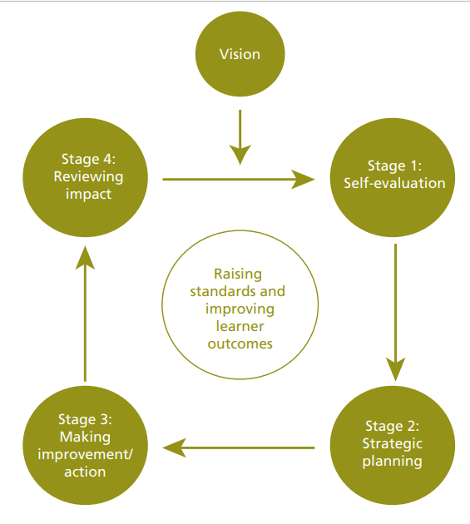
School development planning cycle (Welsh Government, 2014)

Appendix B
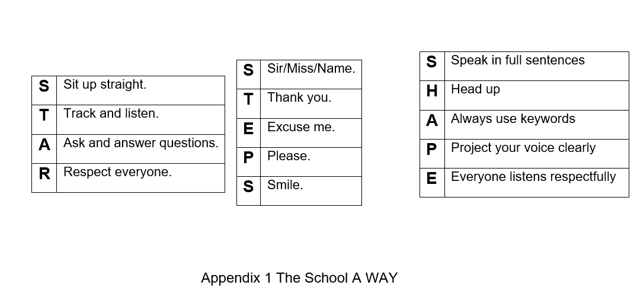
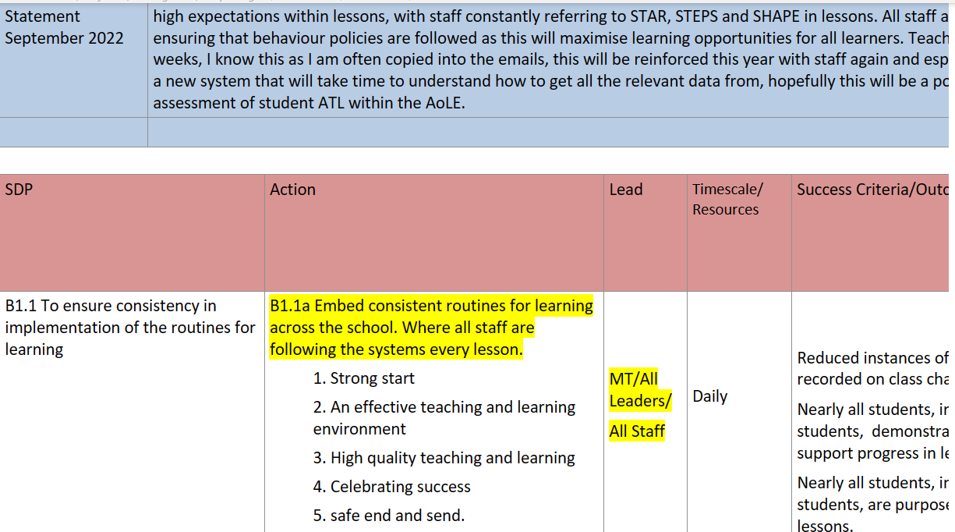
Screenshot of School A’s School Improvement Toolkit
References
[School A] (2022) [School A] School Improvement Toolkit. Swansea [School A]

Bear, G.G. et al. (2017) ‘School-wide practices associated with school climate in elementary, middle, and high schools’, Teaching and teacher education, 63, pp. 372–383. Available at: https://doi.org/10.1016/j.tate.2017.01.012.

Bera (2022). School self-evaluation for school improvement: Principles of effective practice. [online] Available at School self-evaluation for school improvement: Principles of effective practice | BERA

Bera (2018). Ethical guidelines for educational research, Fourth edition (2018) BERA. Available at: BERA-Ethical-Guidelines-for-Educational-Research_4thEdn_2018.pdf

Bronfenbrenner, U. (1979) The ecology of human development : experiments by nature and design. Cambridge, Mass: Harvard University Press. Available online at ProQuest Ebook Central - Reader

Brophy, J. (2006). History of research on classroom management. In C. M. Evertson & C. S. Weinstein (Eds.), Handbook of classroom management: Research, practice, and contemporary issues (pp. 17-43). Mahwah, NJ: Lawrence Erlbaum Associates.

Cohen, J., Mccabe, E. M., Michelli, N. M., & Pickeral, T. (2009). School Climate: Research, Policy, Practice, and Teacher Education. Teachers College Record, 111(1), 180–213. Available at: https://doi.org/10.1177/016146810911100108

Education Workforce Council Wales (2002) Continuing Professional Development An entitlement for all, The General Teaching Council for Wales’ Advice to the Welsh Assembly Government. Available at: CPD Advice final (ewc. wales)

Epstein, M., Atkins, M., Cullinan, D., Kutash, K., & Weaver, R. (2008). Reducing behaviour problems in the elementary school classroom: A practice guide (NCEE 2008-012). Washington, DC: National Center for Education Evaluation and Regional Assistance, Institute of Education Sciences, U.S. Department of Education.
Estyn (2020). Available at: Inspection report School 2020 (gov. wales)

Harris, A. (1998) ‘Effective teaching: A review of the literature’, School Organisation, 18(2), pp. 169–183. Available at: https://doi.org/10.1080/13632439869628.
Hemmeter, M.L., Ostrosky, M.M. and Corso, R.M. (2012) ‘Preventing and Addressing Challenging Behavior: Common Questions and Practical Strategies’, Young exceptional children, 15(2), pp. 32–46. Available at: Preventing and Addressing Challenging Behavior (sagepub.com)

Ingersoll, R.M. and Smith, T.M. (2003) ‘The Wrong Solution to the Teacher Shortage’, Educational Leadership, 60(8), p. 30–.

Jeynes, W.H. (2005) ‘A Meta-Analysis of the Relation of Parental Involvement to Urban Elementary School Student Academic Achievement’, Urban education (Beverly Hills, Calif.), 40(3), pp. 237–269. Available at: https://doi.org/10.1177/0042085905274540.

Langford, R. et al. (2014) ‘The WHO Health Promoting School framework for improving the health and well‐being of students and their academic achievement’, Cochrane database of systematic reviews, 2014(4), p. CD008958–. Available at: https://doi.org/10.1002/14651858.CD008958.pub2.

McIntosh, K. et al. (2016) ‘Identifying and Predicting Distinct Patterns of Implementation in a School-Wide Behavior Support Framework’, Prevention science, 17(8), pp. 992–1001. Available at: https://doi.org/10.1007/s11121-016-0700-1.

My local school (2019) GOV.WALES. Available at: https://www.gov.wales/my-local-school-guide.

Payne, R. (2015) ‘Using rewards and sanctions in the classroom: pupils’ perceptions of their responses to current behaviour management strategies’, Educational review (Birmingham), 67(4), pp. 483–504. Available at: https://doi.org/10.1080/00131911.2015.1008407.

Poulou, M. and Norwich, B. (2000) ‘Teachers’ causal attributions, cognitive, emotional and behavioural responses to students with emotional and behavioural difficulties’, British journal of educational psychology. Received 25 February 1999; revised version received 9 November 1999, 70(4), pp. 559–581. Available at: https://doi.org/10.1348/000709900158308.

Welsh Government (2014). School Development Plans Guidance October 2014 Guidance document no: 155/2014. Available at : School Development Plans Guidance Document (gov.wales)
Welsh Government (2018) Schools in Wales as learning organisations. available at : WELSH GOVERNMENT35678 (gov.wales)

Welsh Government (2022a). School improvement guidance: a framework for evaluation, improvement and accountability. Available at : School improvement guidance: a framework for evaluation, improvement and accountability - Hwb (gov. wales)

Welsh Government (2022b). New framework for school improvement to focus on learner progression. Available at : A new framework for school improvement to focus on learner progression (gov.wales) MONDAY 27 JUN 2022

Welsh Government. (2022c). School Improvement Guidance: Impact Assessment. Available at : School improvement guidance: impact assessment [HTML] | GOV.WALES

