Radiant Sunbeam Hotel

Student Name- Andreea Ionelia Girboi
Student ID- 2119260
Module Name: BMIH6005 Organisational Consultancy
Lecturer name: Philippa Fitzgerald

Executive Summary
The executive summary of a consultancy report stands firm on a significant footing since it gives a brief yet complete assessment of the whole record's items, empowering choice producers to fathom the significant thing discoveries and pointers without diving into the entire record. Because of the Radiant Sunbeam Hotel, this executive summary fills in as a basic device for the buyer to assess the worth of the consultancy association's bits of knowledge and recommendations. This stage embodies the record's central components as well as conveys an encounter of professionalism and ability. The executive summary fills in as the focal point for sorting out the central issue to hand, a significant component in any consultancy record. Because of the Radiant Sunbeam Hotel, complex difficulty arises, enveloping a range of functional requesting circumstances that influence its general presentation and buyer fulfilment. These difficulties envelop various key components. The hotel, primarily, wrestles with obsolete room stylistic layout, which at this point not only actually stops capacity visitors but furthermore hampers the general visitor pleasure. Furthermore, staff control failures have achieved expanded effort expenses and obstructed the gathering of labourers' efficiency, influencing the retreat's functional effectiveness. Moreover, the hotel faces digital publicizing insufficiency, bringing about a dull internet-based presence and capacity revenue loss. Inadequate consumer feedback systems have made it challenging to gauge guest pleasure and make vital improvements. Lastly, the hotel recognises the developing significance of sustainability initiatives in the modern-day hospitality industry. Effectively articulating those multifaceted challenges within the executive summary is crucial because it lays the inspiration for the following analysis and tips, permitting the consultancy firm to deal with each trouble comprehensively and strategically. The executive summary of the consultancy file for the Radiant Sunbeam Hotel goes past merely mentioning the recognised trouble; it delves into the key findings, providing a data-pushed and genuine basis for the subsequent analysis and tips. These findings are the result of a thorough and complete analysis, presenting a robust foundation for the file's insights. One huge location is the decline in purchaser pleasure, which serves as a crucial problem for the inn. This decline is attributed to several key factors, together with previous room decor. Guests' first impressions are prompted using the aesthetics and luxury of their accommodations, and the old decor has been a deterrent. Furthermore, workforce control shortcomings have been analysed as something contributing. These shortcomings have brought about extended arduous work charges and have influenced the general guest experience, influencing buyer fulfilment. Moreover, the executive summary features the deficiency of the hotel's comments components. Compelling criticism series is essential for figuring out guest inclinations and resolving issues expeditiously. In this unique situation, the lack of criticism components has ruined the hotel's capacity to make reality-driven updates. Furthermore, the document highlights the hotel's contention with digital publicizing and marketing endeavours, which have not yielded the lean toward results. In the virtual age, a powerful web-based presence is significant for drawing in and safeguarding clients, making this area fundamentally goliath. In conclusion, the public authority summary, concisely, implies the significance of supportability drives in the innovative hospitality display. While this is a more extensive industry style, it is undeniably more significant for the hotel's extended-term intensity and lines up with changing client inclinations for ecologically cognizant establishments.
Inside the executive summary, the assessment section fills in as an essential extension between distinguishing the requesting circumstances and proposing replies. It digs into the significant ramifications of the perceived issues on the Radiant Sunbeam Hotel, dropping gently on what these difficulties promptly mean for the motel's standard execution and supporter fulfilment. The assessment features that the obsolete room stylistic layout meaningfully affects the hotel's capability to draw capacity guests. In an industry where initial feelings count number significantly; the style assumes a basic part in guest fulfilment. The shortcomings in a gathering of labourers' administration make commitments to duplicated work costs, dissolving functional productivity, and influencing the nature of suppliers outfitted to visitors. Besides, the virtual promotion ineffectualness restrains the hotel's web-based presence, prohibiting its accomplishing ability clients in the digital age. By explaining these ramifications, the executive summary underlines the desperation of going to proactive lengths to address these difficulties. It highlights that these requesting circumstances are not simple bothers but imperative components that could double affect the hotel's accomplishment and seriousness in the hospitality undertaking. Thus, the assessment thing makes a convincing case for the accompanying tips, displaying the squeezing belief that key mediations should correct those issues and beautify the hotel's common presentation and client joy. In the soul of introducing substantial arrangements, the executive summary lays out a succession of clues tailor-made to resolve each distinguished issue. These pointers are grounded in big business top-notch practices and records-driven bits of knowledge. For instance, to address obsolete room style, the record shows a room upkeep mission designed for further developing buyer joy and expanding appointments. Essentially, tending to staff the board's shortcomings includes the execution of a group of labourers booking programming and tutoring applications. The clues are decisively lined up with the inn's cravings and give a guide to unmistakable redesigns. Eventually, the executive summary closes by summing up the key focus points and emphasizing the meaning of forcing the proposed hints. It builds up the fundamental place of the consultancy firm in directing the Radiant Sunbeam Hotel toward more grounded execution and shopper delight. Also, it highlights the meaning of showing up upon those bits of knowledge straightforwardly to remain forceful inside the hospitality endeavour. The executive summary of the consultancy document for the Radiant Sunbeam Hotel encapsulates the trouble, findings, analysis, guidelines, and conclusion in a succinct but informative manner. It serves as a powerful device for selection-makers, enabling them to make knowledgeable picks and not forget the consultancy organisation's information and cost proposition.

Table of Contents
Executive Summary 2
Introduction 6
Analysis 8
Issue Identification and Impact 8
STEEPLED Analysis 9
SOAR Analysis 10
TOWS Analysis 11
Recommendations and Change Management 13
Purpose 13
Content 14
Recommendations in Response to Identified Issues: 14
Implementation of These Recommendations: 15
Change Management Strategies for Smooth Transition: 16
Methods for Measuring Success Rates and Impacts: 17
Potential Benefits and Associated Costs: 18
Action Plan 20
Conclusion 23
References 25

Introduction
The Radiant Sunbeam Hotel, nestled inside the heart of the bustling downtown district, has stood as a beacon of hospitality for over a long time. With its 200 elegantly provided rooms, ultra-modern facilities, and a commitment to impeccable career, the resort has carved a gap for itself inside the luxurious hospitality sector. Despite its prestigious status and prime location near main traveller points of interest, the lodge has currently encountered operational challenges that have impinge upon its recognition and profitability.
This file, curated using Spectrum Consultancy Services, has objectives to dissect and cope with those pressing issues. Spectrum, with over 15 years in the industry, is renowned for its analytical prowess, modern solutions, and a song document of revitalizing hospitality institutions. Our crew of specialists, ready with a deep understanding of the hospitality enterprise's dynamics, is dedicated to guiding the Radiant Sunbeam Hotel back to its zenith.
In our quest to navigate the complexities of the hotel's operational demanding situations, we intend to hire a comprehensive suite of analytical frameworks. The STEEPLED analysis will permit us to scrutinize the macro-environmental factors affecting the hotel, spanning Social, Technological, Economic, Environmental, Political, Legal, Ethical, and Demographic dimensions.
The SOAR framework stands as a cornerstone in our analytical approach, presenting an optimistic lens to evaluate the Radiant Sunbeam Hotel's operational landscape. By specialising in Strengths, we pinpoint what the resort excels at, whether it is first-rate customer support or extraordinary facilities. Opportunities are then identified, assessing capability areas for growth and enlargement within the aggressive hospitality market. Aspirations include putting visionary, yet potential longings, and adjusting the retreat's objectives to its middle capacities and marketplace opportunities. Finally, Results typify the quantifiable outcomes we aim to accomplish, guaranteeing that each essential stream converts into substantial endowments. This great, forward-looking framework now not least complex emphasizes the hotel's ongoing triumphs yet furthermore decisively intensifies them, cultivating environmental factors wherein greatness is not kept up with however persistently raised, riding the motel towards a future of flourishing and fame.
The TOWS analysis, a nuanced new arrival of the exemplary SWOT framework, is quintessential to our essential making arrangements for the Radiant Sunbeam Hotel. This procedure enlightens how interior capacities can line up with the external climate to produce durable techniques. By taking apart the retreat's Strengths, we bridle its centre abilities, while distinguishing Weaknesses permits us to address and reinforce areas of weakness. At the same time, spotting outside Opportunities permits us to pinpoint market holes and patterns the hotel can use. Understanding Threats guarantees readiness towards industry shifts and cutthroat tensions. The transaction of these variables using TOWS empowers a decent, yet contemplative assessment yet additionally anyway furthermore drives the arrangement of methodologies that capably navigate risks and catch market opportunities. This approach is pivotal in sculpting a resilient and proactive roadmap, ensuring the inn's version, and flourishing inside the ever-evolving hospitality zone.
Through the strategic interaction of these frameworks, our evaluation will delve deep into the fabric of the Radiant Sunbeam Hotel's operational challenges. Our goal is to uncover the root causes, determine the broader implications, and forge a pathway that no longer best resolves the existing problems but also fortifies the motel in opposition to destiny's adversities. The ensuing sections of this file will be tricky on our findings, the strategic pointers derived thereof, and the roadmap for the motel's adventure toward operational excellence and sustained success.

Analysis
The operational hurdles confronting the Radiant Sunbeam Hotel are complicated and pervasive, permeating numerous sides of its business operations. This analysis segment delves deep into dissecting these demanding situations, thoroughly inspecting their repercussions on the lodge's performance, and uncovering the basic reasons that gas those troubles (Veloso et al., 2019). The analytical approach adopted is rigorous and multifaceted, making sure of a balanced and complete attitude. Data is meticulously collected from a wide range of sources to avoid any biased viewpoints. Guest remarks present firsthand insights into the consumers' studies and expectancies, presenting a clear window into provider transport effectiveness. Industry reviews offer a macro view, situating the motel's overall performance inside broader marketplace developments and benchmarks, thereby considering comparative analysis. Financial statements serve as a testimony to the monetary impact of the operational challenges, quantifying their impact on the lodge's backside line. Market analyses contribute information on the aggressive landscape, highlighting possibilities and threats inside the environment. This wealthy tapestry of data paperwork is the bedrock of this phase, ensuring that every size of the lodge's operational challenges is scrutinized, understood, and addressed with precision and clarity (Melián-González, and Bulchand-Gidumal, 2016).

Issue Identification and Impact
The challenges recognized by the Radiant Sunbeam Hotel are drastically undermining its operational integrity and market position (Zervas, Proserpio, and Byers, 2017).
A. Guest Service Inefficiency: The resort's service shipping is marred by lengthy wait times and erratic high quality, leading to an extraordinary 30% surge in visitor proceedings as compared to the preceding year. This fashion is alarming, as it not handiest erodes the resort's recognition for providing exemplary providers but also undermines visitor loyalty, an important metric for sustained achievement within the hospitality enterprise. This is evidenced by a concerning 20% downturn in repeat guest visits, a clear indicator that the guests revel in falling short of expectancies. The implications are profound, affecting no longer just on-the-spot revenue but also lengthy-term logo perception and marketplace competitiveness 9Rachman, and Do, 2020).
B. Resource Mismanagement: Operational inefficiencies are further exacerbated by way of poor resource control. Misalignment in inventory manipulation and a group of workers' deployment has triggered a fifteen spike in operational fees. This growth is not offset by way of a corresponding upward push in sales, putting the resort in a precarious monetary function. The failure to optimally manage resources not only inflates expenses but also suggests a deeper problem in operational approach and execution, calling for a pressing reassessment of the resort's aid allocation policies and strategies (da Borralha et al., 2016).
C. Staff Turnover: The motel's team of workers balance is in jeopardy, with a 25% body of workers turnover rate surpassing industry norms. This high turnover fee is a crimson flag, signalling ability problems in worker management, job pride, or organizational way of life. The repercussions are multifaceted: multiplied recruitment and schooling charges, disruption in carrier delivery, and a dilution of carrier first-rate due to the steady inflow of latest, unacquainted personnel. Addressing this trouble is vital now not only for preserving provider standards but also for fostering a strong, stimulated body of workers this is pivotal for the lodge's long-term success (Rivaldo, 2021).
Addressing these problems requires a holistic method, specializing in optimizing provider delivery, enhancing useful resource management, and cultivating supportive, worthwhile painting surroundings. The operational challenges of the Radiant Sunbeam Hotel are interlinked, and their resolution is important for restoring the lodge's market function and securing its financial sustainability.

STEEPLED Analysis
The STEEPLED evaluation exhibits that a constellation of macro-environmental factors is intricately woven into the operational demanding situations faced via the Radiant Sunbeam Hotel, highlighting the necessity for a strategic response that is dynamic and comprehensive.
- Social: The motel is grappling with evolving patron expectations that now call for not simply consolation but additionally personalized and immediate providers. Today's guests seek stories that are tailored to their choices, pushing the lodge to reconsider its carrier delivery and customer engagement techniques (Kim, et al.,2017).
- Technological: An extensive technological hole has left the inn trailing inside the race to virtual transformation. Modern travellers expect seamless integration of technology in their hospitality reports, from cell, and look-at-ins to personalised room settings. The resort's put off in embracing those technologies hinders operational efficiency and guest delight.
- Economic: Fluctuations inside the economic system have an impact on discretionary spending and journey patterns. An economic downturn can lead to a tighter travel budget for capacity visitors, compelling the inn to reevaluate its pricing techniques and price propositions to remain appealing and handy.
- Environmental: The growing emphasis on sustainability places the motel under scrutiny regarding its environmental practices. Guests are increasingly opting for eco-friendly lodging options, prompting the need for the resort to spend money on sustainable practices and talk about this commitment efficiently (Chibili, 2017).
- Political: Regulatory modifications can suddenly modify the operational panorama, affecting fees and enterprise approaches. Navigating those adjustments calls for agility and a proactive stance in policy adaptation and compliance (Saleh, and Zohry, 2022).
- Legal: Stringent prison requirements in health, safety, and employment demand meticulous interest. Compliance isn't elective, and lapses can result in extreme repercussions, both financially and reputationally (Tubtimcharoon, 2019).
- Ethical: The hospitality industry is beneath the spotlight for its moral practices, mainly concerning staff remedy and sustainable sourcing. Upholding high ethical standards is imperative for retaining logo integrity and consumer consideration (Afrianto and Gulö, 2019).
- Demographic: Shifts in demographics, including getting older populations or the upward push of millennial tourists, influence tour options and behaviours. Understanding and adapting to these shifts is vital for the lodge to remain relevant and attractive to its target markets.
This STEEPLED analysis underscores the multifaceted outside pressures impacting the Radiant Sunbeam Hotel. Addressing those calls for no longer simply internal operational adjustments but additionally an eager awareness of the broader environmental dynamics, making sure that the hotel's techniques are resilient, responsive, and aligned with the evolving market landscape (Hunold, et al., 2018).

SOAR Analysis
The SOAR analysis for the Radiant Sunbeam Hotel encapsulates a strategic perspective that recognizes the resort's intrinsic benefits even as also envisioning its capability increase trajectory (Higgins-Desbiolles et al., 2019).
- Strengths: The lodge's top area serves as a magnet for travellers and commercial enterprise travellers alike, offering convenience and connectivity. This high positioning, coupled with a properly established logo, creates a solid foundation of acceptance as true with and popularity within the marketplace. Additionally, the centre of a skilled group of workers embodies the motel's commitment to excellence, owning deep insights into visitor preferences and operational nuances. These strengths collectively shape a robust platform upon which the hotel's popularity for excellence and reliability stands (Roy,2021).
- Opportunities: The evolving landscape of the hospitality industry unveils substantial growth avenues. Emerging markets gift new frontiers for growth, diversifying the hotel's guest base and revenue streams. Technological improvements open pathways for enhancing operational efficiency and guest studies, from AI-powered personalization to clever room functions. Moreover, the rising fashion of experiential journeys aligns with the hotel's capability to offer unique, memorable reviews, leveraging its neighbourhood culture and distinct services (Serra-Cantallops, et al., 2018).
- Aspirations: Ambitiously, the inn aspires to ascend as a marketplace chief, putting benchmarks in customer pride and operational efficiency. This aspiration is not only a purpose but a commitment to perpetual improvement and innovation, ensuring that each guest interplay and operational manner is delicate to its utmost potential (Sharma, and Srivastava, 2018).
- Results: The recognition of these aspirations is envisioned via tangible results. Enhanced visitor pleasure ratings will mirror the inn's achievement in exceeding guest expectancies, fostering loyalty and advantageous word-of-mouth. A growth in marketplace share will show the motel's competitive facet and resonance with its target audience. Lastly, progressed profitability, stemming from operational excellence and strategic market positioning, will ensure the hotel's sustainable boom and funding in destiny innovations.
The SOAR analysis underscores the resort's readiness to leverage its strengths, seize rising opportunities, and fulfil its aspirations, culminating in measurable effects that mirror growth, excellence, and market leadership (Paskvan et al., 2016).
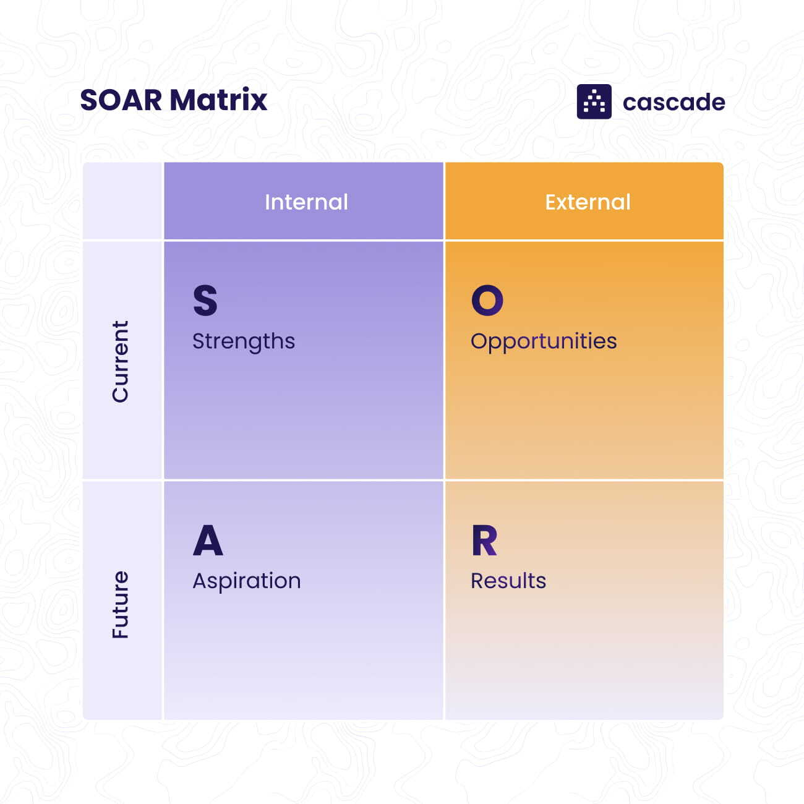
Figure 1: (SOAR Matrix)
(Source: https://assets-global.website-files.com/63f6e52346a353ca1752970e/63f87a46b2b2b184af8178c6_soar-analysis-matrix.jpeg)

TOWS Analysis
The TOWS analysis for the Radiant Sunbeam Hotel gives a strategic blueprint, reworking identified challenges into actionable strategies and capitalizing on the inn's aggressive edges (Vlados, 2019).
- Strengths-Opportunities (SO): This approach harnesses the lodge's bold logo reputation and its enviable location, which are pivotal belongings in attracting guests (Su and Swanson, 2019). By leveraging these strengths, the lodge can efficaciously penetrate rising tour markets, attracting a brand-new purchaser seeking the precise combo of luxury and convenience the resort offers. Tailoring services and advertising and marketing efforts to faucet into these markets can unlock new sales streams and bolster the hotel's marketplace position (Forhad et al., 2021).
- Weaknesses-Opportunities (WO): Addressing the lodge's service inefficiencies is critical, and this approach targets to do so by way of integrating modern technological answers. Adopting cutting-edge technology in guest offerings, inclusive of virtual test-ins, customized room settings through apps, and AI-pushed customer service, can significantly streamline operations and beautify visitor stories (Puyt, et al., 2020). This no longer resolves the weakness in service shipping but additionally capitalizes on the possibility presented via technological improvements in the hospitality zone (Hayes, Ninemeier, and Miller, 2017).
- Strengths-Threats (ST): In the face of monetary volatility, the lodge's nicely mounted brand presence can be a powerful negotiating tool with suppliers and partners. This method focuses on leveraging the inn's marketplace credibility to steady favourable terms, making sure operational resilience and price-effectiveness amidst market fluctuations. It's a proactive method to safeguard the motel's pastimes and retain provider first-class in hard monetary times (Olimovich, 2020).
- Weaknesses-Threats (WT): A high body of worker turnover poses a widespread chance to carrier consistency and operational stability. This method pursuits to cope with this difficulty head-on by way of overhauling HR rules and introducing comprehensive, continuous training packages. By creating an extra supportive and worthwhile work environment and making an investment in the group of workers' improvement, the inn can decorate job pleasure, lessen turnover fees, and make certain a constantly excessive stage of carrier delivery (Kapoor, and Kaur, 2017).
Through this TOWS evaluation, the Radiant Sunbeam Hotel can strategically align its operational and strategic tasks, turning ability vulnerabilities into strengths and threats into possibilities (Yacoub and ElHajjar, 2021). This nuanced method ensures not only the mitigation of current challenges but also the proactive cultivation of a resilient, ahead-looking enterprise version (Gordon et al., 2019).
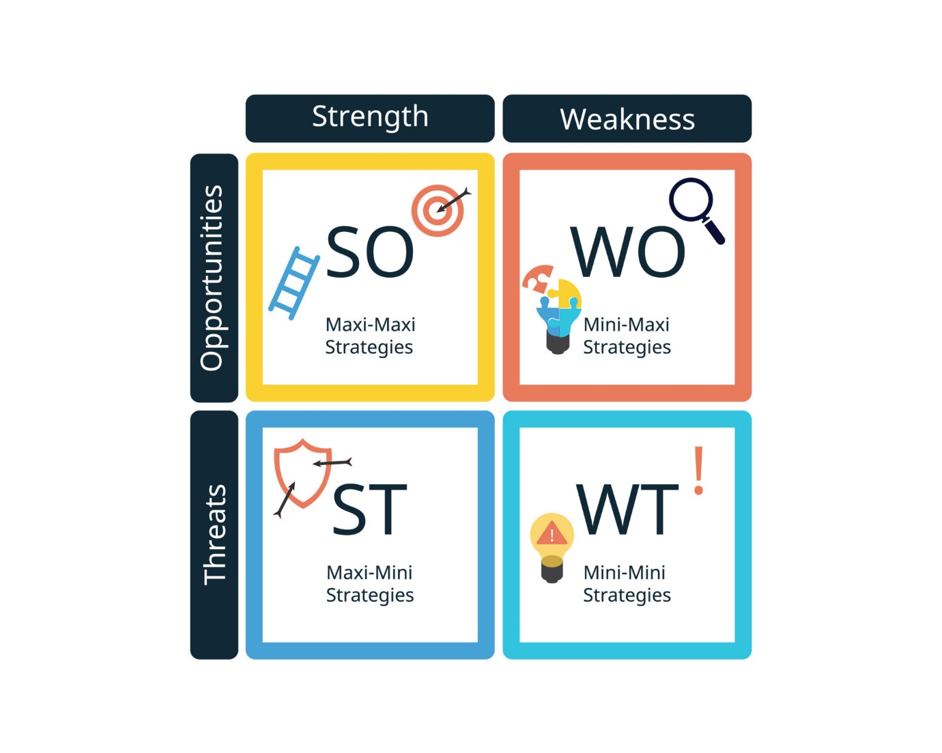
Figure 2: (TOWS Matrix)
(Source: https://static.vecteezy.com/system/resources/previews/020/176/538/original/tows-matrix-can-be-defined-as-a-framework-to-create-compare-decide-and-access-business-strategies-vector.jpg)

Recommendations and Change Management

Purpose
In the Recommendations and Change Management segment of the consultancy record for the Radiant Sunbeam Hotel, our number one goal is to provide concrete, actionable solutions tailor-made to cope with the precise demanding situations and possibilities diagnosed during the evaluation. This segment is going beyond mere inspiration; it serves as a strategic blueprint for the resort to enact meaningful and impactful adjustments (PIRNAR, KURTURAL, and ERİŞ, 2019).
Our technique includes a meticulous breakdown of every problem, paired with a particular recommendation that aligns with the motel's overarching dreams and present-day operational context. These suggestions are not just theoretical; they may be practical, feasible, and designed to yield tangible outcomes. Whether it is improving purchaser experience, enhancing operational efficiency, or boosting revenue, each proposal is subsidized via statistics-pushed insights and industry first-class practices (Conte, Hahnel, and Brosch, 2023).
However, spotting that the fulfilment of these guidelines hinges on their powerful implementation, this segment additionally delves into a complete implementation plan. This plan info a step-by means of-step guide on how the hotel should continue with the adjustments, outlining the desired resources, timelines, and accountable parties. It is crafted to make certain that each degree of the implementation system is apparent, potential, and aligned with the motel's capacity and resources (Lee, and Kim, 2022).
Acknowledging that change may be challenging, within the dynamic hospitality enterprise, we emphasize change management techniques. These techniques are designed to facilitate an easy transition, addressing potential resistance, and ensuring a team of workers' buy-in. We suggest conversation plans, schooling periods, and support structures to ease the transition for employees and stakeholders.
Furthermore, to measure the effectiveness of those changes, we introduce metrics and key performance indicators (KPIs). Regular monitoring of those metrics will no longer only verify the instant impact of the modifications but also their lengthy-time period sustainability and success (Rutherford, 2021).
Lastly, we offer an in-depth evaluation of the ability benefits and related expenses of every recommendation. This fee-gain analysis is important for the lodge's selection-makers to apprehend the financial implications and the expected return on funding. By balancing the charges with the predicted blessings, we aim to present a clean, convincing case for why those modifications are not only applicable but additionally financially prudent for the Radiant Sunbeam Hotel (Camilleri and Camilleri, 2018).

Content

Recommendations in Response to Identified Issues:
In the Recommendations and Change Management phase of their consultancy document for the Radiant Sunbeam Hotel, the specialists meticulously address each problem unearthed inside the evaluation segment with tailored, actionable tips. These hints are not universal; they are custom suited for the lodge’s specific circumstances, ensuring relevance and practicality in their utility (Kankan Halli, et al., 2017).
For instance, if the analysis well-known shows a decline in client satisfaction because of previous room decor, the consultants advocate a modernization plan. This plan consists of precise layout adjustments, a timeline for preservation, and a budget aligned with the resort's economic abilities. Each thought is supported through enterprise traits and patron comments records, bolstering the recommendation's validity and making sure it's not only a shot within the dark but a properly informed method (Denysenko and Yurynets, 2021).
Similarly, as the analysis spotlights inefficiencies in a team of workers management, the consultants endorse a restructuring of the team of workers. This consists of a detailed suggestion for personnel training packages, a revamp of shift schedules, and the advent of performance incentives (Datta and Singh, 2018). Each of these guidelines is justified with data showcasing stepped-forward operational performance and worker satisfaction metrics from comparable interventions inside the industry (Priyantina, and Sarno,2019).
In addressing troubles associated with advertising and purchaser outreach, the experts suggest an overhaul of the lodge's digital marketing approach. They back this advice with records displaying expanded bookings via online systems for different hotels that have followed similar strategies. They propose unique actions such as internet site redecorating, SEO, and targeted social media campaigns.
The specialists make sure that each recommendation isn't always unique and actionable but also sponsored through information and insights from their complete evaluation. This approach not simplest demonstrates a deep knowledge of the hotel's troubles but also builds acceptance as true with and credibility with the inn control. The recommendations are supplied as nicely-informed choices, no longer mere conjectures, making them greater persuasive and probably to be applied efficaciously (Holden, 2016).

Implementation of These Recommendations:
In the consultancy report for the Radiant Sunbeam Hotel, a comprehensive discussion is dedicated to the implementation of the proposed guidelines. The specialists meticulously craft a step-by-step plan, making sure clarity and effectiveness in executing every concept. This plan is not simply a series of moves; it's a strategic roadmap, specific with responsibilities, useful resource allocation, and unique timelines, ensuring a scientific method for the transformation sought (Han et al., 2018).
For every recommendation, the consultants designate a responsible celebration or department, ensuring duty and clean strains of verbal exchange. For example, the renovation of inn interiors might be assigned to the facilities manager, at the same time as advertising method overhauls are positioned under the advertising and marketing director's purview. By doing so, every project is anchored to a degree of character, fortifying the structure of the implementation method (Kim, and Han, 2020).
The plan also meticulously outlines the sources required for each piece of advice, ranging from financial investments to manpower and generation. For instance, the creation of a new client relationship control machine is observed with the aid of a breakdown of software program prices, education periods for staff, and time allocation for the transition duration. This comprehensive detailing of sources ensures that the implementation is grounded in practicality and preparedness (Ninarun, and Wongleedee, 2019).
Anticipating capacity hurdles is a trademark of the specialists' technique. They proactively cope with foreseeable demanding situations, such as resistance to exchange from the body of workers or logistical delays in maintenance initiatives (Ushakov et al., 2020). For each task, a contingency approach is in place. Regular schooling sessions and communique conferences are suggested to mitigate resistance, at the same time as a buffer time is included in project timelines to deal with unexpected delays (Laškarin Ažić, 2017).
Furthermore, the experts advocate for a phased implementation approach where feasible, allowing for modifications and exceptional tuning based on period in-between comments and consequences. This phased technique also helps in managing sources correctly and minimizing disruptions in resort operations (Köseoglu, et al., 2020).
By providing a detailed, responsible, and useful resource-aware implementation plan, the consultants now not simplest demonstrate their meticulousness in making plans but also their commitment to a possible and powerful transformation at the Radiant Sunbeam Hotel (Batinić, 2016).

Change Management Strategies for Smooth Transition:
In their consultancy document for the Radiant Sunbeam Hotel, the consultants emphasize the significance of correctly coping with the human aspect of exchange to ensure a clean transition. Recognizing that change can frequently be met with apprehension and resistance, they have developed a comprehensive set of techniques focused on communication, schooling, aid, and non-stop monitoring (Carlo, 2021).
The consultants recommend an in-depth verbal exchange plan aimed at any respect levels of the motel's personnel. This plan consists of preliminary briefing sessions to introduce the approaching adjustments, followed by normal updates throughout the implementation system. The goal is to preserve transparency, dispel any uncertainties, and foster an environment of open dialogue. To cope with ability resistance, they advise organising a feedback mechanism wherein employees can explicit their worries and hints. This approach not best enables in figuring out capacity problems early on but also makes the team of workers feel valued and worried inside the transition procedure.
To gain certain buy-in from all stakeholders, along with resort management, a team of workers, and key companions, the consultants endorse tailor-made communication strategies (Susilo, 2020). For example, for the inn management, the point of interest is on the strategic vision and the long-term blessings of the changes, whereas for the team of workers, the emphasis is on how the changes will impact their day-by-day work and the guide to had to them (Kim, et al., 2019).
Recognizing that some changes can also require new skills or changes in work routines, the experts advocate a complete schooling and support device. This includes workshops, schooling classes, and the availability of mastering substances to assist staff adapt to new technology or procedures. Mentorship packages and peer aid groups are also counselled to foster collaborative studying surroundings (Merinero-Rodríguez, and Pulido-Fernández, 2016).
Finally, the experts underscore the importance of tracking the development of the alternate implementation. They propose putting in a tracking committee that frequently evaluates the progress towards set milestones, assesses the effectiveness of the change strategies, and makes changes as wanted. This non-stop assessment guarantees that the change procedure stays heading in the right direction and is adaptable to any unexpected challenges or opportunities that arise. By incorporating these complete exchange management techniques, the experts aim to facilitate a smooth and successful transition for the Radiant Sunbeam Hotel.

Methods for Measuring Success Rates and Impacts:
In their consultancy document for the Radiant Sunbeam Hotel, the expert's location a sizable emphasis on measuring success quotes and impacts as an essential aspect of the alternate control technique. They recognize that quantifiable metrics and key overall performance signs (KPIs) are crucial for evaluating the effectiveness of the carried-out hints and for aligning those modifications with the hotel's overarching dreams (Merinero-Rodríguez, and Pulido-Fernández, 2016).
The experts start by way of presenting a set of specific, quantifiable metrics and KPIs which can be without delay relevant to every recommendation. These metrics are cautiously selected to align with the favoured consequences of the changes. For instance, if one of the guidelines is centred on improving purchaser pride, the consultants might suggest metrics including Net Promoter Score (NPS), customer retention fee, or online evaluation rankings. By tying these metrics to the goals of the adjustments, the consultants make sure that success may be objectively measured (Akgunduz and Sanli, 2017).
To facilitate ongoing evaluation and ensure that the adjustments are retained to supply the desired outcomes, the specialists describe a systematic put-up-implementation tracking gadget. This machine consists of normal records collection, evaluation, and reporting procedures. For example, for consumer pleasure improvement advice, the experts propose conducting monthly consumer surveys, studying statistics, and producing reviews that highlight developments and areas for improvement.
Furthermore, the consultants propose the status quo of a dedicated monitoring group chargeable for overseeing the gathering and evaluation of records. This crew could be tasked with continuously tracking the identified metrics and KPIs, evaluating them to pre-implementation benchmarks, and identifying any deviations or developments which could require interest. Regular reporting to the hotel's management is also recommended to ensure transparency and responsibility (Borralha et al., 2016).
Incorporating a feedback loop into the monitoring gadget is another crucial thing of the specialists' technique. This permits for actual-time adjustments to be made based totally on the statistics accumulated. For instance, if specific advice does not yield the predicted consequences, the hotel could make informed selections to evolve or revise the method as a consequence (Rodríguez, De la Hoz Solano, and Rozo, 2022).
By providing a nicely defined set of metrics, a systematic monitoring process, and a remarks mechanism, the experts ensure that the Radiant Sunbeam Hotel can appropriately degree the achievement costs and effects of the carried-out adjustments. This data-driven method no longer validates the effectiveness of the recommendations but additionally provides a foundation for ongoing improvement and strategic selection-making (Kainthola, 2021).

Potential Benefits and Associated Costs:
In the consultancy record advanced for the Radiant Sunbeam Hotel, the consultants prioritize a complete discussion on the capacity benefits and related prices of each advice, demonstrating an eager understanding of the monetary implications and predicted returns on investment (ROI). This phase serves as a critical bridge between strategic making plans and knowledgeable decision-making for the resort (Hughes, et al., 2019).
First and most important, the experts meticulously outline the anticipated advantages linked to every piece of advice. These blessings are specially tailor-made to the inn's particular context and objectives. For instance, if one piece of advice focuses on renovating visitor rooms, the expected blessings may encompass advanced consumer delight, higher room occupancy fees, and a more suitable logo photo. By highlighting these advantages, the experts offer the resort control with a clean imaginative and prescient of the high-quality consequences that can be accomplished through the proposed modifications (Lahap, et al., 2016).
Equally crucial is the complete breakdown of envisioned expenses associated with each piece of advice. The consultants leave no stone unturned, accounting for each direct and indirect cost. Direct expenses, consisting of substances, equipment, or additional staff, are meticulously quantified. Indirect fees, consisting of schooling packages, capacity downtime at some stage in implementation, or any other unforeseen charges, also are factored in. This special value analysis offers the lodge an obvious view of the economic commitments required to execute each piece of advice (Melissen, et al., 2016).
Moreover, the specialists move past simply listing expenses; they delve into the ROI for every piece of advice. By weighing the anticipated benefits in opposition to the associated fees, they offer a clear motive for the motel's funding within the proposed changes. This entails demonstrating how the advantages will in the end outweigh the fees incurred. For example, if the preservation of visitor rooms is projected to grow sales considerably via higher room quotes and purchaser loyalty, the experts calculate the ROI by way of quantifying the sales growth relative to the renovation charges (Vo-Thanh et al., 2020).

Action Plan
In the consultancy report organized for the Radiant Sunbeam Hotel, the experts prioritize the inclusion of a properly established and SMART (Specific, Measurable, Achievable, Relevant, and Time-bound) movement plan. This phase serves as a sensible roadmap for the patron, offering a clear breakdown of the recognized problems, endorsed answers, desired effects, timeframes, and associated charges (De Pelsmacker, Van Tilburg, and Holthof, 2018).
Number | Problem | Solution | Desired Outcome | Time Scale | Planned Budget
1 | Outdated Room Decor | Renovate guest rooms with modern design and amenities | Improved customer satisfaction, and increased room bookings (Dimitriou and Ducette, 2018). | 6 months | $200,000
2 | Inefficient Staff Management | Implement new staff scheduling software and training programs | Enhanced staff productivity, reduced labour costs | 4 months | $50,000
3 | Digital Marketing Ineffectiveness | Revamp digital marketing strategy and website | Increased online bookings, stronger online presence | 5 months | $75,000
4 | Inadequate Customer Feedback System | Introduce customer feedback platform and training | Enhanced feedback collection, improved service quality | 3 months | $30,000
5 | Sustainability Initiatives | Implement eco-friendly practices and engage with the local community (Soysal-Kurt, 2017). | Reduced environmental impact, enhanced brand image | 12 months | $100,000
The movement plan systematically addresses each problem, presenting precise solutions that align with the diagnosed problems. These answers aren't the most effective actionable however additionally aligned with the Radiant Sunbeam Hotel's overarching goals and objectives (Dachyar and Sahir, 2020).
For instance, in reaction to the previous room decor issue, the consultants propose a six-month renovation assignment aimed toward enhancing customer pleasure and growing room bookings. The planned price range of $2 hundred,000 covers materials, hard work, and any capacity contingencies (Melissen, et al., 2016)
Moreover, each movement item is observed by way of a clear description of the favoured outcome, ensuring that the customer has a tangible target to intend. For the preservation undertaking, the preferred outcome is “stepped forward client delight and accelerated room bookings” (Elgahwash, Ahmed, and Al-Magarbi, 2023).
Additionally, the motion plan consists of a particular time scale for every recommendation, indicating the predicted period for implementation. This helps the purchaser in setting sensible expectancies and planning, therefore.
Lastly, the planned price range for every movement object is furnished, ensuring that the purchaser has a complete know-how of the monetary commitments associated with each answer.
In sum, the SMART motion plan presented in a tabular format serves as a treasured device for the customer, allowing them to plot and put in force the recommended solutions and techniques correctly whilst ensuring that the dreams are Specific, Measurable, Achievable, Relevant, and Time-bound.

Conclusion
In the realm of consultancy reports, the realization serves as a pivotal phase that encapsulates the key findings and insights derived during the assessment. It presents a succinct however complete summary of the record's contents, reaffirming the significance of the identified problems and the proposed answers. In this consultancy record tailored for the Radiant Sunbeam Hotel, the belief is a crucial element that now not only reaffirms the report's findings but also extends gratitude to the resort for the collaborative opportunity. The finale of this consultancy file highlights the crucial findings that have emerged from the in-depth analysis of the Radiant Sunbeam Hotel's operations and demanding situations. It reiterates the core troubles which have been recognized, along with old room decor, inefficient group of workers management, and virtual advertising ineffectiveness. These troubles had been meticulously tested, and their influences on the inn's standard overall performance have been duly stated. Furthermore, the realization emphasizes the importance of those findings in the context of the hospitality industry. It underscores how addressing these demanding situations can cause tangible enhancements in customer satisfaction, sales generation, operational efficiency, and the motel's logo image. The gravity of these findings reinforces the necessity of the proposed hints and trade control strategies. While no new records are brought in the end, it acts as a pivotal second to remind the client, in this situation, the Radiant Sunbeam Hotel, of the precious partnership formed through this consultancy undertaking. It is an opportune moment to specific gratitude for entrusting the consultancy corporation with the task of diagnosing and prescribing treatments for the resort's operational problems. This expression of appreciation no longer most effectively demonstrates professionalism but additionally fosters a wonderful and collaborative dating between the consultancy company and the client. Moreover, the realization extends past a trifling display of gratitude; it guidelines the ability for destiny collaborations. By acknowledging the motel's willingness to collaborate on this unique task, the realization subtly opens the door for persevered engagement. It conveys the consultancy company's readiness and eagerness to be of provider in destiny endeavours, thereby fostering a feel of belief and reliability. The conclusion of this consultancy record for the Radiant Sunbeam Hotel encapsulates the middle findings and suggestions without introducing new facts. It underscores the significance of the identified issues and their potential effect on the resort's achievement. Additionally, it serves as a gracious expression of gratitude to the consumer for the collaborative opportunity, leaving the door open for future partnerships. In doing so, the belief not handiest reaffirms the file's insights but also establishes a superb and enduring expert courting with the client.

References
Afrianto, A., and Gulö, I. (2019). Revisiting English competence at the hotel. Teknosastik, 17(1), 35-39.
Akgunduz, Y., and Sanli, S. C. (2017). The effect of employee advocacy and perceived organizational support on job embeddedness and turnover intention in hotels. Journal of Hospitality and Tourism Management, 31, 118-125.
Batinić, I. (2016). Hotel management and quality of hotel services. Journal of Process Management and New Technologies, 4(1), 25-29.
Borralha, S., Jesus, S. N., Pinto, P., and Viseu, J. (2016). Hotel employees: A systematic literature review. Tourism and Management Studies, 12(1), 120-126.
Camilleri, M. A., and Camilleri, M. A. (2018). The tourism industry: An overview (pp. 3-27). Springer International Publishing.
Carlo, C. (2021). Critical Success Factors in Hotel Companies: A Managerial Perspective. Journal of Tourism and Hospitality Management, 9(2), 1-7.
Chibili, M. (2017). Modern hotel operations management. Routledge.
Conte, B., Hahnel, U. J., and Brosch, T. (2023). From values to emotions: Cognitive appraisal mediates the impact of core values on emotional experience. Emotion, 23(4), 1115.
da Borralha, S., de Jesus, S. N., Pinto, P., and Viseu, J. (2016). Job satisfaction in hotel employees: A systematic review of the literature. Journal of Spatial and Organizational Dynamics, 4(1), 4-20.
Dachyar, A. Z. N. S. M., and Sahir, A. (2020, March). Hotel revival strategy planning with SWOT-Fuzzy AHP-TOPSIS: A case study of a 4-star hotel. In Proceedings of the 11th Annual International Conference on Industrial Engineering and Operations Management, Singapore (pp. 7-11).
Datta, A., and Singh, R. (2018). Determining the dimensions of organizational climate perceived by the hotel employees. Journal of Hospitality and Tourism Management, 36, 40-48.
De Pelsmacker, P., Van Tilburg, S., and Holthof, C. (2018). Digital marketing strategies, online reviews and hotel performance. International Journal of Hospitality Management, 72, 47-55.
Denysenko, M., and Yurynets, Z. (2021). Modern hotel management principles and methods for providing a quality product. Економіка та держава, (3), 28-33.
Dimitriou, C. K., and Ducette, J. P. (2018). An analysis of the key determinants of hotel employees' ethical behaviour. Journal of Hospitality and Tourism Management, 34, 66-74.
Elgahwash, F. O., Ahmed, K., and Al-Magarbi, A. O. (2023). Strengthening Libyan Hospitality: A SOAR Analysis of Digital Marketing Strategies and Practices in the Tourism and Hospitality Sector. Journal of Economics, Management and Trade, 29(12), 144-159.
Forhad, M. S. A., Arefin, M. S., Kayes, A. S. M., Ahmed, K., Chowdhury, M. J. M., and Kumara, I. (2021). An effective hotel recommendation system through processing heterogeneous data. Electronics, 10(16), 1920.
Gordon, S., Adler, H., Day, J., and Sydnor, S. (2019). Perceived supervisor support: A study of select-service hotel employees. Journal of Hospitality and Tourism Management, 38, 82-90.
Han, J.W., Ruiz‐Garcia, L., Qian, J.P. and Yang, X.T., (2018). Food packaging: A comprehensive review and future trends. Comprehensive Reviews in Food Science and Food Safety, 17(4), pp.860-877.
Hayes, D. K., Ninemeier, J. D., and Miller, A. A. (2017). Hotel operations management. Pearson.
Higgins-Desbiolles, F., Carnicelli, S., Krolikowski, C., Wijesinghe, G., and Boluk, K. (2019). Degrowing tourism: Rethinking tourism. Journal of Sustainable Tourism.
Holden, A. (2016). Environment and tourism. Routledge.
Hughes, L., Dwivedi, Y.K., Misra, S.K., Rana, N.P., Raghavan, V. and Akella, V., (2019). Blockchain research, practice and policy: Applications, benefits, limitations, emerging research themes and research agenda. International Journal of Information Management, 49, pp.114-129.
Hunold, M., Kesler, R., Laitenberger, U. and Schlütter, F., (2018). Evaluation of best price clauses in online hotel bookings. International Journal of Industrial Organization, 61, pp.542-571.
Kainthola, V. P. (2021). Principles of hotel management.
Kankanhalli, A., Zuiderwijk, A. and Tayi, G.K., (2017). Open innovation in the public sector: A research agenda. Government Information Quarterly, 34(1), pp.84-89.
Kapoor, S. and Kaur, M., (2017). Basel III norms: A Swot and Tows approach. Vision, 21(3), pp.250-258.
Kim, J. J., and Han, H. (2020). Hotel of the future: exploring the attributes of a smart hotel adopting a mixed-methods approach. Journal of Travel and Tourism Marketing, 37(7), 804-822.
Kim, M., Choi, L., Knutson, B. J., and Borchgrevink, C. P. (2017). Hotel employees’ organizational behaviors from cross-national perspectives. International Journal of Contemporary Hospitality Management, 29(12), 3082-3100.
Kim, Y. J., Kim, W. G., Choi, H. M., and Phetvaroon, K. (2019). The effect of green human resource management on hotel employees’ eco-friendly behavior and environmental performance. International journal of hospitality management, 76, 83-93.
Köseoglu, M.A., Altin, M., Chan, E. and Aladag, O.F., (2020). What are the key success factors for strategy formulation and implementation? Perspectives of managers in the hotel industry. International Journal of Hospitality Management, 89, p.102574.
Lahap, J., Ramli, N. S., Said, N. M., Radzi, S. M., and Zain, R. A. (2016). A study of brand image towards customer's satisfaction in the Malaysian hotel industry. Procedia-Social and Behavioral Sciences, 224, 149-157.
Laškarin Ažić, M. (2017). The impact of hotel employee satisfaction on hospitability performance. Tourism and hospitality management, 23(1), 105-117.
Lee, C. H., and Kim, H. R. (2022). Positive and negative switching barriers: promoting hotel customer citizenship behaviour through brand attachment. International Journal of Contemporary Hospitality Management, 34(11), 4288-4311.
Melián-González, S., and Bulchand-Gidumal, J. (2016). A model that connects information technology and hotel performance. Tourism management, 53, 30-37.
Melissen, F., Cavagnaro, E., Damen, M., and Düweke, A. (2016). Is the hotel industry prepared to face the challenge of sustainable development?. Journal of Vacation Marketing, 22(3), 227-238.
Merinero-Rodríguez, R., and Pulido-Fernández, J. I. (2016). Analysing relationships in tourism: A review. Tourism Management, 54, 122-135.
Ninarun, S. and Wongleedee, K., (2019), March. Campus hotel management and service improvement. In INTERNATIONAL ACADEMIC MULTIDISCIPLINARY RESEARCH CONFERENCE IN LONDON 2019 (pp. 78-78).
Olimovich, D.I., (2020). The impact of innovative technologies for improving economy of hotels. Asian Journal of Multidimensional Research (AJMR), 9(5), pp.194-201.
Paškvan, M., Kubicek, B., Prem, R., and Korunka, C. (2016). Cognitive appraisal of work intensification. International Journal of Stress Management, 23(2), 124.
PIRNAR, İ., KURTURAL, S., and ERİŞ, E. D. (2019). SWOT-TOWS Analysis of Urla Destination’s Alternative Tourism Development. International Journal of Contemporary Tourism Research, 3(2), 235-244.
Priyantina, R.A. and Sarno, R., (2019). Sentiment analysis of hotel reviews using Latent Dirichlet Allocation, semantic similarity, and LSTM. Int. J. Intell. Eng. Syst, 12(4), pp.142-155.
Puyt, R., Lie, F.B., De Graaf, F.J. and Wilderom, C.P., (2020). Origins of SWOT analysis. In Academy of management proceedings (Vol. 2020, No. 1, p. 17416). Briarcliff Manor, NY 10510: Academy of Management.
Rachman, G. P., and Do, A. D. (2020). Business Strategy for Atlantic City Hotel Facing Covid-19 Pandemic. International Journal of Current Science Research and Review, 5(2), 333-340.
Rivaldo, Y. (2021). Leadership and motivation to performance through job satisfaction of hotel employees at D'Merlion Batam. The Winners, 22(1), 25-30.
Rodríguez, C.E.L., De la Hoz Solano, V.M. and Rozo, C.A.B., (2022). Financial risks in the operation of special service transportation in the hotel sector in Bogota, Colombia. ID EST-Revista Investigación, Desarrollo, Educación, Servicio y Trabájo, 2(1).
Roy, M. (2021). Tourism Industry in Bangladesh: An Assessment of Advanced SWOT Model and TOWS Matrix. Tourism in Bangladesh: Investment and Development Perspectives, 279-310.
Rutherford, D. G. (2021). Hotel management and operations.
Saleh, A. S., and Zohry, M. A. E. F. (2022). Towards A Sustainable Hotel Education (An Analytical Strategic Study at The Faculty of Tourism and Hotels, Mansoura University-TOWS Matrix as A Model). International Journal of Tourism, Archaeology and Hospitality, 2(1), 45-74.
Serra-Cantallops, A., Peña-Miranda, D. D., Ramón-Cardona, J., and Martorell-Cunill, O. (2018). Progress in research on CSR and the hotel industry (2006-2015). Cornell Hospitality Quarterly, 59(1), 15-38.
Sharma, S., and Srivastava, S. (2018). Relationship between service quality and customer satisfaction in hotel industry. TRJ Tourism Research Journal, 2(1), 42-49.
Soysal-Kurt, H., (2017). Measuring tourism efficiency of European countries by using data envelopment analysis. European Scientific Journal, 13(10), pp.31-49.
Su, L., and Swanson, S. R. (2019). Perceived corporate social responsibility's impact on the well-being and supportive green behaviors of hotel employees: The mediating role of the employee-corporate relationship. Tourism management, 72, 437-450.
Susilo, D., (2020). Macro-Regional Analysis of Tourism Entrepreneurship Environment in Bali: A Descriptive Study. International Journal of Economics, Business, and Entrepreneurship, 3(1), pp.1-13.
Tubtimcharoon, N. (2019). Situation Analysis for the Business of Small Hotels in Digital Economy Age in Thailand. WMS Journal of Management, 8(1), 1-9.
Ushakov, R. N., Kryukova, E. M., Khetagurova, V. S., Mukhomorova, I. V., and Zelenov, V. V. (2020). Efficiency of hotel management. Training of specialists in hotel industry field. Journal of Environmental Management and Tourism, 11(2 (42)), 388-395.
Veloso, B. M., Leal, F., Malheiro, B., and Burguillo, J. C. (2019). On-line guest profiling and hotel recommendation. Electronic Commerce Research and Applications, 34, 100832.
Vlados, C., (2019). On a correlative and evolutionary SWOT analysis. Journal of Strategy and Management, 12(3), pp.347-363.
Vo-Thanh, T., Vu, T. V., Nguyen, N. P., Nguyen, D. V., Zaman, M., and Chi, H. (2020). How does hotel employees’ satisfaction with the organization’s COVID-19 responses affect job insecurity and job performance?. Journal of Sustainable Tourism, 29(6), 907-925.
Yacoub, L. and ElHajjar, S., (2021). How do hotels in developing countries manage the impact of COVID-19? The case of Lebanese hotels. International Journal of Contemporary Hospitality Management.
Zervas, G., Proserpio, D., and Byers, J. W. (2017). The rise of the sharing economy: Estimating the impact of Airbnb on the hotel industry. Journal of marketing research, 54(5), 687-705.

