Guide to supporting Transitions within the Early Years
- Introduction 3
- Aims 4
- Importance of transitions 5
- Needs of the child 6
Individual needs
Social, Emotional and Attatchment needs
Physical needs
Intellectual needs
Importance of play
- Role of the adult 8
Responsibilities of staff
Effective communication
Parent Parentership
Liasing between settings
Creating a nurturing environment
- Interventions 12
Information Transfer Booklet
Effective practice during transitions
Transition Morning
Example activity
- Outcomes 18
- Reference list 19

Contents
Introduction

According to the Department for education and skills (2006), as children grow and develop, they go through many small changes each day. These changes prepare children for bigger transitions that happen as they get older. Most children face transitional changes before the age of 5. For example, from home to nursery or play group into primary school.
Transition should be seen as a process, not an event, and should be planned for and discussed with children and parents. Settings should communicate information which will secure continuity of experience for the child between settings.
(Department for Children, Schools and Families, 2008:10).

According to the Council for disabled children (2015), transitions are a process rather than an event, so the key is to thoroughly plan and prepare for these transitions in order for the outcomes to be successful.
The way in which children respond to these transitions will differ depending on the individual. Some children may respond well, while others may struggle emotionally as well as socially. Therefore, gradual transitions along with well thought out and detailed planning and preparation that supports children will boosting their confidence and self-esteem (Department of education and skills, 2006).

Aims

The aim of this handbook is to provide guidance for early years practitioners on successful transitions for children transitioning from nurseries and playgroups to reception class. It provides practitioners with researched based transitional practice that supports children and their families during the process.

It outlines-
- The importance of transitions and how practitioners can help.
- The needs of children- linking to theory and practice.
- The role of the adult- why close relationships are important and how adults can support children’s learning and development in times of transition.
- Interventions- holistic approaches that support transitions.
- Outcomes of children during times of transition.

As well as providing information on the importance of planning and interventions, this handbook can also be used as a tool for staff training and professional development.

Importance of Transitions

Queensland Government (2017) state that transitioning from nursery to school is a significant milestone in children’s education. If children and their families have a positive experience when starting school, it allows transitions throughout their education to be approached with trust and confidence.
Meggitt et al (2012) states that transitions can affect all areas of development including-
- Emotional
- Physical
- Intellectual
- Physiological

Transitioning to a new setting can be emotionally upsetting. Some children show signs of anxiety, sadness and loss. As a result, there may be changes in behaviour such as becoming withdrawn, showing clinginess and regression. Transitions are an important time in children’s lives, so these changes need to be appropriately supported by the setting’s staff (Meggitt et al, 2012).
Kirova (2010) states that play benefits different areas of development including intellectual, cognitive, physical, social, emotional, and academic. These are also the areas that transitions affect according to Meggitt. Therefore, there are links that play is important in supporting these areas of development, resulting in positive outcomes during times of transition.

Needs of the child

Individual Needs
During times of transition, the needs of children should be considered. Sancho Passe (2011) suggests that paying attention to children’s individual needs will result in long-term success. Sancho Passe also believes that framework for transitions should be based on the needs and strengths of the child, families and the school community for smooth transitional outcomes. Therefore, practitioners must plan for this framework to be successful.
Children’s needs should be met in order for them to grow and develop. This suggestion can be supported by Maslow, whose theory is thought to have an impact on practice as he believed that practitioners should take a holistic approach within learning. This means considering the social, emotional, intellectual and physical qualities that individual children have and how these affect their learning and development (Martin and Joomis, 2007).
His theory also states that children’s cognitive needs cannot be met unless their basic physiological needs are attended to. This suggests that practitioners need to ensure that children feel emotionally as well as physically safe and accepted, particularly during times of transitions. By doing this, it allows children to progress and gives them the opportunity to reach their full potential (Burrell and Riley, 2005).

Social, Emotional and Attachment needs
Evidence suggests that children need appropriate adult support in order to progress. Bowlby’s theory of attachment emphasises the importance of attachment and positive relationships early on in children’s lives. He believed that, by having these positive relationships, children’s confidence and independence can grow. Miller et al (2010) therefore suggests that practitioners must take the opportunity to create these positive relationships before and during transitions to create as many positive outcomes as possible.

Physical needs
The physical needs of children need to be considered within transitions. According to the Council for disabled children (2015), by considering children’s physical need and planning in detail, transitions can become more successful for children. they must be planned in detail. This may include the schools SENCO as well as other professionals from outside agencies. Examples being a nurse or an occupational therapist.
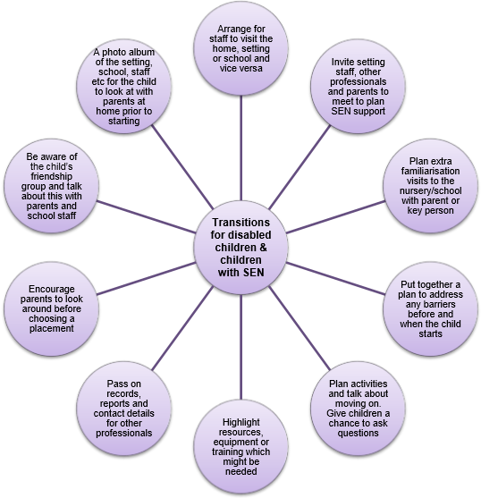
Below is a diagram cited in the Council for disabled children, showing strategies for staff to implement in order to support disabled children during times of transition.

(Council for disabled children, 2015)
Intellectual needs
Like Piaget, Riley and Donaldson suggest that children’s thinking moves through qualitatively different stages. Piaget, Bruner and Donaldson all believed that individual children’s thinking becomes more complex as their intellectual ability develops. This suggests that these needs must be supported as it allows children to grow and develop cognitively (Burrell and Riley, 2005).

Importance of play
Play is known to have an impact on the needs and development of children. According to Dukes and Smith (2014), Montessori’s approach supports this as it is based on the understanding that children can learn and teach themselves when placed in stimulating environments that allow independence. It also emphasises the importance of sensory experiences and the use of natural materials. This approach is a large part of the Foundation Phase Framework, which emphasises the importance of play and learning. So, practitioners must support this by providing opportunities for children to play and develop within a natural, stimulating environment (Welsh Government, 2015).
Kirova (2010) states that Froebel, who invented kindergartens, highlighted the significance of play in a child’s development and giving children freedom of choice, to explore, take control, use their imagination and having a sense of the environment around them. This links into Article 12 of the UNCRC, which states that ‘children have the right to say what they think should happen, when adults are making decisions that affect them, and to have their opinions taken into account’ (Burrell and Riley, 2005:206). Therefore, children have the right to make their own choices.

Role of the adult

Key people that aid smooth transitions could be-
- Teachers
- Teaching Assistants
- Parents
- Nursery staff
- Multi-agencies (For example, Social Worker, Health Visitor, Occupational Therapist, Speech Therapist).
According to Mickelbrough (2011), positivity from practitioners helps build trust as well as build up children’s self-esteem. Vygotsky’s theory viewed the adult as being fundamental to children’s development.
Vygotsky, like Piaget and Donaldson, believed that children’s cognitive development is in stages, where children’s thinking becomes more powerful and flexible. Riley (2007) stated that however, Vygotsky believes that with appropriate adult support, children can function at his level called the Zone of Proximal Development. Vygotsky also talked about the importance of adult’s scaffolding children’s learning. This theory supports the role of practitioners within transitions as it suggests that children should have support from adults to enhance development. This also supports the importance of adults in children’s development as it suggests that adults play a large part in children’s learning.

Responsibilities of Staff
An independent review of curriculum and assessment in Wales suggested that ‘good teaching and learning supports social and emotional development and positive relationships’ (Donaldson, 2015: 117). This shows that practitioners should aim to support children as much as possible during transitional periods by communicating effectively.
Looking at Maslow’s theory, he believed that practitioners must show children that they are respected and valued. He also outlined that practitioner should create a supportive environment within the setting. By doing this, its suggested that children’s needs can be met more easily and effectively, thus supporting Maslow’s hierarchy of needs (Martin and Joomis, 2007).

Effective Communication
Communication is a large part of transitions. This could be between children, parents, colleagues and multi-agencies. This allows for links to be made to support children (Meggitt et al, 2012). According to CEA Rewarding Learning (2014), effective communication between nurseries and primary schools is essential to help ensure progress in children’s learning.

Parent Partnership
According to Silverman (2008), providing information to parents enables them to achieve positive outcomes for both the parents and children. For effective support, practitioners must take a partnership approach. For example, working with nurseries and building strong relationships with parents allows practitioners to know and respond to children’s individual needs.
Mickelbrough (2011) says that practitioners should consider the needs of parents. They may need reassuring during transitional times. Mickelbrough also states that practitioners should remain professional while being warming and understanding.
Meggitt (2012) states that Frobel emphasised the importance of talking to parents and working in partnership to help children learn though play. Similarly, Graham-Clay (2005) says that practitioners should communicate thoughtfully, in a planned approach, in order to promote parent partnership, thus, supporting the child.

Liaising between settings
CEA Rewarding Learning states that transitions to primary school can be made smoother by nurseries liaising with teachers. For example, inviting teachers and children to events like sports day. Also, inviting teachers to visit settings to view and understand the curriculum and learning environment that the children are currently in. This emphasises the importance of liaising between settings, as teachers can have a broader idea of what stages the children are at within their learning in order for them to help with their progression within reception class.

Creating nurturing environments
Transitions can be potentially challenging, so practitioners should nurture children and support them through these times to create positive outcomes. This can be reinforced by the idea of nature versus nurture. Skinner’s theory is that children’s behaviour can be shaped by rewards or punishments. Therefore, practitioners can support children by rewarding them during times of transition.
Lindon (2001) suggests that when comforting and playing with children, physical contact is important. She states that by doing this, it reassures the child and allows them to feel liked and welcomed. Practitioners can also remind children that they are thought about by their parents and siblings by talking about these significant people and what they did with them yesterday, or will do later.

Interventions

Information Transfer Booklet
Some nurseries create transition booklets for individual children to complete with nursery staff as well as parents. Ceredigion County Council (no date), have created a booklet which includes-
- Child’s information- name, date of birth, preferred language and other sibling’s names and age.
- Range of different activities to help practitioners get to know the child-Preferences, ability, stage of development, personality and language development.
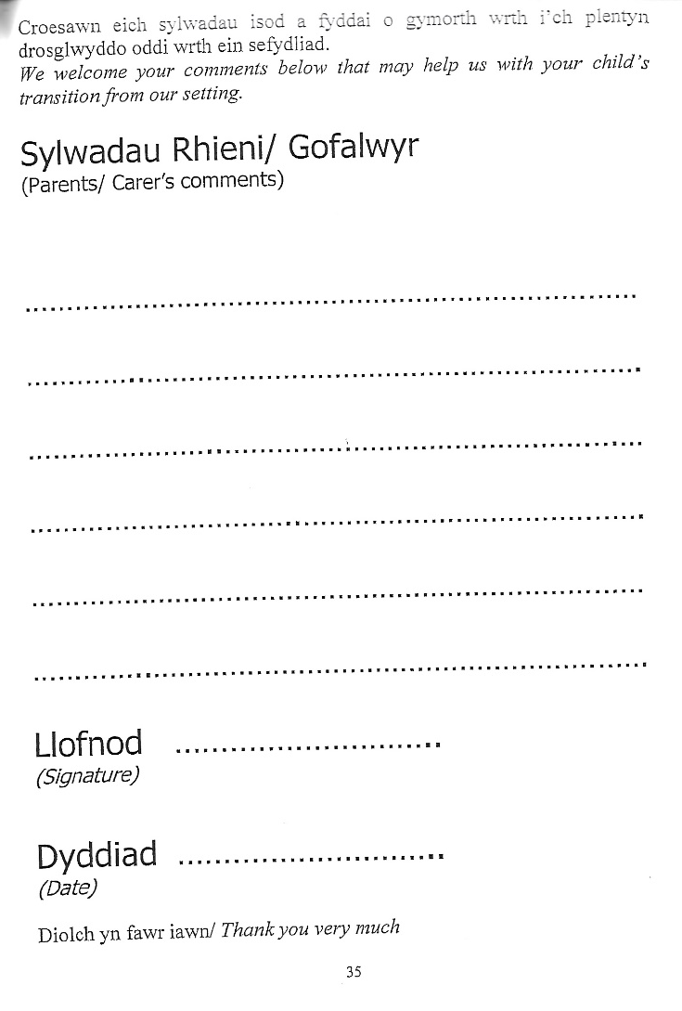
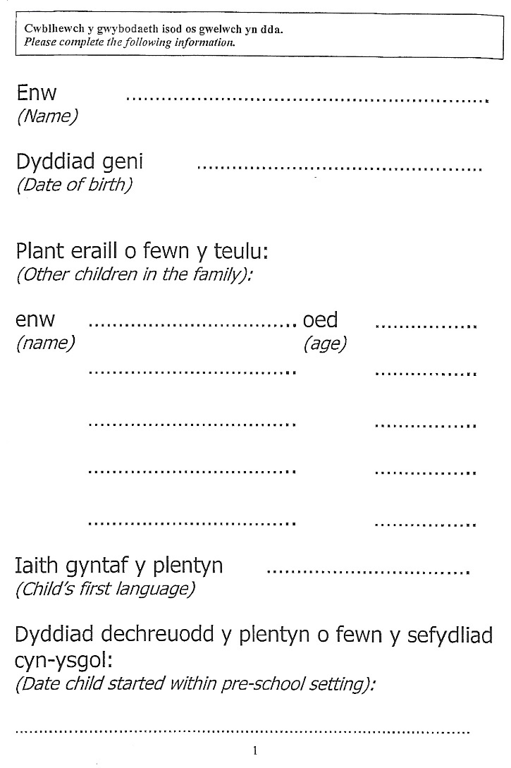
Below are examples of some of the content of the handbook created by Ceredigion County Council, which is utilised within nurseries in the area to support transitioning to reception class.

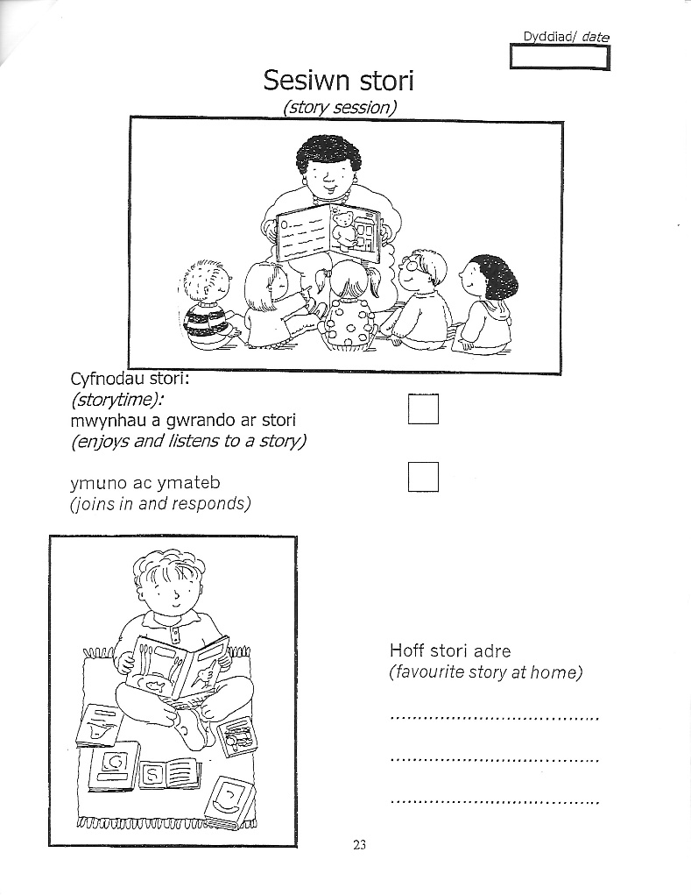
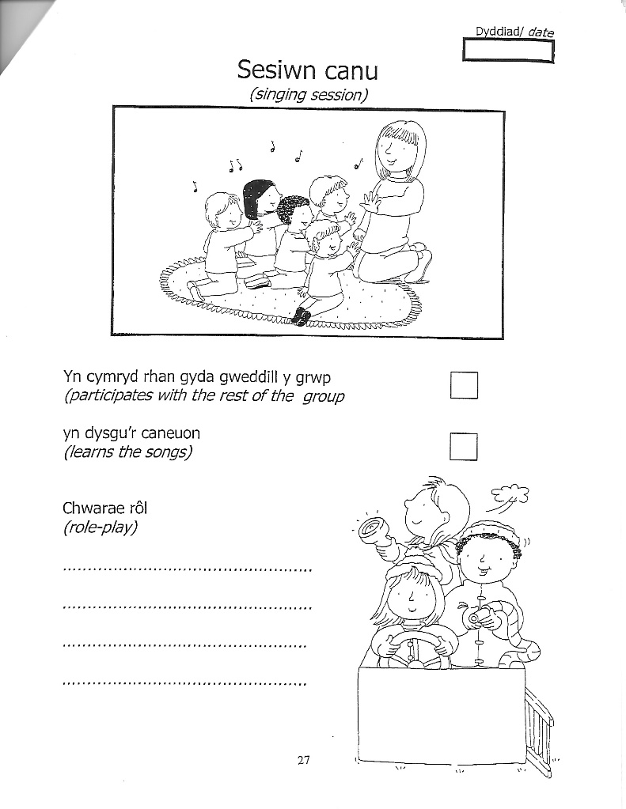
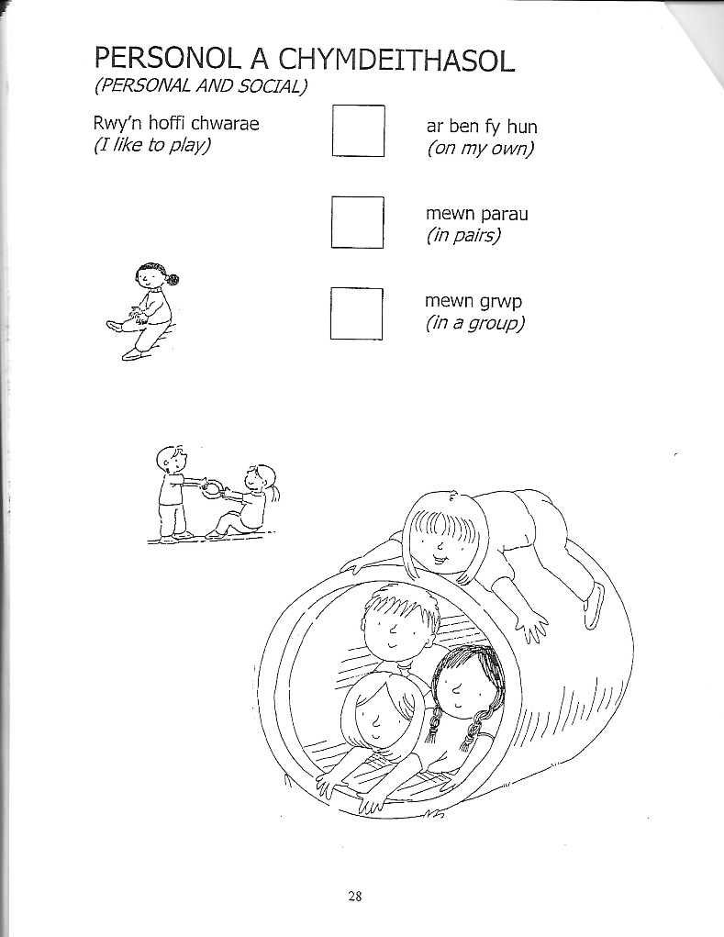
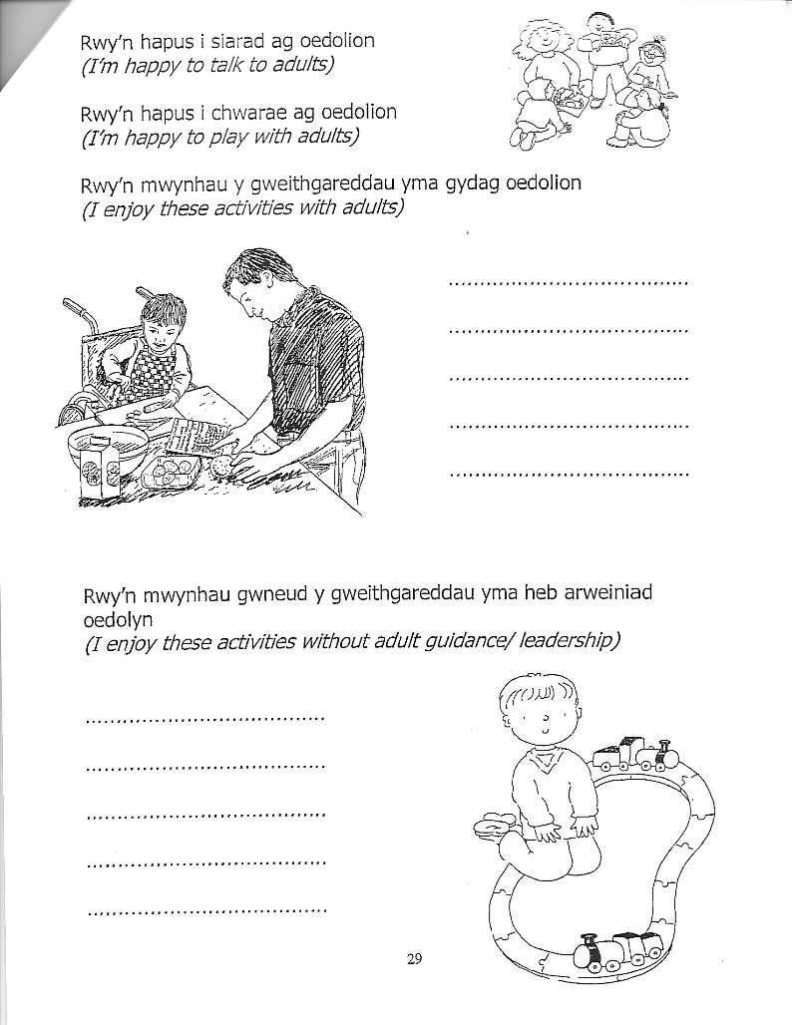
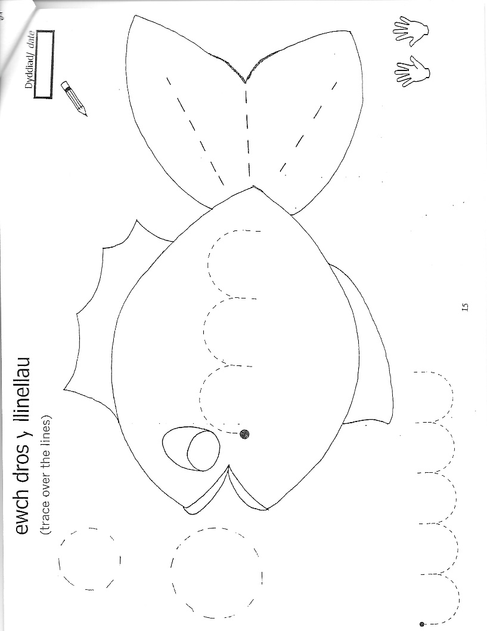

(Partneriaeth Plant Ceredigion, no date)

This booklet is then passed on to the reception class teacher for them to look at as a reference. It allows them to know some basic information about the individual child and whether they may need some additional support.
Looking at a 2012 review on transition processes from nursery to reception, it asked the opinions of a range of practitioners in both nursery and reception classes. They stated that these learning journal booklets are useful in helping children to transition. School staff found them particularly useful as a source of information regarding the individual child.
Both settings agreed that these booklets are successful, although one problem that seemed to occur for both settings is that parents often forgot to bring these booklets into the settings. Some failing to bring them into the reception class for the new class teacher, meaning that some children then lose out on practitioners having the opportunity to use this information to help with the smoothness of the transition (EYCP, 2012).

Below is a chart from the review showing the quantitative results of the successfulness of these booklets. As previously mentioned, most of the booklets were seen by the new teachers but many were unseen as parents did not bring them into the new setting. This indicates that nurseries should give the reception class teacher these booklets directly instead of handing them to parents. This way, teachers are more likely to receive them. This also emphasises the importance of communicating between settings as well as parents.

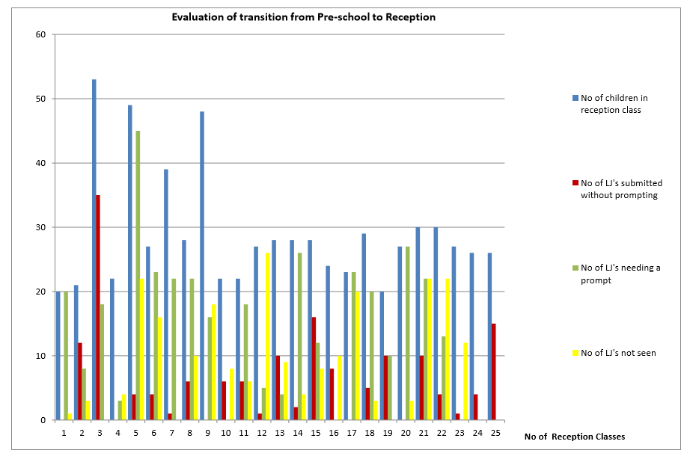
(Source: EYCP, 2012)

Effective Practice during Transitions-

- Key person to liaise with nursery.
- Visit nursery setting/home visit.
- When on a visit, do an activity with the children, such as sing a song or read a book, which can then be done when the children start school. This provides familiarity and comfort which links into Bowlby’s idea that positive relationships are key within transitions (Miller et al, 2010).
- Arrange for children as well as parents to visit the setting. For example, open evenings.
- During visits, pictures could be taken of the new children to create a display within their new setting, thus making them feel welcome as well as promoting inclusion.
- Information can be given to the nursery so that they have a clear guide as to what will happen during the transitional period.
- Information can be given to parents. For example, daily routines, staff list, policies and the role in which the parents have (Kirklees Council, 2013).
Transition Morning-
These visits give children the opportunity to meet and become familiar with staff, as well as the children within the reception class. It also gives children transitioning from nursery the opportunity to familiarise themselves with the layout of the classroom and some of the new routines.
This links into Maslow’s theory which states that children’s social needs such as feeling loved and having a sense of belonging need to be met for them to progress. This aspect of Maslow’s hierarchy of needs focuses on emotional based relationships, such as friendship and having a support system. If children do not have this, it can result in negative social emotions (Martin and Joomis, 2007).

Example activity-

Activity | Paint a self portrait that can be presented to the reception class and/or displayed on a display board.
Learning Objective | - Should paint a picture of themselves, considering what they look like.  - Discuss diversity and the importance of inclusion.  - Discuss quantitative amounts, such as two eyes and one nose.
Resources | - Paper  - Paint
Links to Early Years Foundation Phase | - Personal and Social Development- Well-being and Cultural Diversity  - Communication and Language- Speaking and Understanding  - Mathematical Development  - Creative Development  (Welsh Government, 2017).

Outcomes

EFA Global Monitoring Report. (2007) suggest that smooth transitions boost children’s-
- Feeling of self-worth
- Development of self-esteem
- Self-efficacy
- Autonomy
- Optimism
Research suggests that with the appropriate adult support, children can positively transition into their new setting. Based on this research, it’s suggested that appropriate and thorough planning needs to be done, as well as effective communication between the child, settings, parents and other professionals.
Donaldson (2015: 117), states that ‘summative reporting at key transition points should be supported by portfolio evidence and face-to-face discussions involving the relevant teaching staff’. This will improve the quality of service provided, as it allows staff to liaise with each other regarding how the transition is going for the individual children and work on interventions to support them if they are not transitioning well.
Successful transitions, according to research, results in positive changes and adaptions. The children will be happier and more comfortable within the environment, thus supporting Maslow’s theory.
Transitions can be difficult. Therefore, there may be a need to use different interventions to support the child. This may include parents, other professionals or outside agencies. Parents opinions can be useful as they know the child and any additional needs can be discussed.

Reference list

Burrell, A. and Riley, J. (2005) Promoting Children’s Well-Being in the Primary Years. Stafford: Network Educational Press Ltd.
CEA Rewarding Learning. (2014) ‘Curricular Guidance for Pre-School Education’ http://ccea.org.uk/sites/default/files/docs/curriculum/pre_school/preschool_guidance.pdf [Accessed:20th October 2017].
Council for disabled children. (2015) ‘SEN and disability in the early years: A toolkit 2015’ https://www.foundationyears.org.uk/files/2015/06/Section-10-Transitions.pdf [Accessed: 25th October 2017].
Department for children, schools and families. (2008) ‘Setting the Standards for Learning, Development and Care for children from birth to five’ Practice Guidance for the Early Years Foundation Stage, pp. 1-116. [On-line]. Available at: https://www.foundationyears.org.uk/files/2011/10/EYFS_Practice_Guide1.pdf [Accessed: 17th October 2017].
Department of education and skills. (2006) ‘Seamless Transitions – supporting continuity in young children’s learning’ Primary National Strategy, pp.1-19. [Online]. Available at: http://dnn.essex.gov.uk/Portals/49/Documents/EYFS/Nat%20Primary%20Seamless%20Transitions.pdf [Accessed: 25th October 2017].
Donaldson, G. (2015) Independent Review of Curriculum and Assessment Arrangements in Wales. Wales: OGL.
Dukes. C. and Smith, M. (2014) Provision and Progress for Two Year Olds. London: SAGE Publications Ltd.
EYCP. (2012) Review of the Transition Process From Nursery to Reception in summer 2012. Jersey: Gov.j.
EFA Global Monitoring Report. (2007) Outcomes of good practice in transition processes for children entering primary school. Strong foundations: early childhood care and education.
Graham-Clay, S. (2005) ‘Communicating with Parents: Strategies for Teachers’ The School Community Journal. [Online]. http://www.adi.org/journal/ss05/Graham-Clay.pdf [Accessed:19th October 2017].
Kirklees Council. (2013) ‘Kirklees guidance for transitions in the Early Years’ http://moodle.uwtsd.ac.uk/pluginfile.php/86471/mod_resource/content/1/early-years-transition-guidance-booklet-2013.pdf [Accessed:24th October 2017].
Kirova, A. (2010) ‘Children’s Representations of Cultural Scripts in Play: Facilitating Transition From Home to Preschool in an Intercultural Early Learning Program for Refugee Children’, Diaspora, Indigenous, and Minority Education, 4, April, pp.74–91. [Online]. Available at: https://www.researchgate.net/profile/Anna_Kirova/publication/232858156_Children%27s_Representations_of_Cultural_Scripts_in_Play_Facilitating_Transition_From_Home_to_Preschool_in_an_Intercultural_Early_Learning_Program_for_Refugee_Children/links/581f51c708aeccc08af37e40/Childrens-Representations-of-Cultural-Scripts-in-Play-Facilitating-Transition-From-Home-to-Preschool-in-an-Intercultural-Early-Learning-Program-for-Refugee-Children.pdf [Accessed:18th October 2017].
Lindon, J. (2001) Understanding Children’s Play. Cheltenham: Nelson Thornes Ltd.
Martin, D. and Joomis, K. (2007) ‘Building Teachers: A Constructivist Approach to Introducing Education’, Belmont Cengage Learning, pp. 72–75. [Online]. Available at: http://www.cengage.com/resource_uploads/downloads/0495570540_162121.pdf [Accesses:21st October 2017].
Meggitt, C., Bruce, T. and Grenier, J. (2012) Child Care and Education. Oxon: Hodder Education.
Mickelburgh, J. (2011) ‘Attachment Theory and the Key Person Approach’ early years fsf, January, pp.1. [Online]. Available at: http://eyfs.info/articles/_/personal-social-and-emotional-development/attachment-theory-and-the-key-person-approach-r64 [Accessed: 19th October 2017].
Partneriaeth Plant Ceredigion. (No date) Information Transfer. Ceredigion: Ceredigion County Council.
Queensland Government. (2017) ‘Transition to school: the importance of transitions’ https://det.qld.gov.au/earlychildhood/about-us/transition-to-school/information-schools-ec-services/importance [Accessed:18th October 2017].
Riley, J. (2007) Learning in the Early Years 3-7. London: SAGE Publications Ltd.
Sancho Passe, A. (2011) ‘The Importance of Transition for Children’s Success’, Ready, Spring, pp. 1-4. [Online]. Available at: http://fairfax-futures.org/assets/files/publications/ready.pdf [Accessed:19th October 2017].
Silverman, D. (2008) ‘Transition Information Sessions and Parental Engagement - Guidance notes for schools’ The Grid. [Online]. http://www.thegrid.org.uk/leadership/parents/documents/transition_information_guidance.pdf+&cd=6&hl=en&ct=clnk&gl=uk [Accessed: 20th October 2017].
Welsh Government. (2017) ‘Foundation Phase’ http://gov.wales/topics/educationandskills/foundation-phase/?lang=en [Accessed:26th October 2017].
Welsh Government. (2015) ‘Foundation Phase Framework’ http://learning.gov.wales/docs/learningwales/publications/150803-fp-framework-en.pdf [Accessed:25th October 2017].

