Mariusz Kalasz
1805456
Group name: Team 1
Project Title: Pirate’s Edge
26/11/2020
Evaluation Report
Module Code & Title: Game Design and Asset Creation 1 M5X02043

Table of Contents
Introduction 2
Research Evaluation 2
Game Design Theory 2
Technical Research 4
Game Research 4
Research Conclusion 5
Technique Evaluation 6
Identification and Suitability of Production Methods 6
Development of Techniques and Skills 6
Overall Quality of Work Produced 6
Technique Conclusion 6
Development Evaluation 7
Creativity 7
Relevance to the Brief 7
Contribution within a group 7
Iterative Design Practice 7
Time Management 7
Development Conclusion 8
Analysis (Conclusion) 8
Contextualising the work within a wider theoretical practice 8
Critique of the work which has produced 8
Critique of Author’s practice 8
Bibliography 9

Introduction
The project which the team is working on is called Pirate’s Edge, the game is a mix of 2D characters and 3D environments where you play as a character name Pinky Stete. The aim of the game is to not get caught by the monster chasing you and collect as much coin as you can, in between the player and the end of the level are obstacles (for example flying and rolling barrels) and aids (like ropes which give the player a small speed boost), at the end of the level the player can choose to spend their coin to buy items which will aid them in the next run/level.
The evaluation in this report will be the work the team has done up to now, so this will be an evaluation for the prototype of the game, so it mainly developed to show of the main mechanics and design choices. The project is being developed in Unreal and using sprites which are created in Photoshop and making the 3D models in Maya. The role of the author was in the tech team, so the main roles are working on the engine and additional more tech-oriented tasks.

Research Evaluation
Overall research was very team based, as for searching overall feel and look of the game the whole team was present for that and any new information which was found was shared with all the others. Then the research was well split in-between explorative research and dynamic research but this depended on context, so explorative was used for the design and the art side of the game, but then dynamic was used more for the tech side of the project as it needed more specific answers. Whilst design, art, and animation needed more explorative research as it was more what would fit the best to the game idea.

Game Design Theory
The author’s source of choice which is still used during the development and design of the game is the book called Fundamentals of Game Design by Ernest Adams and Andrew Rollings. The reason of using this source is to keep a good idea on making fun mechanics which have a high quality, however as fun is a subjective matter, Ernest Adams and Andrew Rollings have provided a set of principles which the team kept in mind.
These principles are:
- Gameplay comes first
- Get a feature right or leave it out
- Design around the player
- Know your target audience
- Abstract or automate parts of the simulation that are not fun
- Be true to your vision
- Strive for harmony, elegance, and beauty
In the current stage of the design and development of the game some areas are omitted, for example the abstraction and automation of parts which are not fun, as the team really could not test out to see mechanics which would be annoying for the player, however the jump pads and rope swing are automated instead of requiring the player to use button inputs (however this will be tested).
Anyway, from the beginning “gameplay comes first”, when designing the idea for the game the team had more quickly agreed to the purposed gameplay mechanics of the game to that extent that there was still uncertainty of how it will look, so to say the gameplay came first during the design process is a correct statement to make, the game still needs a lot of polish as the prototype is a show of how the mechanics work, so this can improve the fun factor of the game.
Next principle “get a feature right or leave it out”, this is not really a concern at the moment as it is a prototype, so it is just a proof of concept. However, one feature was omitted as the author could not figure how to make it work, the feature is when the player character is hit by an obstacle the monster chasing you would speed up for a bit and then return to its original speed but due to author’s inexperience in the Unreal engine it could not be figured out at that time. Additionally there are other features which change the velocity of the player character, like when hit by an obstacle they the character slows down for the same time as the monster speeds up and then returns to its normal speed, also the ropes would give the player character a small speed boost but currently it has not been applied to the prototype, so the team is prepared to remove some features which do not work at all due to errors or just do not work in the feel sense of the gameplay as if the final game had features which would not work the players’ experience would be worse.
“Design around the player”, the team when discussing gameplay also came to “but how the player would like that” and many level design ideas had that in mind as well as Beth made the first level so it gradually introduces the player to the mechanics instead of throwing them into the deep end. When discussing the monster the team always came back to the player as if the monster was too fast it would be unfair on them, but if it was too slow the game will be boring as there is no real challenge so getting the right speed of the monster is very important for the player experience as if it is too much or too little the mechanic will not be fun.
“Know your target audience” this principle is a bit of an uncertainty, this is due to the team has not discussed this in detail but the target audience of the game would be for fans of 2D platformers, who like a light hearted approach to some parts, as that is the kind of feel the game is going for but the game itself is a bit of an oddity as it does not follow other platformers with some of its mechanics. But further discussion is needed to really set the target audience for the game.
“Be true to your vision” the team did use a feature lock when it was agreed that there was enough gameplay features and a solid gameplay loop, there were difficulties of this during some meetings as the team when asked did not have solid answers to how the game will look but with aid from the lecturer it was agreed on what style the game will have.
“Strive for harmony, elegance, and beauty” this kind of continues from the previous principle, the team had troubles with what kind of style the game will be, only it was agreed that the environment should fit the style of the characters, as the characters are drawn 2D the environment would need to have drawn-like textures. However there were difficulties with making both work, but a lecturer helped and gave good tips about making the models more exaggerated which in turn makes them more cartoonish, so when those models will be added to the game the 2D and 3D will work with each other well.

Technical Research
Majority of the research done by the author was technical research, due to not having much experience with Unreal many things were taught via tutor support and, watching and reading tutorials on the Internet. These have mixed with each other a lot as there were always questions to the tutor about what was found in the tutorials.

Game Research
The game research which the team did was more for the aesthetic of the game than mechanics, but there was research to have the good general feel of a platformer for the game. So the team has looked at two major games for both areas for the aesthetic part which shared the 2D/3D part of the game’s aesthetic and the basics of gameplay, which are Shantae: Half-Genie Hero developed by WayForward Technologies and directed by Matt Bozon (2016/17), and Super Mario Bros. developed by Nintendo and directed by Shigeru Miyamoto (1985/87) respectably.
Shantae: Half-Genie Hero shows perfectly the 2D characters and 3D environments concept which the project will use in its aesthetics following are some screenshots:
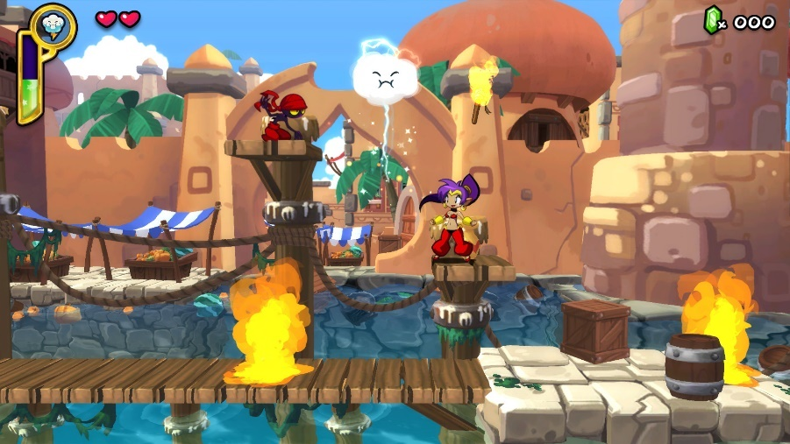

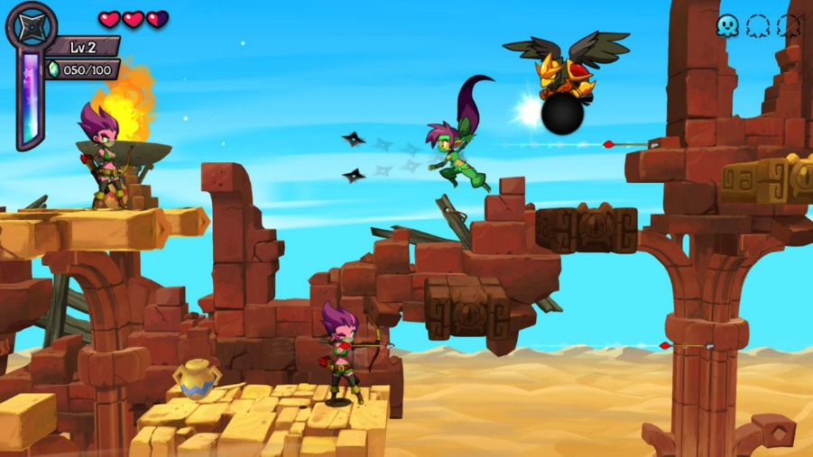

These 2 screenshots (not taken by the author but found via Steam) perfectly show the style which the project is going for, to the extent of the camera angle. The whole style itself is cartoonish in nature even to the textures of the environment as they fit perfectly with the characters and it does not give of that uncanny valley feel, additionally one aspect from those both are shown, so the character do not bleed onto the background they have bolder lines but also their colours are much stronger or the background colours are more died down/blurrier. This was originally brought to attention by Erin in one of the not in lecture meetings, as this makes the player to see who they control and any obstacles which they have to keep in mind much easier, if the colours were the same on background and characters both will bleed into each other making a vision mess.
Super Mario Bros. is the classic of the platformer genre so understanding its simple movement is important to make the project feel like a good platformer, additionally it does use power ups and a collectible system (coins), furthermore it shows good level design for its time (it still holds up compared to other games). There is not much you can show of gameplay by just the screenshot but there can be some description from one.
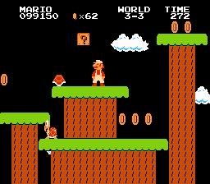
There are couple of things which are the most relevant/important to the project, the HUD, and the coins. Start from the HUD it is very simplistic, and it shows all the information needed so it is important to keep that in mind as an overcluttered HUD is more annoying to deal with. Next the coins are a mechanic which the project will have, and Super Mario Bros. does a good job of doing them as it is a simple mechanic.

Research Conclusion
Overall, the research was satisfactory, on personal research the author should do more research on the aesthetics and design for the project instead of concentrating on engine research. For the whole team the research was good, there were sometimes which maybe required a wider area for it so there were more examples of what the project is striving for.

Technique Evaluation
This was the first time use of Unreal, as the previous experience was in Unity which uses different interface and language. Additionally, Unreal has blueprints which from background of code is kind of confusing to use, so there was a lot of learning experience in just using those. There is an uncertainty if any well-established techniques were being used as this is the first time working with Unreal for the author, except of one which is making actors if they interact in the world in some way.

Identification and Suitability of Production Methods
For this project there were not many choices for engine, two main choices were Unreal and Unity and as only the author had any previous experience with Unity, Unreal was chosen. The other choice is would code everything from scratch but that would be a waste of time.

Development of Techniques and Skills
From the beginning the author improved his skills on techniques and skills with Unreal, by just doing total immersion in it so learning the basic techniques was an improvement, there was no sticking to previous knowledge as Unity is completely different to Unreal, as Unity only uses code, and you need to know how to set up that code, Unreal you can choose between code or blueprints and blueprints are much more beginner friendly and from them can be used to reverse engineer to understand the code. As Unreal was a new experience, many key things were learned are how to create new blueprints and what some nodes do for example cast to.

Overall Quality of Work Produced
The work which the team has produced was very good, in the current situations with covid-19 where all work must be done from home and all meetings are online, the work was done well. Josh has done great work on the modular 3D models for the levels and the textures, Beth did great designs for the prototype level which slowly teaches the player the mechanics by gradually introducing them, Erin has made extremely good points about the colour theme for the levels so the characters and background do not bleed into each other, Ryan has made the mechanics which makes the game more functional and Sam has done great work with the designs for the character so its easier to animate and being much more organised and keeping note of what happened during meetings. In the amount of time and with the annoyance of the pandemic amazing work was done. However, there were issues with communication and that is on the author, as he should have informed of those who were not in the meetings of what was going on.

Technique Conclusion
Overall the technical and skills development during this module were developed very well, many new skills and techniques were developed, for example problem solving skills as compared to using only code to using blueprints the problem solving is different as in blueprints you can only have one of some nodes. Next time more focus will be in learning more Unreal but also learning the other sides for game design process like design and art.

Development Evaluation
The development system is kind of a normal one, the team started with research and design, during that the tech team played around with the idea and setting up the bare bones for 2D/3D game and the art team started their work with the models. The team did have roles and that is how the work has been split up between those roles, as there were two tech team members, one art, one design, one animation and one who went between design and art. The planning was not effective as there was not much planning, well per say there was not many deadlines for specific things, the game was kind of planned out, but it was not set in stone.

Creativity
For the author’s role which is in tech there was not much creativity, as making the prototype work does not have much creative process, except of coming up with some of the mechanics. For example the monster chasing the player and physics based obstacles, but with physics it was as easy as just ticking a box saying “enable physics” and that mechanic was even planned, it was just fan to play around with physics.

Relevance to the Brief
The prototype has followed the brief well, it is a proof of concept which has an interactive world with key mechanics and interactions, however this report might have strayed from the brief as it went over a lot of other points instead of the ones listed.

Contribution within a group
The author was very well engaged with the group, to an extent where he became a semi-leader as many organisations of meetings and reminders came from him, but he is not very organised himself. The communication side was lacking as the author should have informed the team members who were not present at meetings about what was going on and any plans which were agreed on, but also it came to some were not as interactive as others.

Iterative Design Practice
There was not much iterative design practice whilst developing the prototype as it was just adding simple objects like cylinders and spheres and making them do what the main mechanics were supposed to do, mainly some playtesting was done and this was used to see if all mechanics were working properly, however one design point which needs to be consider while playtesting, is to perfect the speed of the monster and maybe decrease the speed of the player character as there is not much of that feeling chased in the game.

Time Management
For the author personal time management needs to improve, as there was a lot of feeling of doing everything last minute, the prototype work was managed alright, but it still needs improving. For the team only one true internal deadline was made, and it uncertain if even all were done by then, this would be much better if a Gantt chart was created so all of the members’ time was planned out with extra time for just in case scenarios. However, the tasks were well prioritised and there was contingency plan if any files get corrupted as there is a group shared google drive.

Development Conclusion
The development process overall went well, majority of things is completed even with the lack of time planning and internal deadlines, that is what should be done differently next time is an actual planned development process with deadlines.

Analysis (Conclusion)

Contextualising the work within a wider theoretical practice
This has been written in detail back in the research section of this report however the main point of that is the game theory of making a game fun with the set principles from Ernest Adams and Andrew Rollings and the prototype/game idea is following those well. However, a game theory from the same people which involves the challenges in the game have been introduced to the game idea, but this should have been there from the start.

Critique of the work which has produced
The work in question is the prototype of the game, so a proof of concept per say so a polished experience is not expected, there was playtesting but to a degree of seeing if the core mechanics are working.

Critique of Author’s practice
Time management was the main issue for the author as he is not very well organised at points, but during this project he understood how important it is to time manage when in the team as if behind of other team members the whole work process will slow down as you have not completed the work which everyone needed to continue, so the author will plan out his work load much more efficiently.
For the team itself, many things should be improved on mainly organisation and communication, organisation by creating Gantt charts so each team member knows what they need to do and by when, and communication by communicating to the team members who were not present during meeting so they know what they need to do and what’s going on.

Bibliography
Adam, E. & Rollings, A. (2007). Fundamentals of Game Design. Pearson Education Inc, USA.
WayForward Technologies, 2016. Shantae: Half-Genie Hero (normal version). [PC, PS4, PS Vita, Wii U, Xbox One, Nintendo Switch] N/A: WayForward Technologies
Nintendo, 1985. Super Mario Bros. [NES, Nintendo Switch (only for Super Mario Bros 35)] N/A: Nintendo

