COHORT 1 GROUP 2
DEVELOPING WORKPLACE CRITICAL THINKING
BMSK5001_BIRM
JUNAYED AHMED (1709372) | LECTURER: ERNEST OVIA
Contents
Introduction 2
Beliefs 3
Values 3
Attitudes 5
Workplace Behaviour 6
Management Theory 8
Conclusion 11
References 12



Introduction

This report will consider and critically analyse the impact of beliefs, attitudes and values on workplace behaviour. It will also identify a management theory, evaluate its modern day relevance and critically assess its impact on belief, value and attitudes. The report will use different opinions of people and give credit to sources.
The main aim of this report is to define the terms belief, value, attitudes and behaviour. Once that has been addressed, an analysis can be made to identify the connection and impact of each group, from different perspectives. This report also aims to seek a relationship between a belief and workplace behaviour. The organisation which this report will discuss is APPLE.
Apple was founded in 1976 by Steve Jobs and Steve Wozniak. They wanted to create something that was easy to use, and in every home. The pair had started building Apple computers in Steve Jobs’ garage. They sold them without monitors or keypads. Steve Wozniak left Apple in 1983 as his interest in Apple computers was fading. Since then, Steve Jobs had revolutionised his innovation. (Richardson and Terrell, 2015).

Beliefs

A belief is when someone has faith in something. It might not be a fact and there may be no evidence to support it, but a person who has the faith, puts their full trust into it. They hold that belief to great importance to them, regardless of what others may think. An example of a belief is that all actions lead to consequences. Now, this statement may not be true, however the person who holds this belief will accept it to be true. It could be that during their life journey, all their actions have led to consequences. Or it could be that as a young child, they were taught all actions have consequences. Anyhow, the person may believe in that statement so deeply that they have created this belief into a value. They value the belief that all actions lead to consequences so whatever they do, they do it with great care and attention to detail. They avoid any mistakes, for the fear of the consequences. Or perhaps it could be that they are a perfectionist and they only want positive outcomes, rather than negative consequences.
Beliefs impact values, which then affects attitudes and behaviours. It is important to address ones beliefs as this is the main source of people’s behaviours. Beliefs are like the stem of a plant. With a belief, a person can grow different ways. Some beliefs may nourish, whereas others dull and unwanted. It is crucial not to mix own beliefs with work beliefs, i.e. the belief that one can be successful without the help of others. Work belief would be success is attained on the basis of great team work. If an employee had that attitude, where they can achieve success without other intervention, then they may not value team work. This can bring bad practices and cause fallouts. Yes, maybe success can be achieved by oneself but if the employer wants team work, then the employee should thrive to meet that expectation.

Values

A value is something that is also of great importance to one. Value is something that is precious. Something that could be rare and fundamental. People often gain values through life experiences and their surrounding environment. Values can include family, friends, education, religion, job, honesty, loyalty and commitment. A value can have positive effect on attitudes. If a person values their job, they will have respect for others. They will have the patience to put up with various personalities and characters , and put up with any working conditions. A person with value for job can also easily adapt themselves to any situation. Taking this into account, it can be suggested that these are traits people should already have. However, just because a person values their job, it does not necessarily mean they would value their colleagues or their environment. They might care deeply about holding their job, but they may care very little for others. This could lead to poor attitudes in the workplace. Peoples values can change over time. If they didn’t value their colleagues or work environment, their poor behaviour may lead to a loss of job. This loss may cause one to open their mind and realise that they now actually value their colleagues. Different situations lead to people creating values, beliefs and attitudes. When they realise the value of the colleagues, this opens more opportunity for stronger relationships, which again can become a value.
An employer who values their team will try everything to support their staff. They want a better atmosphere and want to lessen the workload. They might even do the tasks that is not within their agenda. This would show a keen interest in the team and create positive attitudes. The employer would be seen as a positive role model for all. However, in reality the employer does not actually value their staff or team of people, they value progression of the organisation. If this was to happen, the organisation may not really achieve their goals as the employer is putting on a front. The employer could easily get frustrated and show bad attitude when it comes to pressure. It is important for people or an organisation to clarify their values, even if it is just to themselves so that they can ensure they are in the correct job.

APPLE CORE VALUES

According to Sabutey (2017), Apple’s core values are as follows:
- Make great products.
- Simple, not complex.
- Own and control primary technologies behind Apple products.
- Participate in markets where there can be significant contribution.
- Say no to thousands, focus on the few that are mostly important and meaningful to Apple.
- Deep collaboration and cross-pollination which allows innovation.
- Don’t settle for anything less than excellence. Self-honesty and courage to change.

Sabutey (2017) cited that Robert T. Kiyosaki, the author of Rich Dad, exerted, “inside every great brand is the DNA of the entrepreneur who started it all. That DNA is a precious and valuable asset that few companies even recognize.” Time Cook, CEO of Apple, stated that the core values are the company’s DNA and they must be protected. After the death of Steve Jobs, founder of Apple, Tim Cook suggested that the core values were maintained to successfully maintain the business. Tim Cook valued the core values which is why he made such a statement.
When adhering to ones values, this can have a positive impact on attitudes. Tim Cook valued the core values, which is why he was so certain about the results. He believed in the core values. The core values are what motivates Apple employees in this day.

Attitudes

Attitude is a way of thinking or feeling. It can be intentional or unintentional. It reflects one’s frame of mind and how they perceive things. Attitude can be positive or negative. It is also a great factor that can influence other people into their own thoughts and feelings. A customer enters a shop and sees everyone happy and sharing jokes. One assistant is sitting in the corner, and when approached with a question they give closed answers. The customer then feels the assistant is reluctant to talk, therefore does not give them anymore thought. The assistant then tries to make small conversation about the weather but the customer pay any more attention. They feel the assistant had poor attitude therefore the customer does not invest anymore time into the assistant.
Attitude can be towards an individual, an environment, job or a group of people. The customer may have thought the assistant had poor attitude towards them, however it could be that they do not value their role therefore displaying a poor attitude. It may be that they had poor attitude towards work. Not the customer. Unless one can really get inside someone’s mind they do not know for certain where the attitude was derived from. It is normal for the human brain to jump to conclusions without actual facts . When this occurs, their attitude also changes. Values are what really lights the attitude. The more one values, their attitude may increase. It could be positive or negative. One can have many values but still have poor attitude.
According to an online article, research was done on an insurance company to see any correlation between attitudes and values. They discovered that employee attitudes were different from employee values, where they had communication in common. 2590 employees participated in this survey, with 120 questions asked. Their main research was to identify organisational cultures.
“In the insurance company study, employee attitudes were found to be clearly distinct from employee values. Perceptions of organizational practices were unrelated to values, and only overlapped with attitudes where both dealt with communication.” (Hofstede, 1998).
This article was uploaded in 2019, however it was published in 1998. Times have moved since then. In today’s world, this may not be the same. People are more appreciative of their jobs as they chosen to take that path. Yes, in some cases it may be that they had no other choice, but they will still find something they value within that job. Perhaps it is working in a team, or they value the benefits that comes with it. Anyhow, values can affect attitudes in the workplace.
Going back to Apple, majority of the staff enjoy what they do. They value progression as a whole team. They share this same value and are able to work together. Looking through some employee reviews on Indeed.co.uk (2019), it can be seen that a lot of the reviews have staff saying how they appreciate working as a team and there is always support available, including some comments about receiving benefits whilst working for Apple. This suggests they enjoy working as a team but not necessarily value their team. It could be argued both ways. Nevertheless, this question about value will not be answered unless they were interviewed. Out of 7.8 thousand reviews, Apple scored 4.1 out of 5 stars. This shows Apple are maintaining their core values. What other possible reason could there be for their fantastic score.
“Great company to work for, fun staff and a warm environment. Learned a lot and was always kept on my feet. Pushed me to be better and exceed my capabilities.” Former employee, cited in Indeed.co.uk (2019).

Workplace Behaviour

Workplace behaviour can be derived from peoples beliefs, values and attitudes. They are all relatable in some extent. As mentioned earlier, beliefs can have impact on vales, and values can have impact on behaviour. Behaviour is how someone acts and conducts themselves.
There are many behaviour theories, which include the theory of planned behaviour (TPB). The theory of planned behaviour is one that is widely used for teaching and training. Its main focus is on individuals attitudes and beliefs. MORRIS et al. (2012).
The theory of planned behaviour was initiated by Ajzen (1989), who suggests ways behaviour can change. One of the things he mentioned was intention. A persons intentions can change their behaviour. He also suggests that intentions depend on its strength and influenced by three factors: behavioural attitudes of the consequences and the value of the consequences, their perception of how their behaviour will affect others (subjective norm), and the extend in which they believe they can carry on with their behaviour (behavioural control) Tutor2u, (2018).

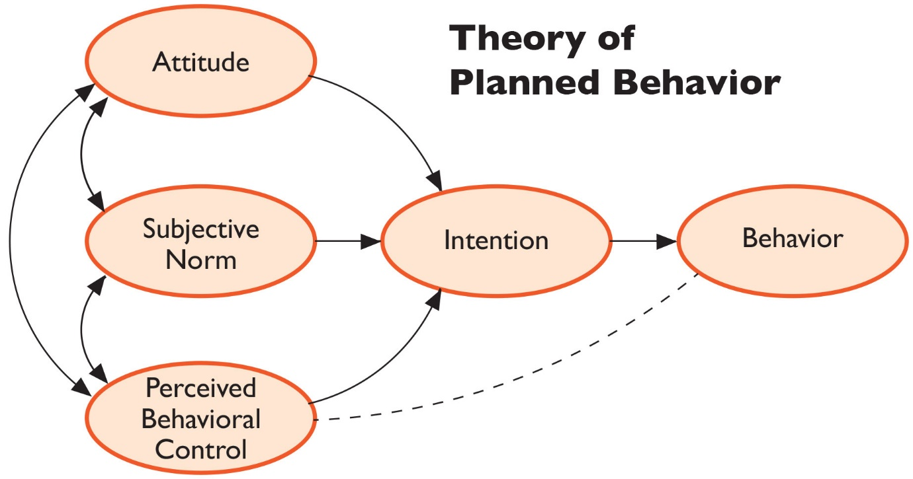

Figure 1. (Onlinetaleem.blogspot.com, 2016).

In this diagram, it can be seen how attitudes, subjective norm and perceived behavioural control can impact ones intention for behaviour and the limits it may possibly have. If an employee at Apple decides not to work on Mondays when they are due for half a day, they will think firstly think why it is relevant to not attend. They will think about how it will affect others and whether or not they believe they will get away with it. Their attitude here displays that they are not committed to Mondays or half days. They will then make the intention of attending or not attending. Whatever they decide, there intention and belief will determine their choice.

Management Theory

According to MacRumours (2019), Apple has 132,000 full time employees as of the end of 2018. They have gained 9,000 more than the previous year. (Rossignol, 2018). Now, how do they manage their staff? Their management theory is through Motivation. They do this by using Intrinsic and Extrinsic rewards. Intrinsic rewards are internal rewards such as appraisals. Extrinsic rewards include money, gifts and recognition. They may receive an ipod or a discount. This motivation system is to make people work harder. They are given challenging tasks. The employee will then feel tasks are given according to their ability, so if a task is challenging, it means they have the capability of achieving that task. The employees are made to feel welcome and are ensured they are enjoying the day to day jobs.
“My job is not to be easy on people. My job is to take these great people we have and to push them and make them even better.” Steve Jobs, cited in Koti (2014). This statement clearly shows Apple values its staff. They want their employees to feel special. They want their employees to push their limits, with a sense of self-gratification and fulfilment after completing tasks. This method can be related to Maslow’s Hierarchy of Needs.
Abraham Maslow’s Hierarchy of Needs is a motivational theory which helps one to identify what factors influences their needs. Maslow developed his model in 1940-50 in the USA. His model consists of five levels of needs, which all have other factors contributing to it. According to Businessballs.com (2019), “the Hierarchy of Needs theory remains valid today for understanding human motivation, management training, and personal development.” It can be said that Apple are using this method for management of their staff. If they are using this method, then they are aware of what factors can influence an individual’s thoughts and actions, and this is what Apple are aiming for. By undertaking the research on Apple, it is obvious they are following the guidelines below.

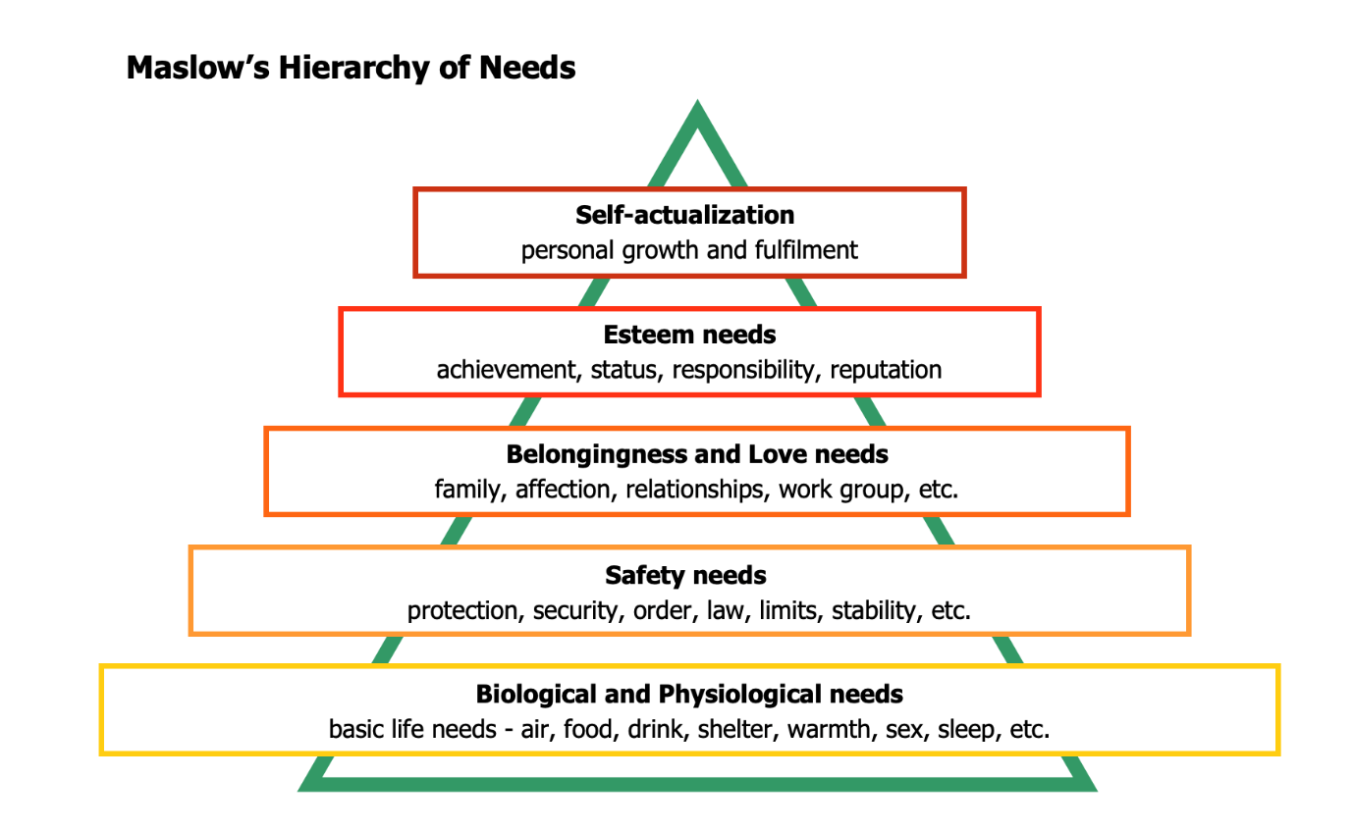
Figure 2. (Businessballs.com, 2019)

Apple understand that every individual has a biological and physiological need. Every individual has some basic life needs such as air, food, water and shelter. As people can acknowledge this, Apple can also identify people need security. Going up the Hierarchy of needs, safety and security are important. This is where Apple can offer a secure job. Going further up, people need a sense of belongingness. This already takes place in Apple. If they are working for Apple, they are in a relationship with others. They have a work group. When associated with other individuals, people want more. They want to show off their skills and assets. They want to share responsibilities with co-workers and hope to build a reputation. Apple supports this by allowing room for progress and self-gratification. To conclude, Apple employees are motivated by their needs. This motivation then helps the company progress. People usually aim to meet their lower needs. Without the lower needs, there is no point or very little point in meeting the higher needs.
“Maslow stated that people are motivated to achieve certain needs and that some needs take precedence over others. Our most basic need is for physical survival, and this will be the first thing that motivates our behaviour. Once that level is fulfilled the next level up is what motivates us, and so on.” Mcleod, S. (2018).
Maslow’s theory can be interpreted differently by different individuals. For someone that works for Apple, may say that Apple do not aim to support their staff, their only goal is to reach higher themselves. Apple’s intention may be to inspire and develop their staff, but the push is too much pressure. The employee may not want recognition for achievements or a high reputation, they may be comfortable at Safety Needs. That alone could bring fulfilment to them. The rest may be irrelevant to them. Self-actualisation and Safety Needs may actually be their main priority, so it would rest at the bottom of the Hierarchy Needs.
On the other hand, a sense of belongingness may be a person’s most significant need, after their basic life needs. A family could be more important to them than status. If there was an opportunity for a promotion, which meant working more hours during the week, a person who values their family would ignore the offer as they would rather have more days in or holidays with their loved ones.
“Maslow (1943) initially stated that individuals must satisfy lower level deficit needs before progressing on to meet higher level growth needs. However, he later clarified that satisfaction of a needs is not an “all-or-none” phenomenon, admitting that his earlier statements may have given “the false impression that a need must be satisfied 100 percent before the next need emerges” (1987, p. 69).” Cited by McLeod (2018). Not every individual or an organisation will follow Maslow’s theory, but the vast majority can relate to it.
Apple’s message is that they want to support and develop their staff, however some reviews from their employees have suggested otherwise. “The management team ruin what could be a good job.” Current employee - cited in Indeed.co.uk. (2019). Here, they inform people that working for Apple could be great, but the management make it difficult. Now this comment could be a fact, or it could be that the individual uses very little initiative therefore needs a push. However, other similar comments could be seen. “Almost all managers are hired from other companies, so very few have any idea what it's like being on the shop floor. They treat employees like children, with very strict time management, "telling off" and employees made to feel 'naughty' for being sick or otherwise taking time off.” Former employee - Indeed.co.uk. (2019).
Not every organisation or individual will be perfect. Yes, Apple have had bad reviews but this does not mean they are a bad company to work for, who know little about running a company or managing its staff. Their business is blooming and this wouldn’t happen without a strong team effort. A manager may control or lead a group of people, but with every individual put together, they all contribute to its progress.

Conclusion

“Our values and beliefs influence our attitudes and therefore our behaviours. Making our values and beliefs explicit is one of the first steps in culture change because talking about them helps us to become more aware of ‘how things are done around here’.” (Values & Beliefs, 2015).
To summarise and conclude this report, it can be said that beliefs and values relate to attitudes and behaviour. It may be positive or negative, however an end result will be there. People are influenced by their surroundings. That could include family, friends, community and environment. People learn from each other. That is where they gain their beliefs from. This belief may become something of value. It will be of great importance so how they act or behave from that will reflect their belief. Workplace behaviour should be kept at professional, however due to factors influencing behaviour, behaviour may be wanted or unwanted. There is always going to be advantages and disadvantages for beliefs, values, attitudes and behaviour, as everything has been derived from somewhere and it has some purpose attached.
There are lots of management theory out there. For a business, it is vital they choose the most suitable management method as not everyone will fit one method. The organisation should choose what is best for their company and their employees. It could be that they need a couple of different methods, e.g. motivation and leadership. Management methods are significant as they carry planning, organising, and other managerial tasks.

References

- Baer, D. (2015). How Tim Cook implants Apple's culture into new employees. [online] Business Insider. Available at: https://www.businessinsider.com/tim-cook-on-apples-culture-and-employees-2015-3?r=US&IR=T [Accessed 31 Jul. 2019].

- Businessballs.com. (2019). Motivational Model: Maslow's Hierarchy of Needs. [online] Available at: https://www.businessballs.com/improving-workplace-performance/motivational-model-maslows-hierarchy-of-needs/ [Accessed 30 Jul. 2019].

- Hofstede, G. (1998). Attitudes, Values and Organizational Culture: Disentangling the Concepts. Organization Studies, [online] 19(3), pp.477-493. Available at: https://journals.sagepub.com/doi/abs/10.1177/017084069801900305 [Accessed 10 Jul. 2019].

- Indeed.co.uk. (2019). Working at Apple: 265 Reviews | Indeed.co.uk. [online] Available at: https://www.indeed.co.uk/cmp/Apple/reviews [Accessed 27 Jul. 2019].

- Koti, K. (2014). Motivation. [online] Apple. Available at: https://applecorporate.weebly.com/motivation.html [Accessed 30 Jul. 2019].

- ManagementMania.com. (2016). Management Methods. [online] Available at: https://managementmania.com/en/management-methods [Accessed 31 Jul. 2019].

- Mcleod, S. (2018). Maslow's Hierarchy of Needs. [online] Simply Psychology. Available at: https://www.simplypsychology.org/maslow.html [Accessed 31 Jul. 2019].

- MORRIS, J., MARZANO, M., DANDY, N. and O'BRIAN, L. (2012). Forestry, Sustainable Behaviours and Behaviour Change: Theories. 1st ed. [ebook] Forest Research, pp.3-6. Available at: http://file:///C:/Users/jun/Downloads/behaviour_review_theory.pdf [Accessed 27 Jul. 2019].

- Onlinetaleem.blogspot.com. (2016). The Theory of Planned Behavior. [online] Available at: http://onlinetaleem.blogspot.com/2016/04/the-theory-of-planned-behavior.html [Accessed 23 Jul. 2019].

- Richardson, A. and Terrell, E. (2015). Apple Computers: This Month in Business History (Business Reference Services, Library of Congress). [online] Loc.gov. Available at: https://www.loc.gov/rr/business/businesshistory/April/apple.html [Accessed 29 Jul. 2019].

- Rossignol, J. (2018). Apple Now Has 132K Full-Time Employees, Spent $14.2B on R&D in 2018 Fiscal Year. [online] Macrumors.com. Available at: https://www.macrumors.com/2018/11/05/apple-2018-form-10-k-highlights/ [Accessed 30 Jul. 2019].

- Sabutey, F. (2017). The 7 Core Values Which Made Apple the Most Valuable Brand in the World. [online] Available at: https://www.expandgh.com/7-core-values-which-made-apple-most-valuable-brand-in-the-world/ [Accessed 9 Jul. 2019].

- Tutor2u. (2018). Theory of Planned Behaviour | Psychology | tutor2u. [online] Available at: https://www.tutor2u.net/psychology/topics/theory-of-planned-behaviour [Accessed 27 Jul. 2019].

- Uher, J. (2016). What is Behaviour? And (when) is Language Behaviour? A Metatheoretical Definition. [ebook] London: London School of Economics and Political Science. Available at: https://www.researchgate.net/publication/295081218_What_is_Behaviour_And_when_is_Language_Behaviour_A_Metatheoretical_Definition [Accessed 21 Jul. 2019].

- Values & Beliefs. (2015). [ebook] Foundation of Nursing Studies, p.1. Available at: https://www.fons.org/resources/documents/Creating-Caring-Cultures/ValuesBeliefs.pdf [Accessed 17 Jul. 2019].

