Karen Anne Windsor 1918576
1918576@student.uwtsd.ac.uk
Abstract
This report documents the design and create of an Access Database for Celtic Caterers.
Database analysis and Design
L4 BSc Introduction to Web and Database Concepts
“Celtic Caterers”
Contents
1. Introduction 3
2. Context Diagram 4
3. Level-0 Diagram 5
4 . ER Relationship 8
5. Site Menu Diagram 9
6. Reports 10
6.1. Customer Orders Report 10
6.2. Events Calendar Report 11
6.3 Low Stock Report 12
6.4 Stock Ordering Report 13
6.5 Current Stock Level Reports 13
7. Forms 14
7.1 Main Menu Form 14
7.2 Customer Menu Form 15
7.2.1 New Customer Details Form 16
7.2.2 Update Customer Details Form 17
7.2.3 New Customer Orders Form 18
7.2.4 Update Customer Order Form 20
7.2.5 Events Calendar Report 20
7.2.6 Update Events Calendar Form 21
7.3 Supplier Menu 22
7.3.1 New Supplier Form 23
7.3.2 Update Supplier Form 23
7.3.3 New Stock Form 24
7.3.4 Update Stock Form 24
7.3.5 Stock Order Form 25
7.3.6 Update Stock Order Form 25
7.4 Admin Menu 25
7.4.1 Menus Form 26
7.4.2 Stores Form 26
8. Queries 27
9. Macros 27
10. References 28
11. Appendices 28
11.1 Processes 28
11.2 Normalising of data 28

1. Introduction
After fact finding the user requirements for the Celtic Caterers are:
- A data base that can be used in all five of their locations:
- Swansea
- Neath
- Port Talbot
- Llanelli
- Carmarthen
- Output in the form of
- Customer Invoice
- Purchase Transactions record
- Catering event diary
- Stock purchasing forecast abilities (Low stock form)
- Events scheduling system (events form)
I started the design by thinking about the key participants and the processes, (see appendix 11.1) I then went on to try and normalise the data I would be trying to save and enter. (see appendix 11.2)
I did use Peter Weverka book Office 365 for dummies [1] for clarification of some points when using Input Masks and sub forms.
I thought that forms in this database would look better if opened in an empty state so used the macro available on Software Solutions [2]

2. Context Diagram

This shows the relationships and data flow between the main participants.

3. Level-0 Diagram

4 . ER Relationship

5. Site Menu Diagram

I was unsure how my database menu would link up, so I create this Menu Diagram within VISIO to show how I want it to look.

6. Reports

6.1. Customer Orders Report

This report shows all the customer orders but can by filtered by those that have been completed using the “Delivered” column
An individual customer order prints out can be printed from the customer order form
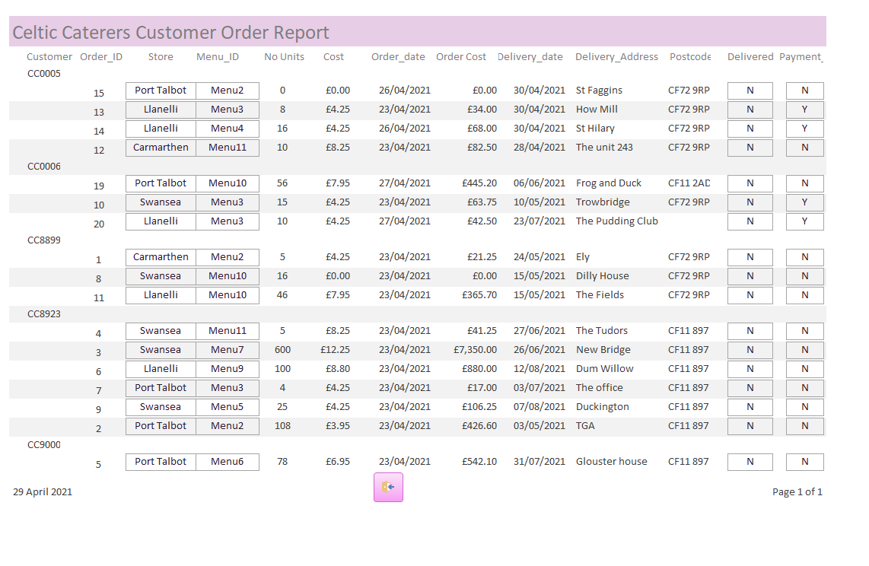

6.2. Events Calendar Report

This report shows all the events that have been booked. The stores can check their own availability. Availability is hard to gauge as the user requirements did not state how many staff are currently working at each site and what output each site is capable of, have left this up to the individual managers when booking as they will know what their stores are available of.
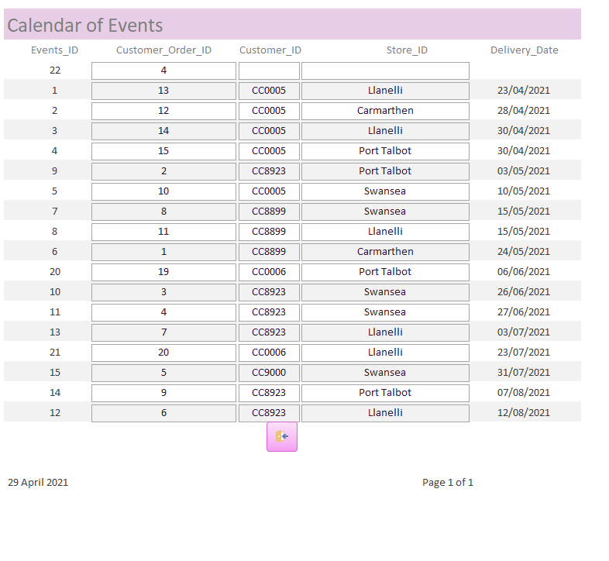

6.3 Low Stock Report

I thought that Celtic Caterers would be interested to know what stock was below the low stock level
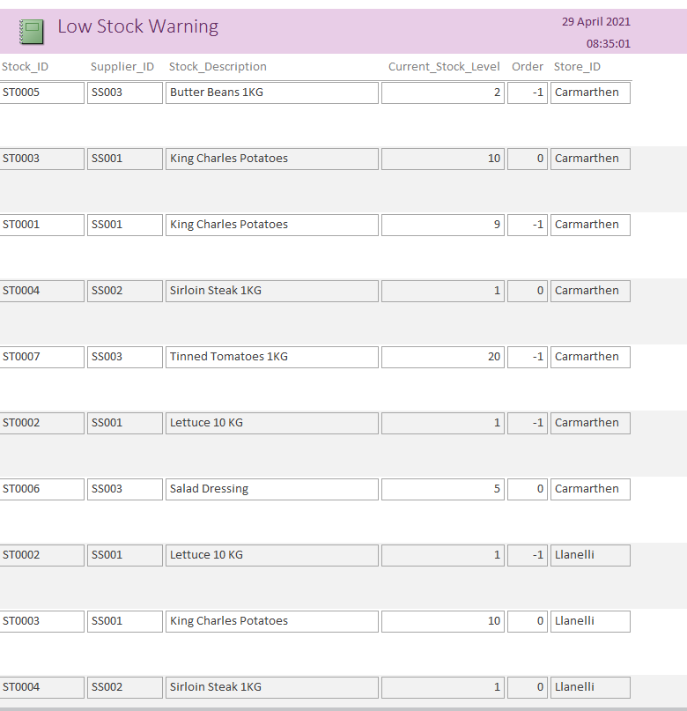

6.4 Stock Ordering Report

This report shows the current stock orders. Celtic Caterers can filter on the “Delivered” column to discover which stock is awaiting delivery.
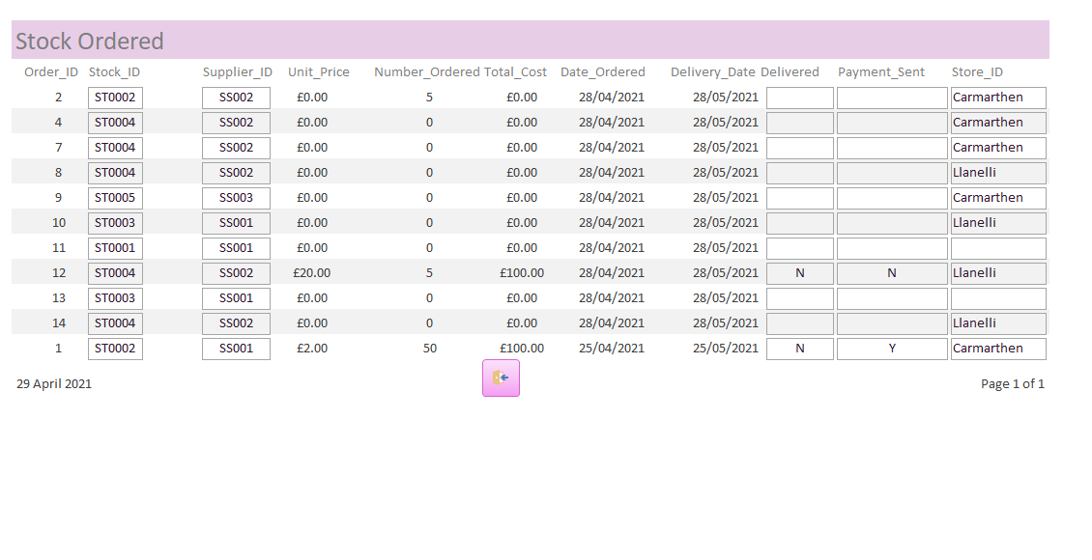

6.5 Current Stock Level Reports

This report shows the current stock levels at all the Celtic Caterers stores. The report can be filtered for each store using the “Store_ID” column.
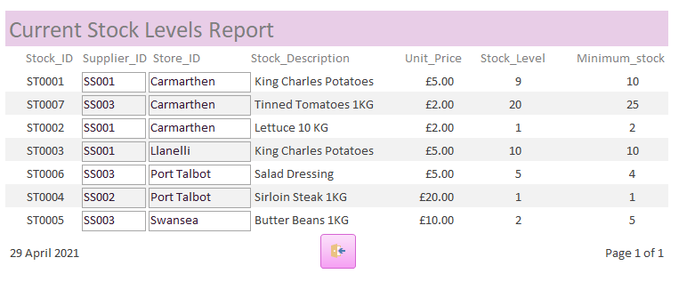

7. Forms

7.1 Main Menu Form

From this menu the user can toggle to the Customer/Supplier and Admin submenus
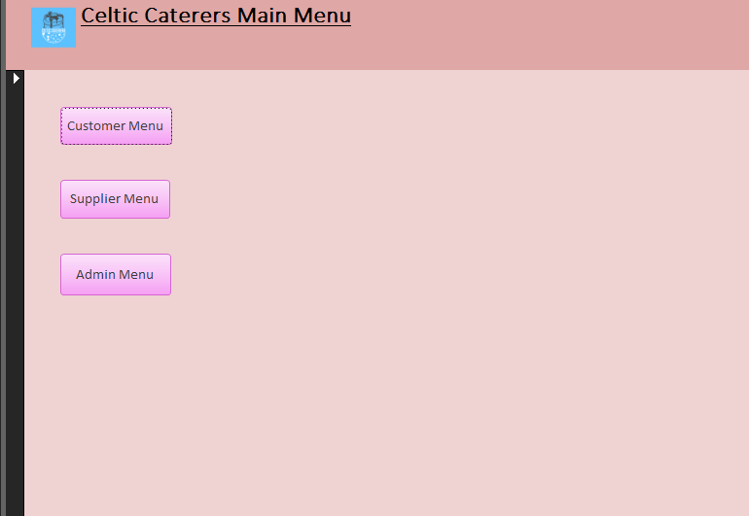

7.2 Customer Menu Form

From this menu the user can:
- Add a new customer’s details to the database
- Amend a current customer’s details
- Add a new customer’s order
- Amend a customer’s order
- Add a new order date to the Calendar
- Amend an event in the Calendar
- Print the event Calendar Report
- Print the Customer Order Report
- Return to the Main Menu
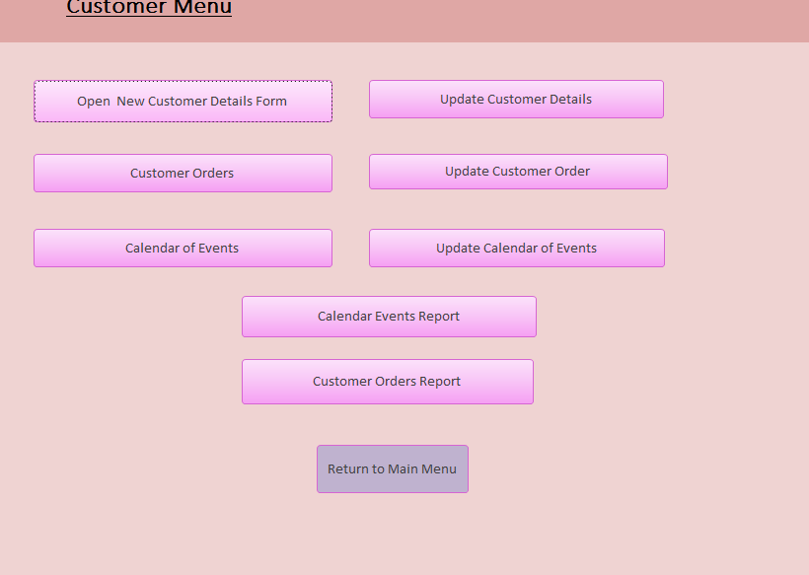

7.2.1 New Customer Details Form

In this form the user can:
- Add new customer details
- Save the form into database
- Print the customers details
- Return to the Customer Menu
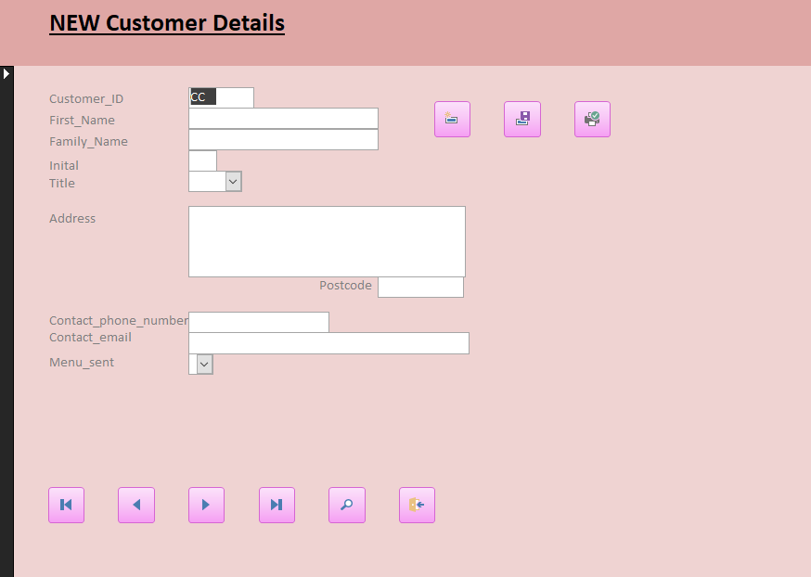

7.2.2 Update Customer Details Form

This form allows the user to:
- Search for a customer using the customer ID
- Update customer details
- Save the new Customer details
- Print the new details
- Delete the record
- Toggle through the records
- Return to the Customer Menu
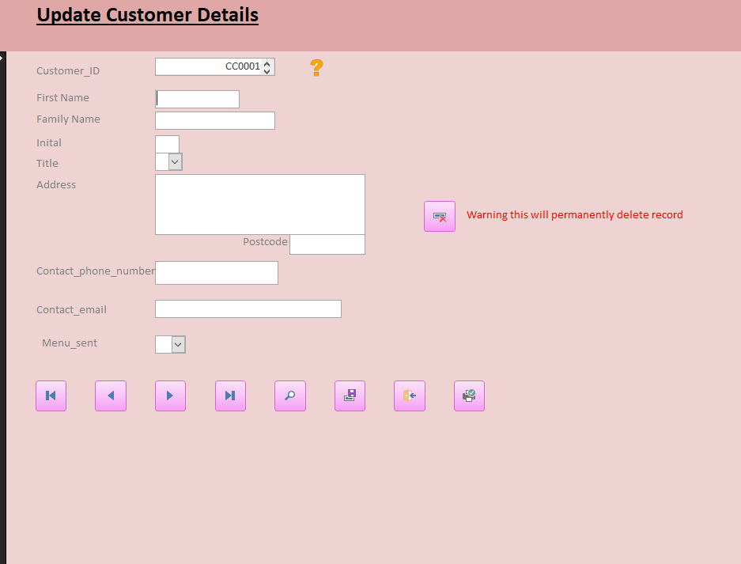

7.2.3 New Customer Orders Form

On this form the user can:
- Add a new customer order
- Check that the order date is ok on the Events Calendar
- Print the customer order
- Automatically load Customer details so that they can check against the Customer ID – using the Customer Details. If they don’t match the user can click on the search family name button. Which will open the search on family name form.
- Automatically open the Menu form which displays the menu description and the cost per unit
- Once the cost per unit and the number ordered have been entered, the form automatically calculates the total cost.
- The order date is automatically defaulted to today’s date
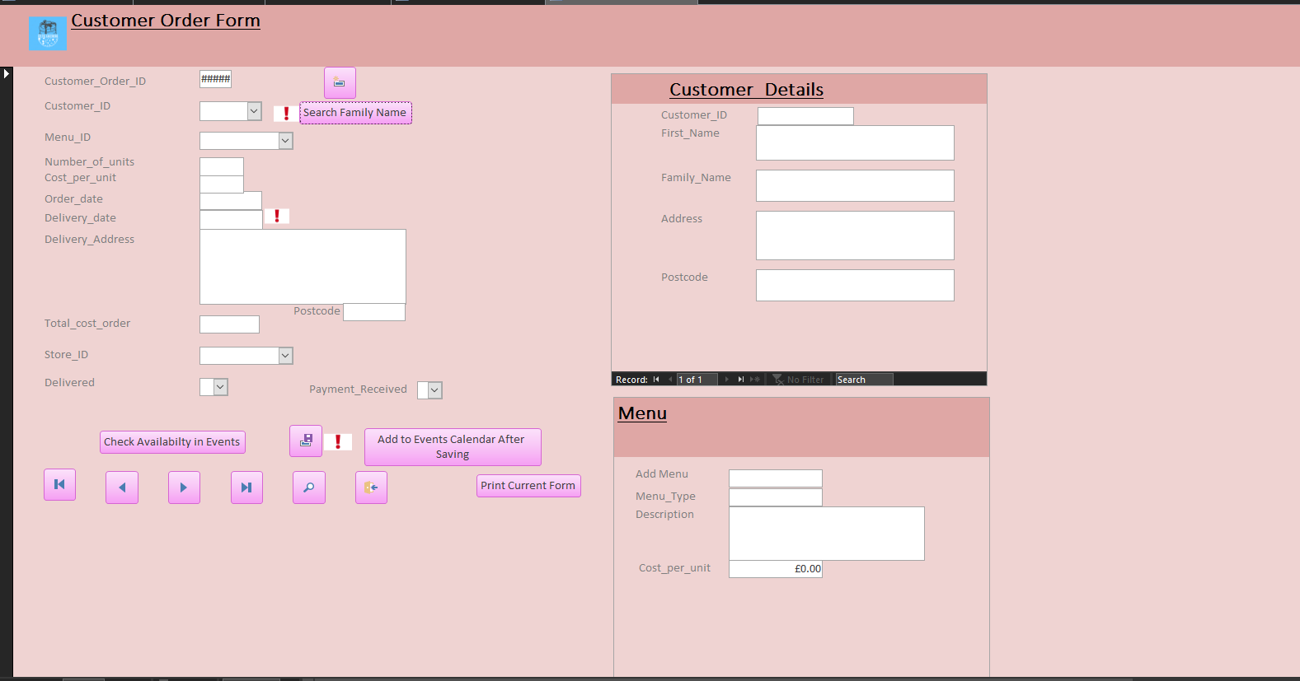

7.2.3.1 Search on Customers Family Name Form

This form allows the user to search for the customers details using their family name. I have added this to the database as there may be an incident where the customer forgets their ID. This form also allows the user to return to the new customer order form.
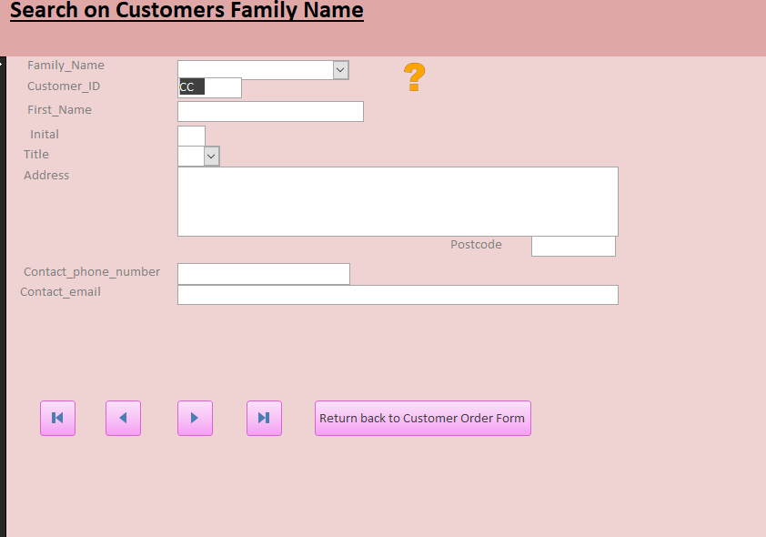

7.2.4 Update Customer Order Form

In this form the user can :
- Update the customer order
- Save the new customer order
- Delete the customer order
- View the customer order for a query
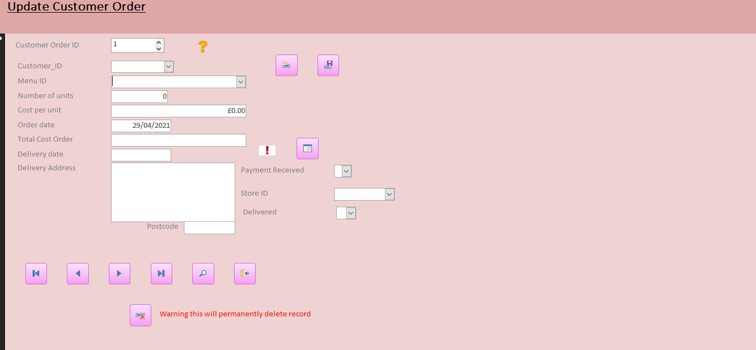

7.2.5 Events Calendar Report

In this form the user can add new event dates
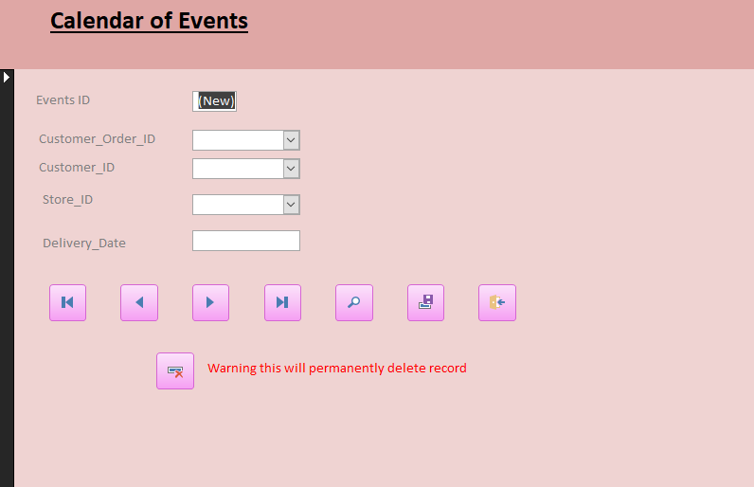

7.2.6 Update Events Calendar Form

This form allows the user to update the customer order date.
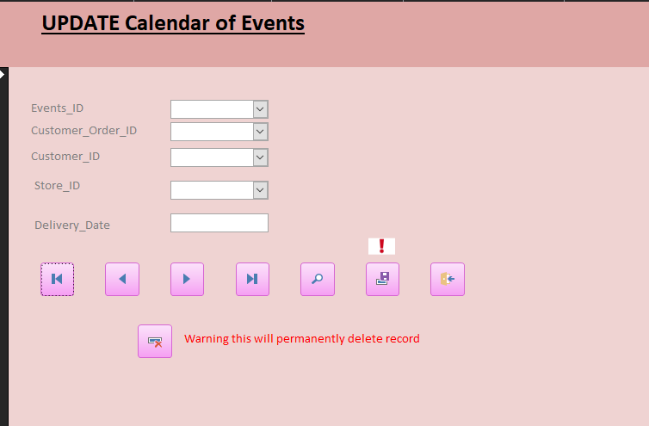

7.3 Supplier Menu

This menu allows the user to:
- Add new supplier
- Update supplier detail
- Add new stock
- Update stock record
- Add new stock order form
- Update the stock order
- Print the low stock report
- Print the total stock report
- Print the stock order report
- Return to the main menu

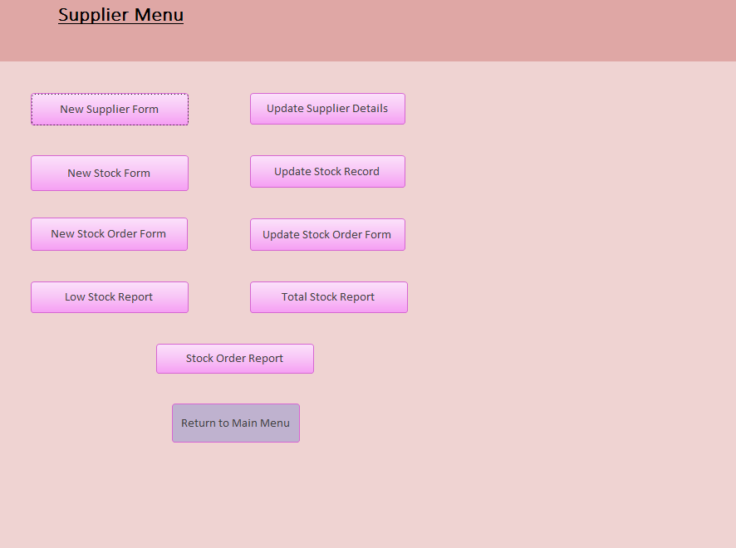

7.3.1 New Supplier Form

This always the user to add new supplier details
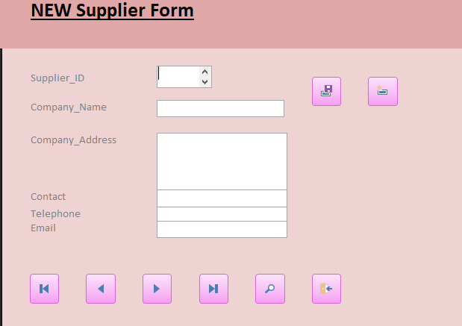

7.3.2 Update Supplier Form

This allows the user to update/delete or search on the Supplier’s details
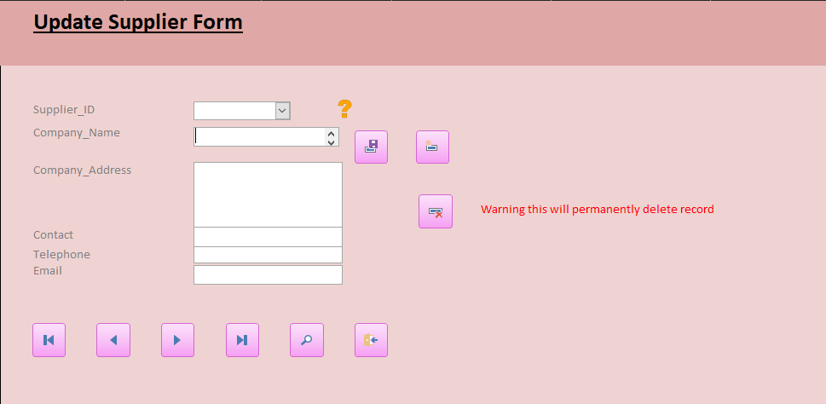

7.3.3 New Stock Form

This always the user to add a new stock type to the database
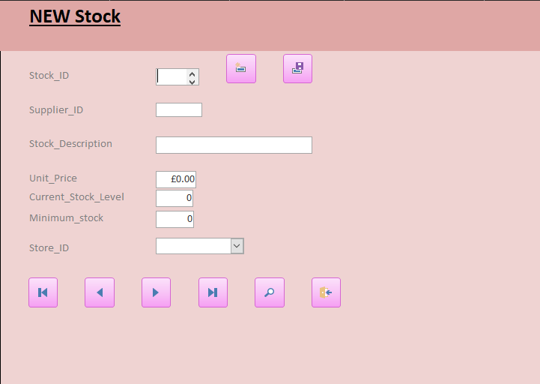

7.3.4 Update Stock Form

This allows the user to update the stock once items are used or orders received. It also allows the user to detail stock if item is withdrawn or not needed in the future.
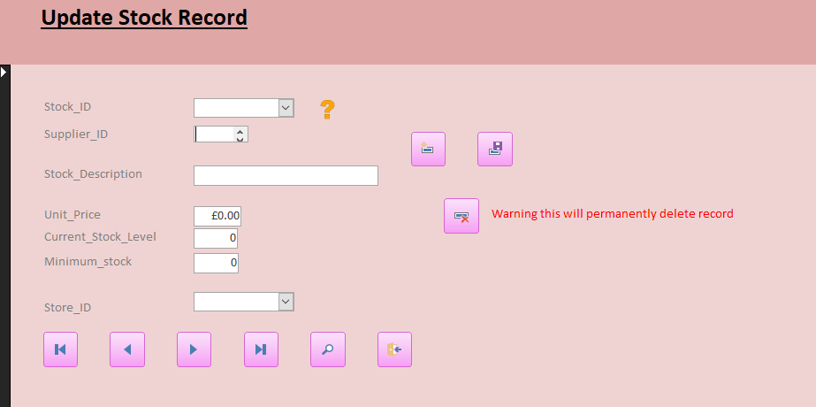

7.3.5 Stock Order Form

This allows the user to order stock – It loads the stock record table so that it automatically loads the stock details and calculates the total cost of the order.
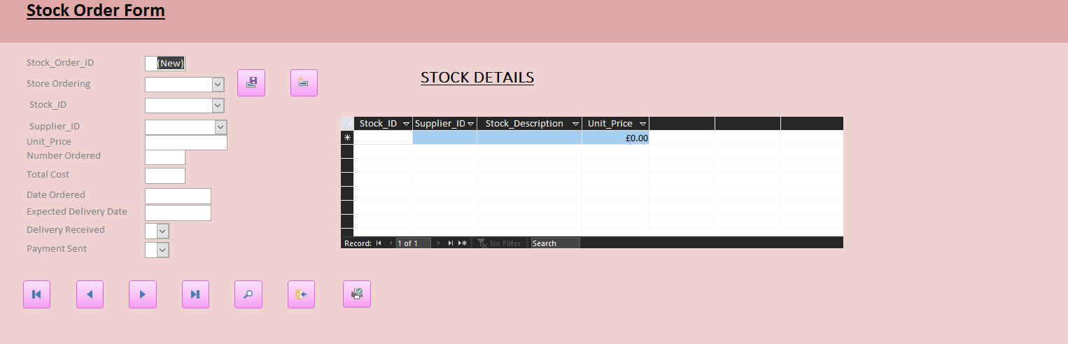

7.3.6 Update Stock Order Form

This allows the user to update the stock order/delete stock order or search on the order
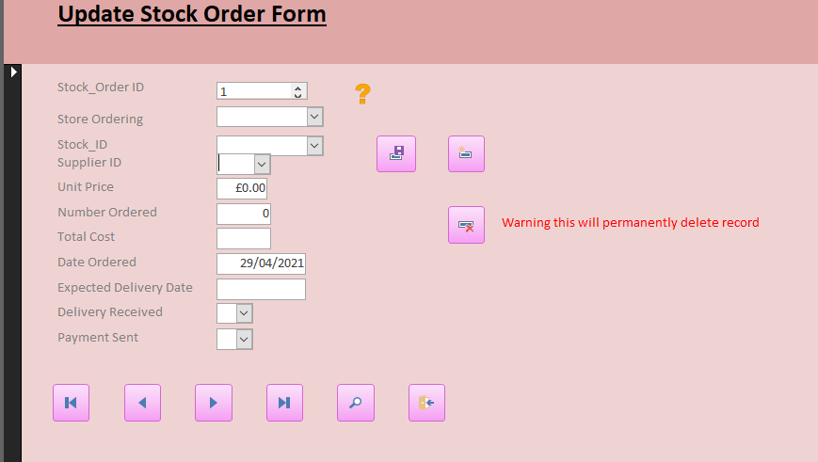

7.4 Admin Menu

This menu allows user to update their menus and stores
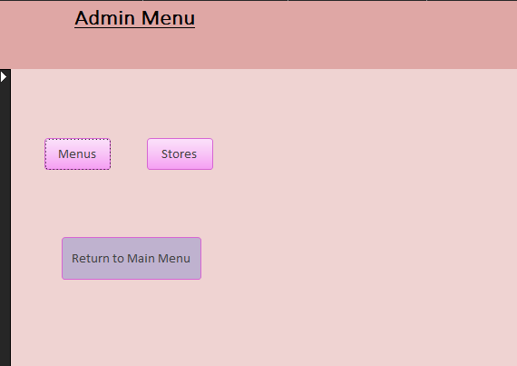

7.4.1 Menus Form

This allows the store manager to update or replace the menus on offer by Celtic Caterers.
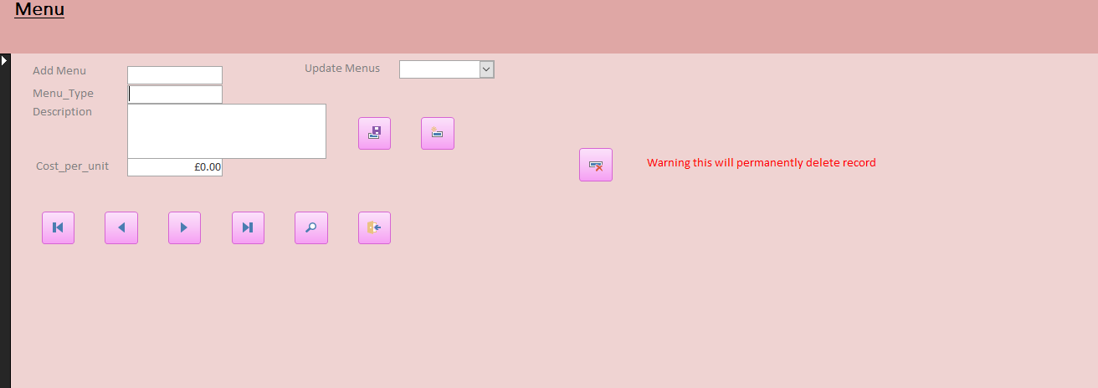

7.4.2 Stores Form

This allows the Store manager to update the stores information:
- Store manager
- Phone number
- Address
- Email
Or add a new store
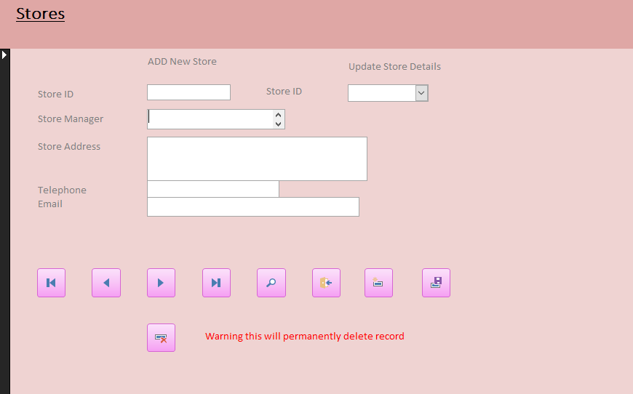

8. Queries

Low stock query to feed into the low stock report
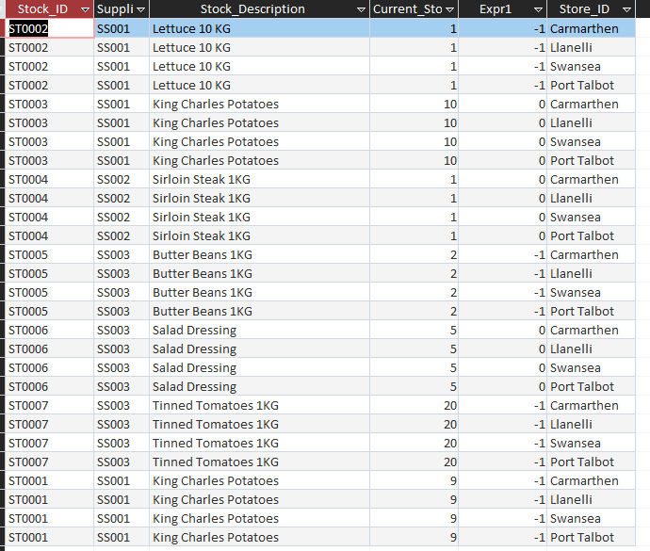

9. Macros

I wrote 1 macro for this database – it allows the forms to be open in an empty setting
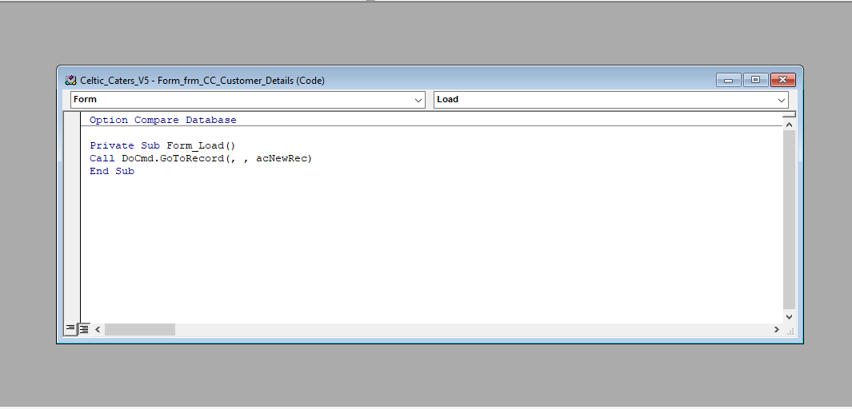

10. References

[1] | P. Weverka, Microsoft Officer 365 for dummies, Hoboken: John Wiley & Sons Inc, 2019, pp. 489 - 567.
[2] | Azurous, “Open blank form when database is opened,” Software Solutions, 15th August 2015. [Online]. Available: https://software-solutions-online.com/open-blank-form-when-database-is-opened-access-vba/. [Accessed 29th April 2021].

11. Appendices

11.1 Processes

11.2 Normalising of data

