

Title page
Student name: Mashud Ali
Student number: 1713109
Module name: Developing workplace critical thinking
Module code: BMSW5001
Assignment title: How individuals’ beliefs, attitudes and values impact on workplace behaviour
Tutor name: Chijioke Uba
Submission deadline: 26th March, 2020

Table of Contents
Executive Summary 2
Part 1: Personal beliefs, values and attitudes 2
Introduction 2
Beliefs 2
Values 2
Attitude 3
Part 2: Organisational beliefs, values and attitudes 3
Application to my workplace experience 4
My workplace values 5
My personal beliefs, values and attitudes 6
Part 3: Application of management theories 6
Introduction 6
Classical Management Theory 7
Scientific Management Theory 7
Administrative management theory 7
Bauracracy Theory…………………………………………………………………………………………………………………………7
Satisfaction and Dissatisfaction Theory………………………………………………………………………………………….8
Chosen Management Theory…………………………………………………………………………………………………………9
14 Principles of management 9
Principles of Management and its application to my workplace 10
Functions of management 11
A. Planning 12
B. Organizing 12
C. Commanding 13
D. Coordinating 13
E. Controlling 13
Analysis of Fayol’s theory 14
Part 4: How the economic environment affects resident businesses………………………………………………14
Conclusion 15
Reference List 16

Executive Summary
The rationale of this study is to scrutinize in detail, the impact on behaviour of values, attitudes and beliefs have in the workplace. To perform this study, it would be necessary to conduct an application management theory and compare to my own real life experiences of the work place and then evaluate how this impacts on my own attitudes, values and beliefs.

Part 1: Personal beliefs, values and attitudes

Introduction
Each and every person has their own set of beliefs, values and attitudes. These beliefs, values and attitudes differ from person to person although many of these may overlap and be shared with others. These beliefs, values and attitudes a developed over a period of time and influenced by numerous factors such as the environment in which we live, cultural, social and emotional experiences and encounters. Just as important is the ability for humans to be able to adapt their beliefs, values and attitudes over time.

Beliefs

Belief is an opinion or something that a person holds or has faith in to be true, it is an assumption that we make about the world. Our values stem from those beliefs, and usually without actual proof or evidence. These are thoughts upheld by people usually formed by cultural and religious beliefs as well as societal and personal experiences.

The belief system is known better as an individual’s identity. An individual’s thoughts or experiences once accepted by the individual as a belief, is then reciprocated as part of an persons belief and identity.

Values
Ideals are comparable to values that individuals embrace themselves by as well as others. It’s what an individual tends to consider being the most important ideology to live and abide by in their day to day behaviour.
It is possible that credence will translate to a value if it forms a fundamental and deep-seated character to them. For illustration, the belief that being untruthful is bad might be transformed into placing importance on an individual’s honesty.

Attitude
Attitudes consist of 3 core elements i.e. Affective, Behavioural and Cognitive. Affective is the emotional and expressive response. Behavioural is the external behaviour expressed. Finally cognitive is the psychological evaluation supported on the internal beliefs and values.
Attitudes characterise an individual and are defined by their emotional and psychological experiences. It can be said that a person’s beliefs and values stem from these.
Attitude plays an important part on how a person behaves. An example of this can be seen in politics. A person will usually follow a party that has similar beliefs and values to themselves.
An individual’s attitude can also be prejudiced by peer pressure from others, a great example of this are teenagers. Their outlook on beliefs and values are usually persuaded by their friends and people around them which are external factors.
Figure 1 below shows how an individuals behaviour is influenced and the relationship between beliefs, values, and attitudes.
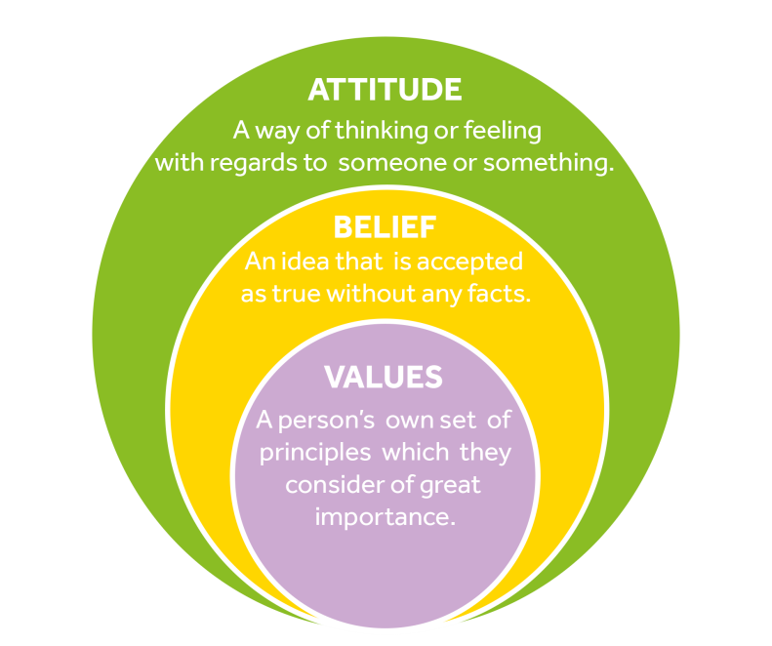Figure 1

Part 2: Organisational beliefs, values and attitudes

There may be some similarities between an organisations beliefs, values and attitudes and that of its employees. However, an organisation is comprised of people from all ages, races and backgrounds, each individual bringing their own set of beliefs, values and attitudes. For a workplaces environment to florish an organisation must respect its employees differences in beliefs and values, yet help them align with the organisations core values. By accepting their differences and finding those aligned core values you make them feel like an integral part of the organisation and in return employees feel responsible for the overall wellbeing of the organisation. According to research, employee satisfaction is in direct correlation the level of alignment (Hyde and Williamson,2000).

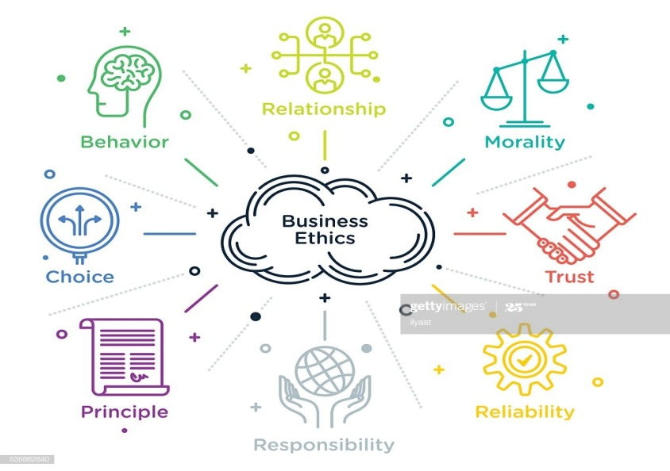

Figure 2

Application to my workplace experience

I worked at Handsworth Wood Boys School which was governed by Birmingham City Council, Birmingham being the second largest city in the country. I found that it was like working for a large organisation and not just an individual school and this fascinated me. How they are able to provide such a broad service all across the city so efficiently is why I have chosen to talk about them in this paper.

My workplace values
According to Birmingham City councils website their core values are the following:
- We put citizens first: We show respect and empathy in everything we do
- We are true to our word: We keep the promises we have made.
- We act courageously: We lead, manage and tackle the difficult issues every day.
- We achieve excellence: We will get things right the first time and every time.

We put citizens first
To put the citizens of Birmingham first and foremost in all decisions made. This can be achieved by being approachable, helpful, empathetic and communicating clearly with residents and understanding their needs. Ultimately finding out what issues they find important and presenting solutions.
Integral to this value is the importance of equality and diversity.
We are true to our word
Holding account for delivery of promises and being consistent in what is said and done builds trust. Therefore, Being honest and taking responsibility is integral.
We act courageously
Doing what is right and acting with integrity even when that may seem difficult. For a better future we should always lead responsibly and look for good change. Sometimes that involves taking bold decisions and leading on new ideas and concepts.
This also involves an element of honesty, and having the courage to admit to our faults and mistakes. Learning from those mistakes but also putting actions into place so they are not repeated.
We achieve excellence
Excellence is working to get things right first time. Key to succeeding in this is to continually improve through listening, learning, innovation and most of all learning from mistakes when they do happen. Excellence can be achieved by performing to the highest professional standards, being innovative and creative in driving forward improvements, taking pride in work, attention to detail, adaptable and flexible in approach, learning from all situations and proactively improve performance.

My personal beliefs, values and attitudes

Since childhood I have developed my own set of beliefs, values and attitudes. These have ultimately been influenced by religion, environment, culture, my life experiences as well as friends and family. As an individual they dictate how I behave in a workplace environment. I would consider honesty, hard working, religious beliefs and family are some of the core values that define me.
Family
Like all employees it is a constant struggle to balance work commitments and family life. Sometimes unforeseeable situations arise where you may need time off, such as; your child or someone you care for gets ill, cancellation of childcare arrangements etc. Workplaces have become very understanding and will do their best to give you the time off that you need.
Religious beliefs
How I conduct myself as an individual in my everyday life is greatly influenced by my religious beliefs, most of which are applicable to the workplace environment and also define me as an employee. These included knowing right from wrong/good from bad, always behaving in a respectful and appropriate manner, being honest and treating everyone as equals.
Hardworking
I have come to believe through experience that hard work is what we physically and mentally exert under duress. We work hard for something we believe in, something we have thought and planned for and will ultimately lead us to happiness, success or a well-being. There is a quote that I read that has always stuck with me “Success travels in the company of hard work. There is no trick, no easy way.”
As an individual you can only achieve so much, when you start working hard as a team however, the achievements are much more rewarding. These behaviours were encouraged in my workplace and even rewarded.
Integrity
Integrity plays an important part within the workforce, which refers to being of upright character, having good judgement and being dependable. I have always considered myself as being a loyal and trustworthy person who is respectful and caring towards others regardless of age race or religion. and to be able to communicate and socialise with people from different culture and walks of life.

Part 3: Application of management theories

Introduction
Management is defined as the process of planning, organising, leading, motivating and controlling an organisation to reach its goal in an effective and efficient manner. As history has shown us, poor management can lead to the failure of a business and therefore good management is vital for success.
In this report I would like to touch upon a few management theories which exist within organisations, and then choose one to examine in detail and how it applies to my beliefs, values and attitude based on my previous workplace.

Classical Management Theory
According to this theory, employees only have physical and economic needs. It excludes an employee’s need for job satisfaction and only focuses on maximising profit i.e. employees are rewarded by salaries and bonuses based on output.
This theory was specifically developed to increase an organisations productivity and therefore its profits. It is no longer as popular as before but some of its ideas are still relevant in modern day organistaions.
Scientific Management Theory
This theory was developed by Frederick Taylor who’s idea was to use a scientific approach to streamline processes and make them more efficient. Ultimately this would boost productiveness and profits. It was based on the belief that managers were more intellectual than the employees and therefore they were better to oversee and manage them. This theory became well suited in manufacturing organisations.
Administrative Management Theory
Developed by Henri Fayol, this theory focussed on making sure an organisation had effective guidelines in place to manage it effectively. He also pioneered the idea that management skills could be taught to individuals, where as previously people thought that management was a natural skill you were born with.
Bureaucratic Theory
Max Weber’s Bureaucracy Theory can be defined as highly structured, formalized, and also an impersonal organisation. He believed that an organisation must have clear rules and regulations with defined hierarchical structure and lines of authority. Max Weber’s bureaucracy theory ideally has the following characteristics:
- A formal hierarchical structure
- Rules-based Management
- Functional Specialty organization
- Up-focused or In-focused Mission
- Impersonal
- Employment-based on Technical Qualifications
Bureaucratic theory is criticised for its rules, however it still exists in many organisations such as Military forces.

Satisfaction and dissatisfaction Two Part Theory
Herzberg’s Motivation Two Factor Theory, states there are two prime factors that an organisations can regulate to persuade individuals motivation in the workplace.
The two factors are:
- Motivational factors: These are factors which can promote individual employees to work more effectively and efficiently
- Hygiene/ cleanliness factors: These do not tend to encourage individual employees to perform better, however they may influence them to become de-motivated if they do not exist.

So this begs the question, what is Two Factor Theory?
Herzberg’s Theory attempts to dig deep into finding the main driving factors for motivation in the workplace. It can be used to enhance the motivation of team members to improve performance.

The two key factors put forward by Herzberg are motivational and hygiene factors.

1. Motivating Factors
The existence of motivators influences employees to perform better. These tend to be found within the job itself.

2. Hygiene Factors
When there is a lack of hygiene factors, these will result in employees to perform less effectively. These hygiene factors are do not exist in the job but are more environmental to the job.

Chosen Management Theory
In this report I will be focusing on Henri Foyal’s Administrative Theory. My reasons for doing so are due to the administrative theory being more closely aligned with my previous employment.

Administrative management theory
By profession Henri Fayol was an engineer eventually becoming the managing director of the company which employed him.
Fayol was of the impression that management was a skill, and as with all skills, these behaviours and skills can be learnt. Henri Fayol used his experiences through the positions he had held, including his position as the managing director of the organisation to develop his administrative management theory. His theory declares that there are 14 principles of management and 5 functions of management.

14 Principles of management
- The diagram below outlines the fourteen principles of management.

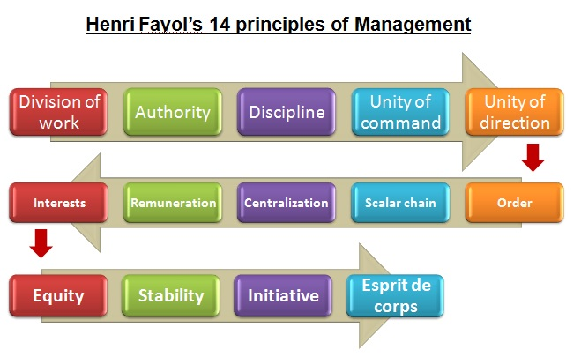
Figure 3

Only the principles which are of greatest relevance and importance to my place of work will be dealt with in greater detail.

Principles of Management and its application to my workplace

Division of work
Division of labour and it’s roles are vital to an organisation running efficiently. At my previous work place there were several divisions of hierarchical labour such as management, deputies, teaching staff and administrative staff. Although, teaching staff are the primary category of labour in a school the other roles are equally as important, as without them teachers would not be able to do their jobs effectively. Everyone knows what is expected from them as they have defined roles.
However, Fayol’s theory does not take in to account the overlapping of roles. As an example, at my school some of the responsibilities the Head teacher had were looking after the staff, the schools finances and the everyday running of the school etc. However, as they had been a teacher before, there were times when they had to step in and take classes when it was required.

Authority and responsibility
Fayol’s theory states that there are 2 types of authority/responsibility, where you have ‘offical’ authority and ‘unofficial’ authority. Official authority is due to hierarchy therefore depends on the position an individual holds in an organisation, the latter comes from a mutual respect of others, sometimes due to a person’s intelligence and experience.
According to Fayol, authority is having the power to give orders to an individual or group and them having to carry those orders out. As in the context of schools, OFSTED set the standards to which every school must follow. Therefore, the management team have an obligation to report to them and make sure they meet the standards set. In order to do this, management requires all the other staff to do their roles at a high standard all the time as everyone plays an important part in the successful running of the school and it is the management’s duty to make sure the organisations goals are met.
Discipline
This is the practice of making sure people obey rules or authority by using negative consequences to correct disobedience.
Fayol’s theory in regards to discipline in my opinion is very narrow and doesn’t take in to account the reasons related to the disobedience. An example I would give would be when a teacher was continuously coming to work late. Fayol’s theory would suggest that they should be disciplined without question. However, the Head teacher sought to talk to the teacher and find out the reasons for the lateness. He found out the teacher was having temporary personal issues due to childcare and they were understanding and able to make arrangements.

Unit of Command
This factor is to do with the hierarchy in an organisation i.e. the line of command i.e. At my school for example, administrative staff would report to the office manager, teachers would report to the head of department, who would report to the deputy head, who would ultimately report to the Head teacher. As you go up the chain of command the greater the authority.

Unity of Direction
In an organisation everyone works together as a team to achieve the same goal no matter what their level of authority, this is known as Unity of Direction. Although a Head teacher is responsible for the performance and running of the school, each of the staff members roles is vital to achieve success.

Equity

Fayol stated that employees are to be treated fairly and with kindness if they are to have a vested interest in the organisations success. This means that managers are not to give differing treatment to people of different positions and not to discriminate.
Equity is needed to create friendly relations between managers and employees and maintain these relations. However, Fayol also believed that sometimes you may need force and be harsh for the sake of equity. This is very clear to see in the school environment, where discrimination is not tolerated, everyone is treated equally and fairly and contributions are valued regardless of their position. Good performance is recognised and appreciated and sometimes rewarded with promotion.

Functions of management
Figure 4 below illustrates the 5 functions of Henri Fayol’s management theory.

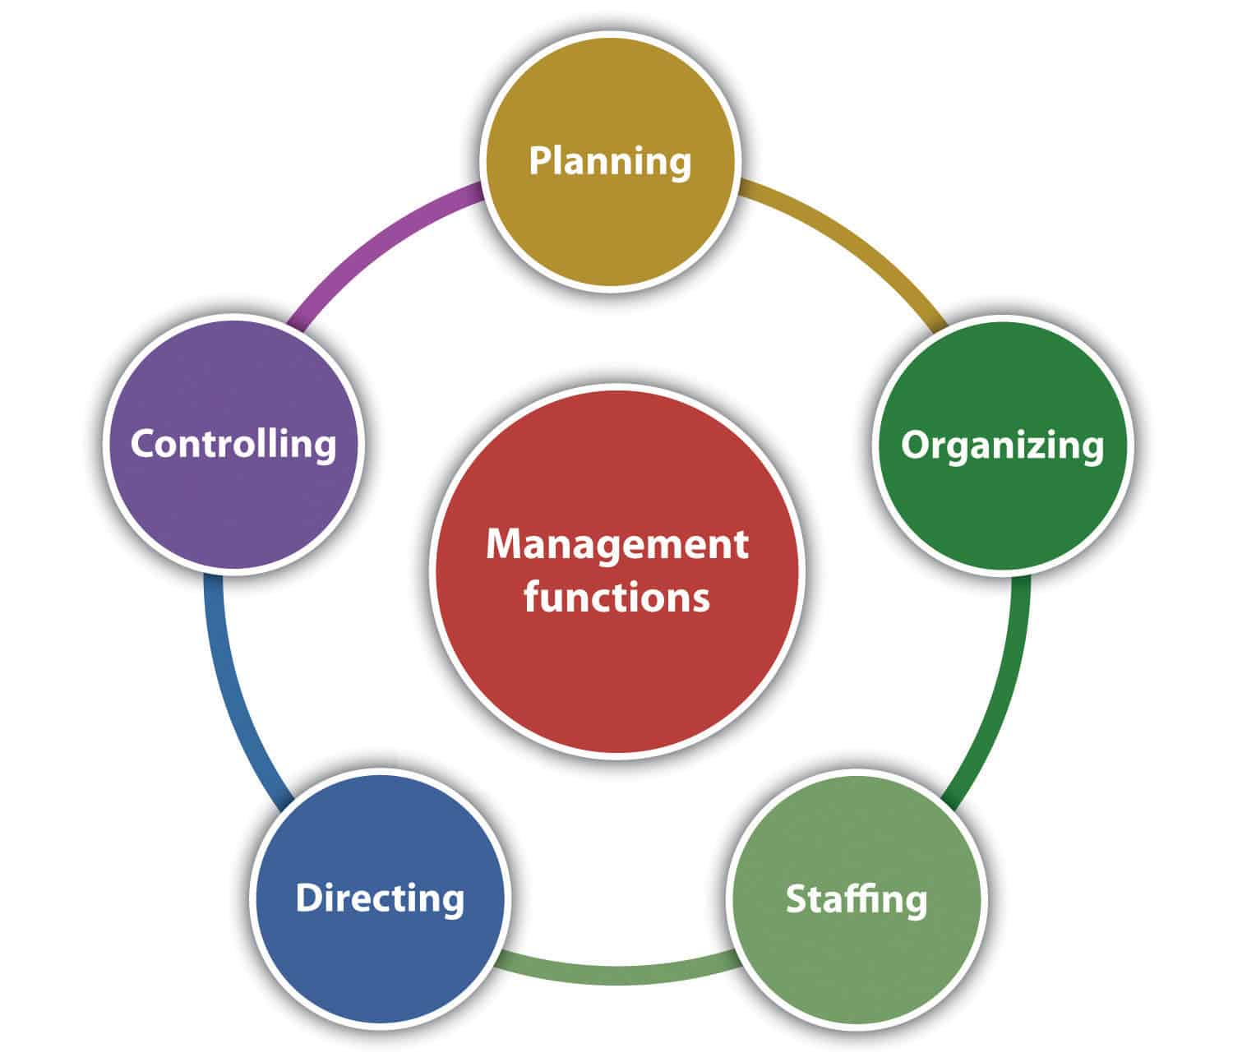Figure 4

A. Planning
Planning is the initial function of management. It places importance on management to pre-empt in making decisions based on future projections.
The planning stage is the function of greatest complexity of all the five functions as foresight is required in order to pre-empt. You must know the end goal and have the required steps planned to achieve it. Planning also places a requirement on being able to idea competencies within individuals to be able to execute the planned actions.

B. Organising
Any business to be successful requires a high level of organisation, without which it is likely to fail. In many ways, as is the case in many situations, there is a requirement for the existence of clear structure and order as well as some level of authority for an organisation to be successful. The need becomes of more importance as the size of the organisation increases.
Organisations need to make sure they have has sufficient cash flow reserves to maintain itself and disburse for supplies, salaries and other operational costs. It needs to have an authority/ management structure so as to facilitate decision making. This requires people with the right level of skills and experiences to be available at the right time. This is to make sure we stay compliant with the laws and regulations at all times.

C. Commanding
To make sure everyone knows what their positions and responsibilities are, they require instructions. Therefore we need we need distinctive lines of command to convey certainty. This will encourage individuals to be responsible and independent.
Without these limitations in situ, there are no defined roles. Therefore, nobody in the organisation will know whether tasks are being completed or not. Another problem is the possibility of multiple employees doing the same tasks. The role of a project manager is an illustration of commanding in an organisation. They ensure employees are given a selected task to complete and make sure they have the independence and initiative to compete them.

D. Co-ordinating

Even when roles are co-ordinated within an organisation, without the above three functions Planning, Organising and Commanding being present it will not work properly. For example, to deliver an individual task to a group deadline would require all employees on that project to deliver at the same time. Therefore, those employees have to co-ordinate with one another to meet the deadline. You may even find some roles are intertwined and require 2 or more people to work together as one employee will affect the other in completing the tasks on time. This is why communication is a key part in co-ordinating.

E. Controlling
Management must exercise a degree of control to make sure tasks allocated are done within the required time frame and standards of quality. This usually happens according to a four-step process:
- Establishing the organisations objectives and required performance standards.
- Measure the real performance and make a report.
- Compare the results found with the performance and quality standards required.
- Take action, be it corrective or preventative.
As an example, management has set a performance standard they require for a specific task. This can be an internal or external standard, however in this example the measured performance is output, therefore management will compare this result with other results i.e. from a previous year to see the difference. They may even compare the result to that of others. Results can then be used to take further measures to boost performance.

Analysis of Fayol’s theory

In organisations all over the world Fayol’s Administrative Management Theory is still implemented. This is more apparent in organisations that are based on hierarchy for example the military. It works very well for certain types of organisations however, it has its flaws.

His theory is very management focussed and does not take in to account the problems and concerns of employees. Management is driven by results whereas employees are driven by ambition, motivation and their work environment, causing their ideologies to clash. Fayol’s theory does not consider factors, such as an employees motivation, employees feeling valued and important within the organisation.

Part 4: How the economic environment affects resident businesses

Introduction
Economic factors are linked with goods, services and money. Although they directly affect business’s, they refer to the economies financial state on a whole be it national or global. The economical environment affects businesses because it decides many of the key details like demand, taxes etc. that affect an organisation.
Economic factors that affect businesses include but not limited to:
- Demand and Supply
- Exchange rates
- Interest rates
- Taxes
- Inflation
- Recession
We will be looking at a few examples and how they affect a business.

Exchange rates
This applies to anyone who deals with the export or import of goods and services. For example increasing or decreasing exchange rates will ultimately affect profit margins. This is due to the fact that the amount the organisation has to pay to its suppliers will go up and down. This also takes a lot of the organisations resources to maintain.

Interest rates
Interest rates are linked with banking institutions, therefore has an effect on all organisations.
This is due to the fact that all organisations in some way or another rely on the banking industry, they may have a loan, have a mortgage or have capital saved in a bank etc. Each of these has a interest rate attached to it and therefore as these rates go up and down it affects the profits of the business.

Recession
This usually changes the purchasing attitude of customers, making them more hesitant to go out and spend money. This in turn may force companies to reduce prices on their goods and services, ultimately reducing profit margins.

Conclusion

From my research and analysis of Foyal’s theory it is clearly visible to understand that belief values and attitude plays an important part on how we conduct and present ourselves in the workplace. For an organisation to be successful, its values, beliefs and attitudes need to align with that of its employees. My research indicates that values, beliefs and attitudes are always evolving. They do not remain the same as they are always being influenced by one’s cultural, religious and environmental experiences along with other factors.
Economic factors are one of the many environmental factors which can affect businesses. Although they relate to the economy on a greater scale, they have a profound effect on any and every company and can be seen in all organizations, from super stores to your local shops.

Reference List

Bush, T., 2020. PESTLE Analysis: Economic Factors Affecting Business. [online] PESTLE Analysis. Available at: https://pestleanalysis.com/economic-factors-affecting-business/ [Accessed 23 March 2020].
Council, B., 2020. Our Council | Working For Birmingham City Council In A Senior Management Role | Birmingham City Council. [online] Birmingham.gov.uk. Available at: https://www.birmingham.gov.uk/info/20102/jobs/1737/working_for_birmingham_city_council_in_a_senior_management_role/3 [Accessed 19 March 2020].
Coursehero.com. 2020. 6 Criticism Of Administrative Management Theory Henri Fayols Management | Course Hero. [online] Available at: https://www.coursehero.com/file/p64ah6f/6-Criticism-of-Administrative-Management-Theory-Henri-Fayols-management/ [Accessed 22 March 2020].
Coursehero.com. 2020. 6 Criticism Of Administrative Management Theory Henri Fayols Management | Course Hero. [online] Available at: https://www.coursehero.com/file/p64ah6f/6-Criticism-of-Administrative-Management-Theory-Henri-Fayols-management/ [Accessed 22 March 2020].
Get-information-schools.service.gov.uk. 2020. Handsworth Wood Boys' School - GOV.UK. [online] Available at: https://www.get-information-schools.service.gov.uk/Establishments/Establishment/Details/103502 [Accessed 21 March 2020].
iEduNote.com. 2020. 14 Management Principles By Henri Fayol. [online] Available at: https://iedunote.com/14-management-principles-henri-fayol [Accessed 24 March 2020].
iEduNote.com. 2020. 14 Management Principles By Henri Fayol. [online] Available at: https://iedunote.com/14-management-principles-henri-fayol [Accessed 22 March 2020].
Immigration Advisers Authority. 2020. Personal Beliefs, Values, Attitudes And Behaviour - Immigration Advisers Authority. [online] Available at: https://www.iaa.govt.nz/for-advisers/adviser-tools/ethics-toolkit/personal-beliefs-values-attitudes-and-behaviour/ [Accessed 18 March 2020].
Immigration Advisers Authority. 2020. Personal Beliefs, Values, Attitudes And Behaviour - Immigration Advisers Authority. [online] Available at: https://www.iaa.govt.nz/for-advisers/adviser-tools/ethics-toolkit/personal-beliefs-values-attitudes-and-behaviour/ [Accessed 18 March 2020].
Immigration Advisers Authority. 2020. Personal Beliefs, Values, Attitudes And Behaviour - Immigration Advisers Authority. [online] Available at: https://www.iaa.govt.nz/for-advisers/adviser-tools/ethics-toolkit/personal-beliefs-values-attitudes-and-behaviour/ [Accessed 23 March 2020].
Management Study HQ. 2020. Henri Fayol's 14 Principles Of Management | Management Study HQ. [online] Available at: https://www.managementstudyhq.com/henri-fayol-principles-of-management.html [Accessed 22 March 2020].
Management Study HQ. 2020. Henri Fayol's 14 Principles Of Management | Management Study HQ. [online] Available at: https://www.managementstudyhq.com/henri-fayol-principles-of-management.html [Accessed 24 March 2020].
management, 5., 2020. 5 Functions Of Management - College Paper Example - Writing Service - Unpaperwjoi.Facetop.Me. [online] Unpaperwjoi.facetop.me. Available at: http://unpaperwjoi.facetop.me/5-functions-of-management-nidydos1661.html [Accessed 23 March 2020].
Managers.org.uk. 2020. [online] Available at: https://www.managers.org.uk/~/media/Campus%20Resources/Henri%20Fayol%20%20Planning%20organisation%20command%20coordination%20and%20control.ashx [Accessed 20 March 2020].
Managers.org.uk. 2020. [online] Available at: https://www.managers.org.uk/~/media/Campus%20Resources/Henri%20Fayol%20%20Planning%20organisation%20command%20coordination%20and%20control.ashx [Accessed 24 March 2020].
MyVenturePad.com. 2020. 14 Principles Of Management For Better Business Operations - Myventurepad.Com. [online] Available at: https://myventurepad.com/14-principles-management-better-business-operations/ [Accessed 22 March 2020].
Pearsoncanada.ca. 2020. [online] Available at: http://www.pearsoncanada.ca/media/highered-showcase/multi-product-showcase/showcase-websites-4q-2012/M03_LANG1160_05_S [Accessed 24 March 2020].
ResearchGate. 2020. How Does Organizational Culture Impact Employee Performance?. [online] Available at: https://www.researchgate.net/post/how_does_organizational_culture_impact_employee_performance [Accessed 22 March 2020].
ResearchGate. 2020. What Environmental Factors Affect Business?. [online] Available at: https://www.researchgate.net/post/What_environmental_factors_affect_business [Accessed 23 March 2020].
ResearchGate. 2020. How Does Organizational Culture Impact Employee Performance?. [online] Available at: https://www.researchgate.net/post/how_does_organizational_culture_impact_employee_performance [Accessed 24 March 2020].
Sciences, S., 2020. The Relationship Between Beliefs, Values, Attitudes And Behaviours. [online] Owlcation. Available at: https://owlcation.com/social-sciences/Teaching-and-Assessing-Attitudes [Accessed 24 March 2020].
Smallbusiness.chron.com. 2020. Management Theories & Concepts At The Workplace. [online] Available at: https://smallbusiness.chron.com/management-theories-concepts-workplace-17693.html [Accessed 23 March 2020].
Smallbusiness.chron.com. 2020. Management Theories & Concepts At The Workplace. [online] Available at: https://smallbusiness.chron.com/management-theories-concepts-workplace-17693.html [Accessed 24 March 2020].
Villanovau.com. 2020. [online] Available at https://www.villanovau.com/resources/leadership/classical-management-theory/ [Accessed 23 March 2020].
Vliet, V., 2020. Henri Fayol Biography And Books, Management Principles Guru | Toolshero. [online] toolshero. Available at: https://www.toolshero.com/toolsheroes/henri-fayol/ [Accessed 20 March 2020].
Vliet, V., 2020. What Are The Five Functions Of Management By Henri Fayol | Toolshero. [online] toolshero. Available at: https://www.toolshero.com/management/five-functions-of-management/ [Accessed 21 March 2020]
Vliet, V., 2020. Henri Fayol Biography And Books, Management Principles Guru | Toolshero. [online] toolshero. Available at: https://www.toolshero.com/toolsheroes/henri-fayol/ [Accessed 24 March 2020].

