

Student Name: Ioana-Theodora Popescu
Student ID: 1922523

Data Handling and Business Intelligence

Assignment 2

University of Wales Trinity Saint David
Module Number: LCBB5000
Module Name: Data Handling and Business Intelligence
Module Tutor: Nazmul Hasan
Table of Contents

Introduction 3
Part 1 3
Analysis of the sales and profit incurred by the superstore. 3
Demonstration of the use of the various data processing functions provided by Microsoft Excel 5
Choice Of data analytic tool for the following report. 7
Part 2 8
The common data mining methods used by emerging businesses. 12
Advantages and disadvantages of the various data processing software 13
Advantages of using SPSS 13
Conclusion 14
Reference List 15
Appendix 16

Introduction

The field of study that allows businesses to make their data-driven decisions can be defined as Business intelligence (BI). Various individual activities complete the field of business intelligence. These factors include data mining, business analytics, visualisation of data, data tools and infrastructure. These activities together can be classified under BI. Effective and optimal use of BI by an organisation offers scope to monitor and measure the performance of a business over a specified period. These activities are conducted with the use of various BI tools (Richards et al., 2019). The following report aims to identify the various BI activities and the tools that allow businesses to make their data-driven decisions. The report highlights the use of the two most widely used data analytic software, one named Ms Excel and the other is named SPSS. The use of these data analytic software will identify how the businesses track and monitor their data to make data-driven decisions (Wieder and Ossimitz, 2015).

Part 1

Analysis of the sales and profit incurred by the superstore.
 | Values
Year | Total sales | Sum of Profit
“2009” | 19928.0005 | 422.2
“2010” | 12069.75 | 845.55
“2011” | 18333.646 | -18.01
“2012” | 4790.897 | 437.11
Grand Total | 55122.2935 | 1686.85
Table 1: Pivot table showing the sales and the sum of profit
(Souce: Learner)
Table 1 identifies the sales and profit incurred by the superstore in the years 2009, 2010, 2011 and 2012. In the year 2009, the total sales incurred by the superstore amounts to 19928.0005 and the profit incurred by the firm for the specific years is 422.2.
Furthermore, in the year 2010, The total sales incurred by the superstore amounts to 12069.75 and the profit of the year amounts to 845.55. Moreover, the sales indicated by the firm for the year 2011, amounts to 18333.646 and the profit for the year amounts to -18.01. This indicates a tremendous decrease in the profit levels of the organisation, due to increased operational expenses of the business. Whereas in the year 2012, the sales of the smile clinic are estimated to be 4790.897 and the profits incurred by the business is 437.11. The total of sales incurred by the superstore amounts to 55122.2935 and the total profit for the respective years amounts to 1686.85.
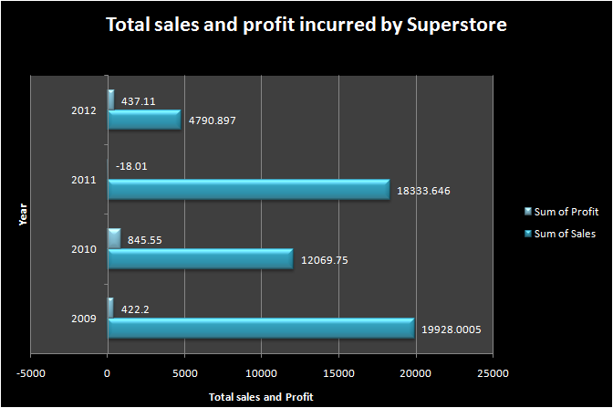
Figure 1: Graphical representation of the total sales and profit incurred by the superstore
(Source: Learner)
Figure 1, compares the total sales and the profit incurred by the superstore for the years 2009, 2010, 2011 and 2012. To present the data, the figure uses the bar graph. Bar graphs can be considered as one of the graphical data analytic tools for processing and presenting the data. The data presentation indicates some of the business insights about the various. The presentation identifies the fact that the highest sales incurred by the business was in the year 2009 and the highest number of profits incurred by the business was during the year 2010.

Demonstration of the use of the various data processing functions provided by Microsoft Excel

Microsoft Excel can be considered as one of the most widely used applications for various data processing activities. The application offers various tools which allow businesses to track and monitor their databases.
The use of the various data analysis software allows the businesses to track and monitor the database of the businesses. This allows the businesses to take the data-driven decisions of the business (David, 2017).
Various tools allow businesses to efficiently handle their data and monitor their progress in the achievements of organisational goals. Some of the data analytics tools include the use of IF, LOOKUP functions, pivot tables and the use of data visualisation tools. These data visualisation tools include the use of graphs and charts (David, 2017).
The various tools and functions of the data analytic applications are discussed below in an effective manner. Furthermore, the following section includes the steps to make use of the various BI or data processing tools used by the businesses.

IF function

The first data analytic function considered by the report includes the IF function. The function provided by Ms Excel allows the businesses to compare the value of a specific data variable with the expected values in a specific database. Therefore, the results derived from the use of the IF function can have more than one output. This allows the data handling process to identify the various changes in the data variables that were not expected to happen. This can be considered as one of the major data processing tools which allow businesses to derive outputs from the various databases more quickly and conveniently. To enter the IF function in MS Excel, there are specific algorithms that must be conducted.
The three steps or algorithms for using the IF function in Ms Excel are as follows.
Step 1: Select a specific cell with the desired value to be tested. Enter the formula with the correct syntax for the IF function and thereby test the satisfaction of the criteria.
Step 2: Input the specific condition, if the checked value satisfies the entered condition.
Step 3: Enter the specific output that must be shown if the checked value does not satisfy the considered condition.
To enter the If function in Ms Excel the following syntax must be followed by the user while entering the specific formula.
= “IF(A2>B2,"Over Budget","NOT OK")”
= “IF(A2=B2,B4-A4," Under budget", “OK”)”
Where A2 and B2 are the range of cells that contain the data to be checked.

LOOKUP function

The second data analytic function considered by the report includes the LOOKUP function. The LOOKUP function can be defined as the data analytic function which allows users to search for specific data from a considered database. This reduces the inconvenience of the users since theory does not have to search for pacific values from the various data sets. The LOOKUP function can be considered as one of the most common data processing tools used by businesses. The data processing tool allows the researchers to search for data with specific values from large databases. This reduces the troubles faced by businesses in their data processing activities. Different from the FIND function n offered by Ms Excel, the lookup function searches for data in a specific position of a different row or column.

FIND function

The third data analytic tool considered by the report includes the Find function provided by Ms Excel. Find Function can be considered as the data analytic tool which allows the researchers to find specific data from the entire interface of a specific database (David, 2017). Similar to the LOOKUP function offered by Microsoft, the FIND tool increases the ease of the users in processing their entered data. Since the use of the specific data analysis tools allows the researcher to derive the specific value from large databases and thereby use the values with the data processing activities.

Pivot table

Data analytic tool which allows the users to search for similar trends in data variables can be defined as a pivot table (David, 2017). Accessibility of using the pivot table is offered in both SPSS and Ms Excel. The pivot table allows the businesses to identify similar trends in the data. This allows businesses to make their data-driven business decisions. Microsoft Excel Can be considered as an analytic application used by most modern businesses to store and process their business-related data. The interface of the Excel offers accessibility to use Pivot tables. The use of pivot tables allows the users to analyse, summarise, organise, categorise and present similar data trends in an organisation.

Choice Of data analytic tool for the following report.

To highlight the results of the data processing conducted over the database for the patients of the smile clinic, the report aims to incorporate the use of pivot tables to highlight the various findings from the data. The use of pivot tables offers various advantages to the researcher. Following are the various advantages that are offered by the use of pivot tables in research.
- The use of pivot tables can be considered as one of the most common data processing tools used by researchers since it is easy to use. Moreover, the results of the data processing are presented effectively and quickly.
- The Use Of pivot tables offers high flexibility to the researchers since they allow the researchers to identify the various similar trends in the considered data variables.
- The use of pivot tables can be considered one of the most appropriate and efficient ways of summarizing various data considerations and thereby presenting them in appealing and understandable ways.
- The use of pivot tables can be considered as one of the most optimal ways of constructing a report.
The above-mentioned reasons can be considered as primary causes for incorporating the use of pivot tables to present the data for the customer base of the Smile clinic.
To access the use of pivot tables in the data analytic software known as Ms Excel, the following steps must be followed.
Step 1: Select the cell or the range of cells that contains the data for consideration.
Step 2: Click insert and then select pivot tables from the drop-down list that appears.
Step 3: Select the cells or the range of cells, where the table is to be entered. Pivot tables can be entered either in a new worksheet or the existing worksheet.

Part 2
Question 1
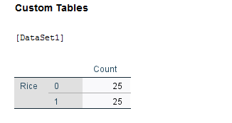
Figure 2 Total number of consumers of smile clinics under the habit of consuming rice.
(Source: Learner)

Figure 2, highlights the various characteristics of the rice consuming habits of the consumers. The pivot table highlights the fact that the count of individuals who are under the habit of consuming rice is 25. The table also highlights the customers of the smile clinic who do not possess the habit of not consuming rice also amounts to 25. However, the user predetermines the conditions fr deriving the output, the condition specifies the fact that the numeric value '1' represents ‘YES’. While the value of ‘0’ stands for ‘NO’.

Question 2
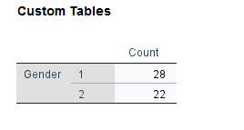
Figure 3: Gender of the patients of Smile clinic.
(Source: Learner)
Figure 3 identifies the gender of the consumers who visit the smile clinic. However, the user pre-specified the data which states that figure '1' stands for male and the value of '2' represents the number of females. The figure indicates the fact that 28 consumers of the clinic are male and 22 consumers of the clinic are female.

Question 3
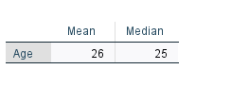
Figure 4: Mean and median of the patients of Smile clinic.
(Source: Learner)

Figure 4 identifies the mean median of the age of the participants. To derive the data, the data processing software named SPSS is used. The figure indicates that the mean age of the consumers is 26 and the median age of the consumers amounts to 25. Mean refers to the average and median can be referred to as the data variable which divides the two half of the variables. These factors are identified in figure 3.

Question 4
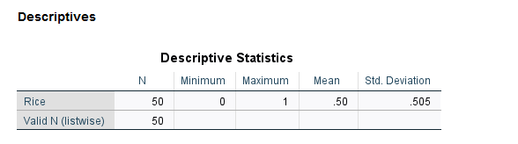
Figure 5: Descriptive statistics of the considered.
(Source: Learner)

Figure 5, identifies some of the statistical values in the context of the data set relating to the consumers of smile clinics. Figure 4 can be identified as the table which evaluates the elements of descriptive statistics for the consumers of the smile clinic. The figure identifies the mean of the consumers who are under the habit of consuming rice. The mean amounts to 0.50 and the standard deviation of the consumers under the habit of consuming rice amounts to 0.505.

Graph
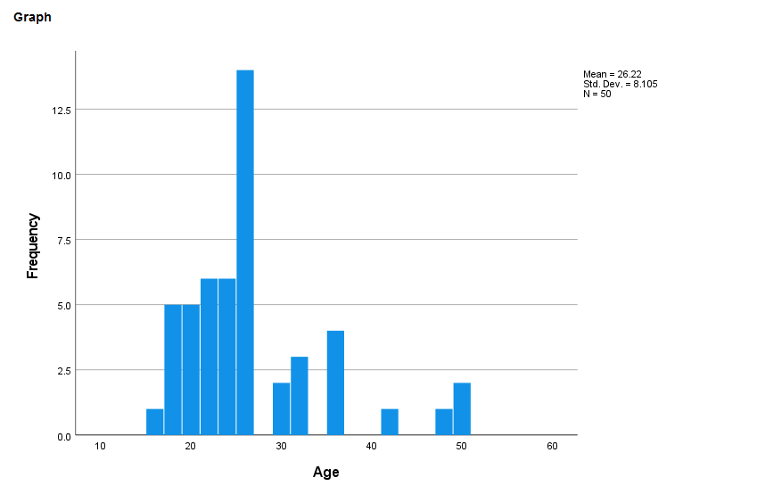
Figure 6: graphical representation of the findings
(Source: Learner)

Figure 6 highlights the findings through a histogram. Histogram identifies the data of the consumers relating to the age and the frequency of the consumers who are under the habit of consuming rice. The X-axis of the diagram measures the age of the consumers while the Y-axis measures the frequency distribution for the specific ages of the consumers.

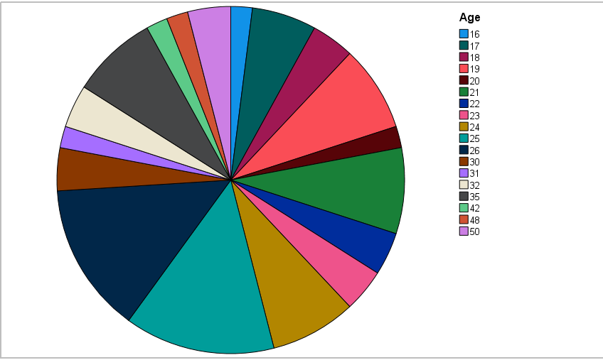
Figure 7: graphical representation of the age
(Source: Learner)

Figure 7 highlights and presents the data in the context of the age of the consumers who visit the smile clinic. To present the data effectively, the report uses a pie chart. An index on the right-hand side of the chart identifies the respective colour for the ages of the patients of the clinic.

Clustering using SPSS
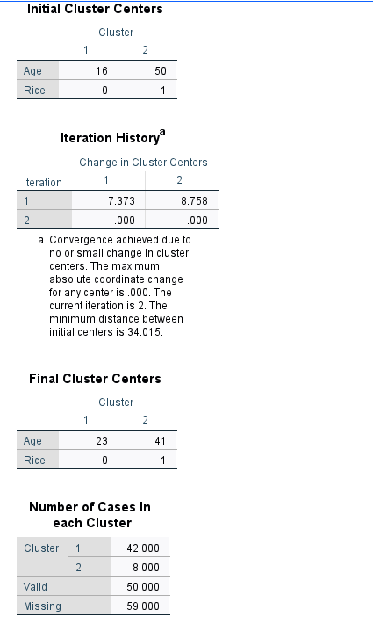
Figure 6: Example of data clustering.
(Source: Learner)

Figure 6, identifies the example of data clustering which identifies some of the common trends between the various data variables. The following cluster considers the variable ‘Age’ and the habit of eating rice. The figure identifies the common link between the two considered variables and presents the pivot table for the data clusters in the age and the rice consumption habits of the consumers.

The common data mining methods used by emerging businesses.

Text mining can be referred to as the field of study which allows businesses to process business-related data. The use of the various data analytic tools allows the business to identify the various patterns that can be seen in the various data sets. Following are the various data mining or text mining methods used by the various businesses.
Clustering:
The Data mining tools allow the businesses to properly visualise the data. The tool is used by the business to identify the various trends in the buying process and the various demographic information in the context of the sales incurred by the business (Agrawal and Agrawal, 2015). The use of the specific data analysis tool allows the businesses to group [the various variables which indicate similar or related trends. The insights derived from the clustering process
Association:
The tools which allow the businesses to identify the various correlation between the various data variables can be referred to as data variables (Injadat et al., 2016).
The use of association allows businesses to identify the various data-driven decisions in the context of determining the strategies that provide a competitive advantage for the firm. In other words, emerging businesses use the specific data mining process to make various data-driven decisions for marketing strategies. Furthermore, the mining tool also allows the business to measure the various demographic characteristics of the demographic relating to the sales incurred by them.
Data cleaning:
The third data analytic tool allows businesses to identify the various errors in the considered data set. The data mining method is termed data cleaning. The data analysis tool allows the business to prepare the data before initiating the process of processing them.
There have been various statistical reports which identify the impacts of data processing of the variables with the various errors present in them (Zhao, 2015). Processing the inaccurate data often results in inaccurate conclusions and therefore to remove the various errors in the databases, the companies use the text mining tools known as data cleaning. The mining tools prevent the businesses from evaluating faulty insights and thus make the wrong organisational decisions.

Advantages and disadvantages of the various data processing software
Advantages of Using MsExcel:
Ms Excel can be considered as one of the most common data processing tools used by modern businesses. Although there are various data processing tools, some businesses choose Ms excel over the other data processing software due to the following reasons.
- One of the major advantages of choosing Ms excel over the other data processing software lies in the fact that the application offers access to macros and a wide variety of templates for presenting the data.
- One of the major advantages of Ms Excel lies in the fact that the files which contain the analysis and presentation of the various business elements can be protected with a password. The application, therefore, offers scope to secure the database of the organisations.
- Microsoft Excel Offers the accessibility to use formulas which offers the scope of quick calculations to the users.

Disadvantages of using Using MsExcel
However, various disadvantages create resistances in the data processing activities.
- Learning the formulas and gathering complete knowledge about the interface of the software takes time. Individuals who do not possess good ICT skills might face resistance in processing data using Ms Excel.
- Some Functions require formulas to be entered with correct syntax. Learning To use all the formulas might take time for the user to be familiar with.

Advantages of using SPSS
- The major advantage of using SPSS is that it is considered as an effective "comprehensive statistical software" that consists of various functions as well as features. These functions and features contribute to simplifying various complicated statistical tests. The incorporation of SPSS is also beneficial for simplifying the overall interpretation of obtained results.
- Additional data can be imported from any other authentic sources, where the data is organised effectively within a database including Excel, spreadsheets, and many others.
- SPSS is also beneficial for checking the accuracy of the obtained data, representing the same in tabular form, hence, ensuring the simplified data analysis.
Disadvantages of using SPSS
The major disadvantage of SPSS is that it is very expensive. Moreover, additional training, skills, and knowledge are required for operating this software.

Conclusion

The report, therefore, identifies some of the major fundamental concepts about the various data processing activities conducted under the field of business intelligence. The report has been prepared into parts. The first part identifies the major data processing tools required by the emerging business to make data-driven decisions. Whereas the second part of the report identifies the basic mining methods and the tools that enable the businesses to search for trends in the databases.

Reference List

Agrawal, S. and Agrawal, J., 2015. Survey on anomaly detection using data mining techniques. Procedia Computer Science, 60, pp.708-713.

David, M., 2017. Statistics for managers, using Microsoft excel. Pearson Education India.

Injadat, M., Salo, F. and Nassif, A.B., 2016. Data mining techniques in social media: A survey. Neurocomputing, 214, pp.654-670.

Richards, G., Yeoh, W., Chong, A.Y.L. and Popovič, A., 2019. Business intelligence effectiveness and corporate performance management: an empirical analysis. Journal of Computer Information Systems, 59(2), pp.188-196.

Wieder, B. and Ossimitz, M.L., 2015. The impact of Business Intelligence on the quality of decision making–a mediation model. Procedia Computer Science, 64, pp.1163-1171.

Winston, W., 2016. Microsoft Excel data analysis and business modeling. Microsoft press.
Zhao, Y., 2015. Data mining techniques.".

Appendix

