Getting Started with Motec I2 Pro for the Load Distribution Exercise

Open Motec I2Pro

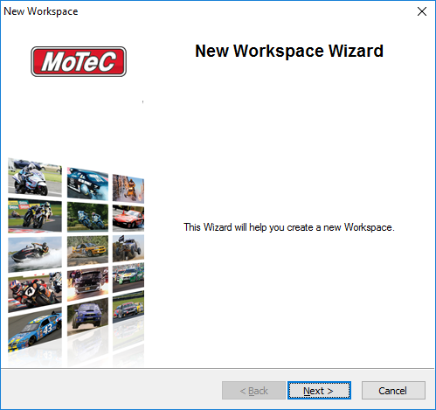

Create a new workspace

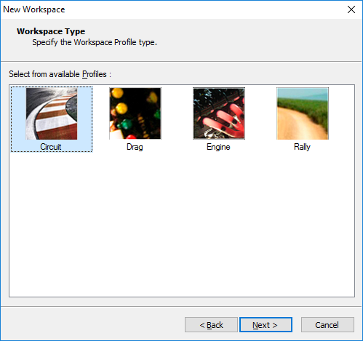

Call it Silverstone Quali

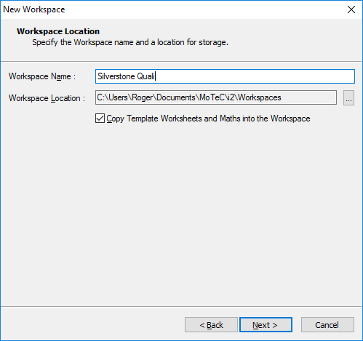
Finish

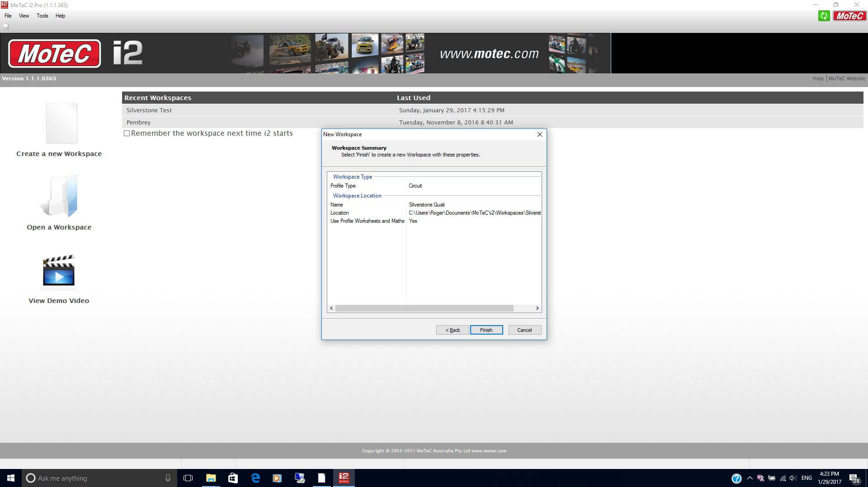
Add time distance graph

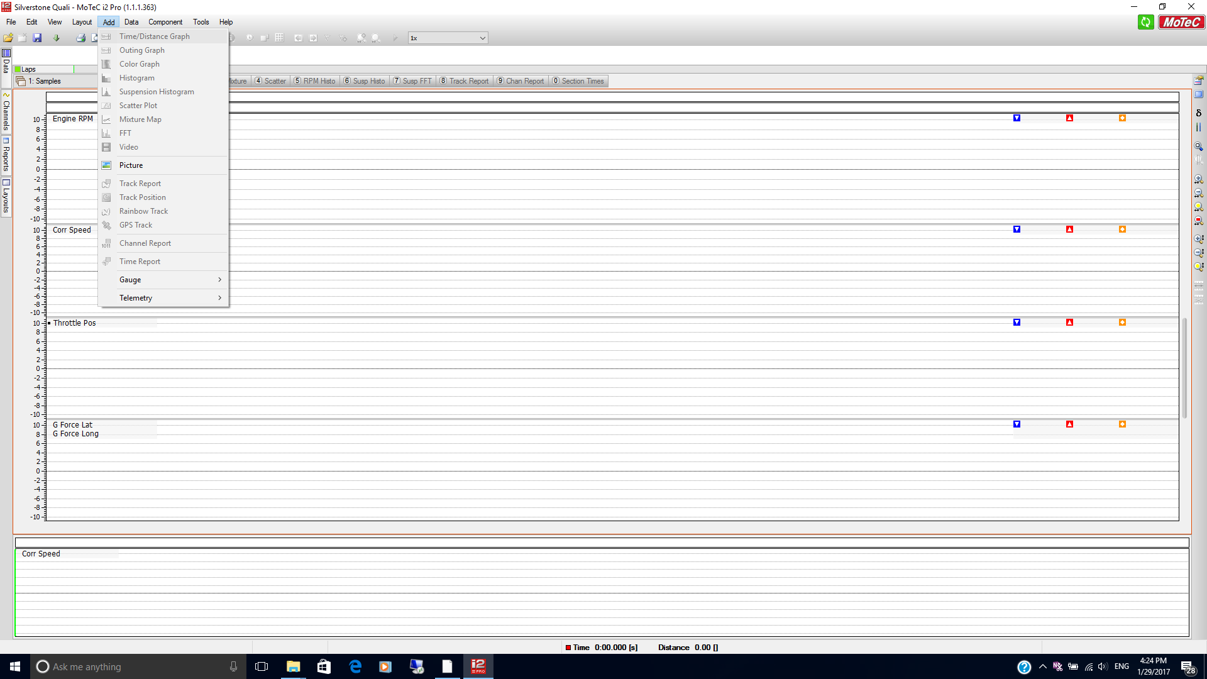
Select channels
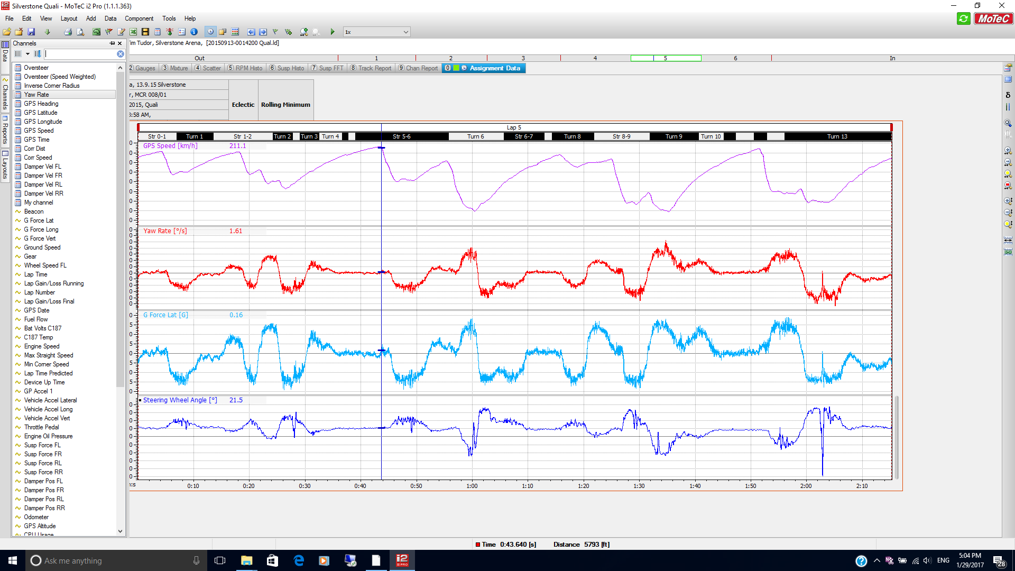

Show track

Find a steady state corner by looking at Lat acc, speed and yaw rate graphs
Turn 6 lap 1 looks good. (F8 Select Lap ) With fairly constant speed, yaw velocity and steering
Centre graph on centre of steady state cornering ( Put cursor at centre of section and then use the H key to centre graph)

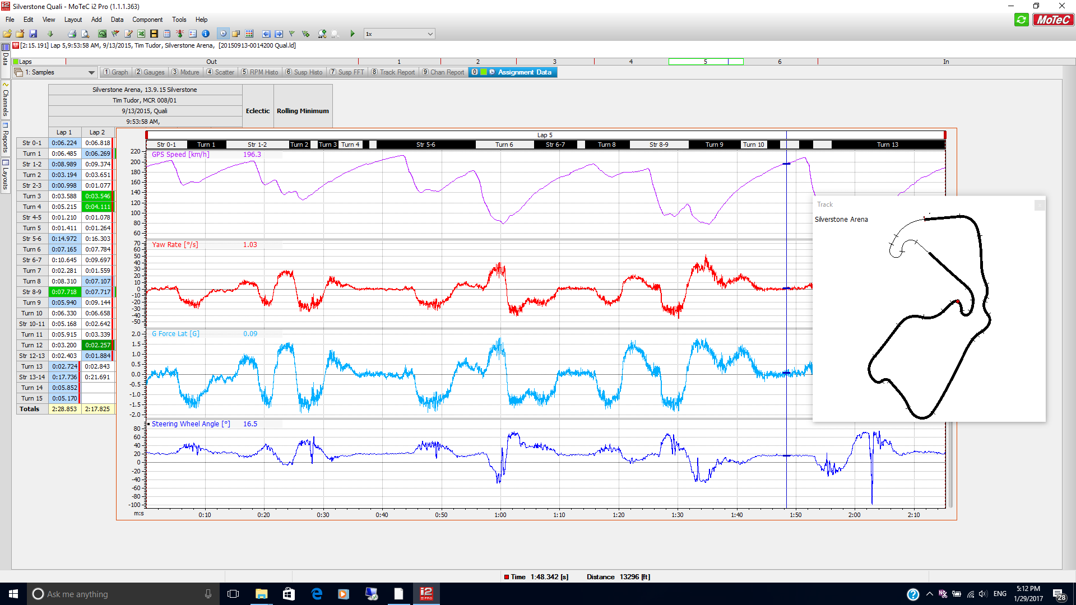

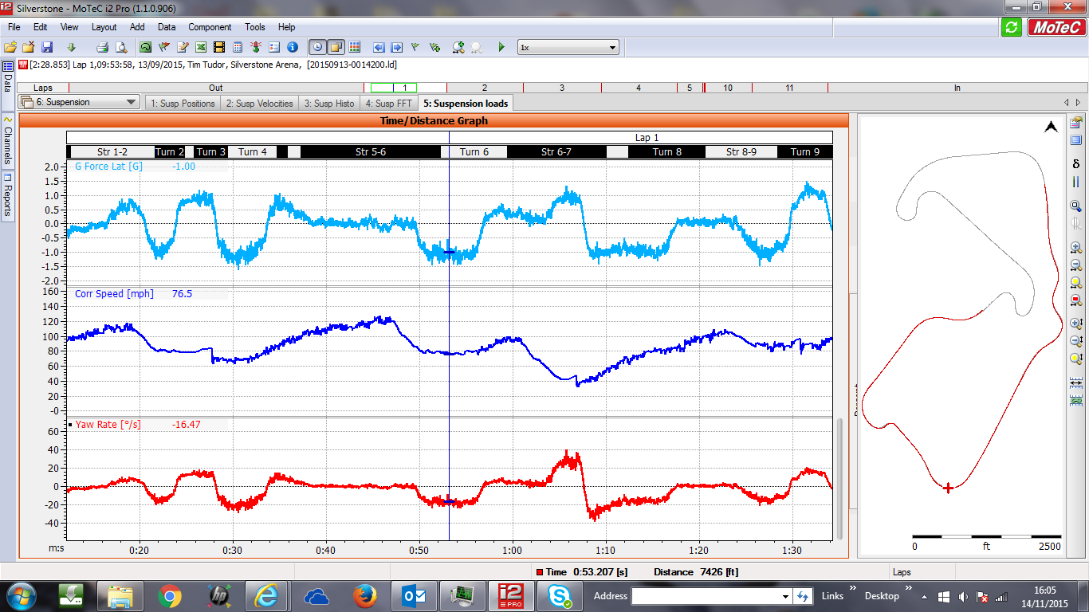

Right Click
Display Measurement to show channel values

Having found this section of track create new worksheet with Lat Acc and the four Suspension Loads on.

Find mean values from right click
Display
Show measurements
Max, Min and Mean values for the data on view are shown on the right for each channel.

Instantaneous values appear on the left next to the channel label

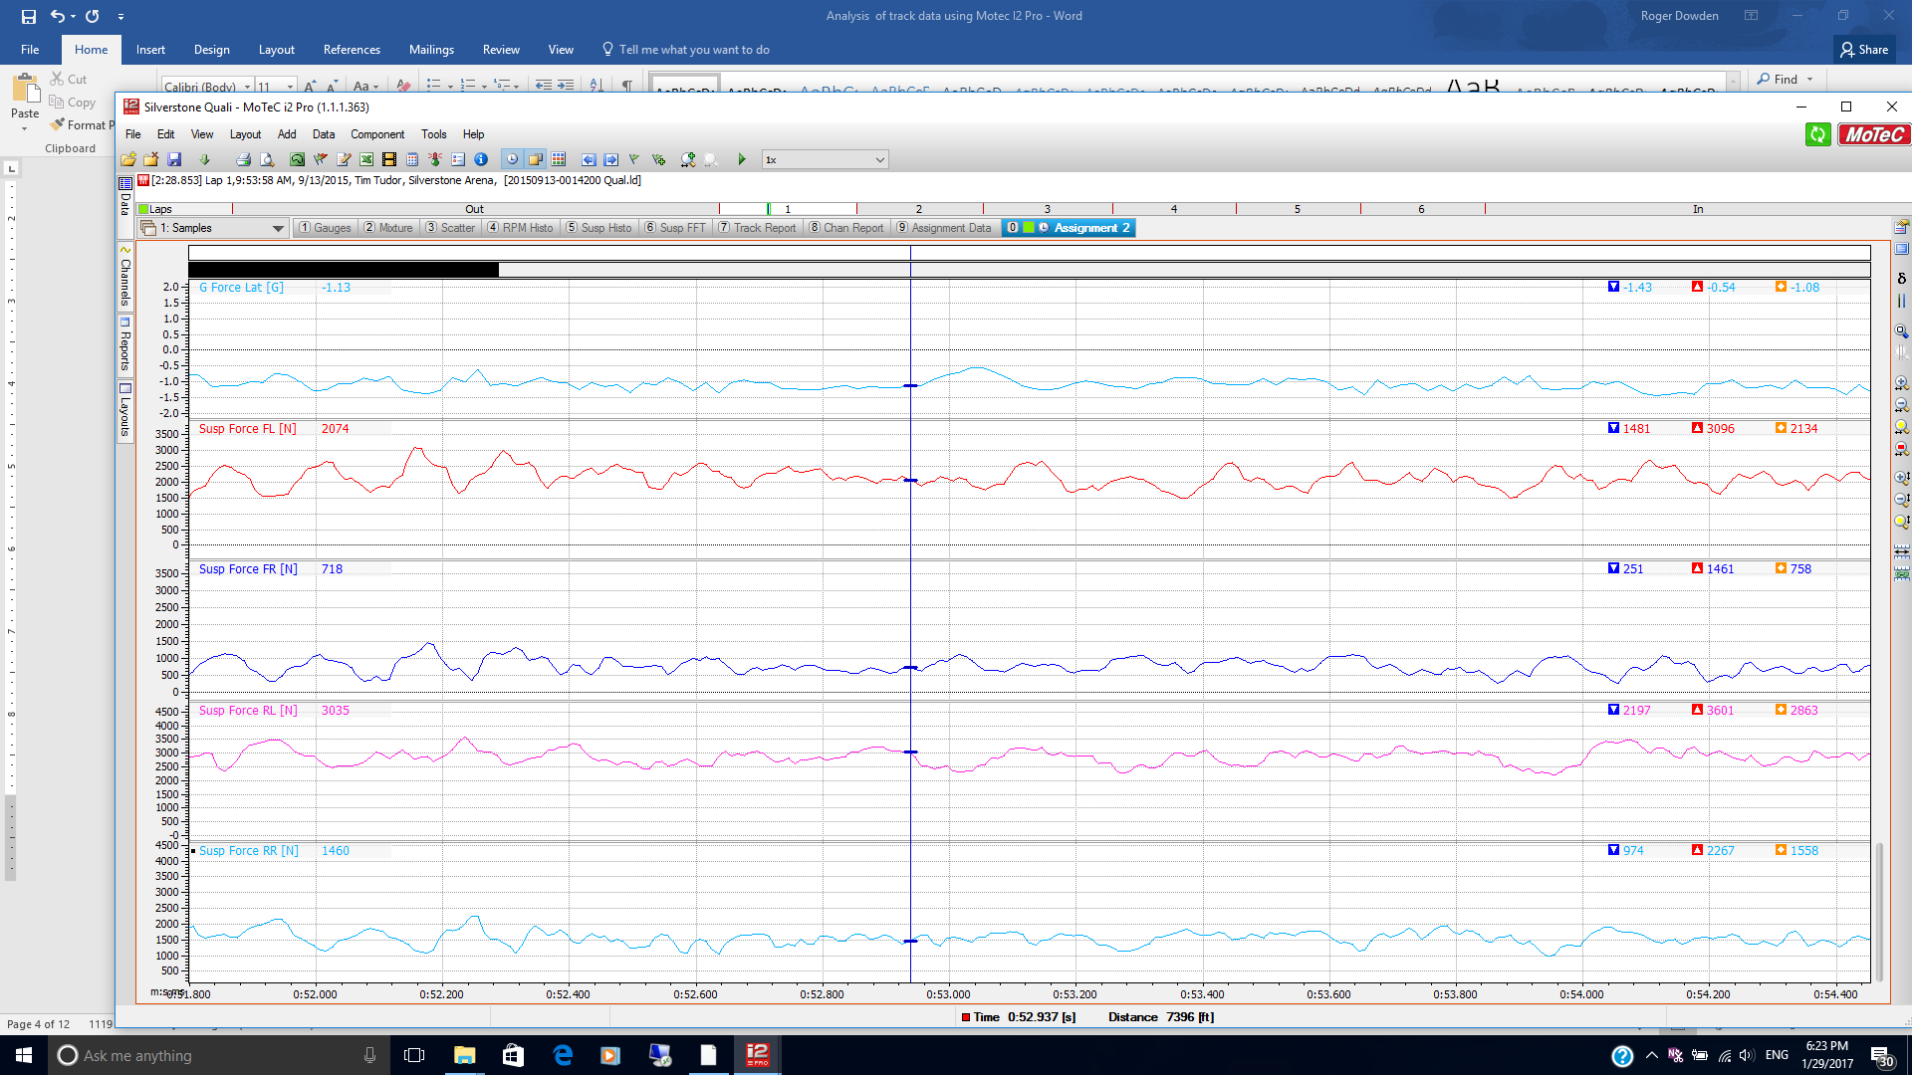

This is an interim stage to show where the values you are using have come from
Now Create Maths channels for Front Load Split, Rear Load Split and Front Rear Loads Split Difference
( FRLSD)

Creating Maths Channels
Go to:

Tools
Maths
Add Expression
Save the appropriate channel name

FLS
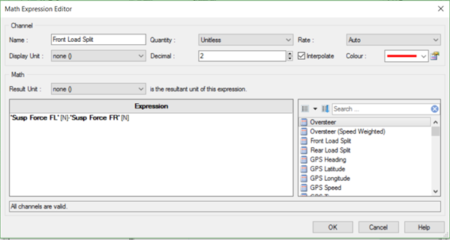

RLS
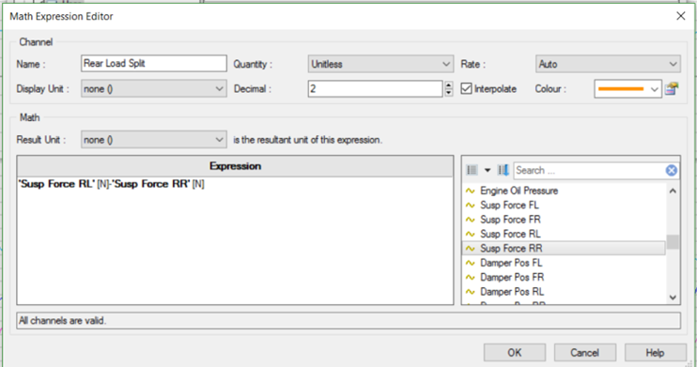

FRLSD
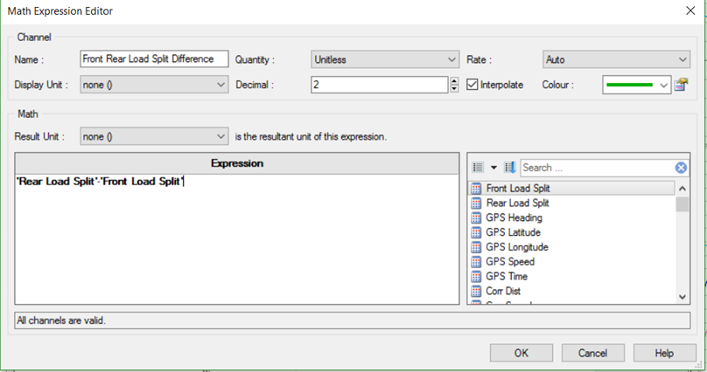

Display Maths Channels

Open a new worksheet and display your new channels
- Lat Acc
- Front Load Split
- Rear Load Split
- Front Rear Load Split Difference

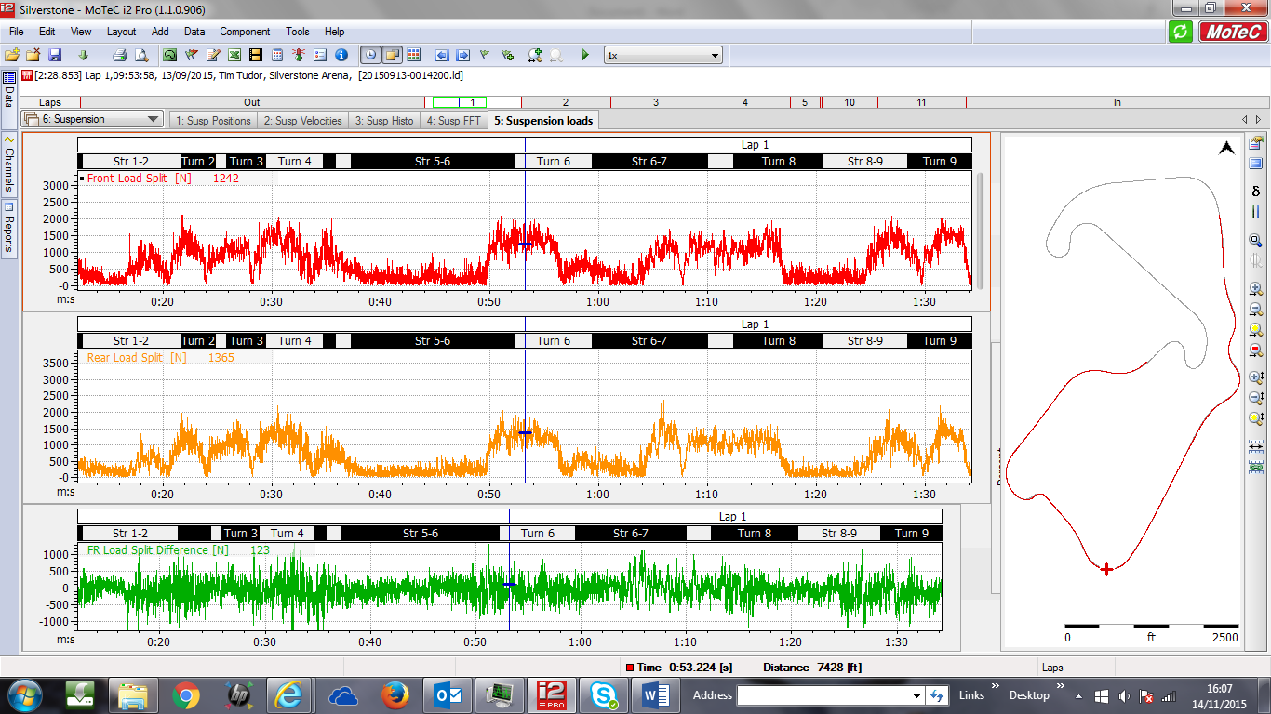

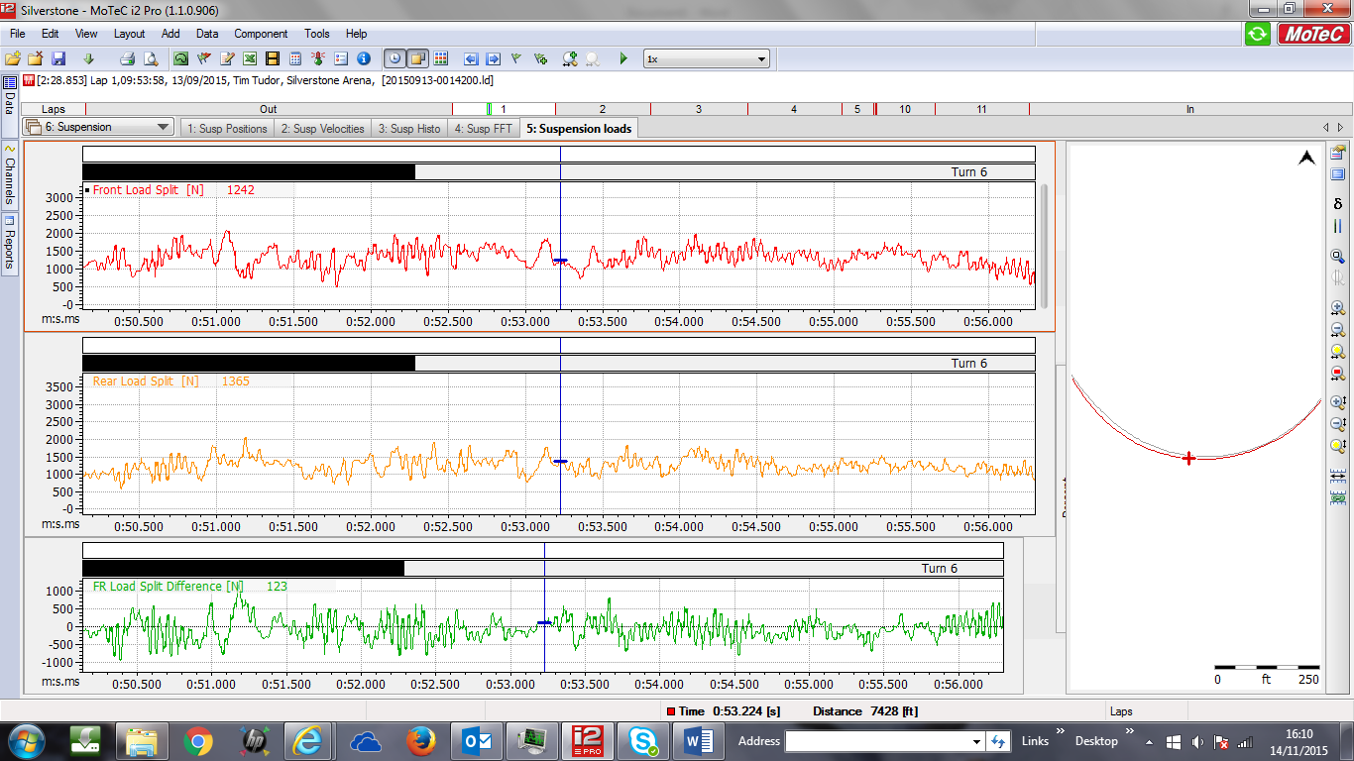

Zoom in (Up key) to highlight just the steady state cornering section

Find Instantaneous values at the cursor.

Find Average values across the length of the zoomed in test section

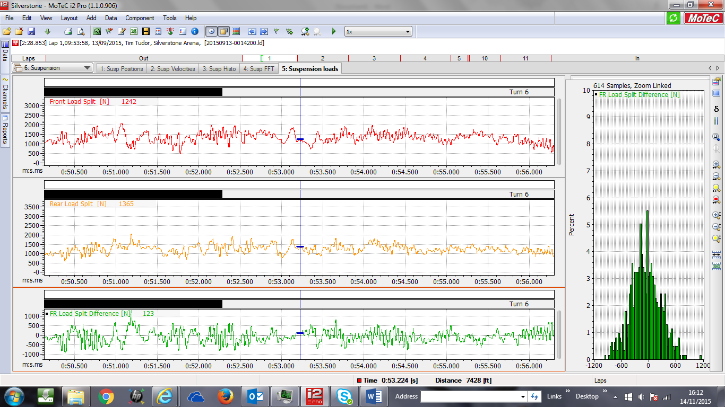

Insert a histogram of the FRLSD channel .

Note that the centre of the profile is to the left – ie negative side of the histogram. In this case the FRLSD equation was Rear Split – Front Split so this indicates that the car at this corner has a propensity for a greater load split at the front.
Does this match what you find with your spreadsheet for the same lateral acceleration?

Further work
Create a Maths channel of FRLSD – FRLSD by Calculation. It the results were accurate it should be zero. It won’t be but suggest reasons for the difference in results. Is it a fixed error or is the difference apparently random ?

Keyboard Shortcuts

The Most Important Keyboard Shortcuts

Views
F8 |  | Data window
C |  | Channel window
V |  | Values window off / on
ESC |  | De-focus the active window and return focus to the worksheet

Data
F4 |  | Overlays off / on
N |  | Next range (e.g. Lap)
P |  | Previous range (e.g. Lap)
F9 |  | Time / Distance mode toggle

Components
F5 |  | Component properties
TAB |  | Focus next component

Active Channel
PAGE UP, PAGE DOWN |  | Select active channel

Graph
LEFT / RIGHT ARROW |  | Cursor movement
CTRL + LEFT / RIGHT ARROW |  | Fast cursor movement
UP / DOWN ARROW |  | Horizontal zoom in / out
F2 |  | Horizontal zoom full out
W |  | Horizontal zoom to default (e.g. 1 Lap)
SHIFT + LEFT / RIGHT ARROW |  | Pan left / right
F3 |  | Variance off / on
E |  | Status and Errors off / on
G |  | Overlapped / Tiled

Windows
ALT+Letter | Activate a main menu item that has the letter underlined.  Or, if a dialog window is active, focus an item or activate a button with a label that has the letter underlined.
TAB | Move to the next item
SHIFT+TAB | Move to the previous item
ENTER | Activate the default button
ESC | Close or cancel an open window
ARROW Keys | Move up and down in a list  Select a dropdown item  Select an option button
SPACEBAR | Activate a button  Toggle a check box select/clear
CTRL+TAB | Next page on a tabbed window
SHIFT+CTRL+TAB | Previous page on a tabbed window

File
CTRL+O |  | Open log file
CTRL+A |  | Close all log files
CTRL+S |  | Save project
CTRL+F8 |  | Unload logged data

General
CTRL+P |  | Print worksheet
F1 |  | Help

Edit
CTRL+X | Cut component
CTRL+C | Copy component
CTRL+V | Paste component
DELETE | Delete component

Views
F8 | Data window
C | Channel window
V | Values window off / on
ESC | De-focus the active window and return focus to the worksheet

Data
F8 |  | Select Lap / Outing / Run (shows Data window)
F9 |  | Time / Distance mode toggle
F4 |  | Overlays off / on
J |  | Single colour for main (shows all channels in the same colour for the main data)
P |  | Previous range (e.g. Lap)
N |  | Next range (e.g. Lap)
CTRL+F |  | Select fastest lap in current file
Q |  | Swap Main and Overlay 0
F2 |  | Horizontal zoom full out
W |  | Horizontal zoom to default (e.g. 1 Lap)
A |  | Animate Start / Stop

Data Window
ENTER | Make the selected item Main
CTRL+ENTER | Make the selected item Overlay 0
ALT+ENTER | Make the selected item an Overlay

Layout
F7 | Select worksheet
CTRL+F7 | Activate Layout Manager
0..9 | Select corresponding worksheet
CTRL+0..9 | Select corresponding workbook
F11 | Previous worksheet
F12 | Next worksheet
CTRL+F11 | Previous workbook
CTRL+F12 | Next workbook

Tools
CTRL+D | Details editor
CTRL+E | Channel editor
CTRL+U | Channel status
CTRL+M | Maths editor
CTRL+T | Setup sheets

Active Channel
PgUP, PgDn | Select active channel
CTRL+H | Hide active channel
CTRL+Delete | Remove active channel
CTRL+SHIFT+M | Edit active channel maths (if maths channel)
CTRL+SHIFT+S | View active channel status (if maths channel)
CTRL+SHIFT+F | Filter active channel
CTRL+SHIFT+O | Scale and offset active channel
CTRL+SHIFT+Z | Zero at cursor active channel
CTRL+N | Properties of active channel

Components General
F5 | Component properties
Tab | Focus next component
SHIFT+Tab | Focus previous component
L | Channel legend off / on
K | Colour channel legend off / on
G | Cycle layout (Overlap / Tiled)
S | Cycle display style
ALT+0..9 | Corresponding colour band off / on
Delete | Delete selected component

GRAPH

Graph Display
E | Status and Errors off / on
F3 | Variance off / on
L | Show channel legend off / on
M | Show measurements off / on
G | Overlapped groups off / on
S | Toggle trace style

Graph Zoom
UP ARROW |  | Zoom in
DOWN ARROW |  | Zoom out
F2 |  | Zoom full out
W |  | Zoom to default (e.g. 1 Lap)
Z |  | Zoom to datum and main cursors
ALT+UP ARROW |  | Vertical zoom in
ALT DOWN ARROW |  | Vertical zoom out
ALT+F2 |  | Vertical zoom full out

Mouse
Double-click, move, click |  | Horizontal zoom
ALT + Double-click, move, click |  | Vertical zoom
CTRL + Double-click, move, click |  | Window zoom
Double-click on the horizontal scroll bar |  | Horizontal zoom full
Double-click on the vertical scroll bar |  | Vertical zoom full

Graph Pan

Keyboard
SHIFT + LEFT / RIGHT ARROW | Pan left / right
SHIFT + UP / DOWN ARROW | Pan up / down (if vertically zoomed)
F | Pan forward
B | Pan back
H | Centre on cursor

Mouse
Click + drag on the horizontal axis | Horizontal pan
Click + drag on the vertical axis | Vertical pan
Click + drag on the horizontal scroll bar | Horizontal pan
Click + drag on the vertical scroll bar | Vertical pan

Graph Cursor

Keyboard
LEFT / RIGHT ARROW | Cursor movement
CTRL + LEFT / RIGHT ARROW | Fast cursor movement
SHIFT+F7 | Place beacon at cursor (if Circuit Project)
 | Place run at cursor (if Drag Project)
 | Place stage at cursor (if Rally Project)
Y | Cursor style
HOME | Cursor to left of screen
END | Cursor to right of screen

Graph Datum Cursor

Keyboard
D | Datum cursor off / on
SPACEBAR | Place datum cursor
X | Swap datum and main cursor

Graph Alignment Offsetting

Keyboard
O | Offsetting axis off / on
CTRL+SHIFT+ARROW | Offset the main lap (offset axis must be on)
ALT+SHIFT+ARROW | Offset the ref lap (offset axis must be on)

Mouse
Drag the main or ref offsetting axis

