Component 2 - Research Report
Student Name: Maria Mohamed Edosa
Student Number:2223484
Lecturer Name: Zeno Leung
LCHS4002_BIRM
Digital Skills and Research Methods

Table of Contents
1. Introduction 3
2. Research design 3
2.1 Research Question 3
2.2 Method 3
2.3 Ethical Considerations 4
3. Results 5
4. Discussion 5
5. Conclusion 7
Reference List 8
Appendix A – Survey questionnaire 9

1. Introduction
Digital skills are important for students as these skills enable them to utilise different technologies for their study, daily life as well as work. Digital skills are being used in various ways such as for using messaging applications, social media, document creation as well as online forums. Digital skills have become necessary for gaining knowledge from online sources by enhancing communication in global context and gaining information regarding current affairs (van Laar et al. 2019). Apart from concerned, incorporation of digital skills is also essential as these are required for professional development of students. Concerned research explores the confidence level of students towards utilisation of digital skills.
The outbreak of Covid-19 pandemic resulted in disruption in education procedures (Arënliu et al. 2021). However, digital learning methods helped in resuming learning process. This assisted both teachers as well as students from around world in educational process. Therefore, digital skills development has helped learners during Covid-19 pandemic period in improving skills. Learner by enabling digital skills within them has been able to continue their learning being confined in their homes. Thus, creating a major influence towards academic development and progress operation education management through digital learning has been developed.

2. Research design

2.1 Research Question
- Do students possess enough confidence for applying their digital skills?
It has been identified that admits COVID-19 pandemic situation, learners have been unable to abide with digital learning skills impacting their accede growth. Though, learners were aware regarding digital learning approaches, lack of guidance and effective technological implementation has been restriction learners in enhancing growth and development. Thus, it can be stated that because of these major challenges and issues application of digital skill has been restricted from the end of learners impacting their academic growth and development. In an overall aspect, it can be evaluated that by implying strategies learners might be able to enhance their skills and develop academic growth by implying digital learning skills.

2.2 Method
The concerned report is aimed at developing an understanding about confidence level of students for using digital skills. Positivism philosophy has been followed for doing following research and factual knowledge about digital skill usage confidence has been collected through observation of students. Collection of factual information according to positivism philosophy has allowed collection of relevant information about digital skills of students. Deductive approach of doing research has been followed for achieving goals of concerned research (Pandey and Pandey, 2021). According to current research approach, existing hypotheses of the internet being biggest setback towards digital education of students have been analysed. Along with concerned, hypothesis of requirement about guidance for students to utilise modern technologies associated with their study have also been explored in concerned research. Along with this, another hypothesis of Covid-19 impacting necessity of digital skills of students in fulfilling their learning requirements has also been developed in this research. These hypothesises would allow exploration of different aspects about importance of digital skills among students.
Primary research method has been incorporated in this research for collection of information directly from students. Information about confidence of students for implementation of digital skills has been collected through process of Survey. Direct involvement of students in survey procedure provided with an opportunity of gaining insights among students about their confidence of applying digital skills. Concerned survey has enabled collection of Primary Quantitative information about confidence level of students for using their digital skills. Quantitative information is useful for analysing a situation numerically and representing findings in a visual manner for better understanding of results (Leatherdale, 2019). A total of 21 students have been included in concerned survey procedure and they were provided with a survey questionnaire containing 6 closed ended questions. Closed-ended questions are useful for directing findings of a research towards a specific path for meeting its objectives.
These questions have been developed in a manner to gain insights about digital skills possessed by students as well as awareness about importance of digital skills among them. Apart from this, confidence level of students for applying digital skills has also been enquired through these questions. Participants for survey have been selected through simple random sampling to avoid the presence of any bias in collected information for concerned research. Bias such as similar issues faced by students of a single educational institution have been avoided for enhancing extent of this research and improving accuracy of results. Information provided through students has been analysed for understanding their confidence for utilising digital skills.

2.3 Ethical Considerations
Some ethical considerations have been maintained for doing concerned research and avoiding any legal issues. Participants of concerned research have not been asked to answer any question that is radical in nature. Along with concern, incorporation of a forceful approach has been avoided for making participants take part in concerned survey procedures. It has been ensured that the opinions of students for any questions included in concerned survey is respected and are not criticised. Principles included under “Data Protection Act 2018 (c.12)” have been followed. This is for restricting unethical usage of personal information of participants (legislation.gov.uk, 2023). Personal information such as name or age of participants have been recorded however, disclosure of any personal information has been avoided.

3. Results
[Refer to Appendix A]
Participants of survey were asked about involvement of their teacher in providing them with digital skills. Among 21 students 52% students stated that their teachers are associated with providing them digital education. On the contrary, 24% participants opined that their teachers do not focus on providing them digital education. Remaining 24% of students were not sure about the role of their teachers in providing them digital education. This question is important for analysing level of involvement of teachers in digital skill enhancement of students.
Opinion of participants about importance of digital skills has been asked in second question of this survey. Among 21 participants 71% were confident about importance of digital skills in their education and 10% were confident that it is not important. Along with this, 19% of students were not sure about importance of digital skills for their education.
Participants were asked about usage of digital technologies in their education in the third question of survey. About 81% participants said that they utilise digital technologies such as online databases for collection of information and online messengers for sharing information. However, 14% of these participants were not sure about their usage of digital technologies for educational purposes. Remaining 5% of students opined that they do not use digital technologies for educational purposes and prefer offline mode of education such as reading books.

4. Discussion
Digital skills have become important for learning procedure of students from around world due to its benefits such as availability of online databases and efficient sharing opportunities. Importance's of digital skills have been significantly highlighted due to requirement of digital learning tools after outbreak of Covid-19 pandemic (Maity et al. 2021). Apart from this, digitisation of every industry and organisational activities is also resulting in requirement of digital technology handling ability requirement among professionals. These digital skills such as ICT skills are developed by students through gathering knowledge about these skills and their practical application. Survey questionnaire included 6 different questions aimed at identification of their confidence level for using digital skills.
Survey conducted in this research included involvement of 21 students from various universities for analysing confidence level among students for their digital skills. According to results of this survey, majority of participants stated that their teachers take steps towards fulfilment of student’s digital skill requirements. However, some students said that necessary steps for developing their digital skills are not being taken by their teachers. This signifies that teachers are required to improve their efforts towards development of digital skills among students.
Awareness among students is also required to be analysed about importance of digital skills in their education. Therefore, a question about this has been asked in the survey to evaluate the impact thoroughly. Majority of participants were positive that digital skills are very important for improving scopes of education. However, negative opinions about importance of digital education as well as participants being not sure about role of digital skills in education signify lack of awareness about it. Proper awareness about role of digital skills in learning procedure of students is, therefore, required to be developed for improvement of digital skill level among students (Mehrvarz et al. 2021).
Findings of this survey process signify that majority of students are associated with usage of digital technologies for their education. However, some participants stated that digital skills are not necessary for their education and some of them did not have any specific opinion about it. This is due to lack of guidance among these students about benefits of digital skills. Therefore, teachers at universities of these students are required to guide them towards benefits of digital skills in education.
Mixed views were represented about confidence of digital skill level among participants. Some of them were confident about it and some of them were either not sure or less confident about it. Therefore, their teachers are required to help them in identifying their digital skill level through tests and providing feedback (Amhag et al. 2019). Digital skills also played a crucial role during Covid-19 outbreak and opinions of students have been asked about it. Almost every participant agreed about digital skills helping them in continuing learning during pandemic period. Along with this, participants were also asked about their digital skills being sufficient or not for professional development. Majority of participants were either not sure about it or thought that they did not possess necessary digital skills. This lack of skill management might create major deficit in career development and enhancement of professionalism. Therefore, teachers at their respective universities are required to guide them towards analyse their digital skill levels and improve according to professional requirements. This will aid them in meeting their career goals as successful professionals.
Self-awareness among students about their digital skills is important for filling any gap present within their digital skills (Skantz-Åberg et al. 2022). Therefore, confidence level of participants about their digital skills aiding them in digital learning has been asked through question 4 of this survey procedure. Students provided mixed opinions about level of their digital skills being efficient enough for educational purposes. About 52% were confident about their digital skills being helpful in digital education along with 5% being not sure about their digital skills. However, 43% of students opined that they are somewhat confident about their digital skills and require further improvement.

5. Conclusion
As analysed from the conducted survey, digital skills possessed by students are also important for their professional development along with their digital learning. These skills aid in fulfilment of their professional duties and achieve professional goals. Therefore, opinions of participants about digital skills possessed by them being helpful in their professional development have also been asked in this survey. Majority of participants, 48% of participants, thought that their digital skills were not efficient enough for professional development. However, it is analysed from obtained survey responses that 43% participants thought they possessed efficiency in digital skills which are necessary for professional development. About 9% participants were not sure about their digital skills and their role in professional development.
Confidence level of students about usage of their digital skills in a proper manner have been analysed in this research. It has been identified that students possess mixed opinions about it and many students do not have confirmation about it. On the other hand, the necessity of teachers to improve their efforts towards enhancement of digital skills among students has also been identified. These strategies will aid students in improving their confidence for employing their digital skills. On the other hand, guidance of teachers would be helpful in development of necessary skills required for performing professional duties by students. Therefore, it can be concluded that this research can be useful for students towards their educational as well as professional improvement.

Reference List
Amhag, L., Hellström, L. and Stigmar, M., (2019). Teacher educators' use of digital tools and needs for digital competence in higher education. Journal of Digital Learning in Teacher Education, 35(4), pp.203-220.
Arënliu, A., Bërxulli, D., Perolli-Shehu, B., Krasniqi, B., Gola, A. and Hyseni, F., (2021). Anxiety and depression among Kosovar university students during the initial phase of outbreak and lockdown of COVID-19 pandemic. Health Psychology and Behavioral Medicine, 9(1), pp.239-250.
Leatherdale, S.T., (2019). Natural experiment methodology for research: a review of how different methods can support real-world research. International Journal of Social Research Methodology, 22(1), pp.19-35.
legislation.gov.uk (2023). Data Protection Act 2018. Available at:https://www.legislation.gov.uk/ukpga/2018/12/contents/enacted[Accessed on:23/2/2023]
Maity, S., Sahu, T.N. and Sen, N., (2021). Panoramic view of digital education in COVID‐19: A new explored avenue. Review of Education, 9(2), pp.405-423.
Mehrvarz, M., Heidari, E., Farrokhnia, M. and Noroozi, O., (2021). The mediating role of digital informal learning in the relationship between students' digital competence and their academic performance. Computers & Education, 167, p.104184.
Pandey, P. and Pandey, M.M., (2021). Research methodology tools and techniques. Bridge Center.
Skantz-Åberg, E., Lantz-Andersson, A., Lundin, M. and Williams, P., (2022). Teachers’ professional digital competence: an overview of conceptualisations in the literature. Cogent Education, 9(1), p.2063224.
van Laar, E., van Deursen, A.J., van Dijk, J.A. and de Haan, J., (2019). Determinants of 21st-century digital skills: A large-scale survey among working professionals. Computers in human behavior, 100, pp.93-104.

Appendix A – Survey questionnaire
Question 1: Do your teachers help you in acquiring digital skills?
Options | Responses | Percentage
Yes | 11 | 52
No | 5 | 24
Not sure | 5 | 24
Total Respondents= 21 |  | 100%
Table 1: Question 1

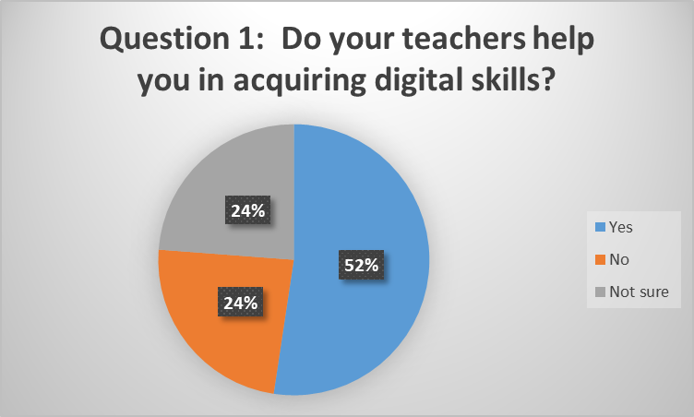
Figure 1: Responses of Question 1

Question 2: Do you think digital skills are important for your education?
Options | Responses | Percentage
Of course, | 15 | 71
Definitely not | 2 | 10
Not sure | 4 | 19
Total Respondents= 21 |  | 100%
Table 2: Question 2

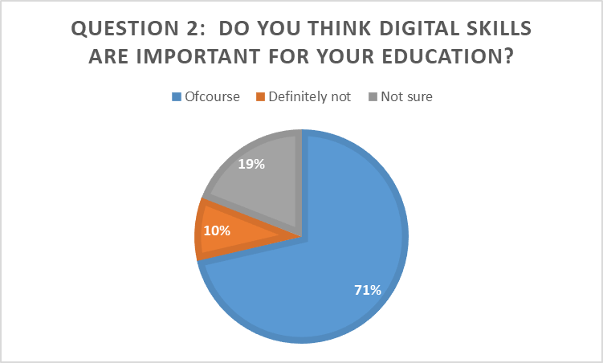
Figure 2: Responses of Question 2

Question 3: Do you use digital technologies for your education?
Options | Responses | Percentage
Definitely | 17 | 81
Not necessary | 1 | 5
Does not have specific opinion | 3 | 14
Total Respondents= 21 |  | 100%
Table 3: Question 3

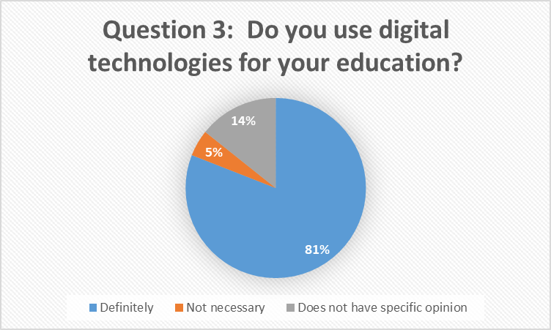
Figure 3: Responses of Question 3

Question 4: Are you confident that your digital skills can benefit you in digital learning?
Options | Responses | Percentage
Very Confident | 11 | 52
Somewhat confident | 9 | 43
Not sure | 1 | 5
Total Respondents= 21 |  | 100%
Table 4: Question 4

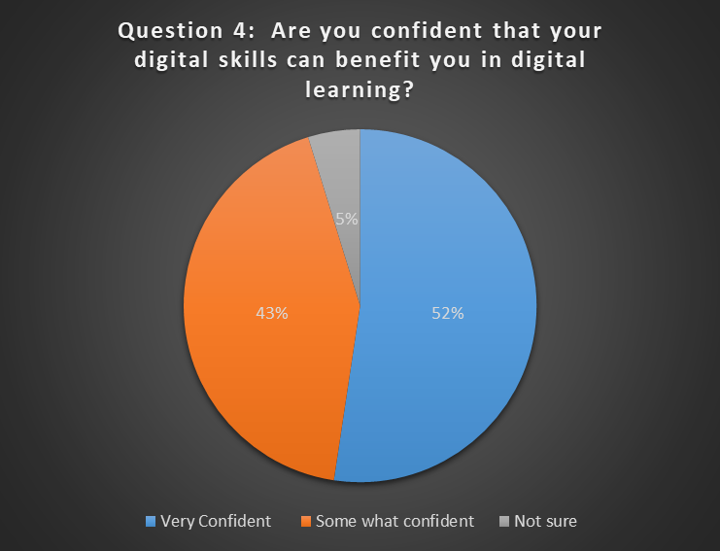
Figure 4: Responses of Question 4

Question 5: Did your digital skills help you during Covid-19 outbreak in your learning?
Options | Responses | Percentage
Yes | 20 | 95
No | 1 | 5
Not sure | 0 | 0
Total Respondents= 21 |  | 100%
Table 5: Question 5

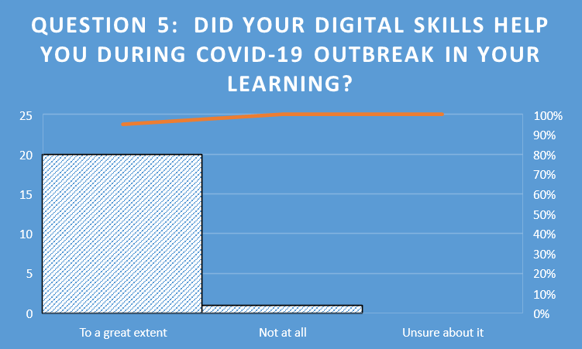
Figure 5: Responses of Question 5

Question 6: Do you think that your digital skills are sufficient for your professional development?
Options | Responses | Percentage
Absolutely | 9 | 43
Not really | 10 | 47
Not sure | 2 | 10
Total Respondents= 21 |  | 100%
Table 6: Question 6

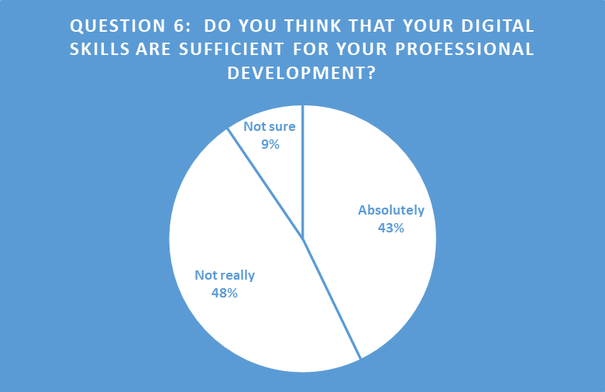
Figure 6: Responses of Question 6

