Assignment One – Thinkpiece

Global Inequality

Introduction

Inequality when it comes to society can be defined as unequal distribution of resources or privileges among people. The Oxford Learner’s Dictionary defines inequality as ‘the unfair difference between groups of people in society, when some have more wealth, status or opportunities than others’. Much of this is due to various systems implemented, prejudice, cultural norms and practices by institutes. Inequality within societies is not new whatsoever and can be traced in almost every civilisation. Inequality is not just nation specific however and happens on a global scale. Oxfam America describes global inequality
‘Global inequality is the unequal distribution of resources, opportunities, and power that shape well-being among the 8 billion individuals on our planet. Distinct from inequality within a country or between countries, global inequality is one way of understanding the different lived experiences of our fellow humans, no matter where they live.’
There are many ways in which inequality happens. Income equality is perhaps the biggest one. This is when income is distributed unevenly in a population of people. In the United Kingdom, income inequality is higher in the 2020s than it was in the 1960s/70s.
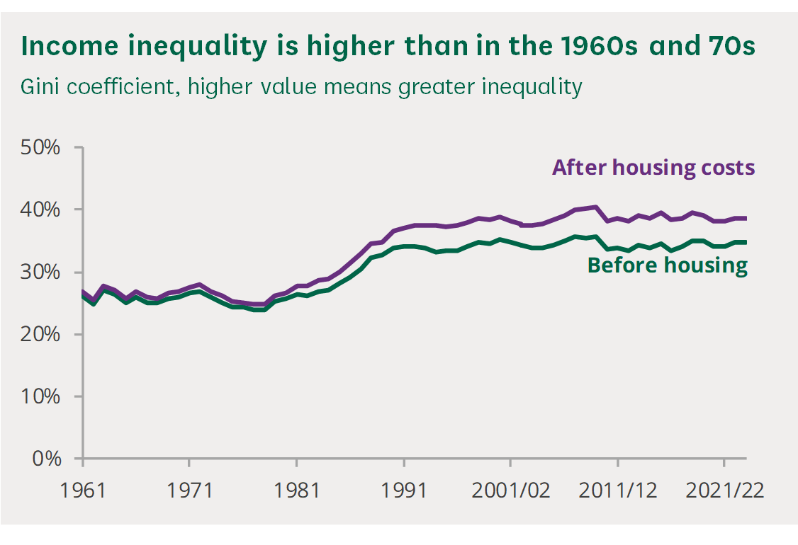
This can be attributed to a post-industrial economy, weakened unions, tax reforms, cuts to welfare programs and outsourcing of jobs/industry.
In this think piece, I will give my thoughts on global inequality, show examples of it and possible ways to lessen the gap in order to make a more equal world.

Main Paragraphs
There are many ways in which someone can be inequal. For example, throughout history minority groups have been oppressed, stripped of rights and by consequence, are unequal. During the late 19th and early to mid 20th century, the Southern United States introduced what was known as the Jim Crow laws. It was a racial caste system (a social structure with a hierarchy that divides people into groups) aimed to oppress African Americans. They became second class citizens and ‘represented the legitimization of anti-black racism’. White people were believed to be superior due to many reasons. As the south was a deeply Christian area, priests and religious folk taught that white people were chosen and biologically “better”.
An example of this oppression can be seen in the case of people of colour being forced to sit at the back of public transport and give up their seats for white people. Racial inequality is a lot better in the modern western world in comparison. Laws have been passed to give rights and opportunities to people of colour that they may not have had access to before. Racism however is taught and is used to justify harmful views and further the self interest of people with dangerous views. As of 2025, the president of the United States of America is Donald Trump who has been known to play towards people who hold discriminatory or racist views. While I am not confident in saying he is inherently racist, his treatment of immigrants in the United States have been less than friendly.
There is an ideology known as communism which aims to eliminate the idea of class. Production is owned communally, and goods are given out dependant on need rather than want. Karl Marx (who was an influential figure in the communist world) gave the world Marxism. The ultimate goal for Marxism was that there would be no need for money, wages or private property. By this logic, there would be no pay inequality due to the fact there is no pay whatsoever. However, this was rarely employed by communist/socialist countries. Many socialist countries (Soviet Union, Cuba and China under Mao) were socialist with the aim of becoming communist. Pay and wages did exist in these countries and were paid much like in a capitalist system, but the gap would be a lot smaller. For example, an engineer would earn more than a factory worker or handyman, but the gap would be considerably smaller. While this may sound fairer and more equal on paper, in practice this has many drawbacks and I believe that a system like this should be avoided when it comes to generating equality. If a brain surgeon and a sweeper earn amounts that are nearly similar there may be a lack of people aiming to study and learn for complicated jobs if they can just get by doing something that requires lower amounts of effort. This would affect productivity and could cause chaos within a nation. Many workers in the soviet union became demoralised due to the fact that pay wasn’t different enough and there wasn’t a lot of opportunity for other careers.
Fixed systems generally lead to corruption, whether it be a capitalist, communist or socialist. If wages were a state controlled thing, people would need to rely on connections and “loyalty” rather than hard work and merit. In the USSR, corruption was rife in the housing sector which inevitably lead to a shortage as people in higher places were able to gain properties.
‘EXAMPLES OF CORRUPTION IN THE HOUSING SECTOR ILLUSTRATE THE TENDENCY OF PUBLIC OFFICIALS TO USE ILLEGAL MEANS TO ACQUIRE HOUSING IN A NATION WITH A SERIOUS SHORTAGE’

Conclusion
In conclusion, this essay has highlighted two systematic forms of inequality (whether intentional or not), given examples of what they do and some critiques against them. I do believe that we should aim for a more equal society, and I do acknowledge that having everyone equal is nearly impossible due to certain beliefs or systems. Governmental systems can accidentally or purposefully create or destroy equality around the world. However, equality in the western world is a lot better than it was several decades ago.

Bibliography
Francis-Devine, Brigid, ‘Income Inequality in the UK’, UK Parliament Research Briefing, https://commonslibrary.parliament.uk/research-briefings/cbp-7484/ [accessed 14 June 2025].
Kramer, J. M., ‘Political Corruption in the USSR (Union of Soviet Socialist Republics)’, National Criminal Justice Reference Service, https://www.ojp.gov/ncjrs/virtual-library/abstracts/political-corruption-ussr-union-soviet-socialist-republics [accessed 16 June 2025].
Oxford Learner’s Dictionary, ‘Inequality’, Oxford Learner’s Dictionaries, https://www.oxfordlearnersdictionaries.com/definition/english/inequality [accessed 14 June 2025].
Oxfam America, ‘What is Global Inequality?’, Oxfam America, https://www.oxfamamerica.org/explore/stories/what-is-global-inequality/ [accessed 14 June 2025].
Pilgrim, Dr. David, ‘What Was Jim Crow?’, Jim Crow Museum of Racist Memorabilia, https://jimcrowmuseum.ferris.edu/what.htm [accessed 15 June 2025].

Oxford Learner’s Dictionary, Inequality, https://www.oxfordlearnersdictionaries.com/definition/english/inequality (Accessed 14/06/2025)
Oxfam America, What is global inequality?, https://www.oxfamamerica.org/explore/stories/what-is-global-inequality/ (Accessed 14/06/2025)
Brigid Francis-Devine, Income inequality in the UK, https://commonslibrary.parliament.uk/research-briefings/cbp-7484/ (Accessed 14/06/2025)
Dr. David Pilgrim, What was Jim Crow, https://jimcrowmuseum.ferris.edu/what.htm, (Accessed 15/06/2025)
J M Kramer, POLITICAL CORRUPTION IN THE USSR (UNION OF SOVIET SOCIALIST REPUBLICS), https://www.ojp.gov/ncjrs/virtual-library/abstracts/political-corruption-ussr-union-soviet-socialist-republics, (Accessed 16/06/2025)

