What is coaching.
Coaching is a method of achieving set goals. The coach through dialogue helps the coachee (client) to correctly set a goal, to find the best way to achieve the goal and reveal hidden inner potential in a person. The coach does not say how to achieve success but asks questions through which the client himself finds the solution to his own tasks. The Cambridge dictionary defines the word "coaching" as "the job or activity of providing training for people or helping to prepare them for something". But the definition isn`t quite right because coaching is not training or preparation - it helps and supports on the way to achieving the goal. (What is a Coaching? Meaning and definition - Full guide 2020, 2021)
A coach in a workplace will teach people the knowledge and tools required to be successful in the chosen field. Good coaching improves employees organisational effectiveness and resiliency in change.
For example, a good coach will always give regular feedback to an employee, thus creating a team feedback culture. A coach will push to attainable limits they will also be open to hear ideas from the employees thus building confidence by asking for employees opinions.
The grow model below is used by many coaches to teach employees to the best of their abilities. It is a simple but powerful framework which structures your coaching.
GROW stands for Goal, Reality, Options and Will.
Firstly, a goal should be established,
Secondly the current reality should be examined. For example, the happenings right now, have steps already been taken towards the goal.
Then the options should be explored. What else could be done? What the advantage or disadvantage would be. What obstacles maybe in the way.
Then lastly to establish the will. How you may overcome an obstacle how you may keep one motivated, how often you should review the progress.
The diagram below explains the model fully.
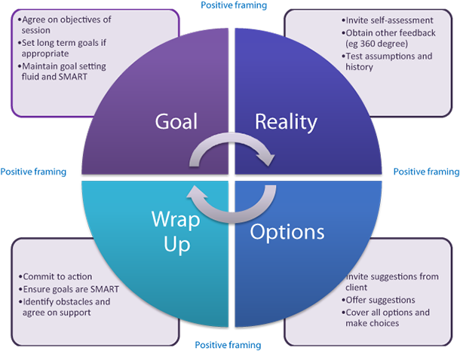
The advantage of the grow model is that it enables a coach to have a structure towards the coaching, but this is also the downside as the coach maybe concentrating too much on the structure and not keeping track of the employee and failing to allow the employee to guide the conversation.

What is mentoring
Mentoring is to support and encourage people to manage their own learning in order that they may maximise their potential, develop their skills, improve their performance, and become the person they want to be. (Mentoring: definitions and principles - University of Reading, 2021)
To tackle the challenges of complex human resources, companies use mentoring. Workplace mentoring is on the rise therefore companies are offering mentoring programs to employees, thus helping employees engaging and develop which helps in retaining the top talent.
The employer would benefit, as mentoring would allow the employer to understand the employee career objective which can then be aligned with the companies goals. Mentoring will teach the employee new skills thus benefiting the organisation, it will ensure employees take on an active role which spreads the knowledge and the best practice within the organisation. Leading to happier employees, allowing the organisation to keep a better retention rate.
The employee would benefit by learning and developing new skills, this will help them in advancing in their careers and will not make them feel stagnant in their roles. Offering a mentoring program to an employee shows a tangible way that the organisation is investing in their careers. Employees then will form friendships in work which will result in an increase in engagement.
Some differences in coaching and mentoring are.
Coaching | Mentoring
Short term.  It is more task based.  It is performance driven – non directive.  Aims to develop the potential of the coachee.  The working partnerships is equal.  Coach/coachee ratio of speaking is 20/80.  May be sourced externally.  Asking a client, a question. | Long term.  It is relationship based.  It is development driven – directive.  The focus is the develop the employee professionally.  The mentor will have more experiences than the employee.  Mentor/mentee speaking ratio is 40/60  Most likely to be from the same organisation.  Telling clients, a solution to their problem.

There are also similarities.
They both support the development of a person.
They are both based on one-to-one relationship.
Having a good personal rapport between both parties is when both methods work best.
A series of meetings is involved over a time period.
Agreement in person is often involved for example a signed contract between two parties.
They both can be integrated onto learning and developing programs.
Counselling is where a trained therapist listens and finds ways of helping an individual who are dealing with emotional issues. Time may be set aside for the counsellor to explore difficulties in a client whether emotionally or stressfully. They act to help clients see things differently. Confidentially is paramount hence a relationship of trust is built.
There are similar attributes to coaching, as they are both rooted to how an individual can help themselves provided they get the correct support. But the main difference is that a counsellor is not there to tell a client what to do or how to do it. But they will help the individual to work out for themselves of what they want to do ad the best approach to take.
Mentoring also has similar attributes to counselling but the assumption is a mentee is well enough to engage with a mentor and if not then counselling is recommended
The long-term success of a business depends on the wellbeing of their employees. Overworked staff ae likely to deliver low quality work and may lack commitment to the organisation. Whereas a well looked after healthy team will feel eager to perform to the best of their ability.

Question 2
A line manager is an employee of an organisation who directs other employees, and they are in charge of the individuals working in that department. A line manager will then report to the person directly ranked above them. Being proficient functionally is of paramount of a line manager.
As you can see the pictures below show the life of a line manager who needs to be able to multitask.

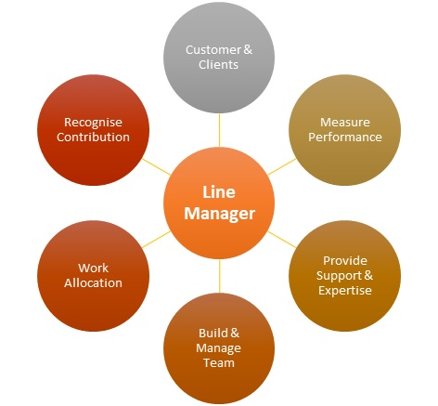

A line manger aligns various strategies in order to achieve the goal of the organisation. Accumulation and the allotment of resources is their responsibility. The companies vison, missions and goals are incorporated the line manager they also act as a role model as they are the first part of control; for and employee. Teamwork and team management skills is where a major role is played by the line manager, they are skilled in collaborating people.
The line manager will act as a coach, as through guided activity and direct discussion an employee will be helped to solve a particular problem.
The line manager will also act as a mentor, where the line manager shares their knowledge and insight to less experienced employees. They also are seen as a role model as someone willing to share their knowledge and skills to benefit the employee and the entire organisation.
The benefits of a line manager are that they are like encyclopaedias walking around. They are like octopuses and are cross trained and are jack of all trades.
Line managers are the bridge between seniors and employees. They ensure employees are doing their jobs properly. It gives a voice to employees so if they need to address their concerns higher up, the line manager will relay the message to the seniors.
By having a line manager better team performance is generated, with better working relationships leading to ultimate a more committed team.
Some drawbacks of a line manager are.
Time constraints as they are always multitasking they need to make sure everything is done on time but unfortunately one cannot be everywhere at one time.
There may be inequality to who gets the training leading to low morale of the employees wo is now coached.
There may be hidden agendas between a line manager and an employee, leading to unfair decisions.
Tips on becoming a good line manager.
God listening skills, get to know your team members, find out about their goals. Find out what makes then want to perform. By doing this it will build trust which will then enable you to get the most out of then.
Good delegation skills. Not all the work has to be done by the line manager, with delegation the team will be more motivated.
Don’t blame others. Be accountable for the mistakes as you are the one responsible for the employees output, whether good or bad.
Make sure to praise hark work. It is good to recognise when your team is doing well. This will make employees more motivated and hey will work harder.
Always plan for the future. I order to get the best out of the staff and to help them to progress. Thus, planning personal development plans in order to enable them to progress in their careers whether it be with yourself or under another management.
This could be done following the OSCAR coaching model.

What is the OSCAR Coaching Model?
In coaching, it’s about getting the one who is being coached (the coachee) to find self-insight and awareness. There are several models that are often deployed and used in coaching, of which the GROW model is considered the most important: Goal, Result, Opportunities, and Will. The OSCAR model is derived from this. The OSCAR Coaching Model is a popular tool in workplace coaching. Its name is also an acronym, which stands for Outcome, Situation, Choices, Actions, and Review. (What is the OSCAR Coaching Model? Definition and questions | toolshero, 2021)
Outcome – the line manager should be clear on what the employee would want to be coached on, what is their desired outcome. For example, an employee maybe afraid in expressing their opinions, talking in front or a large audience. The outcome here would be to talk in front of a large audience clearly and efficiently.
Situation – the current situation of the employee, what is the employees current feeling. For example, a sales professional may get nervous and feel insecure in front of a large audience and may want to run away. This is the information a line manager will need in order to coach the employee to possible actions.
Choices – here it involves the line manager asking the employee their desired choices. In fact, they will both work together to find out the positive or negative consequences of the desired choices made.
Actions – after the consideration of various choices the line manager tell the employee to make actual actions.
Review – looking into how the process is coming on together is very important to plan as the line manager and the coachee will look at it together. Review is important to see what actually went right and what maybe went wrong, what could have been done differently. The key here is the line manager keeping an eye on the employee to see if they remain motivated in attaining the desired goals set.
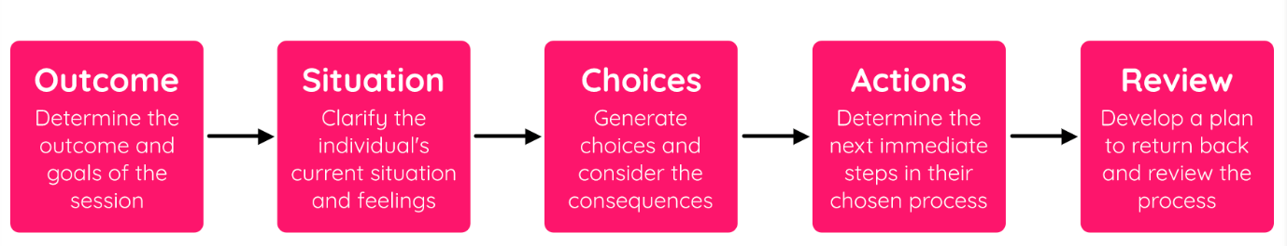

Question 3
What is change management
Change management is the overarching approach taken in an organisation to move from the current to a future desirable state using a coordinated and structured approach in collaboration with stakeholders. (What is change management and organisational change? | APM, 2021)
Through coeporate settings in the form of projects or programs organisatonal change is introduced, thus delivering the business value. However this is only the beginning of embedding the change inorder to make it the new normal for an organisarion.
A successful change management would require behavioural change, so focus on people is increased along with behaviour and culture needed to, prepare the workplace, to demonstrate the change. New behaivoular norms need to be embedded with expectstions altered around the conditions.
Organisational change management ends with begins with the employees involved, the understanding of resistance is required, routines in orgabisational defence, cuktures pervading and to bring people along during this process.
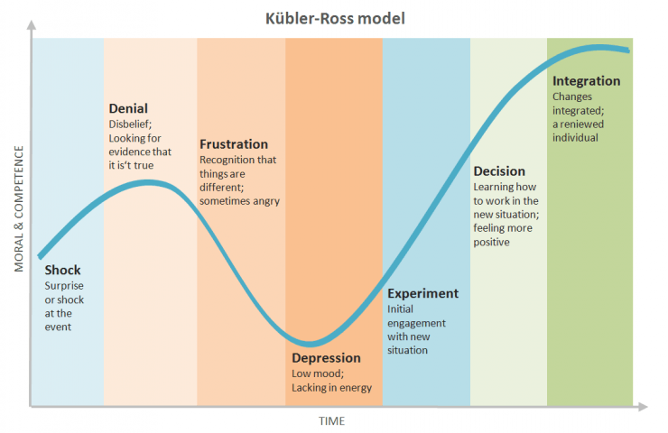
With the help of the Kubler-Ross change model. A coach or mentor can facilitate change.
Stage 1 : denial
An announced change mey come as a shock to team members and become defensive towards the change. Adapting to something new may not be digested at first. An initial dip in productivity may occure.
However with good line manamager coach or mentors, employess should he helped in uinderstaing the reason the change has been made, and what may be in it for them. Simply listening to the employees concern face to face will easg the process.
Stage 2: anger
Some team member may become angry by fearing what lies ahead. An organisaitn may decend into chaos at this dander zone stage.
Therefore managers will need to plan carefully during preparation. Considering the objection and impact people may have this stage should be planned carefully. To minimise stress and in time it will make way for acceptance.
Stage 3: bargaining
By the manager/mentor being open to suggestions it may bring some relief to the employees who are moving closer to acceptance. Make sure clear expectations are set out for those still resisting to do what they only think is important.
Stage 4: depression
A manager should understand that it is not easy to accept change for am employee and my become sressed and deplressed. Therefire the more exiting the traing is for the employee the bette it will be and positive feedback will motivate the team.
Stage 5: acceptance
This is where the eployees realsie that fighting will get them nwhere and accept the change, thus improving productivity.

Questin 5
My reflection.
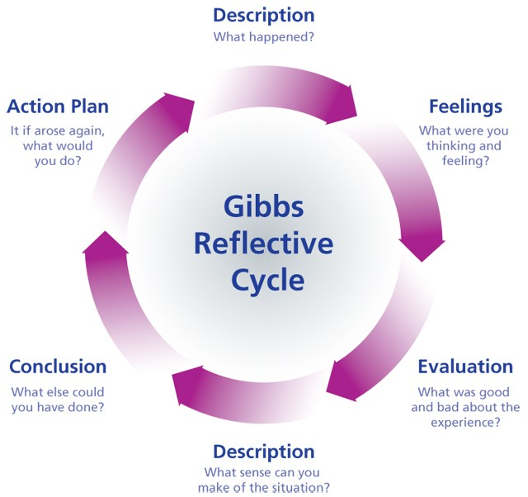
Using the Gibbs reflective cyle I will reflect on my performance as a coach.
We were asked to coach a coachee.
First of all by using the instant pay off coaching model I asked the coachee what the current problem was.
Second I identified that the desired outcome was.
Thirdly a joint brsainstorm was done between my self and the coachee to list the blocks and obstacles.
Lastly we came up with ways around these blocks and the final approach.
The feeling here was that by brainstorming jointly we came up with many ideas and resolutions together in order to overcome the barriers.
The things that were good here are we worked together to come up with ideas. But it would have been better if we could have dobe this session in campus as we had to do it on Microsoft teams and we were not able to meet up with each other due do covid lockdown.
Even though we couldn’t meet up we used video calling in order to catch up and make plans for the session. Even thoigh we worked different shifts we made time to meet uo through videos and complete this task.
We learned here that nothing works better then actually meeting up face to face and working together in order to create better work.
Maybe in the next group group work I can talk about the strengths my coluges have as I will already know what they are from the previous session. We will need to make sure we can meet up phisiccally to make better preparations.

