

BSc (Hons) Ordnance, Munitions & Explosives – Instrumentation and Control

Control System Design

Thomas Beswick – 1910566
21/12/2021

Contents
1 Introduction 3
2 Simulation Setups 3
3 Results 7
4 Discussion 10
5 Conclusion 12
6 Bibliography 13

Introduction

Control systems are used every day in regular life, from maintaining the temperature within the home oven to simply turning the lights on in a dark room. These systems can be either open-loop or closed-loop with the different between them being the requirement of a feedback loop for closed-loop systems. Frank describes the difference as open-loop control directly changes the output based on the inputs, whereas closed-loop systems use the feedback loop to create an error within the system for the inputs to then self-correct [1].

A transfer function is a mathematically calculated equation that represents a control system by theoretically providing output values determined by the given input values. As Bishop and Dorf state, a transfer function will describe the relationship of the dynamics (inputs and outputs) of the system it represents [2]. Within this report, a transfer function will be applied to a given control system and its accurate evaluated.

An important feature of closed-loop systems is the overall stability of the system. As Chau defines, the closed-loop system is designed to be dynamic, which cannot happen without first being stable [3]. One of the most widely used tools for understanding the stability is the Nyquist stability criterion [4], which is represented with the used of the Nyquist plot that can be created within MatLab. This plot will be created for the system used in this report and analysed for stability.

A second method of analysing stability is through the use of a Bode diagram. This diagram will provide the gain and phase margins and is plotted against frequency in order to determine these values [5]. The margins will related back to the Nyquist plot and will provide discrete values to measure the stability of the system.

The final method used in the analysis of stability is the Pole-Zero map. This map will plot the pole and zero values for the transfer function onto a real-imaginary plot. This provides a qualitative analysis of the transfer function that will prove useful when determining stability [6]. As Baraniuk states, the way to determine stability using this plot is simply to demonstrate that all poles are on the negative side of the real axis [6].

This report details the steps of modelling a closed-loop control system within Simulink and MatLab, using unique assigned values. The control system is intended to function a Phalanx close-in weapon system (CIWS) turret, which is known as the most common weapon system of its type in the naval world [7]. A whole system transfer function will be determined for the control system and will be evaluated for stability, control and suitability for the defined function using the tools and techniques available in the MatLab suite. The system must have a response time under 2 seconds in order for the turret to lock on target quickly, at the response of the operator. In addition, the overshoot must be less than 5%. This is to ensure the turret remains as accurate as possible during movement and to ensure that there is as little correction time as possible, meaning the turret has more time on-target.

Simulation Setups
Simulations were setup within the Simulink package of MatLab. In Simulink, the first step was to create a basic control system. This used a step generators, an add function, PID and the ‘plant’ represented by a transfer function. This system is then attached to a scope in order to monitor the system. This setup is show in Figure 1.
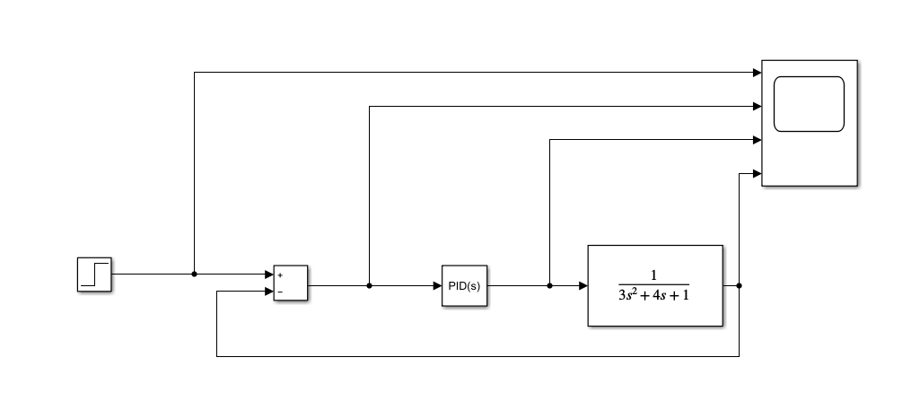
Figure 1 - First setup of the control system
The values in the transfer function were given individually as part of the task brief and were given as seen in Equation (1) [8]:
$$\begin{aligned}G\left(s\right)=\frac{1}{as^{2}+bs+c} \#\left(1\right)\end{aligned}$$

Where A = 3, B = 4, and A = 1.
Once this system was constructed in Simulink the PID controller required setup and optimisation. This is done relatively simply within Simulink using the ‘Tune’ function available when opening the PID interface, shown in Figure 2.
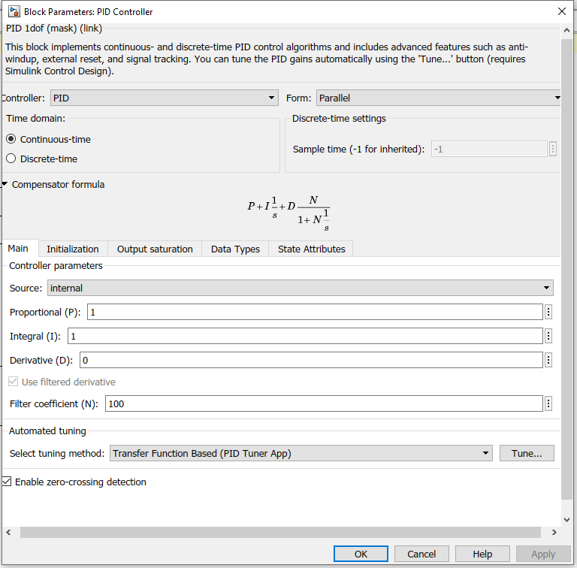
Figure 2 - PID controller parameter interface
Using this tuning feature allows the user to modify the response time and transient behaviour of the controller to return proportional, integral and derivative values that will produce a response that meets the task brief. The performance criteria is a maximum overshoot of 5% and a response time of under 2 seconds.
After optimising the settings within the tuner, the tuner reported a rise time of 0.441 seconds with an overshoot of 0.261%. This was achieved with P = 19.341, I = 5.8007, D = 15.0321 and N = 571.3724. This tuning software also predicts the stability and robustness of the system and can be compared the results found using the Niquist plots found later. A full rundown of the parameters and performance can be found in Figure 3.
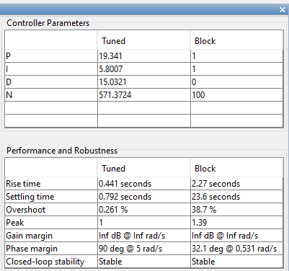
Figure 3 - Tuner settings, parameters and performance
Now we have P, I, D and N values, we can use this to create a whole system transfer function. This was calculated manually with the results shown in Equation (2), and the whole calculation process seen in Annex 1. This transfer function was then inserted into the Simulink model along with a MatLab equation version for both a manually calculated function and MatLab calculated for comparison, the new system model is shown in Figure 4.

$$\begin{aligned}TF=\frac{\left(8608.3s^{2}+11075.631s+3314.36\right)}{\left(3s^{4}+1718.12s^{3}+10894.79s^{2}+11647.0034s+3314.36\right)} \#\left(2\right)\end{aligned}$$

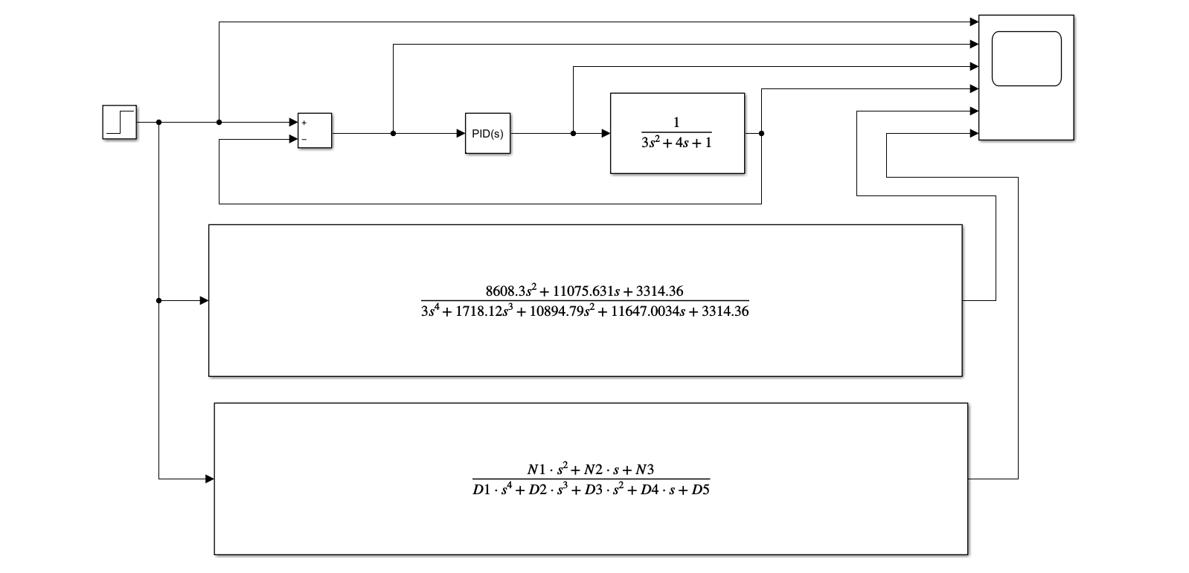
Figure 4 - Full Simulink model with transfer functions (manual and MatLab calculated)

The values used within the MatLab calculated transfer function are found in Figure 5 taken from the MatLab console. The values seen in Figure 4 can also be represented as shown in Equation (3).

$$\begin{aligned}\frac{\left(K_{p}+NK_{d}\right)s^{2}+\left(NK_{p}+K_{i}\right)s+NK_{i}}{as^{4}+\left(aN+b\right)s^{3}+\left(K_{p}+NK_{d}+bN+C\right)s^{2}+\left(NK_{p}+K_{i}+CN\right)s+NK_{i}} \#\left(3\right)\end{aligned}$$

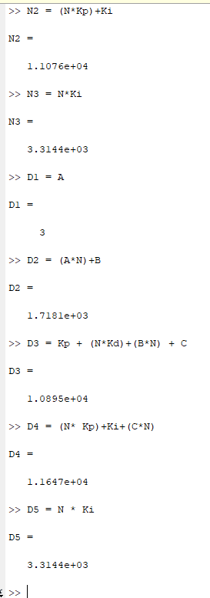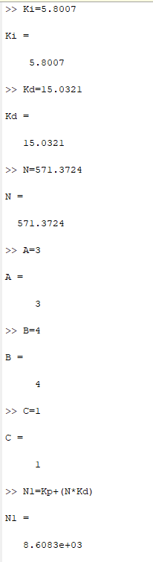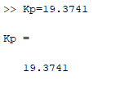
Figure 5 - Values used within MatLab console

Results
Figure 6 shows the results found on the scope pictured in the full MatLab models. The Y-axis is amplitude while the X-axis is a representation of time. Starting from the top each graph shows the following; step input, output following addition gate, output from PID controller, final output from original model, output from manually calculated transfer function and output from MatLab calculated transfer function.
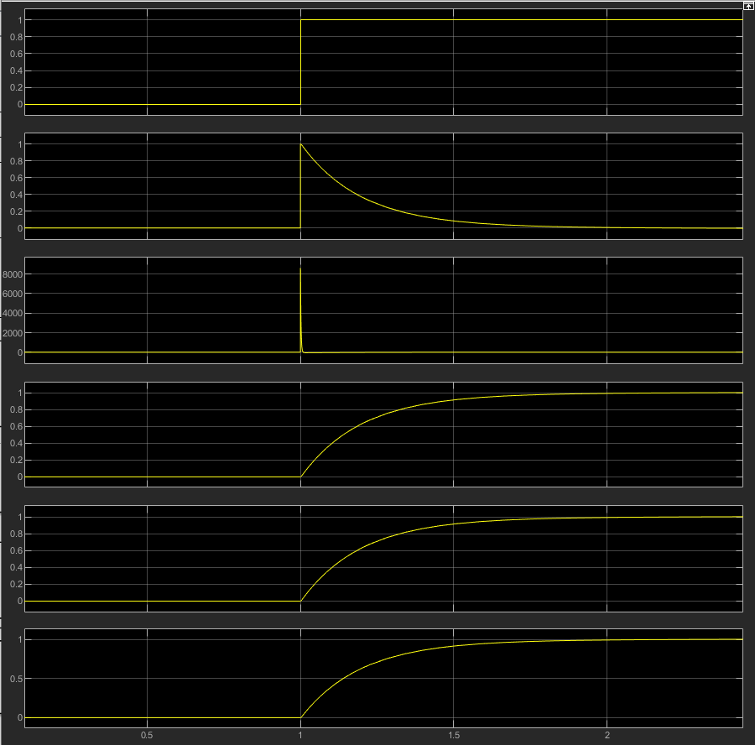
Figure 6 - Scope results
Figure 7 shows the Nyquist plot for the forward transfer function with the stability margin shown as a dotted line.
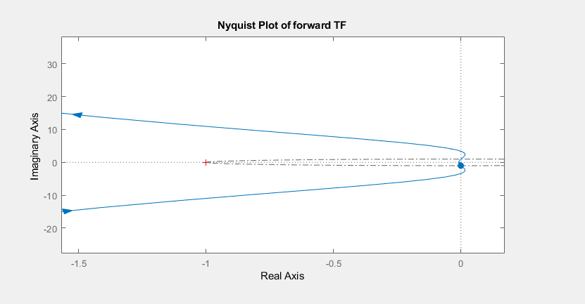
Figure 7 - Nyquist Plot

Figure 8 shows the Pole-Zero map of the transfer function, where an ‘X’, or Pole is a value of ‘s’ that is likely to take the function to infinity and a ‘O’, or Zero is a value of ‘s’ that will take the function zero.

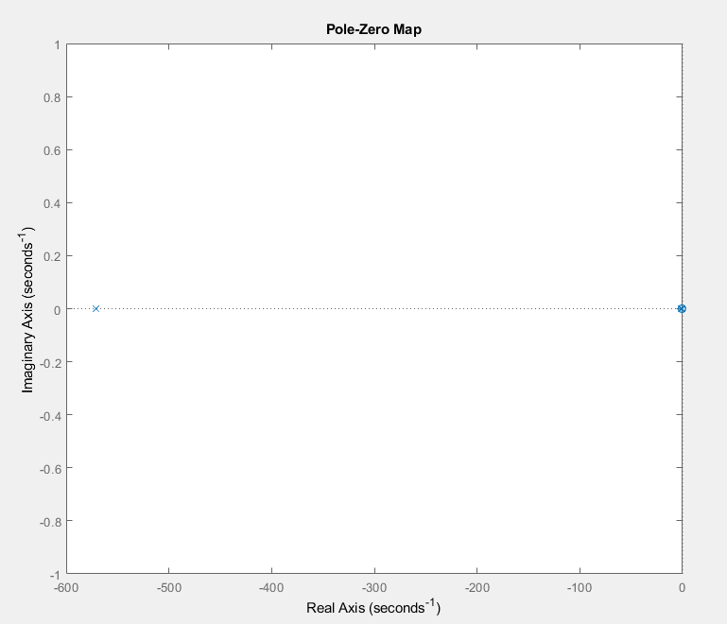
Figure 8 - Pole-Zero Map

Figure 9 shows the roots for the values within the transfer function, this shows the pole and zero locations plotted on the map in Figure 8. The roots of D1 to D5 show locations of the poles while the roots of N1 to N3 show locations of the zero’s.

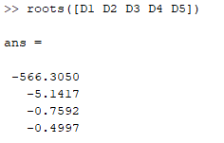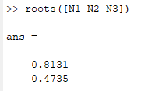
Figure 9 - Pole and Zero locations

Figure 10 shows a bode diagram that also details the gain and phase margin of the transfer function. This diagram also highlights, with a dotted line, where the magnitude crosses the 0 line which gives the phase margin at the same frequency.

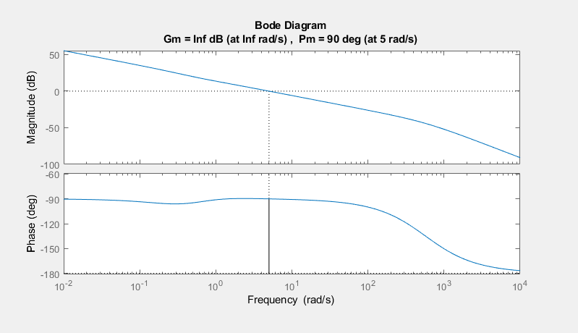
Figure 10 - Bode Diagram
Figure 11 show the pole zero plot of the plant, the results from this are then transferred into an excel calculator show the plant response to the control system. This demonstrates whether the plant has a steady decay or oscillatory response to movement. The graphs produced in excel are shown in Figure 12 and Figure 13.
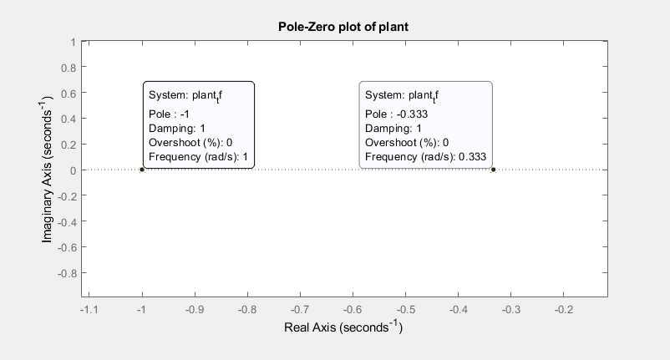
Figure 11 - Pole-Zero plot of plant

Figure 12 - Pole location waveform graph for -0.333 pole found in Figure 11

Figure 13 - Pole location waveform graph for -1 pole found in Figure 11

Discussion
The results obtained from the scope interface shown in Figure 6 show that the three different methods of implementing the transfer function have extremely similar results. Based on these scope results there are no disernable differences between the methods. The main down side for the manual calculation is the additional potentional for human error as there are multiple stages where errors can be made in the calculation. If a single value is out of place during the stages then the final function will be incorrect. The MatLab calculated equation has the advantage of versatility, if the closed-loop system were to undergo changes or values were replaced the recalculation of the transfer function would be quick and easy to complete.
Regardless of this, the scope shows that both transfer functions used are an accurate representation of the system and can be expected to accurately predict the system outputs based on the provided inputs.
Now that the accuracy has been determined, the stability of the system is to be understood. This is especially important within closed-loop systems. Åström and Murray note that the feedback loop in closed-loop systems has the potential to create dynamic instabilities in a system that lead to oscillations or ‘runaway behaviour’ [9].
The first method used to analyse stability is the Nyquist plot shown in Figure 7. This plot was produced in MatLab with the stability margin plotted as a dotted line. The point in which the Nyquist plot crosses zero on the imaginary axis determines the gain margin of the system. As can be seen in Figure 7 the plot crosses zero at the intersection of the axis. This can be interpreted as the system having an infinite gain margin, meaning that the amplitude of the system could be increased indefinitely and would remain stable.
The second point of focus is that where the Nyquist plot crosses the stability margin in the lower-left quadrant. The angle from the real axis that this intersection occurs represents the phase margin. As can be seen in the diagram, this phase margin 90°. This means that the signal that the system processes can be up to 90° out of phase, and the stability will be maintained.
The values determined by the Nyquist plot can be reinforced by plotting the transfer function in the frequency domain on a Bode diagram. This diagram was produced in MatLab and can be seen in Figure 10. The gain margin on this diagram is determined by the frequency in which the phase crosses 180°. As this does not occur in this system, this results in an infinite gain margin, as discussed during the analysis of the Nyquist plot. The phase margin is then derived from the point in which the magnitude crosses zero, as seen in Figure 10 this occurs at 90°. Both of these values are identical to those determined by the Nyquist plot and add further confidence to the stability of the system.
The final method of confirming the stability of the system is through the pole-zero map. As discussed in the results section, the pole-zero map plots the values of the poles and zeroes of a transfer function on the complex s-plane. These locations provide the insight into the determination of the stability of a system. In simple terms, if the poles are found to be on the left side of the imaginary axis (or negative real values) then this is within the stable region, as shown in Figure 14 [10]. In addition to this, the poles being plotted onto the real axis (or having an imaginary value of zero) means that the diminishing instability is not oscillating.
The values seen in Figure 8 and Figure 9 show that the pole locations are found on the left side of the imaginary axis and are plotted on the intersection of the real axis, which therefore means that the system is stable and had no oscillation during the settling period.
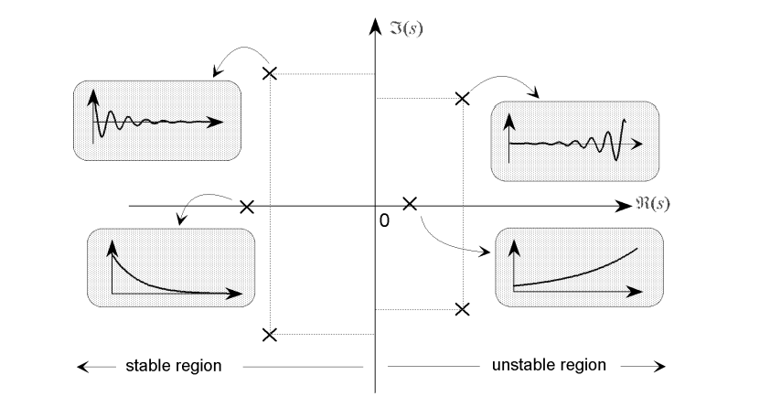
Figure 14 - Pole-Zero plot specification

To fully confirm the overall stability of the system, a pole-zero plot is also done on the isolated plant sub-system to determine the stability of the plant transfer function. The same stability criteria applies as discussed previously, and as shown in Figure 14. This plot for the plant can be found in Figure 11, which confirms that the plant transfer function is stable and has no oscillation. This was then analysed further in Figure 12 and Figure 13 where these poles were plotted in a pole waveform generator within excel. These figures show the diminishing instability over the course 4 to 12 seconds.
While all these results point to an ideal, almost perfect, control system, when implemented onto the physical turret there is likely going to be various trade-offs required. Most expectantly would be cost, the system required to rotate a 6 tonne turret is thought to extremely expensive. In addition to this, the close-loop system adds a degree of complexity to the design over that of an open-loop system which both increased cost, maintenance and the potential for system errors. As discussed, the manual calculation of the transfer function is prone to human error and if done incorrectly in the design phase, can later be detrimental to the operation of the turret. Overall, the theory behind the control system in this report show a robust stability, fast response time with minimal overshoot, but in order to truly test the system, a physical trial would be required.

Conclusion

The results from the various methods of analysis show that the whole system, isolated plant sub-system and the forward path transfer function are stable throughout. All of the methods used correlate with this conclusion.

The pole-zero maps show that the poles are all present on the left side of the imaginary axis, and are plotted on the intersection with the real axis resulting in no oscillation. The bode diagram shows the gain margin as infinite, with a phase margin of up to 90° and the nyquist plot concurs with these values. These facts lead to the conclusion that the system has a robust stability.

The overall result from this experiment shows that the transfer function calculated manually, and via MatLab both result in a stable system that would control a CIWS turret with less than 5% and with a response time of under 2 seconds.

However, this system would likely have some trade-offs when utilised on the physical design. This would include mostly cost due to the size of the control system, as well as maintenance and complexity disadvantages. These trade-offs are difficult to quantify due to the theoretical nature of the analysis conducted and would require a full-scale trial to understand the impact on the product.

Bibliography

[1] | S. A. Frank, Control Theory Tutorial: Basic Concepts Illustrated by Software Examples, Springer Nature, 2018.
[2] | R. C. D. Robert H Bishop, Modern control systems, Pearson Education Limited, 2017.
[3] | P. C. Chau, Process Control: A First Course with MATLAB, Cambridge University Press, 2012.
[4] | L. Wang, PID control system design and automatic tuning using MatLab/Simulink, IEEE Press, 2020.
[5] | J. S. Andrew Butterfield, A Dictionary of Electronics and Electrical Engineering (5 ed.), Oxford University Press, 2018.
[6] | R. Baraniuk, Signals and Systems, 2013.
[7] | NavWeapons, “20mm Phalanx Close-in Weapon System (CIWS),” NavWeapons, 05 March 2018. [Online]. Available: http://www.navweaps.com/Weapons/WNUS_Phalanx.php. [Accessed 21 December 2021].
[8] | S. Mosey, “ACDA5011_sem1_CW1_2021_22 - Assignment Brief,” 2021.
[9] | R. M. M. Karl Johan Åström, Feedback Systems: An Introduction for Scientitsts and Engineers, Princeton University Press, 2008.
[10] | Department of Mechanical Engineering, “Analysis and Design of Feedback Control Systems,” [Online]. Available: https://web.mit.edu/2.14/www/Handouts/PoleZero.pdf. [Accessed 21 December 2021].

ANNEX 1

The following equations are calculations done to achieve a whole system transfer function using given values from the task brief.

A = 3
B = 4
C = 1
Ki = 5.8007
Kp = 19.3741
Kd = 15.0321
N = 571.3724

Add given values into transfer function equation.
$$G\left(s\right)=\frac{1}{as^{2}+bs+c}$$
$$G\left(s\right)=\frac{1}{3s^{2}+4s+1}$$
Transfer function of the PID controller is
$$K_{p}+K_{i}\frac{1}{s}+K_{d}\frac{s}{\frac{1}{N}s+1}$$
$$19.3741+\frac{5.8007}{s}+15.0321\frac{s}{\frac{1}{571.3724}s+1}$$

To calculate the forward path transfer function of the system, the controller’s transfer function must be multiplied by the transfer function of the process:
$$\left(19.3741+\frac{5.8007}{s}+15.0321\frac{s}{\frac{1}{571.3724}s+1}\right)×\left(\frac{1}{3s^{2}+4s+1}\right)$$
$$\left(19.3741+\frac{5.8007}{s}+15.0321\frac{s}{\frac{s+571.3724}{571.3724}}\right)×\left(\frac{1}{3s^{2}+4s+1}\right)$$
$$\left(19.3741+\frac{5.8007}{s}+15.0321\left(s\left(\frac{571.3724}{s+571.3724}\right)\right)\right)×\left(\frac{1}{3s^{2}+4s+1}\right)$$
$$\left(19.3741+\frac{5.8007}{s}+\left(\frac{8588.927s}{s+571.3724}\right)\right)×\left(\frac{1}{3s^{2}+4s+1}\right)$$
$$\left(\frac{\left(\left(s\left(s+571.3724\right)\right)×19.3741\right)+\left(s+571.3724\right)5.8007+s\left(8588.927s\right)}{s\left(s+571.3724\right)}\right)×\left(\frac{1}{3s^{2}+4s+1}\right)$$
$$\left(\frac{19.3741s^{2}+11069.83s+5.8007s+3314.36+8588.927s^{2}}{s^{2}+571.3724s}\right)×\left(\frac{1}{3s^{2}+4s+1}\right)$$
$$\frac{8608.3s^{2}+11075.631s+3314.36}{\left(s^{2}+571.3724s\right)\left(3s^{2}+4s+1\right)}$$
$$\frac{8608.3s^{2}+11075.631s+3314.36}{3s^{4}+4s^{3}+s^{2}+1714.12s^{3}+2285.49s^{2}+571.3724s}$$
$$\frac{8608.3s^{2}+11075.631s+3314.36}{3s^{4}+1718.12s^{3}+2286.49s^{2}+571.3724s}$$
Now we remove the feedback loop and calculate the transfer function of the system as a whole.
Using:

$$TF=\frac{G}{1+GH}$$

Where TF is the transfer function of the whole system, G is the forward path transfer function, and H is the transfer function of the feedback loop, in this case $H=1$
$$TF=\frac{\frac{8608.3s^{2}+11075.631s+3314.36}{3s^{4}+1718.12s^{3}+2286.49s^{2}+571.3724s}}{1+\left(\frac{8608.3s^{2}+11075.631s+3314.36}{3s^{4}+1718.12s^{3}+2286.49s^{2}+571.3724s}\right)×1}$$
$$TF=\frac{\frac{8608.3s^{2}+11075.631s+3314.36}{3s^{4}+1718.12s^{3}+2286.49s^{2}+571.3724s}}{\frac{3s^{4}+1718.12s^{3}+2286.49s^{2}+571.3724s}{3s^{4}+1718.12s^{3}+2286.49s^{2}+571.3724s}+\frac{8608.3s^{2}+11075.631s+3314.36}{3s^{4}+1718.12s^{3}+2286.49s^{2}+571.3724s}}$$
$$TF=\frac{\frac{8608.3s^{2}+11075.631s+3314.36}{3s^{4}+1718.12s^{3}+2286.49s^{2}+571.3724s}}{\frac{3s^{4}+1718.12s^{3}+2286.49s^{2}+571.3724s+8608.3s^{2}+11075.631s+3314.36}{3s^{4}+1718.12s^{3}+2286.49s^{2}+571.3724s}}$$
$$TF=\frac{\frac{8608.3s^{2}+11075.631s+3314.36}{3s^{4}+1718.12s^{3}+2286.49s^{2}+571.3724s}}{\frac{3s^{4}+1718.12s^{3}+10894.79s^{2}+11647.0034s+3314.36}{3s^{4}+1718.12s^{3}+2286.49s^{2}+571.3724s}}$$
$$TF=\frac{8608.3s^{2}+11075.631s+3314.36}{3s^{4}+1718.12s^{3}+2286.49s^{2}+571.3724s}×\frac{3s^{4}+1718.12s^{3}+2286.49s^{2}+571.3724s}{3s^{4}+1718.12s^{3}+10894.79s^{2}+11647.0034s+3314.36}$$
$$TF=\frac{\left(8608.3s^{2}+11075.631s+3314.36\right)\left(3s^{4}+1718.12s^{3}+2286.49s^{2}+571.3724s\right)}{\left(3s^{4}+1718.12s^{3}+2286.49s^{2}+571.3724s\right)\left(3s^{4}+1718.12s^{3}+10894.79s^{2}+11647.0034s+3314.36\right)}$$

This is the whole system transfer function:
$$TF=\frac{\left(8608.3s^{2}+11075.631s+3314.36\right)}{\left(3s^{4}+1718.12s^{3}+10894.79s^{2}+11647.0034s+3314.36\right)}$$

POLE LOCATIONS
ZERO LOCATIONS

Nyquist plot with stability margin plotted. Showing high stability system due to large gain and phase margins.

This shows that the gain margin is “infinity” which is good as it mean we can increase the gain as much as we like and the system will still remain stable.

Phase margin is also 90 degrees, which also shows high stability in the system as it allows the system to be shift within 90 degrees phase and remain stable. Phase margin is determined by the point at which the gain magnitude crosses zero, which is shown in the figure as crossing at 90 degrees.

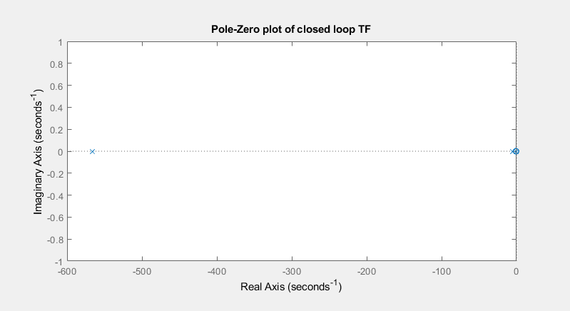

The pole zero of the plant with given values is on the imaginary axis at 0 as the root of the values does not have an imaginary component. This will mean the plant will have no oscillation and will decay at a steady stable rate.

Enter these into the pole location wave form excel sheet. SIGMA = REAL, OMEGA = IMAGINARY (0 if none). Taking roots([a b c]) gives these values.

Plot full closed loop function in excel to determine how the system as a whole will respond. Using roots from screenshot above ‘pole locations’.

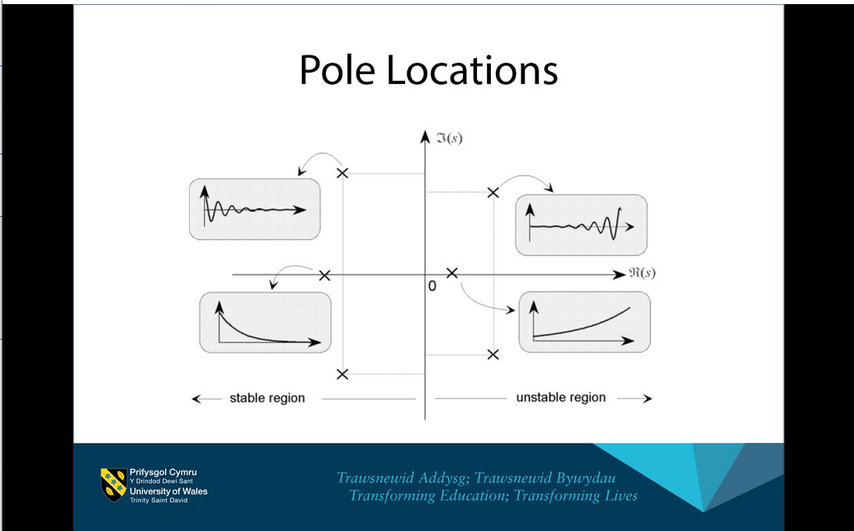Anything on negative real axis can be considered stable as the amplitude will reduce over time. If the pole was located on positive real axis, there would be increasing instability over time.

