Coursework Title
Module Name: Analysing and Solving Problems
Module Code: ACCA4019
Student Name: Abu Bakr Siddeeq
Student ID: 2435732
Lecturer Name: Dr Abida Perveen

Submission date: 17/03/2026

Contents
Assignment Description 3
Problem Scenario 3
Problem Deconstruction 3
Variables involved 3
Prioritising using MoSCoW method 4
Must have 4
Should have 4
Could have 5
Won’t have 5
Proposed Solution 5
Flowchart 6
6
Explanation of the flowchart 6
Step 1 6
Step 2 6
Step 3 6
Step 4 7
Step 5 7
Step 6 7
Step 7 8
Step 8 8
Step 9 8
Reflection and justification 8
References: 9

Assignment Description
You are required to analyse a real-world problem and develop a structured solution using abstract thinking and problem-solving techniques. This assignment assesses your ability to evaluate the problem, identify requirements and constraints, and design a logical, generic solution.

Problem Scenario
A local college is facing difficulties in managing its classroom allocations efficiently. Some rooms are overcrowded while others remain underused, leading to timetable clashes and wasted time as staff and students move between rooms. The college aims to optimise classroom allocation to make better use of available space and improve the overall learning experience.
You have been asked to develop a solution that achieves the following:
- Efficient allocation of classrooms based on class sizes and room capacities.
- Minimised time wasted by students and staff moving between classes.
- Accurate timetabling to ensure all lessons start on time without scheduling conflicts.

Problem Deconstruction
The scenario explains that a local college is facing difficulties using the resources that it has efficiently, resulting in multiple problems and concerns. According to the report, the main problems are:
- Overcrowded room: Too many pupils in one classroom, making teaching less efficient and beneficial for students
- Underused tooms: whilst one class is overcrowded, having classrooms that have spaces remaining shows that the classes are very unevenly distributed
- Timetable clashes: This makes it difficult for both teachers and students to attend classes on time, losing out on valuable time in education, as well as adding constraints and difficulties to teachers to make sure classes are prepared and ready for students to learn
- Distance between classrooms: This wastes teachers' and students' time because of having to walk long distances between classrooms

Variables involved
To completely understand what changes need to be made in order to resolve the classroom allocation problem and make it more efficient, it is essential for these key variables to be taken into account.
ClassSize | NO. of students in each class
ClassCapacity | How many students can fit in each class
RoomSlots | Which rooms will be occupied, and which ones will be free or underused
ClassTimings | When does a class start and end to avoid clashes within lessons
LocationOfRooms | Ensuring that the rooms are close by, making it convenient for both teachers and students to commute with ease and without too much time being consumed

Prioritising using the MoSCoW method
After assessing the problem and breaking it into smaller components and speaking of the variables that are associated with classroom allocation efficiency, I will be explaining what needs to be prioritised through using the MoSCoW technique in order to resolve the issue in the most beneficial way possible.

Must have
- Students must never exceed the class capacity
- Timetables must not clash with one another
- Teachers and students must have an ample amount of time to commute from one class to the next without having to rush or be hasty
- The classes should be within their relevant rooms, i.e., computing classes should be in the computing rooms and science classes in the laboratory, etc

Should have
- The lessons’ schedule should be such that the classrooms for those lessons are close together
- The classes which are underused should be reallocated to smaller rooms so that less space is wasted, or have more students so the room can be utilised more effectively#
- Having a sign on in each classroom informing which classroom it is

Could have
- Application informing of any changes that may occur within the classrooms or classes
- Having a 10-minute gap between each lesson to ensure that students and teachers have more than enough time to attend classes on time

Won’t have
- A notification application which informs which rooms are free on that day
- Extra rooms which may be vacant or spare

Proposed Solution
In this section, I will present to you a proposed solution to the classroom allocation problem, ensuring that there are no classes that are over clashing one another, as well as making the class allocations based upon the class sizes, so classes don’t become overcrowded, as well as underused. I will do this by bringing a flowchart as well as a step-by-step explanation of that flowchart for a complete understanding of the proposed solution.

Flowchart
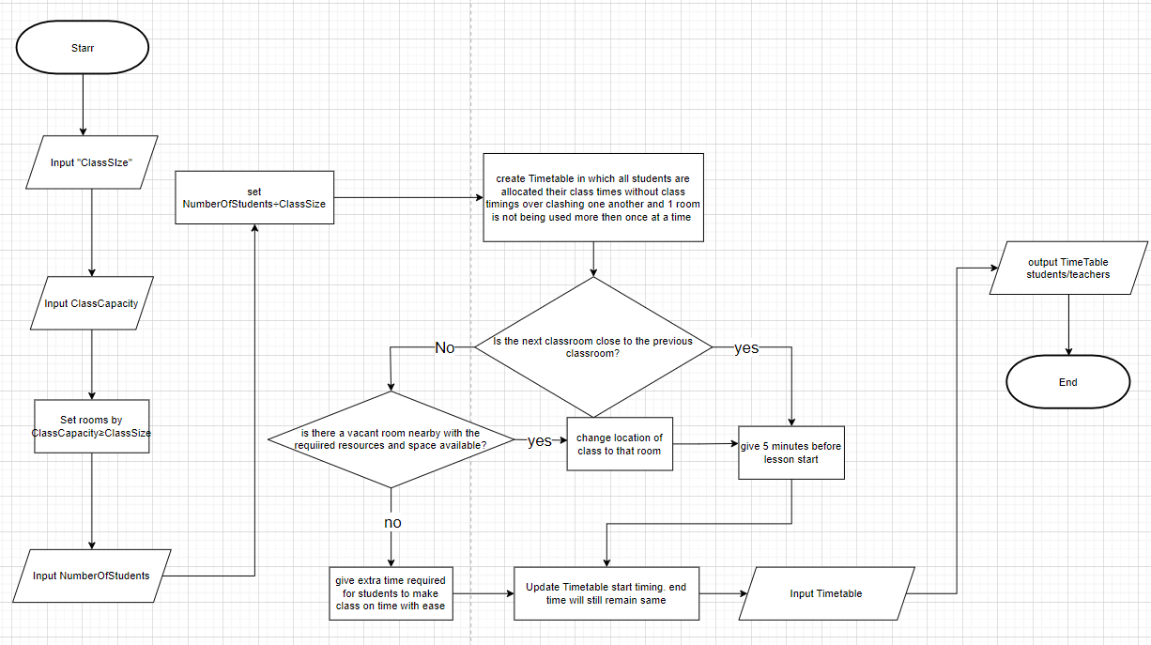

Explanation of the flowchart

Step 1
The flowchart starts with collecting 2 important datasets, “ClassSize” and “ClassCapacity”. This is essential to know before moving forward as we can only allocate the classes to the right rooms if we know how many students there are in each class and how big each class is, as some classes may cater for fewer students, whereas others can cater for many more students.

Step 2
After knowing the number of students in each class and the capacity for each room, you will allocate the class sizes based on the size of the classroom capacity by making sure that the class sizes are either equal to or less than the class capacity. This will ensure that the classrooms are not overfilled nor overcrowded.

Step 3
Once the class sizes are sorted and they are allocated to their correct class capacity. Now we need a new dataset of how many students will be in each class. As some classes will have more students and some will have fewer. This will be vital in placing the students in the correct class size, preventing classes from being overcrowded yet also being weary that classes are not underused.

Step 4
After completing step 3, you will divide the number of students for the desired class/lesson by the number of class size. This will ensure that there is a fair distribution of students in each class and will inform us of how many classes we will need for that science, allowing us to make sure we have enough teaching resources and teachers available for those classes.

Step 5
Now that we know how many classes there are, what the class size is, and the capacities of the rooms, we can move on to the next stage, which is creating the timetable for the pupils and teachers. In this timetable, we must make sure that the classes are not overcrowded, which is why we did step 1 and step 2 as well as making sure that students have enough resources and teachers' support through completion of step 4 for an optimal learning experience. When making the timetable, we need to ensure that the lessons are not overlapping one another and students have enough time to attend their lessons on time and be prepared for the next class.

Step 6
In order to make sure that students have enough time to get from one class to another without being late, and have enough time to settle and be prepared. You need to check if the classes are close or distant from one another. If they are close, then you will start the next class 5 minutes after the previous class finishes
If the next classroom is far, then you will check if there is any room nearby which is vacant with all the necessary resources available to students. It should also be able to cater for the number of students in that class.
But if that isn't possible due to constraints within the facilities and building structure, students should be given more time to go from one classroom to another. For example, if the next lesson starts 5 minutes after the previous lesson finishes, for those students who may have to travel a bit more distance then the other classes, they should be given some extra time so that they are not deprived of coming on time to class. This will encourage and support students to attend lessons on time without placing unnecessary stress or burden upon them. This will also improve puctuality and discipline among students within the college.

Step 7
After completing step 6, update the timetable with new start timings for those students who have to travel some distance in order to get to their classrooms. Classes will end at the same time

Step 8
After completing step 7, the Timetable is ready to be issued and given to the students. Input the timings in the timetable for the students and the teachers. There should be no overclashing within the classes, the classes shouldn’t be overcrowded as well as the classes being fairly distributed according to class size and class capacity. Also, the students should be able to attend classes on time without any excuse or difficulty, as those students whose classes are further away have got extra time to attend their classes

Step 9
After the Timetable is complete. Output the Timetable to the teachers and students, meaning hand the Timetable to them so they know the schedule for their classes and lessons.

Reflection and justification
In this problem scenario, different problem-solving techniques have been used in order to come up with the viable solution presented within this assignment.
Subdividing was one of the methods used to help resolve the problem-based scenario. By subdividing the problem into smaller problems, the smaller problems became easier to manage, and more focus was given to each problem, giving a more effective solution to the problem [1]. It gave an insight into exactly what problems there were and what issues were there that needed to be resolved.
In order to prioritise what needed to be dealt with, the MoSCoW technique was used. By dividing the ideas into must-haves, should-haves, could-haves and won’t-haves, it provided a clear framework for what was required for dealing with the problem-based scenario [2]. This helped focus on what was essential and needed to be dealth first, what could be delayed, what would be nice to have, and what wasn’t required.
Abstract thinking was also one of the methods used to solve the problem. As Abstract thinking goes into the realms of ideas and theories [3], it goes beyond concrete realities. Abstract thinking was vital in dealing with some of the different possibilities that could have arisen after certain decisions were made, such as whether the rooms were close or distant from one another.
The Flowchart was an effective tool that helped represent the solution to the problem by giving a visual representation of the steps that needed to be taken, what decisions may need to be taken into account and made understanding the relationship between each task easier [4]
This proposed solution deals with the main issues relating to the classroom allocation efficiency and classes being overcrowded by limiting the number of students within each class and making sure the class timings do not overlap one another. Due to each student having a different timetable based on their selected subjects, it is difficult to completely save any wasted time, but this proposal tries to mitigate wasted time as much as possible, trying to give as much efficiency as it can.

References:
[1] team, “Breaking Down Complex Requirements into Smaller Sub-problems: A Comprehensive Guide - AlgoCademy Blog,” AlgoCademy Blog, Jan. 05, 2025. https://algocademy.com/blog/breaking-down-complex-requirements-into-smaller-sub-problems-a-comprehensive-guide/ (accessed Mar. 10, 2026).
[2] Atlassian, “Understanding the MoSCoW prioritization | How to implement it into your project,” Atlassian Community, Aug. 30, 2023. https://community.atlassian.com/forums/App-Central-articles/Understanding-the-MoSCoW-prioritization-How-to-implement-it-into/ba-p/2463999
[3] N. editorial team, “Abstract Thinking: Definition, Importance, and Impact on Mental Health,” NeuroLaunch.com, Aug. 22, 2024. https://neurolaunch.com/what-is-abstract-thinking/
‌[4] “Flowcharts: Definition, Benefits, and Examples,” Dovetail.com, Nov. 26, 2024. https://dovetail.com/product-development/what-is-a-flow-chart/
‌
‌
‌

