The McKinsey Quarterly

Fast lines at Digital High

Computers have transformed work. They could also transform education.
February 2001 • T. Michael Nevens
Ten years ago, a school lesson on drought in sub-Saharan Africa might have required students to read a textbook and, perhaps, to watch a film. Today, with the help of computers and the Internet, that lesson could be transformed from a one-way flow of information into an interactive process. Students could go on-line to search for the latest thinking on the causes of drought. They could use e-mail to interview African-studies specialists on the cultural impact of the problem. And they could apply digital geography and weather tools to simulate the effects of drought on local crops and the environment.
But to achieve this new dimension in learning—and, above all, to enhance the performance of students—schools must do more than just wire up classrooms. Although 95 percent of US public schools and 72 percent of classrooms have access to the Internet, and the student-to-computer ratio is currently approaching 10:1 (Exhibit 1), only 33 percent of primary- and secondary-school teachers say that they feel "very well prepared" or even "well prepared" to integrate high-quality digital content into their lessons (Exhibit 2).¹
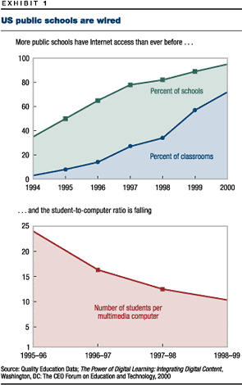
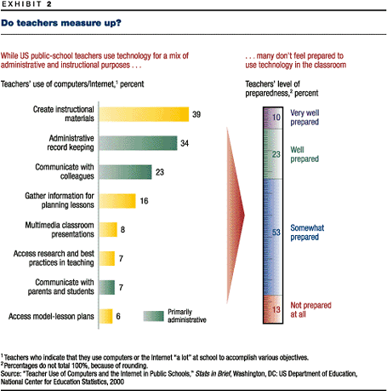
To prepare students for the world of tomorrow, schools must therefore take the next step by helping teachers integrate digital tools and content into the curriculum. Technology is no panacea for educational problems, but experience shows that when it is linked to clear educational objectives, it can help students master traditional skills such as math and reading and prepare students for work in an increasingly technological age (see sidebar "The CEO Forum").
Digital learning integrates technology, connectivity, and digital content into the curriculum. Besides software, digital learning exploits audio, video, CD-ROMs, and World Wide Web sites as well as tools such as e-mail, computer simulations, real-time video discussions, and databases. Above all, it helps students seek and use information in a collaborative, creative, and engaging way that gives both them and their teachers a new kind of educational experience.
Although digital tools may never wholly replace the textbook, they could supplement and enhance learning in almost all grades and subjects because they have certain dynamic characteristics that help students take an active part in learning. Students using digital tools can access and manipulate up-to-date information to formulate hypotheses, evaluate evidence, and draw conclusions. They can explore subjects in greater depth and apply information in increasingly complex ways. They can hone their problem-solving skills and learn how to use information to make decisions. Moreover, because digital content is available in various formats, it can be tailored to a student’s individual learning style. Students who learn visually can rely more on charts and video; those who learn analytically can use text and data.
As technology spreads through the schools, teachers and students will assume new roles. Students will pursue more self-directed projects and set their own goals; teachers will take on the role of facilitator. Parents and outside experts will form part of each student’s learning team.
Moreover, digital learning prepares students for the demands of life and work in a way that traditional educational methods don’t. Since almost half of all students in the United States go straight into the workforce from secondary school, introducing technology into primary and secondary education is essential.² The US Department of Labor has found that nearly all of the job categories expected to expand most in the coming years—in manufacturing plants, health care, and services—will require some technological knowledge. Students should learn to use technology productively to find and manipulate information, to understand systems thinking, and to master interpersonal skills and teamwork. To help students develop these skills, a commission of the US Department of Labor concluded, more emphasis must be placed on thinking creatively, solving problems, and making decisions—the very skills digital learning develops most effectively.³

Where we are today
Tapping the full potential of digital learning takes time. Schools seem to go through several phases before integrating technology into the curriculum effectively.
Stage one: early tech. Computers and Internet connections are still rare. Schools have one computer for every ten or more students as well as a few multimedia computers (see sidebar "A call for equity"). Students use packaged software to reinforce basic skills, either in computer laboratories or, independently, in classrooms. Teachers use technology in a limited way to enhance their own productivity, mainly in administrative functions. Schools typically allocate less than 5 percent of their technology budget to teacher training. At this stage, technology is a supplemental rather than integral part of the curriculum.
Stage two: developing tech. Schools typically have one computer and network connection for every five to ten students and allocate up to 10 percent of the technology budget to teacher training. Teachers and students use technology in ways suited to the curriculum, mainly for research; for communication with experts in universities, corporations, and government; and for presentations. Teachers may enhance lessons by using material from the Web or may tell students to use CD-ROM encyclopedias and the Internet for research projects. Instead of allowing students to direct themselves, teachers at this stage tend to direct them (by choosing Web sites, for instance).
Stage three: advanced tech. Schools have one networked computer for every five or fewer students, as well as access to other tools, such as broadband connections and scanners. Teachers design learning around the technology, using digital tools and content for research, problem solving, data analysis, and correspondence with outside experts. Many students begin to master higher-order intellectual skills (such as collaborative problem solving) and more complex concepts than they would have done without the help of technology. Schools devote between 10 and 25 percent of the technology budget to teacher training.
Stage four: target tech. Schools have about one networked computer for every one to three students and use a full range of other digital tools, including personal digital assistants, voice mail, and video cameras. They devote 30 percent or more of their technology budget to teacher training. Technology is incorporated into learning, in all subjects and grades, to promote student-centered, project-based learning.
Judging by the number of computers and Internet connections, more than half of all US schools were at the early-tech stage in 1998, and almost an additional quarter were at the developing-tech stage (Exhibit 3). However, the way technology is used suggests that many of the latter really fall into the early-tech category.
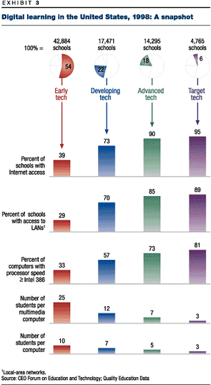
Reaching stage four in every school may seem like an expensive pipe dream, but in fact it is an affordable goal. In 1995, a McKinsey study undertaken for the National Information Infrastructure Advisory Council estimated that equipping US classrooms with one computer for every five students would cost $47 billion, plus an additional $14 billion a year for maintenance and upgrades.⁴ These sums represent an incremental 2.6 percent of the total national school budget. (Currently, US schools spend 1.3 percent of their collective budget on technology.) The cost today is likely to be lower: reaching stage-four levels requires more hardware, but schools have made substantial investments in technology since 1995 and computer costs have fallen. Moreover, money for digital content can be taken from current instructional-materials budgets, reallocating expenditures rather than increasing them.
But is this spending justified in view of the need, in many schools, for smaller classes, higher salaries for teachers, and repairs to buildings? The answer is yes. Different kinds of schools should add technology at different rates, and some schools should address more basic problems first, but technology should be considered in the mix of possible investments. Along with the educational benefits it confers, it can alleviate other difficulties: by increasing the productivity of teachers and providing individual tutorials, for example, it can mitigate the effects of large classes. In any case, many states and the federal government are now running budget surpluses, so there is no better time to equip schools for the future.

Transforming schools
The task of integrating digital learning into the curriculum can’t be left to teachers alone; all stakeholders in the educational system must play a part. Schools and districts, for example, should link digital learning to specific objectives and invest in digital content. Teachers should be trained to incorporate digital learning into the classroom and share their experiences of what does and doesn’t work. Suppliers of educational materials and other organizations must create digital-curriculum units that play the role of traditional textbooks. State administrators must redesign curriculum budgets and allocate resources for technical support. And parents and community members must support all of these investments.

Link technology to educational objectives
Digital technologies can improve a student’s performance only when they are used to achieve specific educational goals. Many US states have learned this lesson the hard way, fueling a debate on whether technology matters in education.
West Virginia’s experience shows what can be achieved with the right approach. In 1990 the state implemented its Basic Skills/Computer Education (BS/CE) program, integrating technology into the curriculum for math, reading, and language arts for each grade. Since then, scores on a common standardized test for all basic skills, the Stanford 9, have risen throughout the state, and statistical analysis shows that one-third of the school-based gain is attributable to the BS/CE program.⁵ The biggest improvements came from moving computers out of laboratories and into classrooms. But the West Virginia data also show the importance of involving all stakeholders, for two-thirds of the gain was attributed to the nontechnological efforts of families and communities.
Every school must learn where best to apply digital tools. Initially they were much used in math and science, in which "drill-and-practice" programs taught basic concepts. They have been even more successful in developing a student’s capacity for higher-order thought, while also proving to be patient and adaptable instructors for students with learning disabilities. More recently, creative teachers have found that the tools can be applied to all parts of the curriculum. Lessons that cross disciplines and focus on problem solving, as well as student-generated projects, lend themselves particularly well to this approach.
Equally important, schools must develop new ways to assess the impact of digital learning. Standardized test scores alone are inadequate, since they fail to reflect many of the key skills that digital learning teaches—forming and testing hypotheses, processing information, collaborating, and communicating in a variety of ways—and their broad scope makes it hard to attribute changes to specific programs. Anecdotal evidence from stage-four schools suggests that digital technology improves the education of students exposed to it, but without more accurate measurements of the nature and extent of these benefits, support for educational technology may wane, and schools may spend their money unwisely.

Invest in teachers . . .
School districts must provide teachers with training if they are to integrate technology into their lessons. But technology training for teachers still isn’t required (though it is an option) in more than 50 percent of schools.⁶ In 1998–99 schools spent $5.65 per student on computer training for teachers, compared with $88.19 per student on new hardware, software, and connectivity.⁷ This level of spending falls woefully short of the US Department of Education’s recommendation that schools allocate at least 30 percent of their technology budgets to teacher training.⁸
Furthermore, technology training should be a continuing process that includes instruction, follow-up questions, classroom observation, and sharing best practices—not a one-shot event. Technical experts should of course teach the mechanics, but the emphasis should be on using technology as a teaching tool. Anecdotal evidence indicates that experienced teachers often make the best technology trainers.
Professional-development and -support programs have been shown to be effective. In fact, one recent study found that almost half of the teachers who during the previous year had received at least 11 hours of training on the integration of digital content and tools into the curriculum said they relied on software and the Internet to a "very great" or "moderate" extent in teaching. Only about a quarter of the teachers who didn’t receive such training gave the same answers.⁹

. . . and in digital content
Once schools have chosen their educational objectives and performance metrics, they must ensure the availability of the digital tools and content they need. The first step is to make an inventory of existing resources and to make sure they are being used. Many schools have found it helpful to create an inventory indexed by subject, grade, and skill. The inventory should state the aim and performance standards of each resource.
Publishers and administrators have a vested interest in the current system of textbook procurement
When the time comes to invest in additional content to fill gaps in the inventory, the many school districts that currently purchase digital content only with their supplemental-materials budgets will find that they need a new approach. Schools now spend $3.9 billion a year on textbooks,¹⁰ and publishers and state administrators have a vested interest in this system. Digital content could eventually decentralize purchasing so that all teachers would have a materials budget allowing them to download tools, texts, and lessons. Even before that day comes, greater flexibility in purchasing is needed to let teachers experiment with digital tools.
Ideally, schools should make their full instructional-materials budget available for whatever content is needed, digital or otherwise. Some are already doing so. In 1990, Texas, after deciding that traditional forms of content were failing to meet some of its educational goals, permitted schools to use textbook budgets to buy digital content. As a result, during the 1998–99 school year, only 17 percent of the state’s budget for instructional materials was spent on textbooks, compared with 30 to 40 percent in other states.¹¹
Rallying support for additional purchases may be difficult if schools have already spent large sums on computer hardware and Internet connections, but this final step is critical if the full benefits of technology are to be enjoyed. Here again, the support of stakeholders will be important.

Create a new curriculum
Teachers must have the freedom to integrate technology into their lesson plans and to experiment, as well as time to share their knowledge with one another. Yet many of them are already overworked, and time spent in discussions with their peers adds to their load. Schools will have to help them make the time.
Similarly, teachers can’t be expected to re-create, individually, all of the work textbook companies and curriculum specialists have done to develop full-blown curriculum units, goals, activities, and assessments. Local and state governments must provide curriculum specialists to work with teachers in evaluating and selecting digital resources and incorporating them into the syllabus. At present, only 18 percent of US teachers report that their schools provide lists of recommended software.
Educational-content companies should create digital-curriculum units that link digital resources to lesson plans, much as textbook companies do now, and these units should be available on-line so that teachers can access them easily. In devising such tools, manufacturers must work more closely with teachers to develop software that fits their needs.
One example—the Little Planet reading program for kindergarten to third-grade classrooms (www.littleplanet.com)—uses animated video stories, computer software, and conventional instruction to develop reading and writing skills. Students participate as individuals, in small groups, and in exercises for the entire class. As these students progress through the program, Little Planet analyzes their performance and tailors reading activities to their needs, giving visual learners more visually stimulating exercises, for example.

Provide support
Technology isn’t a one-time expense. In too many schools, computers languish because of problems that could quickly be fixed if a trained information technology specialist were on hand; a budget for technical support, maintenance, and upgrades is therefore essential. Teachers should have access to support technicians for help in using new software and in correcting problems.
Digital technology is transforming the world of work. To produce the knowledge workers of tomorrow, and to maximize the ability of children to learn, it must also be allowed to transform the world of education.

The CEO Forum
This article is based on research conducted by the CEO Forum on Education and Technology, of which the author is a board member. Founded in 1996, the forum is a four-year partnership between leaders in business and education. It was created to help ensure that every child in the United States has the essential technological, critical-thinking, and communications skills necessary for success in the 21st century. Each year, the forum has released a report highlighting the importance of educational technology and monitored its deployment in schools. McKinsey, a founding board member, continues to support the work of the organization. For more information, see its Web site (www.ceoforum.org).
Return to reference

A call for equity
The US Department of Commerce has documented a widening gap between those who do and those who don’t have access to modern technology. This digital divide may be responsible for perpetuating economic disparities, class advantage, and racial bias. Schools, fortunately, are in a uniquely good position to close this ominous gap.
But there is a disturbing trend in technology and connectivity in the schools that serve the poorest children in the United States. Although 63 percent of all US classrooms were connected to the Internet in 1999, only 39 percent of classrooms were connected in schools where 70 percent or more of all students qualified for free or reduced-price lunches (exhibit).¹ Many of these schools don’t have an adequate infrastructure and electrical capacity for computers, let alone high-speed connections and networks.
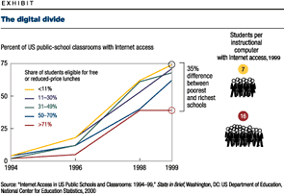
In 1997 only 17 percent of African-American and 20 percent of Hispanic students used computers in school, compared with almost 40 percent of white students. Just 12 percent of Hispanic students and 15 percent of African-American students accessed the Internet in school, compared with 21 percent of their white counterparts.² In addition, African-American and Hispanic students are much less likely than whites to use computers for simulation and more likely to use them for drill and practice.³ The inequality in access to technology continues at home. Whereas 47 percent of white households have computers, only 23 percent of African-American and 26 percent of Hispanic households do.⁴
Federal policy makers have tried to mitigate this disparity through two programs: E-Rate (which gives schools and libraries discounts on Internet access and other telecommunications services) and a federally subsidized school lunch program that pays for supplementary education. Besides not having enough money, these programs don’t go far enough: they must also address the poor infrastructure that prevents many schools from using up-to-date hardware and broadband connections. As the United States moves forward in integrating digital content into the curricula of its schools, technology should be used to remove existing barriers and to avoid creating new ones.

Notes
¹ Mary Ann Zehr, "Poorer schools still lagging behind on Internet access, study finds," Education Week, February 23, 2000.
² Alan B. Kreugar, The Digital Divide in Educating African-American Students and Workers, Working Paper #434, Princeton, New Jersey: Princeton University, Industrial Relations Section, March 2000 (www.irs.princeton.edu/pubs/working_papers.html).
³ Harold Weglinsky, Does It Compute? The Relationship Between Education Technology and Student Achievement in Mathematics, Princeton, New Jersey: Education Testing Service, Policy Information Center, Research Division, September 1999.
⁴ Falling Through the Net: Defining the Digital Divide, Washington, DC: US Department of Commerce, 2000.
Return to reference

About the Authors
Mike Nevens is a director in McKinsey’s Silicon Valley office.

Notes
¹ "Teacher use of computers and the Internet in public schools," Stats in Brief, Washington, DC: US Department of Education, National Center for Education Statistics, 2000.
² "In 1998 the US Department of Education reported that 46 percent of people aged 20 to 24 had a high-school education or less.
³ Learning a Living: A Blueprint for High Performance, Washington, DC: US Department of Labor, The Secretary’s Commission on Achieving Necessary Skills (SCANS), 2000 (www.ttrc.doleta.gov/SCANS/work.html).
⁴ See Ted Meisel, T. Michael Nevens, Margot Singer, and Karen A. Tate, "World class: Schools on the Net," The McKinsey Quarterly, 1995 Number 4, pp. 31–41.
⁵ Jonathan Becker, Robert Kottkamp, Dale Mann, and Carol Shakeshaft, West Virginia Story: Achievement Gains from a Statewide Comprehensive Instructional Technology Program, Santa Monica, California: The Milken Family Foundation, 1999 (www.mff.org).
⁶ Education Technology: Preparing America for the 21st Century, Washington, DC: US Department of Education, Office of the Deputy Secretary, April 24, 1998.
⁷ Technology Purchasing Forecast, 1998–99, fourth edition, Denver, Colorado: Quality Education Data, 1999.
⁸ Getting America’s Students Ready for the 21st Century, Washington, DC: US Department of Education, 1996.
⁹ "Technology counts ’99: Building the digital curriculum," Education Week, September 23, 1999. This report was commissioned by the Milken Foundation for Exchange on Education.
¹⁰ Association of American Publishers, 2000 preliminary estimated book publishing industry net sales, 1992, 1997–2000.
¹¹ Technology in Education, Shelton, Connecticut: Market Data Retrieval, 1999.

