
Malware testing
Independent Project (ACCA6020)
Shannon Wallace (1901768)
Supervisor: carlene campbell

APRIL 2022

Declaration of Originality
I, Shannon Wallace declare that I am the sole author of this project; that all references cited have been consulted; that I have conducted all work of which this is a record, and that the finished work lies within the prescribed word limits.

This work has not previously been accepted as part of any other degree submission.

Signed : swallace

Date : 03/12/2021

Contents
List of Figures 4
List of tables 7
Chapter 1 – Introduction 8
1. Introduction 8
2.4 Aim 9
2.4 Objectives 9
2.4 Structure of the project 10
Chapter 2 – Literature Review 11
2.2. Introduction 11
2.3 Different types of malwares and the impacts 12
2.4 Impact of malware over the years 14
2.5 How does malware work and how to identify? 16
2.7 What is an anti-virus software? 18
2.8 How does an anti-virus software work? 19
2.9 Virtualisation 0
2.10 Simulation Software 2
2.11 Related work 3
2.12 Conclusion 4
Chapter 3 – Research Methodology 5
3.1 Introduction 5
3.2 Methodology 6
3.3.1 Research Process 6
3.3.2 Research Philosophy 7
3.3.3 Research methodologies 7
3.3.4 Philosophies 9
3.3.5 Approach 9
3.3.6 Strategies 9
3.3.7 Choices 9
3.3.8 Time Horizons 9
3.3.9 Techniques & Procedures 11
3.5 Conclusion 12
Chapter 4 - Design & Implementation 13
4.1 Introduction 13
4.2 Problem formulation 13
4.3 Design 15
4.4 Implementation 17
4.4.1 Virtual machine setup 17
4.4.2 Virtual machine network 21
4.4.3 Shared Files 23
4.4.4 Installation of tools and software 25
4.5 Conclusion 30
Chapter 5 – Testing and Evaluation 31
Introduction 31
5.1 Norton anti-virus software 32
5.2 McAfee Anti-virus software 43
5.2.1 Trojan Simulator 43
5.2.2 Ransim Simulator 47
5.2.3 Infection Monkey 49
5.3 Avast anti-virus software 51
5.4 BitDefender anti-virus software 61
Evaluation 71
Chapter 6 – Conclusion and recommendation 78
Chapter 7 – Reflection 79
References 80
Project Management 0
Ethics Form 0
Logbook 1
Appendices 2
Appendix 1- Increasing security 2
Appendix 2: Malware Simulation tools 0
Appendix 3: Further research 1
Appendix 4- anti-virus software list 2

List of Figures
Figure 1: Business change – IBM institute for business value [1] 10
Figure 2: How a worm spread. [9] 12
Figure 3: Last 10 years of total malware [10] 13
Figure 4:Number of internet users worldwide [11] 13
Figure 5: Installation of a malware - Adrozek attack [20] 16
Figure 6: shows the steps on how an anti-virus work [25] 18
Figure 7: Virtualisation - type of hypervisor [34] 0
Figure 8: Networking types - what they can do on vm [45] 1
Figure 9: research onion [41] 5
Figure 10: Deductive and Inductive [42] 6
Figure 11: Scientific method to research( [43] 7
Figure 12: A graph showing a breach or attack [44] 12
Figure 13: Block Diagram of project 13
Figure 14: Screenshot of NZXT software 14
Figure 15: Network/virtual topology 15
Figure 16: Network topology of project 15
Figure 17: Windows 8 name and operating setup (Virtual Machine) 16
Figure 18: Windows 10 name and operating system setup(Virtual Machine) 16
Figure 19: ISO windows 10 17
Figure 20: ISO windows 8 17
Figure 21: Windows 10 installation 18
Figure 22: Windows 8 installation 18
Figure 23: Screenshot of Windows 8 19
Figure 24: screenshot of windows 10 19
Figure 26: Bridged adapter 20
Figure 27: Windows 10 wireshark receiving ping from Windows 8 virtual machine 20
Figure 28: Windows 10 pinging windows 8 virtual machine 21
Figure 29: Sharing folders 22
Figure 30: Shared machine Folders 23
Figure 31: Shared folders working 23
Figure 32: Installation of Wireshark 24
Figure 33: Installation of NZXTCAM 24
Figure 34: Installation of KnowBe4 Ram Simulation 25
Figure 35: Installation of Trojan Simulator 25
Figure 36: Installation of Infection Monkey 26
Figure 37: Installation of Norton 360 26
Figure 38: BitDefender Installation 27
Figure 39:Avast installation 28
Figure 40: McAfee installation 29
Figure 41: screenshot of "malicious file" 31
Figure 42: Norton PC performance before scanning 31
Figure 43: PC performance when scanning 32
Figure 44: Activating trojan simulator with Norton 33
Figure 45: Screenshot of TTSERVE.EXE running - when norton was scanning 33
Figure 46: A diagram of Norton detection - did not detect EICAR file 34
Figure 47: PC performance Norton not scanning - ransim simulator 35
Figure 48: PC Performance. Norton scanning - Ransim Simulator 35
Figure 49: Norton ransim simulator - detected harmful files 36
Figure 50: Incorrectly blocked and vulnerable- Ransim Simulator with Norton 36
Figure 51: Evidence of detecting simulation attack - ransim simulator with Norton 37
Figure 52: Simulator did not get blocked straight away before activation – infection monkey with Norton 38
Figure 53: PC performance with Infection Monkey before scan- NORTON 39
Figure 54: PC performance with Infection Monkey while scanning - Norton 39
Figure 55: Infection Monkey - incoming and outgoing traffic – Norton 40
Figure 56: Screenshot of the infection map and windows 8 wireshark. Norton test with infection Monkey 40
Figure 57: Evidence of Norton blocking Infection Monkey 41
Figure 58: Screenshot of Norton detecting infection monkey 41
Figure 59: screenshot of McAfee instantly blocking Trojan Simulator 42
Figure 60: Further evidence of trojan simulator getting blocked by McAfee 42
Figure 61: Evidence of PC performance before McAfee scan – trojan simulator test 43
Figure 62: Evidence of PC performance with McAfee- trojan simulator test 43
Figure 63: Installation of Trojan Simulator with McAfee 44
Figure 64: TTSERVE running in the background with McAfee running 45
Figure 65: screenshot of McAfee removing Trojan Simulator 45
Figure 66: PC performance before scan with McAfee / ransim simulator 46
Figure 67: PC performance while scanning with McAfee / Ransim Simulator 46
Figure 68: Evidence of McAfee blocking Ransim Simulator 47
Figure 69: Screenshot of Ransim Simulator - Leaving vulnerabilities and false positives 47
Figure 70: Infection Monkey instantly blocked by McAfee 48
Figure 71: PC performance before McAfee scan – Infection Monkey 48
Figure 72: PC performance after McAfee scan – Infection Monkey 48
Figure 73: Infection Monkey successfully sending incoming traffic 49
Figure 74: Trojan Simulator instantly blocked with AVAST 50
Figure 75: PC performance with AVAST not scanning – Trojan Simulator 51
Figure 76: PC performance with AVAST scanning - trojan simulator 51
Figure 77: The trojan Simulator got instantly blocked by AVAST - could not run it 52
Figure 78: AVAST automatically blocked ransim 53
Figure 79: AVAST before scanning for Ransim Simulator 54
Figure 80: PC performance while AVAST scanning for RANSIM simulator. 55
Figure 81: RANSIM activiated and AVAST blocking them 55
Figure 82: A screenshot of ransim simulator attack against AVAST 56
Figure 83: a screenshot of Infection Monkey getting instantly blocked by AVAST 57
Figure 84:PC performance while AVAST not scanning 58
Figure 85: A screenshot of AVAST scanning with Infection Monkey 58
Figure 86: The Infection Monkey was activated and AVAST blocked every attack from Infection Monkey 59
Figure 87: Trojan Simulator automatically blocked by BitDefender 60
Figure 88: PC performance being trojan simulator not active and bitdedefender running. 61
Figure 89: shows pc performance – trojan simulator running and anti-virus scanning 61
Figure 90: BitDefender quick scan and installed trojan simulator 62
Figure 91:Trojan simulator running – task manager 62
Figure 92: Manuel quick scan to detect trojan simulator 63
Figure 93: Ransim instantly blocked by BitDefender 64
Figure 94: PC performance with Bitdefender running 65
Figure 95: BitDefender performance while scanning and ransim activated 65
Figure 96: Screenshot of ransim simulator 66
Figure 97: Infection Monkey instantly blocked by BitDefender 67
Figure 98: PC performance with BitDefender just running 67
Figure 99: PC performance with Infection Monkey and BitDefender running 68
Figure 100: BitDefender blocked Infection Monkey 69
Figure 101: No traffic going through - BitDefender blocked 69
Figure 102: Norton anti-virus performance before and after 72
Figure 103: McAfee anti-virus performance before and after 73
Figure 104: AVAST anti-virus software before and after 74
Figure 105: BitDefender before and after 75

List of tables
Table 1: Stage one process Norton 70
Table 2:Anti-virus software McAfee 71
Table 3:Anti-virus software AVAST 71
Table 4:Anti-virus software BitDefender 71
Table 5: Logbook 79

Chapter 1 – Introduction

Introduction
Citizens use computers and laptops for online shopping, socialising, and working from home. Technology has enhanced over the years, and technology has become more dependable. During the recent global pandemic, technology has been more necessary and is more required due to people working from home. Technology is becoming more powerful, and this decreases security due to people finding other ways to bypass software and updates. According to a government website called “Office for National Statistics,” Abi Casey has said that working from home has increased from 2019 went from 27% to 37% in 2020. [1]
There are different computer viruses, and they can affect the whole PC. It is programmed to spread throughout the PC system, damaging files, and the system. It can also spread through networks affecting multiple PCs. “A virus is a type of malware that self-replicates by inserting its code into other software programs. It spreads from one computer to another, leaving a path of destruction as it propagates [2]. There are many people and businesses that are impacted by a computer virus every day. There are over 1000+ malware programs, and every minute, four companies fall victim to ransomware attacks [2]. There are many malwares out there, and a user can prevent this from having an anti-virus. The NHS is one of the biggest health cares and was attacked by a virus called Ransomware (Which encrypts files on a device and makes the system unusable) in 2017 [3]. The impact of the virus was that the NHS services were offline [3].
A “Novice” user does not understand how anti-viruses work and what they do. A novice user should be aware of viruses and other software that can be harmful. It is essential to be aware of these because they are damageable to a user's computer/laptop device.
Cybersecurity job roles have been increased over the past few years due to technology improvements as well as viruses are more common. Cybersecurity helps protect devices systems, networks, programs, devices, and data from cyber-attacks.

Aim
The main aim of this project is to evaluate the effectiveness and performance of an anti-virus software and PC

Objectives
The objectives are to:
- To conduct a literature review about anti-virus software and different kind of viruses.

- To conduct an experiment in testing a range of anti-virus software usefulness

- To analyse and evaluate the results of the anti-virus software efficiency

- To conduct a review and recommend software features on their performance

- To highlight the importance and raise awareness of a recommended anti-virus software

Structure of the project

Chapter one discusses the background information of the report. It also discusses the aims and objectives of the project.

Chapter two focuses on the literature review.

Chapter three concentrates on the research methodology used in the project.

Chapter four is the design and implementation of the project.

Chapter five is the testing and evaluation of the project

Chapter six is the conclusion and recommendation

Chapter 2 – Literature Review

2.2. Introduction
Most businesses and citizens work are digital in this generation. Due to the recent global pandemic, technology has been used more and allowed the business to work throughout. However, there are negative aspects to this due to confidential data being saved on employees’ laptops, increasing the chances of business data being affected, or a chance of a virus corrupting the data. People and businesses should have a way to keep their devices safe.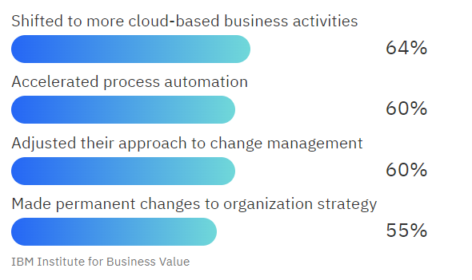
Figure 1: Business change – IBM institute for business value [1]
Figure 1 shows the percentages of how many businesses shifted to cloud-based and the way they adjusted their business due to the recent pandemic. Covid-19 pandemic has changed how organizations around the world operate. A percentage of 65% as shifted to more cloud-based business activities [2]. There is also a greater chance of devices being comprised due to it being cloud-based this is because they can access anywhere.
Criminals find a way to get through the system by checking updates on software, fake emails, download links, and through the network. A person can be misled by an email that looks like an original.
For example, a company called Apple. their email is no_reply@email.apple.com. A fake email would copy the layout and logo of the email. The way to detect a fake email is the email address and the linked links. Even if software helps protect a device from viruses, it is better to know how to prevent and spot a virus from happening.
Shaid and Maarof defined malware as hidden software disguised as functional software. The software code can be edited to cause malicious activities such as stealing data, replicating, disabling security features by not the user who is using the device. Then it can be considered malware [3].
Software/applications can be harmful if not updated regularly, making a gap for any virus to come through, according to Aycock, who described a “Secure Software” as not protected because it has not been compromised yet. Hence, there is no indication that secure software is safe.
An example: Like the stock market, past performance does not guarantee the future outcomes. That is the only guideline users must judge security: the absence of an attack [3].
Security on a device can either be good or bad. It depends on many factors updating software, anti-virus software, firewall, updating the operating system. There are frequent updates to stop malicious users from taking advantage of the software. According to the National Cyber security centre the guidance they give out software updates contain security patches and new security features which are essential to install [5]. See appendix 1 for a guide on how to increase security on your device.

2.3 Different types of malwares and the impacts
A malware is a software that is designed to damage and gain unauthorized access to a device. There are different types of malwares, and they all do different things. According to Fruhlinger, he described malware to be constantly growing and hackers use it to gain access to sensitive data and to cause destruction. [4]
Here is a list of some common malwares:
- Trojans
- Spyware
- Adware
- Worms
- Ransom
All malwares can affect a device by the user downloading the malicious file, and then opening the application. A malware can be downloaded from a website, pop-ups, email attachments and many more. The user is trick into downloading the file as it looks like it from a trusted source.
A malware can also access through software vulnerabilities this could include operating systems, and software. If software and operating systems not regularly updated this causes a gap for a malicious user to see an opportunity to get through, it is a backdoor entrance. It goes through the security and controls in the system.
A trojan malware purpose is to take control of the victim device. Once a trojan is downloaded and activated the user loses control of the system. The malicious user can then delete, copy, and modify all the personal data on your device. According to google and Microsoft they describe a trojan to steal information and allows the malicious user to harm your device by taking full control [5] [6].
A spyware malware purpose is to monitor and steal your data without your knowledge or consent. These data could be sensitive such as bank details, name, address, and other personal data.
An adware malware purpose is to slow down the device, pop up ads on the device, sent ransom demands, and the device keeps crashing. According to google and Gao, kong, bissyande, klein they described adware a software that automatically downloads unwanted material on the device [5] [7].
A ransomware is a malicious software to design block access to a computer system. It spreads to other computers and network. According to a research article called “Ransomware: Evolution, Mitigation and Prevention” they described ransomware as a malware that locks the user out from the computer. It prevents the user from accessing data till you pay the ransom [8].

A worm malware spread through the network by replicating itself. Worms can be used for DDOS attacks, steal data, and conduct ransomware attacks. If one device is affected and connected to the network, then all the other PCs are affected. According to google and Microsoft they describe how a worm to work as a type of malware that can copy itself to other computers and spread through the network. [5] [6]
Figure 2 shows how easily a worm can be spread just by using an USB however worms can also be spread throughout the network when a PC is connected to a network. This would mean to isolate the device from the network to prevent spreading.
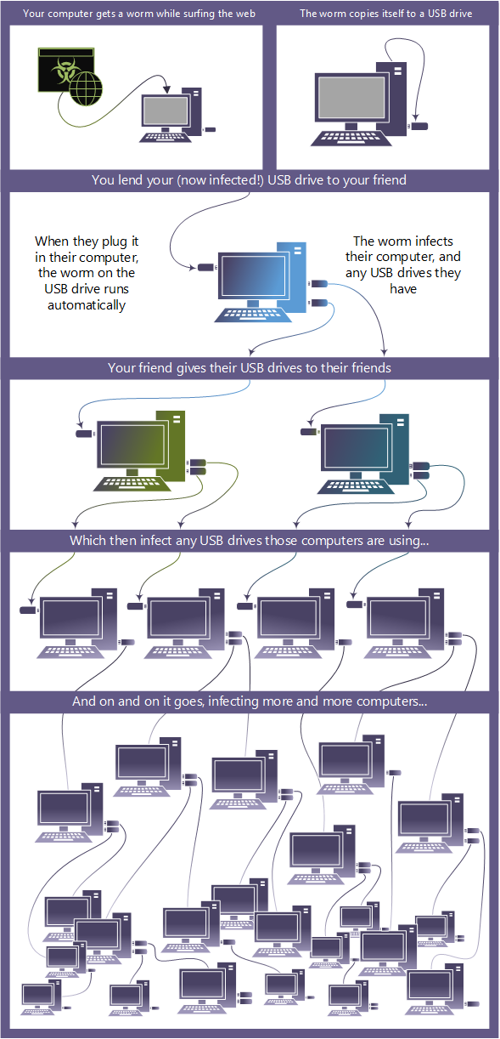
Figure 2: How a worm spread. [9]
As malware can easily be downloaded, the project would be using simulators to conduct the experiment as malware is harmful and can cause deeper complications to the experiment. Specifically, malware simulators. They simulate a malware attack without causing real damage to the device. The simulation attack which will be chosen is ransomware and trojan.

2.4 Impact of malware over the years
Malwares are being created every day and it can be accidentally downloaded. The statistics of the last 10 years of the increase malware that has been made which is over 1 million malware that has been created which was last updated on December 2, 2021. Figure 3 shows the increase.
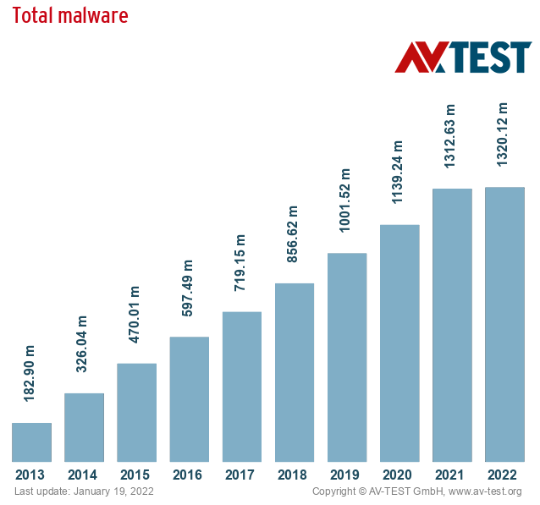
Figure 3: Last 10 years of total malware [10]
There are over 1 billion users using the internet and there are over 1 million malwares. Figure 3 and figure 4 shows the statistics of how many malwares is out there and individuals using the internet. It is a lot of users and a lot of malwares.
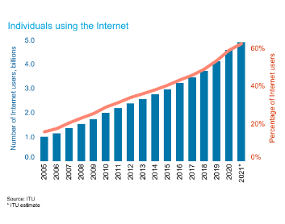
Figure 4:Number of internet users worldwide [11]
According to a website called “SafetyDetectives” [12] It is an estimated that one-fourth of PCs are NOT protected with an anti-virus software, giving them an average 5.5 times more likely to be affected. Figure 3 and figure 4 statistics are important it just shows how rapidly malware has increased and internet users over the years and the statistic of the estimate that one-fourth PCs are not protected with anti-virus just shows that it is an increased chance.
According to a research article by Vijayanand and arunlal [13]. It is an estimate that in 1990 around 200 to 500 viruses were discovered or known to industry. In the year 2000 numbers have grown fast over the few years to 50,000.
The first virus according to Kapersky was called “The Creeper Program” it was one of the first virus created in 1971 by Bob Thomas. The virus was a self-replicating program, it was designed as a security test to see if it was possible. [14] It had no malicious intent just displayed a message.
According to Park, Sharman, Rao, and Upadghyaya the impact of the worm called MyDoom caused so much damage of $1 Billion and $250 million. [15] Mydoom was the most successful virus. It was transmitted through email, and goal was to infect computers. According to money cnn it cost companies up to $250 million in productivity and technical support expenses. [16]

2.5 How does malware work and how to identify?
According to Namanya, Cullen, Awan, Diss. They described the definition of a malware. if the application or file code is changed, added, or removed from a software system to cause malicious behaviour then that is a malware.
A malware can easily be downloaded by accident this could be by opening emails attachment or downloading a software from the internet. The virus is activated by opening the software.
Malware typically infects a machine by tricking the users. It is a program that is made up with some malicious code. According to Andrade, mello, and Duarte malware are programs that are designed to perform harmful actions on a computer.
As mentioned before these are the types of malwares
- Trojans
- Spyware
- Adware
- Worms
- Ransomware
- Fileless malware
These malwares have all the same intentions to cause damage to computers. Cisco has described malware to be intrusive and is designed to damage computer systems and files. [17]
A malware can be dangerous if a user doesn’t have an anti-virus. These malwares can cause a lot of damage such as stealing sensitive data, damaging system, and damaging networks. A malware works by getting through a PC by code and this code can get full access to your PC. Most malware are delivered from email. 94% of malware are delivered by email according 2019 data breach investigations [18], which is how they affect the PC.
According to Microsoft, attackers use this infrastructure to distribute. A malware is installed like a normal program that can be accessed like a normal program. [19] However, the figure 5 shows the process of how the code is different and that it has two different installers and two different servers which are harmful and disguise itself as a legitimate program. Figure 5 shows how a malware work. It accesses deep into the system to get through it. It is based of an malware called Adrozek and it is the infrastructure of a malware.

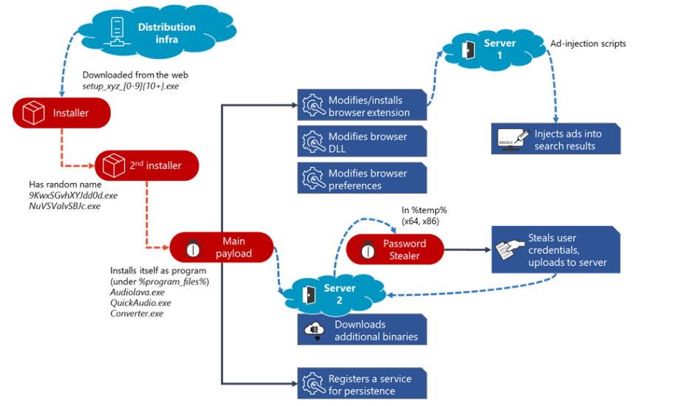
Figure 5: Installation of a malware - Adrozek attack [20]

A malware can affect your PC massively. There are ways to identify if a device has been affected by malware based upon their performance such as:
- Computer run slowly
- Computer stop responding
- The computer crashes and restart
- Applications do not work
- Disks and disk drive become inaccessible
- Malware can affect the network

2.7 What is an anti-virus software?
An anti-virus protects devices from malicious software/files. It is a piece of software that is made to detect and destroy viruses. [21]
“Anti-virus (AV) software are types of software products which attempt to detect, quarantine and /or block malware from running on devices” [22]
It is used to protect data and the device. the data can be damaged if a computer virus get in contact with the device.
An anti-virus software search for viruses, detect viruses, and then removes the viruses from an infected PC this would make the PC safe again to use however data could’ve been taken still.
Windows 10 and windows 11 are operating systems which provide a built-in anti-virus software. It is called “Window Defender” It help protects against malwares. However according to an online blog called “Safety Detectives” Martens stated that windows defender a minimum defence but not as good as other PREMIUM anti-virus software. [12]
There are a range of different anti-virus software, and they are different companies that make this anti-virus software to prevent malicious software from affecting a device. According to a website called TechAdvisor. They described having an anti-virus software as “Crucial” for protecting your files, finances, and personal information. They have reviewed and rated the best to help a person choose an anti-virus. [23]
There are different types of anti-virus software for:
- Cloud based
A cloud-based anti-virus protects the user or business by interacting with a threat database that is stored in the cloud rather than on your computer. There is specific anti-virus software that offers cloud anti-virus. There are integrated into the anti-virus software some free software may offer it, and some may not. According to Kaspersky, which is known for its anti-virus software, they have described a cloud anti-virus is a programmed solution that offloads anti-virus tasks from a user's machine to a cloud-based server. [24]
- Free
An anti-virus software limits the features on the software. However, they still do the basic protection for a device.
- Paid ones
An anti-virus software is paying for all the features to increase security on the device. these features can be cloud, firewall built in, and many more. These features can be disabled to those who have a “free” version.
Relating to the project will be using free and paid ones and will be avoiding cloud based anti-virus softwares.

2.8 How does an anti-virus software work?
An anti-virus software scans a downloaded file on your PC. It goes through the programmed code and see if the code has similarity to a dangerous known malware, then it would remove or prevent the user from opening the software. It is the best way to detect a malware on a PC. An anti-virus software is coded to defend a system against malicious software.
According to a research paper by Choudhary, Saroha, beniwal the anti-virus software works by the malicious software/file being passed to the anti-virus and then it scans the information and disinfect the file. The software/file that are not malicious are sent to a “Interception” phase so it can go towards the destination system. The user is then alerted by a notification on the user interface [25]. The file/application is scanned and if the file is malicious it is deleted from the device by the anti-virus.
Figure 6 shows the progress of an anti-virus software. The source system is the data and then the destination system could be a hardrive or usb. Then the data is cleaned and then can be allowed to access and then the user is alerted by a notification. Figure 6 shows the progress of how an anti-virus software should work.
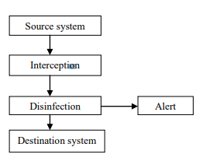
Figure 6: shows the steps on how an anti-virus work [25]
According to a journal by Patil, the anti-virus engine works by the binary code from a file or software being scanned to find these strings that the file/software has if the code matches a similar code to a “virus code” which is a similar pattern then it alerts the user [26]
According to castelli, the first technology used by an anti-virus software is called “signature matching” The anti-virus product contains a database of virus signatures and it detect a virus any time it sees a code that matches the signature in the database. [27] Also, according to Al-Asli and ghaleb they have also said It is a KEY process of any virus intrusion or malware detection system. current anti-virus products heavily relay on these signatures to identify malware. [28]
It is important to know how an anti-virus software work before conducting an experiment which simulate attacks on PCs.

This is the most common technology used in anti-virus software products as it is an efficient way to detect a malware by matching the similar code which are used in malicious software.
An anti-virus has two COMMON ways of operating which are real time and scheduled. However, there is another feature which is called boot-time scans.
These features are:
- Real-time
Real-time access is when the anti-virus is operating. It scans the file for threats when downloaded.
- Scheduled
On- access is a Manuel scan – it is configured to scan at a certain time
- Boot-time scan
This feature scans automatically when the system restarts. This allows the software to scan the files/applications before the operating system FULLY loads. [29] [30]

According to Dataprot on average anti-virus software is only 25% successful at detecting malware. [31]. There are many methods that are used in anti-virus to help detect a virus. Which are:
- Heuristic-based detection
This type of algorithm of signature is known to viruses. It can unearth viruses that has not been detected. This type of approach is more likely to cause a false positive.
- Signature-based detection
This is most common for most anti-virus software. It is easier to detect. This detection type looks for patterns. It observes events and identify patterns which matches known attacks.
- Behavioural detection
This type of detection observes and evaluates the suspicious file. If the detection pattern is detecting a harmful indication based of behaviour and activities, then it will alert the anti-virus software.

False positives are common to happen when you got an anti-virus software. If an application matches the anti-virus tools/methods that were use, then it will flag that application to be harmful. According to Jacobson and Iziorek(2013) they described a “false positive” as an anti-virus program incorrectly determines a legitimate piece of software is a malware program. As the experiment will be using anti-virus software and attacks. The scan, detection and the false positives are important to know as this information will help when conducting the experiment

2.9 Virtualisation
Virtualisation is creating a virtual version of something. According to a research paper they define Virtualisation as creating virtual isolated states of computer platforms, operating systems, storage devices and network resources by using techniques such as time-sharing, simulation and partitioning [32] . They also said that “Virtualisation is one of the major backbone components in cloud computing”. Virtualisation is used a lot and there are different types such as:
- Data Virtualisation
- Desktop Virtualisation
- Server Virtualisation
- Operating system Virtualisation
- Network functions Virtualisation
There are two different kind of hypervisors which are:
- Type 1
A type 1 hypervisor runs directly on the host machine’s physical hardware. This type of hypervisor is called Native. Type 1 hypervisor doesn’t have to load any underlying OS, it is directly connected to the host hardware. Hypervisors that run on physical hardware are highly secure. According to a research paper made by Alexandra Aguiar and Fabiano Hessel they described hypervisor 1 as a “Hardware level Virtualisation”. The task is to manage multiple copies of the real hardware, the virtual boards just like OS manages multitask [33].

- Type 2
A type 2 hypervisor is installed on top of the users existing OS this is called a hosted hypervisor. This type of hypervisor relies on the OS. According to a research paper made by Alexandra Aguiar and Fabiano Hessel they compared the type 2 hypervisor as another user application that simply “Interprets” the guest machine ISS [33]

Figure 7 shows type 1 and type 2 hypervisor. The diagram shows that the type 2 is OS based while type 1 does not have OS based but is based of hardware.
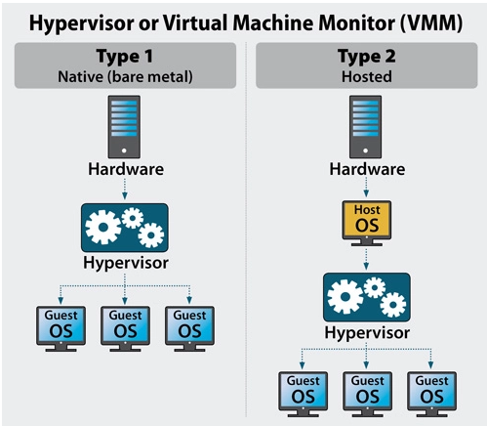
Figure 7: Virtualisation - type of hypervisor [34]
Businesses would use Virtualisation as it helps companies to increase workload. It is faster and easier to back up data. According to Vmware by virtualizing your server infrastructure you can reduce cost and consolidate hardware [35] Virtualisation relates to the project as the project will be conducted on a software called “Oracle VirtualBox”. There will be two virtual machines one with windows 10 and one with windows 8. Referring to the research paper - it interprets the guest machine which will allow the project to happen.
Virtual machine offers different kind of connection type – which allows you to connect to the internet. The different connection types are:
- NAT – allows you to connect - browse, download files, and view.
- Bridged Adapter - Advanced networking. It simulates network and servers in a guest.
- Internal Network – create software-based network -
- NAT network – NAT network is a type of an internal network that allows outbound connections
- Host-only host and set of virtual machines have access.
Figure 8 explains the types above in a table. It is much easier to understand how these connection types work.
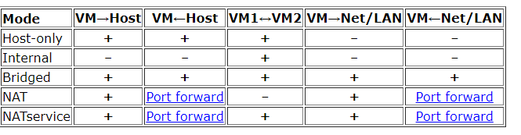
Figure 8: Networking types - what they can do on vm [36]

2.10 Simulation Software
An attack simulation is often used to identify vulnerabilities in businesses. These simulators are similar to technique and paths that malicious actors use. According to an online article they have described cyber security simulations to be useful as components of network security software ad in training exercises for security professionals [37].
This specific simulation software was chosen based of a table in appendix 2. The software was gathered by the type of malware attack and if it was free. This specific software was chosen to be used to conduct the malware simulation attack.
There are multiple simulation tools that can simulate an attack to test how protected your device and network is. The project will be using 3 simulation tools and they are different to each other which are:
- Trojan Simulator
- Ransim Simulator
- Infection Monkey
A file type called Eicar. It is used to test a response of anti-virus without using HARMFUL malware. A software called Trojan Horse Simulator uses this technique. This allows a user to test to see if an anti-virus software detects a virus.
The trojan simulator works by simulating a real trojan server and hiding it in the main window and AutoStart entry to register. To activate must click the install button and it adds to entry and to memory. Then uninstalling it unloads the trojan server from memory and entry registry.
According to the Ransim simulator. The software will simulate 22 ransomware infection scenarios and 1 crytomining infection scenario. The software does not use the user files and runs 100% harmless simulation. The software tool simulates the behaviour of ransomware attack. The simulation tool is there to see if the device is well protected and allows you to test anti-virus software effectiveness. According to KnowBe4 they have recommended that the anti-virus is kept on so it can have accurate and meaningful simulation test. [38]
Another software called Infection Monkey. The tool simulates an attack test networks. Infection monkey has said that it is not a malware, but it uses similar techniques to simulator malware on the network.

2.11 Related work
A technical paper by Daniel Santos a Virtual Machine was used, and a ransomware simulator was used. The performance of anti-virus software results was collected and recorded for analysis. Daniel recorded the CPU and memory of the anti-virus software when conducting the scan for malware presented as a graph. Daniel did a table if the anti-virus software came back with a false-positive, executed, vulnerable and incorrectly blocked. [39] This relates to the current project that is going to be conducted as an experiment is carried out on a virtual machine and simulators are going to be used to conduct the experiment.
Another technical paper by Knowbe4 which was the simulator report. The McAfee was 41% of not detected with the highest being 89% by Microsoft anti-virus software. They did the same tests but with popular anti-virus software [40] This relates to the experiment as ransom simulator was used in this technical paper and will also be using anti-virus software McAfee.
Another technical by AL-Shaheri, Sami; Lindskog, Dale;Zavarsky, Pavol; Ruhl, and Ron. They selected five anti-virus products which were AVG, Kaspersky, McAfee, Avast, and trend micro. The anti-virus software went against 3 rootkits which were Blackenergy, Haxdoor and Papras [41] .This project experiment is similar but not with rootkits as this experiment is more directed to malware simulators.

2.12 Conclusion
This chapter discusses the topics around the project that will be conducted. The research that has been conducted gives further information into the project.

Chapter 3 – Research Methodology

3.1 Introduction
A research methodology used to conduct research for this paper. There are different types of method to research. The research methodology was mostly mix methods. The chapter describe the research and the approach to the project. The research methodology will explain the reasoning behind this project.
The research onion has six layers. The research onion shows the different decisions that you will need when developing a research methodology. Figure 9 shows the research onion layers. These layers help to follow a research methodology. It explains the ways and a purpose of the research that is gathered.


Figure 9: research onion [42]
The purpose of the thesis to show how the importance of an anti-virus software. The knowledge of knowing the different kinds of malware and how to decrease your chances of getting one is important, it keeps the user and the company safe.
According to the book “Research Methods for Business Students” Secondary data can provide a useful source from which to answer, or partially to answer, your research questions. This technique can be usable within the research. Existing information or data was used to conduct research of this project.

Hypothesis
Which anti-virus provide the best protection in a comparative and experimental study?
Are anti-virus software’s providing protection?

3.2 Methodology

3.3.1 Research Process
The analysis process would be done using secondary. The research would have to cover the project. It would be a quantitative analytic. The quantitative research method is better for this project as that method is normally used for projects. The process that is better suited to this project is the deductive as the stages is more suited to an experimental project. The deductive process will be used to gather the project and to test.
There are two different types of research process which is called
- Deductive
Deductive process is theory, hypothesis, observation and confirm or rejection. Deductive research is driven by theory hypothesis and then data is collected and analysis.

- Inductive
Inductive process is observation, pattern, tentative hypothesis, and theory. It starts from a research question, and data is collected and then is generates a hypotheses and theory.

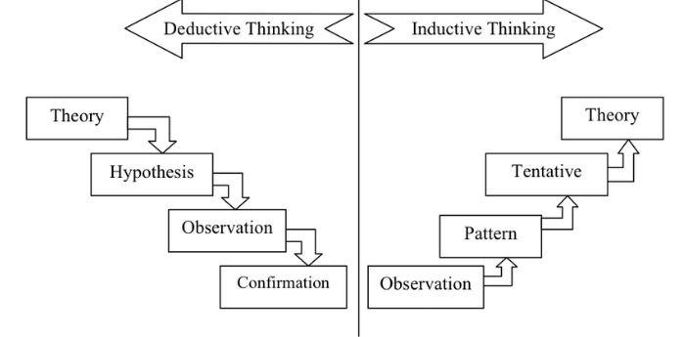
Figure 10: Deductive and Inductive [43]
Figure 10 shows the difference between deductive process and inductive process and how the process works.

3.3.2 Research Philosophy
There are different types of research philosophy. These types are:
- Pragmatism
Answering the research question
- Positivism
Positivism method is based on data collection and hypothesis development. These hypotheses are tested and confirmed. This is better suited to the project because the project will be testing anti-virus against malware emulator.
- Realism
Realism is based on facts, credible data and could be biased.
- Interpretivism
This research philosophy is a method for conducting research among people rather than objects such as medicines and computer.

The research philosophy which is used in the research methodology is called Positivism. It is based on data collection and hypothesis development. According to the book “Research Methods for Business Students” they have explained positivism which is to generate a research strategy to collect these data you are likely to use existing theory to develop hypotheses. These hypotheses will be put to the test and proven [42].

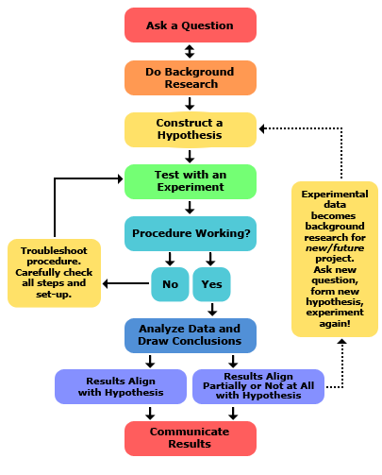
Figure 11: Scientific method to research( [44]
Figure 11 shows the scientific method to research and how a research methodology would work. Doing background research and then testing allow a person to get in depth analysis of their project research.

3.3.3 Research methodologies
The methodology that was used was quantitative research. This type of method is better suited to projects.
To complete the objectives of the project was using existing information or data. The method was researching government websites about guidance for cybersecurity and malware on the internet and using books.
The existing information or data sources are mostly from UK government websites and needed to be from ethical websites. The data sources that were selected were like the project and the data was selected based upon the reliability and the date that the website was updated last.

3.3.4 Philosophies
Positivism will be the philosophy for the experiment. Positivism depends on observations that lead to statistical analysis. The whole PC hardware, and software are going to be monitored by software. This is important to the experiment as it conducts the results which is needed for the project to show how it is effective.

3.3.5 Approach
There are different kind of strategy approaches which are:
- MULTI-STRATEGY
Multi-strategy uses two qualitive methods
- MIXED-STRATEGY
Mixing quantitative and qualitive data
- MONO-STRATEGY
The mono method comprises only one method for study. Which will be used in this project as there only quantitative method.
There are different kind of research design and the one that is suited with this type of project is the Descriptive research design.
A descriptive research design is to obtain data. The data is simply identified and observed. This design gathers information. It can measure the project data specifically and can identify different performance of the software.

3.3.6 Strategies
To achieve the overall aim of the project. This plan required in-depth research into what anti-virus software are, Virtualisation, and what malware. It is important to know an understanding of the project. The research was gathered by using sites such as research gate, government websites, and websites. There are many different types of anti-virus, malware, different types of Virtualisations, and simulation software.

3.3.7 Choices
The project will be using a virtual machine, monitoring tools, and malware simulators. This will allow me to do the project and conduct how the PC performance is and how the anti-virus is effective against the malware simulators. The software which will be used will conducts results which give off information such as false positives, pc performance, and anti-virus effectiveness.

3.3.8 Time Horizons
There are two types of time horizons which are:
Longitudinal – Repeated over an extended period time so this will show data that of the same subjects over a period time.
Cross-sectional – limited to a specific time frame
Related to this project cross-sectional will show results at a given point in time. This method would be used in this project as it quick snapchat of the current data.

3.3.9 Techniques & Procedures
There are different techniques to collect data. The data collection for this project would be collecting through the internet, libraries, and archives. It is secondary data which is qualitative/quantitative data that already exists and was collected by another person for a different reason.
The project will also be containing primary data. There are steps for how the data will be gathered safely. Virtual machines will be used to test malware on. It will be contained and isolated on a device and will be using a range of different anti-virus software. This would be giving primary data due to the test results from the project.
There are different ways to show research. Some of the statistics that were mentioned was shown in a graph image. When collecting data from the project it will be presented in a table that is clear and will also be shown in graphs to show performance of an anti-virus software this include the PC performance, and anti-virus performance. PC performance such as, CPU, memory with an anti-virus software and how well an anti-virus detects a malware.

3.5 Conclusion
This chapter summaries the techniques that were used in the research methodology. The key points of this chapter are the research methodology process which are deductive process, positivism, quantitative, mono method, and cross sectional. These are the type of research process that is used to conduct the experiment and research and this chapter shows the detailed depth of the research process and design.

Chapter 4 - Design & Implementation

4.1 Introduction
The project is about testing the effectiveness of an anti-virus software and evaluating the performance of the pc and network. The project will be on a virtual machine and will be using an emulator to simulate an effect of malware.
Referring to the research aim of this project which is evaluating the effectiveness of a range of anti-virus software and the performance of the PC.

4.2 Problem formulation
The general problem is that cyber-attacks are increasing. Ransomware attacks, phishing attacks, trojan attacks and many more. These cyber-attacks are more likely to focus small businesses and charities. Figure 12 shows the percentages of attacks that are happening to businesses and charities. Further research in Appendix 3
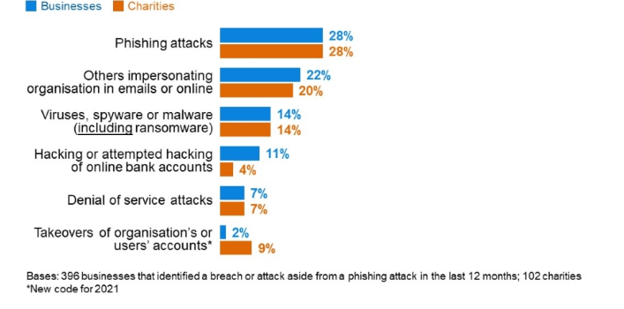
Figure 12: A graph showing a breach or attack [45]

Figure 13 shows the layout of the project and how it is going to work. The diagram shows the anti-virus software, malware simulators, and the monitoring tools that is going to be used in the project.
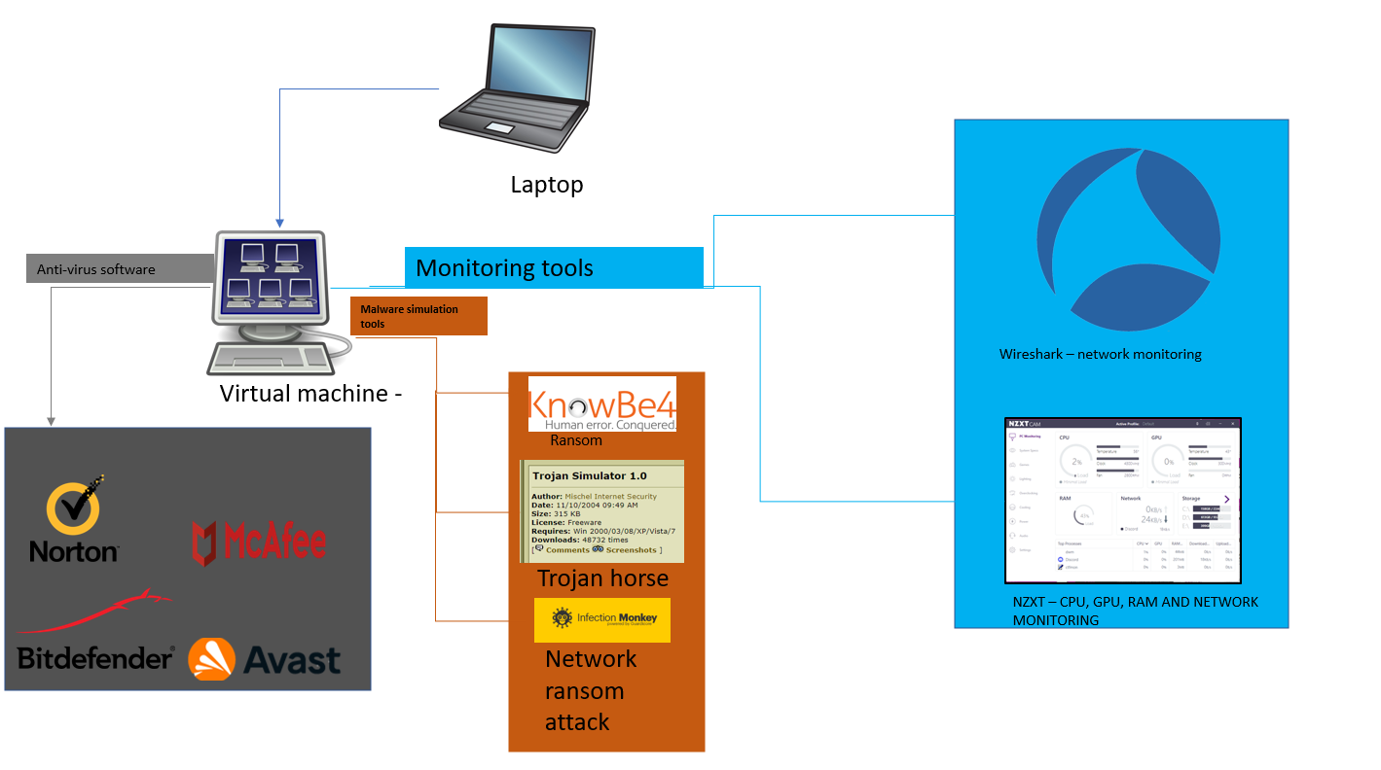
Figure 13: Block Diagram of project

4.3 Design
The design chapter is showing how the project is layout and how the project works. In my literature review research. The research was about different types of malwares, impact, what does it do, and simulator software. The literature review help choose the tools of the project, simulators, and the anti-virus. The anti-virus was based upon the technique the software use to discover malware.

The project requirements are:
- Virtual machines
A virtual machine is going to be needed. The software that is going to be used is called Oracle VM VirtualBox which is going to have windows 10 on it. There will also be another virtual machine which will also require windows 8.

- Anti-virus software(s)
Four anti-virus software will be used in this project. These were picked based upon features, price and technique anti-virus used in Appendix 4. These anti-viruses’ software is called BitDefender, Avast, Norton 360, Mcafee
- Malware simulators
The project will be using a simulator to emulate a type of effect that ransomware influences a pc. The project will be using a ransomware simulator called Ransim, another one called infection monkey, and trojan horse which is eicar file. The software will be run individually – not all at once.

- Hardware and networking monitor tool
The project objective is to see the effect on the PC performance and network when a pc is infected with a malware. The hardware monitor tool that will be used in this project is called “NZXT” it reads the CPU and GPU performance – load, temperature, clock, and fan. Figure 14 shows a hardware monitoring tool that is going to be used in the project which is called NZXT.
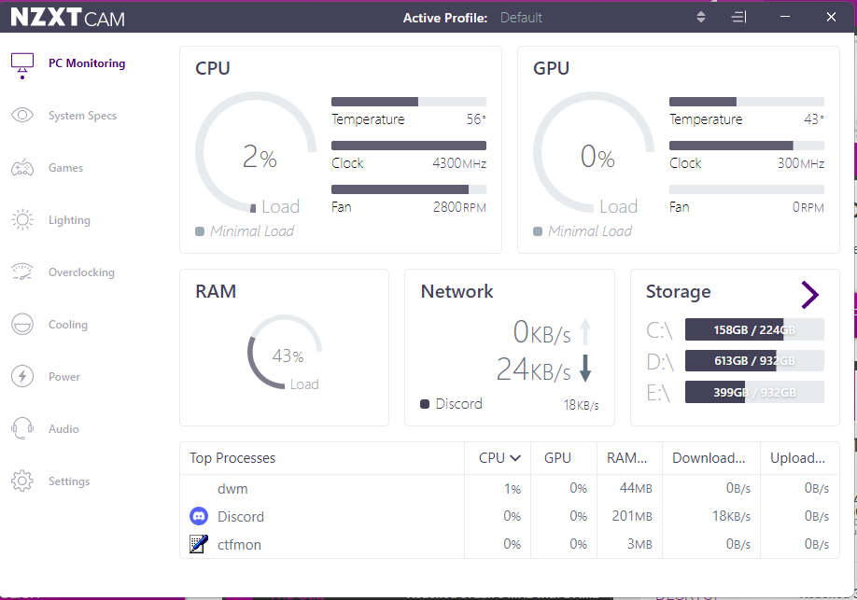
Figure 14: Screenshot of NZXT software

Figure 15 shows the setup of the network in pictures
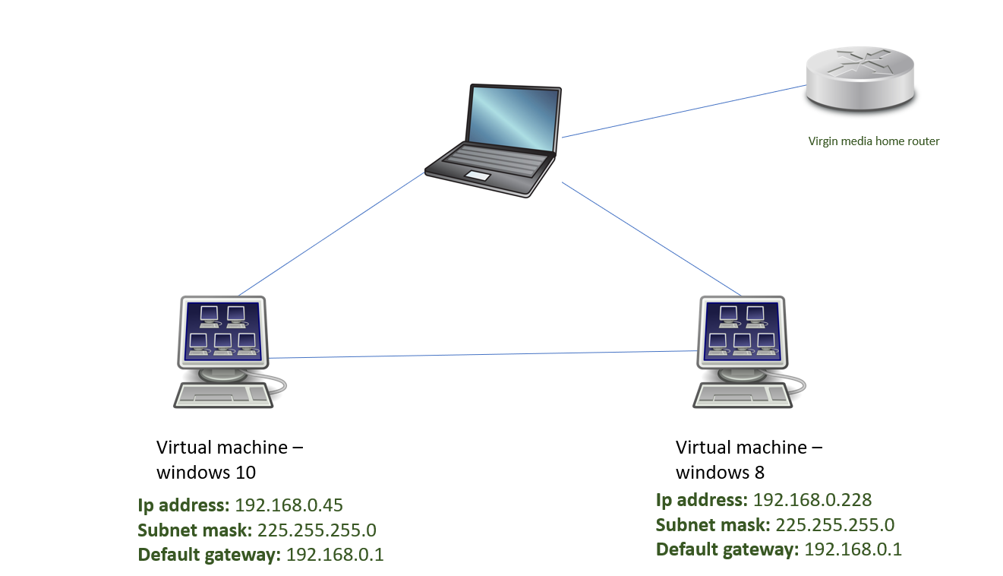
Figure 15: Network/virtual topology
figure 16 shows a network topology of the project virtual network.
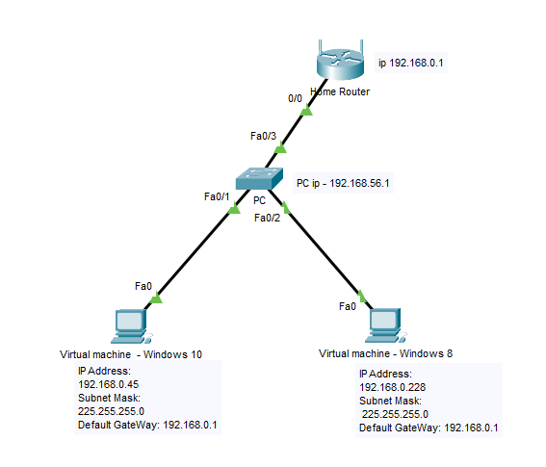
Figure 16: Network topology of project

4.4 Implementation

4.4.1 Virtual machine setup
The first step to this project is to set up the virtual machines. Figure 17 shows the creation of the windows 8 machine.
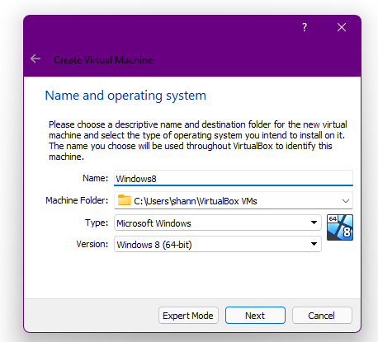
Figure 17: Windows 8 name and operating setup (Virtual Machine)
Figure 18 shows the creation of the windows 10 machine
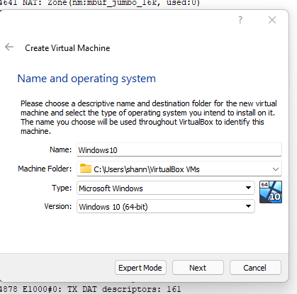
Figure 18: Windows 10 name and operating system setup(Virtual Machine)
The virtual machine has 2048mb base memory and created a virtual disk which has 50gb. The windows 8 had the same setup 2048mb, and a virtual disk which has 50gb. Before the installation of windows 10 and windows 8. The virtual machine needs an ISO disk which allows an installation of windows 10 and 8.

Figure 19 shows the windows 10 iso.
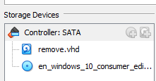
Figure 19: ISO windows 10
Figure 20 shows the ISO for windows 8.
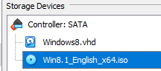
Figure 20: ISO windows 8

The setup for windows 10 and windows 8 installation. The selection of language and keyboard. Figure 21 shows the installation for windows 10.
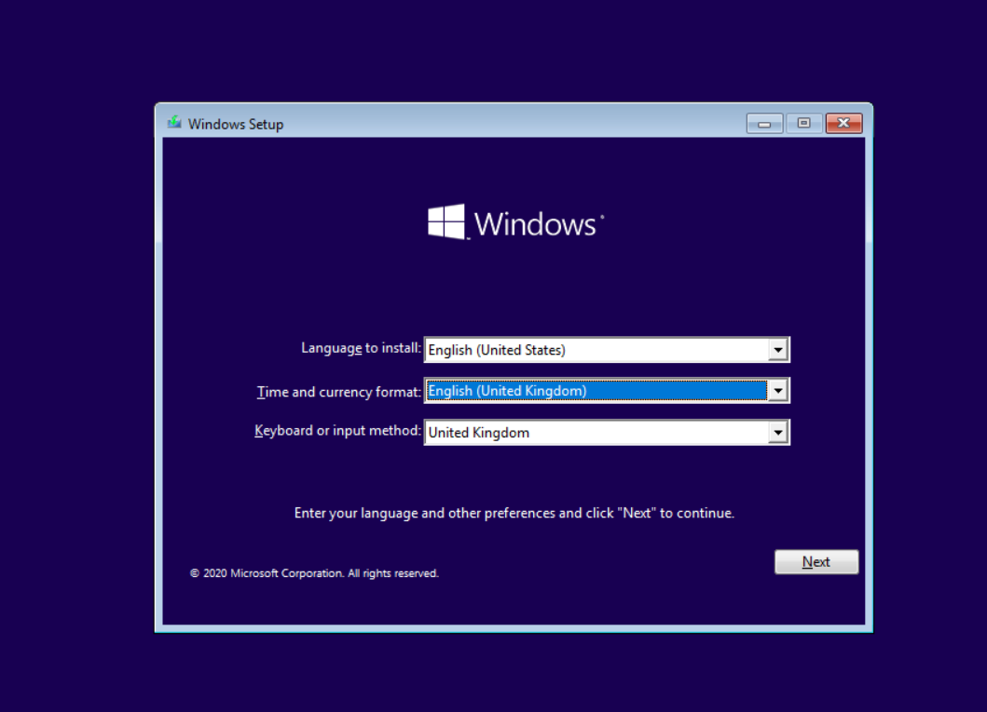
Figure 21: Windows 10 installation
Figure 22 shows a screenshot of the installation for Windows 8.
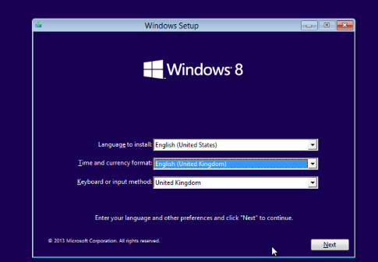
Figure 22: Windows 8 installation

Figure 23 shows evidence of windows 8 being installed.

Figure 23: Screenshot of Windows 8
figure 24 shows that Windows 8 and windows 10 are installed successfully and is now ready to use.
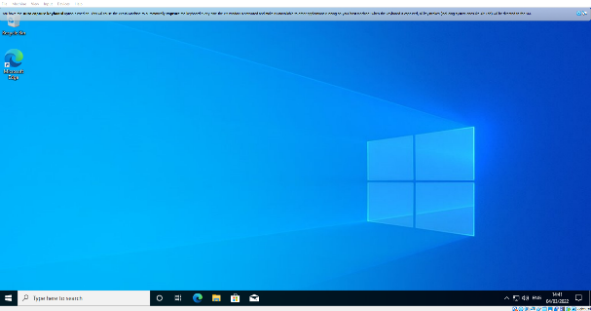
Figure 24: screenshot of windows 10
The virtual machines are all setup ready to use. However, there are settings that needed to be configured before starting the project.

4.4.2 Virtual machine network
The installation of Windows 8 and Windows 10 are complete. The next step to set up the network as mentioned in the literature review. The connection adapter that will be used is Bridged Adapter.
Figure 26 shows the connection type.
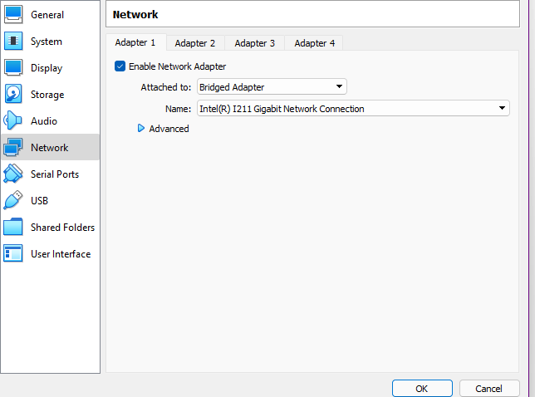
Figure 26: Bridged adapter
Figure 27 shows evidence of the windows 10 machine receiving the ping from windows 8.
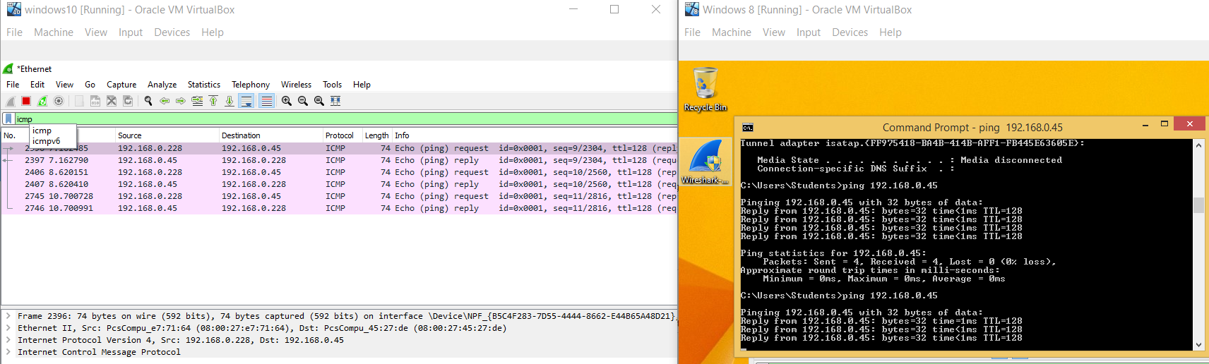
Figure 27: Windows 10 wireshark receiving ping from Windows 8 virtual machine

Figure 28 shows evidence of windows 10 pinging windows 8.
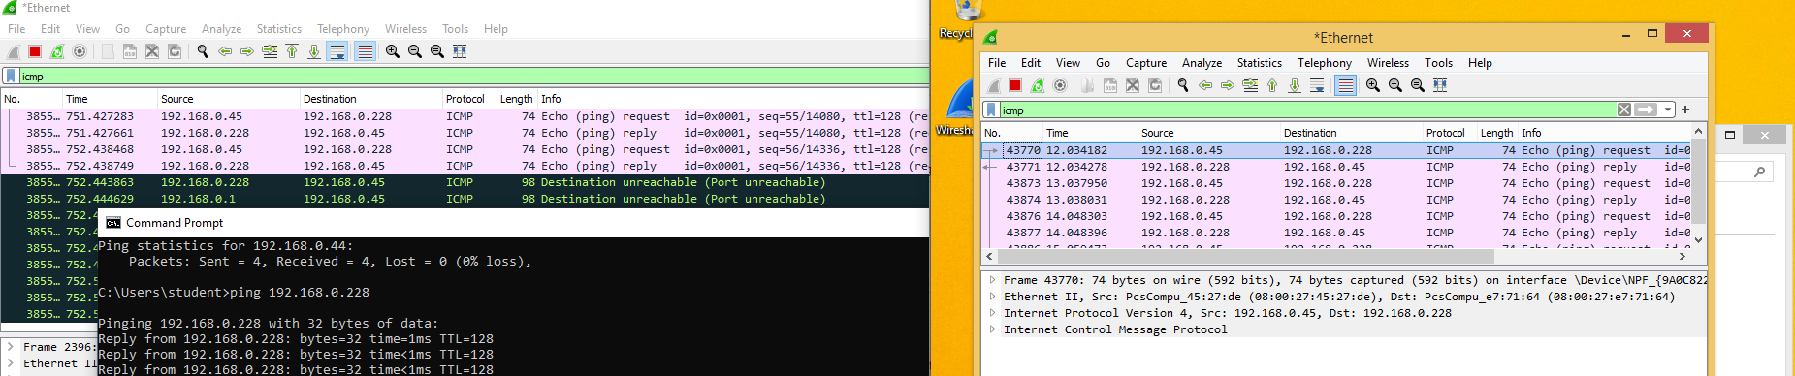
Figure 28: Windows 10 pinging windows 8 virtual machine

4.4.3 Shared Files
The next step after doing the network is doing shared files. The PC and virtual machine would need to be connected to be able to share folders. This will allow to share the software that is going to be used. To be able to do these settings had to be enabled.
Figure 29 shows the installation of the guest additions – this installation allows PC and virtual machine to share folders.
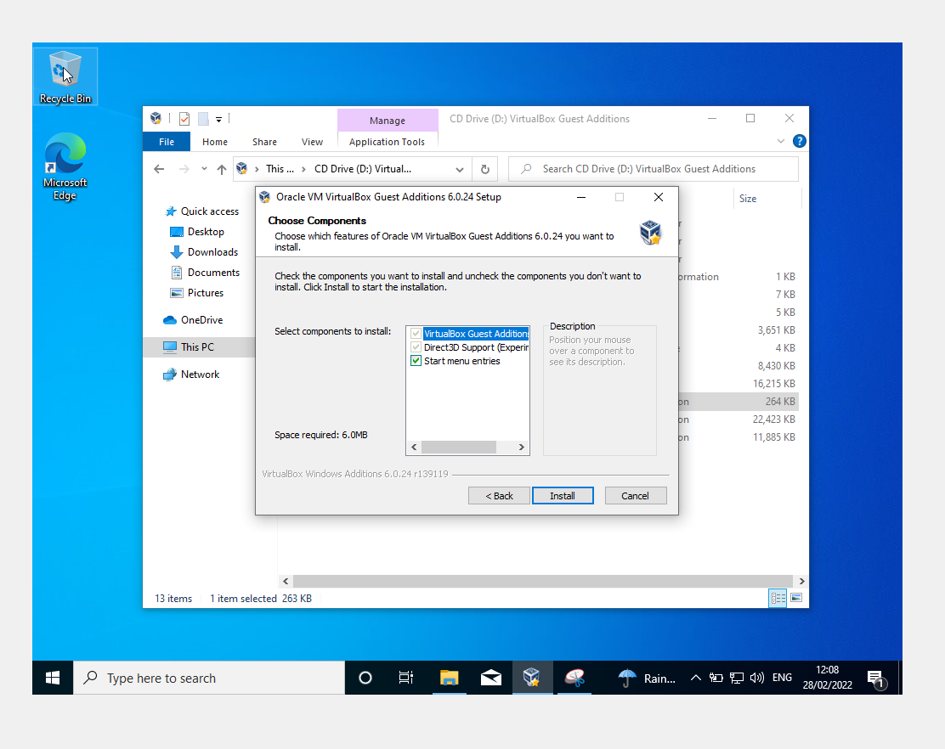
Figure 29: Sharing folders

After the installation the machine needs to restart and then boot up. To be able to share folders there are settings that need to be configured to be able allow access to a certain folder on the PC. Figure 30 shows the configuration of shared folder in the virtual machine settings.
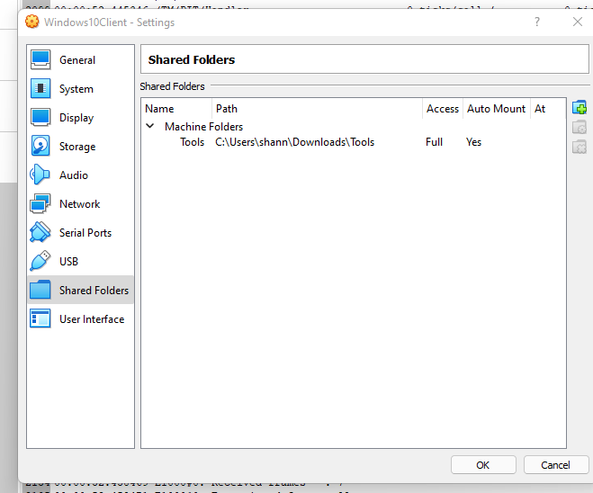
Figure 30: Shared machine Folders
Figure 31 shows a file in the shared folder which allows the VM and the host of the PC to have connection.
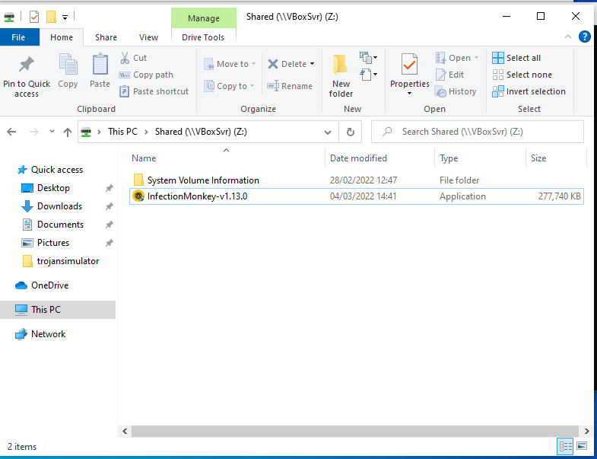
Figure 31: Shared folders working

4.4.4 Installation of tools and software
The installation of tools which is needed for the project are:
- Wireshark
- NZXT cam
The first tool to be installed is WireShark. Figure 32 shows the Wireshark installation.
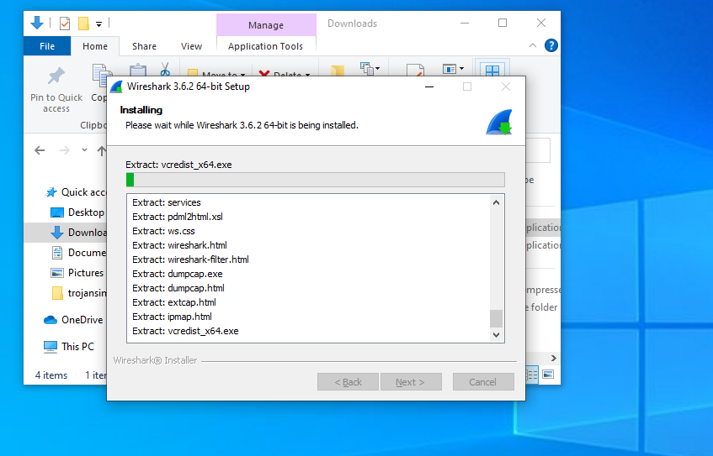
Figure 32: Installation of Wireshark
The next tool is a hardware monitoring tool called “NZXT”. Figure 33 shows the installation process.
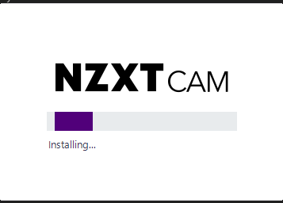
Figure 33: Installation of NZXTCAM

The first simulator will be installing is called RanSim. Figure 34 shows the process of the installation
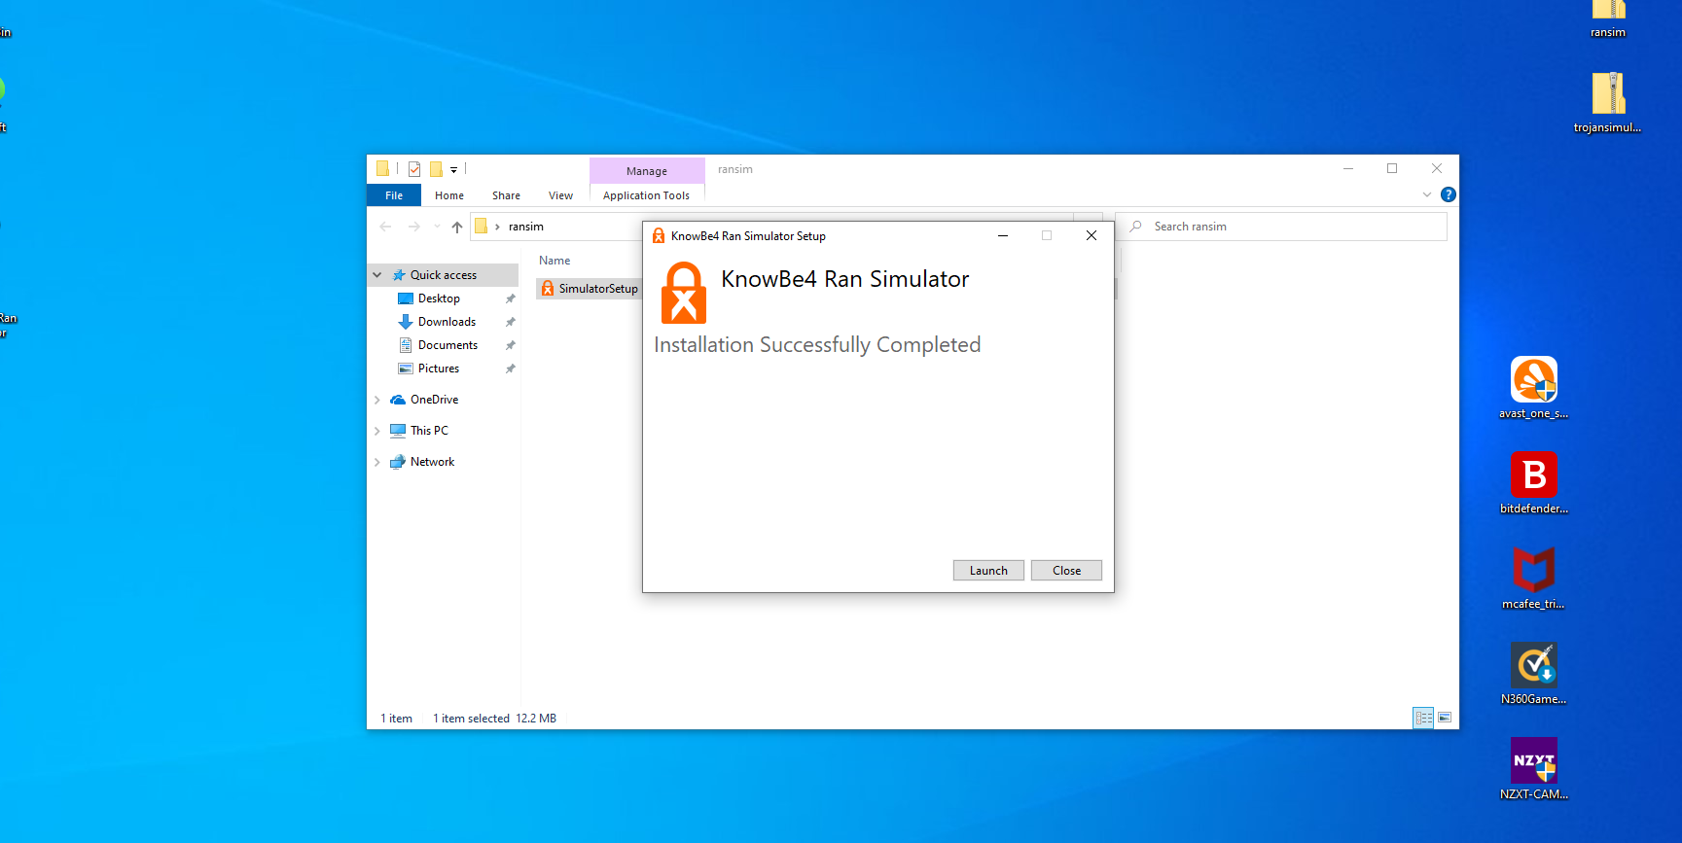
Figure 34: Installation of KnowBe4 Ram Simulation
The next malware simulator installation is called Trojan Simulator. Figure 35 shows the installation process for the trojan simulator.
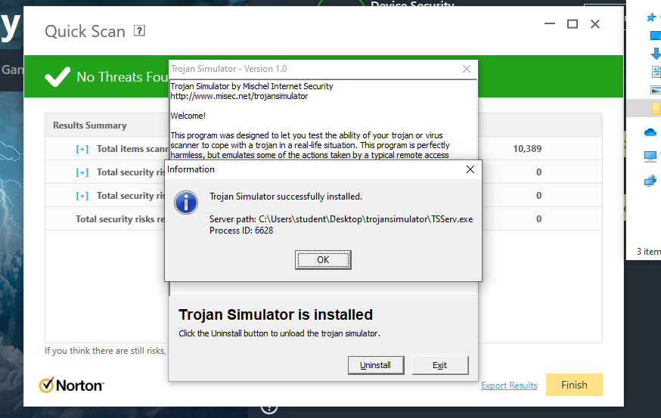
Figure 35: Installation of Trojan Simulator

The final malware that was installed is called Infection monkey. This software requires an internet connection for this simulator to work. Figure 36 shows the installation of the software called Monkey Island/Infection monkey simulator.
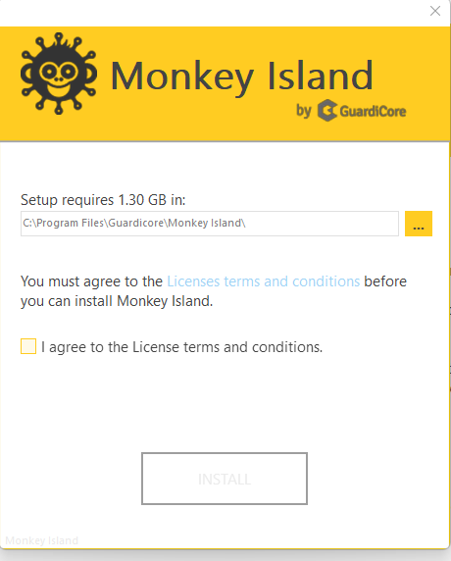
Figure 36: Installation of Infection Monkey
The next step is to install the first anti-virus to be installed is called Norton. Figure 37 shows the installation of Norton being installed.
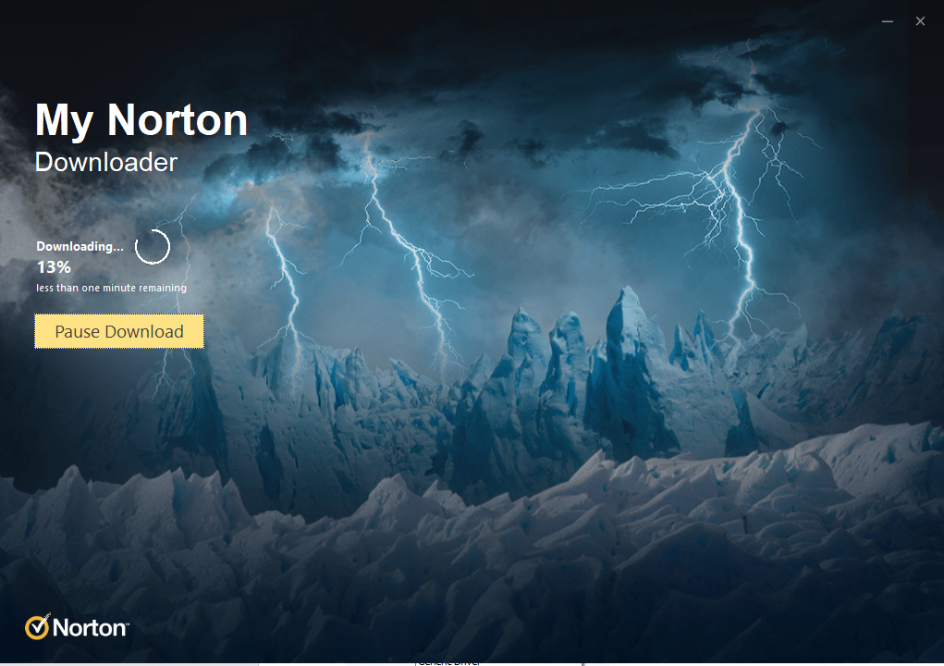
Figure 37: Installation of Norton 360
Next anti-virus software installation is called Bitdefender Security. Figure 38 shows the installation of the anti-virus software of BitDefender.
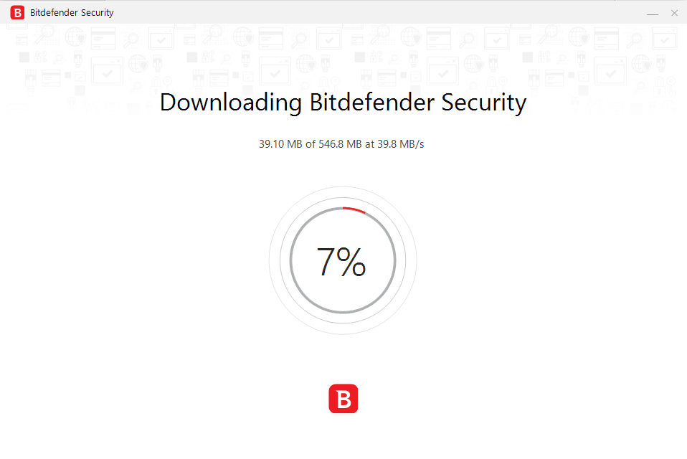
Figure 38: BitDefender Installation

The next anti-virus software installation is called AVAST. Figure 39 shows the AVAST installation on Windows 10 virtual machine.
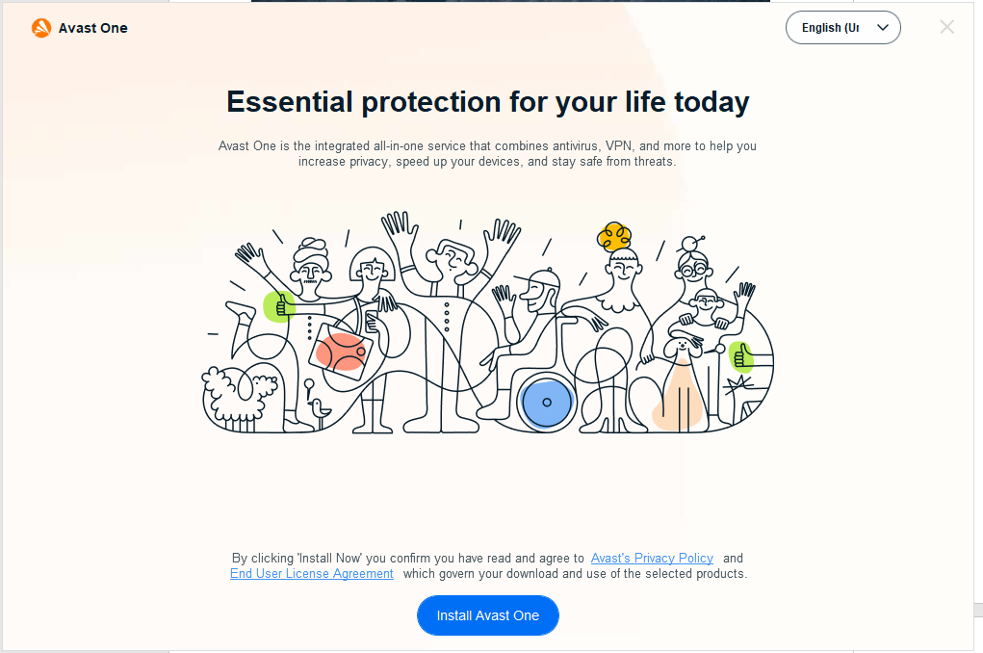
Figure 39:Avast installation
The last anti-virus software installation is called McAfee. Figure 40 shows the installation of McAfee software.
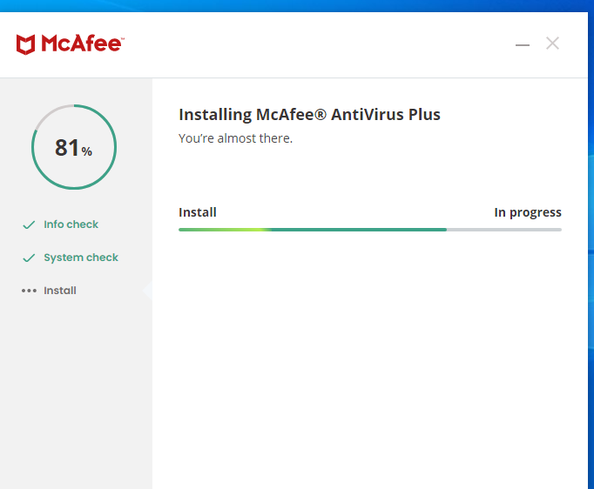
Figure 40: McAfee installation

4.5 Conclusion
This chapter shows the implementation for the project. This chapter shows how the network topology, and a block diagram shows how the project will work. The chapter shows screenshots of setting up the virtual machines and softwares which are needed to conduct the project. The next chapter is the testing and evaluation which this step allows us to process forward.

Chapter 5 – Testing and Evaluation

Introduction
This chapter is conducting the experiment and evaluating the project outcome. The key points of the experiments are simulation of different types of attack, anti-virus software effectiveness and PC performance. This chapter consists of screenshots and showing the results from the softwares.

5.1 Norton anti-virus software

5.1.1 Trojan Simulator
The first stage was to test was on Norton. Norton did not quarantine the “malicious file”. However, it said that “There are many indications that this file is untrustworthy”. It did not remove the file. Figure 41 shows the details of the application.
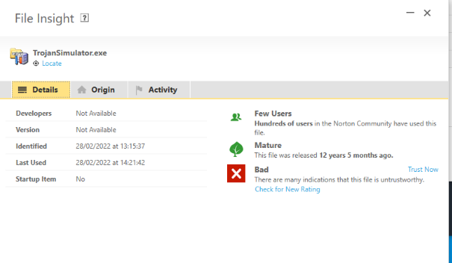
Figure 41: screenshot of "malicious file"
Stage two of the test was to evaluate the anti-virus software based on performance.
The anti-virus performed a scan and while it was running a scan the CPU, and RAM escalated up rather than before which was a steady performance. Figure 42 shows a screenshot of the PC before performance
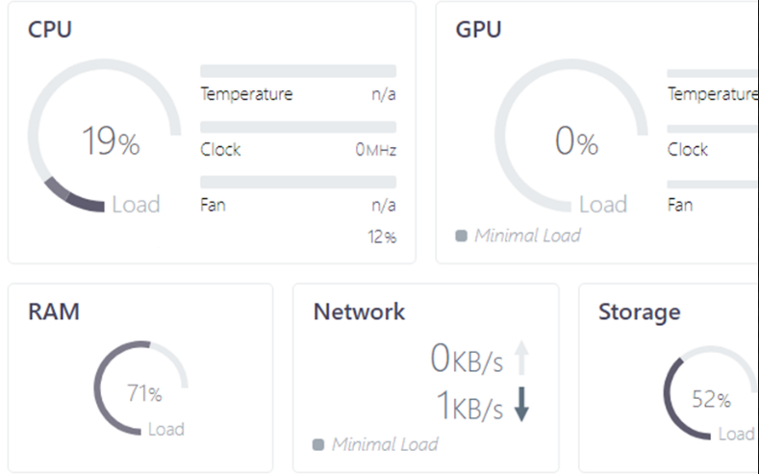
Figure 42: Norton PC performance before scanning

Figure 43 shows a screenshot of the PC performance while Norton was scanning for harmful files.
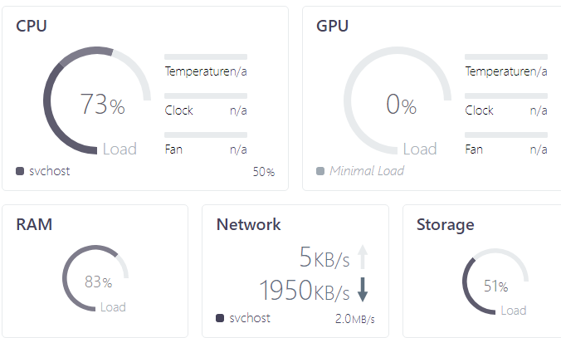
Figure 43: PC performance when scanning

Stage three was to activate the Simulator and record what the anti-virus software does.
A quick scan was done. Figure 44 shows that the Trojan Simulator was installed.
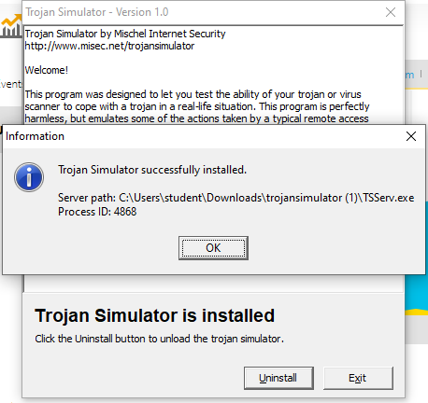
Figure 44: Activating trojan simulator with Norton
Figure 45 shows the task manager shows evidence of the “Trojan Simulator” activated while this was running this still was not detected and to further investigate a manual scan was used to see if the anti-virus software would detect it. The anti-virus continued not to detect it.
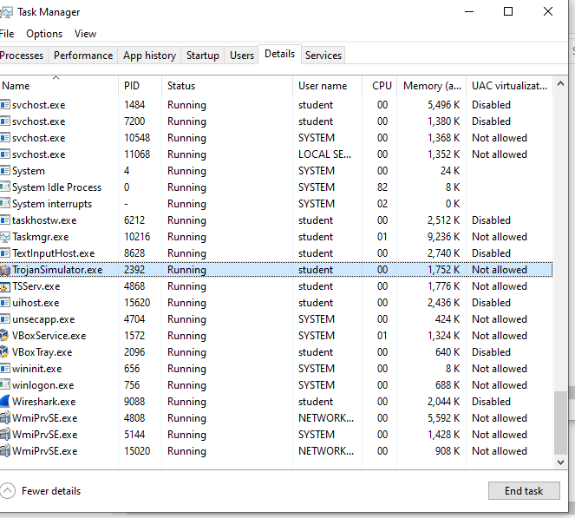
Figure 45: Screenshot of TTSERVE.EXE running - when norton was scanning

Figure 46 The diagram shows that the malicious file was not detected. Norton should have detected as the EICAR file was designed and created to test anti-virus software effectiveness.
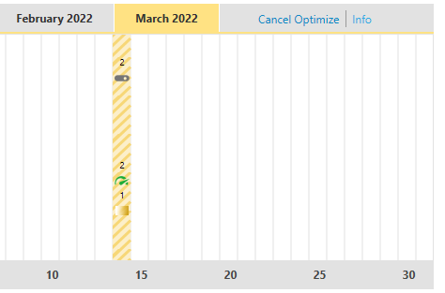
Figure 46: A diagram of Norton detection - did not detect EICAR file

5.1.2 Ransim Simulator
The first stage was to test Norton to see if it picks up the simulator. Norton did not pick up the simulator.
The second stage was to record the performance of the PC before and after it was scanning. Figure 47 shows the performance of the virtual machine
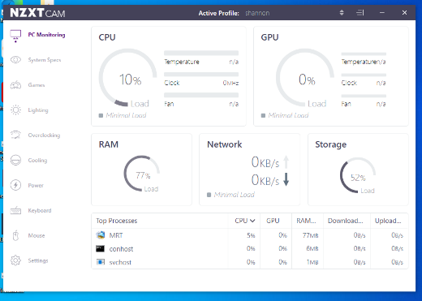
Figure 47: PC performance Norton not scanning - ransim simulator
Figure 46: Norton not running

Figure 48 shows the performance after when Norton was running
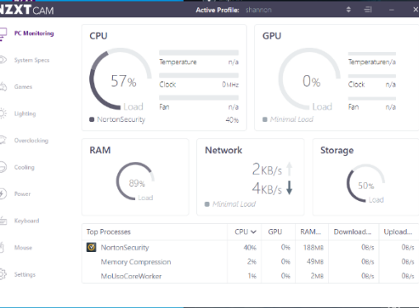
Figure 48: PC Performance. Norton scanning - Ransim Simulator

Stage three was to test if the anti-virus would pick up after activated. When running the ransim simulator, Norton picked up the “harmful” files and was blocking them. Figure 49 shows evidence of the blocking. However, Norton incorrectly blocked and left the system vulnerable with 3 scenarios.
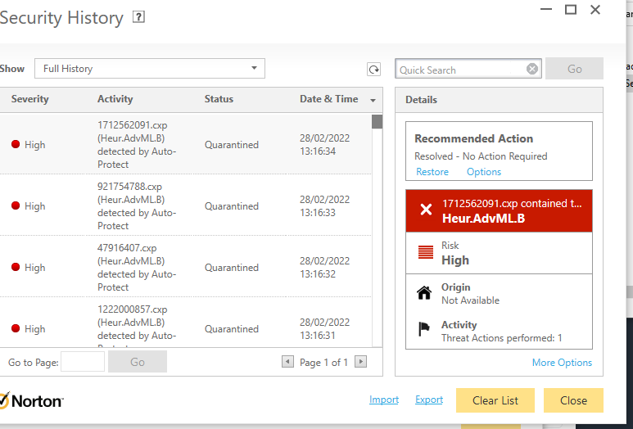
Figure 49: Norton ransim simulator - detected harmful files
Figure 50 shows the results of the ransom simulation attack and how Norton left the system vulnerable. The figure shows that Norton allowed 3/23 scenarios. One of the simulations was a simulation of DearCry Ransomware . The dear cry ransomware is designed to take advantage of the Microsoft Exchange servers.
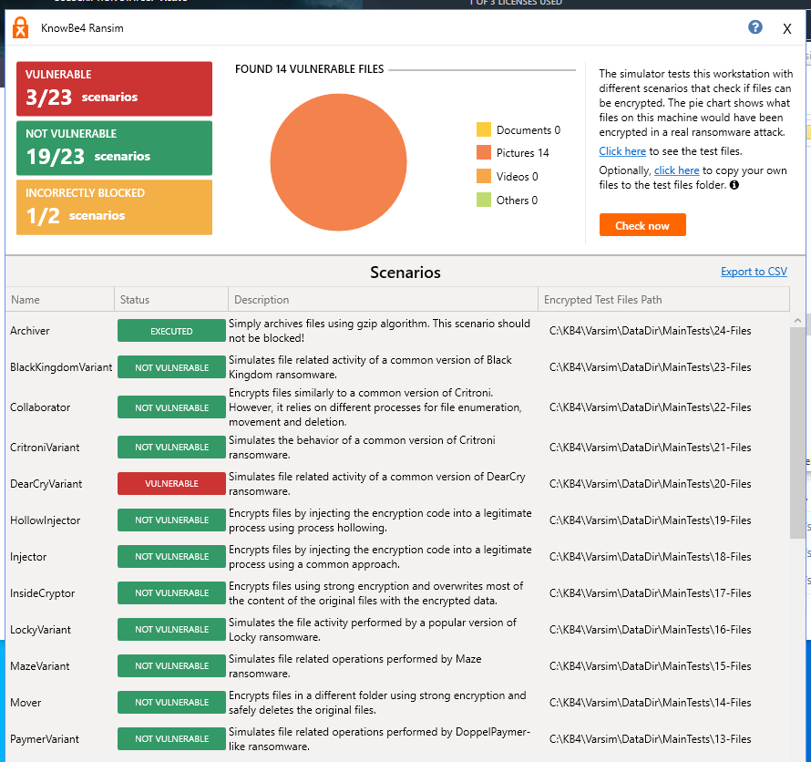
Figure 50: Incorrectly blocked and vulnerable- Ransim Simulator with Norton
Figure 51 shows Norton graph – shows evidence of how many malicious files were and how many times it alerted. There were 67 files and 0 alerts.
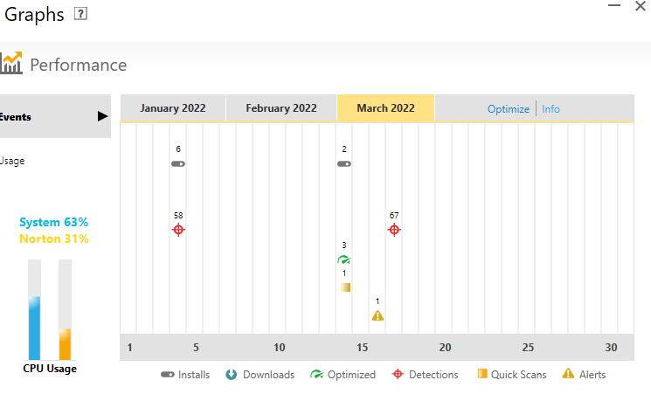
Figure 51: Evidence of detecting simulation attack - ransim simulator with Norton

5.1.3 Infection Monkey
Stage one of the test is to see if the simulator gets blocked. Figure 52 shows that the simulator did not get blocked straight away. Figure 51 shows evidence of the infection monkey running but not activated
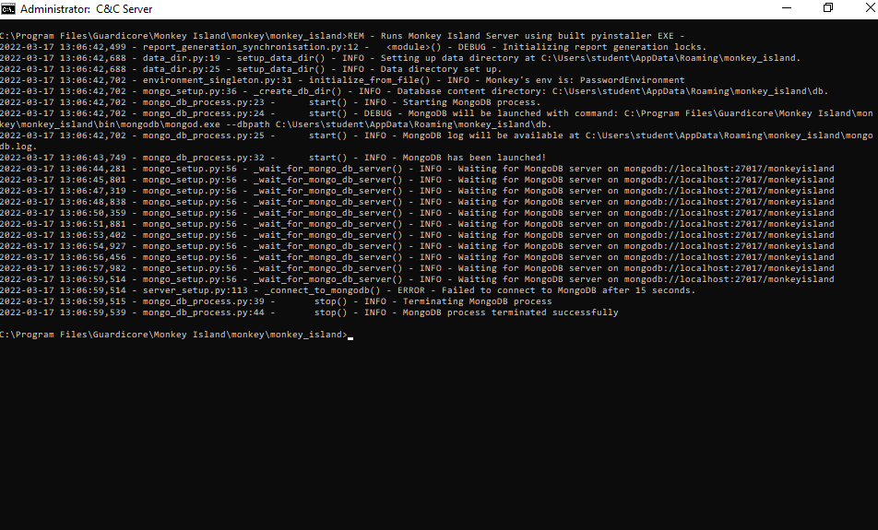
Figure 52: Simulator did not get blocked straight away before activation – infection monkey with Norton

Stage two – PC performance before and after
Figure 53 shows the performance of the PC when Norton is not scanning, just running in the background.
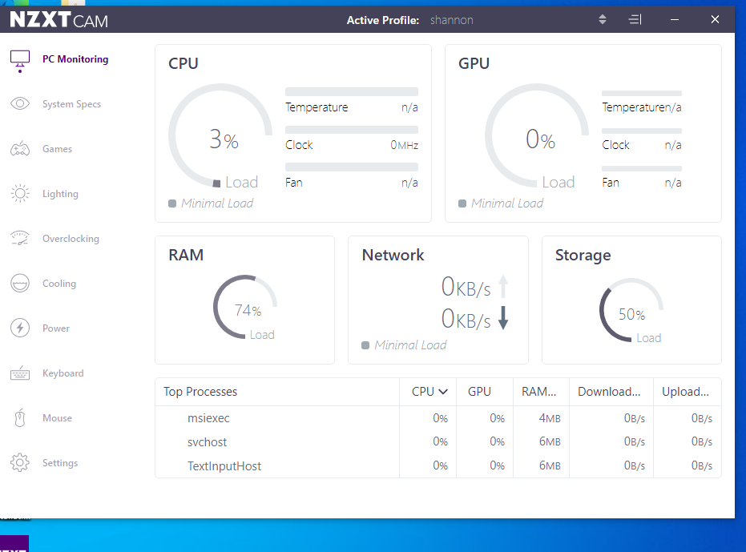
Figure 53: PC performance with Infection Monkey before scan- NORTON
Figure 54 shows the performance of the PC while Norton was scanning after it had been activated.
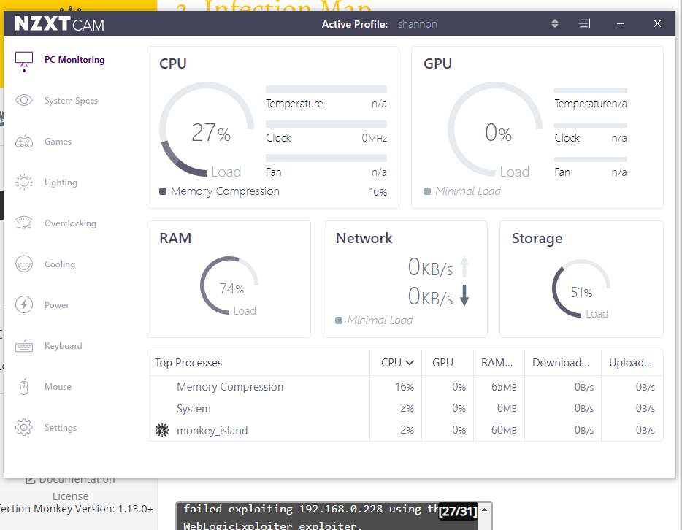
Figure 54: PC performance with Infection Monkey while scanning - Norton

Stage three – activation of malware simulator.
Norton automatically blocked the application. After Norton blocked it, the app Infection Monkey was restored. However, the firewall should have detected incoming/outcoming traffic. Figure 55 shows evidence of Norton being enabled, and scanning.
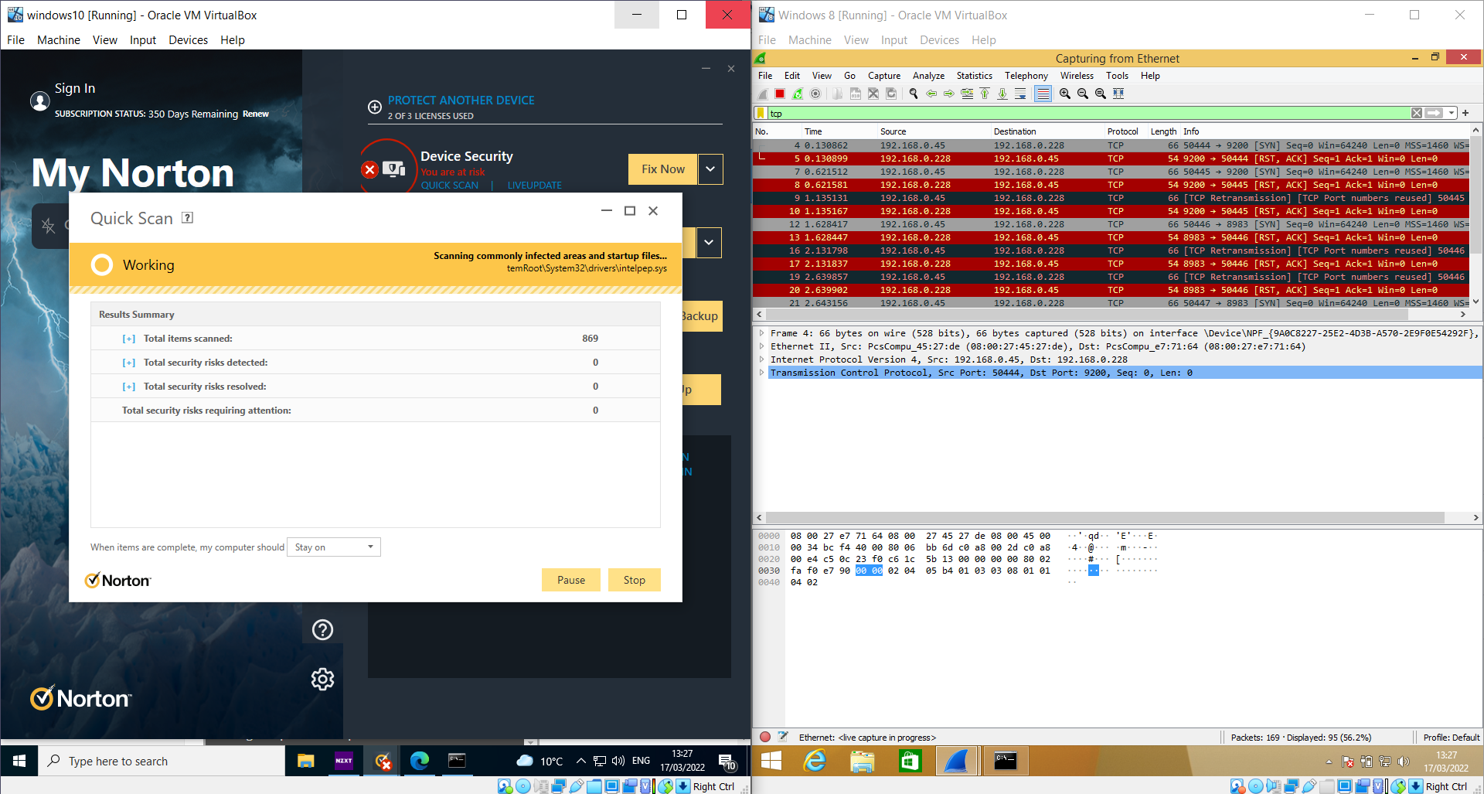
Figure 55: Infection Monkey - incoming and outgoing traffic – Norton
Figure 56 shows the connection of windows 10 and windows 8 and the incoming traffic.

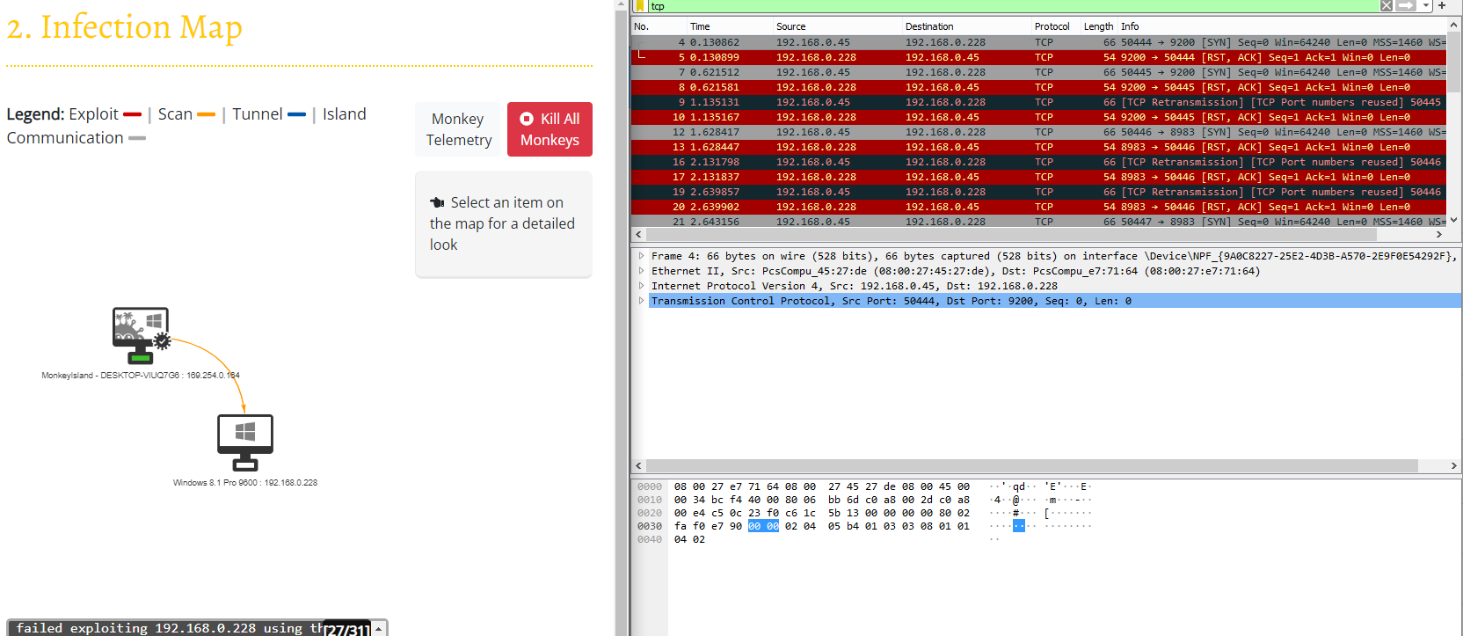
Figure 56: Screenshot of the infection map and windows 8 wireshark. Norton test with infection Monkey

A few seconds after infection monkey was activated Norton stopped the attack as it realised what was happening and then successfully started to block the simulated attack. Figure 57 shows the evidence of the blocking.
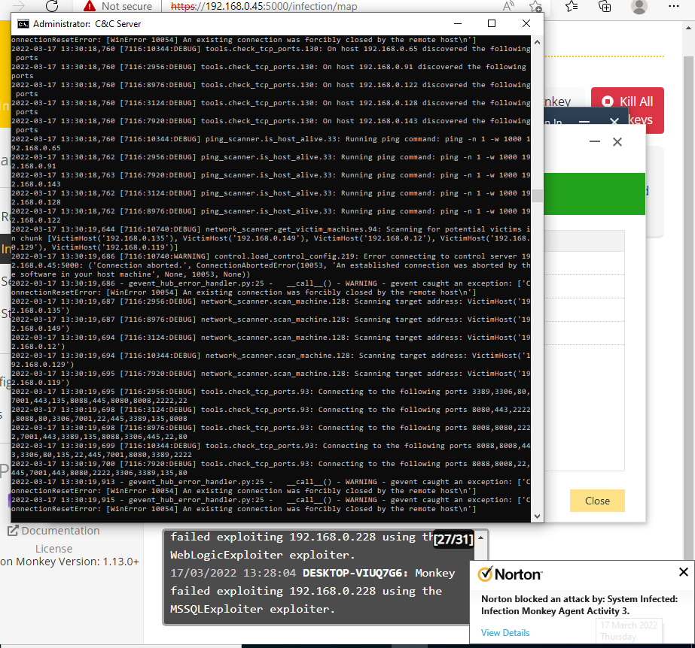
Figure 57: Evidence of Norton blocking Infection Monkey
After Norton started detecting, it detected an overall 290, and alerted 3 times. It blocked the incoming and outcoming traffic and not the APPLICATION. Figure 58 shows evidence of the blocking.
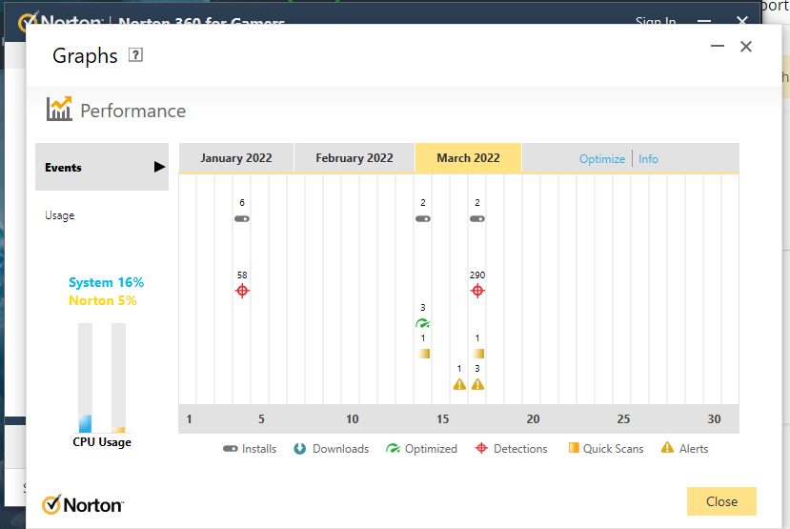
Figure 58: Screenshot of Norton detecting infection monkey

5.2 McAfee Anti-virus software

5.2.1 Trojan Simulator
The first stage is to check if the simulator automatically gets blocked by McAfee software. Which the application was blocked straight away even before activation.
Figure 59 shows evidence of the MacAfee blocking the application.
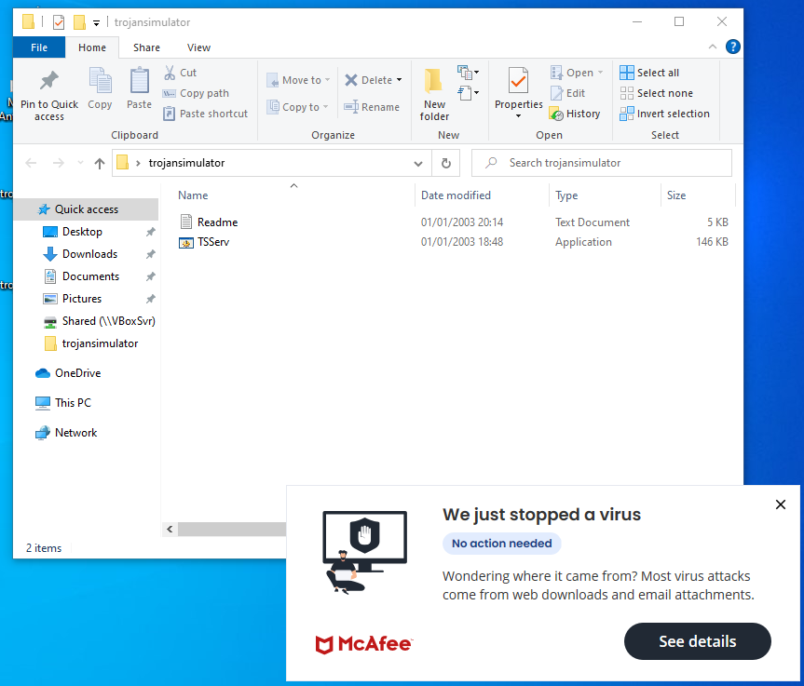
Figure 59: screenshot of McAfee instantly blocking Trojan Simulator
Figure 60 shows even further evidence of blocking the application before activation.
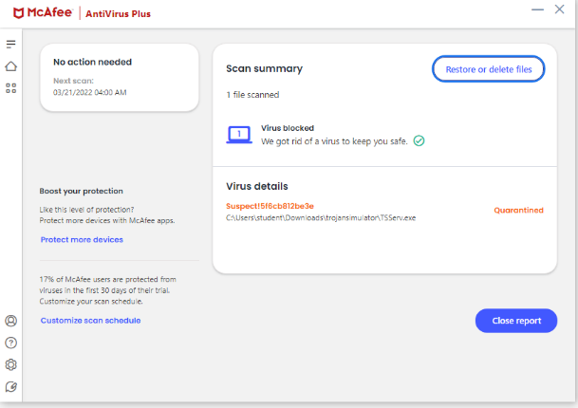
Figure 60: Further evidence of trojan simulator getting blocked by McAfee

The second stage as mentioned before is recording PC performance. Figure 61 shows the PC performance before
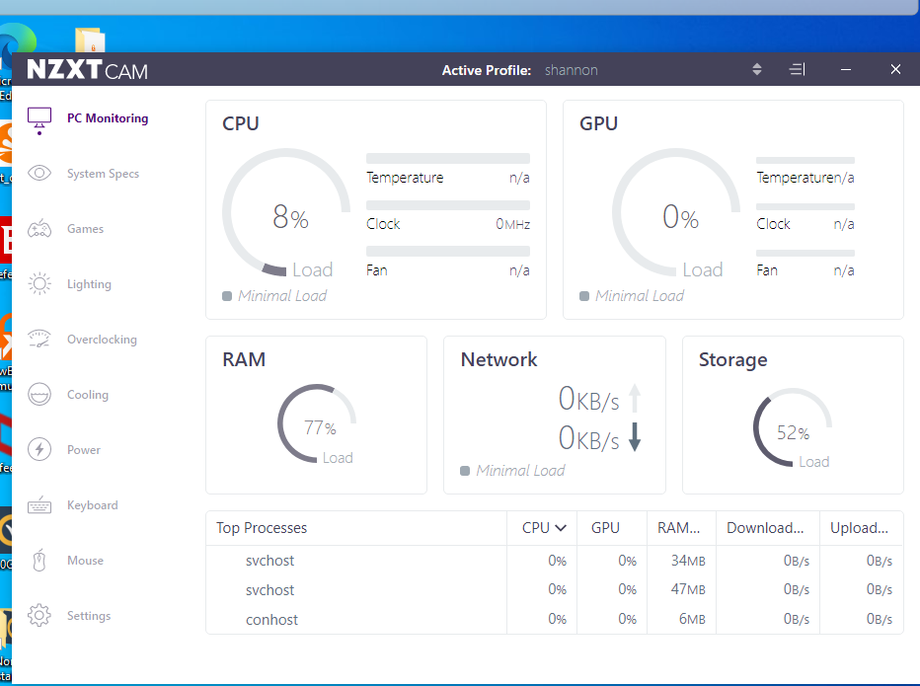
Figure 61: Evidence of PC performance before McAfee scan – trojan simulator test
Figure 62 shows evidence of the PC performance after – when the anti-virus is scanning for the simulator when activated.
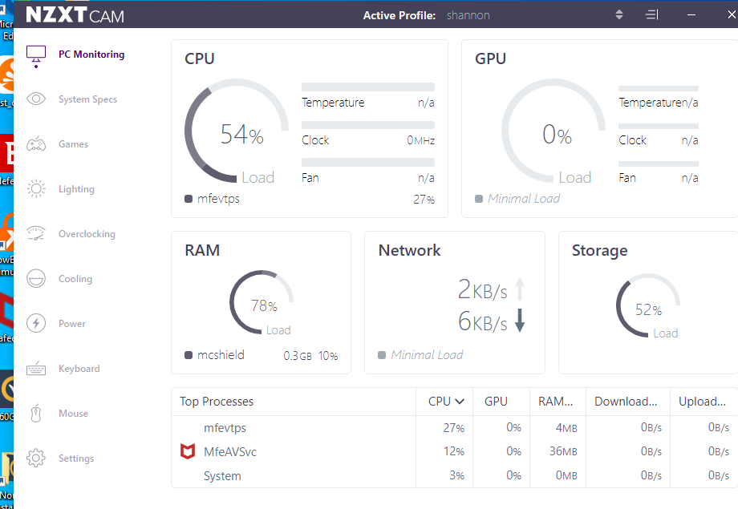
Figure 62: Evidence of PC performance with McAfee- trojan simulator test

Stage three – Activation of simulator
The application was restored and then activated afterwards did a Manuel scan when the application was running to see if McAfee would notice it. While TSSERVE was running, and a scan was done McAfee noticed the application and blocked it.
Figure 63 shows the installation of trojan simulator.
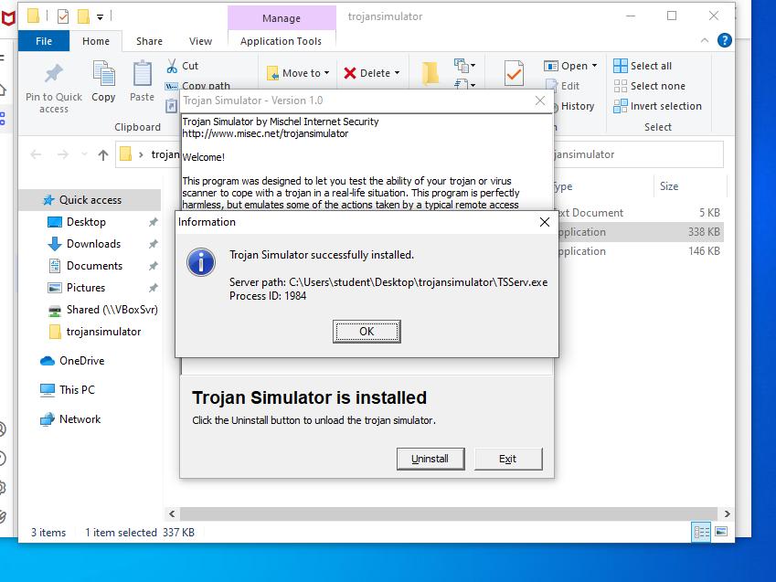
Figure 63: Installation of Trojan Simulator with McAfee

Figure 64 shows the trojan simulator activated and running in the background.
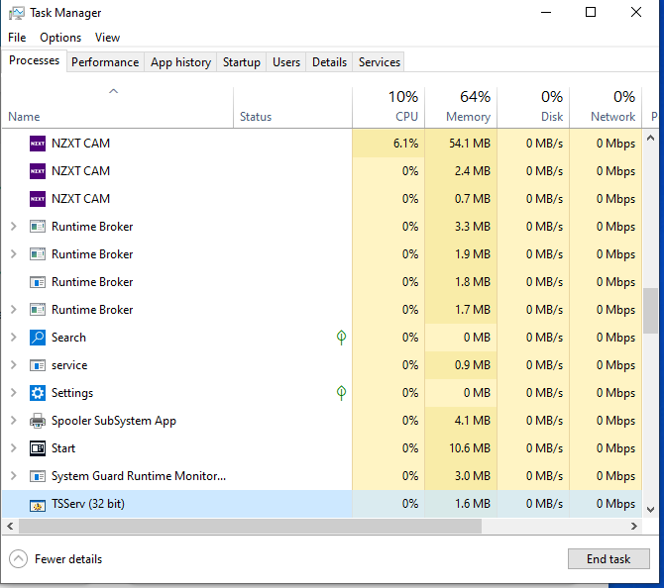
Figure 64: TTSERVE running in the background with McAfee running
Figure 65 shows the evidence of McAfee blocking the application.
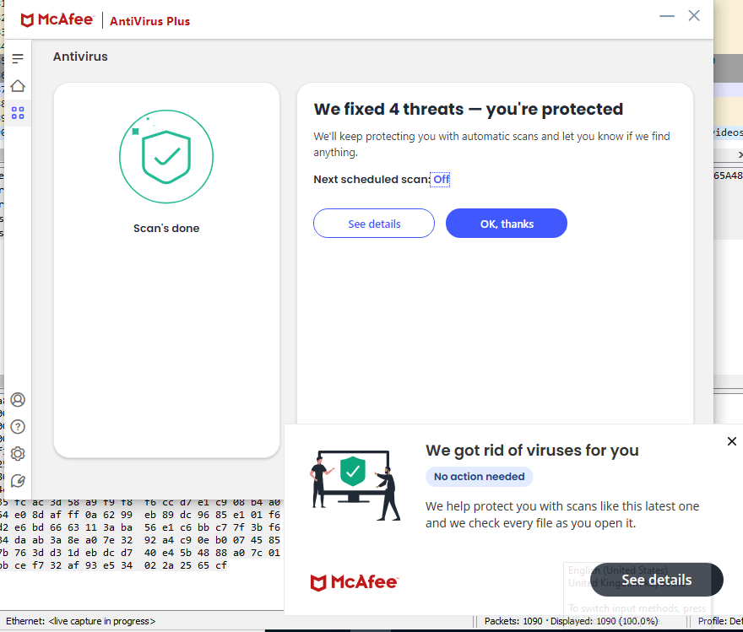
Figure 65: screenshot of McAfee removing Trojan Simulator

5.2.2 Ransim Simulator
Stage one – Simulator Detection
The ransim simulator was automatically blocked by McAfee before the application could conduct the experiment. For the app to be able to simulate an attack it needs to be allowed access. The application was restored and then the experiment could continue.
Stage two – PC performance before and after
Figure 66 shows the PC performance of MacAfee before it scans.
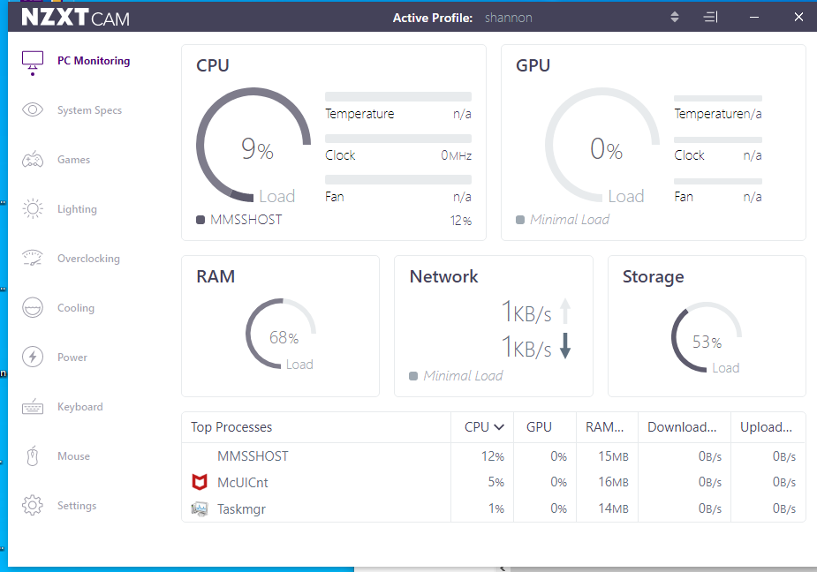
Figure 66: PC performance before scan with McAfee / ransim simulator
Figure 67 shows the PC performance with an anti-virus scanning. This prevented the file from getting encrypted.
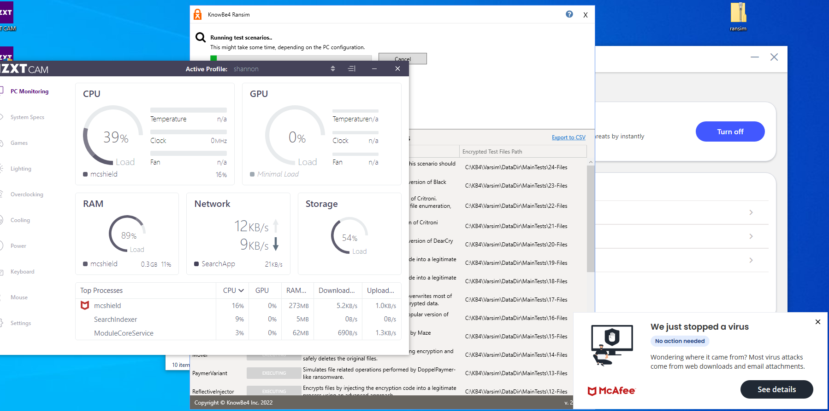
Figure 67: PC performance while scanning with McAfee / Ransim Simulator

Stage three – malware detection when activated
The application was restored, and it was blocked straight away when activated.
Figure 68 shows evidence of the the ransom simulator trying to start but McAfee blocks it.
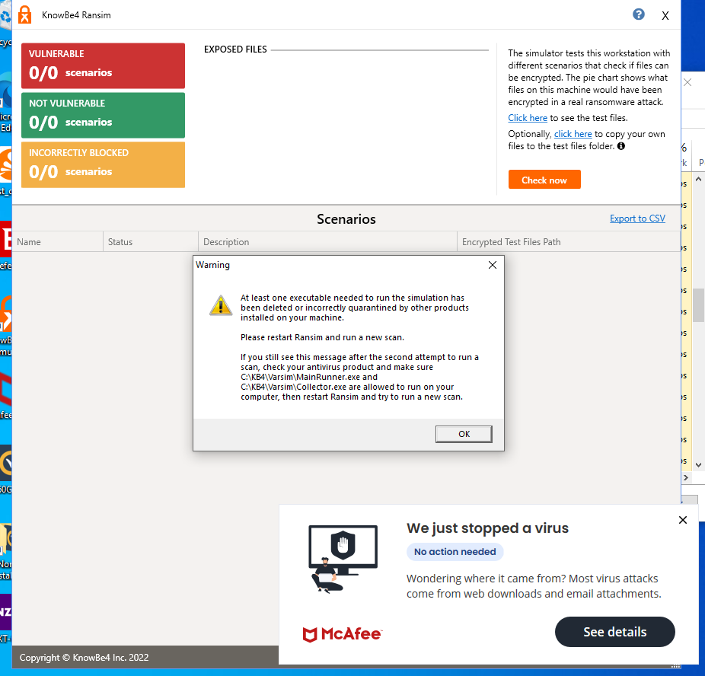
Figure 68: Evidence of McAfee blocking Ransim Simulator
Knowbe4 ransim simulator proved that MacAfee anti-virus was reliable and effective. However, it incorrectly blocked 2 scenarios. Figure 69 shows evidence.
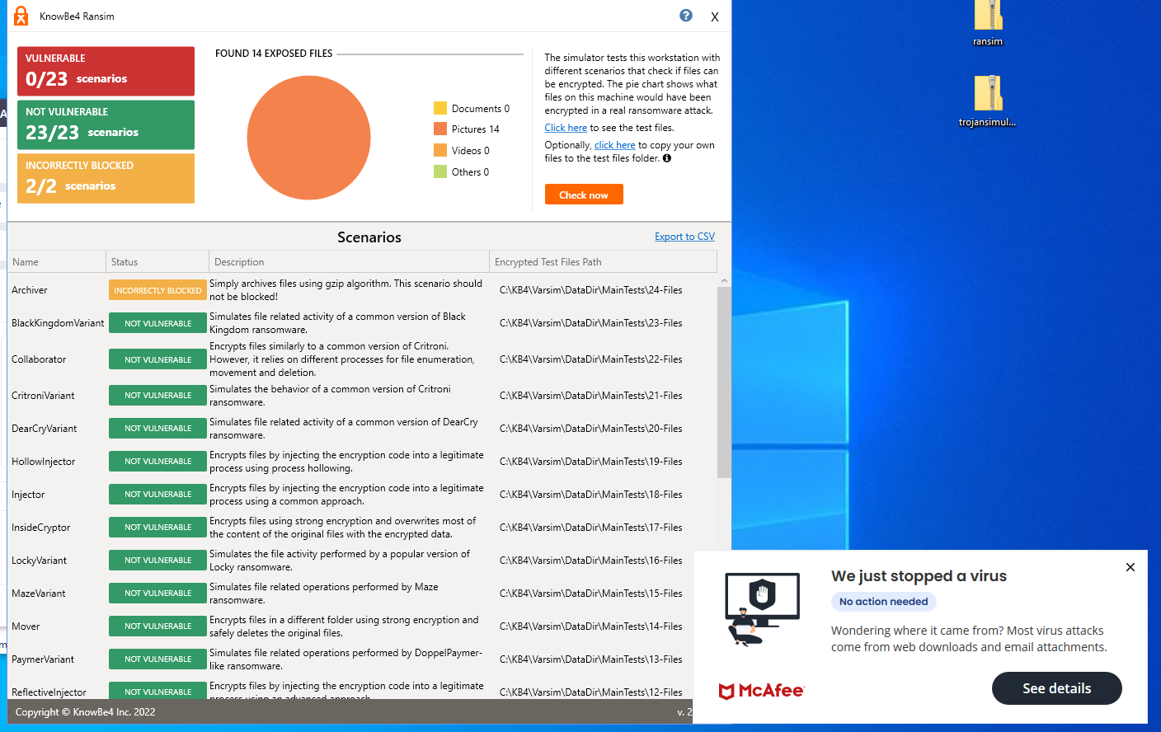
Figure 69: Screenshot of Ransim Simulator - Leaving vulnerabilities and false positives

5.2.3 Infection Monkey
Stage one
Figure 70 shows infection monkey running. McAfee instantly blocked the application before the attack which needed to be manually start.
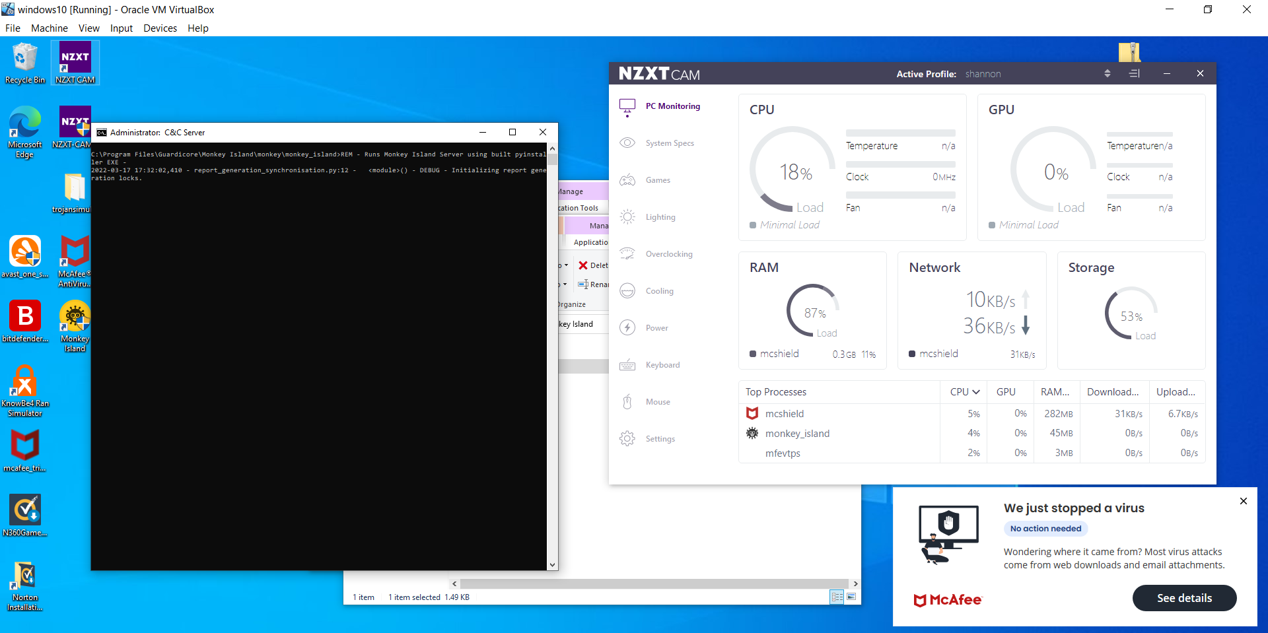
Figure 70: Infection Monkey instantly blocked by McAfee
Stage two
The figure 71 below shows the screenshots of before and after with PC performance.
Figure 71: PC performance before McAfee scan – Infection Monkey
Figure 72 shows the PC performance after
Figure 72: PC performance after McAfee scan – Infection Monkey

Stage three
Figure 73 shows the simulation attack that infection monkey has caused and McAfee stopping it after manually scanning.
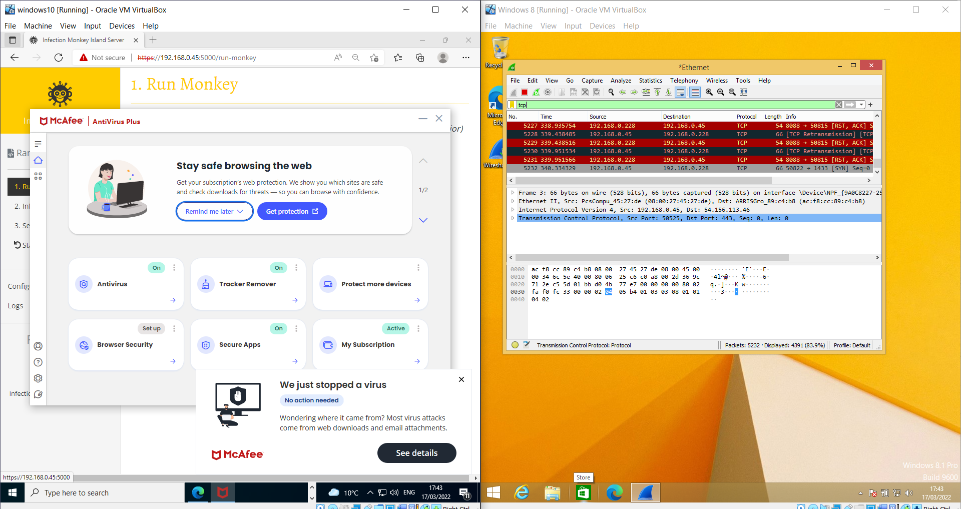
Figure 73: Infection Monkey successfully sending incoming traffic

5.3 Avast anti-virus software

5.3.1 Trojan Simulator
Stage one
Trojan simulator was instantly blocked by AVAST. The application was moved to quarantine so then the application can be executed and then will be able to see if AVAST detects it running. Figure 74 shows evidence of the application being blocked.
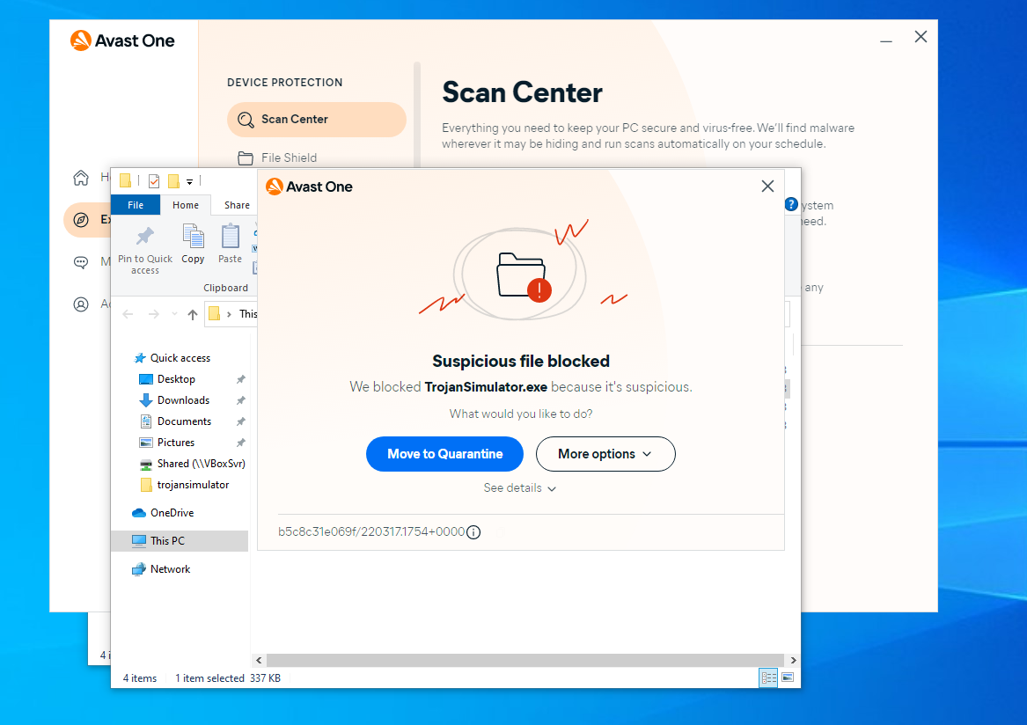
Figure 74: Trojan Simulator instantly blocked with AVAST

Stage two
Figure 75 shows the PC performance while AVAST is just running and not scanning
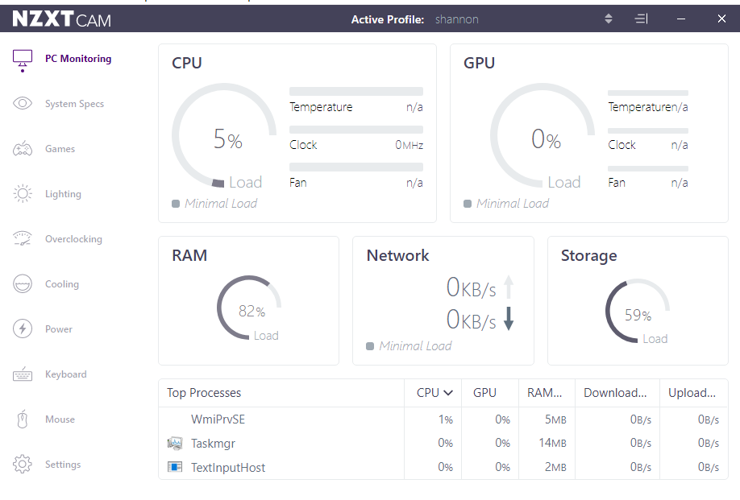
Figure 75: PC performance with AVAST not scanning – Trojan Simulator
Figure 76 shows the PC performance after with AVAST scanning.
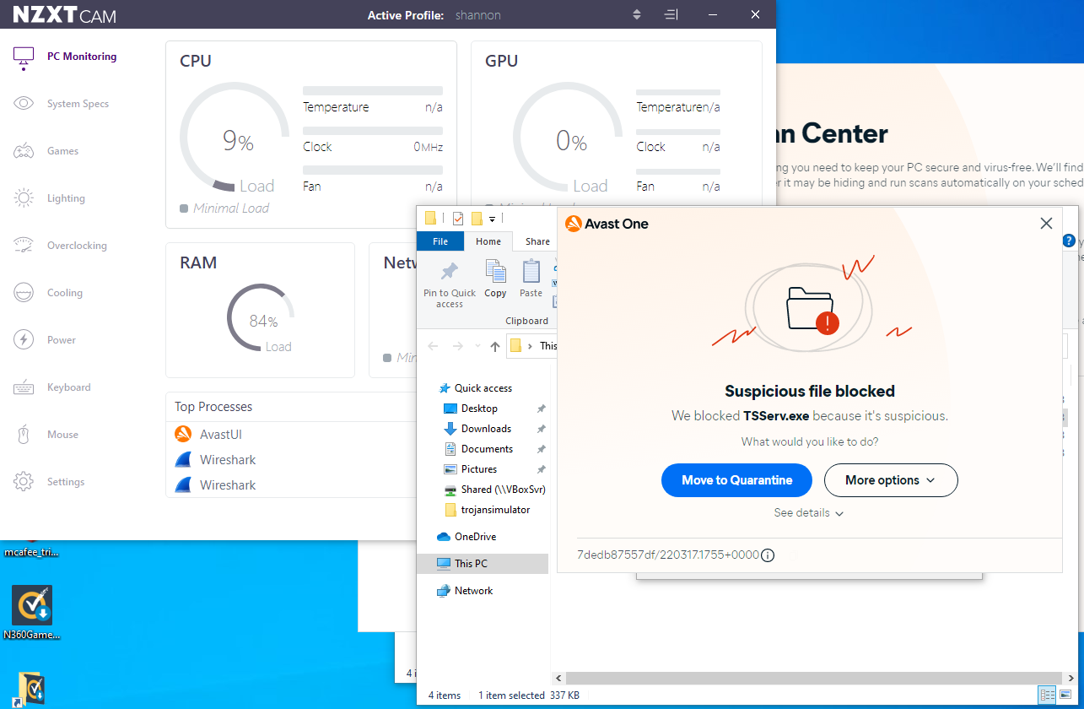
Figure 76: PC performance with AVAST scanning - trojan simulator

Stage three
The application was then executed after being restored. The application was executed and was instantly blocked by AVAST. Figure 77 shows the exe file being blocked.
Figure 77: The trojan Simulator got instantly blocked by AVAST - could not run it

5.3.2 Ransim Simulator
Stage one
AVAST automatically blocked the ransim simulator. The file had to be restored. Figure 78 shows a screenshot of the application being automatically blocked.
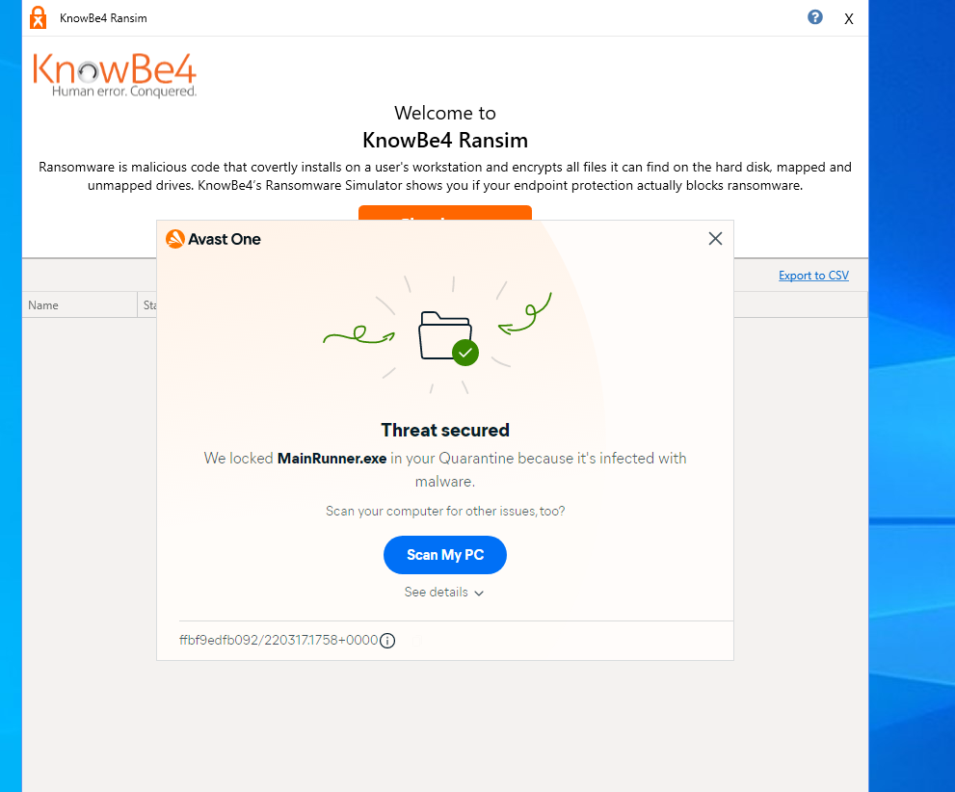
Figure 78: AVAST automatically blocked ransim

Stage two
Figure 79 shows a screenshot of Avast before scanning just casually running in the background.

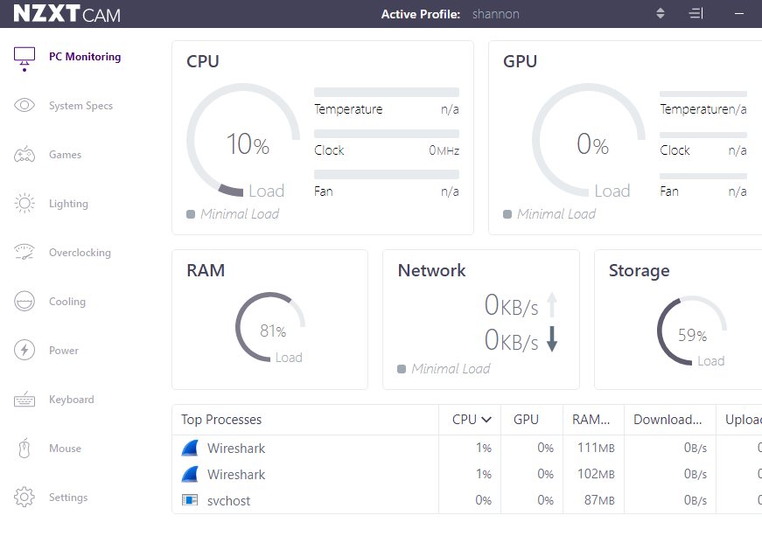
Figure 79: AVAST before scanning for Ransim Simulator

Figure 80 shows a screenshot of the PC performance while the ransim is activated and the avast is scanning
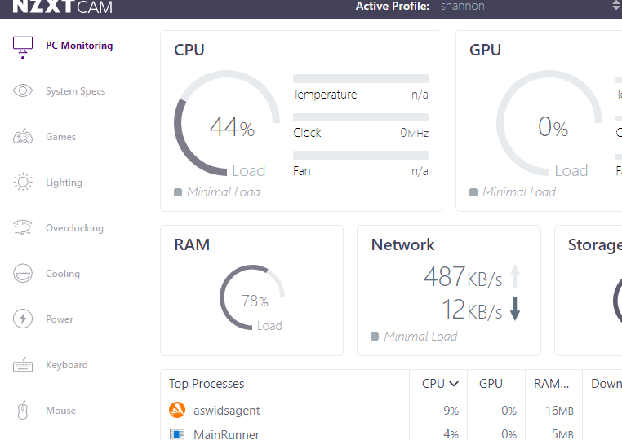
Figure 80: PC performance while AVAST scanning for RANSIM simulator.
Stage three
Figure 81 shows a screenshot of the simulator attack happening and that after the scan Avast picked it up and ask to scan my pc again.
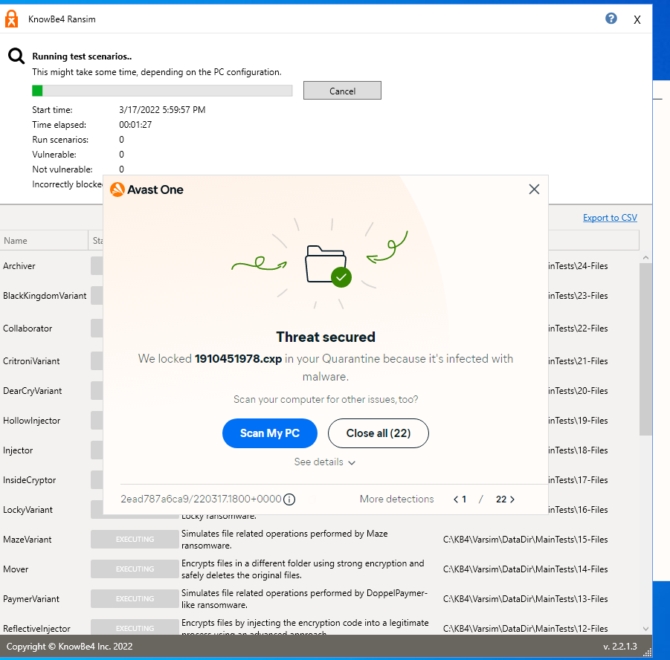
Figure 81: RANSIM activiated and AVAST blocking them

Figure 82 shows that the PC was safe however, 2/2 scenarios was incorrectly blocked.
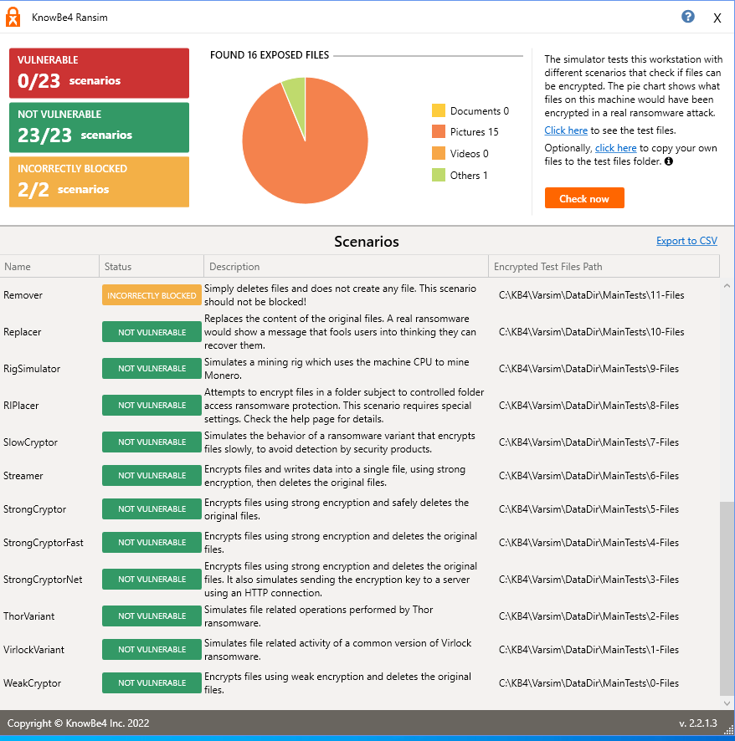
Figure 82: A screenshot of ransim simulator attack against AVAST

5.3.3 Infection Monkey
Stage one
Figure 83 shows a screenshot of the AVAST blocking the application. The application was restored to be able to do the attack.
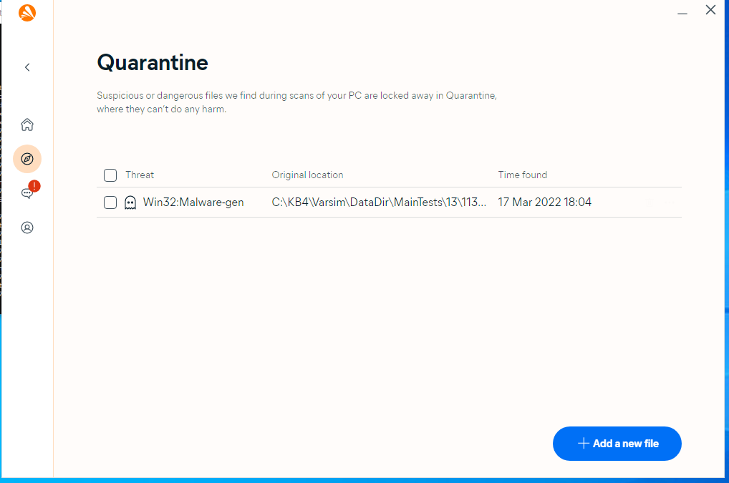
Figure 83: a screenshot of Infection Monkey getting instantly blocked by AVAST

Stage two
PC performance before Avast running. Figure 84 shows screenshot of AVAST performance.
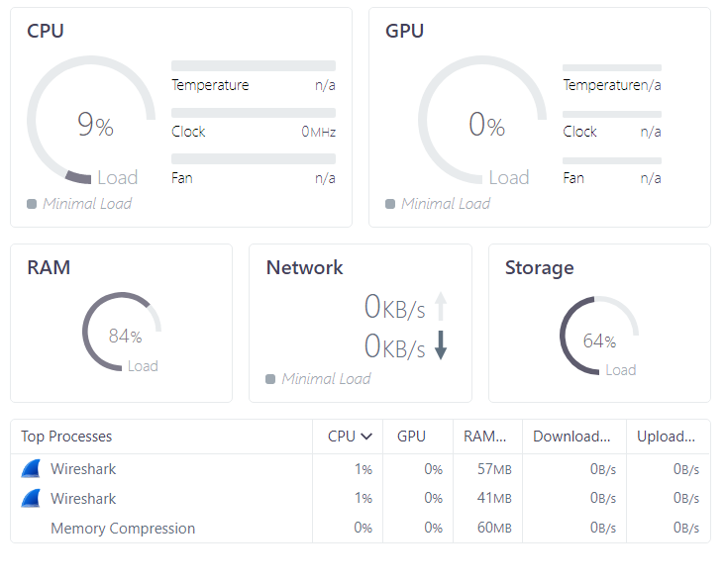
Figure 84:PC performance while AVAST not scanning
Figure 85 shows the performance of the PC while the application was running.
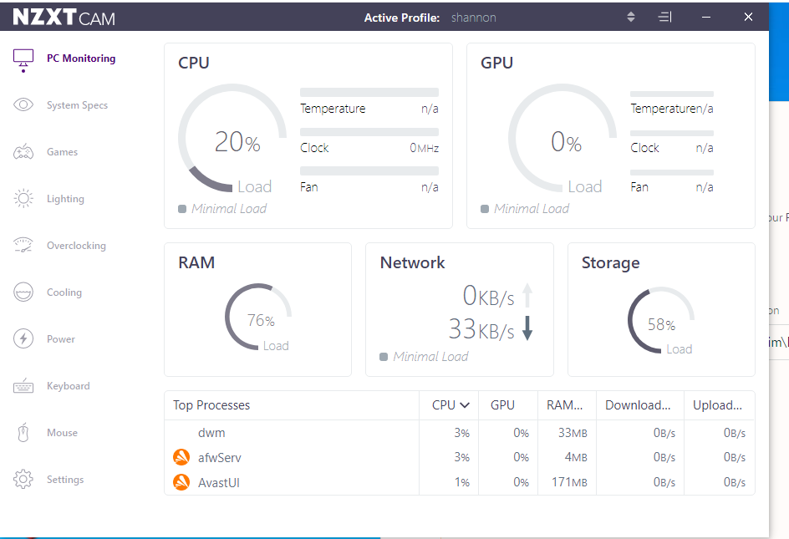
Figure 85: A screenshot of AVAST scanning with Infection Monkey

Stage three
Even when the application was restored the attack was blocked by AVAST. Figure 86 shows a screenshot of nothing going through. The application was instantly blocked every time an attack tries to happen.
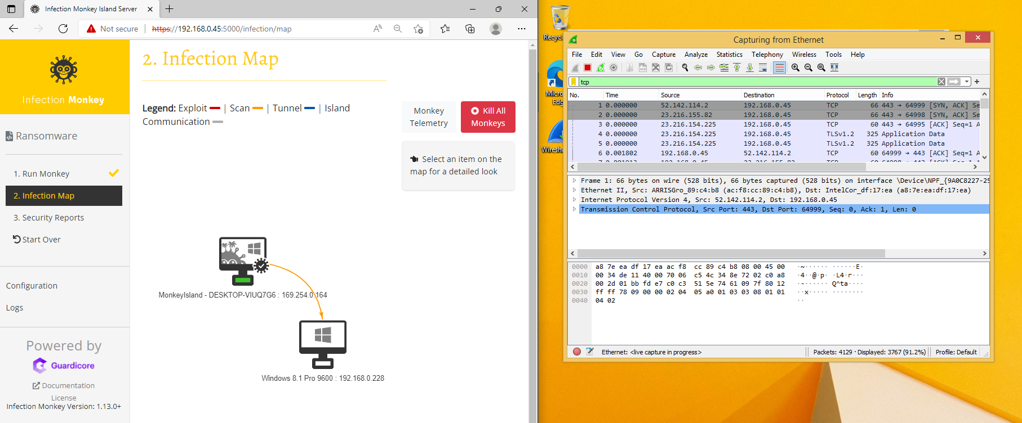
Figure 86: The Infection Monkey was activated and AVAST blocked every attack from Infection Monkey

5.4 BitDefender anti-virus software

5.4.1 Trojan Simulator
Stage one
BitDefender automatically blocked the trojan simulator. The file was restored so then it can be activated. Figure 87 shows the application being automatically blocked.
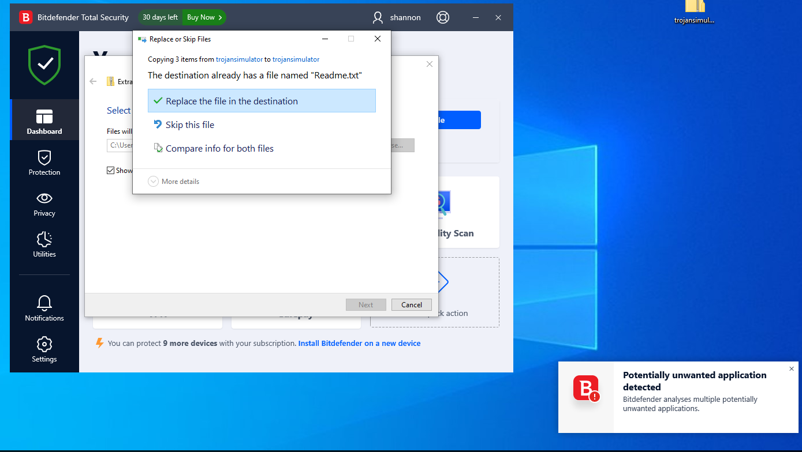
Figure 87: Trojan Simulator automatically blocked by BitDefender

Stage two
Before the Bitdefender software began to scan the PC performance was really high compared to the others. Figure 88 shows a screenshot of the anti-virus software running and no trojan simulator running.
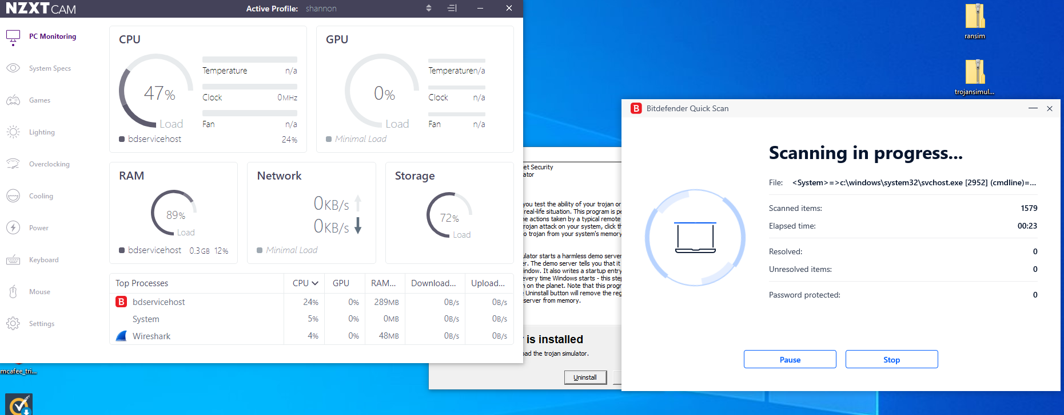
Figure 88: PC performance being trojan simulator not active and bitdedefender running.
Figure 89 shows the performance difference when trojan simulator is running and bitdefender is scanning.
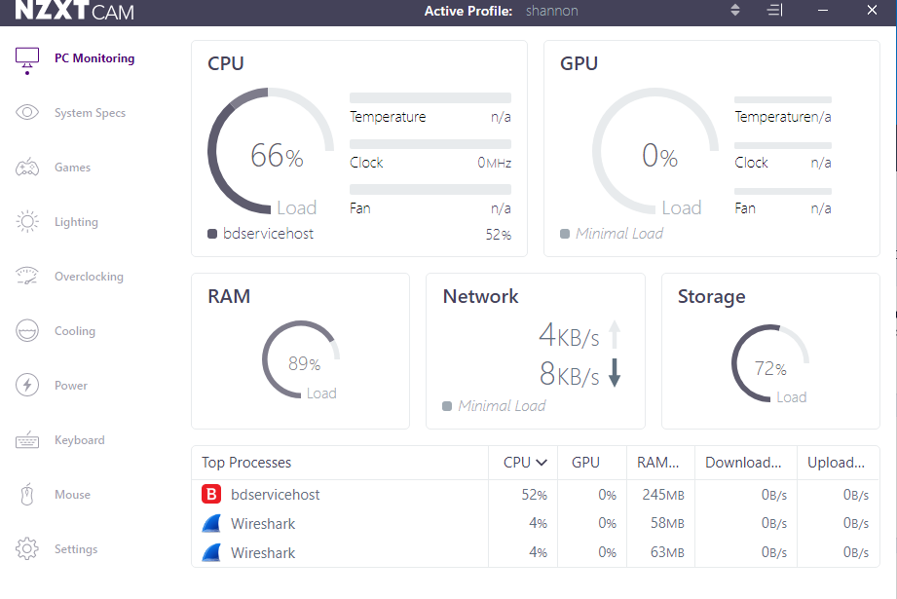
Figure 89: shows pc performance – trojan simulator running and anti-virus scanning

Stage three
Figure 90 shows a screenshot of the trojan simulator running and the anti-virus software BitDefender is running a scan while activated
Figure 90: BitDefender quick scan and installed trojan simulator
Figure 91 shows the evidence of trojan simulator running. The application got blocked after BitDefender finished scanning. Figure 88 shows BitDefender scanning.
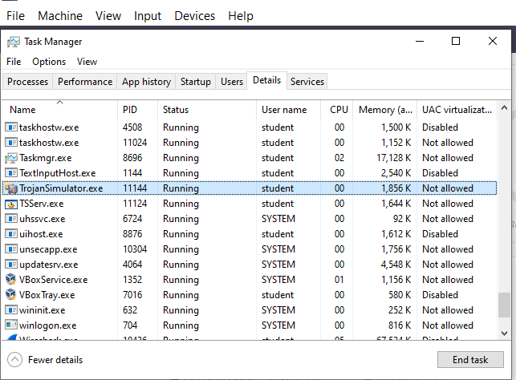
Figure 91:Trojan simulator running – task manager

Bitdefender detected trojan simulator after the scan was completed. Figure 92 shows Bitdefender scanning for the malware.
Figure 92: Manuel quick scan to detect trojan simulator

5.4.2 Ransim Simulator
Stage one
Ransim automatically blocked ransim simulator before activation and was restored to be able to activate. Figure 93 shows evidence of the blocking.
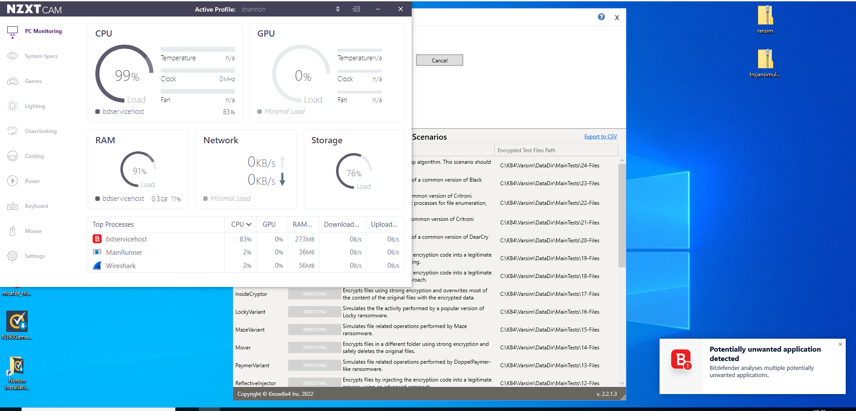
Figure 93: Ransim instantly blocked by BitDefender

Stage two
Figure 94 shows a screenshot of the PC performance with Bitdefender running.
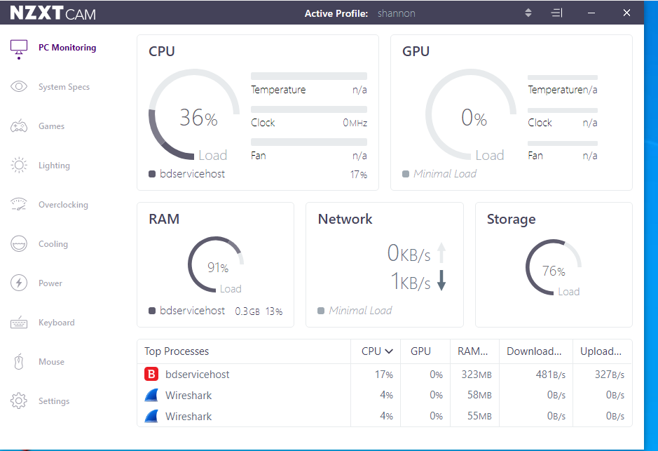
Figure 94: PC performance with Bitdefender running
Figure 95 shows PC performance while ransim simulator was running and the anti-virus software scanning.
Figure 95: BitDefender performance while scanning and ransim activated

Stage three
The application was blocking the scenarios. However, Bitdefender incorrectly blocked 2 scenarios. The anti-virus protected the system well as the system did not come back as vulnerable. Figure 96 shows evidence of the incorrectly blocked files.
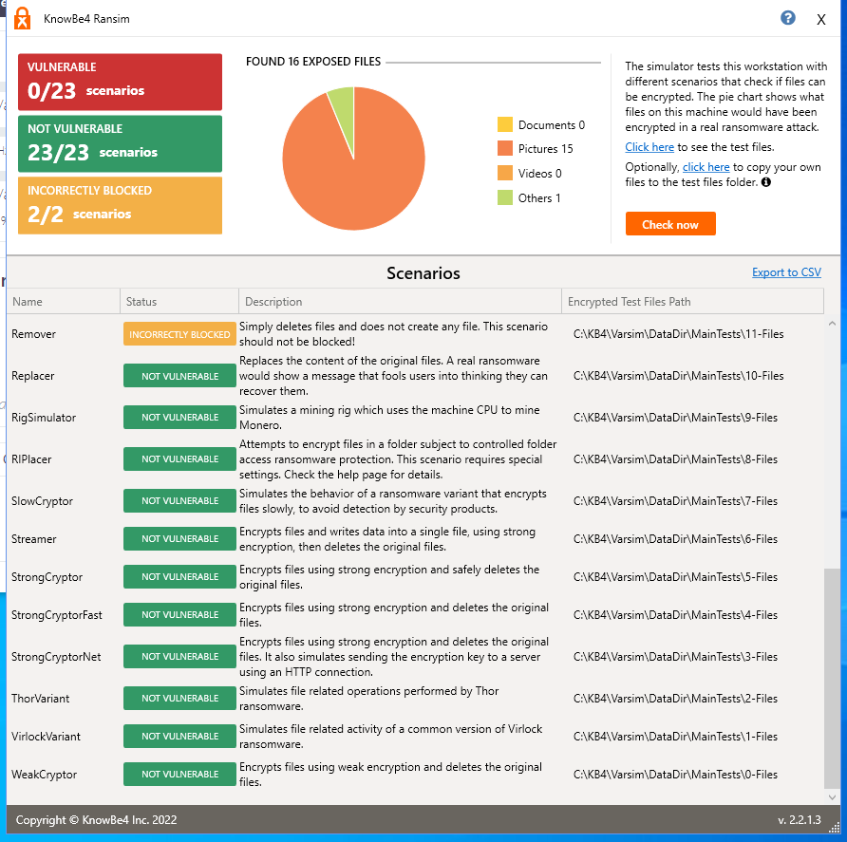
Figure 96: Screenshot of ransim simulator

5.4.3 Infection Monkey
Stage one
The application was automatically blocked by BitDefender, the file was restored so then could execute it. Even when restored the application kept getting blocked. Figure 97 shows a screenshot of the Infection Monkey trying to start and the Bitdefender blocking the access.
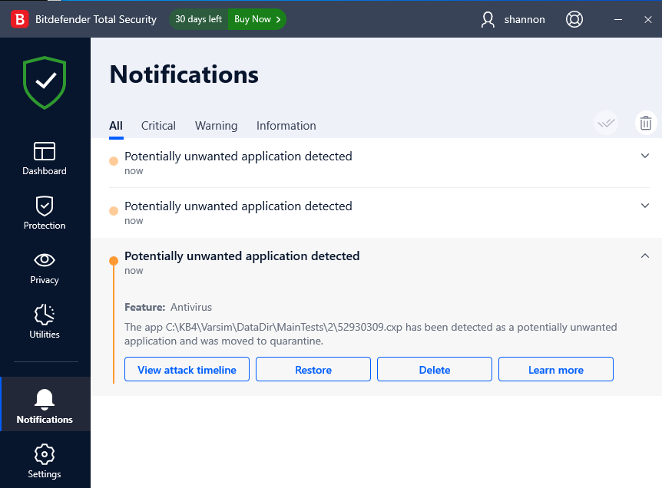
Figure 97: Infection Monkey instantly blocked by BitDefender
Stage two
Figure 98 shows a screenshot of the PC performance with just Bitdefender running.
Figure 98: PC performance with BitDefender just running

Figure 99 shows a screenshot of the performance while infection money and Bitdefender was running.
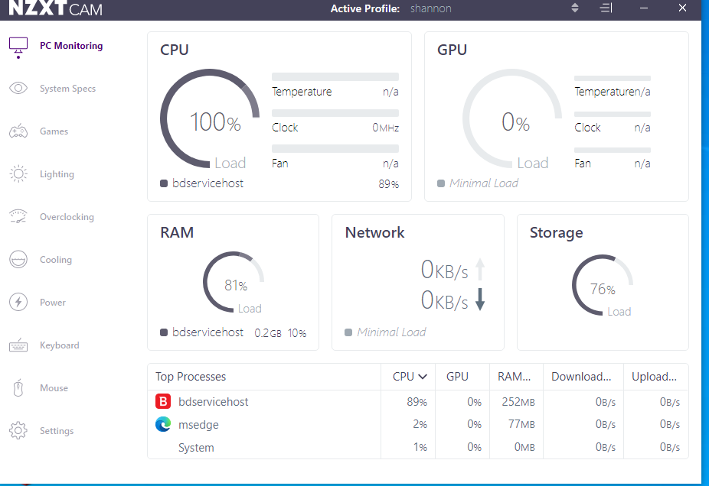
Figure 99: PC performance with Infection Monkey and BitDefender running

Stage three
Exploit was attempted and blocked the attack. Figure 100 shows evidence of the blocking.
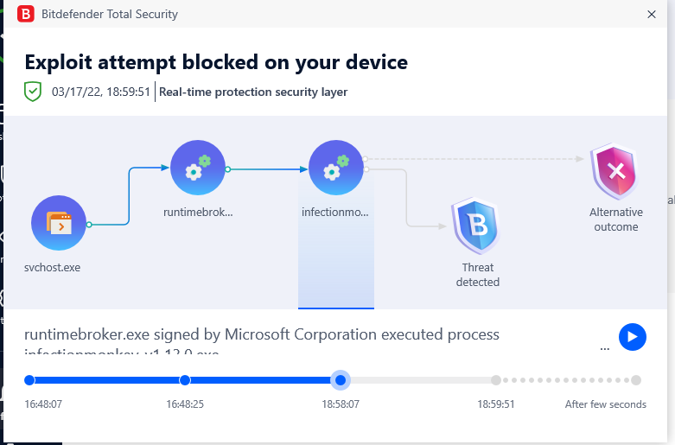
Figure 100: BitDefender blocked Infection Monkey
Figure 101 shows a screenshot of the windows 10 and windows 8 machine. There was no traffic incoming from the infection monkey as BitDefender blocked it after a scan was done.

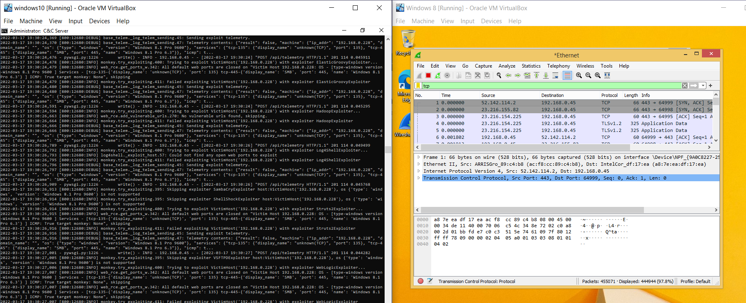
Figure 101: No traffic going through - BitDefender blocked

Evaluation
The actual process was going to be using actual malware on virtual machines. There was a change in plan from doing actual malware to using malware simulations as this would be less harmful to a device. Every simulator and anti-virus software went through the same process.
The project goes into three stages which are:
- Stage one
Application of Simulator detection
- Stage two
PC performance before and after (anti-virus not scanning and while scanning+Simulator)
- Stage three
Anti-virus detects malware simulator activated(This is when malware simulator performs test)
When downloading a malware simulator. Anti-virus software will pick them up as they are harmful files in them. However, the malware simulator is not activated until the user manually activates it. The start of the test was if the simulator got automatically blocked straight away.

Stage one of the project was with Norton with the trojan simulator. Norton did not pick up the EICAR file and allowed the application to run. Stage one for Ransim simulator did not get blocked by Norton. Then, stage one for infection monkey, the application got deleted by Norton.
Table 1: Stage one process Norton
Anti-virus software – Norton(Before activation)
Simulator | Simulator Detected -
Trojan simulator | No
Ransim Simulator | No
Infection Monkey | yes

McAfee, AVAST, and Bitdefender instantly blocked the simulators before even activating the simulators to test, so they all had to be restored.
Stage one of McAfee software they were all blocked. These results were a lot different from table 1 with Norton. Table 2 shows that all the simulators got detected as malware – when not activated.
Table 2:Anti-virus software McAfee
Anti-virus software - McAfee(Before activation)
Simulator | Simulator Detected -
Trojan simulator | Yes
Ransim Simulator | Yes
Infection Monkey | yes

Stage one of AVAST anti-virus software. Table 3 shows that all of them got detected by the AVAST anti-virus software before activation. These results were the same as McAfee and were different to Norton.

Table 3:Anti-virus software AVAST
Anti-virus software - AVAST(Before activation)
Simulator | Simulator Detected -
Trojan simulator | yes
Ransim Simulator | Yes
Infection Monkey | yes

Stage one of Bitdefender anti-virus software. Table 4 shows that all the simulators got detected before activation.
Table 4:Anti-virus software BitDefender
Anti-virus software - BitDefender(Before activation)
Simulator | Simulator Detected -
Trojan simulator | yes
Ransim Simulator | Yes
Infection Monkey | yes

Stage one the expectation was that the applications would get picked up by the anti-virus software as they are malware simulators. They are harmless; however they have similar matching code to real malware applications. Norton gives unexpected results as two of the malware simulators, Trojan Simulator and Ransim simulator, did not get detected, which is fine because it was not activated but should have been picked up by Norton.
After the stage one process, the applications/malware simulators were restored to do the effectiveness test against the anti-virus software. Stage two is the recording of the PC performance before scanning and after scanning. These results were based upon NZXT software.
Stage two is recording the anti-virus software performance before the scan and then after scan. Graph 1 shows the performance before the anti-virus performed a scan and then the performance while scanning. The graph shows that the Ransim simulator was the highest and the trojan simulator was the lowest (Before/After). The chart indicates explicitly the PC performance based on RAM and CPU with Norton. The lowest RAM performance was 71% before and then highest was 89%, which was on Infection Monkey and Trojan simulator. This was an 18% increase. The CPU was increased be 70% as CPU performance on lowest which was with infection monkey by 3% and then the performance after which was RanSim simulator by 73%
CPU average before and after
Before – 10.67%
After – 52.33 %
The performance increased by 41.67%
RAM average before and after
Before – 74.00%
After – 82.00%
The ram performance increased by 8.00%
Graph 1: Norton anti-virus performance before scan and after scan
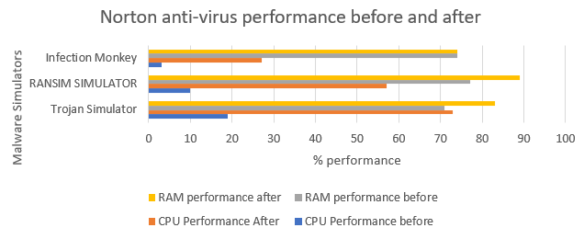
Figure 102: Norton anti-virus performance before and after

Graph 2 shows the performance with McAfee based upon CPU and RAM. The highest on the RAM was 89% and the lowest being 68%. There was an increase in performance of the ram by 21%. The highest and lowest were on Ransim Simulator. The CPU performance before was 8% on Trojan Simulator and the highest being on Trojan simulator which was 54%. There was a 46% increase on the CPU performance.
The average before and after with RAM
Before – 77.33%
After – 78.33 %
Increasing by 1%
The average before and after with CPU
Before – 11.67 %
After – 34.00%
Increasing by 22.33%
Graph 2: McAfee anti-virus performance before and after
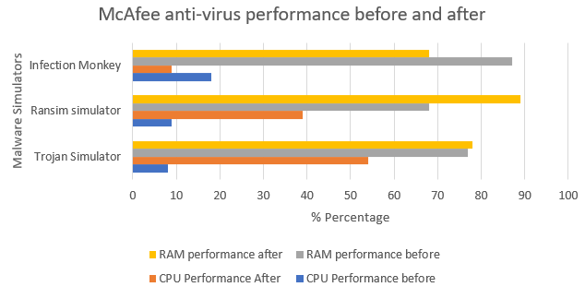
Figure 103: McAfee anti-virus performance before and after

Graph 3 shows the PC performance with AVAST. The CPU performance before with the lowest was with Trojan Simulator by 5%(Before) and then the highest being 44% with ransim simulator(After). There was an 39% increased in the CPU performance. The RAM performance was increased by 3%. The ram before being lowest was 81% Ransim simulator and then highest being 84% with Trojan Simulator.
AVAST CPU average performance before and after
Before: 8.00%
After: 24.33%
Increased by: 36.33%
AVAST RAM average performance before and after
Before: 82.33%
After: 79.33%
Increased by: 3%
Graph 3: AVAST anti-virus performance before and after
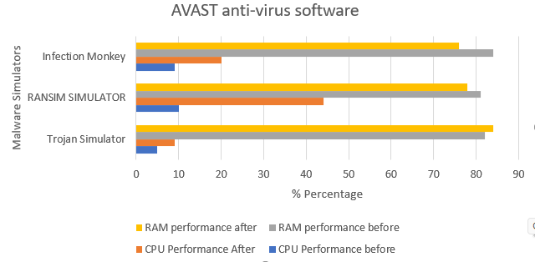
Figure 104: AVAST anti-virus software before and after

Graph 4 shows the PC performance with BitDefender. The CPU performance with the lowest being 36% and highest being 100%. The lowest was with Trojan and the highest was with Ransim Simulator The RAM performance before being 89% and after performance being 91% both of the results were with Infection Monkey. There was an increased of 2% between the highest and lowest of RAM and then 64% increased with CPU.
BitDefender CPU average performance before and after
Before: 39.67%
After: 88.33%
Increased by: 48.67%
BitDefender RAM average performance before and after
Before: 90.33
After: 87.33

Graph 4: Bitdefender anti-virus performance before and after
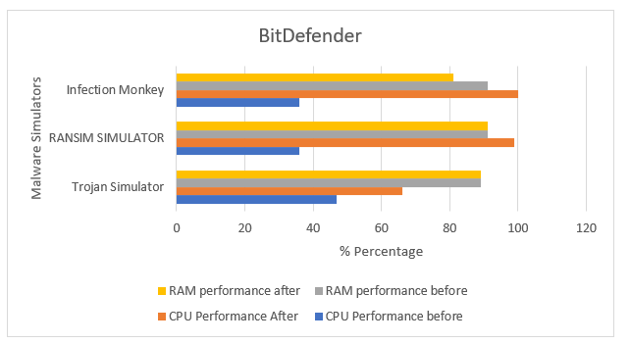
Figure 105: BitDefender before and after
The following process is stage three, which is activating the malware to see if anti-virus software protects. The expectation is for all the anti-virus software to pick up the simulators. Referring to appendix 2 Norton and McAffe both has a firewall built-in.
Norton anti-virus software did not provide protection that was expected. Trojan simulator was failed to be detected and was casually running in the background. Norton did not notice or remove the trojan simulator. Ransim simulator was also was unable to be detected as the PC was vulnerable with three scenarios from the simulator, and ½ scenario was incorrectly blocked. The last test was with infection monkey, and it was detected after a few seconds with the scan. However, it allowed incoming and outcoming traffic.
McAfee software did provide the protection that was expected. The trojan simulator got removed after a scan was done. The ransim simulator blocked the 23 scenarios successfully. However, it incorrectly blocked two scenarios that were not malware. Infection Monkey was successful in ransom as it allowed incoming and outcoming traffic. This allow the files to be encrypted through the network. However, after the scan was completed, it did block the infection monkey software.
AVAST anti-virus software did provide the protection that was expected. Avast correctly blocked the trojan simulator and infection monkey. These results were different as AVAST did not allow infection monkey to have incoming/outcoming traffic compared to McAfee and Norton as it took few seconds for the anti-virus to detect. When conducting the AVAST scan straight away did not allow infection monkey to go through. Ransim simulator got all 23/23 scenarios however incorrectly blocked 2.
BitDefender anti-virus software did provide the protection that was expected. Bitdefender and AVAST were the best at providing protection as they did not allow any of the simulators through. The difference between all of them were that infection monkey got through 2 of the anti-virus software, which were Norton and McAfee while AVAST and Bitdefender did not allow it AT ALL. However, with ransim simulator incorrectly blocked 2 scenarios.
After all these three stages. The best anti-virus software based upon performance IN ORDER was Norton, McAfee, AVAST and then BitDefender. BitDefender was slow to use compared to other anti-virus software. Referring to appendix 2 – the laptop supported BitDefender by the specification and was horrible to use compared to the others. The laptop kept freezing and was slow in scanning.
The best anti-virus software based upon detection in order while malware was activated/not activated was Bitdefender, AVAST, McAfee, and Norton. Norton just failed completely to detect and left the system vulnerable. 2/3 test failed and the anti-virus software did not provide protection. McAfee, AVAST and Bitdefender provided protection but incorrectly blocked 2 scenarios. Norton however only incorrectly blocked ½ scenarios. Referring to the literature review these are called “False Positives”. This happens when software programs that behave like malware are detected by the anti-virus even though they are harmless. This can be a bad thing as anti-virus software would be sensitive to specific downloads.
Referring to Appendix 2 Norton, and McAfee was the paid anti-virus software. Bitdefender and AVAST were the free software. They offered multiple features, and this anti-virus software were picked upon the technique they use to detect malware.
Based on performance and detection, the best anti-virus was McAfee. The performance was not as bad as Bitdefender and protection was not as bad as Norton. Referring to Daniel Santos which is in related work. The project that Daniel conducted was a lot like this one.
He said, "I believe that paid subscription-based anti-virus programs will prove more effective against malware threats due to the extra available features”. In Appendix 2 Norton cost £70 and had a lot of features compared to the others. McAfee cost £30 and protected the device. However, £70 and £30 pounds for an anti-virus that does not detect as well as BitDefender or AVAST. BitDefender and AVAST was mentioned before did not allow any traffic from infection monkey and McAfee did. Daniel Santos results differed as CPU and memory usage for McAfee was high by 100% with CPU performance and 50% for memory. The highest, as mentioned, was 89% for ram and 54% for CPU with McAfee.
Another related work was the ransomware effectiveness report this was by the company of Ransim simulator. According to the report graph 41% of ransom attacks were not detected was by McAfee. McAfee successfully blocked ALL ransim simulator scenarios. Also, according to the effectiveness report only 52% of anti-virus software detect ransomware behaviour. Another related work was by Sami AL-Shasheri, Dale Lindskog, Pavol Zavarskyh, and Ron Ruhl. They used five anti-virus products against roolkits: AVG, Kaspersky, McAfee, AVAST, and trend miro. This paper allowed to go into further research to choose the anti-virus software on this project.

Chapter 6 – Conclusion and recommendation
This report shows how the experiment was conducted. Chapter one discussed the aim, objectives, and the structure of the project. The key findings for chapter one was the aim and objective as it gives information about the project and what the project is about.
Chapter two is the literature review. This part of the project helped me gain more in-depth research about the project. The literature chapter talks about related key points to the experiment. The key findings of the literature review were simulations and related work. The related work helped into inspiration to conduct the experiment and malware simulators were not chosen to start with but after further research it was safer choice to conduct the experiment with. This chapter helped with the aims and objectives of the experiment.
Chapter three discusses the type of research methodology was used to conduct research and the project. This chapter findings were helpful when conducting the research and experiment
Chapter four is the design and implementation of the project. This chapter helped with the aims and objectives. This chapter conducted a plan and set out the project ready for the experiment to happen.
Chapter five was conducting the experiment. This chapter shows how the experiment went and how well the anti-virus performed.
The key findings of the experiment were how each anti-virus software performed and if the anti-virus detected the malware simulators on virtual machines. Virtual machines were used when conducting the experiment as a network was created.
Future changes would be conducting the test differently, such as different anti-virus software and higher budget and would also do a network attack.
The experiment conclusion is that BitDefender and Avast are the worst performing however are the best detection. The reason why that they are not recommend due to the performance issues that happened in the tests. Both anti-virus software was slow and froze the device, which is clearly shown in the graphs. All the anti-virus software chosen upon the technique they use to detect malware. They were also picked on price.
The recommendation for an anti-virus software is the McAfee based of performance and detection. It cost £30 a year and has many features can see this in appendix 2. A free anti-virus software based upon performance and detection would be Avast. Avast was not that slow compared to Bitdefender and does provide good protection considering Norton cost £70 and did not provide the protection that it should have done based UPON this project.

Chapter 7 – Reflection
When conducting the project, I was shocked by the first results as expected anti-virus software should provide protection. Norton cost £70 and that’s not cheap. It offers a lot of features compared to other anti-virus software but does not provide protection when tested.
The project went well and provided evidence of what happened in these tests. The main aim of the project was to evaluate the effectiveness and performance of the anti-virus software and PC. The project results show and evaluate on how the project went.
However, does anti-virus software provide protection? Depending on what anti-virus you get based of these results, I would say McAfee does the job and is cheap compared to Norton. Which McAfee only cost £30 and offers protection.
The strength of this project is that it shows evidence of conducting tests, what anti-virus software provides protection and the performance of anti-virus software.
The weakness of this project is that opportunities for a different kind of malware could have been chosen in this project. Based on research I stuck with the two ransomware simulators and one trojan.

References

[1] | “COVID-19 and the future of business,” IB, [Online]. Available: https://www.ibm.com/thought-leadership/institute-business-value/report/covid-19-future-business. [Accessed 03 03 2022].
[2] | “COVID-19and the future of business,” IBM Corporation, September 2020. [Online]. Available: percentages of how many businesses shifted to cloud based and the way they adjusted their business due to the recent pandemic. . [Accessed 1 03 2022].
[3] | J. Aycock, “People,” in Computer Viruses and Malware, Canada, Springer, 2006, p. 234.
[4] | J. Fruhlinger, “What is malware? Viruses, worms, trojans and beyond,” Proquest, 2018. [Online]. Available: https://www.proquest.com/docview/2086028617/EEF1812A54F549F9PQ/12?accountid=130472. [Accessed 16 12 2021].
[5] | Google, “Protect yourself from malware,” Google, 21 12 2021. [Online]. Available: https://support.google.com/google-ads/answer/2375413?hl=en-GB#zippy=%2Ckeep-your-computer-and-software-updated%2Cuse-a-non-administrator-account-whenever-possible.
[6] | Microsoft, “Trojans,” Microsoft, 28 10 2021. [Online]. Available: https://docs.microsoft.com/en-us/windows/security/threat-protection/intelligence/trojans-malware#how-trojans-work. [Accessed 21 12 2021].
[7] | L. L. P. K. T. f. b. j. k. Jun Gao, “Should You Consider Adware as Malware in Your study?,” 2019. [Online]. Available: https://ieeexplore-ieee-org.ezproxy.uwtsd.ac.uk/stamp/stamp.jsp?tp=&arnumber=8668010. [Accessed 21 12 2021].
[8] | M. M. N. Ronny Richardson, “Ransomware: Evolution, Mitigation and Prevention,” DigitalCommons, 1 1 2017. [Online]. Available: https://digitalcommons.kennesaw.edu/cgi/viewcontent.cgi?article=5312&context=facpubs. [Accessed 1 03 2022].
[9] | “Worms,” Microsoft, 28 10 2021. [Online]. Available: https://docs.microsoft.com/en-us/windows/security/threat-protection/intelligence/worms-malware. [Accessed 03 03 2022].
[10] | “malware,” avtest, 2022. [Online]. Available: https://www.av-test.org/en/statistics/malware/. [Accessed 03 03 2022].
[11] | H. R. E. O.-O. Max Roser, “Internet,” Our world in data, 2015. [Online]. Available: ourworldindata.org/internet. [Accessed 1 03 2022].
[12] | B. Martens, “Is Windows Defender Good Enough in 2021?,” Safety Detectives, 1 December 2021 . [Online]. Available: https://www.safetydetectives.com/blog/windows-defender-vs-antiviruses-is-defender-enough-for-you/. [Accessed 2021 12 21].
[13] | A. K. S. Vijayanand. C. D*, “Impact of Malware in Modern Society,” Journal Of Scientific Research and Development, vol. 593, p. 600, 2019.
[14] | Kapersky, [Online]. Available: https://www.kaspersky.co.uk/resource-center/threats/a-brief-history-of-computer-viruses-and-what-the-future-holds. [Accessed 17 01 2022].
[15] | R. S. H. S. u. Insu Park, “Short term and total life impact analysis of email worms in computer systems,” Decision Support Systems, vol. 43, no. 3, pp. 827-841, 2007.
[16] | “Technology,” Money Cnn, 30 Jan 2004. [Online]. Available: https://money.cnn.com/2004/01/28/technology/mydoom_costs/. [Accessed 17 Jan 2022].
[17] | Cisco, “What Is Malware?,” Cisco, [Online]. Available: https://www.cisco.com/c/en/us/products/security/advanced-malware-protection/what-is-malware.html. [Accessed 17 01 2022].
[18] | “2019 DATA BREACH INVESTIGATIONS REPORT,” VERIZON, 2019.
[19] | M. d. r. team, “Widespread malware campaign seeks to silently inject ads into search results, affects multiple browsers,” MICROSOFT, 10 DECEMBER 2020. [Online]. Available: https://www.microsoft.com/security/blog/2020/12/10/widespread-malware-campaign-seeks-to-silently-inject-ads-into-search-results-affects-multiple-browsers/. [Accessed 17 01 2022].
[20] | Microsoft, “Widespread malware campaign seeks to silently inject ads into search results, affects multiple browsers,” Microsoft, 20 December 2020. [Online]. Available: https://www.microsoft.com/security/blog/2020/12/10/widespread-malware-campaign-seeks-to-silently-inject-ads-into-search-results-affects-multiple-browsers/. [Accessed 03 03 2022].
[21] | A. J. c. i. A. J. P. D. Anitta Patience Namanya, “the world Of malware:an overview,” in 2018 IEEE 6th International Conference on Future Internet of Things and Cloud, Barcelona, 2018.
[22] | “Device Security Guidance,” National Cyber Security Centre - government, 29 6 2021. [Online]. Available: https://www.ncsc.gov.uk/collection/device-security-guidance/policies-and-settings/antivirus-and-other-security-software. [Accessed 24 11 2021].
[23] | “The best antivirus for 2022,” Tech Advisor from IDG, 12 January 2022. [Online]. Available: https://www.techadvisor.com/test-centre/security/best-antivirus-3676938/. [Accessed 17 January 2022].
[24] | “What is Cloud Antivirus?,” Kapersky, [Online]. Available: https://www.kaspersky.co.uk/resource-center/definitions/cloud-antivirus. [Accessed 16 03 2022].
[25] | R. S. M. S. B. Sarika Choudhary, “How Anti-virus software works?,” Ijacsse, Aprill 2013. [Online]. Available: https://www.researchgate.net/publication/308800880_How_Anti-virus_Software_Works. [Accessed 17 January 2022].
[26] | M. M. a. S. I. Babak Bashari Rad, “Evolution of Computer Virus Concealment and Anti-virus techniques: a short survey,” IJCSI International Journal of Computer Science Issues, vol. 8, no. 1, 2011.
[27] | J. Castelli, “Choosing your anti-virus software,” Sans Security Essentials GSEC practical assignment Version 1.3, 12 December 2001. [Online]. Available: https://citeseerx.ist.psu.edu/viewdoc/download?doi=10.1.1.200.2846&rep=rep1&type=pdf. [Accessed 17 01 2022].
[28] | T. A. G. Mohammed Al-Asli, “Review of signature-based techniques in antivirus products,” aprill 2019. [Online]. Available: https://www.researchgate.net/publication/333154690_Review_of_Signature-based_Techniques_in_Antivirus_Products. [Accessed 17 01 2021].
[29] | “Learn more about Boot Time Protection,” Norton, 23 02 2022. [Online]. Available: https://support.norton.com/sp/en/uk/home/current/solutions/v36662094. [Accessed 12 03 2022].
[30] | “Running a Boot-time Scan in AVAST antivirus,” AVAST, [Online]. Available: https://support.avast.com/en-gb/article/132/. [Accessed 12 03 2022].
[31] | B. Jovanovic, “Virus Alert:31 anti-virus statistics and trends,” data proto, 14 November 2019. [Online]. Available: https://dataprot.net/statistics/antivirus-statistics/#:~:text=On%20average%2C%20antivirus%20software%20is,25%25%20successful%20at%20detecting%20malware.&text=Statistics%20on%20computer%20viruses%20and,%2Dthe%2Dline%20antivirus%20software.. [Accessed 11 11 2021].
[32] | R. M. Linda Joesph, “Effects of malware attacks on virtual machine snapshots in a private cloud setup a survey,” ResearchGate, January 2018. [Online]. Available: https://www.researchgate.net/publication/325882225_Effects_of_malware_attacks_on_virtual_machine_snapshots_in_a_private_cloud_setup_a_survey. [Accessed 01 03 2022].
[33] | F. H. Alexandra Aguiar, “Embedded Systems' Virtualization: The Next Challenge?,” IEEE, 2010.
[34] | C. Taylor, “What Is a Hypervisor Server?,” ServerWatch, 17 November 2020. [Online]. Available: https://www.serverwatch.com/virtualization/hypervisor-server/. [Accessed 07 3 2022].
[35] | “Making the Business Case for Virtualization,” VMWARE, [Online]. Available: https://www.vmware.com/content/dam/digitalmarketing/vmware/en/pdf/whitepaper/solutions/business-case-for-virtualization-white-paper.pdf. [Accessed 20 03 2022].
[36] | “VIRTUAL NETWORKING,” VIRTUALBOX, [Online]. Available: https://www.virtualbox.org/manual/ch06.html. [Accessed 03 03 2022].
[37] | N. B. B. E. H. D. N. c. C. S. a. S. S. Vladislav D.Veksler, “Simulations in Cyber-Security: A Review of Cognitive Modeling of Network Attackers, Defenders, and Users,” Frontiers, 15 May 2018. [Online]. Available: https://www.frontiersin.org/articles/10.3389/fpsyg.2018.00691/full. [Accessed 5 03 2022].
[38] | “KnowBe4,” KnowBe4, November 2021. [Online]. Available: https://support.knowbe4.com/hc/en-us/articles/229040167-RanSim#:~:text=RanSim%20is%20a%20tool%20that,running%20%22false%20positive%22%20scenarios.. [Accessed 16 03 2022].
[39] | D. Santos, “Comparison of paid subscription vs freeware software on antivirus program,” [Online]. Available: http://dspace.lib.hawaii.edu/bitstream/10790/6828/1/ssym-fall2021-0015.pdf. [Accessed 2021].
[40] | “The 2017 Endpoint Protection Ransomware Effectiveness Report,” KnowBe4, 2017. [Online]. Available: https://www.knowbe4.com/hubfs/Endpoint%20Protection%20Ransomware%20Effectiveness%20Report.pdf. [Accessed 2 03 2022].
[41] | S. AL-Shaheri, D. Lindskog, P. Zavarsky and R. Ruhl, “A FORENSIC STUDY OF THE EFFECTIVENESS OF SELECTED ANTI-VIRUS PRODUCTS AGAINST SSDT HOOKING ROOTKITS,” ProQuest, 2013. [Online]. Available: https://www.proquest.com/docview/1508545119/F3B427172B7C4FB5PQ/1?accountid=130472. [Accessed 2 03 2022].
[42] | P. L. A. T. MARK N.K SAUNDERS, RESEARCH METHODS FOR BUSINESS STUDENTS, New York:: Pearson Education, 1997.
[43] | A. E. Agwu, “https://www.researchgate.net/publication/236147081_Agwu_2010_Repositioning_Nigeria's_Petroleum_Industry_for_Global_Competitiveness_Repositioning_the_Nigerian_Petroleum_Industry_for_Global_Competitiveness,” Research Gate, September 2010. [Online]. Available: https://www.researchgate.net/figure/Deductive-versus-inductive-approach_fig3_236147081. [Accessed 1 03 2022].
[44] | “Project Guide for steps of the scientific method,” [Online]. Available: Source: https://www.sciencebuddies.org/science-fair-projects/science-fair/steps-of-the-scientific-method). [Accessed 2022 3 3].
[45] | U. government, “Official statistics cyber security breaches survey 2021,” Government UK, 24 March 2021. [Online]. Available: https://www.gov.uk/government/statistics/cyber-security-breaches-survey-2021/cyber-security-breaches-survey-2021. [Accessed 4 3 2022].
[46] | “Viruses vs Ransomware: what is the difference?,” CISCO, [Online]. Available: https://www.cisco.com/c/en/us/products/security/virus-vs-ransomware.html#~related-topics. [Accessed 3 12 2021].
[47] | B. Jovanovic, “A not so common cold: Malware Statistics in 2021,” DATAPROT, 2021 3 2021. [Online]. Available: https://dataprot.net/statistics/malware-statistics/. [Accessed 03 12 2021].
[48] | W. S. -. C. I. O. f. H. a. S. Care, “Lessons learned review of the wannacry ransomware cyber attack,” NHS, 2018 2 1. [Online]. Available: https://www.england.nhs.uk/wp-content/uploads/2018/02/lessons-learned-review-wannacry-ransomware-cyber-attack-cio-review.pdf. [Accessed 3 12 2021].
[49] | A. M. Cindy Anderson, “COVID-19 and the future of business,” IBM Institute for business value, New York, 2020.
[50] | M. A. M. Syed Zainudeen Mohd Shaid, Malware Behavior Image for Malware Variant, Johor, Malaysia: International Symposium on Biometrics and Security Technologies, ISBAST.
[51] | National Cyber Security Centre, “Device Security Guidance,” 29 June 2021. [Online]. Available: https://www.ncsc.gov.uk/collection/device-security-guidance/managing-deployed-devices/keeping-devices-and-software-up-to-date. [Accessed 18 12 2021].
[52] | A. Casey, Business and individual attitudes towards the future of homeworking, UK: April to May 2021, Office for national Statistics, 2021.

Project Management
Before
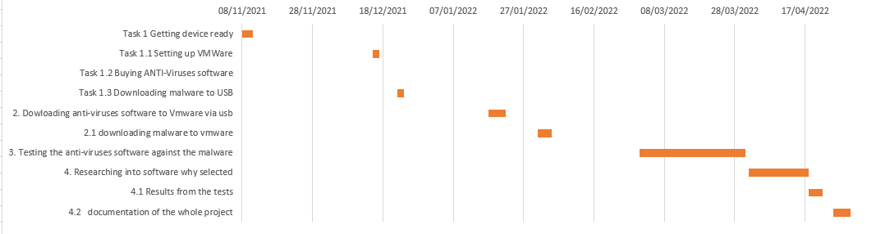
After
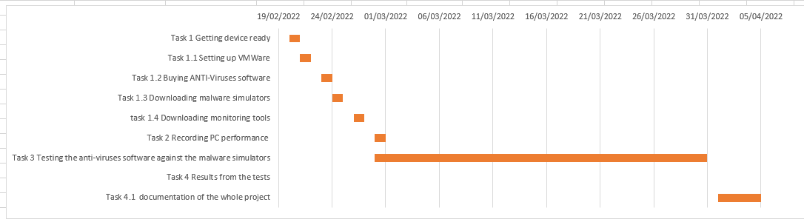

Ethics Form
Ethics form was separately submitted. No ethical issues were identified.

Logbook
Table 5: Logbook
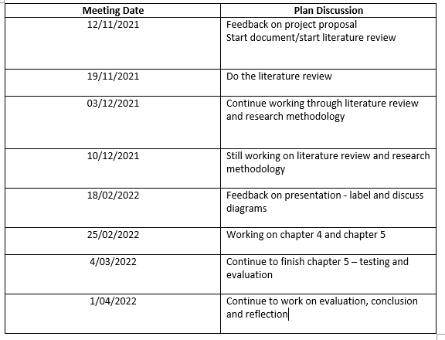

Appendices

Appendix 1- Increasing security
It is essential that end-users know how to stay alerted and take caution to protect their own devices.
There are steps that a user can take to protect a device:
Phishing emails – learn how to identify fake emails by noticing spelling mistakes, attachments, and official email addresses.
Downloading software – Download software from official brands and websites instead of downloading software illegally.
Encrypt sensitive data – When a user is working from home, they should always encrypt their files to prevent data from leaking. It makes it harder for hackers to read the data if files are encrypted.
Anti-virus software – make sure that the device is protected with anti-virus software so it can detect malware on the user device.
Computer and software updates – Keep computer and software updated to the latest version.
According to Google, the guidance they have given is to make sure a user double-checks emails, download files, and keep computer and software updated to the latest. As well as using anti-virus software. The guidance is to be careful of what you are downloading from emails and websites. This will help increase security on a device when taking caution.

Simulator tool | Purchase/free | What does it do? | Site name
Trojan horse | Open source | The trojan horse simulator is an EICAR file. It was created to test anti-virus software. it is harmless file. | EICAR
Infection Monkey | Open Source | The infection monkey software simulates the behaviour of ransomware and a breach attack. | Infection Monkey
Ransim Simulator | Open Source | The ransom simulator is 100% harmless and does not use personal files. It simulates 22 ransomware scenarios. It is 100% HARMLESS | KnowBe4

Appendix 2: Malware Simulation tools

Appendix 3: Further research
Further research, according to the UK government, four in ten business and a quarter of charities report having a security breaches or attacks in the last 12 months this Survey report was published on the 24th March 2021. If users were more aware of how to spot a malware these can lower the risks to businesses and charities. A user can lower risks of malware affecting the PC by using an anti-virus software. The aim of the project is to test the effectiveness of an anti-virus software and to evaluate how the PC performs.

Name | On-demand  Access | On-access  Scan | Boot-time  Scans | Heuristics/SIGANUTRE | CloudAV | Firewall | IDS/IPS
Bitdefender(FREE) | yes | yes | yes | yes | yes | no | none
AVAST(FREE) | yes | yes | yes | yes | yes | No | Avast offers IDS – not IPS
Norton 360(70) | yes | yes | yes | yes | yes | yes | Yes – IDS/IPS
Mcaffee(30) | yes | yes | yes | yes | yes | yes | yes

Appendix 4: anti-virus software list

Name | Price | Features | Link | System requirements | Technique used
Bitdefender | Free(30 day trial)  Anti-virus minimum protection:  £25.99 – 1 year | - Multi-layer ransomware protection  - Protection against malware, spyware, and adware | Bitdefender | Support –  - Windows 7 with service pack 1  - windows 8.1  - windows 10  - windows 11  Memory: 2gb  Software requirements :  - Internet explorer version 11 | - Bitdefender uses signature matching. And uses incremental viruses signature system based upon file types cvd and ivd  - Heuristic detection
Avast | Free | - Block viruses, ransomware, and malware  - Monitor your apps for any suspicious activity  - Advanced firewall to block intruders | Avast | - Supports- Windows 11, windows 10 and windows 8 and 8.1  - 1gb ram or above  - Internet connection | - Data base which is called FileRep – 5 billon kind of files  - A technique called Polymorphism
Norton 360 | £70 – 1 year subscription | - Dark web monitoring  - VPN- ddos protection  - Real time threat protection  - PC safecam  - Firewall smart  - Password manager  - 50gb cloud backup  - Game optimizer  - Block viruses, ransomware and malware | Norton 360 | Supports-  - Windows 11  - Windows 10  - Windows 8 all versions  - Windows 7 | Norton has said that they use a common technique to detect viruses which is called “Signature-based threat detection” and “heuristic detection”
mcafee | £30 – 1 year(trial) | - Virus protection  - Web and email protection  - Data protection and backup  - Home network  - Pc optimization  - Parental controls | Mcafee | Supports  - Windows 11  - Windows 10  - Windows 8  Requirements  - 2gb  - 1ghz processor | Mcafee use  - Signature matching  Heuristic detection

