Business Plan: Sweet Harmony
BA Business Management LCBB5001
Module Name: Entrepreneurship
Student Name: Evdokiya Stefanova 2018698
Lecturer’s Name: Masud Ibrahim

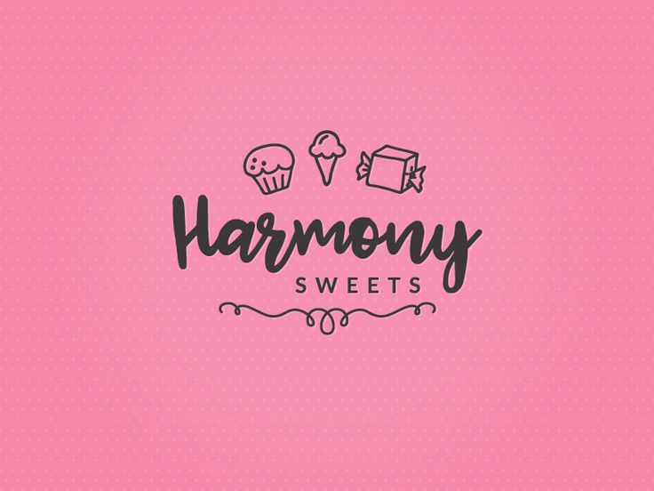
Contents
Sweet Harmony 3
Products 3
Goals 3
Legal Format of the Startup Company 3
Management of the Company 3
Ownership 3
Staff 4
External Services 4
PESTEL Analysis 4
Political 4
Economic 4
Social 4
Technological 5
Legal 5
Environmental 5
The 4 Ps (Product, price, place, promotion) 5
Product 5
Price 6
Place 6
Promotion 6
Cash flow forecast 8
References 9

Sweet Harmony
Sweet Harmony Vegan Dessert Shop is an idea of a specialty dessert shop dedicated to offering many options based around vegan desserts, since our aim is to cater to the growing demand for plant-based products that is rising recently. ‘Contemporary cultural commentaries note veganism has gone mainstream and coined the term Big Veganism’ says Sexton et al. (2022).
We will provide every type of dessert we can think of, from cakes, cookies, pastries, ice creams, beverages and other things all from natural organic ingredients.

Products
We will offer a selection of cakes of many flavours including chocolate, vanilla, carrot, etc. Cookies, brownies, muffins, croissants, dairy-free ice creams in different flavours made from coconut milk and other plant based milks as well as vegan milkshakes, coffees and teas.

Goals
To become an example in veganism and encourage other start-ups to follow our lead, and to become recognized for our delicious products whilst maintaining a plant-based use of ingredients ensuring animal welfare.

Legal Format of the Startup Company
Sweet Harmony will be a limited liability company, ‘this combines the limited liability of a corporation with the tax benefits normally associated with a partnership’ says Gazur and Goff (1990). It will have general liability insurance, property insurance, business license, food establishment permits, and health and hygiene license. I will also trademark the name and logo in preparation for future expansion.
The funding required for this venture I will try to get through grants as the government is helping people start off their small businesses, ‘there are funding programmes for start-up businesses’ says Eade (2021). This is because the UK relies on businesses to keep the economy flowing, Thurik (2003) mentions ‘business ownership can reduce the level of unemployment within the UK’.

Management of the Company

Ownership
The director and shareholder of Sweet Harmony will be Evdokiya Stefanova, a hospitality professional with several years of experience serving customers and receiving excellent feedback, with her vision to fulfil the niche market needs of vegan desserts she will lead the company to success and expand further, driving a rising trend and demand for vegan sweets.
They will be in charge of selling products, accepting catering requests for events, managing inventory, preparing the shop for sales, receiving customer feedback and assisting with peak times as well as managing the organization and driving the strategic vision of the business. They will also maintain the social media accounts of the business.

Staff
We will hire one or two staff to help with the sales of the products, the products will be pre-bought or pre-made so the actual business will only be selling. The staff will be expected to help with the sales, handle customer service and complaints, maintain the shop clean and up to standards and provide feedback to the owner.

External Services
An accountant will be hired to manage financial records, keeping the books updated and help with financial planning by giving advice, as well as filing taxes for the company.
We will also hire a marketing team to run campaigns for us when starting the business.

PESTEL Analysis
‘In strategic management it is necessary to evaluate the business environment’ according to Kozel et al. (2017), this is why we are using PESTLE analysis to investigate the macroeconomic factors surrounding our business idea.

Political
The business has to comply with regulations and health and safety food standards and regulations, also proper labelling has to be put on all products.
Government grants for start-ups and small businesses is what we are relying on to fund our business, so policy surrounding this is important. Currently Cowling et al. (2020) found that ‘there are tangible benefits associated with local finance that are likely to generate a positive local economic multiplier that extends beyond the funding period’.
Lastly import and export taxes are important now that we are living in a post-brexit UK, there may be extra costs associated with importing ingredients or products from outside.

Economic
There is a growing market demand for products of vegan origin, this is what will lead to our increased sales, however if there is economic struggle or a downturn in job prospects and security, people might start saving instead of continuing to spend like usual and this will mean our products would probably be first in line to be cut from people’s spending habits, ‘because of high out-of-pocket costs, products would be most affected by economic decline’ says Fujihara et al. (2017).
Cost of ingredients and products can also be quite expensive due to the nature of the vegan desserts being more expensive since they are ethically sourced and natural.
Inflation rates can influence spending power of customers too, as well as costs of running the business so it is something to keep track of as well.

Social
The latest trends are increasing awareness of customers about health, veganism, and plant-based products. We can market towards these trends as our products fit them perfectly and attract a broad audience that matches our business.
Martinelli and Berkmaniene (2018) find that ‘female gender, leftist political inclinations and atheism’ are more closely linked to veganism, therefore we can try marketing towards those segments. Learning about the environment makes people more conscious and leads to an increased rate of veganism.

Technological
Effective use of social platforms and e-commerce will be crucial to this business, we aim to spread ourselves through social media and to have bookings for custom orders for events such as weddings, parties, birthdays, etc. For this we will need a web or app developer to help set our business up, leading to a boost in sales and increased brand awareness by the public.
Developments in ‘food technology’ are highly anticipated, they deal with genetic modification of aliments and ‘one of the reasons for such interest in new food technologies is the anticipated range of benefits they can bring the consumer and the food sector’, says Rollin et al. (2011). This includes possible developments in plant-based dairy alternatives or egg substitutes for example.
Supply chain technology will be essential as well, as the business is based on pre-ordering and selling stock of different desserts and pastries, therefore efficient supply chain advancements can help the food be fresher and provide more easily ready availability. For example the amazon drones are a type of supply chain technology.

Legal
As a business we will make general vegan recipes and pastries but we will also aim to make our own, when this happens we have to look into intellectual property laws to protect our unique recipes which will increase our brand’s uniqueness.
When advertising as a healthy alternative we also have to be sure we are in accordance with marketing laws as health claims are scrutinized and they should be verifiable and real.

Environmental
As mentioned previously consumers favour environmental responsibility and also less animal cruelty, which ties with the aim of this business in appealing to this audience. Therefore we would like to go the extra mile and use eco-friendly packaging and easily disposable containers, which will further position us as an ally of the environment and reinforce our image.
We will not have much waste management as we order most of our products but however our carbon footprint may be high due to this, therefore we will try to locally source our products to reduce it as much as possible.

The 4 Ps (Product, price, place, promotion)

Product
Our products are vegan friendly desserts including cakes, cookies, ice creams and others ensuring they are all plant-based and one hundred percent vegan.
We will use high quality ingredients and products that are locally sourced whenever possible, as well as offering new pastries originally made by us to make us different than other vegan dessert options already available. Our products will also be with eco-friendly packaging to reinforce our existing image.

Price
We will set a competitive price within the vegan desserts area, however these are more expensive than traditional desserts with the added value of being healthy and anima cruelty-free. This is how we will provide the value indicated by our prices.
We will also do bundle deals for events such as parties when the order size exceeds a large amount, and do offers like 3 for 2 to encourage people to try our diverse catalogue.

Place
We will choose a location in the centre, where we can have the most visibility and accessibility by Birmingham’s citizens due to the high foot-traffic.
We will also have a strong online presence mainly for orders as we plan for pick-ups to be the bigger part of our business, to achieve this we will also use different delivery methods such as in-store sales, delivery, and potentially we could partner with restaurants and they could offer our desserts in their menu.
If there is any food festival or fair we will also participate with our own stands to let ourselves be known and reach a different audience.

Promotion
As mentioned previously social media will be our main method of promotion, as this is how we can easily spread the word of our business from person to person, Dwivedi et al. (2015) say ‘social media has gained tremendous fame as a highly impactful channel of communication in these modern times of digitised living’ and it is not hard to see why, in the current world everyone could see our ads and learn about us from the comfort of their home without having to be near our physical store.
We will engage with the community through social media and eventually try to have collaborations with vegan influencers as they would be interested in supporting our way of doing business, this would also add credibility to us in the vegan community as we would have been ‘vetted’ by a prominent figure in the community already.
Then we would do the classic offers 3 for 2, loyalty programs and such to encourage people to keep coming back and try our different products, maybe bringing their friends along the way. At the start of the business and maybe once every few months we also plan to have tasting sessions to bring curious people and have them check out our flavours so they may feel inclined to buy from us and have more of their favourite dessert.

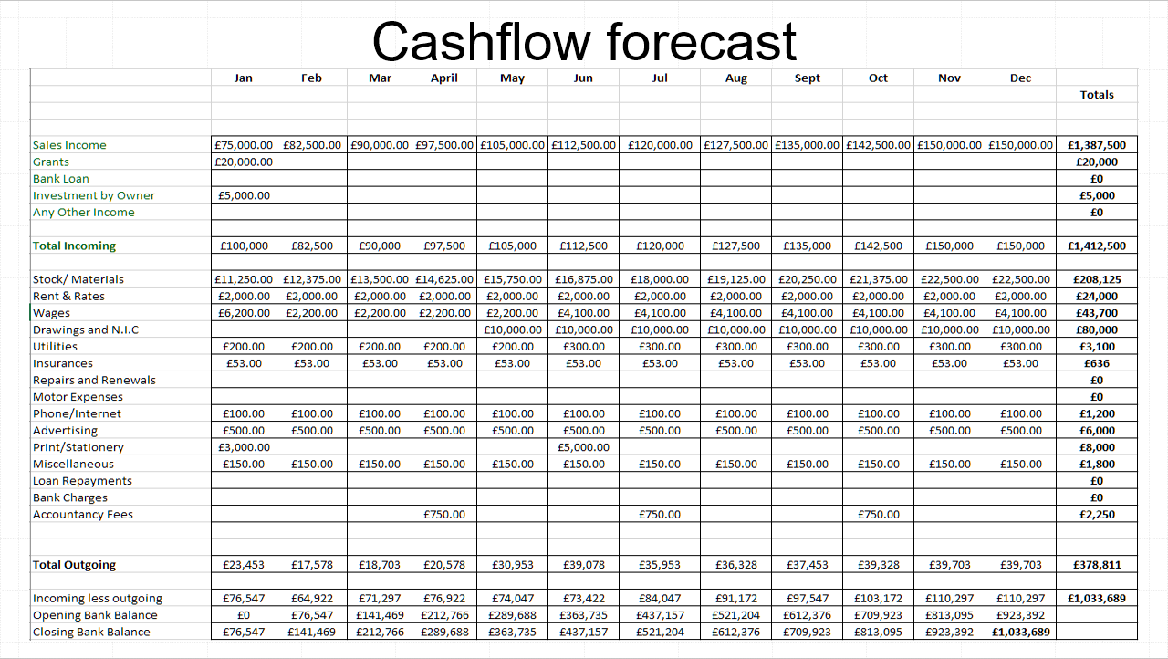

Cash flow forecast
In the cashflow forecast we can see that the initial investment of £20000 with £5000 from personal savings will be mainly used to buy a lot of stock, pay rent, and a hefty sum of wages due to paying for a marketing campaign to start off the business, and to pay for a web page and phone app to be developed.
There will also be initial investment for any equipment we may need such as tills and machines to make drinks.
The wages will eventually go higher as I hire more staff to manage the shop, and utilities too as we use them more to deal with a higher amount of customers. Stock costs also go higher to match the increasing demand.

References
Sexton, A. E., Garnett, T., & Lorimer, J. (2022). Vegan food geographies and the rise of Big Veganism. Progress in Human Geography, 46(2), 605-628. Available at: https://journals.sagepub.com/doi/abs/10.1177/03091325211051021 (Accessed 12th June 2024)
Gazur, W. M., & Goff, N. M. (1990). Assessing the limited liability company. Case W. Res. L. Rev., 41, 387. Available at: https://heinonline.org/HOL/LandingPage?handle=hein.journals/cwrlrv41&div=15&id=&page= (Accessed 12th June 2024)
Eade, R. (2021). Business grants for business growth and recovery. Available at: https://www.open-access.bcu.ac.uk/11372/1/Business%20grants%20for%20business%20growth%20and%20recovery.pdf (Accessed 12th June 2024)
Thurik, R. (2003). Entrepreneurship and unemployment in the UK. Scottish Journal of Political Economy, 50(3), 264-290. Available at: https://onlinelibrary.wiley.com/doi/abs/10.1111/1467-9485.5003001 (Accessed 12th June 2024)
Kozel, R., Chuchrová, K., & Šanda, M. (2017). PESTLE analysis and its impact factor as an innovative IT application in industrial enterprises. IDIMT 2017: Digitalization in Management, Society and Economy–25th Interdisciplinary Information Management Talks, 93-100. Available at: https://d1wqtxts1xzle7.cloudfront.net/89520376/IDIMT_proceedings_2017-libre.pdf?1660295262=&response-content-disposition=inline%3B+filename%3DModelling_the_Service_Value_Chain_for_Sm.pdf&Expires=1719840408&Signature=ShTCvTtNn77ierKzU69awA-wQ2t~J2hzbuyLex-xaHXYGCqtDY1cjm0Qr4XF3cq5IVM6nUbtqysaccCX-QP3jSKP1CijqU7q27yYFbkj~AwFmVLKhhVFhihu1rATbaqabGdOvYpvjlaWCwkEC~N160zZx71h61Ger2MA6WQDtN~4gR0tS24xMYXjKrO61KBHsJPTeM-2-ipZALUZMknW-UX6aFbSGEVvCNwW5~d4rtj6WTpc3ZneensZDQqsi7Cx9vztPVsjdBiw2WalOgDHUWZns34xHCxMLmmA3~gctlB9pjrsi5m-SOmMQJYq2iB30PEFPMKnnC6C3umVDqH31Q__&Key-Pair-Id=APKAJLOHF5GGSLRBV4ZA#page=96 (Accessed 12th June 2024)
Cowling, M., Nadeem, S. P., Foster, C., & Baranova, P. (2020). Can Local Finance Add Value to Local Small Business? Evidence from a UK Local Loan and Grant Fund. International Review of Entrepreneurship, 18(1). Available at: https://www.tara.tcd.ie/bitstream/handle/2262/104737/1622.pdf?sequence=1 (Accessed 12th June 2024)
Fujihara, N., Lark, M. E., Fujihara, Y., & Chung, K. C. (2017). The effect of economic downturn on the volume of surgical procedures: a systematic review. International Journal of Surgery, 44, 56-63. Available at: https://www.sciencedirect.com/science/article/pii/S1743919117304971 (Accessed 12th June 2024)
Martinelli, D., & Berkmanienė, A. (2018). The politics and the demographics of veganism: notes for a critical analysis. International Journal for the Semiotics of Law-Revue internationale de Sémiotique juridique, 31, 501-530. Available at: https://link.springer.com/article/10.1007/s11196-018-9543-3 (Accessed 12th June 2024)
Rollin, F., Kennedy, J., & Wills, J. (2011). Consumers and new food technologies. Trends in food science & technology, 22(2-3), 99-111. Available at: https://www.sciencedirect.com/science/article/abs/pii/S0924224410001950 (Accessed 12th June 2024)
Dwivedi, Y. K., Kapoor, K. K., & Chen, H. (2015). Social media marketing and advertising. The Marketing Review, 15(3), 289-309. Available at: https://www.ingentaconnect.com/content/westburn/tmr/2015/00000015/00000003/art00003 (Accessed 12th June 2024)

