International
Business Communications
Student ID: 1914253
19th of April 2022

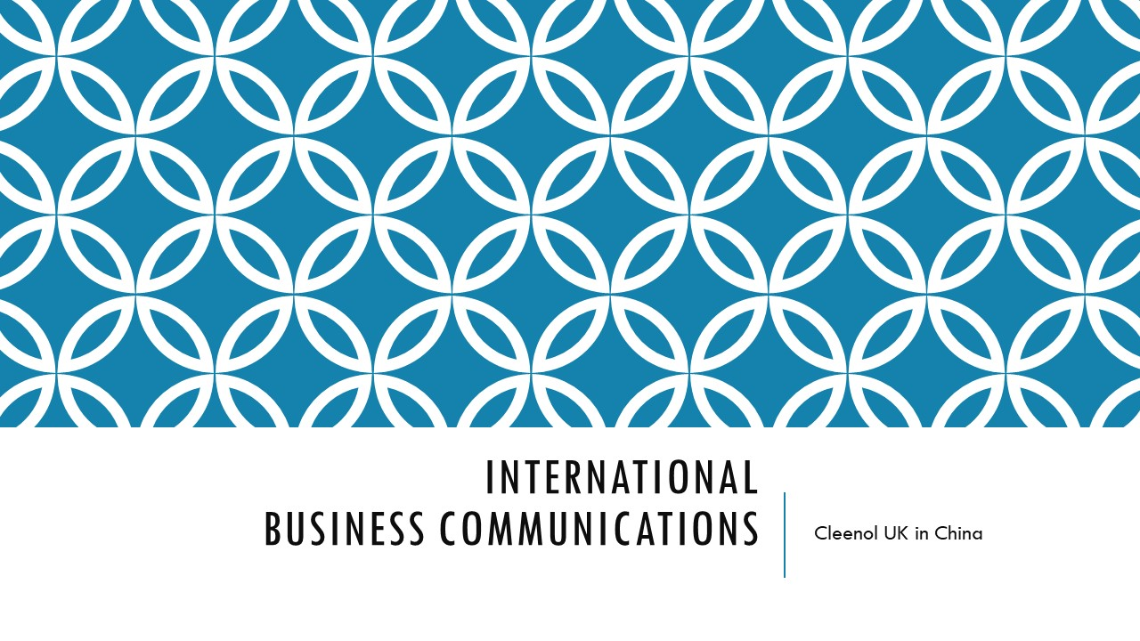

- Group leader: Alexandru-Marian Dima

Introduction
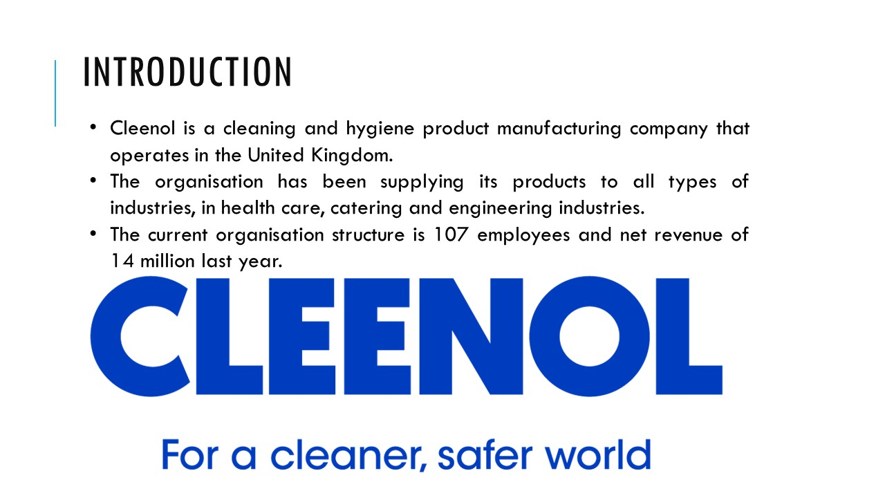
International business communication is a practice in which an organisation communicates and delivers its products across the border. Cleenol is a cleaning and hygiene product manufacturing company that operates in the United Kingdom. The organisation has been manufacturing products that can be used as cleaners and sanitisers and are used for commercial, industrial and domestic cleaning purposes. The organisation produces products like oven cleaners, floor cleaners, dishwashers, hand soaps, machines, dishwashers, and toilet cleaners that cater for hygiene and safety for all. The organisation has been supplying its products to all types of industries, in health care, catering and engineering industries. The current organisation structure is 107 employees and net revenue of 14 million last year.

Agenda of presentation
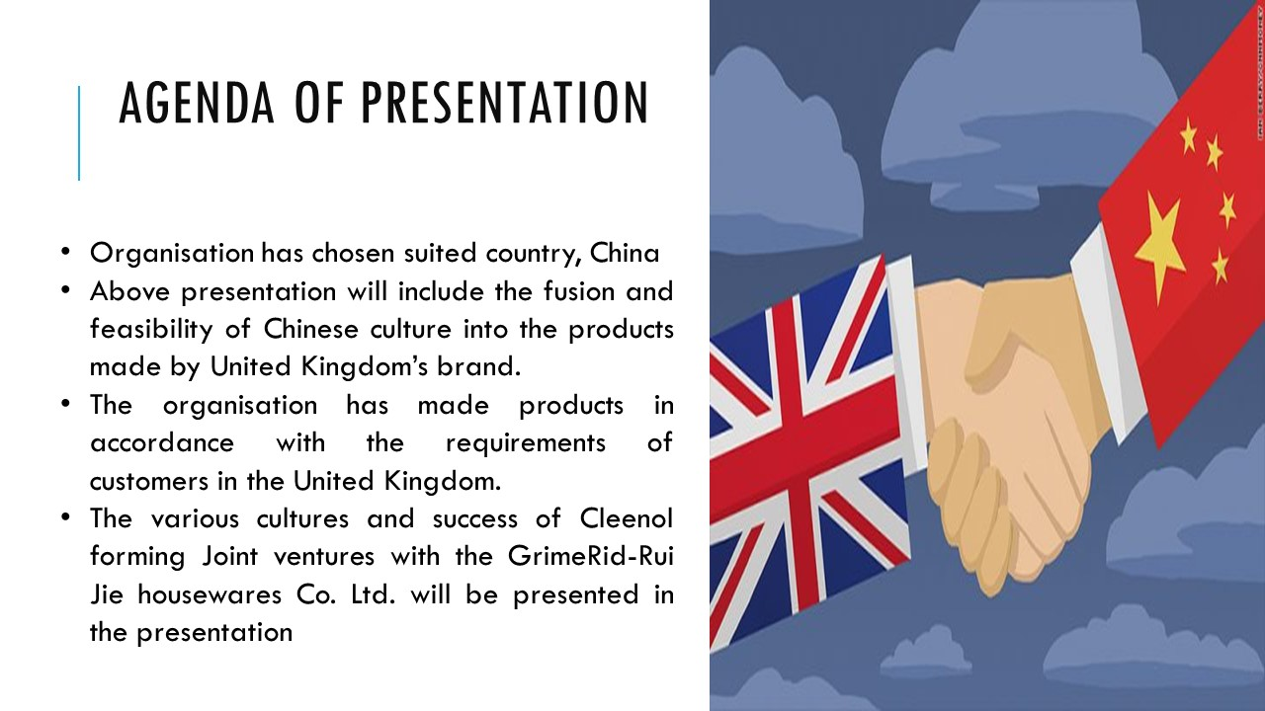
Cleenol is a cleaning and hygiene product manufacturing company that operates in the United Kingdom. The organisation has been manufacturing products that can be used as cleaners and sanitisers and are used for commercial, industrial and domestic cleaning purposes. Cleenol currently severs in the middle United Kingdom but aims to serve in international places as well. The organisation has chosen suited country, China (cleenol.com 2022). The above presentation will include the fusion and feasibility of Chinese culture into the products made by United Kingdom’s brand. The organisation has made products in accordance with the requirements of customers in the United Kingdom. The various cultures and success of Cleenol forming Joint ventures with the GrimeRid-Rui Jie housewares Co. Ltd. will be presented in the presentation.

Business context
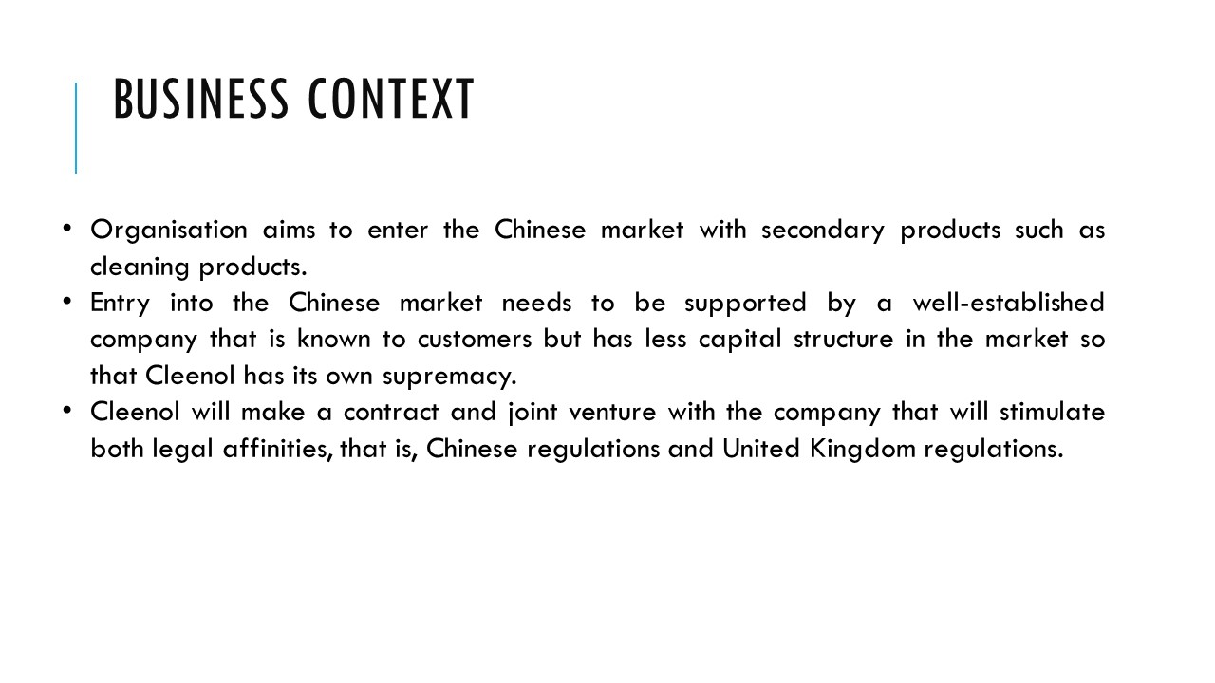
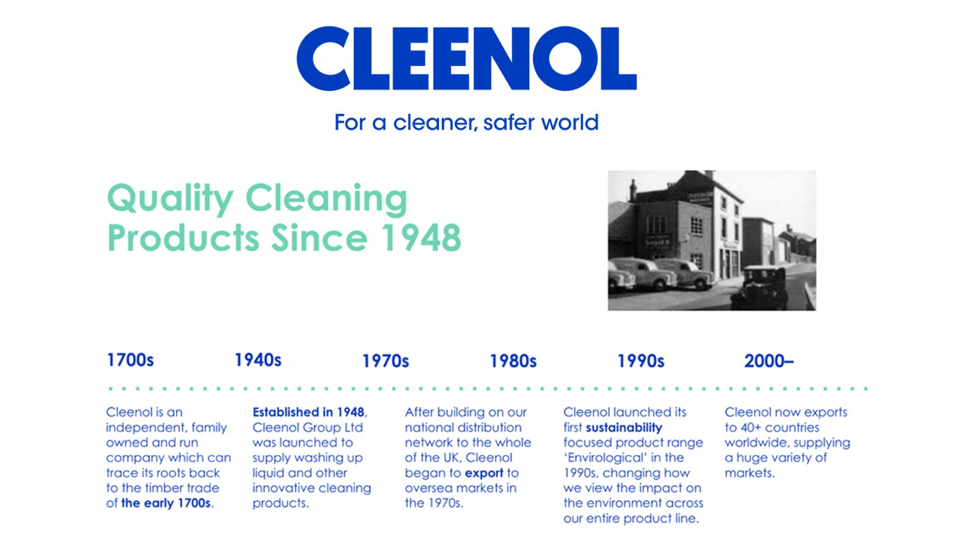
Cleenol is forming Joint ventures with the GrimeRid-Rui Jie housewares Co. Ltd. which has been making plastic mob cleaners in the country for a very long time. The organisation aims to enter the Chinese market with secondary products such as cleaning products (Meyer, 2016). The organisation will make a joint venture with plastic brushes and mob making company, which can section be a brand extension into cleaning products as well. The organisation has a huge customer base in the United Kingdom, but entry into the Chinese market needs to be supported by a well-established company that is known to customers but has less capital structure in the market so that Cleenol has its own supremacy. Cleenol will make a contract and joint venture with the company that will stimulate both legal affinities, that is, Chinese regulations and United Kingdom regulations.

Introduction of Chinese culture
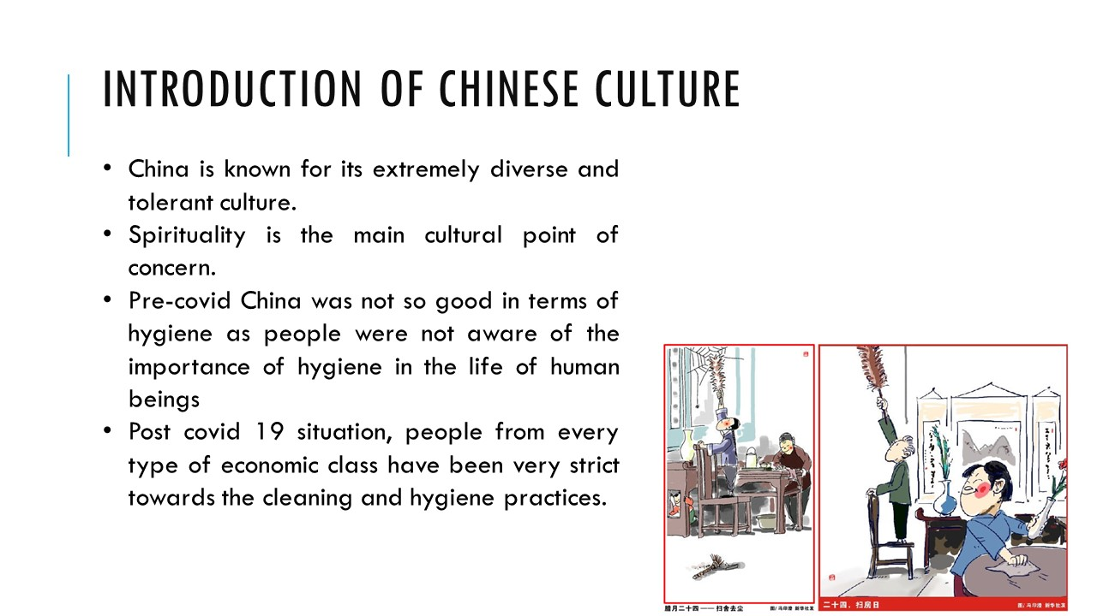
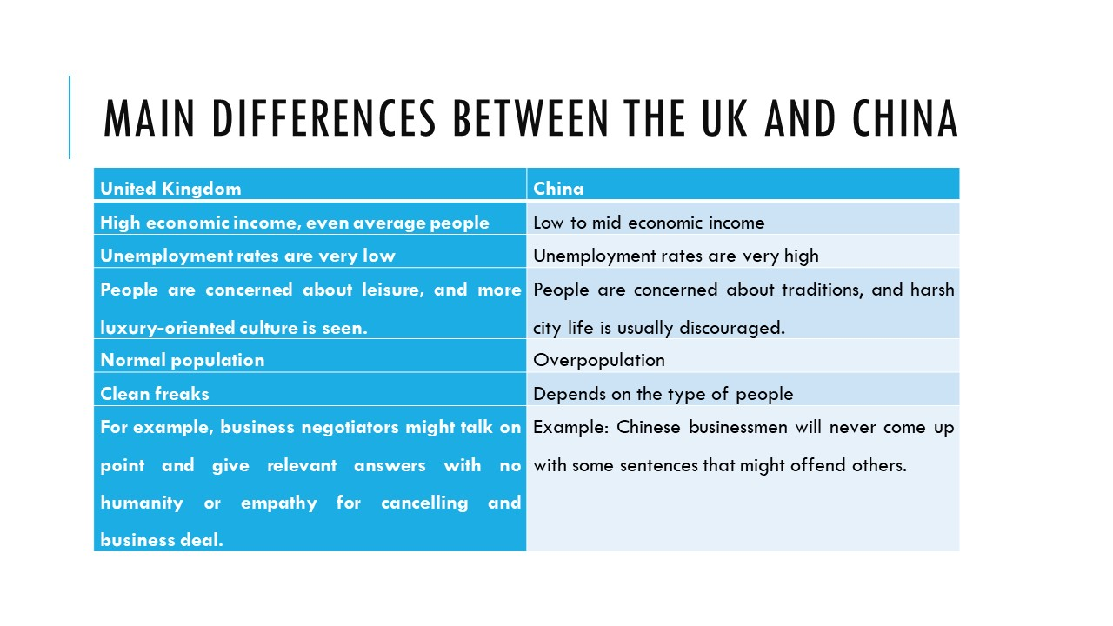
Chinese cleaning culture
China is known for its extremely diverse and tolerant culture. The country has a very rich and different culture, and spirituality is the main cultural point of concern. Pre-covid China was not so good in terms of hygiene as people were not aware of the importance of hygiene in the life of human beings. But after the covid 19 situation, people from every type of economic class have been very strict towards the cleaning and hygiene practices. The organisation has been manufacturing products that can be used as cleaners and sanitisers and are used for commercial, industrial and domestic cleaning purposes. At a later stage, the country had only hyped business in cleaning products in the season of the Laba festival (Chipaike and Mhandara 2013). But post covid the evident hype in dales of cleaning products gas shown huge opportunities to international business to establish their respective business in the country.

Main differences between the UK and China
United Kingdom | China
High economic income, even average people | Low to mid economic income
Unemployment rates are very low | Unemployment rates are very high
People are concerned about leisure, and more luxury-oriented culture is seen. | People are concerned about traditions, and harsh city life is usually discouraged.
Normal population | Overpopulation
Clean freaks | Depends on the type of people
For example, business negotiators might talk on point and give relevant answers with no humanity or empathy for cancelling and business deal. | Example: Chinese businessmen will never come up with some sentences that might offend others.

Statistics of cleaning companies and financial figures
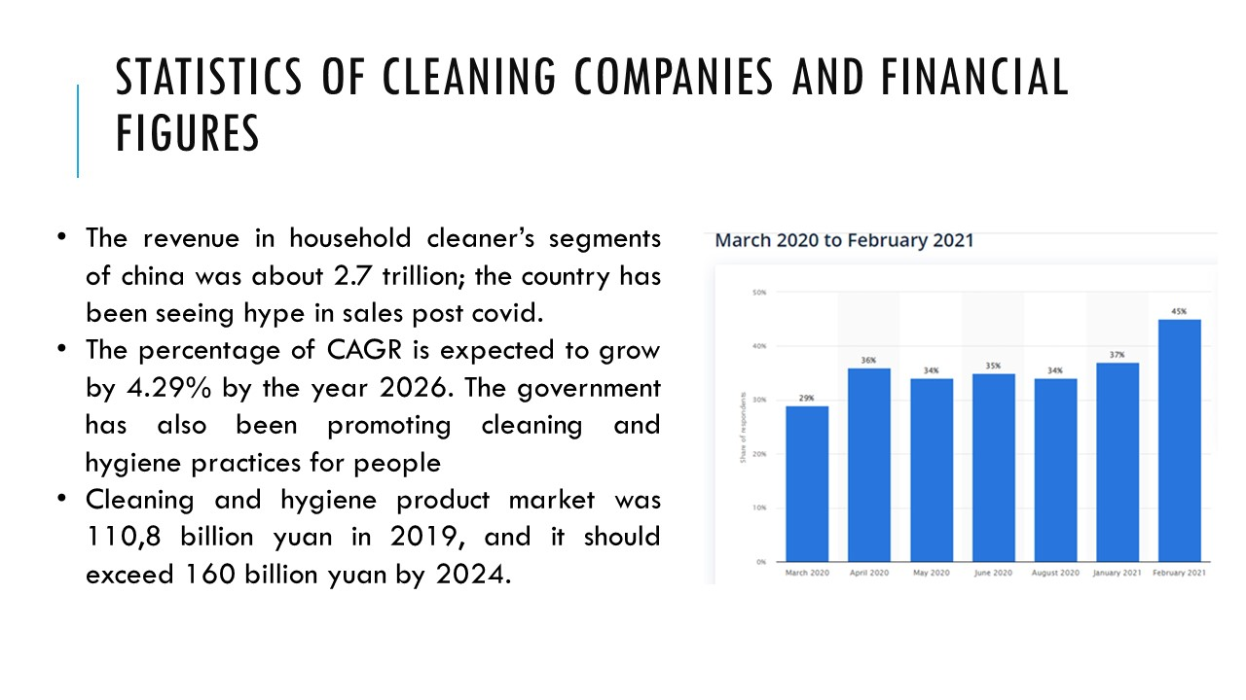
The revenue in household cleaner’s segments of china was about 2.7 trillion; the country has been seeing hype in sales post covid. The percentage of CAGR is expected to grow by 4.29% by the year 2026. The country has been flourishing with a new market as the hygiene awareness portion in the people has raised irrespective of the economic base. The government has also been promoting cleaning and hygiene practices for people (Brown et al., 2017). The cleaning and hygiene product market was 110,8 billion yuan in 2019, and it should exceed 160 billion yuan by 2024.

Success factors of joint ventures
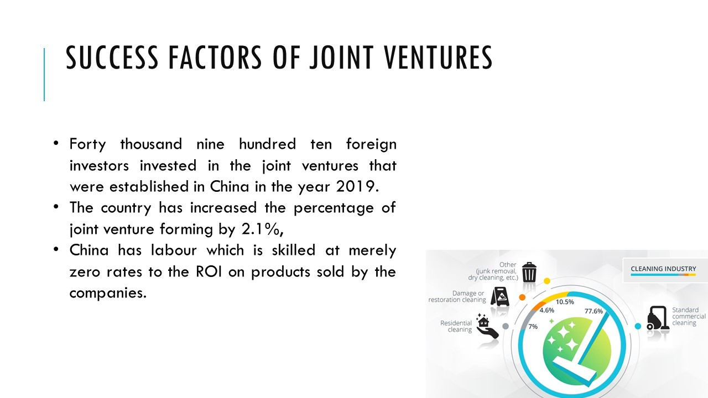
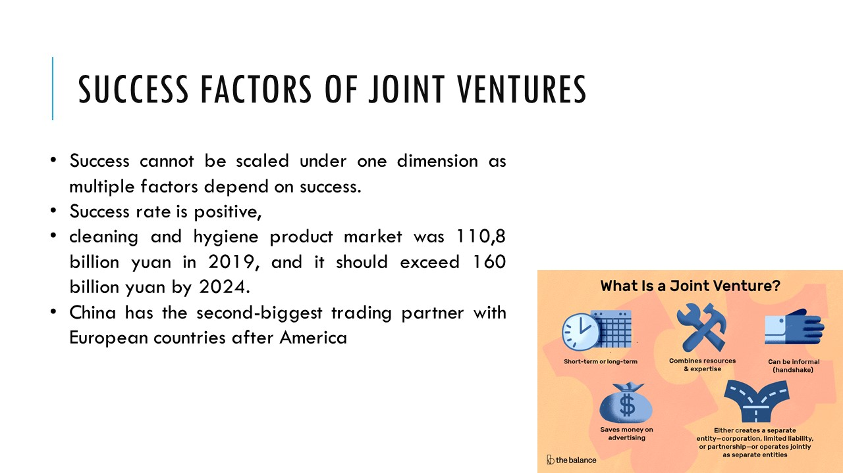
Forty thousand nine hundred ten foreign investors invested in the joint ventures that were established in China in the year 2019. The country has increased the percentage of joint venture forming by 2.1%, and the total revenue even year has been in trillions as the attraction of the various investors in China is labour which is skilled at merely zero rates to the ROI on products sold by the companies. The success rate of Joint ventures in-country is medium to high (Rosales 2013).
Success cannot be scaled under one dimension as multiple factors depend on success. In terms of Cleenol, the success rate is positive, and the production demand and usage in three sections that are industrial, commercial and domestic households can be taken. The cleaning and hygiene product market was 110,8 billion yuan in 2019, and it should exceed 160 billion yuan by 2024. Additionally, China has the second-biggest trading partner with European countries after America, which is 375.1 million products supplied by china to European countries. The trading practice seems to be positive for Cleenol as well (Ojo 2016).

Cleenol forming joint venture with GrimeRid-Rui Jie housewares Co. Ltd
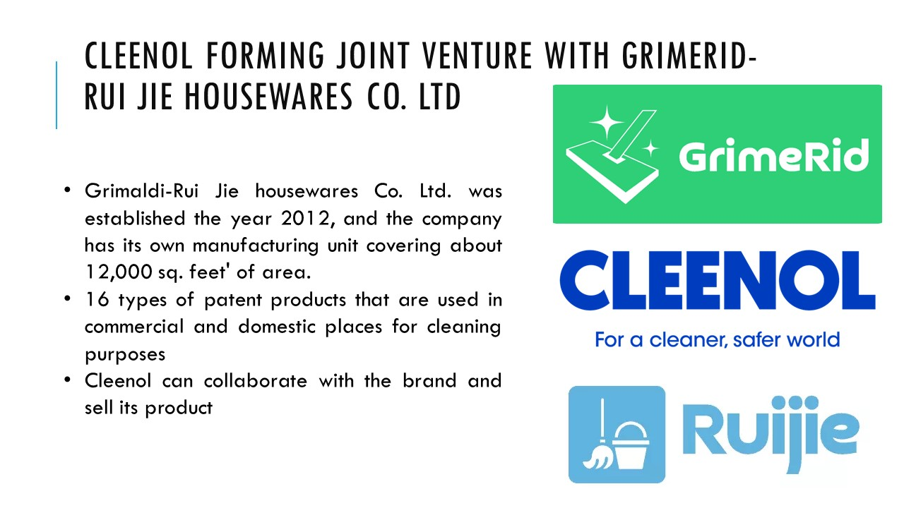
Grimaldi-Rui Jie housewares Co. Ltd. was established the year 2012, and the company has its own manufacturing unit covering about 12,000 sq. feet' of area. The organisation makes 16 types of patent products that are used in commercial and domestic places for cleaning purposes. They have products like mops and buckets, microfibre mops, PVA steam mops, and foldable buckets. An organisation like Cleenol can collaborate with the brand and sell its product as a by-product o the current product of the brand. Cleenol can cater positive relationship with the brand and China to have elevated profits in the international market (Naughton et al., 2015).

Failure factors of joint ventures
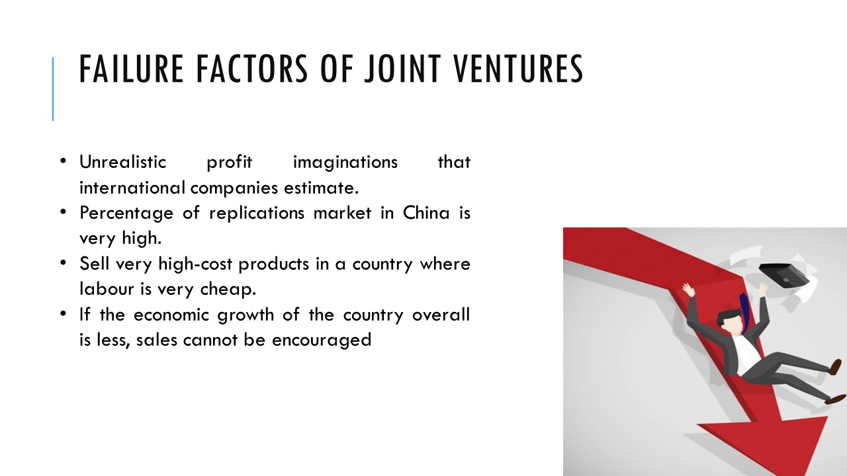
The main issue with joint ventures failing in china is the unrealistic profit imaginations that international companies estimate. The labour cost and skilled work are factors that might reduce the product manufacturing cost but cannot directly increase sales. Various automobile and electronic companies have accepted the challenge to survive in the market in China as well as the percentage of replications market in China is very high. Another reason for the failure of the joint venture in Chinese country is international organisation aims to sell very high-cost products in a country where labour is very cheap. If the economic growth of the country overall is less, sales cannot be encouraged (Nolan, 2014).

Cultural sensitivity in China
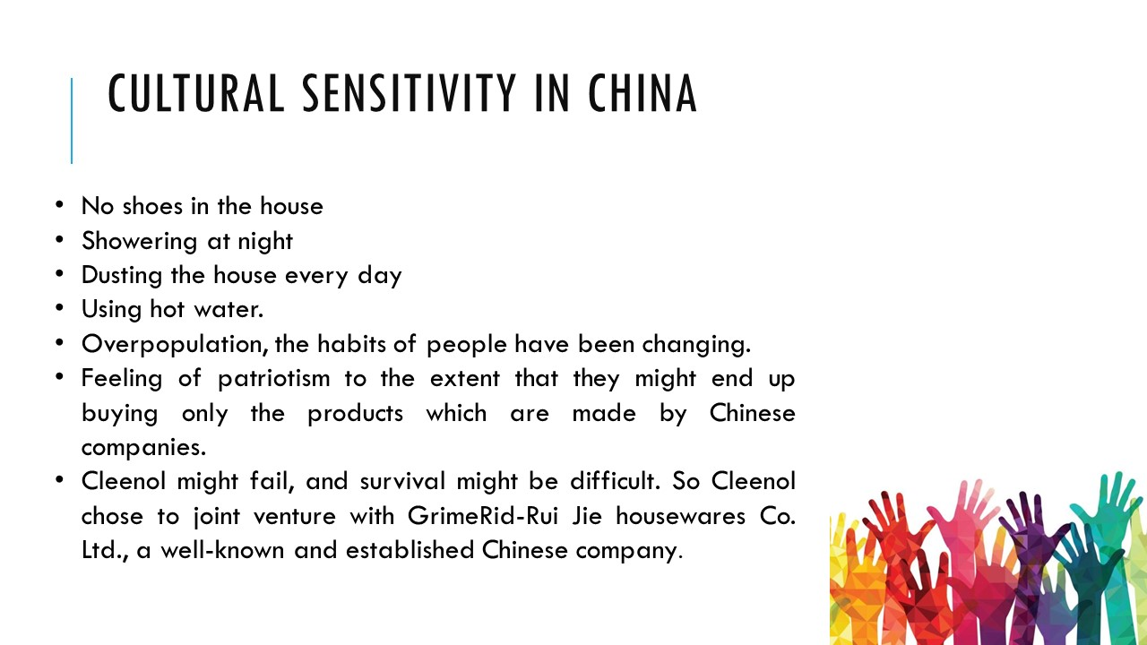
Chinese cleaning culture
In accordance with the habits of people, the culture of the country has been very different. People have practised no shoes in the house, showering at night, dusting the house every day and using hot water. The practices traditionally in Chinese people have been very assertive towards cleaning, but in later stages, with overpopulation, the habits of people have been changing. The main reason for the shift was economic income and overpopulation with the fast life. This gave rise to many diseases and other problems within people (Al-Tamimi 2013).
People have a very sensitive attitude toward culture. Then they have the feeling of patriotism to the extent that they might end up buying only the products which are made by Chinese companies. In such a situation, companies like Cleenol might fail, and survival might be difficult. So Cleenol chose to joint venture with GrimeRid-Rui Jie housewares Co. Ltd., a well-known and established Chinese company.

Hofstede cultural dimension
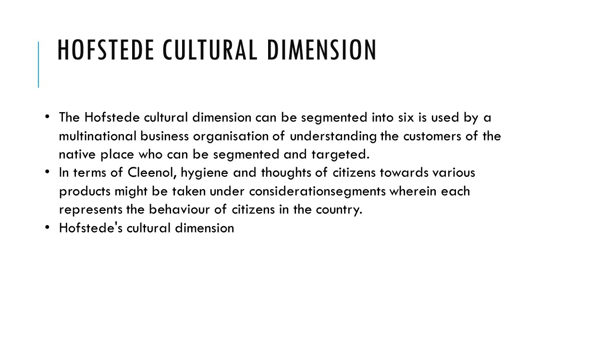
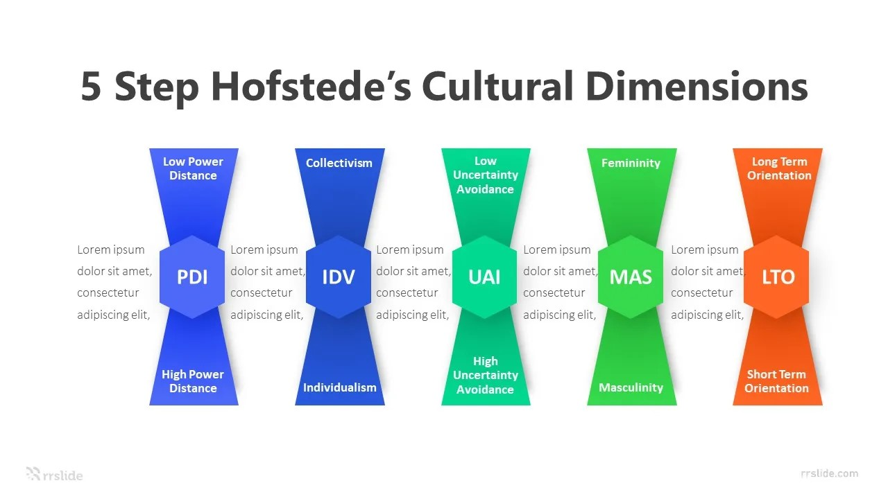
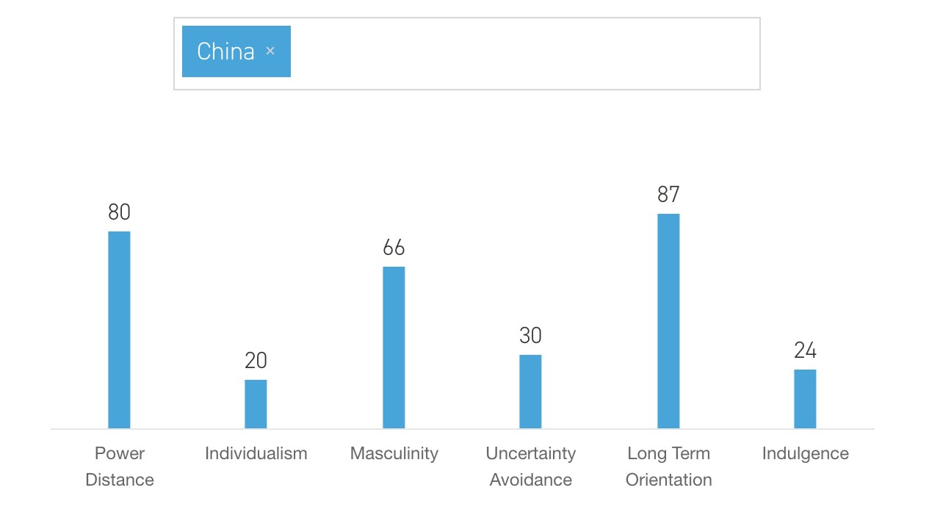
The Hofstede cultural dimension can be segmented into six segments wherein each represents the behaviour of citizens in the country. Hofstede's cultural dimension is used by a multinational business organisation of understanding the customers of the native place who can be segmented and targeted. In terms of Cleenol, hygiene and thoughts of citizens towards various products might be taken under consideration (Fry 2019).
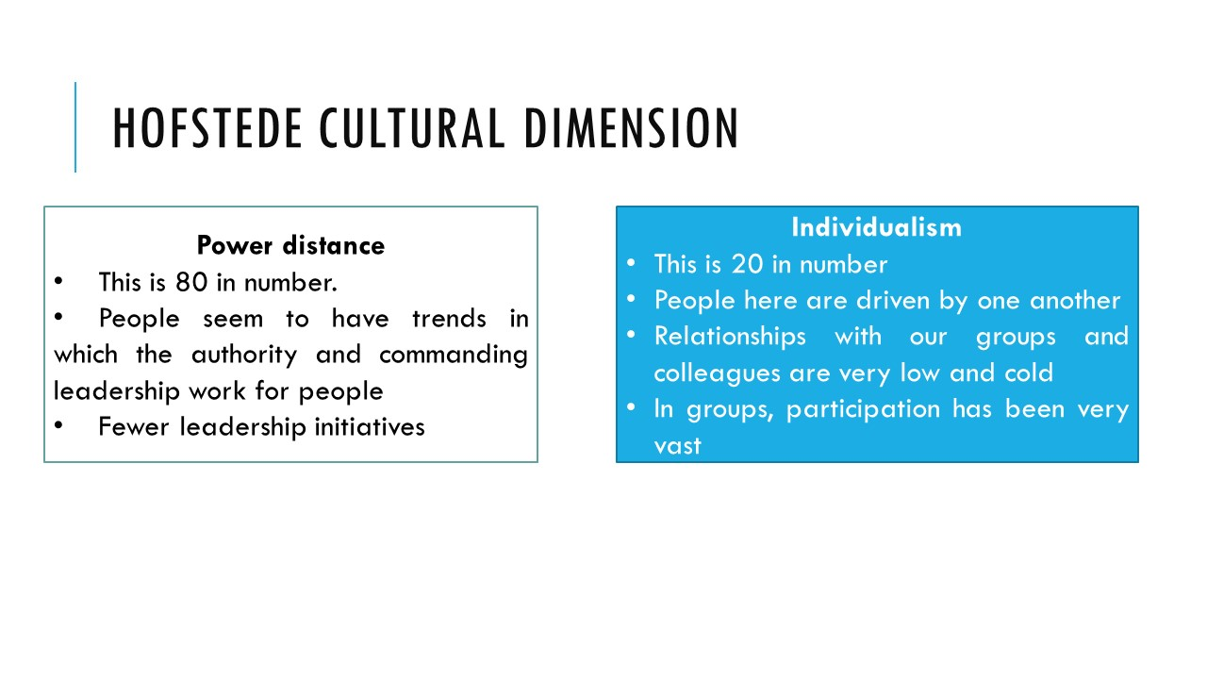
Power distance
- This is 80 in number.
- People seem to have trends in which the authority and commanding leadership work for people
- Fewer leadership initiatives
Individualism
- This is 20 in number
- People here are driven by one another
- Relationships with our groups and colleagues are very low and cold
- In groups, participation has been very vast
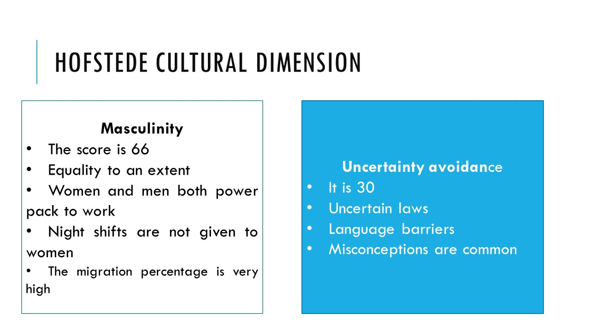

Masculinity
- The score is 66
- Equality to an extent
- Women and men both power pack to work
- Night shifts are not given to women
- The migration percentage is very high

Uncertainty avoidance
- It is 30
- Uncertain laws
- Language barriers
- Misconceptions are common
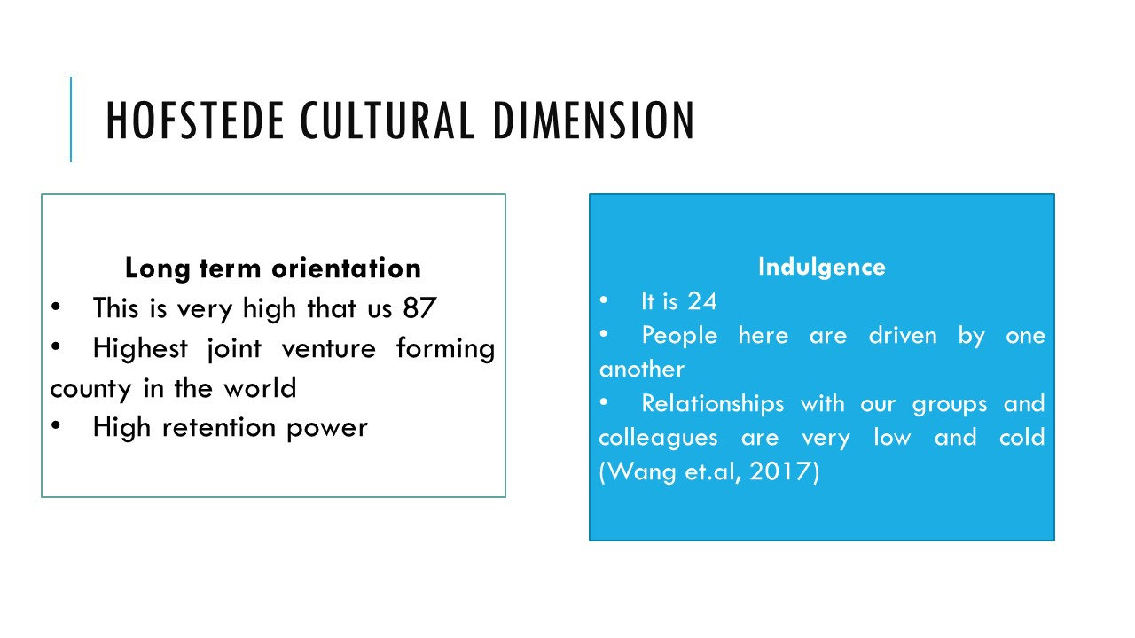
Long term orientation
- This is very high that us 87
- Highest joint venture forming county in the world
- High retention power
Indulgence
- It is 24
- People here are driven by one another
- Relationships with our groups and colleagues are very low and cold (Wang et.al, 2017)

References
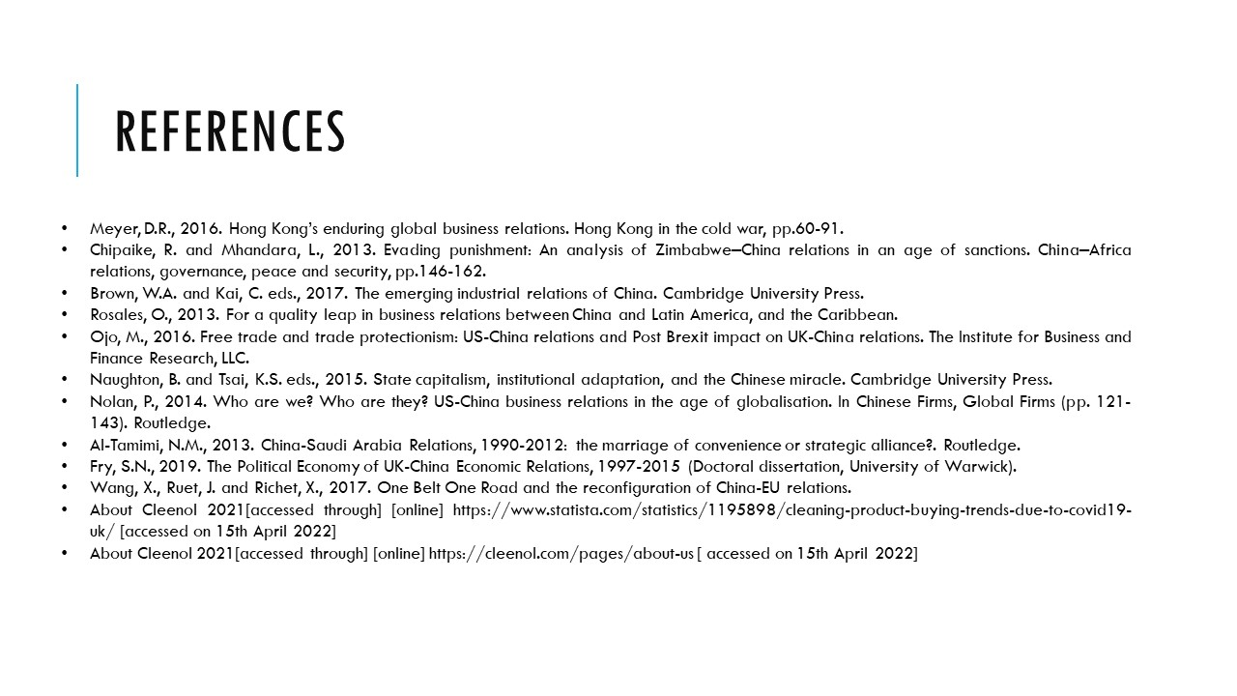
Meyer, D.R., 2016. Hong Kong’s enduring global business relations. Hong Kong in the cold war, pp.60-91.
Chipaike, R. and Mhandara, L., 2013. Evading punishment: An analysis of Zimbabwe–China relations in an age of sanctions. China–Africa relations, governance, peace and security, pp.146-162.
Brown, W.A. and Kai, C. eds., 2017. The emerging industrial relations of China. Cambridge University Press.
Rosales, O., 2013. For a quality leap in business relations between China and Latin America, and the Caribbean.
Ojo, M., 2016. Free trade and trade protectionism: US-China relations and Post Brexit impact on UK-China relations. The Institute for Business and Finance Research, LLC.
Naughton, B. and Tsai, K.S. eds., 2015. State capitalism, institutional adaptation, and the Chinese miracle. Cambridge University Press.
Nolan, P., 2014. Who are we? Who are they? US-China business relations in the age of globalisation. In Chinese Firms, Global Firms (pp. 121-143). Routledge.
Al-Tamimi, N.M., 2013. China-Saudi Arabia Relations, 1990-2012: the marriage of convenience or strategic alliance?. Routledge.
Fry, S.N., 2019. The Political Economy of UK-China Economic Relations, 1997-2015 (Doctoral dissertation, University of Warwick).
Wang, X., Ruet, J. and Richet, X., 2017. One Belt One Road and the reconfiguration of China-EU relations.
About Cleenol 2021[accessed through] [online] https://www.statista.com/statistics/1195898/cleaning-product-buying-trends-due-to-covid19-uk/ [accessed on 15th April 2022]
About Cleenol 2021[accessed through] [online] https://cleenol.com/pages/about-us [ accessed on 15th April 2022]



