University of Wales Trinity Saint David (UWTSD)
Module Code: BMHP5015
Module Title: Changemakers: Building your Personal Brand for Sustainable Employment
Employability Report
Student Name: Marzena Kaldowska
Student Number: 2410515
Lecturer: Caroline Salami

INTRODUCTION
The role I have chosen for this report is Medical Secretary (Band 4) at Mersey and West Lancashire Teaching Hospitals NHS Trust, advertised on NHS Jobs with a closing date of 16 August 2026. The Trust provides acute, community and specialist services across 21 sites, supporting more than 600,000 people. The Medical Secretary role is central to ensuring accurate clinical documentation, effective communication between multidisciplinary teams, and high-quality administrative support for consultants and service managers.
I am interested in this role because I want to develop strong skills in medical documentation and gain exposure to senior clinical and managerial staff. Working closely with decision-makers would allow me to learn quickly, understand service operations, and build a foundation for future progression within the NHS. My previous healthcare experience, combined with analytical and communication strengths, aligns well with the expectations of this position.
This report will analyse the employability skills required for the role, evaluate my current competencies, outline how I can build a strong personal brand, and present a detailed action plan to achieve this career goal.

https://www.jobs.nhs.uk/candidate/jobadvert/C9409-26-0768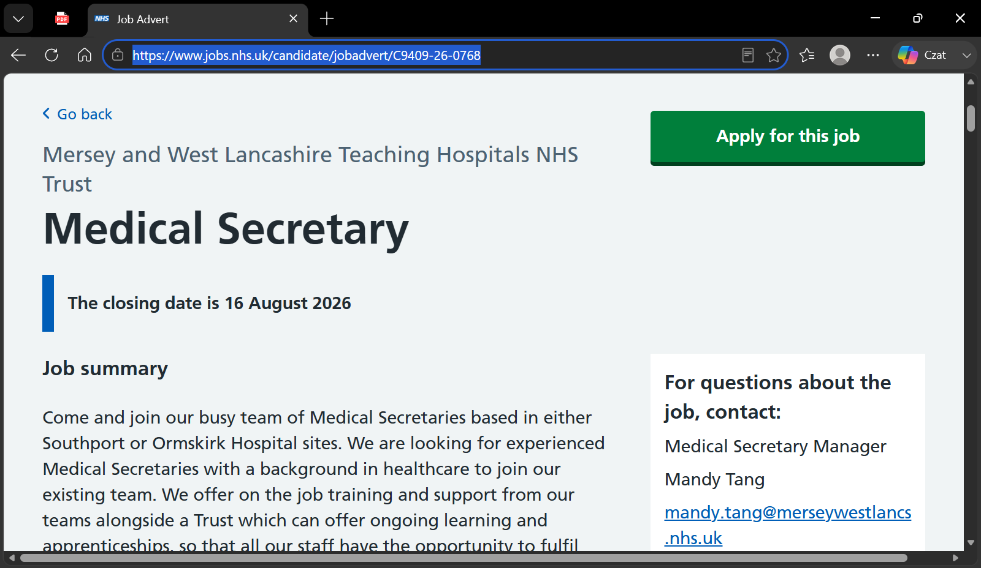

Analyse the Employability Skills Required
The Medical Secretary (Band 4) role requires a blend of technical, administrative and interpersonal skills that support high-quality patient care. According to the NHS job advert, applicants must have previous medical secretarial experience, extensive knowledge of medical terminology, and experience of minute taking. These requirements reflect the complexity of the role, which involves managing clinical documentation, coordinating communication between multidisciplinary teams, and supporting consultants with accurate and timely administrative work.
Communication is one of the most important employability skills. Medical Secretaries liaise with consultants, nurses, administrative teams and external agencies, meaning they must communicate clearly, professionally and with sensitivity. This aligns with NHS Values, particularly Communication, Compassion and Commitment to Quality of Care. Effective communication is also central to the Skills for Care Core Skills Framework, which highlights the importance of information handling and interpersonal skills.
Organisation and time management are essential. The job advert states that “being a team player is essential together with first-rate organisational skills.” Medical Secretaries manage multiple tasks simultaneously, including scheduling clinics, preparing correspondence, updating patient records and supporting consultants’ workflow. The Employability Skills Framework identifies organisation, planning and prioritisation as core competencies in roles involving complex information and deadlines.
Information management and accuracy are also critical. Medical Secretaries handle confidential patient information, clinical letters, referral documents and MDT notes. Errors in documentation can affect patient care, clinic scheduling and communication between departments. The 6Cs of Nursing, particularly Competence and Care, reinforce the importance of precision and responsibility. The NHS Code of Confidentiality requires strict data protection standards, making information governance a key employability skill.
Minute taking is explicitly required. This specialised skill involves active listening, summarising complex discussions and producing clear, structured records of meetings. Using the STAR model, minute taking supports clinical governance, service planning and patient safety by ensuring decisions and actions are recorded accurately.
Teamwork and collaboration are essential because the role requires liaising with “all relevant departments within the Trust and multiple outside agencies.” The Kolb Learning Cycle helps explain how teamwork skills develop through experience: observing team dynamics, participating in collaborative tasks, reflecting on interactions and applying learning to future situations.
Finally, the Trust emphasises ongoing learning and development, offering “on-the-job training and apprenticeships.” This highlights adaptability, willingness to learn and commitment to professional growth. These attributes align with the CareerEDGE Model, which emphasises personal development, reflection and experience as key components of employability.
Overall, the Medical Secretary Band 4 role requires communication, organisation, accuracy, teamwork, confidentiality and specialised administrative skills to support clinical teams effectively.

Evaluate Your Own Skills
Evaluating my own skills against the requirements of the Medical Secretary (Band 4) role allows me to identify how well I currently meet the expectations of the position and where further development is needed. The NHS job advert specifies that applicants must have previous medical secretarial experience, extensive knowledge of medical terminology, strong organisational skills, the ability to liaise with multiple departments, and experience of minute taking (NHS Jobs, 2026). Reflecting on my background, I can identify several strengths that align closely with these requirements, as well as areas that require targeted improvement.
To structure this evaluation, I used a SWOT analysis, which helped me compare my current competencies with the job specification. My key strengths include logical and analytical thinking, which support accuracy in documentation and problem-solving in fast-paced clinical environments. These skills are essential for managing complex information, preparing clinical correspondence, and ensuring that patient records are updated correctly. Additionally, my strong communication skills enable me to interact effectively with clinicians, managers, patients and external agencies. This aligns with the job advert’s emphasis on liaising with “all relevant departments within the Trust and multiple outside agencies,” demonstrating that communication is a core competency for this role.
My previous experience in healthcare settings has also equipped me with an understanding of clinical workflows, patient pathways and the importance of confidentiality. Working closely with patients and multidisciplinary teams has strengthened my interpersonal skills and my ability to remain calm and professional in challenging situations. These experiences reflect the NHS Values, particularly Communication, Compassion and Commitment to Quality of Care, which underpin the behaviours expected of administrative staff supporting clinical services.
However, the SWOT analysis also highlighted several areas for development. The job advert requires “extensive knowledge of medical terminology,” and while I have a solid foundation from my previous roles, I recognise the need to advance this knowledge further to meet Band 4 expectations. Similarly, minute taking is listed as an essential requirement. Although I have experience summarising information and preparing reports, I have not yet developed formal minute-taking skills used in MDT meetings or consultant-led discussions. This is an area I need to strengthen to ensure I can produce accurate, structured and timely records of clinical meetings.
Another development area is gaining confidence with NHS digital systems, such as PAS, EPR, ICE and digital dictation platforms. While I have experience with electronic documentation, I have not yet used the specific systems employed within Mersey and West Lancashire Teaching Hospitals NHS Trust. Developing competence in these systems will be essential for performing daily tasks efficiently and supporting consultants effectively.
To deepen this evaluation, I applied Gibbs’ Reflective Cycle to a recent experience in my care role. During a shift, I was responsible for documenting observations and communicating changes in a patient’s condition to senior staff. Reflecting on this experience helped me recognise the importance of accuracy, timely communication and professional responsibility — all of which are central to the Medical Secretary role. Gibbs’ model also encouraged me to identify what I could improve, such as structuring information more clearly and ensuring that documentation follows organisational standards.
I also considered Maslow’s Hierarchy of Needs to understand my motivation for pursuing this role. My desire to work closely with senior staff and develop advanced administrative skills reflects my focus on the esteem and self-actualisation levels of the hierarchy. I am motivated by opportunities for growth, learning and professional recognition, which the Trust explicitly supports through “ongoing learning and apprenticeships” (NHS Jobs, 2026).
Finally, the CareerEDGE Model highlights the importance of experience, reflection, emotional intelligence and career development learning. My background in healthcare, combined with my reflective practice and interpersonal strengths, provides a strong foundation for employability. However, enhancing my technical skills — particularly minute taking, medical terminology and NHS systems — will be essential for achieving full readiness for the Band 4 role.
Overall, my evaluation shows that I possess several strong competencies aligned with the Medical Secretary position, while also identifying clear development areas that will be addressed in my action plan
Building a Personal Brand and Professional Identity
A strong personal brand communicates my values, strengths and professional identity. For the Medical Secretary role, my brand is shaped by analytical thinking, communication skills and commitment to high-quality administrative support.
My core values include accuracy, confidentiality, responsibility and clear communication. These align with NHS expectations and the job advert’s emphasis on organisational skills and liaison work. Demonstrating these values builds trust with consultants, nurses and managers.
My unique selling point (USP) is the combination of healthcare experience, analytical thinking and interpersonal skills. Unlike candidates with purely administrative backgrounds, I bring direct care experience, giving me insight into patient pathways and clinical environments.
To promote my professional identity, I will maintain a well-structured CV and a professional LinkedIn profile showcasing achievements and training. Joining LinkedIn groups such as NHS Administrative Professionals will help build visibility. According to Social Capital Theory, networking increases access to opportunities, information and mentorship.
Engaging in CPD courses, webinars and NHS training programmes aligns with the CareerEDGE Model, which emphasises experience, reflection and career development learning. Holland’s Theory of Career Choice suggests individuals thrive in roles aligned with their personality type; my strengths fit the “conventional–realistic” profile suited to structured administrative work.
Overall, my personal brand reflects professionalism, accuracy, communication and commitment to learning.

Action Plan and Timeline
A structured action plan is essential for progressing towards the Medical Secretary role. The plan below outlines steps over the next 24 months, based on SMART goals and informed by Bandura’s Self-Efficacy Theory.
Goal 1: Improve minute-taking skills (Months 1–3)
- Complete a recognised minute-taking course.
- Practise summarising real meetings.
- Seek feedback from supervisors. Indicator: Accurate, structured meeting notes.
Goal 2: Strengthen medical terminology (Months 1–6)
- Complete an advanced terminology course.
- Create a glossary of specialist terms. Indicator: Confident use of terminology.
Goal 3: Develop NHS systems proficiency (Months 3–9)
- Complete online modules for PAS, EPR and ICE.
- Shadow administrative staff. Indicator: Independent use of systems.
Goal 4: Build professional brand (Months 1–12)
- Update CV and LinkedIn.
- Join NHS administrative groups.
- Attend webinars. Indicator: Increased visibility.
Goal 5: Apply for Band 4 roles (Months 12–18)
- Submit applications.
- Attend interviews. Indicator: Securing a post.
Goal 6: Explore progression (Months 18–24)
- Identify CPD opportunities.
- Discuss development with managers. Indicator: Clear pathway to PA/Data roles.

GOAL | Timeline | Actions | Success Indicators
Minute-taking skills | Months 1–3 | Complete course; practise summaries | Accurate, structured meeting notes
Advanced medical terminology | Months 1–6 | Complete terminology course; create glossary | Confident use of specialist terms
NHS systems proficiency | Months 3–9 | Online modules; shadow staff | Ability to use PAS/EPR/ICE independently
Build professional brand | Months 1–12 | Update CV/LinkedIn; join NHS groups | Increased visibility and networking
Apply for Band 4 roles | Months 12–18 | Submit applications; attend interviews | Securing a Medical Secretary post
Explore progression | Months 18–24 | Identify CPD; discuss development with managers | Clear pathway to PA/Data roles

Conclusion
This report has explored the employability requirements of the Medical Secretary (Band 4) role at Mersey and West Lancashire Teaching Hospitals NHS Trust and evaluated how my current skills align with these expectations. The job advert highlights the need for strong organisational abilities, communication skills, medical terminology knowledge and minute-taking experience. Through my self-assessment, I identified several strengths that match these requirements, including analytical thinking, logical problem-solving and effective communication developed through my previous healthcare experience.
I also recognised clear development areas, particularly advanced medical terminology, NHS digital systems and formal minute-taking skills. The action plan I created outlines realistic and achievable steps to address these gaps through structured learning, CPD courses, networking and practical experience. By following this plan, I will strengthen my professional identity and enhance my readiness for the Band 4 role.
Overall, this process has clarified my career direction and reinforced my motivation to work closely with clinical teams and senior staff. Building expertise in medical documentation and administrative support will enable me to contribute effectively to Five Star Patient Care and progress confidently within the NHS administrative pathway.

Reference List
Bandura, A. (1997) Self-efficacy: The exercise of control. New York: W.H. Freeman.
CareerEDGE Model (2015) Centre for Employability, University of Derby. Available at: https://www.derby.ac.uk (Accessed: 4 August 2026).
Gibbs, G. (1988) Learning by doing: A guide to teaching and learning methods. Oxford: Oxford Polytechnic.
Holland, J.L. (1997) Making vocational choices: A theory of vocational personalities and work environments. 3rd edn. Odessa, FL: Psychological Assessment Resources.
Kolb, D.A. (1984) Experiential learning: Experience as the source of learning and development. Englewood Cliffs, NJ: Prentice Hall.
Mersey and West Lancashire Teaching Hospitals NHS Trust (2026) Medical Secretary – Job Advert. NHS Jobs. Available at: https://www.jobs.nhs.uk/candidate/jobadvert/C9409-26-0768 (Accessed: 4 August 2026).
NHS (2015) NHS Values. Available at: https://www.england.nhs.uk/about/nhs-constitution/ (england.nhs.uk in Bing) (Accessed: 4 August 2026).
Skills for Care (2023) Core Skills Framework. Available at: https://www.skillsforcare.org.uk (skillsforcare.org.uk in Bing) (Accessed: 4 August 2026).
Social Capital Theory (2020) Cambridge Dictionary of Sociology. Cambridge: Cambridge University Press.
STAR Model (2024) UK Civil Service Success Profiles. Available at: https://www.gov.uk/government/publications/success-profiles (gov.uk in Bing) (Accessed: 4 August 2026).

