
Project Planning and Management in the work place.
Managing Projects in the Organisation

June 25, 2021
CARLY NORTH 1904917
University of Wales Trinity St David

Executive Summary
The purpose of this report was to investigate and identify different tools that were used to help engage, weather there are any failings and to present options for redress. The report shows that the skills for the workplace course can face many issues but also can attract people to join the course.
Different Project Management tools were used to monitor and help evaluate results to gain feedback to help advertise the course.

Introduction
A project is a great opportunity for organizations and individuals to achieve their business and non-business objectives more efficiently through implementing change (My Management Guide, 2021).
Project Management is the application of processes, methods, skills, knowledge and experience to achieve specific project objectives. Project management has final deliverables that are constrained to a finite timescale and budget (Association for Project Management, 2021).
Our project was to recruit candidates to join the Skills for the Workplace Course. Between us all as a group we created a questionnaire to send to the students who had already graduated to gain feedback and knowledge, this helped us to gain the best possibly results to help with the best way to attract and advertise for more people to join the course. Our group then based on the information we received designed our promoting materials which will be used to send to our potential candidates.
Tools were used to monitor and help evaluate results to gain feedback to help us advertise the course.
The tools we used to help us with our project were performance, i.e., group cooperation, which consisted in separate tasks and joint monitoring of the progress. Because each of our group members had a part of the job to do.

Main Findings
Phase 1
Project Life Cycle.
A life cycle for project management is a five-stage structure designed to help project managers to effectively complete projects (Brown, L, 2019).
The benefits of using the life cycle within our project was that we were able to use the Belbin test to create a good team (Accelerate Uk, 2021). Our group scheduled a date to get the project completed. Due to the economic situation with the coronavirus there’s loss of employment, people are more likely to gain education to get a job therefore our project was aimed to gain to attract potential candidates to come on the course. The life cycle phases helped our group to build our tasks we needed to complete to make sure we attracted candidates. The limitations was the time, not being able to meet all of us together, the pandemic being a very un-clear situation in regards to lectures being online this discourages people to start the course. Not being able to meet in person, having meetings online which then slows the communication and interaction.
The first phase of our project was the Initiation phase, as a group we created our team by using the Belbin theory. This allowed us to allocate each group member with the correct tasks. We allocated the tasks to each member so each member of the group was able to identify what role they need to play to help with the project.
Using the Belbin test, as a group recognized what role each member of the group would like to play. Then we split the tasks allocating each individual of the group to certain phases.

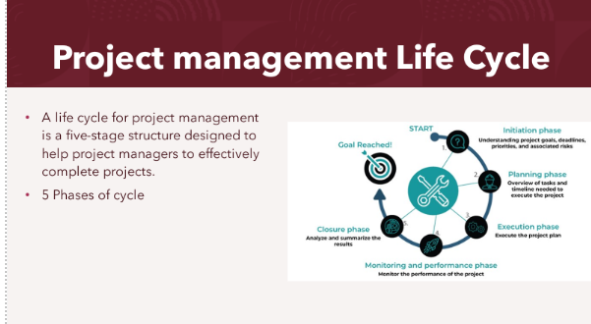

Quad Chart
The second phase of the project is the quad chart. A quad chart is a four-page chart which is a visual and descriptive overview of a project. It’s a tool that’s very basic but highly effective (Kiskis, D, 2020).
Each section in our quad chart simplified how each stage of our project was undertaken. In the first stage of the quad chart Our group aimed to promote and recruit potential candidates for the skills for the workplace program. The objectives were to create a recruitment plan to attract more people to apply for the course. We had stake holders such as project managers, graduated students, potential students also a skill for the workplace co-ordinator. Our desired goals for the project were to create a marketing plan by doing research with previous students that had already been on the program.
To begin this stage, we had to create questionnaires to gather the information from previous students gathering the feedback to help us to provide accurate information to potential candidates. Our group asked previous students if they benefited from the course and if the course was worth recommending. The next process was to produce advertising materials to use on social media, based on the knowledge our group gathered flyers were made and sent out putting in a lot of impact in our advertising to attract working parents and people withing the age category of 25+. Recruiting four people on to the program selection process our group had to check the candidate’s language skills to make sure candidates were able to join the course without any difficulty.
The feedback we received had crucial impact on the way how we promoted the course.
The triangle in the middle of our quad chart presents the motive why we chose this project such as in this case going through the pandemic crisis with such high employment loss, the skills for the workplace course could offer a new perspective to get a job or promotion.
Using this triangle tool within this project our team was able to have a clear view on what we were doing, how we needed to start and what was indicating all we had achieved towards success as a project management group.

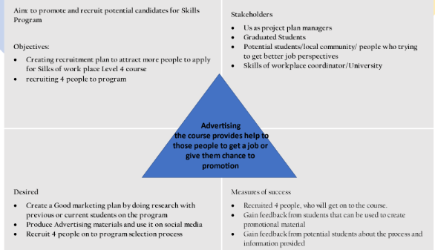

Phase 2
Stakeholders/Stake holder analysis
Steak holders are Individuals and organisations actively involved in the project, or whose interests may be affected negatively or positively because of project execution or successful completion of the project (Fernandes, J, 2014).
Steak holder analysis is an extremely useful technique for identifying, understanding, and prioritizing all stakeholders who may wield influence or power over a business or project (Patrick Grégoire, 2019).
The interests of all stakeholders who may affect or be affected by the project can be identified through a stakeholder analysis. At various stages of the project, different groups should be encouraged to participate. Methods for reducing potential negative consequences and dealing with unfavourable stakeholders.

The Advantages:
- Boost your credibility.
- Unique and diverse perspectives on issues are provided.
- Access to resources (of all types) that would not have been available otherwise.
- Facilitate the approval and decision-making process.
- Improve decision-making by increasing transparency.
- Starts the process of organic change management.

The limitations
There is always a drawback to each positive outcome. Stakeholder participation in a project is no exception. The following are some of the potential drawbacks of involving stakeholders:
- Delays and a lack of development at first
- Perceptions of leadership qualities are being harmed.
- Expectations that were mismanaged

The stake holders were:

Project Managers – High importance and primary influence as they are directly involved into the project process. Working on individual parts/tasks of the project, but at the same time providing effective teamwork and collaboration by effectively connecting these tasks to the successful completion of the project. They are the drivers because of their highest importance and involvement.
Our project manager had to Create our project, plan and schedule our project by Spreading individual tasks, creating marketing materials and organizing and attending weekly team meetings to discuss our project progress.

Graduated students – Their contribution was to Share their experience with what they've learned and how they benefited and developed during their time at the course. Our group done this by Creating a questionnaire/survey to fill out, by doing this as a group we were able to Gain feedback from graduated students.

Potential students-local community, people who were trying to get better job perspectives - Engagement and desire for future development. Our job was to Keep them involved by supplying and Providing marketing materials we had to do this as a group by advertising on social media posters, Face to face/online meetings and also Share the results from the questionnaire we had given candidates and explain the benefits of the course.

UWTSD/Skills coordinator – Their main role was to Monitor and navigate the project steps and schedule or even support. Their role was to Organize and attend weekly team or individual meetings to discuss the project progress, Providing the project plan and accomplish weekly tasks.

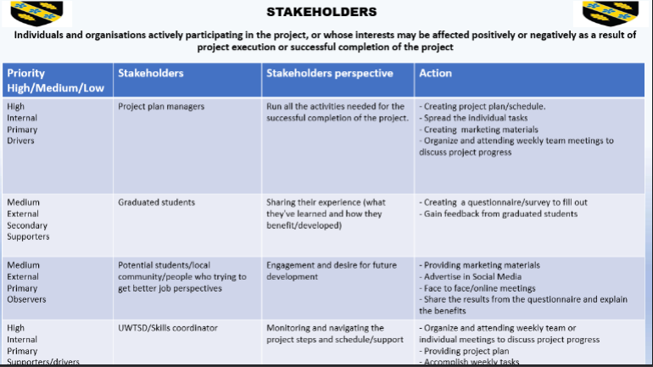

Phase 3

WBS

Project manager states that a WBS is a work breakdown structure which is a visual, hierarchical and deliverable-oriented deconstruction of a project (Project Manager, 2021).
Our Work Breakdown Structure diagram identified what we had to do as a group to achieve our project scope which entailed a diagram for a Marketing strategy to be able to develop and recruit candidates for the skills for the work place course. We then had two deliverables which was to Create a Marketing Plan and Recruit potential students. We took the deliverable out of creating a Marketing Plan by dividing them into two sub deliverables. Firstly, creating advertising Material to recruit potential students.
We Created posters some Flyers and questionnaires to attract potential candidates onto joining the course. We then uploaded them onto social media. When looking at the other deliverable which was to recruit potential student’s we needed to look at the sub deliverables which was to identify interested candidates and inform them of the benefits of the course, our group informed potential candidates by preparing them for the interview and the recruitment process. We informed the skills co-ordinator to arrange interviews and a selection date.
The advantages of having a work break down structure to help with our project helped our group by making sure each member had a task which had a specific amount of time for their task to be completed. Our group had to take in account that each member had to complete one task before moving on to the next. Monitoring progress and being able to keep track of each task and the overall project schedule was down to using the work breakdown structure, this helped us to pay attention to the critical tasks and assign extra resources if we fell behind on our schedule.
The limitations of a work break down structure can mean that the process can be a pain by having a step-by-step approach (Reddy, C, 2021).
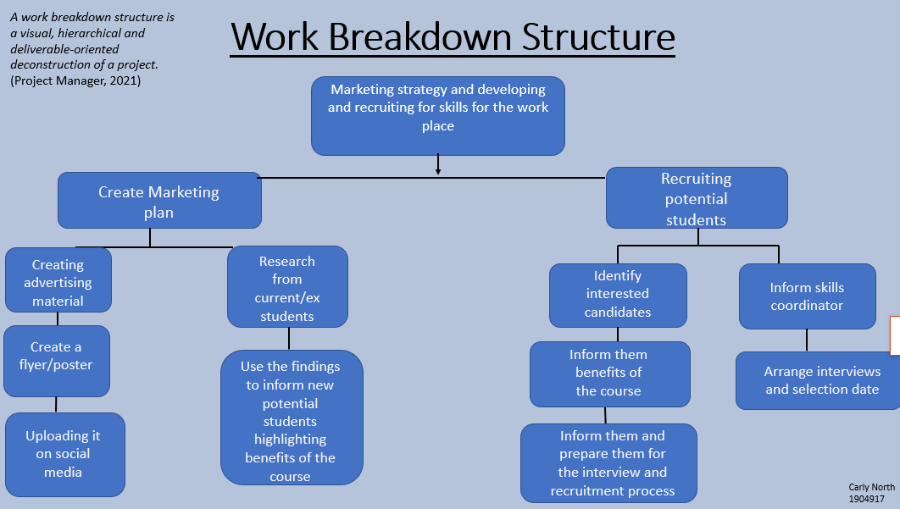
Gannt Chart
A Gantt chart is a popular type of a project manager’s tool known as a Bar Chart that illustrates a project Schedule (Webber, J, 2020).
As a group we then had to undertake a Gantt chart. The Gannt Chart was a very useful tool that helped to show all the activities that our group had to take against a time frame Once we completed our Work breakdown structure, we then linked our activities within a Gantt Chart with a time frame to schedule our activities with a start and end date of completing our project (Meardon, E, 2021).
We structured our Gantt chart by using excel to put our data in to receive measurable results. (Vertex42, 2019). The Gantt Chart worked well for us as we only had a short time frame for our project therefor the Gantt Chart was an easy tool to check our progress by visualising our activities and our deadlines.
Our Gantt Chart shows how long on a time scale it took for each task to be completed. A Gantt chart is the project manager’s most used tool. It is used to convey the most critical information and it plays an outsized role in project success (Peng, B, 2018).
The advantages of using a Gannt chart for our project was that it helped as it was an easy tool to help construct our project giving us the completion date of each task, we were each allocated.
The limitations of using the Gannt chart was that it didn’t demonstrate the effects of any delays in any one activity on the start of another activity, thus on the project completion time.
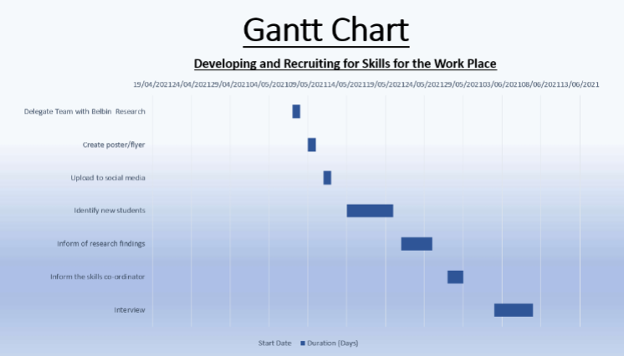
Network Diagram
Network diagrams serve as visual representations of a project (Sinnaps, 2020).
A Network Diagram is also known as a flow diagram, which is also a graphical representation of the tasks we had to achieve in our project. (Kukhnavets, P, (2020)
The network Diagram helped us as a group to keep track of our progress of each stage in every activity our group had to take to achieve our project, this was done by finding potential students to join the skills for the workplace course. The network diagram showed how much time was allocated for each activity that was taken.
The start of our network diagram shows what we firstly had to do to complete the tasks we had allocated each member in our group to achieve to be able to gain success in what we were trying to imply to gain potential students onto the course.
Firstly, we had to research using the Belbin theory to gain which roles would be best for each group member, as the diagram emphasises this took a day to complete, we then went on to designing posters, this took two days for us to complete. We uploaded to social media to attract any candidates by informing the co-ordinator of the research we had completed we had the feedback to start the interviewing process which took us to the end of the process.
The advantages of using a network diagram for our project was that all project activities were shown in sequence with relevant interrelationships, the network diagram used in our project helped our project managers and team during our planning and organizing stage.
The limitations of using the Network diagram in our project was that tasks could have been missed out which could have affected the project from the in correct results from the network diagram.
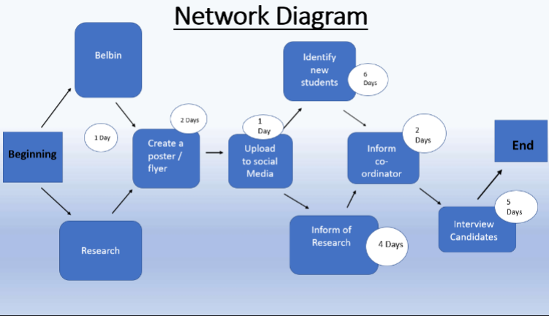
The work break down structure, Gannt chart and Network diagram were three tools in which were useful to help our group complete our project as all the three tools were closely linked together.
Phase four
Monitoring
Closure phase in the project management cycle confirms completion of the delivery of our project as well as meeting satisfaction of the stake holders as well as communicating the final disposition to make the team.
Progress monitoring is related to goals - which is the expected progress to which we had to strive through to complete our designated tasks, discussed in our group over the entire time interval from the beginning to the end and actual progress of our project (Fontein, D, 2021). Thanks to the expected progress and actual progress, our group could monitor the time in the selected schedule within our group, it was once a week at meetings summarizing the progress and daily chat. Another aspect was the budget that our group didn't have due to it was a university project and we had to use the free tools available to us to design the leaflets. Another one was people in our group, due to the number of people in the group, the number of people in the group was adjusted to the needs. The last one was the the scope, in this case, delivering service helped to be able to find candidates and helping them attend for an interview.
For us as a group to be able to have control of all the factors, we needed to use the tools available for project managers. These were the project life cycle, quad chart, stake holder’s analysis, WBS, Gantt chart, risk analysis, Iron triangle, swot, and pestle.
Using the Swot analysis or Pestle can be defined in a risk assessment. In this case, the more precise tool in our group’s opinion was the SWOT analysis. (CIPD, 2020)
The internal factors are
Strengths
- Team were familiar with each other
- Team were familiar with the course in question
- group skills through prior Belbin analysis
- having appropriate tools for people from the group to make posters and leaflets in terms of marketing

Weaknesses
- online work
- adjusting schedules for meetings and group progress
- unfamiliarity with applicants
- strict time and availability restrictions
The external factors are
Opportunities
- Team being able to offer applicants support
- Technology support from the UWTSD
Threats
- Coronavirus restrictions and the uncertainty
- Applicant being unsuccessful
- Technology difficulties
- Absence from team member
- Unengaged applicants
- Candidates refuse to be the students at UWTSD

- time-management- lack of time and meeting the progress of the project with the set goals
That is why our group have listed Threats as the most important points in our Risk Analysis. And this, in turn, is a direct summary of the Iron Triangle. Because each project is a measure of the triangle and each angle means monitoring progress over time, scope and cost.
Iron Triangle
The iron triangle, also known as triple constraint, project management triangle or flexibility matrix, models the constraints project managers work within on every project they oversee (Villanova, 2021).
Risk Analysis
Risk Analysis is a process that helps you to identify and manage potential problems that could undermine key business initiatives or projects (Mind tools, 2021).

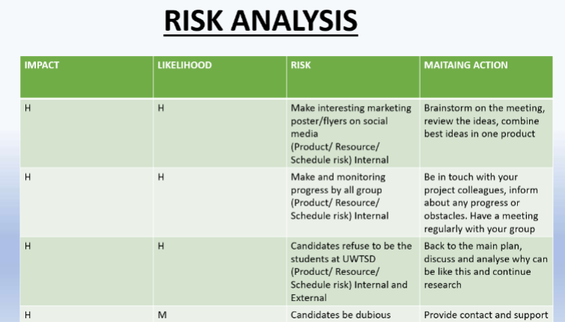
The Pestle Analysis
A PESTLE analysis is a framework to analyse the key factors (Political, Economic, Sociological, Technological, Legal and Environmental) influencing an organisation from the outside. It offers people professionals insight into the external factors impacting their organisation (CIPD, 2021)
Political- Brexit uncertainty
Economic-Possibility of volatile employment market
Social- Reduced social team activity due to the coronavirus
Technological- Increased technological communication necessary
Legal- Pandemic restrictions could fillip home study
Environmental- climate change concern driving change in higher education habits
Hard outcomes
- Evaluation of the project was that we had to find 4 candidates with minimal resources, time and budget.
Soft outcomes
- Students received support from us, they were satisfied with the progress, they learned how to apply for studies (illuminative - sharing experience)

- Students could continue their education; get the information they benefit from and can share it with others (Formative)

- This is another experience gained as a project manager, sharing knowledge through people and showing the strongest points, a lesson on contact with the client (Reaction)
The experience our group gained in the project allowed us all to gain practical knowledge. Each tool had a purpose and was an unchanging element of progress. The project had shown that there are universal tools that will allow us to operate with each other later in contact with candidates. In this case, they were students that we found by a monitoring progress and evaluation progress. Each side benefited from it, which is why our group consider the project was a success.

Conclusion
The experience our group gained in the project allowed us all to gain practical knowledge. Each tool had a purpose and was an unchanging element of progress. The project had shown that there are universal tools that will allow us to operate with each other later in contact with candidates. In this case, they were students that we found by a monitoring progress and evaluation progress. Each side benefited from it, which is why our group consider the project was a success.

Recommendations
Based on our project findings shown that Team members responses should be collated and compared by faculty members, a report compiled outlining all areas for development, and recommendations based on this report.

Reference List
My Management Guide, (2021) A project is a great opportunity for organizations and individuals to achieve their business and non-business objectives more efficiently through implementing change. Available from What is a Project? – Definition and Key Characteristics (mymanagementguide.com) [accessed on June 18th at 10.00]
Association for Project Management, (2021) Project Management is the application of processes, methods, skills, knowledge and experience to achieve specific project objectives. Available at What is project management? | APM [accessed on June 19th at 2.00]
Brown, L (2019) A life cycle for project management is a five-stage structure designed to help project managers to effectively complete projects. Available at What is Project Management Life cycle & Its Phases? (invensislearning.com) [accessed on June 20th at 9.45]
Accelerate Uk, (2021) Belbin Team Roles Available at Belbin Team Roles - Introduction to Belbin Leadership Training | Accelerate [accessed on June 20th at 950]
Kiskis, D (2020) A quad chart is a four-page chart which is a visual and descriptive overview of a project. It’s a tool that’s very basic but highly effective. Available at The Quad Chart as a Strategic Planning Tool | by Dan Kiskis, PhD | Strategy for the Rest of Us (usingstrategy.com) [accessed on June 20th at 10.00]
Fernandes, J (2014). Steak holders are Individuals and organisations actively involved in the project. Available at How to differentiate between a negative and positive Stakeholders ? - Whizlabs Blog [accessed on June 20th at 10.15]
Grégoire, P (2019) Steak holder analysis is an extremely useful technique for identifying, understanding, and prioritizing all stakeholders who may wield influence or power over a business or project. Available at Stakeholder Analysis: Definition, Tools & Techniques | Borealis (boreal-is.com) [accessed on June 20th at 11.00]
Project Manager, (2021) A work breakdown structure is a visual, hierarchical and deliverable-oriented deconstruction of a project. Available at https://www.projectmanager.com/work-breakdown-structure#:~:text=A%20work%20breakdown%20structure%20%28WBS%29%20is%20a%20visual%2C,the%20activities%20needed%20to%20achieve%20a%20successful%20project. [accessed on June 23, 2021 at 10.00]
Reddy, C (2021) The limitations of a work break down structure can mean that the process can be a pain by having a step-by-step approach Available at Work Breakdown Structure: Advantages and Disadvantages - Wise Step [accessed on June 23rd at 10.05]
Webber, J (2020) A Gantt chart is a popular type of a project manager’s tool known as a Bar Chart that illustrates a project Schedule Available at How to Make a Gantt Chart in 5 Steps - ProjectManager.com [accessed on June 23rd at 10.10]
Meardon, E. (2021) What is a Gantt chart? Available at What is a Gantt chart? | Atlassian [accessed on June 23rd at 10.11]
Vertex42, (2019). How to make a Gantt chart in Excel. [online] youtube.com. Available at https://www.youtube.com/watch?y=un8j6QqpYa0 [Accessed on June 23rd at 10.15]
Peng, B, (2018). The complete guide to Gantt charts available at The Complete Guide to Gantt Charts (projectengineer.net) [Accessed on June 23rd at 10.20]
Sinnaps, (2020) Network diagrams serve as visual representations of a project Available at How does a Network Diagram work in Project Management | Sinnaps [accessed on June 23rd at 10.25]
Kukhnavets, P., (2020). Project Network Diagrams: Quick Overview of the Powerful Tool available at https://www.//hygger.io/blog/project-network-diagrams-quick-overview/#advantages-of-using-network-diagram [accessed on June 23rd at 10.30]
Fontein, D (2021) Progress monitoring is related to goals - which is the expected progress to which we had to strive through to complete our designated tasks. Available at Project Monitoring: What It Is and Why It's Important (unito.io) [accessed on June 23rd at 10.35]
CIPD, (2020) Swot Analysis available at SWOT Analysis | Factsheets | CIPD [accessed on June 23rd at 10.37]
Villanova, (2021) The iron triangle, also known as triple constraint, project management triangle or flexibility matrix, models the constraints project managers work within on every project they oversee. Available at What is the Iron Triangle of Project Management? | Villanova University [accessed on June 23rd at 10.40]
Mind tools, (2021) Risk Analysis is a process that helps you to identify and manage potential problems that could undermine key business initiatives or projects Available at Risk Analysis and Risk Management - Decision Making from MindTools.com [accessed on June 23rd at 11.00]
CIPD, (2021) A pestle analysis is a framework to analyse the key factors influencing an organisation from the outside. Available at PESTLE Analysis | Factsheets | CIPD [accessed on June 24th at 9.00]

