

BA BUSINESS MANAGEMENT
Assignment 1

Module: Community Engagement
Code: LCBB4002
Lecturer: Dr Akinseye Aluko
Name: Nezabravka Vasileva
Student ID: 2129046

SUBMITTED ON THE 02/12/2022

Table of contents

- Introduction
- Birmingham Commonwealth games
  - Community engagement
  - Standards
  - Stakeholders’ participation
  - Social media
- Conclusion
- References

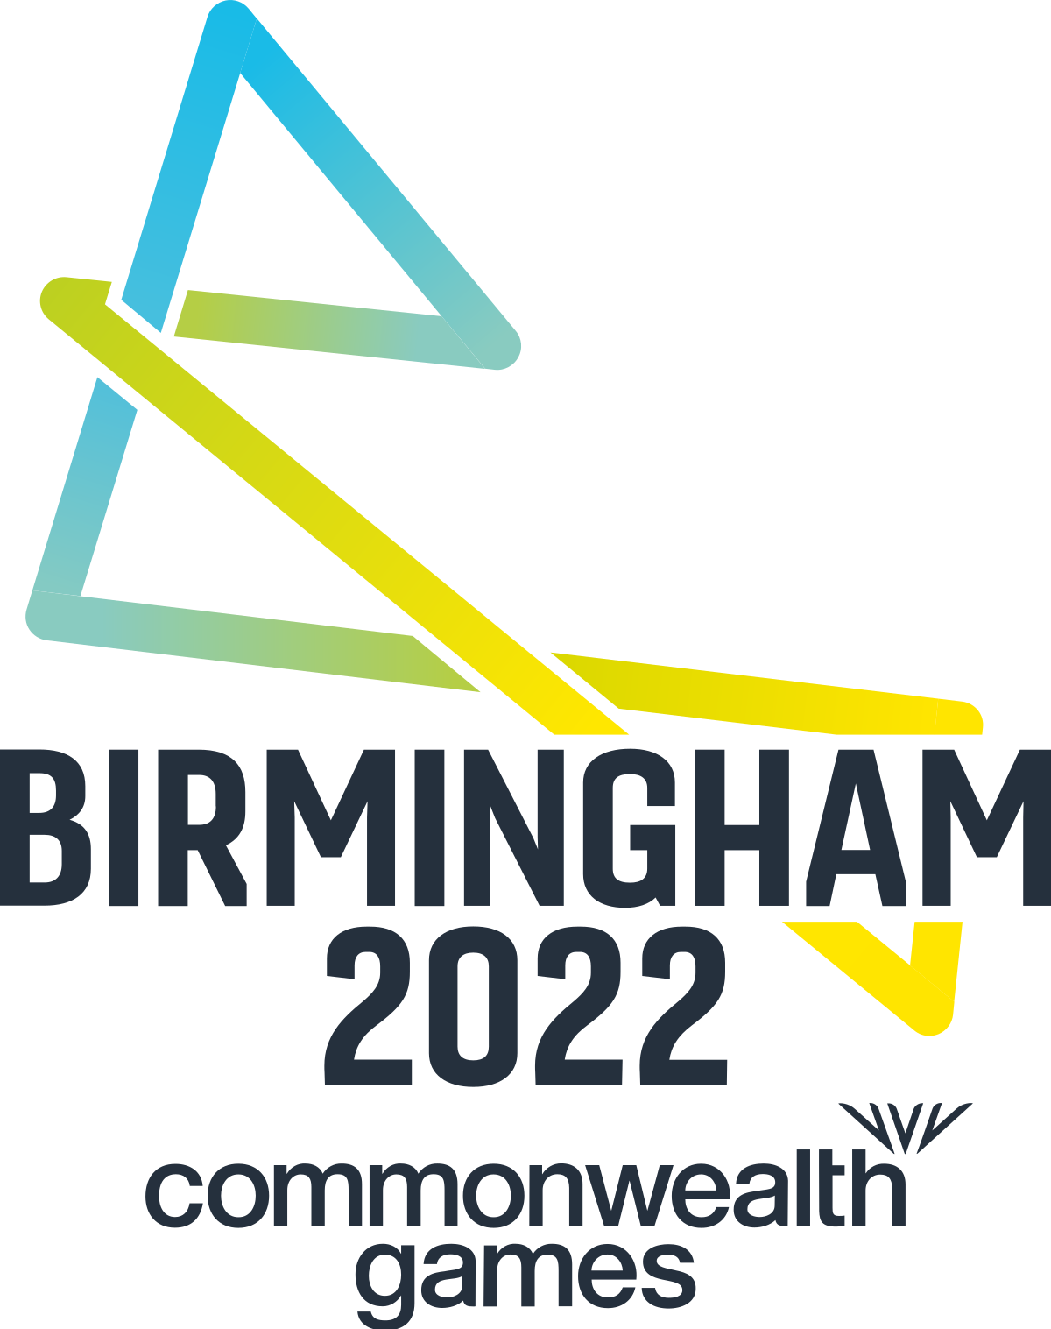

- Introduction
The Birmingham Commonwealth Games, the greatest multi-sport event that take place in England in ten years, attracted nearly 1.5 million attendees in addition to thousands of competitors of the highest calibre. Birmingham 2022 has served as a home Games for every nation and is host to more than 180 nationalities. These amazing Games have captivated the attention of the city, region, and viewers across the world from the time the famous "Raging Bull" charged into the Alexander Stadium on premiere night to the final comments from the renowned Ozzy Osborne as the curtain closed. (Birmingham 2022 commonwealth games: The highlights, 2022)

This report will give an overview of the Games and determine the most effective practises that have been followed, such as the criteria and guidelines for community engagement and the involvement of stakeholders. Determine the partners' relationships as well as the best engagement tactics for each (social media platforms). Then, give a thorough account of how multiple social media platforms might be employed as a support for the project.

- Birmingham Commonwealth Games
The Commonwealth Games in Birmingham bring people together, whether they are sportsmen from other nations or groups from the entire city and area. They embody the Commonwealth ideals of humanism, fairness, and determination in every action taken in getting ready for this storied festival of sport. The Commonwealth Games have a profound impact on anyone in the Cotswolds and even beyond via a celebration of exciting, quick sport, exuberant culture, and innovative business. This historic occasion offers the chance to recognise the capacity of humanity and the world society.

This ceremonial event has a clear mission to leave a long-lasting good influence when competitors compete for gold in the 2022 Games and tourists swarm from all over the world. Their goals are to: foster human interaction; advance health and welfare; encourage communities and sportsmen to reach their highest potential and enjoy happier, healthier lives by connecting them. Encourage sustainable growth and aspiration while opening possibilities for trade, investment, employment, and skill development. By collaborating to build new and better residences, facilities, and transportation linkages, local communities may be transformed and strengthened. (Our purpose and Brand, 2022)

The Commonwealth Games aim and multi-community involvement via engagement, but their own choice will and not under compulsion, are both recognised here, as are all the fundamental tenets of the community engagement project.
No matter their age, gender, language level, religion, culture, or political views, all participants develop a connection with one another that is essential for a positive outcome and the efficiency of community engagement.
All the communities that work together are mobilised, and their talents help to realise this enormous project that is being carried out in Birmingham.

  - Community engagement
This unique event is organized by the B2022 Community Engagement Team in honour of the Windrush Generation and its descendants and in partnership with the society's Legacy Centre of Excellence. They are asking key partners to resume the day's activities in a nostalgic environment examining the history of Windrush after the inauguration of the Windrush statue at New Street Station. With the topic of "History, Culture, and Sport that has moulded a generations and England as we recognize it," special guests from the area can exchange their tales and perspectives with the public, leading people on a trip from the past to the future. All groups are welcome to attend this open tournament and interact via a shared history of migration. (Community engagement, 2022)

The £6 million Commonwealth Games Community Fund was established by Birmingham City Council, the city's proudest venue. The goal is to make it easier for community groups to join, interact with, and participate in the Games. People have the ability to enjoy the Games in their own unique style and take action they believe is crucial for their community. The Community Fund was created to be regionally led, developed, and distributed. It contains three financial pots, each of which seeks to optimize the positive effects and lasting effects of hosting the Games while also fostering pride, tolerance, and social togetherness in the city.

These games are an excellent example of cohesiveness and support in involving many diverse populations, but with one purpose and ideals, thanks to financial aid from the government, nongovernmental Organizations, the city council, the local community, businesses, and many more sponsors.
Without the community engagement team, none of this would be possible; they play the most significant and accountable role in the conception, planning, and implementation of this fantastic event.

United by Birmingham 2022 honours and supports exemplary neighbourhood initiatives carried out by neighbourhood and local organization. The United By family has so far accepted more than 50 initiatives. The Organising Committee's (OC) Community Engagement team is trying to make the Games more accessible to much more West Midlands residents and locations.

2.2 Standards
The selection process for the Commonwealth Games Northern Ireland (CGNI) have been aligned with the nomination policy and consideration standards to choose competitors rated in accordance with: Potential medallist at Birmingham 2022, Possibly a top 8 spot in Birmingham in 2022, A developing athlete with the ability to place in the top 8 at the 2026 Commonwealth Games who is progressing within an NGB context of performance management.

Four rounds of athletes are considered. Athletes should be aware that being considered does not guarantee nomination. All candidates who have once met the criterion are taken into consideration in the first round. Athletes who are improving and near to the standard are given preference in round 2, followed by athletes who might join a relay team in round 3, others, and reserves in round 4. In order to provide a realistic benchmark for a spot in the final, Athletics NI considered the season's bests of competitors who placed 7th, 8th, and 9th as well as the actual 8th placements in prior Games. (Commonwealth Games Birmingham 2022: Selection policies overview: Competition opportunities: Athletes in Northern Ireland)

New safeguards have been established as a result of the Birmingham 2022 Commonwealth Games Act, which forbids unlawful affiliations with the Games and prevents blitz advertising by third party companies that are not formally affiliated with, sponsors of or collaborators of the Games. Additionally, it forbids any unapproved marketing near or inside the areas of the Games, the specifics which are outlined in government laws. (Birmingham Commonwealth Games Act, 2022)

Basically, in order to engage the community effectively and efficiently, there are always certain standards that must be satisfied. These competitions serve as evidence that all requirements were satisfied and that their holding was feasible.
All participants spoke with one another and worked together to develop a strategy for community and stakeholder involvement. Timely information and feedback on choices and actions made were also provided. The rules of justice and equality for all participants were also observed.

  - Stakeholders’ participation
The Solihull Metropolitan Borough Council is investigating possible Commonwealth Games-related activities and events. A quick provides information on the kinds of initiatives and programs the Council could think about hosting for the Borough. Normally, it takes 5 to 10 minutes to complete the questionnaire. There are two different versions designed primarily for children and young people and the other for all Borough citizens and stakeholders. (Commonwealth Games Resident & Stakeholder Survey, 2022)

Sport serves as the foundation for the special ties and friendships that bind a third of the world's population—citizens of the 72 Commonwealth countries and territories—together. The Commonwealth Games Federation (CGF) has played a pioneering role in unifying the athletes, people, and nations of the Commonwealth via the transforming and bridging force of sport for further than 80 years. The Commonwealth Games Federation (CGF) is the entity in charge of the future plan of the Commonwealth Games, Commonwealth Youth Games, and strategic process and activities within the Commonwealth Sport Association. The Commonwealth Games Federation (CGF) fosters tranquil, resilient, and thriving societies throughout the Commonwealth by collaborating with 72 Commonwealth Games Associations (CGAs) in 6 regions.

The goal of CGF Partnership (CGFP), a joint project among Lagardère Sports and the Commonwealth Games Federation (CGF) that was founded in 2017, is to find long-term, durable business relationships that will help produce upcoming Commonwealth Games. The Birmingham 2022 delivery teams include incorporated resources from CGFP who provide experience from past Games and help create revenue for the Games via business arrangements, TV rights, licencing, and merchandising. The Commonwealth Games Associations (CGAs) and the Commonwealth Sport Movement are both being developed by the CGFP, as are the possible host towns' efforts to determine if it would be feasible to hold the Games. (Our partners, 2022)

All parties involved work together to achieve a common objective while being driven by the desire for successful outcomes.

  - Social media
A product, service, or company is promoted to the general public that are in or near the Games area or who are viewing or listening to the live telecast of a Games event during a certain time period called "Games location advertising." This could include placing adverts on automobiles when those ads are a part of an assault promotional campaign, putting up, foisting, or demonstrating any type of advertisement that features a company logo and/or name (like a billboard, online screen, crest, or flag), and delivering or supplying promotional materials to advertise a good, service, or enterprise. (Birmingham 2022 Commonwealth - Greater Birmingham Chambers)

The information given before and during advertising on how these games would be run and who would be taking part. In addition to being broadcast on several TV stations, results, participation, and interaction may also be accessed via social media sites including Instagram, Facebook, Twitter, LinkedIn, and YouTube. These platforms have given us all access to information on these games even nowadays.

- Conclusion
The Birmingham Commonwealth Games is a significant occasion that has united numerous individuals from 180 various countries to organise these games. This was made possible because of the community engagement team's amazing abilities, knowledge, and cooperation. Through effective engagement of all communities from the political, economic, financial, cultural, social, and environmental fields, they were able to bring together all stakeholders and participants.

An undeniable fact that serves as further evidence that community engagement is at the core of every event that takes place in the community is that the partnership between all organisations, businesses, the local community, the Birmingham government, financial institutions, cultural and educational institutions such as schools and universities, health institutions, and many others led to the amazing result of this project.

There is always a danger, a challenge, and influence from both internal and external sources while performing such games. For even greater success in the future, it is advised to engage more communities, more individuals, and very effective engaging advertising.

- References:
2022 Commonwealth Games Resident & Stakeholder Survey (2022) GBSLEP. Great Birmingham and Solihull LEP. Available at: https://www.gbslepgrowthhub.co.uk/news/2022-commonwealth-games-resident-stakeholder-survey (Accessed: November 29, 2022).
Birmingham 2022 Commonwealth - Greater Birmingham Chambers (no date) https://www.greaterbirminghamchambers.com. Great Birmingham Chambers. Available at: https://www.greaterbirminghamchambers.com/media/897155/commonwealth-games-trading-restrictions-briefing.pdf (Accessed: November 30, 2022).
Birmingham 2022 commonwealth games: The highlights (2022) GOV.UK. GOV.UK. Available at: https://www.gov.uk/government/publications/birmingham-2022-commonwealth-games-the-highlights/birmingham-2022-commonwealth-games-the-highlights (Accessed: November 25, 2022).
Birmingham Commonwealth Games Act (2022) Commonwealth Games - Birmingham 2022. Available at: https://www.birmingham2022.com/corporate/who-we-are/commonwealth-games-act (Accessed: November 28, 2022).
Commonwealth Games Birmingham 2022: Selection policies overview: Competition opportunities: Athletes in Northern Ireland (no date) Athletics Northern Ireland. Available at: https://athleticsni.org/Athletes/Competition-Opportunities/Selection-Policies-Overview/Commonwealth-Games-Birmingham-2022 (Accessed: November 28, 2022).
Community engagement (2022) Commonwealth Games - Birmingham 2022. Available at: https://www.birmingham2022.com/community-engagement (Accessed: November 28, 2022).
Our partners (2022) Commonwealth Games - Birmingham 2022. Available at: https://www.birmingham2022.com/corporate/who-we-are/our-partners (Accessed: November 29, 2022).
Our purpose and Brand (no date) Commonwealth Games - Birmingham 2022. Available at: https://www.birmingham2022.com/about-us/our-purpose (Accessed: November 28, 2022).

