
Name- Harsimran Kaur Hira
Student ID - 2218345
Course - MBA Banking and Finance
Module Name - Dissertation
Module Code -LCMB7020_LON
Lecturer Name - David Coker

Enhancing Internet Banking Security Through Intelligent Defense Mechanisms


Master’s Degrees by Examination and Dissertation
Declaration Form.
1. This work has not previously been accepted in substance for any degree and is not being concurrently submitted in candidature for any degree.
Signed - Harsimran Kaur Hira
Date – 19 Oct 2023
2. This dissertation is being submitted in partial fulfilment of the requirements for the degree of Master in Business Administration.
Signed - Harsimran Kaur Hira
Date – 19 Oct 2023
3. This dissertation is the result of my own independent work/investigation, except where otherwise stated.
Other sources are acknowledged by footnotes giving explicit references.
A bibliography is appended.
Signed candidate - Harsimran Kaur Hira
Date – 19 Oct 2023
4. I hereby give consent for my dissertation, if accepted, to be available for photocopying, inter- library loan, and for deposit in the University’s digital repository
Signed (candidate)- Harsimran Kaur Hira
Date – 19 Oct 2023
Supervisor’s Declaration.
I am satisfied that this work is the result of the student’s own efforts.
Signed: …………Dave Coker…………………………………….
Date: ……………20/10/23…………………………………...

Abstract
Internet Banking and its popularity in the modern economy is phenomenal in nature, and personal and professional choices have been deeply influenced by the opportunities provided by Internet Banking. The effective growth of tools and techniques has channelled the use of Internet Banking in a course of prosperity, and the financial growth of the business has been effective with the incorporation of Internet banking. The development of intelligent defence mechanisms has ensured Internet Banking with definite sets of practices and growth factors, and the use of AI and machine learning has empowered the growth of Internet Banking on a major scale.
The research work has identified several aspects of cybersecurity and Internet banking, and primary data collection has been followed by the researcher. A set of ethical acts and activities has also been considered to protect the research from any kind of allegations and critical analysis of data has been effective to generate new insights from the research.
Acknowledgment
I want to thank my professors and guide for their constant support in conducting the research work and for their assistance in identifying data for the research. I am also thankful to them for their supervision over the entire research, and for believing me as a competent candidate. I convey my gratefulness to my classmates and friends as well, for their support and encouragement.

Table of Contents
Chapter 1 7
1.1. Introduction: 7
1.2. Background and Context: 7
1.3. Research Problem and Objectives: 8
1.3.1. Research Problem: Enhancing Internet Banking Security 8
1.3.2. Research Objectives 8
1.4. Research Questions 9
1.4.1. Guiding Research Questions: Understanding Security and AI/ML Integration 9
1.5. Theoretical Framework: 9
1.5.1. Conceptualizing Intelligent Defence Mechanisms 9
1.5.2. Integration within Cybersecurity Landscape 10
1.6. Significance and Contribution: 10
1.6.1. Advancing Internet Banking Security 10
1.6.2. Leveraging AI and ML for Enhanced Defence 10
1.7. Scope and Limitations: 11
1.8. Ethical Considerations: 11
1.9. Dissertation Organization: Chapters Overview 11
1.10 Conclusion: 12
Chapter 2: Literature Review 12
2.1 Introduction 12
2.2 Internet Banking: A Revolution in Banking Activities 12
2.3 Internet Banking and Its Impacts on Socioeconomic and Sociocultural Life 16
2.4 Intelligent Defence Mechanism: A Fight against Cybersecurity 19
2.5 AI to Create Cyber Security 21
2.6 The Role of Machine Learning in creating security for Internet Banking 22
2.7 Challenges Faced 23
2.8 Literature Gap 25
2.9 Conclusion 26
Chapter 3: Research Methodology 26
3.1 Introduction 26
3.2 Participants 27
3.3 Design 27
3.4 Materials and Apparatus 28
3.5 Research Ethics 29
Chapter 4: Findings and Discussions 29
4.1 Introduction 29
4.2 Findings 30
4.3 Discussion 42
4.4 Summary 46
Chapter 5: Conclusions and Recommendations 47
5.1 Recommendations 47
5.2 Conclusions 48
5.3 Research Limitations 49
5.4 Future Research Opportunities 50
References 51

Chapter 1

1.1. Introduction:
The introduction serves as the gateway to the dissertation, focusing on the critical subject of Internet banking security within contemporary financial systems. It underscores the intrinsic value of secure online transactions. With the surge in cyber threats, it becomes evident that more than conventional security measures are needed to counter advanced attackers (Aljawarneh, 2017). This demands innovative strategies for safeguarding sensitive financial data. Incorporating Artificial Intelligence (AI) and Machine Learning (ML) is a promising avenue for bolstering security. These intelligent technologies offer the potential to adapt and respond dynamically to evolving threats.
In this context, the introduction outlines the central themes: the significance of Internet banking security, the escalating challenges presented by cyber threats, and the demand for advanced defence mechanisms. It succinctly introduces the research's focus on AI and ML as potential solutions to fortify Internet banking security, setting the stage for the subsequent exploration of these concepts throughout the dissertation. The technical programming and analytical method have been effective in creating a steady base for banking security, and the intelligence has been utilized to ensure the growth of the performance of the banking performance. On the other hand, Kaur & Kautish, (2022), mention that the usage of AI and machine learning have been the key focus of banking management to encourage activities as per the industrial requirements, and a better stakeholder policy has been successfully generated.

1.2. Background and Context:
The background and context section delves into the historical progression of Internet banking, showcasing its transformation into a cornerstone of the contemporary digital economy. It elucidates how this evolution has reshaped financial transactions and interactions, underlining its pivotal role today (Pechetti et al., 2019). Furthermore, the section delves into the escalating apprehensions linked to security breaches, fraudulent activities, and cyber-attacks plaguing the financial sector. It emphasizes the rising threats that jeopardize the integrity of online transactions and customer data, underscoring the urgency for robust security measures (Habib Ullah Khan et al., 2023). Consequently, the limitations of traditional security approaches are illuminated, illustrating their inability to counteract the intricacies of advanced cyber adversaries effectively. This discussion underscores the necessity for innovative defence mechanisms that can adapt and respond nimbly to dynamic threats. In sum, this background and context section encapsulates the evolution of Internet banking, underscores its significance, exposes mounting security concerns, and underscores the inadequacy of traditional security, collectively forming the foundational backdrop against which the study's exploration of intelligent defence mechanisms unfolds. The efficiency of digitalization has played a pivotal part in the development of market acts and programming, while the reformed and redesigned security has been able to engage more stakeholders. The emergence of cyberattacks and illegal data access have mandated the formation of advanced security, and machine learning and artificial intelligence share a direct relationship with the banking activities allotted for the development of data security (Manser Payne, Peltie & Barger, 2021). However, the vision to create a dynamic form of business management through economic practices and market programs has been able to ensure better Internet Banking and the practices have been wider and less confined.

1.3. Research Problem and Objectives:

1.3.1. Research Problem: Enhancing Internet Banking Security
The research problem establishes the necessity for robust defence mechanisms within Internet banking security. It acknowledges the pressing challenge posed by mounting cyber threats, necessitating the development of proactive measures to safeguard sensitive financial information (Kaur & Kautish, 2022).

1.3.2. Research Objectives
- To understand the development of security for Internet Banking and its impact on socioeconomic and sociocultural life.
- To evaluate the defence mechanisms that are generated by the banking management to counter threats and attacks.
- To interpret Artificial Intelligence's role in creating cybersecurity for Internet Banking.
- To analyse the role of machine learning in creating security for Internet Banking.
- To examine the challenges faced by the banking management while adapting artificial intelligence and machine learning.

1.4. Research Questions

1.4.1. Guiding Research Questions: Understanding Security and AI/ML Integration
- What is the significance of the development of security for Internet Banking and its impact on socioeconomic and sociocultural life?
- What are the defence mechanisms that are generated by the banking management to counter threats and attacks?
- What is the role of Artificial Intelligence in creating cybersecurity for Internet Banking?
- What is the role of machine learning in creating security for Internet Banking?
- What are the challenges faced by the banking management while adapting artificial intelligence and machine learning?

1.5. Theoretical Framework:

1.5.1. Conceptualizing Intelligent Defence Mechanisms
The theoretical framework provides a conceptual lens through which the study examines intelligent defence mechanisms. These mechanisms are characterized by their adaptability and dynamism, attributes inherently associated with Artificial Intelligence (AI) and Machine Learning technologies (Khan, 2019).

1.5.2. Integration within Cybersecurity Landscape
Integrating AI and ML within the broader context of cybersecurity forms a crucial aspect of the theoretical framework. These technologies augment traditional security measures by introducing advanced capabilities. Anomaly detection and behavioural analysis are highlighted as pivotal AI/ML applications, allowing systems to recognize deviations from standard patterns and identify potential threats in real time (Khan, 2019). The theoretical framework emphasizes the symbiotic relationship between intelligent defence mechanisms and the adaptive power of AI/ML. It elucidates how these technologies respond dynamically to evolving cyber threats, marking a paradigm shift from static security measures. This framework acts as a conceptual scaffold, guiding the subsequent exploration of the study's objectives and contributing to the overarching goal of enhancing Internet banking security through AI and ML integration.

1.6. Significance and Contribution:

1.6.1. Advancing Internet Banking Security
The significance of this study lies in its potential to significantly advance Internet banking security in the face of escalating cyber threats. By delving into integrating Artificial Intelligence (AI) and Machine Learning (ML) in defence mechanisms, the study offers a pathway to fortify financial transactions and safeguard sensitive data (Miranda, 2018). The research's outcomes can directly impact clients’ confidence in online banking, enhancing trust and credibility within the digital economic landscape.

1.6.2. Leveraging AI and ML for Enhanced Defence
Furthermore, the study underscores the transformative potential of AI and ML in augmenting defence mechanisms. Their ability to adapt and learn in real-time positions them as dynamic tools to combat constantly evolving cyber threats. This adaptability, coupled with applications like anomaly detection and behavioural analysis, empowers financial institutions to address vulnerabilities and mitigate risks pre-emptively (Aw et al., 2019). By underscoring the significance of this study, it becomes apparent that the integration of AI and ML within Internet banking security represents a pivotal advancement that aligns with the imperatives of the digital age. It showcases the value of staying ahead of emerging threats and fostering a secure environment for online financial activities (Velmurugadass et al., 2021).

1.7. Scope and Limitations:
The scope of this study encompasses a comprehensive examination of AI and Machine Learning (ML) applications within Internet banking security. It aims to explore the diverse ways these technologies can enhance defence mechanisms, from anomaly detection to predictive modelling (Manser Payne et al., 2021). The study delves into the potential benefits that AI/ML integration can offer in countering cyber threats and fortifying online financial transactions.

1.8. Ethical Considerations:
Ethical considerations are pivotal in this research, guiding the methodology and data usage. The study adheres to ethical principles by solely primary data sources. This approach safeguards individuals' privacy and intellectual property rights while maintaining transparency in data acquisition. Additionally, proper referencing is paramount to acknowledge original writers and sources, ensuring academic integrity. Preventing biases is central to this research's ethical framework (Liu et al., 2020). Rigorous data selection and analysis methods are employed to maintain impartiality and avoid undue influence on research findings. The research aims to represent the subject matter objectively and accurately by impartially categorizing and analysing data. Adhering to ethical guidelines underscores the integrity of the study's findings and contributes to the credibility of its conclusions within the academic community and beyond.

1.9. Dissertation Organization: Chapters Overview
The structure of the dissertation is designed to systematically delve into the study's core themes. The upcoming chapters are strategically organized to provide a coherent progression of ideas. Chapter 2 conducts an extensive literature review, critically examining Internet banking security issues and the potential of AI/ML. Chapter 3 presents the research methodology, detailing data collection and analysis techniques. Chapter 4 comprehensively analyses research findings, addressing security weaknesses and AI/ML applications. Chapter 5 engages in-depth discussions, interpreting outcomes, implications, and limitations. The concluding chapter summarizes key findings, reaffirms the significance of AI/ML in enhancing Internet banking security, and outlines avenues for future research. This structured approach thoroughly explores the research's objectives and contributes to the academic discourse.

1.10 Conclusion:
In conclusion, this introductory chapter has underscored the critical significance of intelligent defence mechanisms within Internet banking security. It highlighted modern financial systems' escalating cyber threats and the imperative to adapt security measures. Integrating Artificial Intelligence (AI) and Machine Learning (ML) is a promising avenue to bolster defence mechanisms. This chapter has set the stage for subsequent explorations, emphasizing the pivotal role of AI/ML in fortifying online transactions, protecting sensitive data, and ensuring the resilience of Internet banking systems against evolving threats.

Chapter 2: Literature Review

2.1 Introduction
Venturing into the newly designed market has been deeply influenced by technological approaches, while changes have been adopted by different industries on a significant scale. According to Sharma, Singh & Sharma, (2020), the development of Internet banking in the international market has been empowered by software-based activities, while the relationship between stakeholders and the banking industry has improved. For secured transactions, Internet Banking is facilitated by different practices, such as the incorporation of Artificial Intelligence and Machine Learning. The chapter of the research will analyse different aspects of Internet banking, and the usage of intelligent defence mechanisms for Internet banking security will also be discussed.

2.2 Internet Banking: A Revolution in Banking Activities
The professional and personal programming of monetary transactions have experienced a massive change with the evolution of Internet Banking, and online activities have been a definite part of socioeconomic behaviour in the international market. The economic trajectory has been empowered by the opportunities created through mobile applications and websites of different financial institutions and since the 2000s, it has been the most prominent way for customers to access bank accounts (Rahi et al. 2020). The pace of the banking system has been elevated through it, and in several cases, conventional branch banking has been replaced with Internet Banking, as the spectrum of benefits is wide and reliable. On the other hand, Arif Aslam & Hwang, (2020), argue that the technical growth and superior forms resonate with the banking requirements, but the purpose of branch banking is still vivid and essential. The report also suggests that the Asian market is the biggest user of Internet Banking, and in 2020, China and the Far East were observed with online banking users of 805 million. Ly & Ly, (2022), mention that in Europe, 58% of people between the ages of 16 and 74 use online banking for professional and personal purposes. Digital prosperity in the international market has changed the traditional outlook of economic transactions, and online banking activity has been a part of the core banking methods.
Password and other credentials, as observed, are provided to customers to ensure the security of transactions and data, and secured websites are also developed by banking organisations to empower the growth of services and stakeholder policies. According to Kumar, Sachan & Kumar, (2022), Internet banking not only includes safe monetary transactions, but sociocultural aspects are further prioritised by financial institutions to ensure a steady stakeholder relationship. Different types of financial transactions are facilitated by banking institutions, including financing loans, electronic bill payments and funds transfer between accounts or customers. The report also mentions that some banking bodies allow customers to access transactional evidence directly, and bank statements can also be used for certain claims by customers. Internet banking ensures the growth of business programs for different commercial enterprises, as it creates opportunities for easy transactions, while the changes can also be empowered by the role of management for future benefits and activities. Chang et al. (2020), argue that though banking activities through the Internet experience better practices and resilient approaches, different issues of business monetary security are also observed in this regard. Though Rahi et al. (2021), refute the arguments by stating that the banking institutions are careful about their spontaneous regulation, and the essential modes of governance are reliable and effective. Two-factor authentication is empowered by the economic institutions, including PIN and TAN, based on which customers can control transactions and their voluntary involvement is solely counted. Machine learning and artificial intelligence have played a pivotal role in securing monetary transactions, while TAN or one-time-password generators, such as chip TAN protect economic activities from external and internal cyber threats.
The image presented below refers to Internet banking and its several efficient activities, based on which the market programming and economic practices proceed, and transactions are conducted with utmost care and caution. According to it, Internet banking facilitates the offering of more economic services, as well as increases customer loyalty. On the other hand, it can also be observed that Internet banking promotes customer access and attracts new customers, based on which banking institutions benefit on a significant scale. The incorporation of Internet banking reduces customer attrition and provides services offered by competitors.
The evolution of Internet banking since its debut has had far-reaching consequences for the way people handle their personal money. There have been challenges throughout this transition, especially in terms of security. Strict security measures for online banking are necessary to protect customers' personal information and the integrity of monetary transactions. The goal of this literature study is to assess the societal, cultural, and economic effects of safe online banking.
According to Sodoma et al. (2019), the advent of Internet banking at the turn of the century brought with it a variety of benefits and new security issues. Con artists, virus creators, and identity thieves quickly targeted online banking. Financial institutions swiftly implemented extensive security measures in response to these new dangers. Encryption was used as one of these precautions to make sure no one else could see private data except those who were supposed to. Multi-factor authentication is a security approach used by many banks and other financial organizations today. This method needs two pieces of identification (a password and biometric data, for example) to get access to an account. Financial institutions are now more secure thanks to the use of intrusion detection systems, which keep an eye out for and report any unusual behaviour. The above safety measures were implemented to ensure that customer's credit card and other personal information was secure during online transactions. Online banking is much more secure today than it was a decade ago because of developments in encryption and other security measures (Nazaritehrani and Mashali, 2020).
There would be significant societal and economic benefits to enhancing the security of online banking. As per Lin et al. (2019), due to the widespread availability of internet-based financial services, customers may check their money, pay bills, transfer cash, and even invest without leaving the comfort of their own homes. Customers who bank online rather than at a branch might save both time and money on commuting costs. Access to financial services, especially for those living in underserved or physically inaccessible locations, has been greatly expanded because of the widespread usage of financial technology. By increasing people's access to banking and other financial services, "financial inclusion" aims to narrow economic gaps. Because of the convenience and security of Internet banking, people's perspectives on and relationships with money and financial institutions have shifted significantly. Customers now have more faith in online banking because of stricter safety protocols. The extensive use of mobile banking apps has greatly sped up the shift away from a cash-based economy. Consumers' outlooks and behaviours have shifted significantly as a result of the change (Singh and Srivastava, 2020).
Cultural standards about financial privacy have shifted because of concerns about the protection of personal and financial information in the digital era. According to Arif et al. (2020), it is important to think about and handle any problems that might arise as a result of this growth, however. Online banking is safer than ever before because of developments in encryption and other protections. However, in order to get these advantages, one must follow a unique and intricate body of legislation. It's possible that these rules may make it harder for banks and their customers to utilise internet banking. People worry that they may be left behind in the digital economy since the financial sector is so reliant on technology. This relates to the possible marginalization of people whose access to the internet and other technological resources prevents them from fully participating in economic life. The economic and cultural areas of modern civilization have been affected by the evolution of online banking security mechanisms. Digital currency's widespread acceptance has significantly altered financial access, output, and trust. It has, however, prompted questions about digital exclusion and the need for extra regulation. If we want to reap the advantages of this rapidly developing technology, banks, governments, and the general public must successfully manage the conflict between the security and ease of online banking (Rawwash et al., 2020).

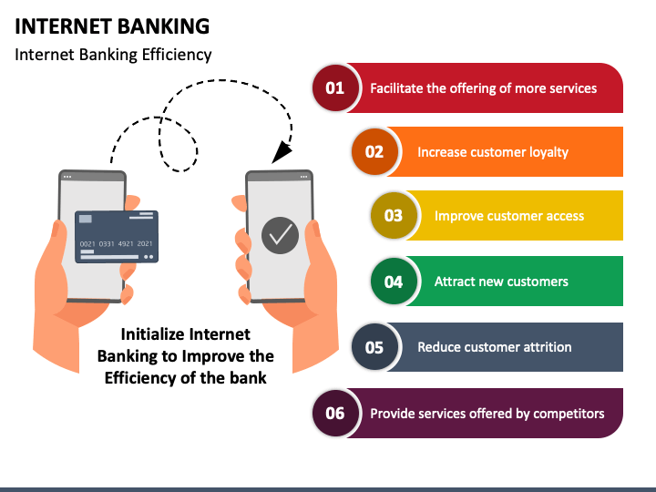
Figure 1: Internet Banking
Source: sketchbubble, (2021)

2.3 Internet Banking and Its Impacts on Socioeconomic and Sociocultural Life
The emancipation of economic activities in the course of social and economic life has gradually enriched the living standard and effective cooperation, while the monetary movements have been more dynamic and centralised in nature. According to Hassan & Farmanesh, (2022), the spectrum of activities has achieved new lines of thought and activities, while the emergence of secured approaches has enacted a steady relationship between customers and institutions on a significant scale. Traditional transactions and branch banking have been facilitated with redesigned models, through which customer participation has increased on a significant scale. However, the report also mentions that the impact of Internet banking has been worldwide, and the regional movements and efficiencies have been empowered through definite scales of measures and e-activities. In the post-Internet period, several sedentary banking activities have been energised by electronic processes, and the fragility of activities has been reduced with time. Gokmenoglu & Hesami, (2020), mentions that financial institutions have been more concrete and collaborative in empowering the growth of the monetary system through Internet banking, and the sociocultural values have been retained as per customer needs and a wide scale of requirements. The imagery of success is derived from customer satisfaction and activities, while the aims and objectives have been accomplished through new techniques and strategies, based on which the economic programmes have been influenced.
The cultural establishment developed by the monetary forums is deeply rooted in the corporate strategies and economic practices taken forward by the banking industry, and customer values as per their requirements have been fulfilled on a significant scale. On the other hand, the cultural assurance in different regions, based on language and other subsets, has been enacted by the banking institutions to strategies it in a reliable pathway. The transparency of activities has been maintained by the management, while the economic transactions and creative values have been redesigned with effective acts and principles (Khan et al. 2020). It is observed that the activities of financial forums and Internet banking belong to an identical interdisciplinary plain, and mutual opportunities are generated by mutual activities. A report by Hassan & Farmanesh, (2022), mentions that in the South Asian region, in the last few years, the number of users has increased by 16.74%, and the cultural acts and activities developed by the financial organisations have played a significant role in it. The report mentions that during the pandemic, no-contact delivery of products seized a major part of business, and no-cash transactions also became popular in this region, as well as, in other parts of the world.
The bar chart presented below refers to banking growth in South Asia, in two different countries, Vietnam and Thailand, and in this regard, the increasing notion of installing and sessions have been considered for the financial year of 2022-2023. According to the chart, with respect to the global scenario, installation has increased by 15% and in the case of sessions, the upliftment is observed by 32%. On the other hand, in Vietnam, installation and sessions have increased by 47% and 128%, respectively, and in Thailand, the statistics are observed at 95% and 141%.

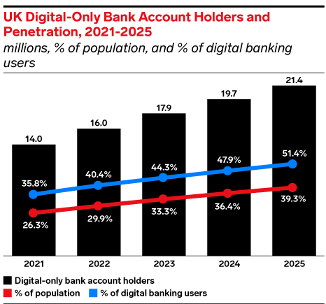
Figure 2: UK Digital banking users’ percentage
Source: Elm, (2021)
A report by Elm, (2021), stated that in UK almost 40% adult users using digital payment method. The association between digital financial services and the socioeconomic status of people have been a key factor in determining the future of Internet banking, and in third-world countries, the practices initially face different difficulties due to different acts and activities. On the other hand, it can also be observed from the aforementioned study that in terms of education, age, occupation and gender, the usage of Internet Banking is also energised, and the development is empowered through durable acts and activities. Sharma, Singh & Sharma, (2020), mention that by reducing the service cost, banking bodies are able to perform steadily with Internet banking and relevant web-based activities.
The graph presented below the online banking users in the UK between 2007 to 2022, and an increasing notion and spontaneity can be observed from the chart. In 2021 and 2022 the number of users has reached 86% and 93%, and the increasing number of users of online bankers has been beneficial for the country’s overall economic growth. On the other hand, the efficiency of dealing with the cyberthreats can also be comprehended from the graph, which also benefits the public-life of the UK.

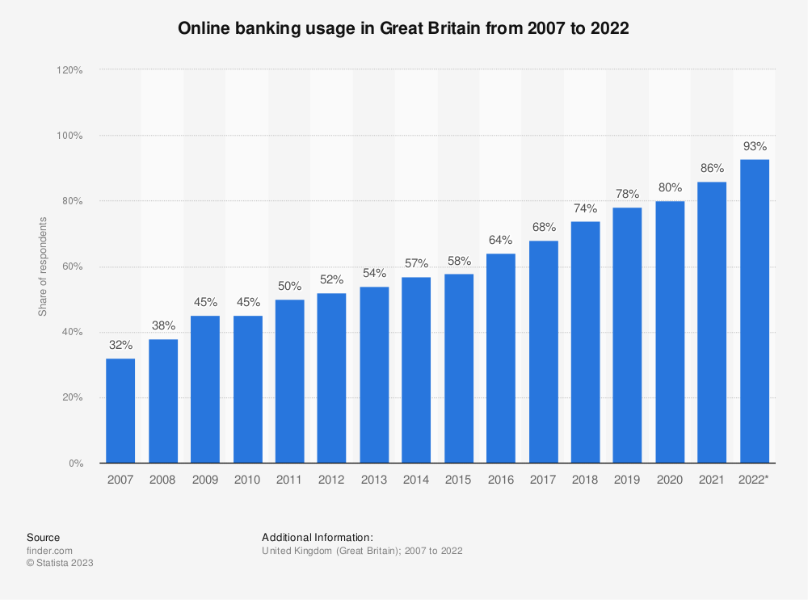
Figure 3: Online Banking Usage in GB from 2007 to 2022
Source: Statista, (2023)
Without refuting the intensity and essential values of branch banking, the report mentions that the productive values and economic practices that have been generated by Internet banking will be a bigger turn in future, and with the increasing pace of digital transformation, it will eventually become the most preferred mode of monetary programming. The sociocultural and socioeconomic impact of Internet banking has also changed the traditional flow of services, and communication has been more effective and spontaneous with it. Digital literacy and financial literacy are the two social factors that influence Internet banking and its outcomes, and in different regions, statistics of the concerned factors act differently.

2.4 Intelligent Defence Mechanism: A Fight against Cybersecurity
In spite of the effective growth and practices developed for Internet Banking, several cyber threats are observed that question the uniformity and certainty of Internet banking in different cases. According to Khan et al. (2020), the challenges faced by customers regarding the security of money and information question the ability of financial institutions, while effective growth and money management are hampered. The report suggests that digital safeguards are formed by the institutions, and customers have all right to know about them. PIN and TAN programs are two basic safeguard programs adopted by Internet banking, while the security measures also include “256-bit encryption” and “128-bit encryption”. On the other hand, it is also observed that the role of the management, in this regard, plays a crucial role in the development of security. The criteria-specified transaction is only allowed by the applications and websites, while the incorporation of Debit Blocks protects the bank accounts from “unauthorised electronic charges” (Rahi et al. 2021). A threshold value is also determined by the layered security system developed by Internet banking policies, and a certain number of transactions is also allowed and identified per day. Transactions get cancelled if the number of transactions exceeds the limit. The aforementioned report also suggests the usage of the “Internet Protocol reputation-based tools”, which assists the e-banking security system by blocking any unwanted connection between accounts and any susceptible IP address. The data and information are kept safe from any kind of manipulation and misuse so that customers do not have to face any tantrums. System procedure and internal control are further empowered by the management to ensure the development of Internet banking Programmes, while the efficiency of practices is created with definite acts and approaches. The collaborative values created by the Internet Banking manager, while the changes brought into the action are encouraged through the stakeholder policies and estimations of monetary practices. The challenges are approached with effective terms and conditions, while the security of transactions is ensured through the discussed programmes.
The image depicted below refers to the threats to cyber-security in Digital banking and in this regard, threats, such as unencrypted data, malware, third-party service, spoofing and phishing and others have been identified.
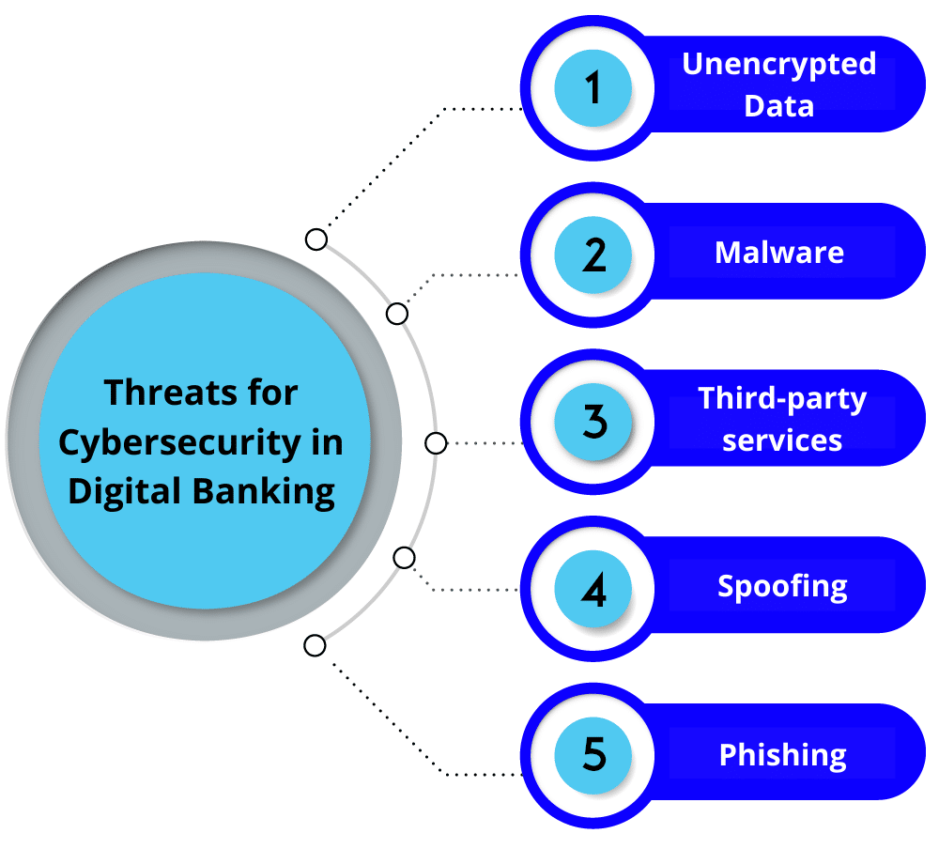
Figure 4: Threats for Cybersecurity in Digital Banking
Source: enterslice, (2022)

2.5 AI to create cyber security.
More stringent safety measures are required to secure customers' personal information and financial activities as online banking becomes the norm. Online monetary systems are increasingly relying on artificial intelligence (AI) to keep them secure from new and emerging dangers. In this assessment of the relevant literature, we assess the strengths, weaknesses, and results of AI in its pivotal position as the architect of online banking security. Rahi et al., (2020), artificial intelligence improves the safety of online banking in a number of ways. Machine learning techniques, a branch of AI, can quickly scour massive databases for abnormalities and patterns that can suggest intrusions. Potentially, these algorithms might prevent fraudulent or illegal access by identifying out-of-the-ordinary user activity in real-time. Furthermore, AI-driven systems may develop and improve over time, picking up lessons from previous assaults to better defend against similar ones in the future. Given the ever-changing nature of cyberattacks, the ability to adjust defences swiftly is crucial.
AI is particularly effective at performing routine security duties related to protecting online financial transactions without human intervention. By instantly responding to questions and keeping an eye out for questionable activities, AI-powered chatbots may boost consumer happiness and safety. Distributed Denial of Service (DDoS) assaults are easier to spot and stop when monitored by artificial intelligence systems. To make it harder for fraudulent users to get access to accounts, artificial intelligence (AI) may enhance authentication procedures by using biometrics and behavioural analysis. The application of AI to the field of cybersecurity is not without its challenges and worries. Adversarial attacks threaten AI systems because they use input manipulation to fool AI algorithms. The possibility of cybercriminals defeating AI-driven security measures is quite worrisome. Data and algorithmic biases might lead to discrimination or privacy abuses, which raises ethical concerns about the use of AI (Karnavat and Garugula, 2023).
The effects of AI-driven cybersecurity on the world of online banking are far-reaching. Having a staff with experience in AI technology and cybersecurity is crucial as financial institutions increasingly depend on AI for security. Competition for jobs is high because of the rising need for AI and cybersecurity experts. There may be far-reaching ramifications for the financial services sector and the public's understanding of this problem if artificial intelligence is used for online banking security. The digital banking sector as a whole might benefit from adopting AI security solutions since, they could boost user trust. There is little question that AI is crucial to improving online banking safety. The forefront of automating digital banking, identifying risks in real time, and delivering adaptive protection is artificial intelligence. Online usage of AI presents risks and ethical considerations that must be properly managed. The use of AI in online banking has wider implications than just increased safety, especially for the relationships between banks and their customers. Finding a happy medium between AI-powered security and ethical problems will be crucial as the digital banking ecosystem develops (Chauhan et al., 2019).

2.6 The role of machine learning to create security for the Internet Banking
As per Mukusheva et al.(2021), machine learning is gaining ground as an AI subject of relevance for safeguarding electronic money transfers. With the goal of lowering risks to customers' financial data and transactions, this literature review will analyse the pros and downsides of using machine learning to the problem of online banking security. When it comes to protecting customers from cyber threats, online banking relies heavily on machine learning algorithms. These algorithms make it possible to spot suspicious patterns in massive datasets very instantly, which may be used to uncover fraud or security flaws. For instance, security alerts may be triggered when machine learning models identify suspicious login or transaction trends. By taking this measure, financial institutions will be protected against theft and fraud. Machine learning's versatility is a huge help when it comes to protecting money transfers made over the internet. Models trained with machine learning may eventually be better able to spot previously unknown threats. The continually evolving nature of cyber threats makes rule-based security systems more ineffective and urgently in need of replacement. Due to its built-in approach to continual improvement, which enhances its effectiveness over time, machine learning has the potential to greatly improve the security of online banking (Naeem and Ozuem, 2021).
As per Rahi et al. (2020), the use of machine learning to improve the safety of online banking is promising, but there are still some significant hurdles to jump. Machine learning models can only perform well with extensive amounts of training data. False positives and negatives may arise in threat detection algorithms if they are based on faulty or inadequate data. Adversarial assaults, when an adversary tries to surreptitiously affect a machine learning model's behaviour, may be achievable if the model is sufficiently complex. Machine learning poses threats to online banking security that go well beyond the purely technical. Investments in technology, software, and human resources may be necessary if banks and other financial institutions want to use machine learning for security reasons. The application of machine learning in the banking sector raises privacy and ethical concerns. Strict data protection criteria must be met while amassing and analysing vast amounts of user data for reasons of security.
Hence it can be said that machine learning protects digital monetary systems by illuminating hidden flaws and enabling flexible countermeasures. It is a critical tool for safeguarding digital money transfers because of its capacity to review data in real-time and react to emerging hazards. Data of insufficient quality, algorithmic biases, and hostile attacks are only some of the problems that need fixing (Vinoth et al., 2022). There might be repercussions for money, people, and privacy if machine learning is employed to protect online banking. As the use of machine learning to protect customer dollars and private information grows more ubiquitous, financial institutions will need to strike a balance between the two advantages.

2.7 Challenges Faced
The banking sector might greatly benefit from the use of AI and ML in the areas of efficiency, customer service, and security. The goal of this literature study is to dissect the most significant problems in banking administration brought on by technological progress. The risks of data breaches, difficulty finding and retaining top personnel, ethical dilemmas, and over-reliance on technology dominate discussions.
As per Liang et al. (2029), leaders in the financial sector confront substantial hurdles due to the wide range and complexity of relevant laws and compliance requirements. Standards in the financial sector span a wide range of topics, including the protection of private information, consumer rights, and the prevention of money laundering. The safety of financial transactions and the protection of consumer rights are extremely seriously, which is why the management has adopted such severe regulations. For the safe use of machine learning and AI in banking operations, as well as the sustainable upkeep of any gains, compliance with regulatory frameworks is crucial. Maintaining compliance with the law while getting the most out of AI and ML might be difficult. This is mainly because these algorithms need regular upkeep and tweaks to keep them in compliance with current standards. The banking sector has a responsibility to protect customers' personal data. Therefore, it is crucial in this industry to keep people's private details protected. Since AI and ML systems rely heavily on big datasets for training and operation, concerns concerning data security and privacy have emerged. It's difficult and time-consuming to maintain client data security while still using it responsibly and tapping into AI and ML's potential. Another degree of complication is added by foreign data protection rules like the General Data Protection Regulation (GDPR) and the California Consumer Privacy Act (CCPA). A hefty fine may be in order if you break the regulations (Shehu, & Shehu, 2023).
For AI and ML technologies to be successfully implemented, it is necessary to have a workforce that is well-versed in data science, machine learning, and artificial intelligence. The lack of capable people has become a major issue in banking management. Significant expenditures in recruiting and maintaining talent are necessary for the effective implementation and maintenance of AI and ML systems in today's tight labour market. It's possible that today's workers need further education and instruction in order to take full advantage of the dynamic technology environment. It is possible that this kind of training calls for a significant time and monetary commitment. Ethical considerations at the executive level have a significant impact on the use of AI and ML in banking operations. Many ethical questions are raised by the combination of AI and ML, all of which need to be explored and answered. Such systems may unintentionally promote biased behaviour in sectors like banking, risk assessment, and customer service because of the inherent biases of historical data. It is challenging to formulate ethical guidelines for AI and ML that prioritize openness and responsibility. Banks need to find a happy medium between fostering innovation and behaving ethically if they want to gain and keep the trust of their consumers and the regulatory organizations that monitor them. You should proceed with prudence in the face of the ever-changing financial landscape. When banks find this sweet spot, they boost customer trust while staying in regulatory compliance (Ghelani et al., 2022). There is great potential for better judgment to result from the integration of AI and machine learning. But we should not put all our technology hopes in one basket, since doing so would devalue individuals. Important banking decisions, such as spotting fraud and approving loans, need the use of human judgment and expertise. An over-reliance on algorithms may damage customer connections and add to a lack of responsibility and transparency during times of crisis.
The application of AI and ML to the field of financial management may have various advantages. However, there are difficulties and obstacles to overcome. Executives at banks and other financial firms face challenging strategic choices every day. Some of them include filling up the industry's skill shortages, dealing with ethical concerns, not relying too much on technology, and satisfying regulatory requirements. Finding the sweet spot between fostering innovation and enforcing responsibility is essential for the successful integration of AI and ML into financial procedures. If this is the case, we must keep working to solve the ensuing problems even if the situation evolves (Scholefield and Shepherd, 2019).

2.8 Literature Gap
The lack of in-depth study on the unique challenges experienced by different demographic groups may contribute to the risk of unintended effects related to growing security measures, especially AI and machine learning. The accompanying literature review does a good job of addressing the benefits and drawbacks of using AI and machine learning to protect online banking, but it doesn't go far enough into how people from different backgrounds may be affected by these innovations.
To understand how customers of online banks with varying degrees of digital literacy are affected by AI-driven security measures, further study may be required. It would be interesting to see whether those who aren't as tech-savvy are deterred from utilizing online banking because of the availability of such stringent security measures. This has the potential to further increase the gap between those with and without enough means to obtain financial services. There is also a large information gap about how AI and ML security procedures influence the personal data of different groups. Some people could be more worried than others about the information they supply being used by AI-driven systems. By contrasting how people from different cultural backgrounds see the safety of online banking, we may get some understanding of the cultural and social factors at play.
Little thought has been given to the ethical difficulties posed by the use of AI and ML in online banking security, especially in regard to prejudice and unfairness. It is crucial to understand how these innovations may unintentionally promote bias and prejudice in financial transactions and judgments if we are to make banking services available to everyone. In conclusion, there is a dearth of studies that investigate the effects of demographic factors like age, income, education level, and digital literacies on the risks associated with using AI and ML for online banking security. These holes must be patched if online banking security is ever going to advance in a way that benefits all customers.

2.9 Conclusion
The chapter of the study has identified different aspects of Internet Banking and the revolutionary image in monetary practices it has successfully produced with technical acts and activities. It can be concluded from the chapter that the creative acts and measures set forward by the financial management are enacted with legal programmes, and the socio-economic and socio-cultural factors of customers have been valued on a significant scale.
It can also be concluded that the growth factors empowered by Internet banking also include the practices procured to establish a steady platform to protect the data and information of customers from any kind of cyber threats. Internal controls, transaction value thresholds, IP programs and others have been identified by the management to control the efficiency of Internet Banking. The chapter has discussed the role of AI and Machine Learning, which have played a key role in protecting the interests of customer values. Moreover, a set of literature gaps has also been identified in the concerned chapter, based on which the research could have been more detailed.

Chapter 3: Research Methodology

3.1 Introduction
Research methodology includes the tools and techniques that ensure the growth of a study in a fluent way, so that the researcher can present it as per the aims and objectives. The concerned chapter of the study will highlight the participants considered for the research work and how their participation has been able to create a database for further analysis as per the purpose of the study.

3.2 Participants
For conducting the research effectively, 50 participants and their responses have been considered by the researcher, and the inclusion criteria emphasise their experience of using Internet Banking, at least five times. The researcher has considered the section of people for the development of the research from different regions so that regional changes can be understood and new insights from their experience can be gained (Newman & Gough, 2020). All the participants were above 18, and the regional consideration has been beneficial for the research work to comprehend their experience regarding Internet banking and the role of the intelligent defence mechanism. Moreover, by considering people from different regions, the researcher has enhanced the platform of the study, as well as cultural diversity has been emphasised. English has solely been the mode of communication to avoid any kind of lingual barrier among people, and their priorities in participation have been considered for the prosperity of the research work.
A convenient sampling method has been considered by the researcher to programme the research work by effective means and measures and the usage of data has been strictly supervised for critical analysis (Pandey & Pandey, 2021). A stable sample size of 50 participants has been considered and the survey has been helpful to procure data. On the other hand, social media platforms have been utilised by the researcher to ensure the development of the research by connecting people with easy means. A broad spectrum of communication has been developed with a standard quality, and their privilege to participate in the research was equal. The researcher did not encourage any kind of sociopolitical and socioeconomic discrimination in developing the study and the survey link has also been shared through email invitations. Personal communication has empowered the research, as participants enjoyed a free zone to opine and respond as per their thoughts and experiences.

3.3 Design
The researcher has utilised the “cross-sectional design” for the collection of data at a single point in time, which provided better insights regarding Internet banking and the current state of intelligent defence mechanisms that protect users’ interests. A collective snapshot of the research topic has been granted by considering cross-sectional design, and it has been beneficial to collect data from participants at a “specific period” (Mukherjee, 2019). The practical nature of the data collection design has also been beneficial as it is a less time-consuming process and cost-effective, as well. A diverse group of participants has also been examined through the cross-sectional design and a broader range of experiences and perspectives related to Internet banking and intelligent defence mechanisms has been aided.
A widespread survey method has been considered by the researcher to ensure a better database, and in this regard, online platforms have been considered. The ease of responses has been a key focus of the researcher for collecting data, and as social media platforms connect a broad range of people, these have been beneficial for the research (Mishra & Alok, 2022). On the other hand, the sociocultural varieties empowered for the research work have also benefited from the widespread practices developed through social media platforms.
An open-ended survey questionnaire has been utilised by the researcher for collecting data, and in this regard, the diversity of questions has been programmed to procure data from people and their effective participants. The questions are based on the usage of Internet Banking and the incorporation of Intelligent Defence Mechanisms, and their experiences and perspectives have been considered for the collection of data. Demographic information and data relevant to Internet banking and cybersecurity have been collected and the open-ended questions have been easier for the people to understand and respond as per their ideas and experiences.

3.4 Materials and Apparatus
The core platform for collecting data and administering has been the Google survey questionnaire and the close-ended survey questionnaire has been effective in ensuring the development of the research work on a significant scale. The ease of use as developed by the Google survey questionnaire does not require any critical technical methods, and it also confirms editing, adding, and recording of survey questions for different research purposes (Budianto, 2020). Multiple-choice questions and checkboxes were provided to procure data from the participants and the useful condition to direct to another question, based on the previous one has been effective for participants as it requires a minimum effort to respond.
Various aspects of Internet Banking and defence mechanisms have been asked through open-ended questions, and the responses have been customised for the development of the research work as per the aims and objectives of the study. The researcher has considered the interpretivism research philosophy for interpreting data with academic and social values. The subjective reality of data has further been focused on by the researcher to understand data, and the critical analysis of data has been effective in deriving new insights, based on Internet banking and the defence mechanisms.

3.5 Research Ethics
The data has been secured from any kind of manhandling or misuse, and the participants were anonymous. Their identity was kept secret and any kind of personal questions were not asked. The research was conducted under their voluntary patriation, and purpose of the study and aim was clearly mentioned to them. Moreover, rights to withdraw their responses at any time were provided to them. The participants did not have to face mental pressure or harm while participating in the survey and their personal and professional fields were not interfered at any cost. The participants were not discriminated, based on their personal faith, ethnicity, or gender.

Chapter 4: Findings and Discussions

4.1 Introduction
The development of technical measures and programmes has redesigned Internet marketing, while the challenges are mitigated for better movements of practices. The implication of AI and machine learning has played a pivotal role in creating effective acts and activities for the development of cybersecurity, and digital programmes are settled for providing a better platform for economic transactions and programmes.
The concerned chapter of the study will identify several primary data and the data will be presented in pie-chart forms. The data will also be critically analysed to gain new insights into the research work.

4.2 Findings
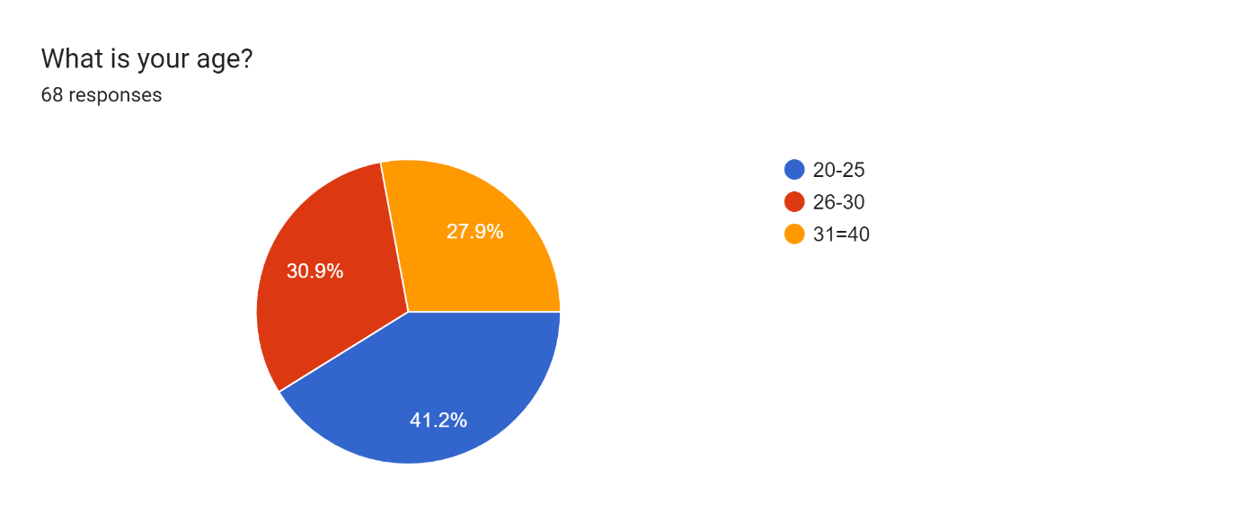
Figure 5: What is your age?
Source: Self-created
The pie-charts depicted in the concerned section of the report refer to different aspects of Internet banking with respect to intelligent defence mechanisms and relevant factors and how it impacts cybersecurity.
Figure 5 depicted below refers to the age group of participants as per their involvement in the research work and data collection. According to the chart, 30.9% of people belong to the age group of 26-30, while 27.9% of them belong to 31-40. On the other hand, it can further be observed that 41.2% of participants belong to the age group of 20-25. People from different age group and their participation has been beneficial for the research to collect data from different points of view.
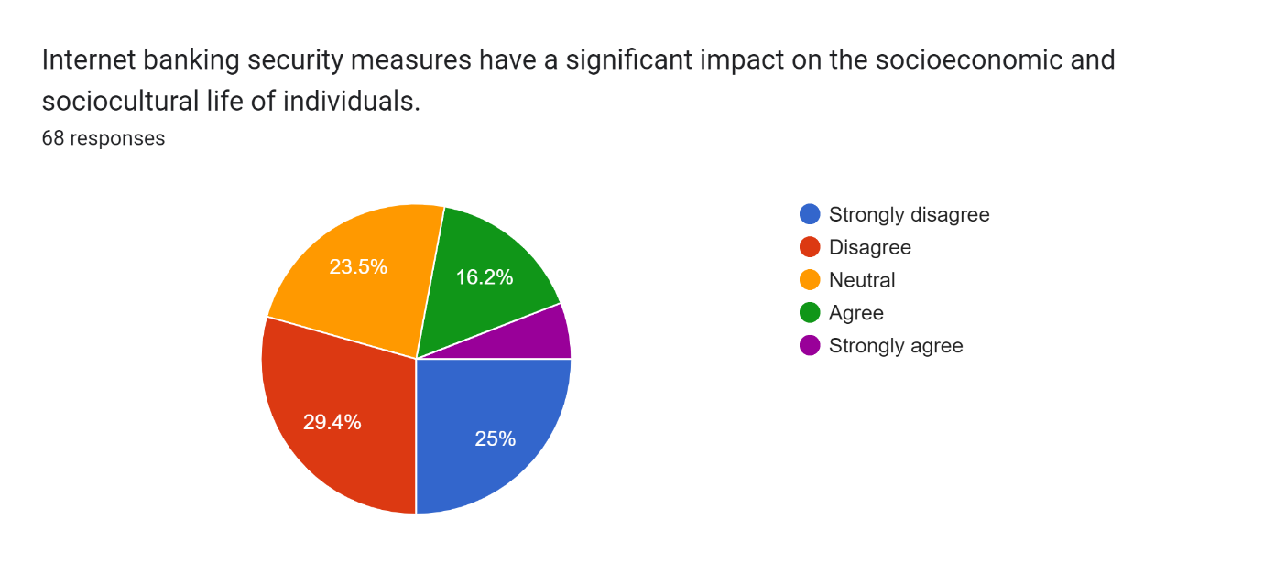
Figure 6: Internet banking security measures have a significant impact on the socioeconomic and sociocultural life of individuals.
Source: Self-created
Figure 6, as observed, presents a pie chart, based on the examination of the impact of Internet banking security measures on the socioeconomic and sociocultural life of individuals. In this regard, 68 responses have been considered by the researcher through the survey questionnaire. According to the findings, it is observed that 29.4% disagreed with the impact, while 25% strongly disagreed with the statement. On the other hand, it can also be observed from the chart that 16.2% of participants agreed that the impact of Internet banking security measures on the socioeconomic and sociocultural life of individuals is significant. Lastly, it can further be observed that 23.5% of people, who participated in the research work opted to remain neutral while responding. The maximum number of people who participated in the research work did not agree with the impact of Internet security banking, while the changes brought into action do not bother them as long as their practices are impactful and fruitful to them for long-term practices.
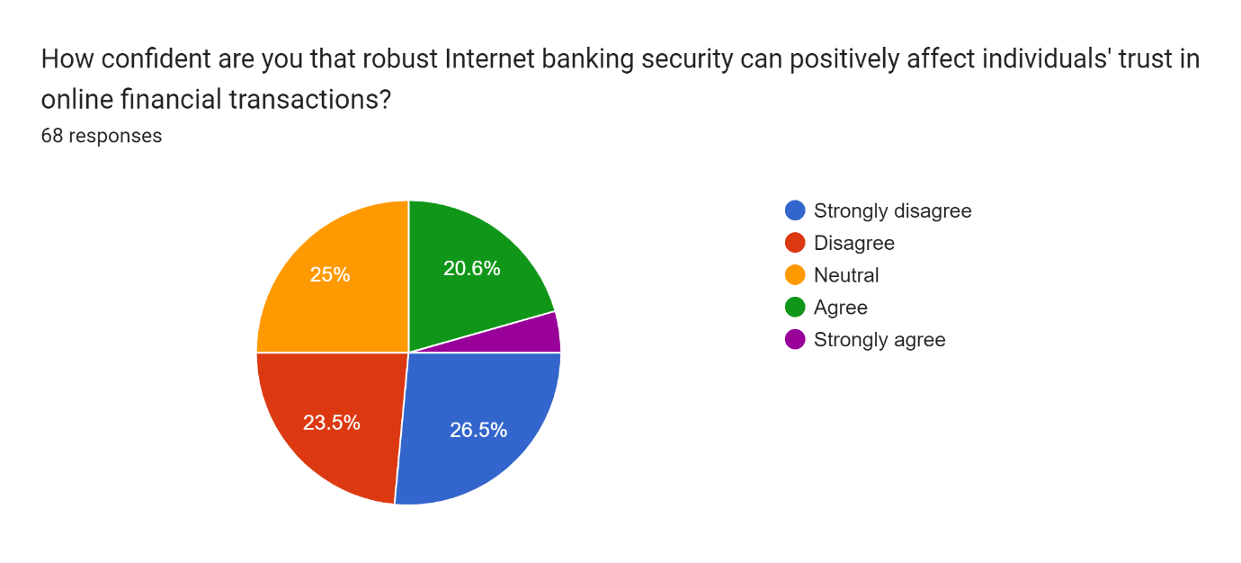
Figure 7: How confident are you that robust Internet banking security can positively affect individuals trust in online financial transactions?
Source: Self-created
Figure 7 examines the confidence of people regarding robust Internet banking security and how it affects an individual’s trust in online financial transactions. According to the pie chart, observed in the figure, 23.5% of people disagreed with the statement that robust internet banking security can positively affect individuals’ trust in online financial transactions. On the other hand, it can also be observed from the chart that 26.5% of people, who participated in the research did not opt for the robust Internet banking security and its impact that can positively affect an individual’s trust in online financial transactions. It is also observed from the chart that 20.6% of people agreed with the robust Internet banking security and its impact that can positively affect an individual’s trust in online financial transactions. Moreover, 25% of participants chose to remain neutral while responding, and the others strongly agreed. It is noticed while collecting data that the maximum number of people do not value the impact of security and its relevant programmes, based on which, their performance can be extended for long-term programmes. However, a certain section of people opted for the robust Internet banking security and the requirements of intelligent defence mechanism, which can ensure their performance with effective acts and activities, and the changes brought into the action is beneficial for the development of Internet banking with reliable acts and activities for future practices.
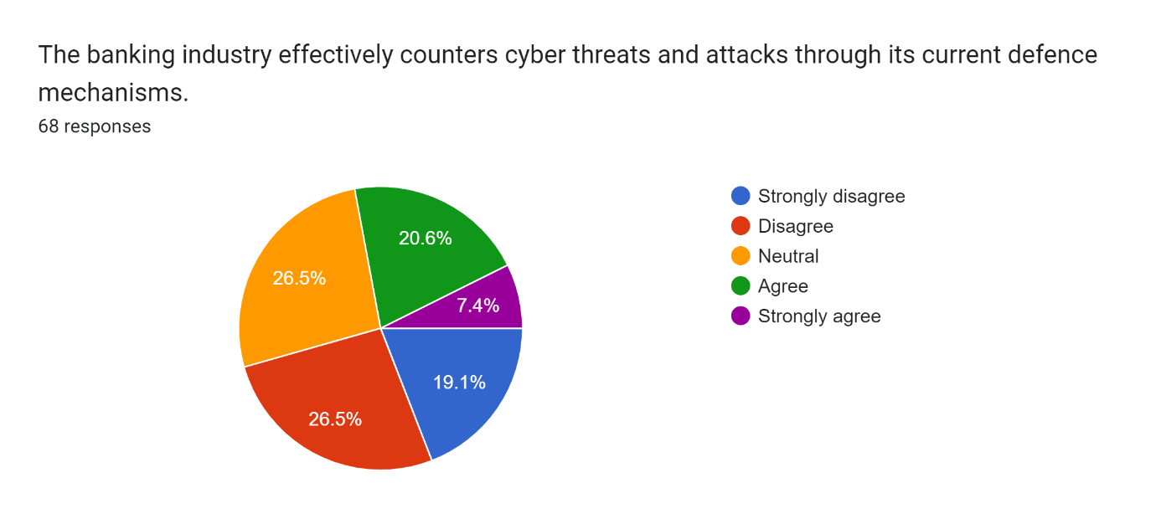
Figure 8: The banking industry effectively counters cyber threats and attacks through its current defence mechanisms.
Source: Self-created
68 responses, as observed, have been prioritised to examine whether the banking industry effectively counters cyber threats and attacks through its current defence mechanisms or not. Figure 8 identifies that 26.5% of people did not agree with the fact that the banking industry effectively counters cyber threats and attacks through its current defence mechanisms. On the other hand, 19.1% of people strongly disagreed with the statement and their responses refer to the lack of potential acts and activities and the current flow of activities relevant to the market growth and business programmes. It is further observed from the chart that 20.6% of people, who participated in the research agreed with the statement that the banking industry effectively counters cyber threats and attacks through its current defence mechanism, while 7.4% strongly agreed with it. It is observed from the findings that a maximum number of people are not satisfied with the role of the banking industry in countering cyber threats and attacks through its current defence mechanism, so the industry needs to implement more effective acts and activities, based on which customer requirements can be fulfilled.
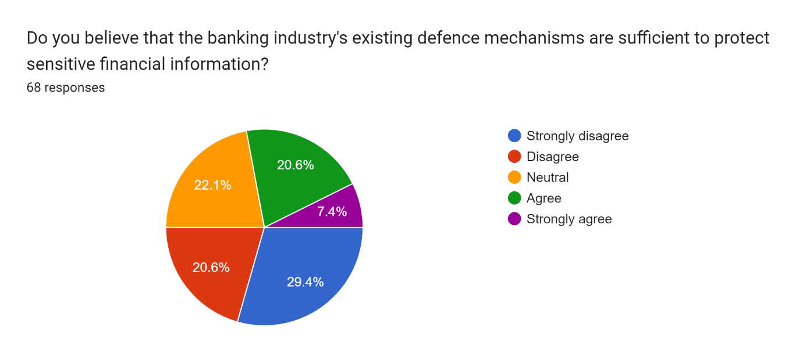
Figure 9: Do you believe that the banking industry’s existing defence mechanisms are sufficient to protect sensitive financial information.
Source: Self-created

Figure 9 refers to whether the participants believe that the banking industry’s existing defence mechanisms are sufficient to protect sensitive financial information or not. In this regard, 68 responses have been considered, and it is observed that, among them, 20.6% of participants disagreed that they believe that the banking industry’s existing defence mechanisms are sufficient to protect sensitive financial information. On the other hand, it is observed that 29.4% of people who participated in the research disagreed with the statement that the banking industry’s existing defence mechanisms are sufficient to protect sensitive financial information, while 7.4% strongly agreed with it. It is further observed from the chart that 20.6% of people agreed with the thought that the banking industry’s existing defence mechanisms are sufficient to protect sensitive financial information, while 22.1% chose to remain neutral.
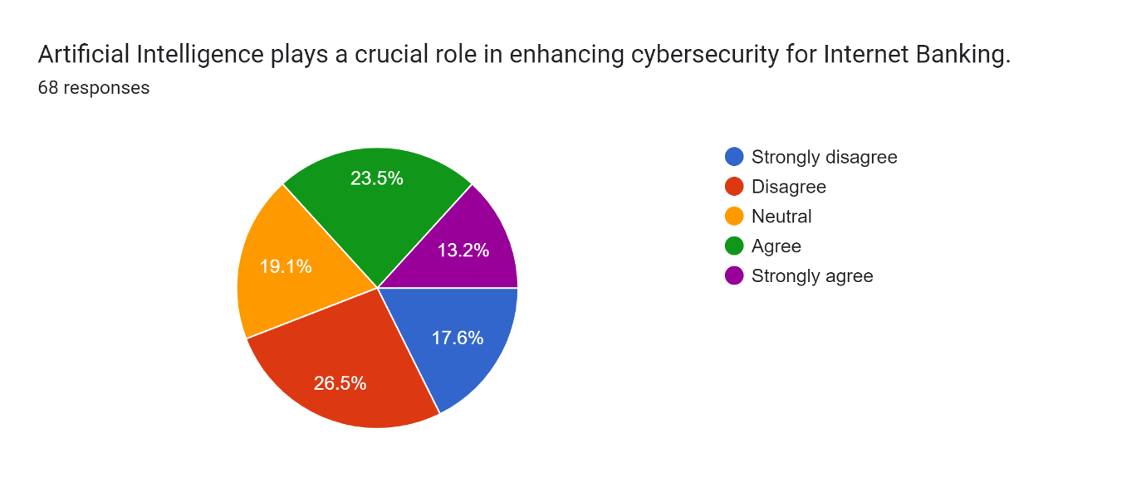
Figure 10: Artificial Intelligence plays a crucial role in enhancing cybersecurity for Internet banking.
Source: Self-created
Figure 10, as depicted above, refers to the role of artificial intelligence in enhancing cybersecurity for Internet banking and the perception of people regarding it. 68 responses have been observed, and a variety of data has been procured through it. According to the pie chart, 26.5% of people disagreed with the crucial role of AI in enhancing cybersecurity, while 17.6% of people strongly disagreed with it. On the other hand, it can also be observed from the chart that 19.1% of people chose to remain neutral while responding, and 13.2% of people who participated in the research opted for the stronghold of AI in the case of enhancing cybersecurity for Internet banking. 23.5% of people agreed with the role of AI in enhancing cybersecurity for reliable growth factors and market programmes to enhance the usage with effective acts and care.
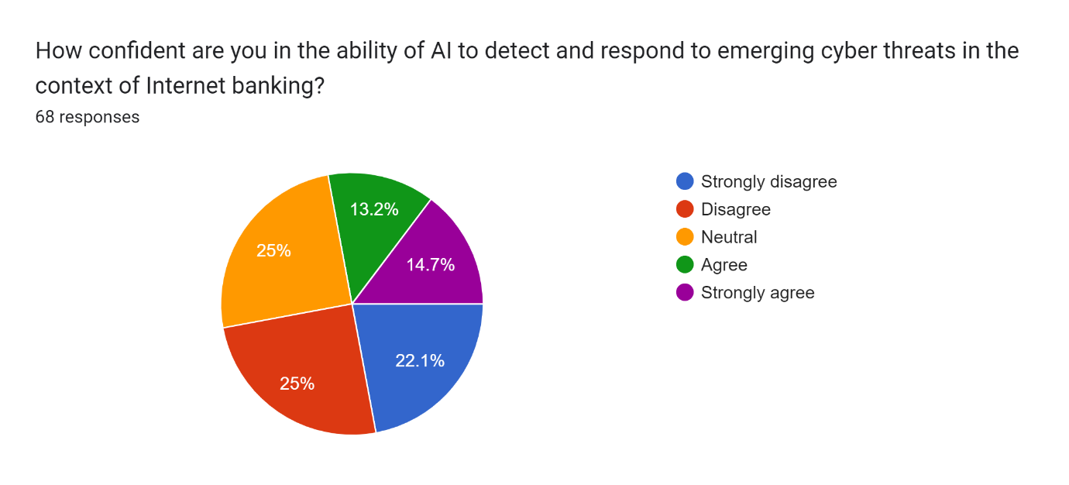
Figure 11: How confident are you in the ability of AI to detect and respond to emerging cyber threats in the context of Internet banking.
Source: Self-created
Figure 11 refers to the examination of the ability of AI to detect and respond to emerging cyber threats in the context of Internet banking. According to the chart, 25% of participants did not show any confidence regarding the ability of AI to detect and respond to emerging cyber threats in the context of Internet banking. On the other hand, 22.1% of participants strongly disagreed with the ability of AI to detect and respond to emerging threats in the context of Internet banking, while 25% of the rest chose to remain neutral while responding regarding the statement and observation. It is further observed from the chart that 13.2% of people agreed with the statement that the ability of AI to detect and respond to emerging cyber threats in the context of Internet banking is high in nature, and 14.7% opted for the strong ability of AI to detect and respond to emerging cyber threats in the context of Internet banking. The emergence of AI in the banking industry, as observed, is a key programme that is important to ensure the growth of stakeholder and shareholder relationships.
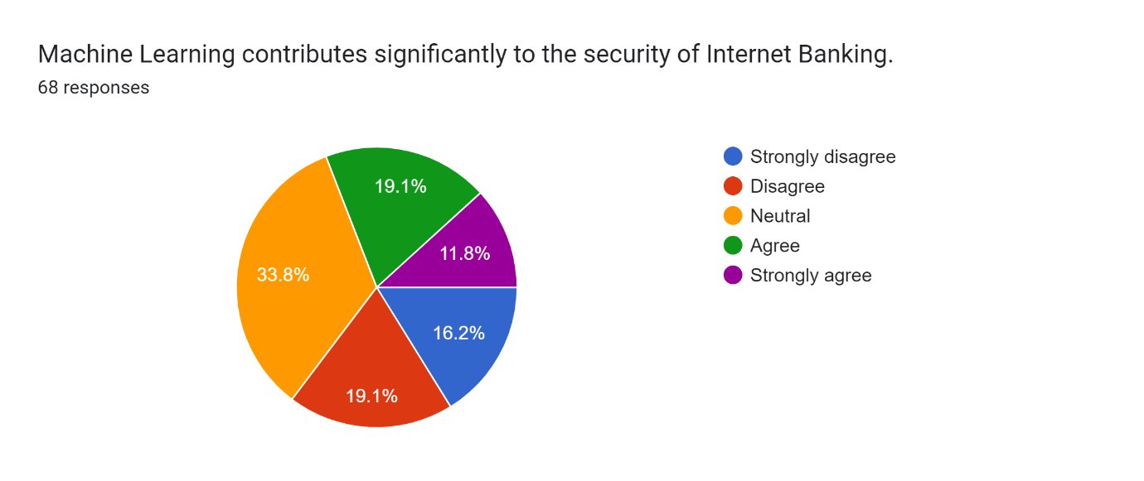
Figure 12: Machine Learning contributes significantly to the security of Internet Banking
Source: Self-created
Figure 12, as observed above refers to machine learning and its contribution to the security of Internet banking, and people’s opinions and thoughts have been understood through the survey. 68 responses have been considered to understand the particular findings, and it is observed that 19.1% of people disagree with the statement that machine learning has a significant contribution to the security of Internet banking, while 16.2% of the rest strongly disagreed with the contribution of machine learning for the development of security of Internet banking. Moreover, the chart also highlights that 11.8% of the people, who participated in the survey, opted for the strong contribution of machine learning for the development of banking security for long-term practices, and 19.1% of the rest agreed to the statement. Lastly, it is observed that 33.8% of people chose to remain neutral while responding to the fact-finding by the researcher. The outcomes of the question refer to people’s neutrality and lack of awareness regarding the usage of machine learning for the development of Internet banking security for long-term purposes and the overall view regarding the incorporation of intelligent defence mechanisms for the development of banking security.
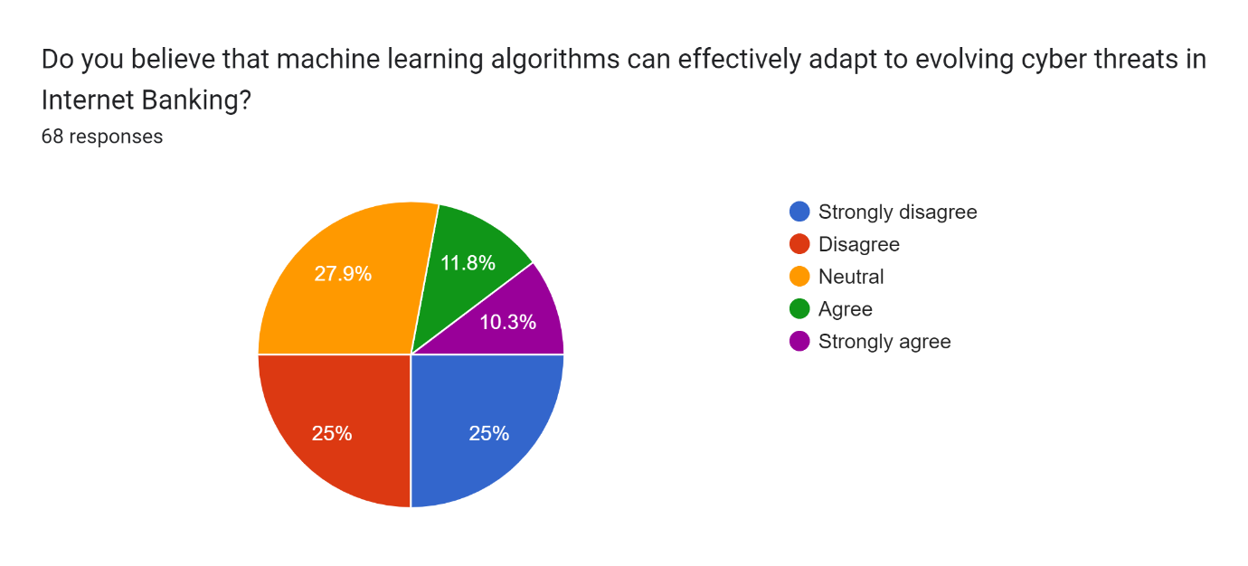
Figure 13: Do you believe that machine learning algorithms can effectively adapt to evolving cyber threats in Internet banking.
Source: Self-created
Figure 13 represents the pie chart, based on the findings derived through the examination of the statement that machine learning algorithms can effectively adapt to evolving cyber threats in Internet banking. According to the chart, 25% of people, who participated in the research disagreed with the statement of the effective adaptation of machine learning algorithms with respect to evolving cyber threats in Internet banking. On the other hand, it is observed that 25% of the rest strongly disagreed with the statement and 11.8% opted that the role of machine learning algorithms can be effective in evolving cyber threats in Internet Banking. The chart also suggests that 27.9% of people remained neutral while responding to the inquiry and 10.3% strongly agreed to the statement. The overall findings refer to the reliable notion of machine learning algorithms for the development of cybersecurity and its effective activities regarding the development of Internet banking in its most usable form.
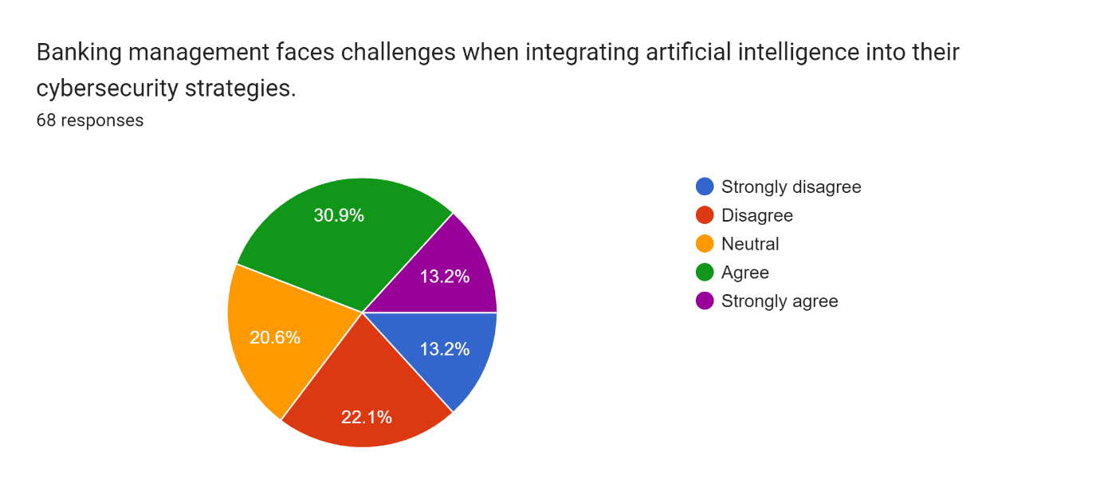
Figure 14: Banking management faces challenges when integrating artificial intelligence into their cybersecurity strategies.
Source: Self-created
Figure 14 represents the inquiry regarding banking management and whether it faces challenges when integrating artificial intelligence into its cybersecurity strategies. According to the chart, it is observed that 30.9% of people, who participated in the survey opted for the challenges that are faced by the banking management while integrating artificial intelligence with cybersecurity strategies. On the other hand, it is also observed that 13.2% of participants strongly agreed with the challenges that are faced by banking management while integrating different forms of AI with the strategic development of cybersecurity on a significant scale. 13.2%, as observed, strongly disagreed with the challenges and 22.1% do not think that the banking management faces challenges regarding the integration of artificial intelligence with the development of cybersecurity for long-term programmes. The rest 20.6% of people remained neutral while responding to the inquiry regarding the existence of challenges and issues faced by the banking management while integrating AI with the cybersecurity forms and management.
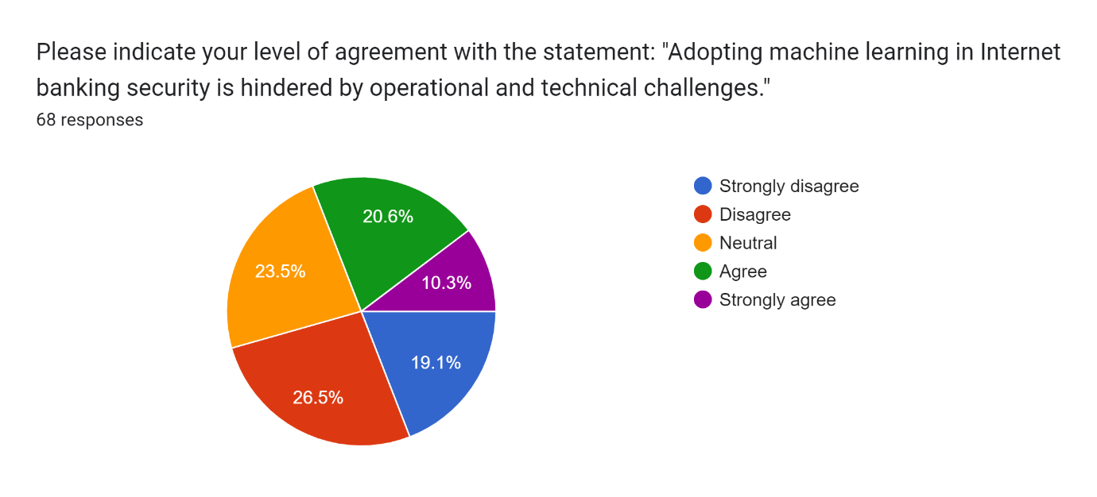
Figure 15: Please indicate your level of agreement with the statement: “Adopting machine learning in Internet banking security is hindered by operational and technical challenges”.
Source: Self-created
Figure 15, observed above, refers to the participants’ level of agreement with the statement that adopting machine learning in Internet banking security is hindered by operational and technical challenges. 68 responses have been procured through the survey and it is observed that 26.5% of participants did not agree with the statement, while 19.1% of the rest strongly disagreed with the statement: “Adopting machine learning in Internet banking security is hindered by operational and technical challenges”. On the other hand, it is also observed that 20.6% of participants agreed with the statement and 10.3% of the rest strongly disagreed with the statement, “Adopting machine learning in Internet banking security is hindered by operational and technical challenges”. 23.5% of participants chose to remain neutral with the fact and it is observed that the adaptation of machine learning in Internet banking security is significant in nature, while the growth of the management depends on operational and technical improvement despite challenges and hindrances.

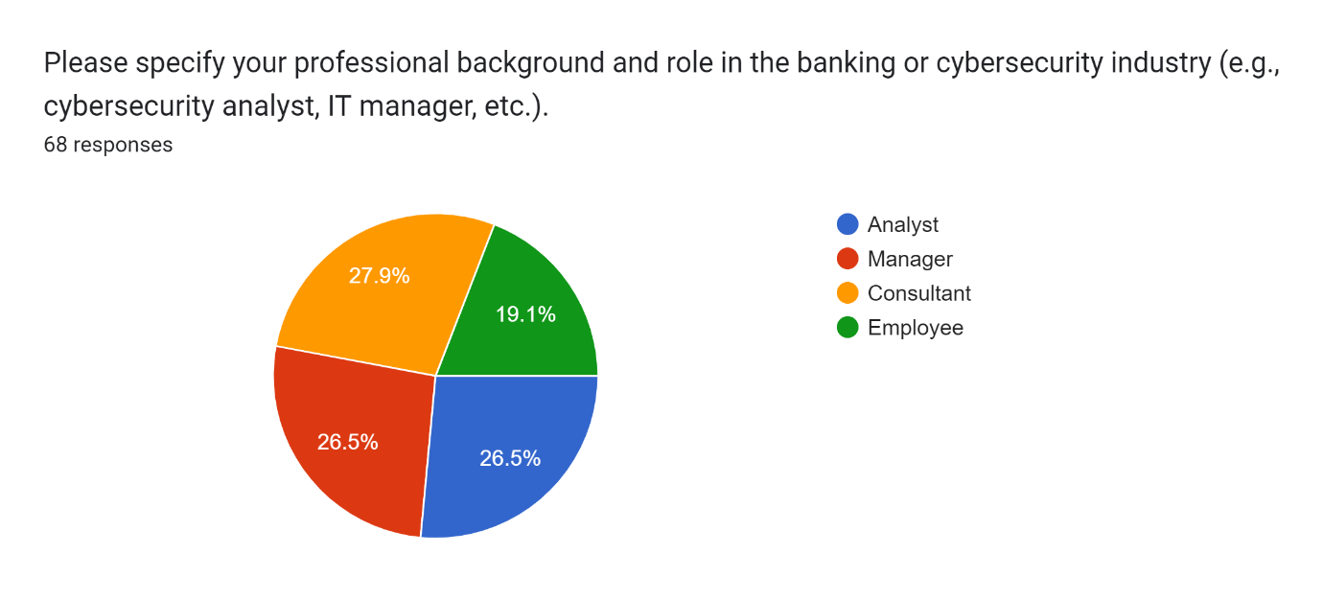
Figure 16: Please specify your professional background and role in the banking cybersecurity industry.
Source: Self-created
Figure 16 observed above refers to the specification of professional background and the role in the banking cybersecurity industry. It is observed from the chart that 26.5% of people, who participated in the survey are managers and the other 26.5% are analysts. On the other hand, it is observed that 27.9% of the rest are consultants and 19.1% are employees. The diversity of participants from different professions has been beneficial for the study and their perceptions and experience have been effective in the development of the study as per the aims and objectives.
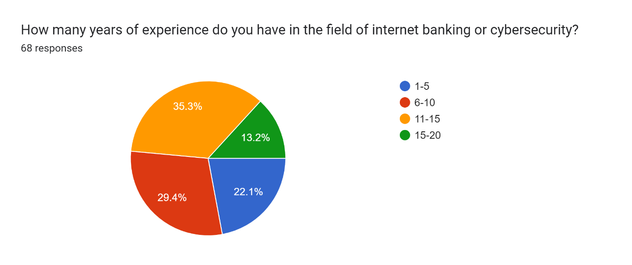
Figure 17: How many years of experience do you have in the field of Internet banking or cybersecurity?
Source: Self-created
Figure 17, observed below refers to the years of experience people have in the field of Internet banking or cyber security. According to the chart, 29.4% of people, who participated in the research work have experience of 6 to 10 years, while 22.1% of the rest have experience of 1 to 5 years. On the other hand, it is also observed from the chart that 35.3% of people have experience working in the field of cybersecurity or Internet banking for 11 to 15 years. It is further observed from the report that 13.2% of people have experience of 15 to 20 years. Their experience in different aspects of Internet banking and cybersecurity have shaped their idea regarding the growth of market programming and the customer relationship for long-term banking programmes with the incorporation of intelligent defence mechanism.

4.3 Discussion
The previous section of the study has identified several primary data from the Google survey form distributed among people for procuring data as per the aims and objectives of the research. The development of Internet banking in professional and personal practices may not disown branch and retail banking, but it has redesigned the technical growth of economic culture and transactions on a significant scale. As observed, the growth of AI and machine learning has a strong impact on banking practices and security. It can be stated from the findings that the awareness regarding AI and machine learning is not enough among people to deal with Internet banking, though a certain section of people is aware of these factors that develop banking programs (Ganesh & Prabu, 2020). The analysis of data can further represent that the growth factors relevant to the management refer to the significant allotment of business programmes and personal transactions which use secret data for effective acts and services. On the other hand, it is also observed that the emergence of cyber threats and security issues have been able to affect the banking programmes on a significant scale, while the threats impact the economic practices popular among users. The misuse and mismanagement of data are affected due to the lack of cybersecurity and the challenges are observed at different levels. The incorporation of AI and machine learning offers a homogeneity of economic and technical practices, based on which the creative development of the programs is generated as per the user requirement (Liu, Crespo & Martínez, 2020). The offers empower the base level of security, and the transactions are ascertained with exclusive codes and operational factors.
Despite the security, several challenges are observed in different spheres of the market. The technical challenges hindered the decision-making, as found in the previous section, while the growth of practices is hampered due to the lack of market programmes and economic issues (Manser Payne, Peltier & Barger, 2021). On the other hand, due to the challenges, the socioeconomic and sociocultural aspects of economic practices are further hampered, and the development of economic acts and activities are also affected due to the lack of market programmes and business values. The shareholder and stakeholder relationships of banks are affected as well, while the assurance to secure data and information of users are also affected. Moreover, the issue with decision-making and effective practices affects the growth of banking performance and it also restricts a fluent practice of Internet banking with different acts and activities (Khan et al. 2020). The issues with the management of financial transactions affect the productive acts and activities that are promised to customers and retention is dropped due to banking mismanagement and misuse of programmes.
It can further be observed from the previous section of findings that the issues with machine learning algorithms are a key factor for the development of market factors, and the challenges impact the daily life practices of users due to the emerging threats regarding cybersecurity (Chauhan et al. 2019). On the other hand, due to socioeconomic and sociocultural differences security practices require different acts and activities for the benefit of customers on a significant scale. The spontaneity of Internet banking follows the cybersecurity practices for the effective growth of market programmes and business values, while the challenges regarding economic factors are mitigated with different technical acts and activities (Arif, Aslam, and Hwang, 2020). The supervision of challenges and the incorporation of different acts and activities are empowered by the role of the management, while the development of economic plans and schemes are settled for long-term practices. The thriving economy in the international market benefits from the decision-making and incorporation of relevant activities and the changes are incorporated as per the requirements.
Banking online securely is more important than ever as our lives become more digitised. There are numerous advantages to banking online, but there are also significant risks associated with the enhanced convenience. The development of effective cybersecurity solutions in the face of a dynamic threat landscape now relies heavily on artificial intelligence (AI). The present research utilises significant numerical and statistical facts to better comprehend how AI may assist in guaranteeing the safety of online banking.
Due to AI's capacity to streamline the process of detecting and preventing fraudulent actions, online banking is now safer than ever. The Association of Certified Fraud Examiners (ACFE) estimates that fraud costs businesses worldwide over $5 trillion each year. Machine learning methods enable artificial intelligence (AI) systems to swiftly review massive information, making it simpler to discover outliers and patterns that may indicate fraudulent activity. Visa recently made a statement praising the role of AI in reducing financial fraud threats, noting that AI-powered systems have prevented more than $25 billion in fraud in 2019. The use of AI in cybersecurity aids authentication procedures by making them more user-friendly. Twenty-seven per cent of those surveyed by Javelin Strategy & Research reported being concerned about the security of their online banking credentials. Biometric authentication methods, such as facial recognition and fingerprint identification, are used in artificial intelligence (AI) solutions because they are far more secure than password-based systems. Because of biometrics, unauthorised access is reduced, and the user experience is enhanced.
Online banking security relies heavily on the speed with which potential flaws and attacks are identified. Artificial intelligence-driven software is continually analysing data streams and system records to spot vulnerabilities. According to the Ponemon Institute, artificial intelligence aids in the detection and mitigation of cyber risks, as agreed upon by 68% of firms polled. Artificial intelligence can also predict future events, enabling proactive measures to be implemented in the field of cybersecurity. If machine learning models were able to identify zero-day vulnerabilities, the attackers' window of opportunity may be drastically reduced (Liang et al. 2019). The use of artificial intelligence (AI) has the potential to improve several facets of network security, including data privacy. To conduct secure online banking transactions, the ability to encrypt sensitive financial data is essential (Mukusheva et al. 2021). Algorithms based on artificial intelligence are important for improving security because they have the potential to reveal weaknesses in cryptographic systems. Artificial intelligence powered DLP systems can keep an eye on your data in real-time, protecting it from intrusion and thwarting would-be hackers. Cybersecurity Ventures predicts that by the year 2030, artificial intelligence might lower the cost of data breaches by 30 per cent. This demonstrates the importance of this technology in avoiding monetary and other asset losses. Online banking security is not yet where artificial intelligence excels. The requirement for ongoing adjustment is a barrier to continuous progress. The ever-evolving nature of cyber threats necessitates that artificial intelligence systems continually learn and update their models. Gartner predicts that by 2022, 80% of AI programmes will need to be retrained due to bias in data and algorithms. This is why it's so important to keep investing in AI-powered security solutions.
Finally, AI is essential for creating effective cyber defences for online banking. Online financial transactions are now safer thanks to AI's ability to identify fraud, improve user authentication, find security vulnerabilities, and protect private information. All of the research provided shows that AI helps reduce cybersecurity threats. However, banks must stay vigilant and invest in AI systems that can adjust to the ever-changing nature of security threats. Artificial intelligence (AI) has been and will continue to be crucial for individuals and businesses to keep their wealth intact in the face of rapid technological change.
The initial benefits of machine learning for online banking security include the simplification of the elimination of any security breaches. Traditional methods of cyber security rely mainly on predetermined rules and signatures, which may not be flexible enough to deal with constantly evolving threats. In contrast, machine learning relies on historical information and statistical patterns to detect suspicious behaviour and security flaws. It was found in Deloitte's "Future of Cyber Survey 2020" that machine learning-driven security solutions may be up to 70% more successful than rule-based systems in identifying new cyber hazards (Lin et al. 2020). Also, machine learning models are well-suited to the administration of large datasets, which is essential for the safety of digital currency transactions. Daily monetary transactions generate a deluge of information. To accurately assess this data for indicators of cyber threats, machine learning algorithms use statistical methods like clustering and regression analysis. By quickly finding patterns and irregularities in transaction data, this speeds up the process of identifying hazards. The Ponemon Institute ("2019 Cost of a Data Breach Report") estimates that the use of machine learning can reduce half the time it takes to detect and halt a cyberattack.
Online banking is just as secure as its weakest link, thus user authentication is essential. The application of behavioural biometrics has reimagined machine learning as a means of user authentication. Statistical analysis of user behaviour, such as typing velocity, mouse clicks, and smartphone use patterns, may help sharpen user profiles. These profiles provide an extra barrier between your network and potential intruders. According to OneSpan's research (included in their study "2020 State of Adaptive Authentication"), a 99.7 per cent detection rate for fraudulent activity was reached utilising behavioural biometrics supported by machine learning. Online banking fraud may be mitigated by machine learning. As more and more transactions take place online, so too have more sophisticated frauds. Suspicious activities may be spotted in real-time by analysing transaction data using machine learning models. If a customer who often makes little purchases in the region makes a big purchase abroad, the system may flag the transaction as suspicious. According to the Association of Certified Fraud Examiners ("2020 Report to the Nations"), fraud losses have dropped by 56% thanks to the use of machine learning in the prevention of fraud (Ghelani et al. 2020). The "2020 Report to the Nations" details how machine learning may be used to improve both everyday cybersecurity operations and quick responses. By analysing the attack vectors and the entire scope of the problem, machine learning models may aid security professionals in responding to security breaches more effectively. IBM Security's "Ponemon 2019 Cost of a Data Breach Study" found that the average cost of a data breach may be reduced by $1.2 million for firms with good incident response systems, such as those using machine learning. When it comes to safeguarding monetary transactions conducted online, machine learning has quickly surpassed all others. One of the many ways it does this is by analysing large amounts of data, looking for outliers, authenticating users, and preventing fraud (Torres & Ladeira, 2020). This highlights the importance of machine learning in enhancing the security of online banking systems by reducing the number of false positives and improving the accuracy with which threats may be discovered. As the financial sector undergoes fast transformation, machine learning is assuming an increasingly important role in cybersecurity.

4.4 Summary
The chapter has identified several primary data procured from the survey and they have been presented in pie-chart format. The data has also been critically analysed and it is observed that the role of AI and machine learning is significant in ensuring the growth of internet banking in the international market. It can further be observed that the sociocultural and socioeconomic aspects of Internet banking play a key role in the development of Internet banking, and security issues affect the personal and professional usage of Internet banking. Technical awareness and digital knowledge are found limited, and the neutrality of people while responding denotes it.

Chapter 5: Conclusions and Recommendations

5.1 Recommendations
- The communication between back-end servers and applications should be secured to protect data, and the management should also ensure that the application solely communicates with the “intended system” (Mohotti & Aruppala, 2022). Moreover, “encrypted transport protection” and HTTPS tunnelling should also be protected from any kind of disparities and misconduct so that Internet banking can be used without any second thought regarding security. The authentication of back-end systems and mobile devices should be well-established for securing the use of Internet banking for personal and professional purposes.
- According to Verma, (2019), the “application hardening mechanism” should be incorporated to make the network difficult to break by any outer threat, and in this regard, the source code should be obfuscated for the safety of relevant data and information. The report further indicates that any kind of tampering attempt should be approached with care and caution, and malevolent accesses should be denied with immediate acts and activities. Ganesh & Prabu, (2020), mention that threats influenced by simulators, debuggers and emulators should be prevented and the device must be protected for long-term functions. Moreover, jailbreaking or rooting of devices should be considered as a key method to make the platform safe and user-friendly.
- The “cryptographic keys” must be protected from any kind of malfunction or attack, and in this regard, mobile applications should be developed with encrypted values. Secured storage should be offered to devices, and the attackers should be prevented from recovering keys in any illegal manner (Naeem & Ozuem, 2021). “Runtime Application Self-Protection” (RASP) should also be considered as a “sentinel framework” for monitoring functioning parameters for the protection of Internet banking. In any case, if an attack is detected, the proactive mechanism for defence should be formed in an actionable manner to protect transactions through Internet banking. Individual requests from attackers should be blocked with immediate actions, and voluntary crashing of applications or reporting malfunctions to the respective bank-end server should be also promoted (Sadekin et al. 2019). The sentinels should not be left easy to be detected by any attackers, and they must be protected from any kind of deactivation in any situation. The strategies with the development of tools and techniques must be acted upon to ensure the spontaneity of Internet banking. The development of security factors should also be promoted to keep the software safe, and the sentinels can be protected from the threat of incapacitation.
- Mobile applications should be able to access “public key infrastructure” (PKI) to check the legitimacy of different banking applications, and other activities should also be protected from any kind of threats with the development of appropriate distribution channels (Mohotti & Aruppala, 2022). Unverified and insecure applications are addressed by PKI, while PKCS mechanisms also enforce banking security with the development of different acts and activities. Stronger authentications, such as “biometric authentication”, in this regard, should also be supported and security layers must be increased with auto-update facilities to reduce vulnerabilities by making the system bulletproof from attackers. Moreover, auto-update also provides opportunities to access modified versions.

5.2 Conclusions
The socioeconomic and sociocultural aspects of Internet banking have been presented in detail way, and the research work reflects the role of the intelligent defence mechanism responsible for the development of better opportunities for users. It can be concluded from the research that the challenges faced by users regarding cybersecurity are mitigated with advanced approaches and programmes, and in this regard, the role of AI and machine learning is significant in nature (Sadekin et al. 2019) On the other hand, it can also be concluded from the research that the evolving technology guides the pathway of smart banking, where users require minimum effort for their transactions and investment (Naeem & Ozuem, 2021). The game-changing notion empowered by Internet banking has maximised the popularity of Internet banking, despite several problems. It can also be concluded from the research work that the lack of awareness regarding the utility of technologies, such as AI and machine learning is a key factor. Issues regarding cybersecurity affect the entire progress of Internet banking, while the professional and personal approaches do not receive the required support. Moreover, the adhering practices regenerate several traditional banking methods by blending them with technological practices, while the changes have been effective to create new opportunities for users for long-term practices.
The well-identified and well-crafted security that is empowered for Internet banking include effective care and caution for long-term practices, and the changes that are brought into the action are measured with constant supervision. The incorporation of practice that create a better deal between mobile applications and banking server has been diverse in nature, and the data mining and predictive analysis have been key aspects of Internet banking with effective acts and activities (Ganesh & Prabu, 2020). Moreover, web-based platforms and mobile applications have also been successful to generate effective programmes and policies for the development of Internet banking with intelligent defence mechanism.

5.3 Research Limitations
Despite a detailed discussion and critical analysis, the research has presented, several limitations can also be observed, due to which the research faced several difficulties. The natural flow of the research has been hampered due to the limitations, while the outcomes of the research have also been affected.
- Firstly, the entire research work received a limited scale of time, which affected the understanding and analysis. Though a set of aims and objectives was identified, and a set of research questions, was also identified by the researcher to empower the research in a positive way, the limited timeframe affected its continuity with wide understanding and application. Due to the limited timeframe, the research could not hold a steady dynamic, which would benefit the research with effective acts and activities.
- Secondly, the limited timeframe affected the data collection as well. The lack of quality data and analysis restricted the study’s growth on a significant scale, and the comprehension of the research topic was affected. The lack of critical analysis and data limited the generation of new insights from the research, while the spontaneity of the research work was also affected, and the outcomes were limited by such hindrances.

5.4 Future Research Opportunities
The research not only provided a detailed analysis of Internet banking and the role of intelligent mechanisms, but it also paved a pathway for the development of future research activities. Further research, based on the upcoming challenges of Internet banking and its impact on the social life of people, can be conducted as per a certain set of aims and objectives. Moreover, another research work regarding the required acts and activities that can empower the use of Internet banking for long-term periods. Moreover, the exclusive use of Internet banking for business bodies can also be understood through further research activities.

References
Aljawarneh. (2017). Online banking security measures and data protection (S. Aljawarneh, Ed.). Information Science Reference. https://doi.org/10.4018/978-1-5225-0864-9
Arif, I., Aslam, W., & Hwang, Y. (2020). Barriers in adoption of internet banking: A structural equation modeling-Neural network approach. Technology in Society, 61, 101231.https://doi.org/10.1016/j.techsoc.2020.101231
Aw, Jiang, J., & Jiang, J. Q. (2019). Rise of the Machines: Factor Investing with Artificial Neural Networks and the Cross–Section of Expected Stock Returns. Journal of Investing, 29(1), 6–17. https://doi.org/10.3905/joi.2019.1.108
Budianto, A. (2020). Legal research methodology repositions in research on social science. International Journal of Criminology and Sociology, 9(1), 1339-1346. https://d1wqtxts1xzle7.cloudfront.net/94536525/Legal_Research_Methodology_Reposition_in_Research_on_Social_Science-libre.pdfa
Chang, Y. C., Enkhjargal, U., Huang, C. I., Lin, W. L., & Ho, C. M. (2020). Factors affecting the Internet banking adoption. Jurnal Ekonomi Malaysia, 54(3), 117-131. https://www.ukm.my/jem/wp-content/uploads/2021/05/jeko_543-9.pdf
Chauhan, V., Yadav, R., & Choudhary, V. (2019). Analyzing the impact of consumer innovativeness and perceived risk in internet banking adoption: A study of Indian consumers. International Journal of Bank Marketing, 37(1), 323-339. https://doi.org/10.1108/IJBM-02-2018-0028
Dutta, A., Ghosh, P., & Bala, A. (2022). Internet Banking Safety Framework: An Evaluation of the Banking Industry in Bangladesh. In Cross-Industry Applications of Cyber Security Frameworks (pp. 148-158). IGI Global. 10.4018/978-1-6684-3448-2.ch008
Elm, M. (2021) The UK digital-only Banks Report, Insider Intelligence. Available at: https://www.insiderintelligence.com/content/uk-digital-only-banks-report
Ganesh, R., & Prabu, G. (2020). Determination of internet banking usage and purpose with explanation of data flow diagram and use case diagram. International Journal of Management and Humanities, 4(7), 52-58. https://www.ijmh.org/wp-content/uploads/papers/v4i7/G0674034720.pdf
Ghelani, D., Hua, T. K., & Koduru, S. K. R. (2022). Cyber Security Threats, Vulnerabilities, and Security Solutions Models in Banking. Authorea Preprints. https://doi.org/10.22541/au.166385206.63311335/v1
Gokmenoglu, K., & Hesami, S. (2020). Internet banking adoption among Generation Y customers: an application of extended TAM. International Journal of Services Operations and Informatics, 10(4), 330-349. https://www.worldscientific.com/doi/full/10.1142/S021987702150036X
Habib Ullah Khan, Muhammad Zain Malik, Shah Nazir, & Faheem Khan. (2023). Utilizing Bio Metric System for Enhancing Cyber Security in Banking Sector: A Systematic Analysis. IEEE Access, 11, 80181–80198. https://doi.org/10.1109/ACCESS.2023.3298824
Hassan, H., & Farmanesh, P. (2022). Customer adoption of self-service technologies in Jordan: Factors influencing the use of Internet banking, mobile banking, and telebanking. Management Science Letters, 12(3), 193-206. http://www.ijafb.com/PDF/IJAFB-2022-45-12-27.pdf
Karnavat, A. T., & Garugula, A. M. G. To Study the Impact of Internet Banking in the banking system. https://biogecko.co.nz/admin/uploads/8.%20Anurag%20-%20Petricia%20Roseline.pdf
Kataria, S., & Nafis, M. T. (2019, March). Internet banking fraud detection using deep learning based on decision tree and multilayer perceptron. In 2019 6th International Conference on Computing for Sustainable Global Development (INDIACom) (pp. 1298-1302). IEEE. https://ieeexplore.ieee.org/abstract/document/8991389
Kaur, & Kautish, S. (Eds.). (2022). AI-enabled agile Internet of things for sustainable FinTech ecosystems. IGI Global.
Khan, B. U. I., Olanrewaju, R. F., Anwar, F., Mir, R. N., & Yaacob, M. (2020). Scrutinising internet banking security solutions. International Journal of Information and Computer Security, 12(2-3), 269-302. https://www.inderscienceonline.com/doi/abs/10.1504/IJICS.2020.105180
Khan. (2019). Machine learning and cognitive science applications in cyber security (Khan, Ed.). IGI Global. https://doi.org/10.4018/978-1-5225-8100-0
Khattak, S., Jan, S., Ahmad, I., Wadud, Z., & Khan, F. Q. (2021). An effective security assessment approach for Internet banking services via deep analysis of multimedia data. Multimedia Systems, 27, 733-751. https://doi.org/10.1007/s00530-020-00680-7
Kumar, R., Sachan, A., & Kumar, R. (2020). The impact of service delivery system process and moderating effect of perceived value in internet banking adoption. Australasian Journal of Information Systems, 24. https://journal.acs.org.au/index.php/ajis/article/view/1923
Liang, D., Zhang, Y., Xu, Z., & Jamaldeen, A. (2019). Pythagorean fuzzy VIKOR approaches based on TODIM for evaluating internet banking website quality of Ghanaian banking industry. Applied soft computing, 78, 583-594. https://doi.org/10.1016/j.asoc.2019.03.006
Lin, W. R., Wang, Y. H., & Hung, Y. M. (2020). Analyzing the factors influencing adoption intention of internet banking: Applying DEMATEL-ANP-SEM approach. Plos one, 15(2), e0227852. https://doi.org/10.1371/journal.pone.0227852.t011
Liu, Crespo, R. G., & Martínez, O. S. (2020). Enhancing Privacy and Data Security across Healthcare Applications Using Blockchain and Distributed Ledger Concepts. Healthcare (Basel), 8(3), 243–. https://doi.org/10.3390/healthcare8030243
Ly, B., & Ly, R. (2022). Internet banking adoption under technology acceptance model—Evidence from Cambodian users. Computers in Human Behavior Reports, 7, 100224. https://www.sciencedirect.com/science/article/pii/S2451958822000586
Manser Payne, Peltier, J., & Barger, V. A. (2021). Enhancing the value co-creation process: artificial intelligence and mobile banking service platforms. Journal of Research in Interactive Marketing, 15(1), 68–85. https://doi.org/10.1108/JRIM-10-2020-0214
Miranda. (2018). Enhancing Cybersecurity Awareness Training: A Comprehensive Phishing Exercise Approach. International Management Review, 14(2), 5–56. http://www.imrjournal.org/uploads/1/4/2/8/14286482/imr-v14n2art1.pdf
Mishra, S. B., & Alok, S. (2022). Handbook of research methodology. http://74.208.36.141:8080/jspui/bitstream/123456789/1319/1/BookResearchMethodology.pdf
Mohotti, D. S. W. C., & Aruppala, W. D. N. (2022). Determinants of internet banking adoption in Sri Lanka. http://repository.kln.ac.lk/handle/123456789/25761
Mukherjee, S. P. (2019). A guide to research methodology: An overview of research problems, tasks, and methods. https://books.google.co.in/books?hl=en&lr=&id=RbOtDwAAQBAJ&oi=fnd&pg=PP1&dq=Research+methodology&ots
Mukusheva, A. G., Zholamanova, M. T., & Kuchukova, N. K. (2021). Financial Technologies in the Banking Sector: Prospects and Security. Вестник Карагандинского университета DOI, 92, 102. DOI 10.31489/2021Ec1/92-102
Naeem, M., & Ozuem, W. (2021). The role of social media in internet banking transition during COVID-19 pandemic: Using multiple methods and sources in qualitative research. Journal of Retailing and Consumer Services, 60, 102483. https://doi.org/10.1016/j.jretconser.2021.102483
Naeem, M., & Ozuem, W. (2021). The role of social media in internet banking transition during COVID-19 pandemic: Using multiple methods and sources in qualitative research. Journal of Retailing and Consumer Services, 60, 102483. https://www.sciencedirect.com/science/article/pii/S0969698921000497
Nazaritehrani, A., & Mashali, B. (2020). Development of E-banking channels and market share in developing countries. Financial Innovation, 6(1), 12. https://link.springer.com/article/10.1186/s40854-020-0171-z
Newman, M., & Gough, D. (2020). Systematic reviews in educational research: Methodology, perspectives, and application. Systematic reviews in educational research: Methodology, perspectives, and application, 3-22. https://library.oapen.org/bitstream/handle/20.500.12657/23142/1007012.pdf?sequenc#page=22
Pandey, P., & Pandey, M. M. (2021). Research methodology tools and techniques. Bridge Center. http://dspace.vnbrims.org:13000/jspui/bitstream/123456789/4666/1/RESEARCH%20METHODOLOGY%20TOOLS%20AND%20TECHNIQUES.pdf
Pechetti, Jindal, A., & Bose, R. (2019). Exploiting Mapping Diversity for Enhancing Security at Physical Layer on the Internet of Things. IEEE Internet of Things Journal, 6(1), 532–544. https://doi.org/10.1109/JIOT.2018.2842056
Rahi, S., Ghani, M. A., & Ngah, A. H. (2020). Factors propelling the adoption of internet banking: the role of e-customer service, website design, brand image and customer satisfaction. International Journal of Business Information Systems, 33(4), 549-569. https://doi.org/10.1504/IJBIS.2020.105870
Rahi, S., Mansour, M. M. O., Alghizzawi, M., & Alnaser, F. M. (2019). Integration of UTAUT model in internet banking adoption context: The mediating role of performance expectancy and effort expectancy. Journal of Research in Interactive Marketing, 13(3), 411-435. https://d1wqtxts1xzle7.cloudfront.net/92062746/10-1108_JRIM-02-2018-0032_201ISI-libre.pdf
Rahi, S., Othman Mansour, M. M., Alharafsheh, M., & Alghizzawi, M. (2021). The post-adoption behavior of internet banking users through the eyes of self-determination theory and expectation confirmation model. Journal of Enterprise Information Management, 34(6), 1874-1892. https://www.emerald.com/insight/content/doi/10.1108/JEIM-04-2020-0156/full/html
Rawwash, H., Masad, F., Enaizan, O., Eneizan, B., Adaileh, M., Saleh, A., & Almestarihi, R. (2020). Factors affecting Jordanian electronic banking services. Management Science Letters, 10(4), 915-922. http://dx.doi.org/10.5267/j.msl.2019.10.004
Sadekin, M. S., Mukta, S. N., & Shaikh, M. A. H. (2019). Customers’ trust on e-banking system in Bangladesh. International Journal of Economics, Finance and Management Sciences, 7(6), 178-186. https://www.researchgate.net/profile/Mohammad-Sadekin-2/publication/340091910_Customers'_Trust_on_E-Banking_System_in_Bangladesh
Scholefield, S., & Shepherd, L. A. (2019). Gamification techniques for raising cyber security awareness. In HCI for Cybersecurity, Privacy and Trust: First International Conference, HCI-CPT 2019, Held as Part of the 21st HCI International Conference, HCII 2019, Orlando, FL, USA, July 26–31, 2019, Proceedings 21 (pp. 191-203). Springer International Publishing. https://link.springer.com/chapter/10.1007/978-3-030-22351-9_13
Shehu, V. P., & Shehu, V. (2023). Human rights in the technology era–Protection of data rights. European Journal of Economics, Law and Social Sciences, 7(2), 1-10. https://doi.org/10.2478/ejels-2023-0001
Sharma, R., Singh, G., & Sharma, S. (2020). Modelling internet banking adoption in Fiji: A developing country perspective. International Journal of Information Management, 53, 102116. http://repository.usp.ac.fj/12151/1/Modelling_Internet_banking_in_Fiji.pdf
Singh, M., Kaur, P., & Chaoudhary, N. (2022, December). Standards and Security in Information Calling through Internet Banking. In 2022 11th International Conference on System Modeling & Advancement in Research Trends (SMART) (pp. 1531-1534). IEEE. https://doi.org/10.1109/SMART55829.2022.10047621
Singh, S., & Srivastava, R. K. (2020). Understanding the intention to use mobile banking by existing online banking customers: an empirical study. Journal of Financial Services Marketing, 25(3-4), 86-96. https://doi.org/10.1057/s41264-020-00074-w
Sodoma, R., Hrytsyna, O., Yakubiv, V., Pavlikha, N., Shmatkovska, T., Tsymbaliuk, I., ... & Brodska, I. (2019). Development of electronic banking: A case study of Ukraine. http://doi.org/10.9770/jesi.2019.7.1(17)
Torres, R. A. L., & Ladeira, M. (2020, December). A proposal for online analysis and identification of fraudulent financial transactions. In 2020 19th IEEE International Conference on Machine Learning and Applications (ICMLA) (pp. 240-245). IEEE. https://doi.org/10.1109/ICMLA51294.2020.00047
Velmurugadass, Dhanasekaran, S., Shasi Anand, S., & Vasudevan, V. (2021). Enhancing Blockchain security in cloud computing with IoT environment using ECIES and cryptography hash algorithm. Materials Today: Proceedings, 37, 2653–2659. https://doi.org/10.1016/j.matpr.2020.08.519
Verma, K. (2019). A study on acceptance of mobile banking and internet banking. Lexipedia, 34. https://www.researchgate.net/profile/Vineeta-Agrawal/publication/360995765_Embracing_Digital_Technology_in_Banking_A_study_on_Trends_Challenges
Vinoth, S., Vemula, H. L., Haralayya, B., Mamgain, P., Hasan, M. F., & Naved, M. (2022). Application of cloud computing in banking and e-commerce and related security threats. Materials Today: Proceedings, 51, 2172-2175. https://doi.org/10.1016/j.matpr.2021.11.121
Wang, V., Nnaji, H., & Jung, J. (2020). Internet banking in Nigeria: Cyber security breaches, practices, and capability. International Journal of Law, Crime and Justice, 62, 100415. https://doi.org/10.1016/j.ijlcj.2020.100415
Wang, V., Nnaji, H., & Jung, J. (2020). Internet banking in Nigeria: Cyber security breaches, practices, and capability. International Journal of Law, Crime and Justice, 62, 100415. https://doi.org/10.1016/j.ijlcj.2020.100415

