BA SOTAH – International Hotel Management
Module- Financial Management for the Hotel Industry
Module Level- 5
Module code- BMIH5007
Lecturer- Dale Clarke

Assignment title- Assignment 2: Marriott International
Student Name: Tanjil Islam
Student ID: 2026022

Table of Contents
Introduction 3
Task 1 4
a) Interpretation of the Financial Ratio Performance of the Marriott International Inc. and Discussion on the Trends seen in its Key Financial Ratios 4
b) Examination of the Limitations of Ratio analysis and Why an Understanding of Ratios and their Fluctuations is Essential for Hotel Management in Analysing the Information Seen in their Financial Statements 8
c) An Explanation of Ratios and Their Significance in Decision Making 9
Conclusion 11
References 12

Introduction
Ratio analysis is a mathematical technique for analyzing a financial document of a firm, such as the income statement and the balance sheet to gather knowledge about operational effectiveness, its solvency and profitability (Drake and Fabozzi, 2012). In order to get insights into profitability, solvency, operational effectiveness, ratio analysis examines data from the financial statements of a firm (Gibson and Boyer, 2013). External users who set standards frequently associated with risk may also demand ratio analysis. Inventory turnover ratio, gross profit margin, and current ratio are a few examples of ratio analysis. In this task, the financial statements of Marriott International, Inc., which is an American based lodging service provider company, is going to be analysed, according to the financial ratios. Also, the understanding of the limitations and importance of financial ratios in hotel management in decision making is going to be investigated.

Task 1

a) Interpretation of the Financial Ratio Performance of the Marriott International Inc. and Discussion on the Trends seen in its Key Financial Ratios
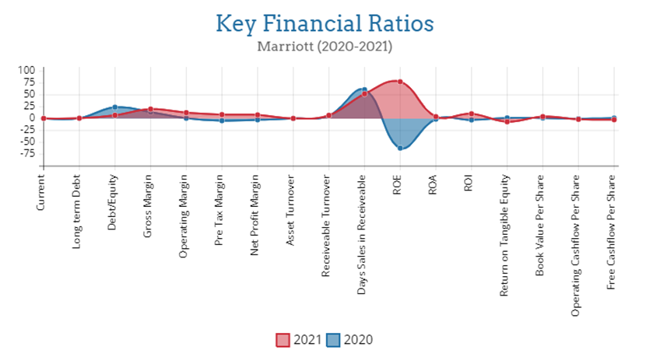
Ratios serve as benchmarks for businesses. They assess the stocks of a certain sector and compare a present performance of a company to its past results. Ratio analysis is a useful tool that a business may use to better understand its progression through time (Drake and Fabozzi, 2012). In the projected figure, key financial ratios of the Marriott from the year 2020 and 2021 have been shown. In this part, the financial ratio performance of the Marriott, from 2020 to 2021 have been analyzed. Also, the trends seen in some of the key financial ratios have been discussed in detail.
Gross Profit Margin and Net Profit Margin
Larger margins of gross profit margin often signify more profitable businesses (Welc, 2022). In the case of Marriott, higher ratio with 13.8019 in 2020 and 20.2136 in 2021 shows that the firm is not devoting an excessive amount of its income to costs associated with manufacturing, such as wages and raw materials. It should be noted that large gross profit margins may not always imply high net margins. Because of considerations like as interest and tax charges, net margins are sometimes much lower than gross margins, which can be seen from the Marriott's net profit margin. This implies that even if the company can reduce its cost of products sold, additional expenditures such as, payment of interest and administration might eat into its profits.
Debt to Equity Ratio
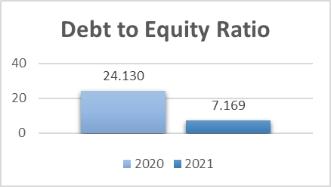
Using equity as a measure, this examines if a company is constantly borrowing much higher than it is able to realistically repay. Because the debt/equity ratio in both 2020 and 2021 is larger than one, the company is considered to be in debt. However, since it decreases from 24.1302 to 7.1697 in a year, it can be stated that it is borrowing less and repaying its debt more quickly.
Current Ratio
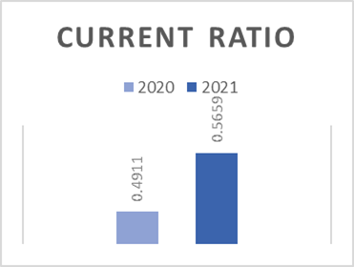
If the ratio is less than 1, it means that the company's obligations that are due in the next year or less are higher than its assets, cash, or other short-term assets that are anticipated to be converted into cash in the next year or less (Babalola and Abiola, 2013). Although several circumstances might negatively impact the current ratio of a strong corporation, a current ratio that is lesser than 1.00 may sound frightening. A business with a current ratio under 1.00 frequently lacks the cash necessary to cover all of its short-term commitments at once. As seen in the current ratio of the Marriott from 2020 and 2021, both of the ratio is under 1.00, which may sound frightening. But the upward trend for the Marriott International might mean improved collections, a quicker turnover of inventory, or that the debt has been repaid.
Return on Assets
Because ROA demonstrates how well a business uses its assets to produce profits, investors may use it to identify promising stock possibilities (Bloomenthal, 2022). The Marriott's ROA ratio increased throughout the time, from -1.0809 to 4.3009, demonstrating the company's success in boosting earnings with each investment.
Long-term Debt to Capital Ratio
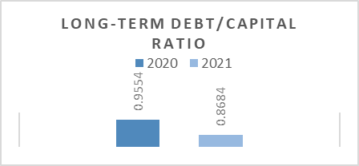
The classic debt-to-equity (D/E) ratio has a variant called the long-term debt to capitalization ratio that displays a company's financial leverage. If it is below 1.0 it is said to be a healthy long-term debt to total capitalization ratio (Welc, 2022). The ratio for the Marriott is less than 1.0 for both years, indicating that the company is strong, has no financial problems, and has a reasonable amount of debt.
Return on Equity Ratio
The return-on-equity, or ROE, statistic is used to evaluate returns on investments. It assesses how well a company leverages equity of the shareholder to create profits (Bloomenthal, 2022). Marriott International Inc.'s ROE grew from -62.093 to 77.7228 between 2020 and 2021. This might be regarded an excellent ROE because it improved significantly over time. This might imply that the company performed an excellent job of increasing earnings by utilising shareholder capital. As a result, shareholder value may have grown.
Asset Turnover Ratio
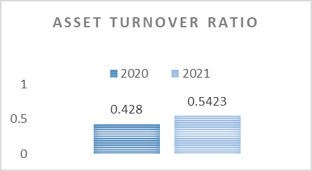
As it shows a more effective use of resources, a greater asset turnover ratio is advantageous. On the other hand, a smaller ratio shows that the organization is not utilizing its resources as effectively (Wilkins, 2022). The asset turnover for the company grew within a year, from 0.428 in 2020 to 0.5423 in 2021, indicating a moderate utilization of assets to create revenue.
Fundamental analysis employs dozens of financial ratios, from which, a few key financial ratios of the Marriot International Inc. have been briefly interpretated and discussed. In order to get a reliable assessment and make more confident financial decisions, a range of ratios has to be calculated and analysed.

b) Examination of the Limitations of Ratio analysis and Why an Understanding of Ratios and their Fluctuations is Essential for Hotel Management in Analysing the Information Seen in their Financial Statements
Comparing the performance of an organization or of other organizations over a period of years frequently is important. It may be used to analyse the liquidity, profitability, and performance of a firm or other comparable businesses from year to year. Ratio analysis has a number of drawbacks, just like any other method of financial research. To prevent drawing false conclusions, it is essential to be aware of these limits (Faello, 2015). The following are among the most significant constraints of ratio analysis.
Information from the Past
The data utilized in the study is based on actual past performance a hotel has made public. As a result, measurements from ratio analysis may not accurately predict future business performance (Baginski et al., 2014).
Effects of inflation
The frequent publishing of financial statements causes inflation since there are gaps in time in between publishing. Actual values cannot be shown in the financial accounts of a hotel if inflation has taken place between periods. As a result, until a hotel has been corrected for inflation, the figures from various time periods cannot be compared (Alayemi, 2015).
Financial statement manipulation
Ratio analysis of a hotel is made based on data that the company reports in its financial accounts, which might be manipulated (Baginski et al., 2014). The management of the hotel may falsify this data in order to report results that are better than the true performance of the hotel. Ratio analysis may thus be inaccurate in capturing the hotel's underlying nature since basic analysis is unable to identify information that is being presented in a misleading manner. It is crucial for an analyst to be mindful of the alterations and to constantly do thorough research prior drawing the conclusions.
Effects of the season
A hotel ratio analyst should be mindful of seasonal variables that might adversely impact their work. If the analysis is not corrected according to the impacts of seasonality, the findings of the study may be interpreted incorrectly (Ayoun and Kim, 2015).
Modification to the accounting process
The value of inventory may alter, if a hotel has modified its accounting standards and practices, which is referred to as the modification of accounting method (Alayemi, 2015). For example, the price of stock can be decreased and the sales cost can be increased if a hotel utilizes the first in first out technique for inventory valuation initially before charging to the last in first out approach. If this is the case, portion of net profit and gross profit is lost. The net profit ratio, gross profit ratio, and stock turnover ratio in this instance are somewhat different.
Importance of understanding ratios and their fluctuations in hotel management
The importance of understanding ratios and their fluctuations in hotel management in analysing the information seen in their financial statements are:
- It supports upcoming decision-making.
- Ratio analysis enable the comparison of present performance to historical data.
- It assists in monitoring and locating problems that may be brought to light and fixed.
- It allows to compare a performance of the hotel with that of other hotels.
While ratios can provide helpful information about a company, they should be used in conjunction with other measures to provide a more complete view of the financial situation of a firm.

c) An Explanation of Ratios and Their Significance in Decision Making
By carefully examining both historical and current financial records, investors and analysts use ratio analysis to assess a company's financial condition. Statistical information may show how a business is doing through time and be used to predict how it will possibly do in the future. This information may be used to assess how a firm compares to others in its industry and to benchmark its financial performance against industry averages. The financial statements of a hotel provide all the information needed to compute the ratios, making it simple for investors to apply this method (Pavone et al., 2021). There may be several departments and sectors that use different non-financial measures. For instance, a marketing division of a hotel may examine client capture using a conversion click ratio.
Importance of ratio in decision making
Ratio analysis serves as a decision-making tool for managerial staff and is primarily intended to notify stakeholders about the financial status of the company like a hotel (Williamson et al., 2015). Several purposes are served by ratio analysis in order to make decisions in managing a hotel. Such as,
- To begin with, ratio analysis may be used to monitor a firm through time in order to better comprehend the course of operations.
- Also, Initial evaluations of a company's ratios might compare many reporting periods or look at the ratios for a specific moment in time to provide insight into the company's financial health and operational performance.
- Furthermore, it may be used to make comparisons with those of other comparable organizations to see how well the business is performing in comparison to the competitors.
- Finally, ratio analysis may be used to work toward a set of predetermined internal or external standards.
Ratios can have downsides and restrictions, therefore, despite being helpful tools, ratios must be employed with extreme caution while making any decision.

Conclusion
One such approach for detecting changes in a company's financial status is ratio analysis of its financial statements. only one ratio is insufficient to accurately assess the company's financial status. It is necessary to assess several ratios collectively and compare them to ratios from the previous year or even to other businesses in the same sector (Baginski et al., 2014). unlike other companies, financial analysis of a hotel places a great deal of emphasis on this kind of comparison component of the study. Ratios are parameters, not exact or absolute measurements, which should be kept in mind. Ratios must thus be evaluated carefully to prevent drawing the wrong conclusions. For further sorts of ratio analysis, a financial analyst of a hotel like Marriott International Inc. should make an effort to understand the meaning behind the statistics, put them in the suitable context, and, if required, pose the appropriate questions.

References
Alayemi, S.A., 2015. Choice of accounting policy: Effects on analysis and interpretation of financial statements. American Journal of Economics, Finance and Management, 1(3), pp.190-194.
Ayoun, B. and Kim, W.G., 2015. Ratio analysis for the hospitality industry: A cross sector comparison of financial trends in the lodging, restaurant, airline, and amusement sectors. The Journal of Hospitality Financial Management, 13(1), pp.59-78.
Babalola, Y.A. and Abiola, F.R., 2013. Financial ratio analysis of firms: A tool for decision making. International journal of management sciences, 1(4), pp.132-137.
Baginski, S.P., Wahlen, J.M. and Bradshaw, M., 2014. Financial reporting, financial statement analysis and valuation. Cengage learning.
Bloomenthal, A., 2022. Financial Ratio Analysis: Definition, types, examples, and how to use, Investopedia. Investopedia.
Drake, P.P. and Fabozzi, F.J., 2012. Financial ratio analysis. Encyclopedia of Financial Models.
Faello, J., 2015. Understanding the limitations of financial ratios. Academy of accounting and financial studies journal, 19(3), p.75.
Gibson, C.H. and Boyer, P.A., 2013. Financial statement analysis.
Pavone, P., Migliaccio, G. and Simonetti, B., 2021. Investigating financial statements in hospitality: a quantitative approach. Quality & Quantity, pp.1-25.
Welc, J., 2022. Financial statement analysis. In Evaluating Corporate Financial Performance (pp. 131-212). Palgrave Macmillan, Cham.
Wilkins, G., 2022. 6 basic financial ratios and what they reveal, Investopedia. Investopedia.
Williamson, J.W., Mayo, C.R. and Casson, M., 2015. THE USE OF RATIO ANALYSIS IN HOSPITALITY AND TOURISM OPERATIONS. Consortium Journal of Hospitality & Tourism, 9(2).

