Module Name: Leading and implementing work place change (BMSW6103)
Student Name : Md Ruhul Amin
Student Number : 1712097
Lecturer Name : Dennis Pepple

Table of Contents
Introduction 3
Question-1 4
Organisational power and politics 4
Impact of Power Struggles on the Stakeholders 4
Power and Politics are Integral to Human Nature 5
Question-2 6
Salience Model of Stakeholders Analysis 6
Using the Power Interest Matrix 9
After the stakeholder analysis, look at how each one relates to or explains each other 11
Limitations of the Salience Model 13
Limitations of power interest matrix model Matrix 14
Question-3 15
The Thomas Kilmann Conflict Model 15
Two Differing Approaches 15
The Five Models to the Management of Conflict 17
Recommendation 20
Conclusion 21
References 22

Introduction
Today in the changing world the company need to adopt the new change to manage their business properly. For any kind of organisation, stakeholders are the core part of their business. For maintaining their business accordingly to their proposed way they need to proper arrangements for their stakeholder management. This assessment discusses stakeholder management and different theories of stakeholder management. According to the case study, the company is facing problems with their employees. The post office employees are on a strike as they did receive their wages in time and enough amount of salary. So they are not working and in a strike with is affecting almost 11000 sub-offices over the UK. To solve their problem different stakeholder theories and management strategies are provided as recommendations. Overall a detailed framework of stakeholders analysis according to their importance and effectiveness is provided in this report.

Question-1

Organisational power and politics
Organisational power and politics are two inter-connected terms which are impactful for any organization. It is a term that refers to the strategies of persuasion and the endeavours that are carried out to maintain personal control in the workplace. It is noticed that workers utilize organizational politics as a weapon to abuse their position, achieve excessive popularity, and destroy the image of someone else in their firm. This is seen happening in the majority of situations (Drezner and Farrell, 2014). One of the most important aspects of office politics is that it almost always results in a decrease in positive energy and productivity in the company.
However, although, indeed, organizational politics are often portrayed as negative, this is not always the case. Working in an organization is not an easy task since it requires the ability to deftly manage fluctuating power bases and competing goals (Farrell and Drezner, 2018). This post office should work to resolve the conflict between their employees. Otherwise, it will be seen that they are ultimately harming the company by showing authority over each other. The company will face losses. Because almost all employees at a certain level of a company are entitled to dignity and respect. A sense of brotherhood should be inculcated among them. So every employee should be respectful to each other. Otherwise, the post office will do its damage by showing the power among the employees.

Impact of Power Struggles on the Stakeholders
When considering the effects of power and politics on shareholders and other stakeholders, it is common to find that the rank-and-file workers are the biggest losers in the power games. This is because shareholders and other stakeholders tend to be more interested in profit. This is because they have discovered that individuals at the top are always fighting and arguing with one another. As a consequence, they are depressed to work, which results in attrition and poor performance. In addition to this, the rank and file employees frequently find that they are caught in the middle of rival factions and have the impression that they are being sacrificed by the factions whose sole interest is in advancing their agendas (Silva, 2017). Thus internal conflict is a curse for any company. There can be several types of dangers. Here every stakeholder will go to show their power. Again, each stakeholder may have different ideologies. In that case, the matter will be more complicated. At some point, it will be seen that the matter will be involved in political conflict. There is a saying that "when elephants fight, even the grass in the middle is damaged". It will then be seen that the conflict of stakeholders will become intractable for the Post Office. So the post office should sit with all the stakeholders and make a consensus among them. Keeping them satisfied by bringing coolness to the rules.

Power and Politics are Integral to Human Nature
Having said that, it is crucial to emphasise that not all struggles for dominance result in negative outcomes. Sometimes the winning side is the consequence of the losing side becoming too authoritarian or dictatorial (Sowmya and Panchanatham, 2011). This is what occurred as a result of the power battles in organisations like Hewlett-Packard and Apple, where the old guard was introduced and brought back for the benefit of the company. Additionally, having a system of internal checks and balances is usually beneficial for a business. This helps to guarantee that the organisation does not have an excessive level of centralised power and control. Additionally, it is advantageous for the business to make special efforts to encourage disagreement since the more diverse and different the viewpoints, the easier it will be for the business to choose the best course of action. In addition, when it comes to making decisions, approaches that are more inclusive of other points of view are superior to those that are more unilateral every day of the week. In conclusion, power and politics have been around for as long as humanity has, but it is also true that there is a balancing mechanism that kicks in whenever there is a tendency to cross the limits (Fageha and Aibinu, 2013).
As the case shows that the employees are on a strike to increase their wage and their wage was frozen from 2020-21. For this, they are using their stakeholder's power in this strike. As they are the main stakeholder in this organization so this organization depends a lot on them they are using this power. This strike will create a lot of negative impact on the organization as this is an internal problem of the organization the organization should have solved the problem internally but this problem is public now and shameful for the organization (Kelada, 2015). The organization will lose its reputation. So post office should pay their employees on time. Because if the post office does not comply with the labour law, it will face various legal complications. This will damage the reputation of the company and new applicants will not want to work here. So the post office should follow the labour laws and treat the employees fairly.

Question-2

Salience Model of Stakeholders Analysis
A crucial step in the process is to categorize the stakeholders. In this step, organisations classify the various stakeholders according to their authority, interest, urgency, and so forth. Following the categorization, they will work on developing their strategy for managing stakeholders.
Here, a stakeholder has three attributes:
1. Power: Power may be defined as the influence or power that a stakeholder has on their project or the goals it aims to achieve. Pay attention to the influential parties involved. The number of these stakeholders is rather low (Wood et al., 2021). The post office should limit the power of all stakeholders. Or, make laws punishing them for using their power for immoral purposes so that no one can abuse their position.
2. Legitimacy: A stakeholder's legitimacy may be measured by how actively engaged they are in their project. Organisations should not waste their time on a stakeholder who does not have a valid interest in the matter. It is important to listen to the reasonable claims made by various stakeholders. So the post office should remove all the stakeholders who are not careful about their jobs and appoint new locks.
3. Urgency: The degree to which the needs of the stakeholders demand urgent attention defines the level of urgency. Time sensitiveness and significance of the issue are two components that determine the level of urgency (Aaltonen, 2011). They need to find out if any of the requirements have a time limit associated with them or whether the requirements simply need to be fulfilled. Stakeholders who do not value time are unproductive for any company. So the post office should remove these sloppy stakeholders and appoint someone responsible and punctual.
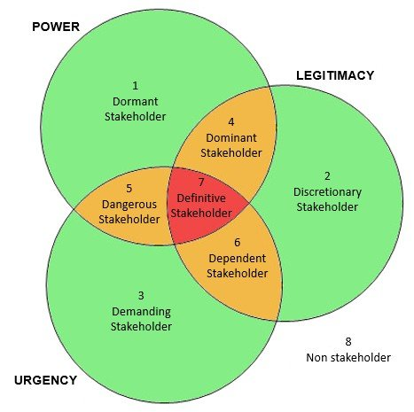
Figure: Silence Stakeholders Analysis Model
Source: Stakeholdermap.com., 2022
This model is classified into 3 sections and these sections contain 7 types of stakeholders.
Latent Stakeholder
- Dormant
These stakeholders have a low level of legitimacy, but a high level of power, and a low level of urgency. Because of their enormous power, they have the potential to affect their project. Therefore, they need cautious administration to be successful. He is not interested in the project that they are working on (Wosahlo, 2014). Despite this, they will continue to keep a close eye on this stakeholder since they occupy a position of influence, and they cannot predict when they may alter their opinion. As such stakeholders have potential, it is wise to keep them in the company. So Post Office should retain this category of stakeholders by providing the mentioned facilities.
- Discretionary:
These stakeholders have a high legitimacy, but their power is low, and their urgency is low as well. Organisations will comply with their demands even though they are not very powerful and they are not very urgent since they are legitimate. For instance, non-governmental organizations (NGOs) and philanthropic organizations fall within the category of discretionary stakeholders (Mok and Shen, 2016). Although they lack authority and an immediate sense of need, they are valid stakeholders. Since such stakeholders do not have much potential, it will not be wise to keep them in the company. So the post office should not provide the mentioned facilities to this category of stakeholders but exclude them from the company and appoint new stakeholders. In that case, priority should be given to the mentioned potential stakeholders.
- Demanding
These stakeholders have a strong sense of urgency, but they have little influence and very little credibility. They often make their voices heard and have the ability to sway the opinions of other stakeholders if their criteria are not satisfied. These many stakeholders are interested in receiving attention. These things need careful management to function properly. Such less trustworthy or untrustworthy stakeholders are dangerous for the company. So Post Office should appoint trusted stakeholders without thinking about such stakeholders.
Expectant Sakheloders
- Dominant
These stakeholders are highly powerful and legitimate, but they are not in a hurry. Since these parties have a legitimate interest in the project that organisations are working on, organisations will take care to handle them carefully. Due to their lack of urgency, they are placed lower on the hierarchy than the core group. Consider the situation where they are creating a system in which the local governments are participants (Pedrosa-Ortega et al., 2019). Due to their authority and reputation, even if they don't raise any urgent issues about their project, they will nevertheless manage them carefully. Such stakeholders should be given adequate training to make them accountable to the company so that they become accountable to the company.
- Dangerous
They are capable of aggressive behaviour and might make their project more difficult to carry out. They are going to handle the management of them very carefully. For instance, let us say that they are doing business in a distant region of a third-world nation. In this scenario, a gang of terrorists from the area may constitute a threat to the organization and should be avoided. All of the employees of their team must remain safe (Sedereviciute and Valentini, 2011). They have a responsibility to identify these stakeholders and take measures to protect against the risks they present. Such stakeholders care a lot about the company. So Post Office should retain this category of stakeholders by providing the mentioned facilities.
- Dependent
Despite having relatively little power, these stakeholders have a strong feeling of legitimacy and urgency. Due to their lack of significant power, they won't give these stakeholders as much attention. People who live in that region can be seen as dependent stakeholders if they are carrying out building work there, for example. Due to the credibility and extreme urgency that these stakeholders provide, they will keep an eye on them. They could organize themselves into a group, or they might connect themselves with influential stakeholders. If their standards are not satisfied, this may put them in a difficult position. Such stakeholders also care a lot about the company. Such stakeholders are the main driving force of a company. They are always dedicated to the company. So Post Office should retain this category of stakeholders by providing the mentioned facilities.
Definitive Stakeholders
- Core Stakeholders
These stakeholders carry a significant amount of influence, and their concerns are of a pressing and legitimate kind. Organisations are going to exercise very careful management over them (Mok and Shen, 2016). This particular classification is often known as the "definitive" category. This category could also include the executive leadership of their company.
According to the analysis, the office employees are the core stakeholders of the company and they need to listen to their employees to run the organisation properly. Because any organisation can not run without the attachment of its core stakeholders. And these employees are the most powerful stakeholders so they deserve attention.

Using the Power Interest Matrix
Arrange the persons on their list of stakeholders in order of their level of interest and influence concerning the project they're working on. It's conceivable that some of them have the power to either thwart or advance their proposal (Olander and Landin, 2015). This is a possibility. Some individuals will likely have a strong interest in what they're doing, while others won't be very bothered by it at all. Both reactions are possible.
Depending on the traditions that are commonly observed inside the company, the team members may see this as an uncomfortable practice. The team's members must be able to have a great deal of confidence in one another. The assistance of a third-party facilitator or expert in this particular field might certainly prove to be helpful. They can maintain objectivity during the whole research and are not involved in the internal politics of the corporation (Maqbool et al., 2015).
High authority individuals have a stronger need to be placated, while high-interest individuals have a greater desire to be taught. More than those in high-interest positions, people in high authority want to be placated. When a stakeholder has both of these qualities, they must carefully control their expectations.
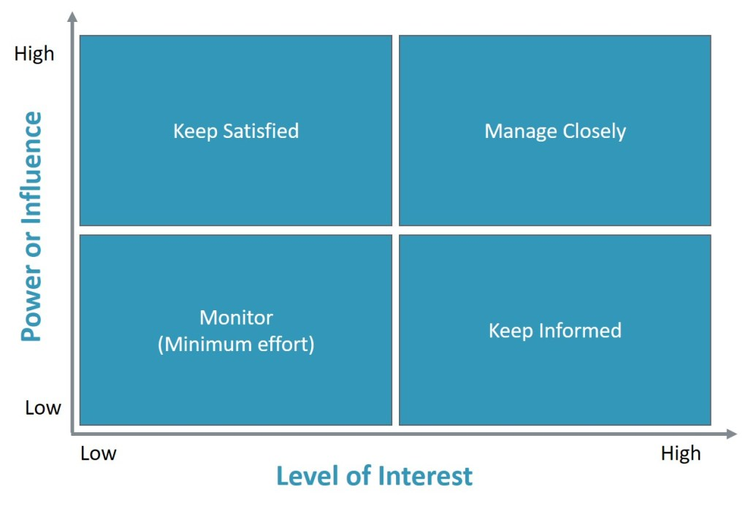
Figure: Stakeholder Management using the Power Interest Matrix
Source: Every, 2022
The diagram above shows the different approaches they should have for the segregated stakeholders.
- High power – High interest: these potential project stakeholders are likely to be decision makers and will have the most significant influence on the outcome of the project. They need to maintain close contact with these stakeholders to successfully manage their expectations (Newcombe, 2013).
- High power – Low Interest: These project stakeholders must be kept abreast of the latest developments about the project. Even though they may not care about the result, they have significant influence. It is important to proceed with caution while interacting with these types of stakeholders because, if they get dissatisfied, they may utilize the authority they possess unfavourably.
- Low power – High interest: Keeping these persons sufficiently informed and communicating with them to make sure that no serious problems are developing is of utmost importance (Winch et al., 2017). These individuals are often able to be of great assistance with the many facets of their project.
- Low power – low interest: keep an eye on these individuals, but avoid using unnecessary time and effort on the excessive conversation.
Employing this analytical tool can help businesses better understand how to spend their time and resources in the most effective ways. To understand where their genuine power rests and how to keep the participation of their most important stakeholders, it is crucial to dedicate a substantial amount of time and attention to strategic planning. They must ensure that they are communicating with them via the proper channels and ways of communication if they want to keep their audience's interest in what they have to offer. Using this method has the disadvantage that, unless they are well acquainted with their stakeholders, they face the danger of incorrectly adding them to their grid. A common cause of the mistake is placing a stakeholder where they should be instead of where they actually should be (Guðlaugsson et al., 2020). This is the reason why it is crucial to know who they are, meet them, interview them, and understand their values and ideas; having this information will assist put them in the appropriate location on the grid, and it will truly give us a clear image of who they should be concentrating on. The post office should first select the stakeholders that are important to their company. And to check the good and bad from among those who are in doubt by observing them closely. Then transfer the responsibility of the company to those whose names remain on the verification list by providing them with the expected benefits. Besides, they should be in regular contact with them and remind them of their responsibility.
According to this model of analysis, the employees of the post office are the high-powered high interest section. Overall company and business performance run on their involvement in the company. So the company new to manage them properly but they are not taking this seriously and not paying employees wages in time so they are on a strike and this is ruining the reputation of the organization.

This is relevant to the case study of the post office strike, according the model analysis. According to the method, these postal workers fall within the high-impact, low-interest stakeholder group. And this approach suggests maintaining the satisfaction of these stakeholders. Therefore, it is essential for the business to maintain these workers' satisfaction in order to provide a certain favourable result.

After the stakeholder analysis, look at how each one relates to or explains each other
Stakeholder theory has been studied extensively, resulting in different schools of thought. The stakeholder theory investigates the interaction between a firm and all the groups involved in its operations or product. Relevant stakeholders could be any person, group, organization, institution, or society (Shahbaz et al., 2018). These many groups of stakeholders often have different goals and sometimes compete. As a result, firm management often makes trade-offs between alternative demands to maximize value. The stakeholder theory doesn't address these trade-offs, leaving it open to criticism. Due to limited time and resources, companies often can't engage and manage all of their stakeholder groups. This hinders firms' success (Wood et al., 2021). As a result, the theoretical framework presented here becomes even less useful. They may define the key stakeholder groups with the use of this framework. The effect of the stakeholder groups might vary from negligible to major depending on the characteristics. Managers should be aware of the organisations or entities that have the potential to affect the firm to meet the legal and moral interests of legitimate stakeholders. Dormant stakeholders do not need to have a formal relationship with the corporation to have power and utilise it for coercion, utilitarian purposes, or symbolic purposes. Some stakeholders call for prompt management engagement and attention because they exhibit all three traits. This paradigm allows for the subdivision of stakeholders into seven different typologies, ranging from dormant stakeholders, who merely have power, to definite stakeholders, who have all three criteria. Each stakeholder group may alter categories depending on the scenario since this framework is flexible (Aaltonen, 2011). A community group, for example, that is a typical dependent stakeholder with legitimacy and urgency, may swiftly transform into a definite stakeholder by securing government backing, if necessary8. A stakeholder is a typical dependent stakeholder if they exhibit all three of these traits (Patrus et al., 2013). The community's relevance seems to be subordinate to all stakeholder groups having higher-priority demands on the organisation, according to the economic situation. More and more prominent community members are joining as non-executive directors (NEDs). Non-executive directors (NEDs) increase independence, which improves corporate accountability (Pedrosa-Ortega et al., 2019). Powerful NEDs have a wealth of knowledge and experience about the organization's impact on the community and the expectations of influential community groups. Because of their knowledge and experience, these NEDs can now highlight the importance of community-prominent NEDs. It's a gross understatement to say that NEDs on company boards may not boost legitimacy. They make it easier for the company to declare the community activities it participates in. This category of non-executive directors (NEDs) must ensure the company engages in sufficient CSR and communicates this to stakeholders through annual reports (Mok and Shen, 2016). This is their most important duty. This is expected to benefit both the business and society. These analysis models have internally connected to the analysis of the basic sake holder and provide them according to importance as needed.
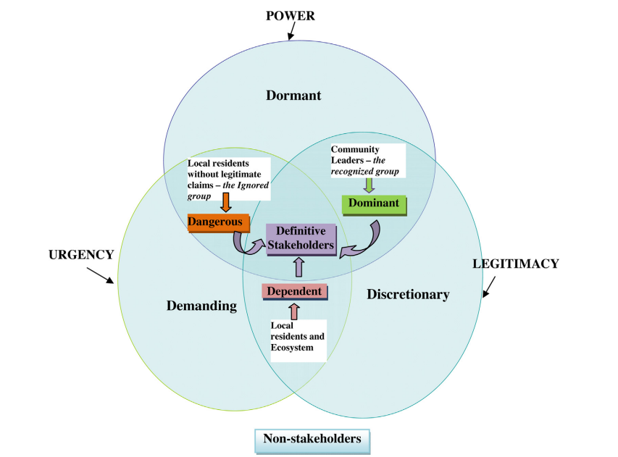
Figure: Stakeholders Analysis and Interconnection
Source: Stakeholdermap.com., 2022
Each of the stakeholders is connected with the other in this case the post office employees are the main stakeholder of the organisation. If they don’t work accordingly the other stakeholder management will be in trouble. So the company need to properly engage these stakeholders with their other stakeholder to get the maximum advantage.
Based on the post office's case study. Government is the primary stakeholder in the post office, and staff and customers are its primary long-term stakeholders in the UK. The UK Post Office network should be owned by a variety of stakeholders, including personnel, customers, and the community, rather than just its workforce. That was the advice from a significant report released today by Co-operatives UK, which has been researching the matter for the UK government. Post Office Ltd., which is currently wholly controlled by the government, runs retail mail, financial, governmental, and telephone services out of around 11,500 branches across the UK. The majority of these branches are privately owned and operated by associates. 1,000 branches are currently administered by mutual organizations, while 373 branches, known as Crown Offices, are controlled by the Post Office. Each branch varies depending on the number of employees and keyholders.

Limitations of the Salience Model
The process of categorizing stakeholders is very subjective. A project manager can consider a stakeholder as "threatening," while another manager can see the same stakeholder as just "demanding." There is a possibility that the culture and values of the project manager may influence how they interact with the stakeholders.
Each of the three traits is classified as either "present" or "absent" in the model. However, these qualities could exist in varied degrees. For instance, depending on which group they belong to, this paradigm views the stakeholders as either having power or not having power (Mok and Shen, 2016). However, the level of authority among the various stakeholders may vary. The project manager will not get any help from this method when comparing one stakeholder to another based on a certain trait shared by the two stakeholders. Does one stakeholder, for example, have more power than the others? This is not even somewhat considered by the Salience Model (Newcombe, 2013). That does not mean that this model is not suitable for stakeholder analysis. Maybe you can't get an accurate information with this. But by using this model, the post office will be able to analyze the sufficient information of its stakeholders. By using this model, the post office will know about the power, legitimacy and seriousness of their stakeholders towards the work.
The approach is predicated on three characteristics: power, legitimacy, and a sense of urgent need. However, there may also be other characteristics that have a role in the connections between stakeholders. This model can not relate to the needs of the stakeholders this is the limitation of this study. So the case gets less beneficial from this study.

Limitations of power interest matrix model Matrix
A framework for resource distribution among numerous business units is provided by the power interest matrix model Matrix, which also makes it possible to compare a large number of other business units. The power interest matrix model matrix does have various limitations, some of which are as follows:
Corporations are assigned to either the low or high categories by the power interest matrix model matrix, however, generally speaking, companies may also be assigned to the medium group. As a consequence, the business may not adequately portray its true nature (Maqbool et al., 2015). There is a lot of subjectivity involved in making the difference between high and low.
The use of power interest matrix model analysis is not capable of assisting managers in taking into consideration synergies that may or may not exist between the numerous SBUs that make up the product portfolio (Сherepovitsyn et al., 2019).
This model can not analyse the position of the post office employees and also cannot provide the range of high and low power. So this model can not analyse the case study effectively. So, in this case, Post Office should not explore power and position through this model. Through this model, the high and low range must be determined in advance if the stakeholders' power is to be allocated accurately.

Question-3
Conflicts between employees and their colleagues are not uncommon in the workplace. Personal differences between coworkers may sometimes lead to friction that has to be resolved. In addition, there is a possibility of task-related conflicts resulting from either the leadership or the policies of the firm. In any event, finding solutions to disagreements that arise in the workplace is an essential task. Conflicts in the workplace are not desired for several reasons, including the performance of the firm and the well-being of individuals (Kantek and Kartal, 2015). To find a solution to the disputes that arise in the workplace, let's have a look at the Thomas Kilmann Conflict Model.

The Thomas Kilmann Conflict Model
Thomas and Kilmann's Conflict Model is a clever and practical method for studying conflict resolution. Conflict resolution is a crucial litmus test for managerial skills since people find it to be agonising. Individuals respond in several ways to conflict. Thomas and Kilmann investigated how people settle disputes. They derived a lot of inspiration and ideas from people's everyday activities. They discovered that most people utilise one of the five tactics to try to settle interpersonal disputes (Thompson, 2019). Kenneth Thomas and Ralph Kilmann developed a framework employing these five methods. The Thomas-Kilmann Conflict Mode Instrument, sometimes referred to as the TKI, was created in 1974.
However, before they go into the specifics of TKI, let's get the basics down. To begin, the TKI presents information about the two aspects of conflict management. Consider them to be two different avenues that they may pursue. They may choose to resolve the disagreement by either being forceful or cooperative with the other party (Schaubhut, 2018). This model can help the employees and management to fix their conflicts between them. By applying the theory of the model the company can create an effective way to fix their problem and end the conflict.

Two Differing Approaches
Two "dimensions" or conflict-resolution techniques are possible, according to the Thomas Kilman Conflict Model. These tactics are essentially various ways to deal with the tension already present in the situation (Jolanta, 2015). Each individual is free to choose whether they wish to approach the matter cooperatively or aggressively.
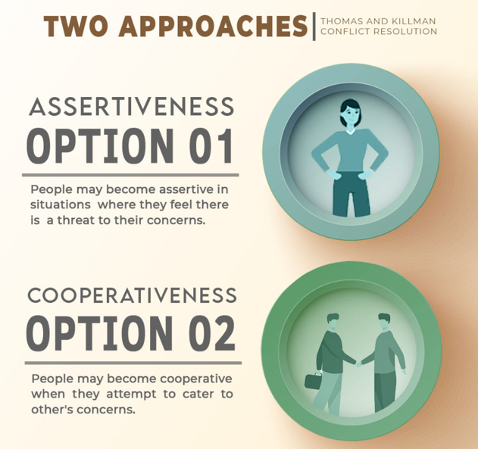
Figure: Two Differing Approaches
Source: Mishra, 2022
People have the potential to become more forceful in circumstances in which they believe there is a danger to their concerns. On the other side, they could become more cooperative when they make an effort to address the problems of others (Thomas, 2015). These dimensions provide us with a viewpoint that allows us to better comprehend the five different approaches to conflict management. Lastly, it is important to point out that T&K has underlined that there is no better strategy, and this should be recognized. The method that a manager takes should be determined by the circumstances (Henjewele et al., 2013). For the case study, the best situation for the company is to make cooperate with their employees and start their service as soon as possible. So option two may be the best fit for the situation of post office employees.

The Five Models to the Management of Conflict
Thomas Kilmann's conflict model teaches us that there are five distinct approaches to resolve disputes, which is the most significant lesson to take away. These modes may be divided into two dimensions, also known as approaches, as was previously stated (Thomas, 2019). Let's first arrange them on a chart to observe how they appear. This will make it simpler for them to comprehend the model. They will examine each of these modes in more detail in the next section.
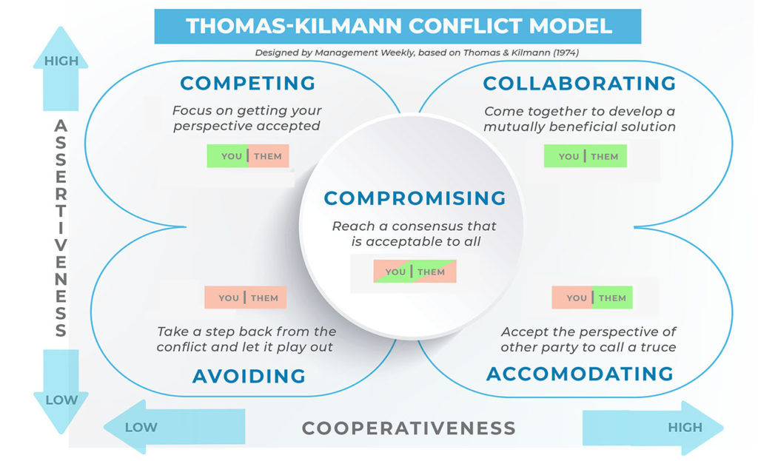
Figure: The Five Models for the Management of Conflict
Source: Managementweekly.org., 2022
Competing
In the upper left corner of the chart, they see aggressiveness at a high level but collaboration at a low level. There is competition right here at this location (Kardashina and Shangina, 2016). When they turn to be aggressive, this indicates that they utilize the approach of 'competing' as a way of resolving conflicts. In addition to this, they stop cooperating with the party that they are fighting against. However, despite its seemingly nefarious nature, this tactic is rather harmless. When they are in a position of more authority and need a resolution to a problem quickly, they might consider switching to this model (Caputo, 2013). When they are forced to make difficult decisions, it is also essential that they adopt this method.
Avoiding
The avoidance approach is a manifestation of passive conflict management. Despite this, if they were to evaluate the situation objectively, they would all agree that they should address the problems head-on. However, those of us who had the most confidence would have approached situations when avoiding confrontation was preferred (Thomas, 2018). Additionally, some concerns are so little that people shouldn't spend their time focusing on them.
To be successful, this tactic requires avoiding conflict and keeping one's opinions and emotions to oneself. People also choose this tactic when the price of facing the problem and solving it is much greater than the price of tolerating the dispute (De Madariaga and Valor, 2007). But putting off the problem will not make it go away. However, all it does is bury the issue even farther, which might lead to further disagreements down the road.
Accommodating
Now, they are making strides toward reaching agreements via techniques that are less contentious as time goes on. Their accommodating mode may be so mindful of the other side that they're willing to call a ceasefire even if it means giving up their position in the conflict in exchange for peace. It may be beneficial under circumstances in which the dispute would be a complete and utter waste of their time (Fujita, 2018).
This model is characterized by a high level of cooperativeness and a low level of assertiveness, according to the Thomas and Kilmann Conflict Model. they compromise their position to ensure the satisfaction of the opposing side.
Collaborating
When they and the other person are on the same page about how to resolve the problem, they use the collaborative approach to conflict resolution. This is the best possible solution. It takes place when both sides are reasonable, has comparable power and authority, and are willing to cooperate. This is made much simpler by the decentralized nature of the organization.
In most situations, the first step is a comprehensive conversation. they must have an understanding of each other's points of view (Koley and Rao, 2018). This results in a more in-depth examination of the current predicament. In addition to this, they make an effort to comprehend one another's prerequisites. At long last, the office management has arrived at a resolution from which all sides may potentially gain.
Compromising
They have finally reached the metaphorical middle ground in the Thomas Kilmann Conflict Model. Their behaviour is represented by the centre of the chart, where they exhibit a mix of moderate forcefulness and cooperativeness. There are several situations when they probably don't want a drawn-out resolution. Time is necessary when collaborating (Riasi and Asadzadeh, 2015). Additionally, there are situations when people want to take a stand but do not want to seem too aggressive.
As the employees are the basic stakeholders of the company so they must keep their employees satisfied and move forward by compromising with their employees.
Through this model, the Post Office will examine the relationship between its employees. That is, the post office employees, i.e. its stakeholders, will determine how they maintain relations among themselves. They will check whether they have clashed with each other on any internal issues. Moreover, this conflict may also be due to personal reasons between their colleagues. However, this model will verify whether there is any personal enmity between them. In that case, the post office can monitor the movements of their stakeholders. It can also be considered by looking at how they are talking to each other or whether someone is helping someone or not. Moreover, co-workers do their work by helping each other. So the post office will take care that they are collaborating properly with one colleague or not. Moreover, when they sit in a monthly or weekly meeting, they have to consider how they are receiving each other. It should be seen whether one is avoiding the other or not. Besides, it should be noted whether there are any compromising issues between them. For example, if someone misbehaves with someone, then the post office has to see how the other person is reacting to it. If the opposite takes it naturally and forgives the colleague, it means that the relationship between them is good. Otherwise, if someone does not compromise, then it should be understood that the relationship between them is not right. In this way, the post office will verify the relationship between their stakeholders. What each of these elements indicates has been discussed in the previous section.

Recommendation
According to the resolution approach according to the model, the most relevant strategy to solve the problem may be collaborating with the employees. As the employees are on a strike because not getting enough wage timely. So this is a very crucial stage for the company to take the decision. They can collaborate with their employees and discuss with them to solve the problem this can help the company to solve the problem as soon as possible. If they start an agreement with employees and take some time to fix the problem then this will be helpful for the company. If this situation starts and goes on then the companies may face lots of losses both profit and reputation.
They also can think about the compromising process, in this process the company can simply agree with all of the demands and get back to their job. This is the easiest way to tackle any kind of situation here. But this may not be that much profitable for the company.

Conclusion
This assignment discusses the different stakeholders of the company and its organizational framework. Stakeholders are the main key to any kind of organization or business. The company need proper care and nursing to make sure their business goes well according to their plan. But if any stakeholders get offended or do not get enough attention then they may quit the business and the organisation may fall into difficulties. According to the scene, the 114 Crown Post Offices and 11,500 sub-post offices in the UK will be closed for 24 hours. CWU members are upset about a pay freeze in 2021-22 and a 2% raise the following year. Different models and frameworks are discussed here and proper recommendation according to the scenario is provided.

References
Aaltonen, K., 2011. Project stakeholder analysis as an environmental interpretation process. International journal of project management, 29(2), pp.165-183.
Caputo, A., 2013. Systemic stakeholders’ management for real estate development projects. Global Business and Management Research: An International Journal.
De Madariaga, J.G. and Valor, C., 2007. Stakeholders management systems: Empirical insights from relationship marketing and market orientation perspectives. Journal of Business Ethics, 71(4), pp.425-439.
Drezner, D. and Farrell, H., 2014. The power and politics of blogs. American Political Science Association.
Every, P., 2022. Stakeholder Management using the Power Interest Matrix - Solitaire Consulting Limited. [online] Solitaire Consulting Limited. Available at: <https://www.solitaireconsulting.com/2020/07/stakeholder-management-using-the-power-interest-matrix/> [Accessed 29 June 2022].
Fageha, M.K. and Aibinu, A.A., 2013. Managing project scope definition to improve stakeholders’ participation and enhance project outcome. Procedia-Social and Behavioral Sciences, 74, pp.154-164.
Farrell, H. and Drezner, D.W., 2018. The power and politics of blogs. Public Choice, 134(1), pp.15-30.
Fujita, K., 2018. Compromising Adjustment Strategy Based on TKI Conflict Mode for Multi‐Times Bilateral Closed Negotiations. Computational Intelligence, 34(1), pp.85-103.
Guðlaugsson, B., Fazeli, R., Gunnarsdóttir, I., Davidsdottir, B. and Stefansson, G., 2020. Classification of stakeholders of sustainable energy development in Iceland: Utilizing a power-interest matrix and fuzzy logic theory. Energy for Sustainable Development, 57, pp.168-188.
Henjewele, C., Fewings, P. and Rwelamila, P.D., 2013. De-marginalising the public in PPP projects through multi-stakeholders management. Journal of Financial Management of Property and Construction.
Jolanta, M.A.J., 2015. Diversity management’s stakeholders and stakeholders management. In Proceedings of the 9th International Management Conference" Management and Innovation For Competitive Advantage", Bucarest (pp. 780-793).
Kantek, F. and Kartal, H., 2015. Conflict management in student nurses: a systematic review. Journal of educational and instructional studies in the world, 5, pp.62-67.
Kardashina, S.V. and Shangina, N.V., 2016. Psychometric characteristics of the Russian version of the Thomas-Kilmann questionnaire («Thomas-Kilmann conflict mode instrument-TKI-R»). Pedagogical Education in Russia, 11, pp.216-228.
Kelada, J.N., 2015. Stakeholders management: A total quality approach. In ASQ World Conference on Quality and Improvement Proceedings (p. 448). American Society for Quality.
Koley, G. and Rao, S., 2018, October. Adaptive human-agent multi-issue bilateral negotiation using the Thomas-Kilmann conflict mode instrument. In 2018 IEEE/ACM 22nd International Symposium on Distributed Simulation and Real-Time Applications (DS-RT) (pp. 1-5). IEEE.
Managementweekly.org. 2022. [online] Available at: <https://managementweekly.org/wp-content/uploads/2021/05/main-TKI-model-720-1024x623.jpg> [Accessed 29 June 2022].
Maqbool, R., Rashid, Y. and Ashfaq, S., 2022. Renewable energy project success: Internal versus external stakeholders' satisfaction and influences of the power‐interest matrix. Sustainable Development.
Mishra, A., 2022. Thomas Kilmann Conflict Model. [online] Management Weekly. Available at: <https://managementweekly.org/thomas-kilmann-conflict-resolution-model/> [Accessed 29 June 2022].
Mok, M.K. and Shen, G.Q., 2016. A network-theory-based model for stakeholder analysis in major construction projects. Procedia Engineering, 164, pp.292-298.
Newcombe, R., 2013. From client to project stakeholders: a stakeholder mapping approach. Construction management and economics, 21(8), pp.841-848.
Olander, S. and Landin, A., 2015. Evaluation of stakeholder influence in the implementation of construction projects. International journal of project management, 23(4), pp.321-328.
Patrus, R., Carvalho Neto, A.M.D., Coelho, H.M.Q. and Teodósio, A.D.S.D.S., 2013. Corporate Social Responsibility and labor relations: a research agenda about internal stakeholders management in UN’s global compact signatory corporations. Revista Brasileira de Gestão de Negócios, 15, pp.22-38.
Pedrosa-Ortega, C., Hernández-Ortiz, M.J., García-Martí, E. and Vallejo-Martos, M.C., 2019. The stakeholder salience model revisited: Evidence from Agri-food cooperatives in Spain. Sustainability, 11(3), p.574.
Riasi, A. and Asadzadeh, N., 2015. The relationship between principals’ reward power and their conflict management styles is based on Thomas–Kilmann conflict mode instrument. Management Science Letters, 5(6), pp.611-618.
Schaubhut, N.A., 2018. Technical brief for the Thomas-Kilmann conflict mode instrument description of the updated normative sample and implications for use CPP research department. 2007. TKI_ Technical_Brief. pdf (Accessed on 5 April 2018).
Sedereviciute, K. and Valentini, C., 2011. Towards a more holistic stakeholder analysis approach. Mapping known and undiscovered stakeholders from social media. International Journal of Strategic Communication, 5(4), pp.221-239.
Shahbaz, M.S., Chandio, A.F., Oad, M., Ahmed, A. and Ullah, R., 2018. Stakeholders' management approaches in the construction supply chain: A new perspective of Stakeholder's theory. International Journal of Sustainable Construction Engineering and Technology, 9(2), pp.16-25.
Silva, L., 2017. Epistemological and theoretical challenges for studying power and politics in information systems. Information Systems Journal, 17(2), pp.165-183.
Sowmya, K.R. and Panchanatham, N., 2011. The organisational politics-behavioural intention of bank employees. The Journal of Commerce, 3(1), p.8.
Stakeholdermap.com. 2022. [online] Available at: <https://www.stakeholdermap.com/stakeholder-analysis/stakeholder-salience.jpg> [Accessed 29 June 2022].
Thomas, K.W., 2015. An overview of the Thomas-Kilmann conflict mode instrument.
Thomas, K.W., 2018. An overview of the Thomas-Kilmann conflict mode instrument (TKI). Retrieved June, 3.
Thomas, K.W., 2019. Thomas-Kilmann Conflict Mode Instrument: Profile and Interpretive Report. 2010.
Thompson, I., 2019. Thomas–Kilmann Conflict Mode Instrument. In The Procurement Models Handbook (pp. 122-124). Routledge.
Winch, G.M., Morris, P. and Pinto, J., 2017. Managing project stakeholders. The Wiley guide to project, program, and portfolio management, pp.271-289.
Wood, D.J., Mitchell, R.K., Agle, B.R. and Bryan, L.M., 2021. Stakeholder identification and salience after 20 years: Progress, problems, and prospects. Business & Society, 60(1), pp.196-245.
Wosahlo, P., 2014. An analysis of the implementation of palliative rehabilitation in five UK hospices using the Stakeholder Salience Model. Progress in Palliative Care, 22(6), pp.342-346.
Сherepovitsyn, A.E., Ilinova, A.A. and Evseeva, O.O., 2019. Stakeholders management of carbon sequestration project in the state–business–society system. Записки Горного института, 240, pp.731-742.

