Welsh Legislation and Policy - (ALN)  The Welsh Government prioritises early identification and support for autistic children, guided by legislation promoting equity, inclusion, and wellbeing (Welsh Government, 2016).  Additional Learning Needs and Education Tribunal (Wales) Act 2018: Introduced a unified, person-centred ALN system for ages 0–25, replacing the SEN model and supporting Individual Development Plans (IDPs) (Welsh Government, 2018).  ALN Code for Wales (2021): Statutory guidance encouraging collaboration between professionals, families, and educators.  Equality Act (2010) & Education Act (1996): Mandate reasonable adjustments and support for learners with additional needs.  Curriculum for Wales (2022): Supports adaptive teaching and views all learners as ambitious, capable, and confident.  Social Services and Well-being (Wales) Act 2014: Requires person-centred care and assessments by local authorities.  Mental Health Acts (1983, amended 1997) & NHS Act (2006): Ensure access to suitable health and mental health support.  Well-being of Future Generations Act (2015): Promotes early intervention, reducing inequality, and long-term planning.  UNCRC & Children’s Rights Measure (2011): Oblige Welsh Ministers to uphold children’s rights in policy decisions.  Estyn: Inspects inclusion and early years education (Estyn, 2022)  .  Care Inspectorate Wales (CIW): Regulates childcare settings to meet legal and ethical standards (Care Inspectorate Wales, 2022).  Code of Practice on the Delivery of Autism Services in Wales: Outlines the duties of local authorities, health boards, NHS trusts, and Regional Partnership Boards, developed with input from autistic individuals, families, carers, and service providers (Welsh Government, 2021).  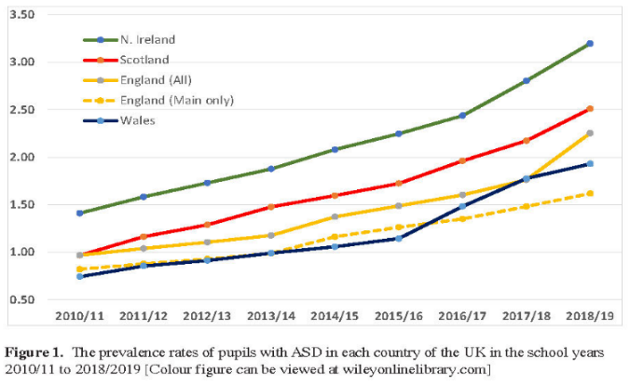  Source: McConkey (2020)
  Introduction to ASD
  Autism Spectrum Disorder (ASD) is a lifelong neurodevelopmental condition that varies widely between individuals, affecting how they perceive the world and interact socially (Alsayouf et al., 2022; National Autistic Society, 2024). ASD includes former separate diagnoses such as Asperger’s syndrome and pervasive developmental disorder (Alsayouf et al., 2021). Core traits include social communication difficulties, repetitive behaviours, focused interests, and atypical sensory responses (American Psychiatric Association, 2013). The term "autism" was first coined by Bleuler in 1911 and later defined by Kanner in 1943 as the condition known today as ASD (Blatt, 2025; Silverman, 2012). It affects roughly 1 in 59 children and is more common in boys (Centres for Disease Control and Prevention, 2018). In the UK, autism diagnoses rose by 787% between 1998 and 2018 (Office for National Statistics, 2021).
  Signs and Symptoms of ASD
  Young children with (ASD) often exhibit challenges in social communication, such as delays in speech development and difficulty interpreting social cues, including eye contact and body language (National Autistic Society, 2024). Many children with ASD also engage in repetitive behaviours like hand-flapping or rocking, showing a strong focus on particular interests or objects, sometimes to the exclusion of other activities (Autism Anglia, 2024). They may also have heightened sensory sensitivities, reacting intensely to sounds or becoming upset by specific textures (NHS, 2022). In addition, children with ASD often resist changes to their routines and have trouble managing their emotions, which can result in meltdowns when they feel frustrated or overwhelmed (Snap Cymru, 2024). ASD can be diagnosed as early as 18 months; however, most children are identified after age three (Autism Wales, 2024). People diagnosed with ASD frequently experience additional mental health conditions, such as anxiety, attention-deficit/hyperactivity disorder (ADHD), obsessive-compulsive disorder (OCD), mood disorders, and other types of disruptive behaviour disorders (Gadow et al., 2018; Gotham et al., 2020).
  Diagnosing ASD
  Diagnosing Autism Spectrum Disorder (ASD) in children involves gathering detailed developmental histories from parents or caregivers and observing the child's behaviour by healthcare professionals (NICE, 2021). (NICE, 2021) provide guidelines that recommend assessments based on the diagnostic criteria outlined in the Diagnostic and Statistical Manual of Mental Disorders, 5th Edition (DSM-5) and the International Classification of Diseases, 11th Revision (ICD-11) (NICE, 2021). These assessments should include a comprehensive evaluation of the child’s social communication skills, behaviours, and medical history (American Psychiatric Association, 2013; WHO, 2022). The process considers cultural factors and the possibility of under-recognition, particularly in groups such as girls or children with learning disabilities (NICE, 2021). The guidelines emphasise the importance of a multi-source approach, ensuring that the diagnosis is accurate and clinically relevant
  (NICE, 2021)
  ASD Barriers and impacts on Children and Families
  Many children with ASD face significant barriers in mainstream education, including sensory sensitivities, social interaction difficulties, and emotional distress (Hasson et al., 2022; Catalyst Group, 2023; McDougal, Riby & Hanley, 2020). They often struggle with interpreting social cues, maintaining eye contact, and engaging in conversation (Cheng, 2024; Naznin et al., 2023). Stigma and misunderstandings about ASD further intensify these challenges (Simón et al., 2023). Executive functioning difficulties and anxiety around transitions also affect learning, while conventional teaching methods may not meet their needs (Holmes, 2024). Behavioural issues like meltdowns can disrupt learning, and a lack of tailored support worsens outcomes (Holmes, 2024; Frontiers in Psychology, 2022). Families often face delayed diagnoses, limited services, financial strain, and difficulty accessing education support (National Autistic Society, 2023; Crane et al., 2016; Sharpe & Baker, 2007), contributing to caregiver stress and anxiety (Hayes & Watson, 2013; O'Nions et al., 2014).
  Support Strategy for children with ASD
  The Attention Autism Programme is an evidence-based intervention designed to enhance communication and attention skills in children with ASD. The programme focuses on engagement, attention, and communication, adapting to the learning styles of autistic and neurodivergent children (Davies, n.d.; Just One Norfolk, n.d.). The programme consists of four stages, each aimed at fostering attention and communication skills (Toppelberg et al., 2020). Research suggests that children with ASD, especially those with limited social communication, benefit from the intervention, as it uses motivating, visually stimulating activities to capture attention (Harris et al., 2017). A pilot study by occupational therapists found that training in Attention Autism increased confidence in establishing rapport and engagement (Emerald Publishing, 2023). Additionally, the National Autistic Society (2021) reported improvements in social communication and joint attention in young children with ASD., Attention Autism remains widely implemented in Early Years settings, schools, and therapy programs (Davies, n.d.; Just One Norfolk, n.d.).
  
  Source, Explore your Senses, (2024)
  Inclusion and inclusive practice
  Inclusion in early years education involves recognising and addressing the systemic, attitudinal, and physical barriers that some individuals face due to their personal circumstances (Early Years Alliance, 2019; Early Years Alliance, n.d.). Discrimination may appear through behaviours, resources, or underlying beliefs (Louis et al., 2023:96). Inclusive practice means removing barriers to learning so all children, including those with ASD, can fully participate. This requires flexible teaching, responsive communication, and supportive environments (Florian & Black-Hawkins, 2011). Birth to 5 Matters (2022) highlights inclusion as an ongoing process of identifying and overcoming barriers, valuing children’s diverse expressions, and adapting practice to meet individual needs.
Question 1
Does an ASD diagnosis in a child automatically result in an identification of ALN in the Early Years?
According to ALNET (2018) and the Equality Act (2010). there are two tests to determine if a child has ALN. The first test assesses whether a child has a learning difficulty or disability, possibly linked to a medical condition, by determining if they face greater learning challenges than their peers or have a disability, as defined by the Equality Act (2010), that limits their access to typical educational resources (Equality Act, 2010; ALNET Act, 2018) The second test evaluates if the child requires Additional Learning Provision (ALP), which may include support inside or outside the classroom or from external professionals. If ALP is necessary, the child is considered to have ALN under both the Equality Act (2010) and the Additional Learning Needs and Education Tribunal (Wales) Act 2018 (Equality Act, 2010; ALNET Act, 2018).

Question 2
Could you provide an example of how Early Years settings can foster inclusive practice for children with ASD?
A multisensory approach to learning benefits young children with autism by improving communication, social skills, and cognitive development. By engaging multiple senses, it supports language development, memory, and emotional regulation while encouraging peer interaction and fostering inclusion in learning environments (Advanced Autism, 2024; Autism Toolbox, 2024). Rooted in Gardner’s theory of multiple intelligences, this approach caters to individual strengths and enhances overall learning outcomes (Advanced Autism, 2024).

