ACBA5010
Client letter and draft BEP
By Ben Kneeshaw
SN: 1902457

Civic Centre
Oystermouth road
Swansea
SA2 3SN

To whomever this may concern

The following letter and appended BEP (BIM execution plan) outline the processes to be used to ensure the proposed infant school is completed to the required standard of ‘BIM level 2’. This is a joint venture with the welsh government and will also meet the standards designated under the ‘21st century schools’ programme.
BIM is a process for information management, aimed at ensuring effective collaboration from the design stage through to handover and operation. All government funded projects in the UK are required to be completed to a minimum of BIM level 2 (McPartland, 2014). This involves thinking of the building as an asset, as opposed to a project, with suitable documents produced to allow it to be managed as such (BSI, 2019).
McPartland (2014) states that for a project to be certified as BIM level 2 it must comply with the following conditions:
- Mixture of 3D models and 2D drawings, with CAD standards in line with BS 1192:2007.
- Data sharing carried out via a CDE (Common data environment).
- Individual roles and responsibilities agreed upon.
- Adoption of appropriate naming conventions.
- Arrangements in place in order to create and maintain project specific codes and spatial co-ordination.
- Information shared between all members of the project team (via CDE).
- Suitable information hierarchy supporting the concepts of the CDE and document repository.
- An information sharing process (via CDE) specific to the project, allowing coordination between project participants and various systems.
- All CAD/modelling software to be exportable to one of the common file formats (such as revizto).

A diagram illustrating the different levels of BIM and the subsequent requirements is included overleaf for further reference.
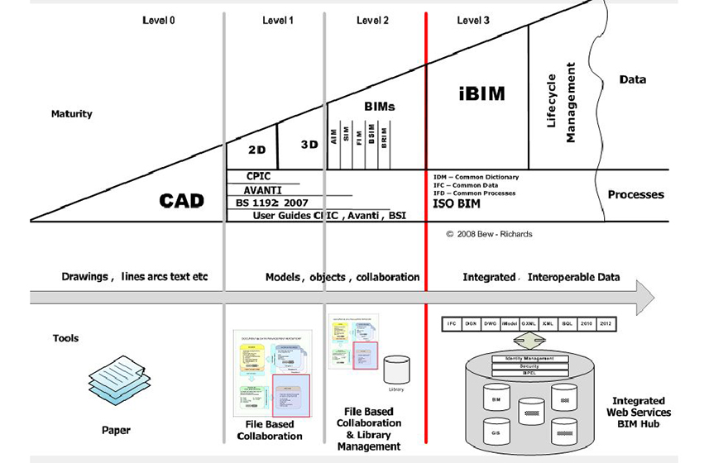
Figure 1: BIM wedge ‘Richard Bews Wedge’ (Tekla, 2021)

Continue overleaf for the appended ‘BIM execution plan’, please be aware this is a draft document and may be subject to change.

Yours sincerely,
Ben Kneeshaw
Lead consultant for ‘Ysgol Bae Abertawe’ project

5010-UWTSD-XX-XX-SP-W-0001-BEP-S0-A

BIM Execution Plan

5010 – ‘Ysgol Bae Abertawe’ Infant school

Table of contents

1. Introduction ………………………………………………………………… Page 5
1.2 Project information ……………………………………………………… Page 5
1.3 Common data environment (CDE) ……………………….…………… Page 5
2. Management ……………………………………………………………….. Pages 6-8
2.1 Individual responsibilities………………………………………………. Page 6-7
2.1.1 Client ………………………………………………….…………………. Page 6
2.1.2 Client’s representative ……………………………….………………. Page 6
2.1.3 Facilities (Asset) manager ……………………………….………….. Page 6
2.1.4 Main contractor ……………………………………………….…….…. Page 6
2.1.5 Consultant task teams ……………………….……….……………… Page 6
2.1.6 Subcontractors/specialists ……………………….…………………. Page 7
2.2 Information management……………………………….………………. Pages 7-8
2.2.1 Organisational information requirements (OIR) …….…………… Page 7
2.2.2 Asset information requirements (AIR) ………….…………………. Page 8
2.2.3 Project information requirements (PIR) ………….……………….. Page 8
2.2.4 Exchange information requirements (EIR) ………….…….…….... Page 8
2.2.5 Project information model (PIM) ……………………….…….…...... Page 8
2.2.6 Asset information model (AIM) ………………….…...…….…….… Page 8
3. Planning and documentation …………………………….….…………. Pages 9-10
3.1 Capability and capacity review…………………….………..………… Page 9
3.2 Task information delivery plan (TIDP) ……………………………... Pages 9-10
3.3 Master information delivery plan (MIDP) ………………………….. Page 10
3.4 Responsibility matrix …………………………………………………. Page 10
4. Standards, methods and procedures ……………………………….. Pages 11-12
4.1 Federation strategy ………………………………………….………… Page 11
4.1.1 Volume strategy ……………………………………….…………….. Page 11
4.1.2 Spatial strategy ………………………………………….…………... Page 11
4.1.3 Units and measurement ……………………………….…………… Page 11
4.2 File naming conventions …………………………….………………. Page 12
5. IT solutions ………………………………………………….…………… Page 13
5.1 2D/3D/4D modelling …………………………………….…………….. Page 13
5.2 Document production …………………………………….………….. Page 13
5.3 Collaborative working ……………………….………….……………. Page 13
6. Closing statement ………………………………………….…………… Page 14

Introduction

The contents of this document outline the processes in place to ensure the proposed project meets the requirements of BIM level 2.

Project information

The project is a 90 pupil infant school proposed for the Swansea marina area. Named ‘Ysgol Bae Abertawe’, it is to be built by the city council in tandem with the Welsh assembly under the ‘21st century schools’ programme. It will be single storey and comply with the guidelines set out by the ‘21st century schools’ programme for area usage and recommended room size.

Common data environment (CDE)

In order for effective collaboration between all parties a CDE is required. This will allow both structured and unstructured information to be deposited into a ‘project information model’ (PIM) and an ‘asset information model’ (AIM) (BSI, 2019, clause 4.1). Through use of correct ‘information management processes’ (such as correct naming conventions) a CDE allows effective file sharing from project start to finish, culminating in an effective AIM for handover to the client. For this project the CDE to be used will be ‘Revizto 5’.

Management

Individual responsibilities

Successful implementation of BIM requires stakeholders to perform their roles and responsibilities as outlined in this section.

Client

The client will be informed of BIM processes, providing support to the project team to meet key BIM objectives. It is the responsibility of the client to provide their information requirements at the outset (BSI, 2019, clause 5.1), this will ensure all requirements are met for the project.

Client’s representative

It is the client’s representative’s duty to authorise information exchanges at any key decision points for the client.

Facilities (Asset) manager

It is the ‘Asset manager’s role to provide clarity and feedback on any AIM deliverables specified by the client (BSI, 2019, clause 5.1). This will ensure AIM objectives are delivered effectively.

Main contractor

It is the main contractor’s duty to act as ‘project information manager’ and project fulfilment manager’, managing the PIM throughout the design and build phase of works (BSI, 2019, clause 5.1). This will be used to produce an AIM for handover to the client upon completion of works.

Consultant task teams

Individual consultants shall adhere to the specifications in this document and are collectively responsible for the PIM during their contracted phase, as they will contribute towards it (BSI, 2019, clause 5.1).

Subcontractors/Specialists

The responsibilities of subcontractors/specialists are the same as that of consultants.

Information management

All project/asset information will be managed in accordance with the relevant ISO standards (BS EN ISO 19650-1:2018). This involves all information requirements being taken into account and used to produce a PIM during the design and construction phase, ultimately culminating in an AIM for handover to the client upon completion. A diagram detailing this process is included in figure 1.
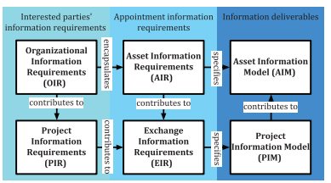
Figure 1: Hierarchy of information requirements (BSI, 2019, Figure 2)

Organisational information requirements (OIR)

These are the information requirements set out by the client’s organisation, often consisting of information needed to satisfy high-level strategic objectives of the client (BSI, 2019, clause 5.2). The client should express these requirements at the outset.

Asset information requirements (AIR)

These are the information requirements of the asset. The AIR will satisfy the requirements of the OIR whilst encapsulating any additional requirements of the main contractor (BSI, 2019, clause 5.3). This will culminate in a coherent set of requirements to be used as the basis for the AIM provided at handover.

Project information requirements (PIR)

These are the information requirements for the project. The PIR can be defined as the information needed to inform or answer any of the client’s strategic objectives during the design and build phase (BSI, 2019, clause 5.4). These will contribute heavily to the EIR.

Exchange information requirements (EIR)

These are the requirements for information exchange. These define the information required for exchange at certain points in the project, often at the completion point of various critical stages (BSI, 2019, clause 5.5). These help specify the PIM as it will be the PIM that this information is pulled from for exchange with the client.

Project information model (PIM)

The PIM is a model designed to assist the team during the design and build phase of works. It will be built up by: the main contractor, subcontractors and relevant consultants. Its function is providing construction and design related information such as: construction methods, costing, scheduling etc. (BSI, 2019, clause 5.7). It will eventually contribute some information to the AIM but some will be unnecessary after completion of works, however this should still be kept on file for future audits.

Asset information model (AIM)

The AIM is a model designed to support day-to-day asset management as specified by the client (BSI, 2019, clause 5.6). This will consist of all AIR and some information drawn from the PIM. This will include information such as: equipment records, maintenance dates and maintenance costs. This will be provided to the client at handover.

3. Planning and documentation

Effective planning and documentation is crucial to successful implementation of BIM and will therefore be present at all stages of works.

3.1 Capability and capacity review

In order to ensure BIM level 2 for the project, all subcontractors, consultants and specialists involved in the delivery team will be subject to a review of their capability and capacity to deliver this level of BIM. This will ensure the prospective delivery team are capable of meeting the information requirements for the project (BSI, 2019, Clause 8.1).
The review will take the form of ‘BIM capability assessments’, sent to all prospective members of the delivery team. BSI (2019, clause 8.2) state this review should contain/assess the following:
- Commitment to comply with the relevant ISO standards and the information requirements of the project.
- Ability to work collaboratively, including experience level in container-based collaborative working.
- Access to and experience of the information technologies required for the project, as defined by the information requirements.
- The quantity of suitably experienced personnel available to work on the proposed asset or project tasks.
Only those who complete this review to the required standard will be allowed involvement in the proposed project. This review can be undertaken by either the client or main contractor (BSI, 2019, Clause 8.1), in this case it will be the responsibility of the main contractor.

3.2 Task information delivery plan (TIDP)

Each task team involved in the delivery team will be required to produce a TIDP; these will ensure deliverables are completed to the appropriate time frame as defined by the information requirements. BSI (2019, clause 10.1) cite these should include the following:
- How information will meet requirements defined by the EIR or AIR.
- When information will be delivered.
- How information will be delivered.
- How information will be co-ordinated with other relevant information.
- What information will be delivered.
- Who is responsible for information delivery.
- Who the intended recipient will be.

3.3 Master information delivery plan (MIDP)

Alongside the TIDP’s the main contractor will produce a MIDP. This will encompass the TIDP’s produced and form the main plan for information deliverables and delivery, helping to form the PIM. It will follow the same standards as the aforementioned TIDP’s (Clause 10.1 of ‘BS EN ISO 19650-1:2018’).

3.4 Responsibility matrix

A responsibility matrix will be produced as part of the delivery planning process. BSI (2019, Clause 10.3) state this should outline: information management functions, project or asset information management tasks and information deliverables. Essentially, this will allow each part of the delivery team to understand the responsibilities that themselves and other team members are allocated as part of the project.

4. Standards, methods and procedures

The methods and procedures outlined in this chapter are designed to ensure the collaborative work on the PIM is sufficient to meet the demands of BIM level 2.

4.1 Federation strategy

The federation strategy helps plan the information production of various task teams, defining the information containers required from each team for successful implementation into the CDE (BSI, 2019, Clause 10.4). It encompasses a number of strategies designed to ensure each team is operating within the same geometric and spatial parameters, allowing for effective population of the CDE.

4.1.1 Volume strategy

A coherent volume strategy is crucial to ensure 3D spatial constraints are adhered to by all disciplines. As such, this will be developed prior to model population, helping to eliminate risks of clashing in the CDE. BSI (2019, clause 11.1) state that issues in the information model should be avoided during production rather than identified after, an effective volume strategy will help this become a reality.

4.1.2 Spatial strategy

A spatial strategy will be developed alongside the volume strategy. This will establish elements such as a common grid and levels to be used across the various task teams. A shared co-ordinate system will be established for use on all elements of the PIM. As with the volume strategy this will ensure adherence with clause 11.1 of ‘BS EN ISO 19650-1:2018’.

4.1.3 Units and measurements

In order for effective collaboration in the CDE a standard set of units and measurements will be adopted by all task teams contributing to the PIM. This is important as ‘information managed in the CDE should be understandable by all parties’ (BSI, 2019, clause 11.3). In accordance with this the units to be used will be ‘metres squared’ for space, ‘metres cubed’ for volume and dimensions of objects will be shown in ‘millimetres’. Drawings/models will be produced to 1:1 scale.

4.2 File naming conventions

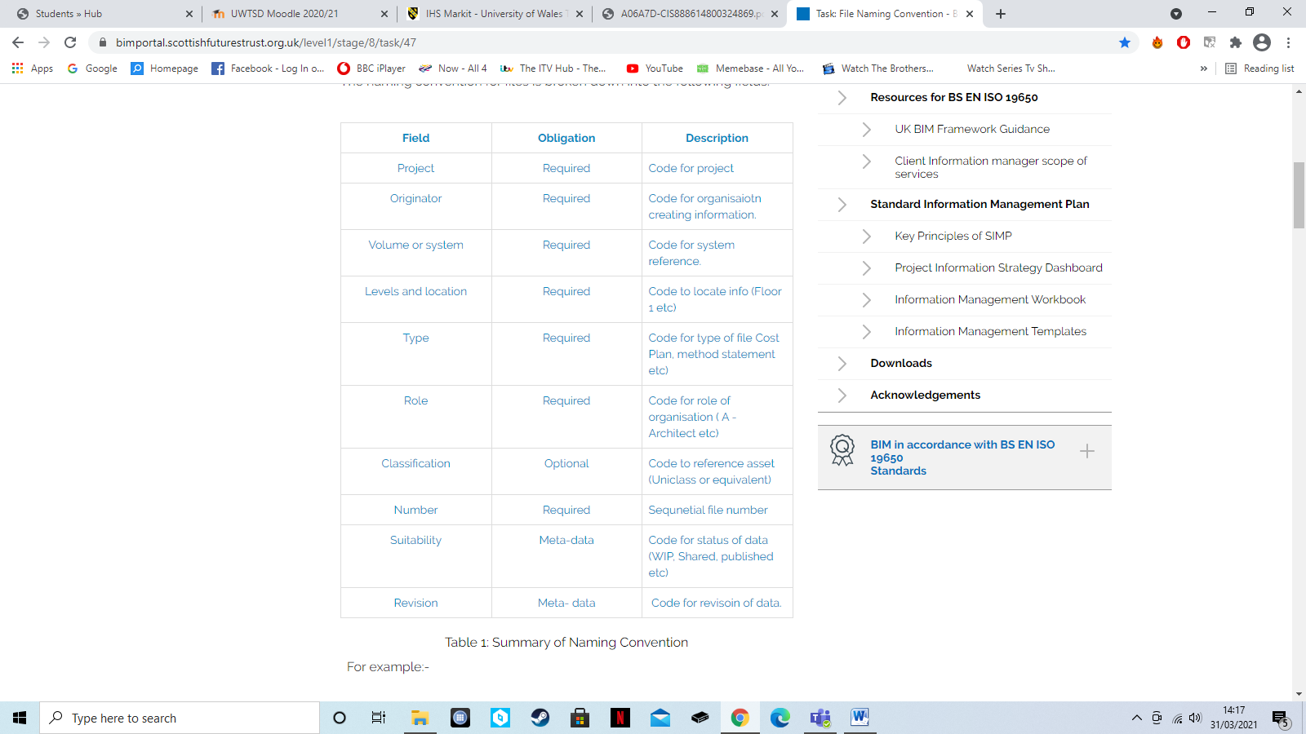
BSI (2019, Clause 11.3) cite that in order for information to be understandable by all parties a means of structuring and classifying information should be adopted. This will be done by using appropriate naming conventions for all files developed as part of the BIM process. A table illustrating the conventions to be used is shown in figure 2, with an example of how this would look included in figure 3. These will be used by all task teams and anyone involved in the PIM production process.
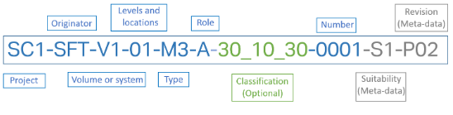
Figure 2: Table showing naming conventions (scottishfuturetrust, 2021)
Figure 3: Example of naming conventions in use (scottishfuturetrust, 2021)

5. IT solutions

In order for the collaborative working process to be effective a number of IT solutions will be adopted.

5.1 2D/3D/4D modelling

Those producing 2D/3D/4D modelling will be required to use AutoCAD or Revit, with AutoCAD being used for 2D modelling and Revit being used for 3D/4D modelling. This will ensure compatibility with the chosen CDE (Revizto 5).

5.2 Document production

Any documents produced as part of the process (such as this BEP) will be produced using the Microsoft office suite of programmes. This will ensure compatibility across the task teams.

5.3 Collaborative work

As previously mentioned collaborative work will be carried out through the chosen CDE (Revizto 5).

6. Closing statement

The methods, procedures and solutions in this document will ensure the proposed project is completed to the required level of BIM (level 2), maintaining compliance with the relevant ISO standards (BS EN ISO 19650-1:2018).

