Jamie Leung

Materials
Rubber Properties

Contents page

Introduction
Experimental Method
Results
Analysis of Results
Analysis of experimental inaccuracy and cost/quality
Discussion
Conclusion
Acknowledgements
References

Introduction

This assignment will be studying the key properties of Rubber materials and an experiment will be carried out to obtain force data of a rubber band to demonstrate how a rubber band can deform before snapping. Understanding how the rubber band's characteristics affect the behaviour of the material when a force is applied is the goal of this experiment. With the force data information, I will be looking to calculate engineering stress/strain & true stress/strain with which allow me to focus on Youngs modulus & Ultimate Tensile Strength.
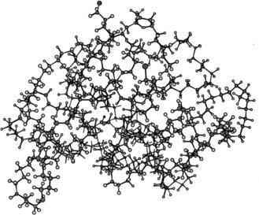

Figure 1 - Polymer

Rubber is a type of polymer – to be exact, an elastomer type polymer. A polymer is a substance that has molecules linked in extended, repetitive chains. Polymers have distinct features due to their structure and how they are bonded, which can be modified for various needs (1). These chains are single bonded units which are identical but can form together to form chain links.
Elastomers are polymers with both viscous and elastic characteristics. When stretched or deformed, this elastomer polymer can return to its original shape. Rubber has a lot of elasticity since it can be stretched to separate its links.

Elastomers typically have; (2)
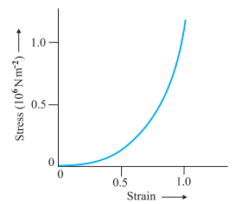
- High failure strain
- Low Young's modulus
- High yield strengths

The purpose of the experiment is to demonstrate how a rubber band can expand before it breaks. The stress/strain diagram for an elastomer material is displayed below. I anticipate that the diagram constructed from the findings of this experiment will resemble the one to the right.
Figure 2 - Stress Strain Curve 1

Experimental Method

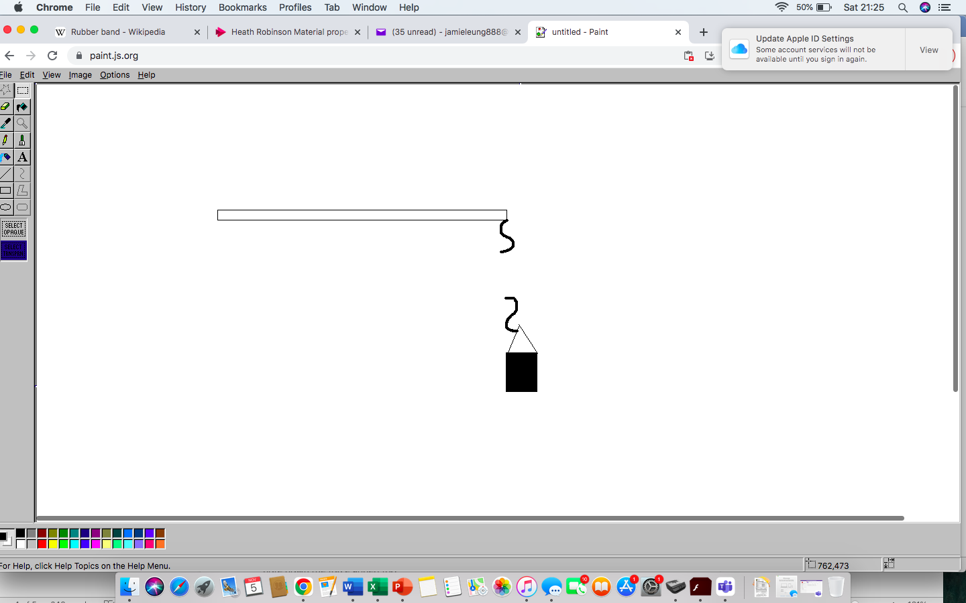

Equipment required;
- Rubber Band
- Bucket
- Measuring Tape
- Garage Door
- S hooks
- Measuring Jug
- Scales
Figure 3 - Experiment Diagram 1

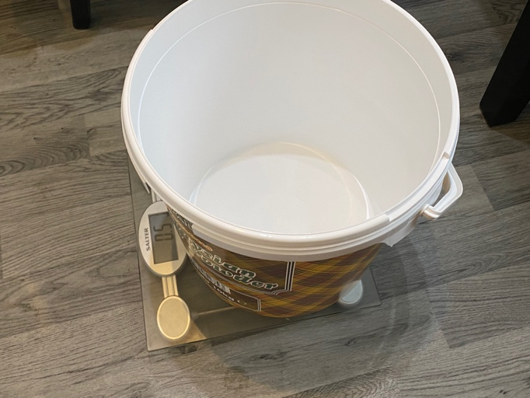
The approach I selected for this experiment entailed attaching two S hooks—one to my garage door and the other to a bucket—connected together with a rubber band.
Figure 4 - Weighing Bucket
Before starting the experiment, I needed measure a couple of things such as the elastic bands length using a measuring tape whilst no force was being applied to it. Another check that needed to be carried out was the bucket had to be weighed before the water was added so that I knew the exact weight of the water being added and to make the results as accurate as possible.

The bucket was used to place pressure on the rubber band by adding water into the bucket in 100ml increments with help from a measuring jug and this step is repeated until the rubber band snaps. After each time I added water in, I would measure the length of the rubber band (to see how much it has extended by) and I would note down the force added.

Images of the experiment can be seen below;
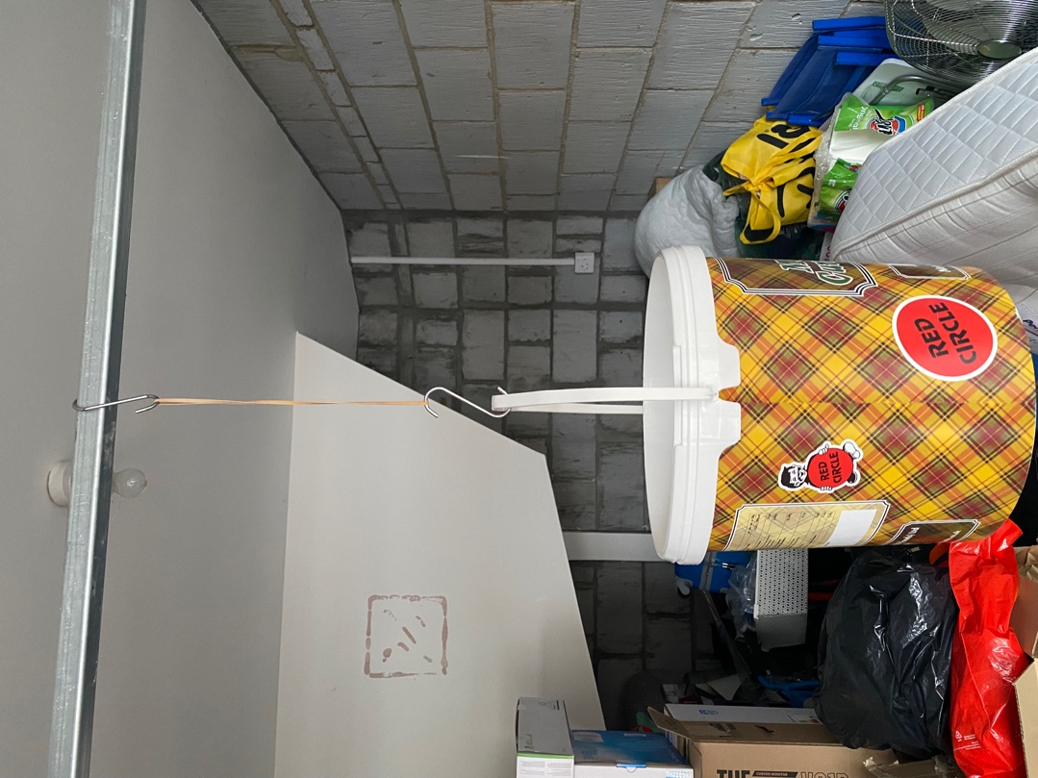

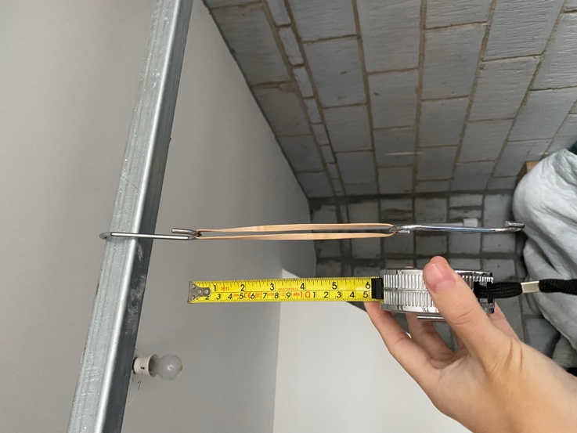

Figure 5 - Experiment Image 1
Figure 6 - Experiment Image 2
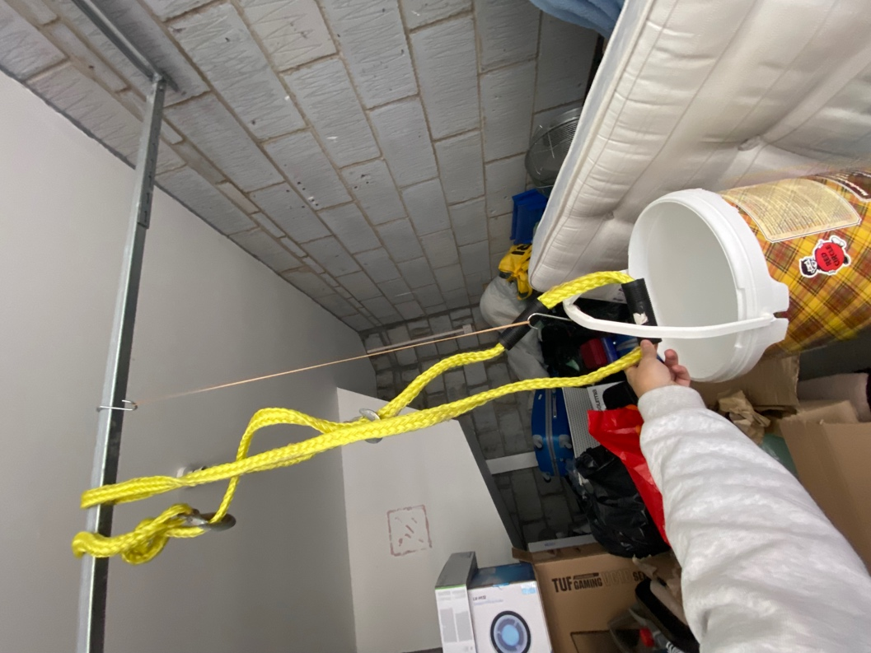

Safety sling had to be added halfway through as the bucket would have spilled all over my garage. In contrast to the two images – you are able to see how far the elastic band has stretched from adding a weight to the bucket.

Figure 7 - Experiment Image 3

Results

From the experiment I gathered data such as length of the elastic band, amount of water and force. This data will help me calculate the engineering stress & true strain of the elastic band which is the main objective from this assignment.

I used Microsoft Excel to log down these results and to create a graph.
The results from the experiment can be seen below;

Water (ml) | Force (gf) | Length (mm)
0 | 0 | 160
0 | 500 | 290
100 | 600 | 330
200 | 700 | 367
300 | 800 | 405
400 | 900 | 438
500 | 1000 | 472
600 | 1100 | 510
700 | 1200 | 527
800 | 1300 | 545
900 | 1400 | 561
1000 | 1500 | 575
1100 | 1600 | 585
1200 | 1700 | 602
1300 | 1800 | 627
1400 | 1900 | 642
1500 | 2000 | 662
1600 | 2100 | 671
1700 | 2200 | 680
1800 | 2300 | 699
1900 | 2400 | 710
2000 | 2500 | 720
2100 | 2600 | 728
2200 | 2700 | 738
2300 | 2800 | 740
2400 | 2900 | 769
2500 | 3000 | 778
2600 | 3100 | 780
2700 | 3200 | 785
2800 | 3300 | 793
2900 | 3400 | 801

Figure 6 - Experiment Graph

Analysis of Results

Length (mm) | Engineering Strain | True Strain
160 | 0 | 0
290 | 0.8125 | 0.59470711
330 | 1.0625 | 0.72391884
367 | 1.29375 | 0.83018803
405 | 1.53125 | 0.92871325
438 | 1.7375 | 1.0070451
472 | 1.95 | 1.08180517
510 | 2.1875 | 1.15923691
527 | 2.29375 | 1.19202673
545 | 2.40625 | 1.22561198
561 | 2.50625 | 1.25454709
575 | 2.59375 | 1.27919623
585 | 2.65625 | 1.29643803
602 | 2.7625 | 1.32508363
627 | 2.91875 | 1.36577273
642 | 3.0125 | 1.38941449
662 | 3.1375 | 1.42009174
671 | 3.19375 | 1.43359532
680 | 3.25 | 1.44691898
699 | 3.36875 | 1.47447693
710 | 3.4375 | 1.49009115
720 | 3.5 | 1.5040774
728 | 3.55 | 1.51512723
738 | 3.6125 | 1.52877001
740 | 3.625 | 1.53147637
769 | 3.80625 | 1.56991715
778 | 3.8625 | 1.58155271
780 | 3.875 | 1.5841201
785 | 3.90625 | 1.5905099
793 | 3.95625 | 1.60064941
801 | 4.00625 | 1.61068713

After completing the experiment, I was now able to analyse my results to find out the strain. The two types of strain I will be looking at in this report is ‘True Strain’ & ‘Engineering Strain’. The natural log of the ratio of the current length to the initial length is the true strain (3). The engineering strain is calculated by dividing the amount of distortion in the direction of the applied force by the material's starting length (4).

Engineering Strain can be calculated by using this formula;$$Engineering Strain \left(ε\right)=\frac{∆L}{L0}$$
$$∆L=Change in Length$$
$L0=Orginal Length$

The formula used to determine True Strain is shown below;$$True Strain \left(εt\right)=\sum{\frac{∆L}{L}}$$
$\sum{=The sum of}$
$∆L=Change in Length$
$L=Length$

The Results for Engineering Strain & True Strain can be seen in the table to the right -

The next two things I will be looking at is Engineering Stress and True Stress. The starting cross sectional area is used to calculate Engineering Stress whereas, True Stress is calculated by the force divided by the actual cross-sectional area. To work out the above two, Cross Sectional Area must be calculated beforehand. The Cross-Sectional Area was calculated by measuring the elastic band with the following formula used to work out the rest of the results. NL stands for New elastic band length & OL stands for original elastic band length.

Cross Sectional Area | Engineering Stress | True Stress
11.7 | 0 | 0
6.46 | 0.42 | 0.76
5.67 | 0.50 | 1.04
5.10 | 0.59 | 1.35
4.62 | 0.67 | 1.70
4.27 | 0.75 | 2.07
3.97 | 0.84 | 2.47
3.67 | 0.92 | 2.94
3.55 | 1.01 | 3.31
3.43 | 1.09 | 3.71
3.34 | 1.17 | 4.12
3.26 | 1.26 | 4.52
3.20 | 1.34 | 4.91
3.11 | 1.43 | 5.36
2.99 | 1.51 | 5.91
2.92 | 1.59 | 6.39
2.83 | 1.68 | 6.94
2.79 | 1.76 | 7.38
2.75 | 1.84 | 7.84
2.68 | 1.93 | 8.42
2.64 | 2.01 | 8.93
2.60 | 2.10 | 9.43
2.57 | 2.18 | 9.92
2.54 | 2.26 | 10.44
2.53 | 2.35 | 10.86
2.43 | 2.43 | 11.69
2.41 | 2.52 | 12.23
2.40 | 2.60 | 12.67
2.38 | 2.68 | 13.16
2.36 | 2.77 | 13.71
2.34 | 2.85 | 14.27
$$Cross Sectional Area=\frac{11.7×OL}{NL}$$
Section
1.5
3.9
Area
5.85
Total Cross-Sectional Area
11.7

Engineering Stress can be calculated by using this formula;
$$Engineering Stress (σ)=\frac{F}{A_{0}}$$

The formula used to determine True Stress is shown below;
$$True Stress \left(σ_{t}\right)=\frac{F}{A}$$

F = The load.
A = The cross-sectional area at which the load is applied
A0 = Cross Sectional Area before deformation
Results for Cross Sectional Area, Engineering Stress & True Strain can be seen in the table to the right.

The next data I will be looking at is Force. Previously the force from the water was measured in gf however, I will be converting this into Newtons. The formula used to covert this unit is shown below;

$$Force=mg$$
$$Force=mass × Accelleration \left(Due to gravity\right)$$

Force (gf) | Force (N)
0 | 0
500 | 4.905
600 | 5.886
700 | 6.867
800 | 7.848
900 | 8.829
1000 | 9.81
1100 | 10.791
1200 | 11.772
1300 | 12.753
1400 | 13.734
1500 | 14.715
1600 | 15.696
1700 | 16.677
1800 | 17.658
1900 | 18.639
2000 | 19.62
2100 | 20.601
2200 | 21.582
2300 | 22.563
2400 | 23.544
2500 | 24.525
2600 | 25.506
2700 | 26.487
2800 | 27.468
2900 | 28.449
3000 | 29.43
3100 | 30.411
3200 | 31.392
3300 | 32.373
3400 | 33.354
$$Force \left(N\right)=gf×\frac{9.81}{1000}$$

Pictured below are two types of graphs. The first graph is the curve for Engineering Stress against Engineering Strain and the second graph is the curve for True Stress against True Strain.
Figure 7-Engineering Stress Strain Curve

Figure 8 - True Stress Strain Curve

The next part of this assignment is finding the Youngs modulus at the initial stretch point and the ultimate tensile strength of the elastic band based on the two graphs curves above. Youngs modulus Young's modulus is a measurement of a material's capacity to resist length changes when subjected to pressure (5). To calculate Youngs modulus we are able to use the gradient of the initial stress point. I have used an orange line to represent the gradient on both graphs.
True Stress Strain Graph

$$E=\frac{Stress}{Strain}$$

$$E=\frac{2.94}{1.16}$$

$$E=2.53 x {10}^{6}$$

Engineering Stress Strain Graph

$$E=\frac{Stress}{Strain}$$

$$E=\frac{2.19}{0.92}$$

$$E=2.38 x {10}^{6}$$

From the Engineering Stress/Strain curve we are able to see this rubber can stretch about 4 times its original length before it snaps, and that stress is proportional to strain in the first section where we will see a constant in young modulus. The next thing to calculate is Ultimate Tensile Strength. Ultimate Tensile Strength is the materials ability that it can withstand before any fracture occurs which can be seen on the graphs represented with the red lines.

In the Engineering Stress/Strain curve, the Ultimate Tensile Strength is 2.8507mm²
In the True Stress/Strain curve, the Ultimate Tensile Strength is 14.2716mm²
From the True Stress/Strain curve, we are able to see that the material rubber hardens as we apply stress onto it.

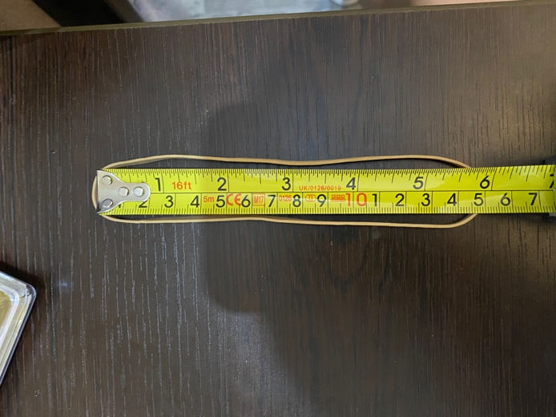
When pressure is applied to some materials, creep can occur. In this experiment, creep was seen when the rubber band stretched. The rubber band was permanently longer after this deformation since it would not go back to its normal length. I put this to the test by measuring the elastic band in advance without applying any pressure to it (Figure 9). Following the measurement, I tugged the elastic band apart continuously for two minutes while applying stress on it. I became aware that letting go requires far less force than pulling in as I was doing so. Although the band appears to be the same, I measured it when pressure was applied, and the findings showed that the elastic band's length increased by 0.6mm. This is a perfect example of creep and that the material has permanently deformed.
Figure 9
Full results table shown below.

Water (ml) | Force (gf) | Length (mm) | Engineering Strain | True Strain | Force (N) | Cross Sectional Area | Engineering Stress | True Stress
0 | 0 | 160 | 0 | 0 | 0 | 11.7000 | 0.0000 | 0.0000
0 | 500 | 290 | 0.8125 | 0.59470711 | 4.905 | 6.4552 | 0.4192 | 0.7599
100 | 600 | 330 | 1.0625 | 0.72391884 | 5.886 | 5.6727 | 0.5031 | 1.0376
200 | 700 | 367 | 1.29375 | 0.83018803 | 6.867 | 5.1008 | 0.5869 | 1.3463
300 | 800 | 405 | 1.53125 | 0.92871325 | 7.848 | 4.6222 | 0.6708 | 1.6979
400 | 900 | 438 | 1.7375 | 1.0070451 | 8.829 | 4.2740 | 0.7546 | 2.0658
500 | 1000 | 472 | 1.95 | 1.08180517 | 9.81 | 3.9661 | 0.8385 | 2.4735
600 | 1100 | 510 | 2.1875 | 1.15923691 | 10.791 | 3.6706 | 0.9223 | 2.9399
700 | 1200 | 527 | 2.29375 | 1.19202673 | 11.772 | 3.5522 | 1.0062 | 3.3140
800 | 1300 | 545 | 2.40625 | 1.22561198 | 12.753 | 3.4349 | 1.0900 | 3.7128
900 | 1400 | 561 | 2.50625 | 1.25454709 | 13.734 | 3.3369 | 1.1738 | 4.1158
1000 | 1500 | 575 | 2.59375 | 1.27919623 | 14.715 | 3.2557 | 1.2577 | 4.5198
1100 | 1600 | 585 | 2.65625 | 1.29643803 | 15.696 | 3.2000 | 1.3415 | 4.9050
1200 | 1700 | 602 | 2.7625 | 1.32508363 | 16.677 | 3.1096 | 1.4254 | 5.3630
1300 | 1800 | 627 | 2.91875 | 1.36577273 | 17.658 | 2.9856 | 1.5092 | 5.9143
1400 | 1900 | 642 | 3.0125 | 1.38941449 | 18.639 | 2.9159 | 1.5931 | 6.3922
1500 | 2000 | 662 | 3.1375 | 1.42009174 | 19.62 | 2.8278 | 1.6769 | 6.9383
1600 | 2100 | 671 | 3.19375 | 1.43359532 | 20.601 | 2.7899 | 1.7608 | 7.3842
1700 | 2200 | 680 | 3.25 | 1.44691898 | 21.582 | 2.7529 | 1.8446 | 7.8396
1800 | 2300 | 699 | 3.36875 | 1.47447693 | 22.563 | 2.6781 | 1.9285 | 8.4250
1900 | 2400 | 710 | 3.4375 | 1.49009115 | 23.544 | 2.6366 | 2.0123 | 8.9296
2000 | 2500 | 720 | 3.5 | 1.5040774 | 24.525 | 2.6000 | 2.0962 | 9.4327
2100 | 2600 | 728 | 3.55 | 1.51512723 | 25.506 | 2.5714 | 2.1800 | 9.9190
2200 | 2700 | 738 | 3.6125 | 1.52877001 | 26.487 | 2.5366 | 2.2638 | 10.4420
2300 | 2800 | 740 | 3.625 | 1.53147637 | 27.468 | 2.5297 | 2.3477 | 10.8581
2400 | 2900 | 769 | 3.80625 | 1.56991715 | 28.449 | 2.4343 | 2.4315 | 11.6866
2500 | 3000 | 778 | 3.8625 | 1.58155271 | 29.43 | 2.4062 | 2.5154 | 12.2311
2600 | 3100 | 780 | 3.875 | 1.5841201 | 30.411 | 2.4000 | 2.5992 | 12.6713
2700 | 3200 | 785 | 3.90625 | 1.5905099 | 31.392 | 2.3847 | 2.6831 | 13.1638
2800 | 3300 | 793 | 3.95625 | 1.60064941 | 32.373 | 2.3607 | 2.7669 | 13.7136
2900 | 3400 | 801 | 4.00625 | 1.61068713 | 33.354 | 2.3371 | 2.8508 | 14.2717

Analysis of experimental inaccuracy and cost/quality

The Experiment I designed could have been improved in several different ways and there were different factors that I didn’t take into account which may have affected my results. For example, one of the ways I could have improved it was measuring the elastic band from different points and taking an average from it. In the experiment, I only took points from one spot of the elastic band which may have been different from the other surface areas. In addition to the elastic band, another potential problem could have been the choice of elastic band. Different elastic bands show different properties and all vary in quality.

One inaccuracy that may have occurred is error compounding. In the experiment to make it more accurate, it would have been better to weigh the bucket AND water after every time water was added to make sure the weight was correct. However, this was not feasible as it would cause disruption with the experiment unhooking everything etc.

Inaccurate measurements of force and length could have been another possible mistake with the results. First off, because my scales are old and haven't been calibrated, I'm not sure if they're 100% accurate. Furthermore, it might not be the best choice to use a tape measure to measure the elastic band length while it is in the air; a digital reader, such as a Vernier Calliper, might have been a better choice.

Discussion

If I was do this experiment again and had more time and money, I would definitely invest in a fixed stand instead of hanging it off my garage frame to make it more stable. In addition to this, I would try to repeat the experiment with different types of elastic bands to see the difference between them all and can potentially average them out and use that as the main data source. Another thing is use digital tools such as Vernier Calliper or Micrometre instead of using a measuring tape/ruler to make results more accurate. If I had more time, I would’ve done the same experiment with the elastic bands set in different temperatures. For example, one chilled and another heated, I believe I could’ve seen the different effects that it would have on the elastic properties.

As I mentioned in my introduction, I anticipated that my stress/strain curve would resemble the one in Figure 2, which shows an increase in graph that begins virtually straight-line-like before escalating in a curve.

Since I only needed to buy the S hooks, which cost about £4, the experiment ended up being relatively inexpensive. The remaining tools, including the measuring jug, bucket, elastic bands, and scales, were all already in my home.

Conclusion

In my opinion, I believe the experiment was an overall success as I achieved exactly what I wanted with producing two graphs showing engineering stress against engineering strain and true stress against true strain curves. This allowed me to progress further and study the key properties of rubber and allowed me to calculate Youngs modulus & ultimate tensile strength. I could have adjusted the experiment to maximise the precision of the findings and to cut down on inconsistency. Nevertheless, considering that this was my first try and the limitations of my resources, I would generally say that I am satisfied with the outcome of this experiment.

Acknowledgements

Within this assignment I would like to acknowledge my parents for letting me use the garage to conduct my experiment. Also, giving me permission to use all the equipment such as weighing scales, measuring jug and the bucket. All equipment was cleaned and returned back to designated areas.

References

- Johnson, T. (2019). What Exactly Is a Polymer? [online] ThoughtCo. Available at: https://www.thoughtco.com/what-is-a-polymer-820536 [Accessed 7 Nov. 2022]
- BYJUS. (n.d.). Elastomers: Definition, Examples, Properties, Types, Applications. [online] Available at: https://byjus.com/physics/elastomers/ [Accessed 7 Nov. 2022].
- AHSS Guidelines. (2021). Engineering Stress-Strain vs. True Stress-Strain. [online] Available at: https://ahssinsights.org/forming/formability/engineering-stress-strain-true-stress-strain/#:~:text=True%20strain%20is%20the%20natural [Accessed 6 Nov. 2022].
- www.nde-ed.org. (2019). Nondestructive Evaluation Physics : Materials. [online] Available at: https://www.nde-ed.org/Physics/Materials/Mechanical/StressStrain.xhtml [Accessed 6 Nov. 2022].
- The Editors of Encyclopedia Britannica (2019). Young’s modulus. In: Encyclopædia Britannica. [online] Available at: https://www.britannica.com/science/Youngs-modulus [Accessed 11 Nov. 2022].

Figure 1 - www.sciencedirect.com. (n.d.). Polymer - an overview | ScienceDirect Topics. [online] Available at: https://www.sciencedirect.com/topics/medicine-and-dentistry/polymer [Accessed 7 Nov. 2022].

Figure 2 - Toppr-guides. (2019). Toppr-guides. [online] Available at: https://www.toppr.com/guides/physics/mechanical-properties-of-solids/hookes-law-and-stress-strain-curve/ [Accessed 11 Nov. 2022].

