Electronic Circuits Testing and Applications
Programme: Beng/HND Automotive, Motorcycle & Motorsport Engineering
Module: Electrical Control Systems
Module Code: ACHA4010
Student Name: William Davies
Student Number; 2400569
Lecturers Name: Ryan James
Date of Submission: 06/04/25

Contents
Electronic Circuits Testing and Applications 1
Introduction 3
Task 3 4
Scope Time Division Calculations 4
Function Generator Output Sine Wave 5
Basic Capacitor Calculations 7
Capacitor Discharge Table 7
Plot log(V) Vs Gradient 7
Gradient Calculation & Comparison 8
Uses for Capacitors 8
Question Inaccuracies 9
Bibliography 10

Introduction
In this assignment I will be demonstrating the tests of AC and DC electronics. Based on the in-class practical of which the testing of capacitors was carried out. I will be carrying out a write up, on the practical and outlining the inputs, outputs, charge discharge etc.

Task 3

Scope Time Division Calculations
Frequency (∫) of wave = 250 Hz
Period (P) of a wave 1/∫ = 1/250 = 0.004
Therefore = P full = 0.004 sec
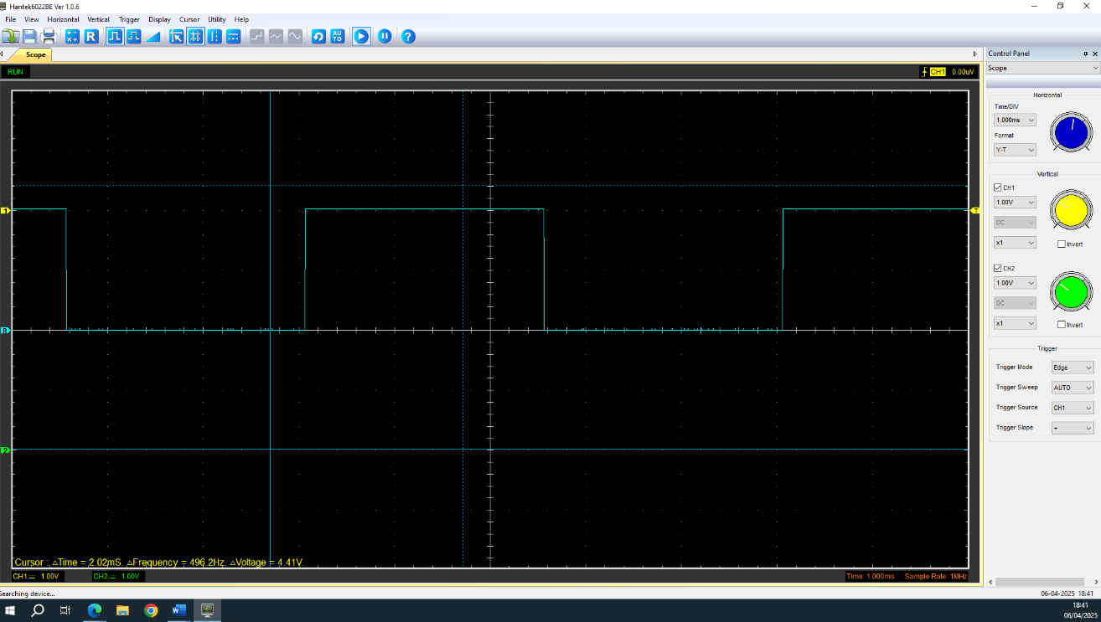
No. of divisions (T div) = 10
T (div) = P full / ∫ = 0.004 / 250 = 0.000016 sec

Function Generator Output Sine Wave
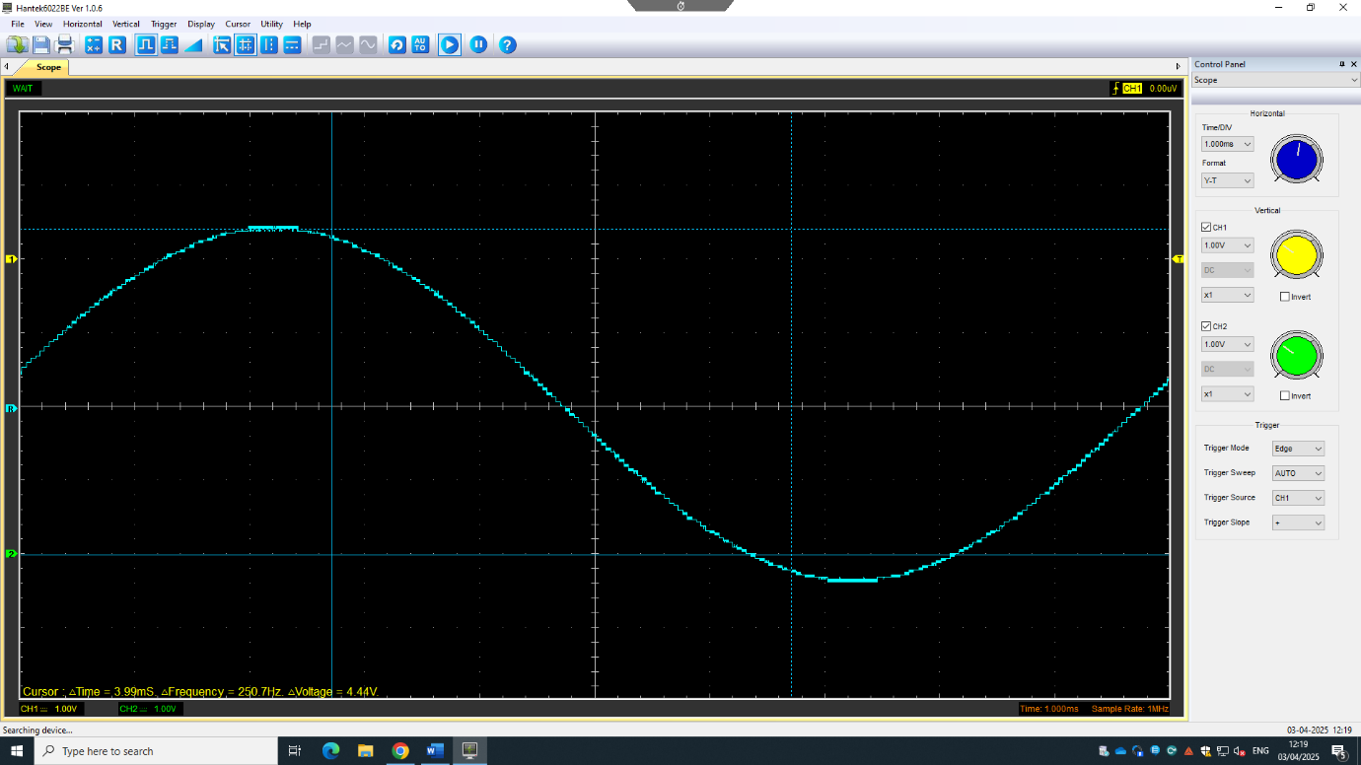
Figure 1: Output Sine Wave and Values
Figure 1 is showing the AC sine wave which displays the oscilloscope at a peak-to-peak voltage of 4.83 Volts.

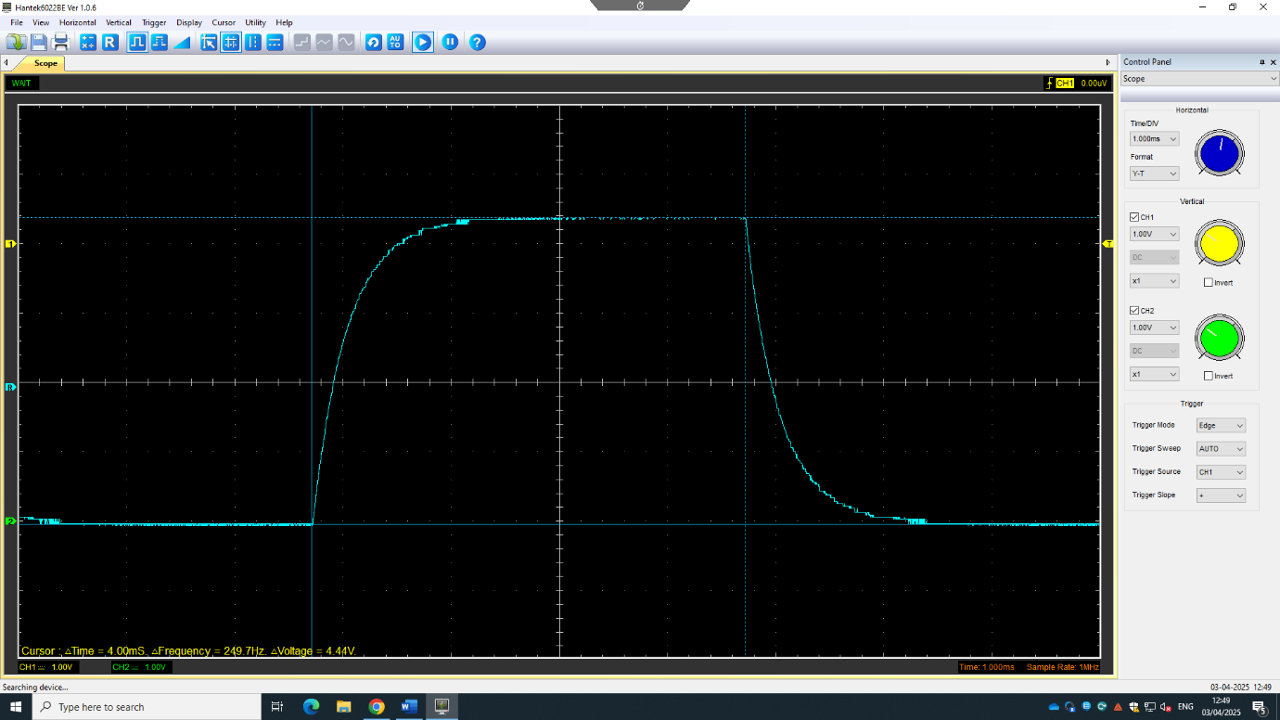
Capacitor Charge and Discharge Wave
Figure 2: shows the charge of the capacitor
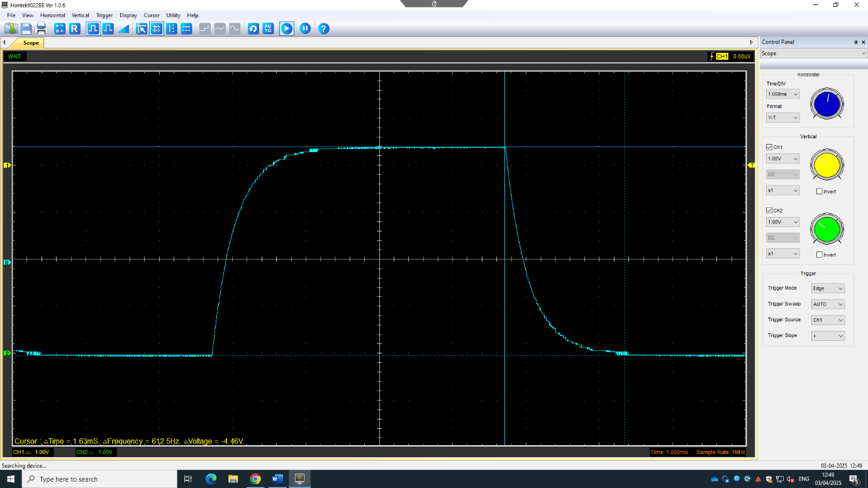
Figure 2 shows that from flatline to fully charged goes from -2.09V to 2.35V. It charges 4.44 Volts
Figure 3: shows the discharge of the capacitor
Figure 3 shows the discharge of the capacitor from 2.35 Volts to -2.05 Volts. Therefore the discharge of the capacitor drops the voltage by -4.45V.

Basic Capacitor Calculations
t = R.C =t/C = 1ms/250mHz = R = 4Ohms

Capacitor Discharge Table
Time (uS) | Voltage (V) | In (V) | dy = y2- y1 | dx = x2 – x1 | dy/dx
Time (uS) | Voltage (V) | In (V) | dy = In(V)2 – In(V)1 | dx = Time2 – Time 1 | dy/dx
7.22 | 1.51 | 0.412109651 | x | x | x
9.63 | 1.92 | 0.652325186 | 0.240215535 | 2.41 | 0.0996745
11.7 | 2.32 | 0.841567186 | 0.189242 | 2.07 | 0.09142126
19 | 3.2 | 1.16315081 | 0.321583624 | 7.3 | 0.04405255
24.1 | 3.45 | 1.238374231 | 0.075223421 | 5.1 | 0.01474969
32.5 | 3.86 | 1.350667183 | 0.112292952 | 8.4 | 0.01336821
43 | 4.17 | 1.427916036 | 0.077248852 | 10.5 | 0.00735703
53.2 | 4.28 | 1.45395301 | 0.026036974 | 10.2 | 0.00255264
69.2 | 4.32 | 1.463255402 | 0.009302393 | 16 | 0.0005814
72.5 | 4.37 | 1.474763009 | 0.011507607 | 3.3 | 0.00348715
95.4 | 4.43 | 1.488399584 | 0.013636575 | 22.9 | 0.00059548

Plot log(V) Vs Gradient

Gradient Calculation & Comparison
Log(V)
Log = Ln(Voltage)
dy = In(2) – In(1)
dx = Time(2) – Time (1)
dy/dx = dy / dx
 | Capacitance | Delta | Percentage difference
Actual | 1 µF | x | X
Marker Calculation | 2.006µF | ‘-' 1.006µF | 200.60%
Gradient Calculation | 13.56µF | ‘-' 12.56µF | 1256%

Uses for Capacitors
Temporary Power Supply – are used in devices such as emergency back up circuits as they store energy, so if something fails as a power supply, the capacitor is able to temporarily supply power to the circuit
Power Smoothing – enables to store the releases energy to smoothen out the power supply variations
Filtering – the capacitor filters out any AC ripple from the DC outputs
Coupling & Decoupling – the capacitors pass any AC signals between stages while
blocking the DC voltage.
Capacitors reduce the voltage spikes and any noise within the power lines by grounding the high frequency signals.
Capacitors are versatile electronic components which are used to store and manage electrical energy.
They help to stabilise the power supplies, filter signals, control timing in circuits and they are very essential when it comes to the applications like a motor starting and signal processing.
Capacitors are used for the energy recovery and regenerative braking system. As the car brakes the capacitor holds the regenerative charge
They are also used to store energy for any quick bursts of power especially in acceleration in hybrid/EV vehicles
Capacitors are also used in the airbag systems to ensure that there is a quick deploy. The airbag control module relies on the capacitors to provide a burst of energy to trigger the airbag

Question Inaccuracies
I think one inaccuracy of this practical is that it may not be consistent values. This is because I didn’t do the practical a certain number of times. This could cause inaccurate results. I also think that a fault of the practical was that some of the breadboards weren’t all up to spec, they have been used for years, and decline its productivity. The wires weren’t up to spec either, therefore there were poor wire contacts losing conductivity and resistance. There could also be noise vibrations from the wires therefore adding to the values of the voltages.

Bibliography
Hantek application – Author Hantek. Accessed on 29/03/25
Capacitor uses - Top 10 capacitors for automotive applications - Electronic Products. Author – AspenCore. Accessed on 06/04/2025

