Entrepreneurship LCBB5001 Assessment 1

Student ID: 2111701

Table of Contents
Introduction 2
Successful skills as an Entrepreneur 2
SWOT Analysis 3
Skill audit 5
PEST analysis on the UK macro environment 9
Political: 10
Economic: 10
Social: 10
Technological: 11
Conclusion: 12
References 13

Introduction
If would-be business owners want to be successful in their undertakings, it is imperative for them to have a comprehension of these characteristics and to work towards cultivating those qualities in themselves. It is also imperative that would-be business owners work towards cultivating these characteristics in themselves. There is no way around the fact that in order to be successful as an entrepreneur, one must have all of the qualities that you have listed as essential, such as a clear sense of direction, the capacity to take calculated risks, the skill to identify and address issues, a "just do it" attitude, effective communication abilities, a willingness to engage in difficult tasks, and the ability to juggle multiple responsibilities at once. It is also important to bear in mind that even though some people may be born with these characteristics, others have the ability to cultivate them through concentrated effort and continuous training. While it is true that some people may be born with these characteristics, it is also true that others have the ability to cultivate them.

Successful skills as an Entrepreneur
Successful business owners have a distinct set of skills, behaviors, and personality characteristics that enable them to negotiate the challenging landscape of the modern business world (Wei, 2019). Therefore, veery successful entrepreneurs should have certain skills, behaviours and traits, as mentioned in Appendix A. According to the information provided in Appendix A, accomplished businesspeople display the following characteristics:
Skills:
Leadership
Communication
Financial management
Sales and marketing
Creativity
Networking
Time management
Strategic planning
Behaviours:
Initiative
Creativity
Risk-taking
Adaptability
Persistence
Resilience
Traits:
Passion
Self-motivation
Confidence
Perseverance
Visionary thinking
Flexibility

SWOT Analysis
Strengths | Weaknesses
Good communication and leadership skills  Creativity and passion for entrepreneurship  Self-motivated and driven | Struggle with time management  Lack of confidence in decision-making abilities
Opportunities | Threats
Opportunities in sales and marketing  Growing demand for eco-friendly products | Intense competition in the market  Economic downturns and market fluctuations  Legal and regulatory hurdles

Because of my abilities in management and communication, my team views me as an excellent leader and a source of inspiration. Because I possess these characteristics, I am able to guide and motivate the members of my team to achieve excellence. Because I possess these qualities, I am able to successfully handle my team and motivate those who are around me. In addition, I have the managerial abilities and the ability to create teams that are necessary to coax the best performance out of my staff (Reyad, 2019). My ability to come up with innovative techniques to business is a product of my inventiveness and the exhilaration I get from being an entrepreneur. I am able to offer my business an advantage over its rivals by utilising these strategies. In addition, I am self-motivated and have the determination to see my objective through to its conclusion, regardless of the challenges that I encounter along the way. In spite of the fact that I anticipate encountering resistance along the way, I am resolute in my commitment to see my objective through to its conclusion.
It's possible that I won't be able to successfully manage the finances of my business because I haven't had enough instruction or experience in the field of financial administration. As a direct consequence of this, I may have some difficulties in store for me. In addition, I have trouble keeping track of time, which frequently results in my being late for things and leaving work incomplete. This is a significant problem for me given the number of obligations I have already taken on. Because I don't always trust my own reasoning, I tend to avoid taking chances unless it's completely necessary to do so. This, of course, is the last point, but it's still important. In this regard, I have a lot of room for growth (Sariwulan, 2020).
The market presents an abundance of choices, particularly in the challenging fields of marketing and sales. These two spheres present the greatest potential for professional advancement. If you make the most of these possibilities, you might experience sizeable increases in your financial standing. My expertise in customer service and product promotion needs some work if I'm going to make the most of these opportunities and expand my company. I have faith that if I put in the effort, I will be able to realise my goal of becoming a more effective salesman and salesperson. Because of my interest in issues pertaining to the environment, I've observed an increase in the desire for products that are favourable to the environment. I believe that this emerging pattern holds a lot of potential. In my opinion, this presents a potential area for further investigation.
There is a lot of competition in the market, which makes it more difficult to differentiate oneself from the other businesses and increase one's portion of the total customer base. Alterations in the market and economic downturns both have the potential to have a detrimental effect on my company. This is something that I need to keep in mind for the future. If I want to stay on the right side of the law, I may also face impediments in the form of requirements enforced by the government and the judiciary system. I will have to find a way around both of these obstacles if I want to remain in compliance with the law.

Skill audit
If would-be business owners want to be successful in their undertakings, it is imperative for them to have a comprehension of these characteristics and to work towards cultivating those qualities in themselves. It is also imperative that would-be business owners work towards cultivating these characteristics in themselves. There is no way around the fact that in order to be successful as an entrepreneur, one must have all of the qualities that you have listed as essential, such as a clear sense of direction, the capacity to take calculated risks, the skill to identify and address issues, a "just do it" attitude, effective communication abilities, a willingness to engage in difficult tasks, and the ability to juggle multiple responsibilities at once (Tomy, 2020). It is also important to bear in mind that even though some people may be born with these characteristics, others have the ability to cultivate them through concentrated effort and continuous training. While it is true that some people may be born with these characteristics, it is also true that others have the ability to cultivate them.
SKILLS I HAVE: | EXAMPLE
Communication skills  Time management skills  Problem-solving skills  Teamwork and collaboration skills  Leadership skills  Adaptability and flexibility  Technical skills | My communication skills include being able to communicate myself directly and in writing in a way that is understandable and persuasive. I am proficient in the art of active attention, able to comprehend the viewpoints of other people, and able to communicate with those people in a manner that fosters reciprocal respect and understanding.  Skills in time management: I am able to prioritise duties and successfully control my time, which enables me to make objectives and produce high-quality work. I am proficient in planning and organizing, and I am able to simplify challenging chores by breaking them down into a series of digestible stages and allocating my time appropriately.  Skills in problem handling I am able to recognise problems, analyse information, and come up with innovative solutions to difficult challenges. I am proficient in critical thinking, able to consider numerous perspectives at once, and able to devise original solutions to challenging problems.  Skills in teamwork and collaboration: I am able to work successfully in a team setting, contributing my skills and knowledge while also appreciating and considering the contributions of others to the group. My communication skills are strong, and I am able to work cohesively with members of a team who come from a variety of experiences to accomplish our shared objectives.  Skills in leadership: I am able to encourage and motivate others, providing clear instruction and assistance while also encouraging team members to take responsibility of their work, and I am able to do all of these things. I have excellent decision-making skills, am able to make difficult choices, and am able to lead by example by establishing high standards and holding myself responsible.  Adaptability and flexibility: I am able to adjust to shifting conditions and flourish in surroundings that are consistently evolving. My ability to solve problems, adapt my strategy to fit the situation, and come up with original responses to unforeseen obstacles are all strengths of mine.  Abilities pertaining to technology: I am fluent in the pertinent applications and tools, and I am able to use them to accomplish duties in an expedient and effective manner. I am adept at troubleshooting and am able to recognise and resolve technological problems in a prompt fashion. For instance, I am proficient in the use of Adobe Photoshop for the purpose of graphic design work.
SKILLS I'D LIKE TO IMPROVE: | HOW?
Speechmaking in public  Negotiation abilities  Project administration abilities  Creativity as well as inventiveness  The processing and interpretation of data  Emotional intelligence  The ability to communicate in a foreign language | My goal is to boost both my self-confidence and my ability to make compelling presentations in front of large audiences by participating in public speaking activities. I intend to get more practise by enrolling in a public speaking group and looking for opportunities to deliver speeches in front of an audience.  Building professional relationships and expanding my network are two aspects of my professional life that I would like to develop further. I intend to increase the number of industry events and conventions that I go to, as well as practise my networking skills by introducing myself to new people and maintaining consistent communication with them.  My goal is to become better at analysing data and deriving significant conclusions from it. I would like to increase my ability to do both. I intend to further my knowledge of data analysis and statistics by enrolling in classes, and I will also look for opportunities to put these skills to use in my current position.  Competence in a foreign language: I would like to enhance my competence in a foreign language because doing so would enable me to communicate more effectively with coworkers and customers who come from a variety of different environments. I intend to enrol in language courses and engage in conversation with people who are natural speakers.

PEST analysis on the UK macro environment
An analysis known as a PEST analysis is a method that examines the macroenvironmental variables that have an effect on a company. The PEST research takes into consideration four different factors: political, economic, social, and technological (Kiesha Frue, 2020).

Political:
The governmental climate in the UK is steady, which provides a favourable environment for commercial enterprises. The decision made by the United Kingdom to withdraw its membership from the European Union (EU) has introduced a significant amount of unpredictability into the areas of business and legislation. Because of this, it is more challenging for businesses to create plans for and actually carry out their activities (Tyler, 2022). Changes in taxation rates and policies have the potential to have an effect on the cost of doing business, which in turn has the potential to have an effect on the profitability of businesses (Bush, 2016).

Economic:
The economy of the UK is beginning to rebound from the epidemic, despite the fact that inflation is at its greatest level in thirty years (Eierle, 2022). This may result in an increase in the costs associated with starting and maintaining a business. Additionally, the expense of basic materials as well as labour is increasing, which may have an effect on the company's profitability. Meanwhile, employment rates can have an impact on a company's ability to locate competent workers. Because of the relatively low unemployment rate in the UK, businesses may have a more difficult time locating personnel who possess the essential abilities (The Macro Environment And Pest Analysis, 2019).

Social:
The United Kingdom is experiencing a rise in its population's ethnic and cultural diversity, which creates new possibilities for companies to target specific consumer subgroups. In addition, there is a growing interest in purchasing products and services that are healthier for society and the environment. This interest has been on the rise in recent years. Additionally, people are putting a greater reliance on maintaining a healthy equilibrium between their personal and professional lives, which can have an impact on the types of professions and businesses that are in demand as a result of this trend (www.edrawmind.com, n.d.).

Technological:
The United Kingdom (UK) is a market that is very tech knowledgeable, and technology is changing the way businesses function. In order for businesses to maintain their level of competitiveness, they must embrace and implement newly developed technologies. The economy of the United Kingdom is highly digitized, which creates opportunities for businesses that are able to capitalise on the latest technological advances. Additionally, the country has a long and illustrious history of inventiveness, particularly in sectors such as the technology industry and the bioengineering industry. Despite this, more and more business owners, particularly those who conduct the majority of their activities online, are expressing their growing anxiety regarding the state of cybersecurity.
In general, the economic climate in the UK presents businesses with a diverse range of opportunities and challenges to contend with. In spite of the fact that there is a great deal of unpredictability surrounding Brexit and the changing of government policies, the country's strong economy, educated population, and technological innovation present a significant opportunity for advancement and accomplishment (Zakeri, 2022). A business will be able to achieve success in the market if it is able to successfully navigate the complexities of the economic environment in the UK and make the most of the opportunities that are presented to them (Zahra, 2022).
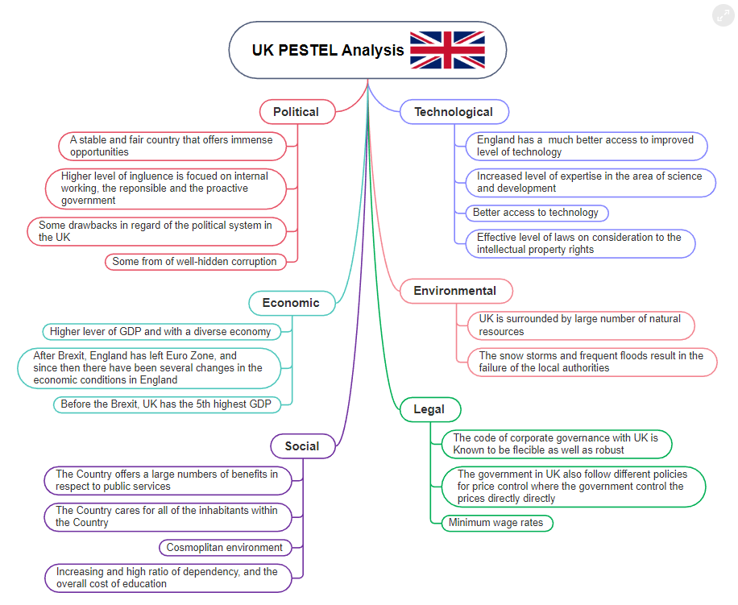
Figure 1UK PESTLE ANALYSIS (www.edrawmind.com, n.d.)

Conclusion:

In conclusion, becoming an entrepreneur requires a distinct collection of abilities, behaviour and characteristics. As a prospective entrepreneur, I have recognised my individual strengths, vulnerabilities, opportunities, and dangers by conducting a personal SWOT analysis and conducting a talent assessment. In addition to this, we conducted a PEST analysis.

References
- Bush, T. (2016). An Example PEST Analysis of The UK. [online] PESTLE Analysis. Available at: https://pestleanalysis.com/pest-analysis-of-the-uk/.
- Eierle, B., Hartlieb, S., Hay, D. C., Niemi, L., & Ojala, H. (2022). External factors and the pricing of audit services: A systematic review of the archival literature using a PESTLE analysis. Auditing: A Journal of Practice & Theory, 41(3), 95-119.
- Kiesha Frue (2020). Understanding Pest Analysis with Definitions and Examples. [online] PESTLE Analysis. Available at: https://pestleanalysis.com/pest-analysis/.
- Reyad, S. M. R., Musleh Al-Sartawi, A., Badawi, S., & Hamdan, A. (2019). Do entrepreneurial skills affect entrepreneurship attitudes in accounting education?. Higher Education, Skills and Work-Based Learning, 9(4), 739-757.
- Sariwulan, T., Suparno, S., Disman, D., Ahman, E., & Suwatno, S. (2020). Entrepreneurial performance: The role of literacy and skills. The Journal of Asian Finance, Economics and Business, 7(11), 269-280.
- The Macro Environment And Pest Analysis (2019). The Macro Environment & Pest Analysis. [online] Learnmarketing.net. Available at: https://www.learnmarketing.net/pestanalysis.htm.
- Tomy, S., & Pardede, E. (2020). An entrepreneurial intention model focussing on higher education. International Journal of Entrepreneurial Behavior & Research.
- Tyler, R., (2022) New British businesses hit record numbers, according to Global Entrepreneurship Monitor, Times Online; https://www.thetimes.co.uk/article/new-
britishbusinesses-hit-record-numbers-according-to-global-entrepreneurship-monitor-gxk06t825 Last assessed 10.02.2022
- Wei, X., Liu, X., & Sha, J. (2019). How does the entrepreneurship education influence the students’ innovation? Testing on the multiple mediation model. Frontiers in psychology, 10, 1557.
- www.edrawmind.com. (n.d.). UK PESTLE Analysis | Mind Map - EdrawMind. [online] Available at: https://www.edrawmind.com/mind-maps/28467/uk-pestle-analysis.
- Zahra, S. A., Petricevic, O., & Luo, Y. (2022). Toward an action-based view of dynamic capabilities for international business. Journal of international business studies, 53(4), 583-600.
- Zakeri, S., Konstantas, D., & Cheikhrouhou, N. (2022). The grey ten-element analysis method: a novel strategic analysis tool. Mathematics, 10(5), 846.

