BSc (Hons) Health and Social Care

Module: Public Health Policy

Module code: BMHP5013
Assessment 2

Lecturer: Barbara Chinyani

Student: Alia Ashrafi 1916229

Content Page
1.Introduction - P3

2.Background of coronavirus and Covid-19 – P4-8

3.Strategies used to measure, monitor and control– P4-8

4.Current public health policy P8-9

5. Models and Theories of health behaviour change – P9-10

6. Impact of legislation and policies– P9-10

7.Ethical considerations – P10-11

8.Recommendations -P11

9.References – P12-13

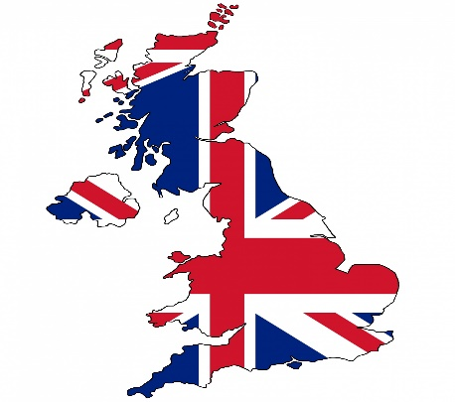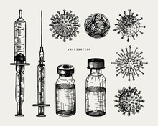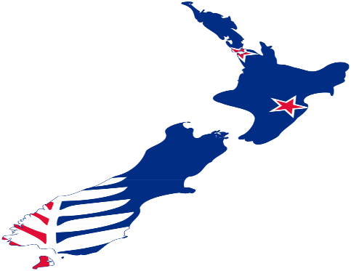
This Photo by Unknown Author is licensed under CC BY-SA

Introduction
The WHO announced COVID-19, a worldwide disaster, a Public Health Emergency of International Concern in late January. Only a few weeks, the epidemic had reached pandemic levels, impacting more than 100 nations. Because of the rapid rise in reported cases worldwide, preventing and controlling COVID-19 was significant concern on both a national and global scale. Government directives are an essential resource for societies, and they instruct people about how to defend themselves from COVID-19. But they also teach policymakers and healthcare providers about how to take steps to reduce the spread of COVID-19. (Yoo, et al., 2020)
This is a structured comparative study that will compare the various methods and techniques implemented in the UK and New Zealand to assess, track, and manage the occurrence of Covid-19. The report would thoroughly review current changes in health and social care policy, their effect on human health and welfare in health and social care environments, and an overview of the interaction between law, policy, and practise: goals and approaches; methods, processes, and policies; lifestyle and behaviour.
Background
Coronavirus: Human coronaviruses date back to 1965 when virologist Tyrrell and Bynoe discovered that they could transmit a virus called B814. The report, led by virologist David Tyrrell at the Common Cold Unit in Wiltshire, England. It was discovered in human embryonic tracheal organ cultures taken from an adult with a common cold's respiratory tract. Inoculating the medium from these cultures intranasally in human participants showed the existence of an infectious agent; colds were developed in a large proportion of the subjects, but Tyrrell and Bynoe were unable to create the agent in tissue culture at the time. (Kahn & McIntosh, 2005) Seven coronaviruses may infect humans. In 2002, the virus that triggers SARS originated in southern China and rapidly spread to 28 additional countries. By July 2003, over 8,000 individuals had been poisoned, and 774 had died. In 2004, a minor epidemic of just four other cases occurred. This coronavirus is associated with fever, headaches, and respiratory symptoms such as coughing and shortness of breath.
MERS began in 2012 in Saudi Arabia. Almost half of the nearly 2,500 incidents have occurred in residents of or visitors to the Middle East. While less infectious than SARS, this coronavirus is more lethal, killing 858 people. It exhibits the same respiratory effects like influenza, but it may also result in kidney failure. (Hansa Bhargava, 2020)
COVID-19: COVID-19 is a recently identified coronavirus that causes an infectious disease. The virus was first discovered in Wuhan, China, in December 2019. Coronavirus 2 causes severe acute respiratory syndrome (SARS-CoV-2). The majority of patients infected with the COVID-19 virus may have mild to moderate respiratory symptoms and heal without needing any special care. People above the age of 65 and those with existing medical conditions such as coronary disease, asthma, chronic respiratory disease, and cancer are at a higher risk of developing severe illness. Being fully educated on the COVID-19 virus, the condition it triggers, and how it progresses is the only approach to deter and slow down transmission. Clean your hands regularly, use an alcohol-based rub to protect yourself and others from bacteria, and avoid rubbing your skin. When an infected individual coughs or sneezes, the COVID-19 virus spreads mainly by droplets of saliva or discharge from the nose, so respiratory etiquette is often necessary (for example, coughing into a flexed elbow). (WHO, 2021)

Strategies
To limit the spread of the COVID-19 virus, different countries have used various techniques such as social distancing, quarantine, isolation, lockdowns, curfews, travel bans, school/college closures, and so on, with varying outcomes. This study aimed to compare the COVID-19 pandemic containment techniques used by the United Kingdom and New Zealand. This comparative study will help determine the efficacy and efficiency of these countries' policies and the best course of action for controlling the spread of the COVID-19 virus in other parts of the world.

United Kingdom: The United Kingdom (UK) is one of the COVID-19 pandemic's worst-affected nations. According to WHO, from 3 January 2020 to 10 May 2021, there were 4,433,094 confirmed cases of COVID-19 in this country, with 127,603 deaths. (WHO, 2021)
When the pandemic first broke out, the UK initially adopted a policy to increase people's immunity, which enabled the virus to spread to roughly half of the population. However, as the number of positive cases grew, the Government shifted its mitigation strategy to repression (lockdown).

On March 24, 2020, the lockdown suppression plan was implemented, with all enterprises and educational institutions closed except for healthcare and vital goods supplies.
Since June 1, 2020, the Government has relaxed the lockdown restrictions, despite the high risk of COVID-19 transmission. Furthermore, there has been a greater focus on testing, tracking, prevention, and the use of contact-tracing technologies. (Alanezi F et al., 2020)
Measure, monitor and control:
Lockdown, Social distancing, face covering, maintaining the basis of good hygiene, NHSTest and Trace
Closures and limits were implemented in March 2020
- The Prime Minister declares the UK's first lockout, telling people to "remain at home."
- Lockdown steps become legally effective.
Continued lockdown in April 2020
- The lockdown has been extended for a period of 'at at least' three weeks. Until controls are relaxed, the Government establishes five criteria that must be met.
May 2020: Lockdown relaxation commenced
- The Prime Minister announces a conditional agreement to lift the lockdown, stating that those who cannot work from home can return to work but stop taking public transportation.
- The Prime Minister says the UK's "national incubation" is coming to an end, and he announces the relaxation of controls and the removal of the 2m social distancing law.
Summer 2020: Limitations and local lockdowns continued
- In Leicester and parts of Leicestershire, the UK's first regional lockout goes into effect. In England, further limits are being lifted, including the reopening of bars, restaurants, and hairdressers.
- In England, local authorities have been given new powers to enact social distancing.
- Additional lockdown limitations were imposed, including the reopening of indoor theatres, bowling alleys, and soft play areas.
Autumn 2020: Resurrection
- In England, the 'Rule of Six' prohibits social gatherings of more than six people indoors and outdoors.
- In England, the Prime Minister introduces new limits, including returning to working from home and a 10 p.m. curfew for the hospitality industry.
Circuit breakers: October 2020
- In England, a new three-tiered scheme of Covid-19 restrictions was begun.
- The Prime Minister declares the second lockdown in England to protect the NHS from a "medical and moral disaster."
In November 2020, new lockdowns were implemented.
- In England, a second nationwide lockout comes into force.
- Up to three households will be able to get together over the five-day Christmas timeframe from December 23 to 27
December 2020: The first vaccines were authorised, along with a new version.
- Immunisation, the emergence of a new version, and outbreak
- With a new Tier 4: 'Stay at Home' warning stage, the PM announces stricter restrictions for London and South East England. The rules for Christmas mixing have been tightened.
January 2021: Expanded vaccination and third lockdown
- The United Kingdom has entered its third national lockdown.
February 2021: Concerning variants and vaccine efficacy
- Face masks are required on public transportation and in public places.
- Reopening in the spring of 2021
Phase 1 begins in March 2021.
- Schools in England reopened, with secondary schools requiring students and teachers to wear masks during lessons and take twice-weekly tests.
Phase 2 April 2021.
- In England, outdoor bars, restaurants, and non-essential shops have reopened. The Scottish Government has accelerated the process of easing lockdown, allowing six individuals from six households to meet outside. (Institute.for.government, 2021) (Freedman, 2020)

New Zealand: In response to the coronavirus disease 2019 (COVID19) pandemic, New Zealand committed to an elimination plan on March 23, 2020. NZ Prime Minister Jacinda Ardern declared on March 26 that the nation would be put on high alert (the highest level of a four-level response framework). NZ had just over 100 COVID19 cases at the time, with no deaths, so this "go early, go hard" strategy shocked many. NZ, on the other hand, had legitimate reasons to seek removal. The New Zealand Government's response to the COVID-19 pandemic received widespread coverage in both national and international media, which lauded Prime Minister Jacinda Ardern's leadership and rapid response. (Michael G Baker, et al, 2020)
Between 3 January 2020 and 10 May 2021, New Zealand announced 2,288 confirmed cases of COVID-19 with 26 deaths to the WHO. (WHO, 2021)

March- April 2020
- COVID-19 Reaction (CVD) The Cabinet Committee was created.
- The Pasifika Festival was already cancelled. The Pasifika Festival, scheduled for March 14–15, 2020, has been withdrawn by Auckland Mayor Phil Goff due to concerns about the spread of COVID-19.
- Implementation of border controls
- Anyone entering New Zealand will be required to self-isolate for 14 days, according to the Government. For people travelling from New Zealand to the Pacific, cruise ships are prohibited, and stringent regulations are in effect.
- The COVID-19 elimination strategy for Aotearoa/New Zealand has been written.
- New Zealand has joined an international group calling for an inquiry into the source of COVID-19.
June – July 2020
- Move down to Alert Level 1
- The COVID-19 All-Government Response Group has been established.
August – September 2020
- Activation of Alert Levels 2 and 3 has been announced (the second wave begins)
- QR code posters will be needed for all businesses after the 2020 general election is postponed.
- A New Zealand flag must be displayed in all companies and workplaces by law. QR code for COVID Tracer
- The Surveillance Plan and Testing Strategy Committee were formed.
- Face masks become mandatory on public transport
- Stricter requirements for border worker testing
October – November 2020
- Establishment of a Controlled Isolation Allocation System
- A contract for the purchase of 1.5 million Pfizer/BioNTech vaccines has been signed.
- Masks are now needed for all public transportation in Auckland and domestic flights.
December 2020 – January 2021
- The COVID Tracer software has been modified to provide Bluetooth capabilities.
- COVID has a summer resurgence strategy in motion.
- For arrivals, pre-departure testing becomes obligatory.
- Masks are now required on all international Air New Zealand flights.
- A tentative schedule for the vaccination programme has been established.
- Mandatory room confinement for arrivals following the day-12 test
February, March and April 2021
- Air New Zealand is experimenting with a global wireless travel pass.
- The Government has published its vaccination schedule.
- Rapid reviews of the national response to COVID-19 have been published.
- The Government has proposed an increase in support for Pacific health services and communities.
- Travel from India has been temporarily halted. (Mcguinnessinstitute, 2021)

Current Public health policies/situation/Legislations
United Kingdom:
The Health Protection (Coronavirus) Regulations 2020 is published by the UK government on February 10, 2020. It is a legal document that outlines the legal framework that underpins the British Government's original containment and separation policies, which grants the government emergency authority of the National Health Service, medical care, schools, police, the Border Force, local governments, funerals, and trials. Three English statutory instruments levied the limitations. Passengers on public transportation in England were required to wear a face-covering (Face Mask) beginning June 15, 2020.
Self-isolation for up to 14 days (which was reduced to 10 days on December 14, 2020) with anyone who tests positive or who lives with or has been in direct contact with someone who has tested positive is one of the laws, which only extend to England. Legal penalties or fixed fines of up to £10,000 on a sliding scale can be imposed to violate the regulations. Failure to obey is a crime that may be prosecuted or punished by releasing a violation paper (Legislation, 2020). The laws extend to both Scotland and Wales in Scotland. In Scotland and Northern Ireland, the Health Protection Act also bans foreign travel.
Businesses in England, Northern Ireland, and Scotland and the Republic of Ireland are subject to the legislation. It also prohibits the closing of companies in England and Wales and Northern Ireland and Scotland. Travel from England to England and Scotland to Scotland, Wales, and Northern England is also restricted under the health security. (Legislation.gov.uk, 2021)
A total of 50,097,812 vaccine doses had been distributed as of May 8, 2021. (WHO, 2021)

New Zealand:
- Order (No 6) 2021 COVID-19 Public Health Response (Alert Level Requirements) COVID-19 Public Health Response (Alert Level Requirements) COVID-19 Public Health Response
A section 70 order has been issued
- Since 27 April, a Section 70 order has been given for people coming from New South Wales.
Travel from countries with a very high risk of terrorism
- The Government has established a new category of the very high-risk nation' to mitigate the risk of many infected people flying to New Zealand.
Travel without a quarantine with the Cook Islands and Australia
- Separate quarantine-free travel arrangements with the Cook Islands and Australia have been created.
New Zealand has been placed on Level 1 alert throughout the country
- In New Zealand, wearing a face mask or covering is required on all public transportation and flights. (Health.govt.nz, 2021)
A total of 266,55 vaccine doses had been administered as of April 30, 2021 (WHO, 2021)

Models and Theories of health behaviour change
SARS-Cov-2, the virus that triggers COVID-19, is transmitted primarily by human behaviour, and modifying behaviour is critical to avoiding transmission in the absence of pharmaceutical treatments. Isolation and social distancing interventions, such as stay-at-home orders, have been implemented worldwide to mitigate influenza spread but at a high risk to people and the community. In addition to these measures, we urgently need effective interventions to increase adherence to behaviours that individuals in communities should use to protect themselves and others, such as the use of tissues to catch expelled droplets from coughs or sneezes, the use of face masks when appropriate, hand-washing on all occasions when necessary, disinfecting objects and surfaces, physical distancing, and not touching. Direct research is urgently needed to guide the implementation of such approaches, but behavioural science techniques and models will help get things started.

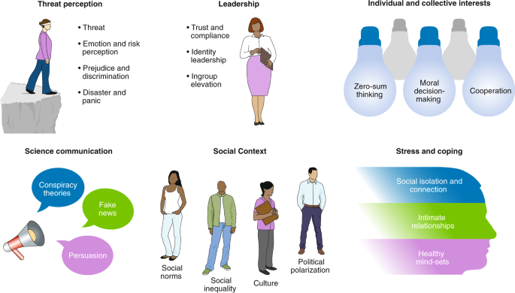
(Picture source: online)

Overall Ethical Considerations (WHO, 2007)
Balancing rights, interests and values
- Specific human rights and civil liberty should have to be restricted in the general interest in emergency circumstances. Individual rights restrictions must be fair, equal, egalitarian, and nondiscriminatory. Policymakers should use ethical criteria to weigh contradictory arguments while considering competing needs and values.
Measures to improve public well-being provide a robust scientific basis
- Public health programmes with high expenses and pressures should be saved for cases when they may be realistically predicted to make a difference in pandemic outcomes. The virulence and transmissibility of the next influenza pandemic will not be understood until it has begun to spread broadly.
Both facets of preparation can have transparency, citizen participation, and public participation
- Policy choices and the reasons behind them should be made transparent and accessible to public review. This will continue to raise public consciousness of disease-related threats and encourage citizens to take preventative measures to avoid them. It would also assist in securing civic and civil society consensus on the usage of preventive and prophylactic interventions. Maintaining public confidence, enhancing decision-makers credibility, and ensuring transparency are all critical.
Early public communication, dialogue with the public, and preparation are also important.
- The guidelines and protocols for making decisions in an influenza pandemic should be shared as soon as possible. Throughout the pandemic, the information accessible would evolve regularly, necessitating changes to response strategies. Information should also be conveyed in a straightforward, non-alarmist manner. Communication is based on three principles: trust, accountability, and transparency. Preparation would allow for the creation of both linguistically and culturally acceptable development and cover the whole community.
Resource constraints
- Any country must make appropriate preparations for an influenza pandemic. Since different countries have different access to resources, what is fair for one nation will not be reasonable for another. Comprehensive proposals can be impossible to execute due to a lack of funding and urgent healthcare requirements. The international nature of the challenge and the role of international cooperation in implementing a global solution highlight the need for collaboration.

Recommendation
- No nation will be clear of the virus in today's internationally linked environment before global eradication is achieved. For the world and the UK to recover more quickly, successful and prompt responses to the simultaneous, interconnected crises compounded by Covid-19 – humanitarian, socioeconomic, and climate emergency – are needed.
- Strong management of a structured, collaborative, gender-specific, conflict-sensitive, and needs-based response at the global and national levels, including donors and key stakeholders such as INGOs, local CSOs, and labour unions, to ensure total influence and value for money in an open and accountable manner.
- Security of a prosperous civil society in countries impacted by the Covid-19;
- Development and humanitarian programmes address all types of prejudice and stigmatisation that may limit people's access to resources and organisations critical to the Covid-19 response and recovery.
- Care, medications, and vaccines for Covid-19, with steps to ensure fair, public, global access to vaccines.

References
Alanezi F, A. A. A. S. & Alanezi , F., 2020. A Comparative Study on the Strategies Adopted by the United Kingdom, India, China, Italy, and Saudi Arabia to Contain the Spread of the COVID-19 Pandemic. Journal of healthcare leadership, 12(1), pp. 117-131.
Freedman, L., 2020. Strategy for a Pandemic: The UK and COVID-19. Global politics and strategy, 62(3), pp. 25-76.
Hansa Bhargava, M., 2020. www.webmd.com. [Online]
Available at: https://www.webmd.com/lung/coronavirus-history#:~:text=Scientists%20first%20identified%20a%20human,Seven%20coronaviruses%20can%20infect%20humans.
[Accessed 9 May 2021].
Health.govt.nz, 2021. www.health.govt.nz. [Online]
Available at: https://www.health.govt.nz/our-work/diseases-and-conditions/covid-19-novel-coronavirus
[Accessed 10 may 2021].
Institute.for.government, 2021. www.instituteforgovernment.org.uk. [Online]
Available at: https://www.instituteforgovernment.org.uk/sites/default/files/timeline-lockdown-web.pdf
[Accessed 10 MAY 2021].
Kahn, J. S. M. P. & McIntosh, K. M., 2005. History and Recent Advances in Coronavirus Discovery. The Pediatric Infectious Disease, 24(11), pp. S223-S227.
Legislation.gov.uk, 2021. www.legislation.gov.uk. [Online]
Available at: https://www.legislation.gov.uk/uksi/2021/364/contents/made
[Accessed 10 may 2021].
Mcguinnessinstitute, 2021. www.mcguinnessinstitute.org. [Online]
Available at: https://www.mcguinnessinstitute.org/projects/pandemicnz/covid-19-timeline/
[Accessed 10 MAY 2021].
Michael G Baker, A. K. A. J. V. & et al, 2020. New Zealand's COVID‐19 elimination strategy. Wiley Public Health Emergency Collection, 1(1), p. 1.
WHO, 2007. https://apps.who.int. [Online]
Available at: https://apps.who.int/iris/bitstream/handle/10665/70006/WHO_CDS_EPR_GIP_2007.2_eng.pdf;jsessionid=CD95A7DB40BD80F9B626EEFD50DD181E?sequence=1
[Accessed 10 may 2021].
WHO, 2021. www.covid19.who.int. [Online]
Available at: https://covid19.who.int/region/euro/country/gb
[Accessed 10 May 2021].
WHO, 2021. www.who.int. [Online]
Available at: https://www.who.int/health-topics/coronavirus#tab=tab_1
[Accessed 9 MAY 2021].
Yoo, J. D. S. F. D., yoo & Yoo, J. D., 2020. Comparative analysis of COVID-19 guidelines from six countries: a qualitative study on the US, China, South Korea, the UK, Brazil, and Haiti. BMC Public Health, 1(1), pp. 1-16.

