

MBA General Management

Dissertation: Digital transformation of Zara in the UK

Name of University : UWTSD
Programme of Study:MBA General Management
Name : Anuja Sathimandiram Vinodkumar
Student ID:2218255
Supervisor(s):Munodzinesa Zuwirai

DECLARATION FORM
I declare that this dissertation has been written solely by myself and that it has not been submitted, in whole or in part, in any previous application for a degree in this university or any other institutions. In addition, I have acknowledged all main source/s-author/s appropriately in parts of this dissertation where I have quoted work from others.
Sign : Anuja Sathimandiram Vinodkumar
Date: 11/01/2024

ACKNOWLEDGEMENT
Without the help and advice of several people, this dissertation on Digital Transformation of Zara in the UK would not have been able to be finished. My profound thanks go out to Munodzinesa Zuwirai, my dissertation adviser, for all of her helpful advice and inspiration during the research and writing phases. I would further like to extend my gratitude to my parents and peers.

ABSTRACT
Introduction: The digital transformation of Zara in the UK was fraught with difficulties, chief among them being the complex integration of digital technologies into their pre-existing organisational framework. Employee training programmes were introduced after resistance to change was overcome, promoting a digital literacy culture. Making sure that data was secure and that UK data protection regulations were followed became crucial, resulting in large investments in cybersecurity.
Literature review: The intricate integration of digital technologies into Zara's pre-existing organisational framework was one of the major challenges faced by the UK retailer during its digital transition. After resistance to change was overcome, employee training initiatives that promoted a culture of digital literacy were implemented. Massive investments in cybersecurity were necessary to ensure that data was protected and that UK data protection laws were fulfilled.
Methodology: According to the methodology chapter, the researcher will use a deductive research strategy in conjunction with an interpretivist research paradigm. Secondary sources, which include research papers, studies, and articles from synthetic sources, will be used to collect data. By matching the abstracts of the chosen research studies with the current research questions, objectives, and aims, the legitimacy of the selected research studies for data extraction will be guaranteed.
Findings: With an emphasis on supply chain optimisation and cutting-edge technologies, ZARA's digital transformation has taken the company to new heights. With a production cycle of less than three weeks, ZARA's rapid supply chain was made possible by utilising RFID for real-time inventory tracking. The incorporation of augmented reality into its smartphone application transformed the online shopping encounter by resolving the difficulty of virtually trying on clothing. Operational efficiency was improved by data-driven tactics like machine learning algorithms and tailored marketing. ZARA's digital initiatives contributed to a 36% increase in online sales in 2020, demonstrating the brand's ability to effectively adapt to changing consumer preferences and technical improvements.

Table of Contents
DECLARATION FORM 2
ACKNOWLEDGEMENT 3
ABSTRACT 4
CHAPTER 1: INTRODUCTION 9
Background & Problem Statement 9
Research Aim 13
Research Objectives 14
Research Questions 14
Significance / Relevance of Study 14
Brief Research Methodology 15
Structure of the rest of the project 16
CHAPTER 2: LITERATURE REVIEW 17
Introduction 17
Research Areas / Topics – Is it critically reviewed? 17
Digitalization has affected ZARA's overall business performance in the UK. 17
The obstacles ZARA faces when integrating digital applications into its workplace 20
Chronology of digital transformation strategies of ZARA. 23
Analysing Digital Marketing and Social Media Strategies of ZARA. 25
Analyzing how digital technologies have enhanced ZARA's operational efficiency in the UK. 27
Investigating the role of digital applications in empowering employees and transforming the organizational culture at Zara in the UK. 29
Eco-friendly procedures and sustainability efforts are incorporated into Zara's digital operations in the UK 30
Conceptual Framework 33
Conclusion of Chapter 33
CHAPTER 3: RESEARCH METHODOLOGY 35
Introduction 35
Research Design 35
Research Philosophy 36
Research Approach 37
Research Strategy 38
Data Collection Methods 38
Data analysis 39
Ethical Considerations 39
Limitations 40
Research Question 40
Research Hypothesis 40
CHAPTER 4: FINDINGS / RESULTS, ANALYSIS AND DISCUSSION 42
Summary / Presentation of Findings / Results 42
4.1 Analysis and the impact of digitalization on the overall business performance of ZARA. 42
4.2 Analyzing the challenges in the digital transformation of ZARA. 47
4.3 Benefits of adopting digital and social media marketing strategy at Zara 49
4.4 Comparative study of online and store sales of Zara 53
Analysis of Results 55
Discussion of Results 59
Impact of Digitalization on ZARA's Business Performance 59
Challenges and Solutions in ZARA's Digital Transformation 61
Chapter Conclusion 62
CHAPTER 5: CONCLUSIONS AND RECOMMENDATIONS 64
Summary of main findings 64
Conclusion based on the research questions 65
What are the impacts of digital transformation on the business operation of Zara in the UK market? 65
How has ZARA implemented digital applications in its business operations in the UK? 65
What are the challenges and benefits of digital transformation witnessed by ZARA considering the UK market? 66
Recommendation (Practical and Theoretical) 66
Practical recommendation 66
Theoretical recommendation 67
Limitation of Research 67
Recommendation for Future Work 68
REFERENCES 69

Contents of Figures
Figure 1 Zara.com's net revenues in e-commerce from 2014 to 2022 10
Figure 2 Trends in weekly online income for fashion and accessories in the UK by 2020 11
Figure 3 Conceptual Framework 33
Figure 4 Linking digital value chain restructuring, governance, and labor process transformations in the fashion. 42
Figure 5 Zara online sales trends 47
Figure 6 Number of social media followers worldwide 2022 48

CHAPTER 1: INTRODUCTION

Background & Problem Statement
In the dynamic landscape of the 21st century, businesses are compelled to adapt swiftly to the digital revolution or risk obsolescence. Stated that with the introduction of digital technologies, the retail sector, which serves as a testing ground for consumer trends, has experienced a significant change. Zara, an iconic fashion retailer, has not been impervious to this paradigm shift. According to Brydges, Retamal, and Hanlon (2020), The United Kingdom, being one of the world's leading fashion markets, provides a unique and challenging terrain for retailers, and the discerning tastes of UK consumers, coupled with their increasing reliance on digital platforms for shopping, have necessitated a paradigm shift in the strategies employed by fashion retailers. ZARA, cognizant of these market dynamics, embarked on a digital transformation journey within the UK, aiming not only to meet customer expectations but to exceed them.
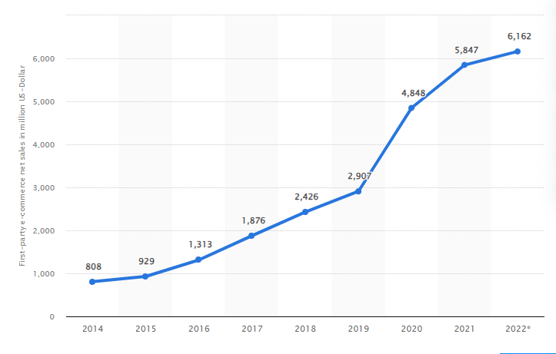
Figure 1 Zara.com's net revenues in e-commerce from 2014 to 2022
Source: (Statista, 2023)
Figure (1) expresses that operating under the name Zara USA, Inc., zara.com is an online retailer with an international emphasis that predominantly produces e-commerce net sales in the United States, United Kingdom, and Spain. In terms of product offerings, the "Fashion" category accounts for the majority of Zara.com's e-commerce net sales (Statista, 2023). Moreover, the offer includes items in the "Toys, Hobby & DIY" area. In 2010, the internet store opened for business. The net revenue of zara.com grew from 808 to 6162 from 2014 to 2022, which is a great success for the business. This information provided by Zara USA, Inc. and zara.com highlights ZARA's global online retail presence, with notable net sales in e-commerce. Notably, their e-commerce net sales are dominated by the "Fashion" sector. This information, while relevant to a wider context, shows ZARA's worldwide digital transformation and e-commerce success, which has affected the company's digital plans in the UK market.

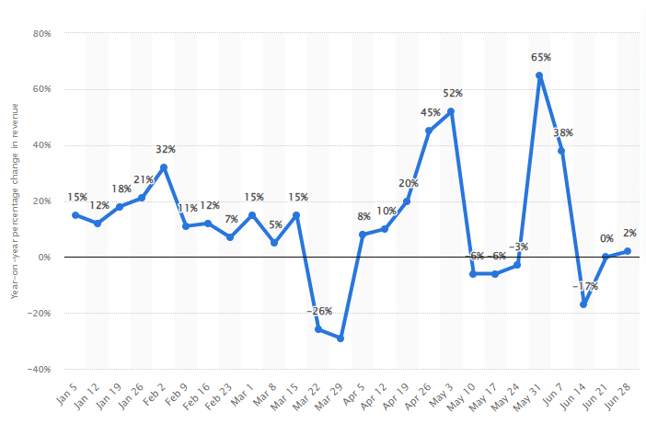
Figure 2 Trends in weekly online income for fashion and accessories in the UK by 2020
Source: (Chevalier, 2021)
Figure (2) expresses that the coronavirus (COVID-19) pandemic that struck the UK in late March 2020 caused a noticeable loss in online revenue numbers for the fashion retail industry, with the worst drop occurring in the week concluding 29 March by 29 per cent. Generally, throughout the crisis, online sales in the sector of fashion and accessories have improved starting in mid-April (Chevalier, 2021). This background emphasizes how crucial digital transformation is for businesses like ZARA to improve online operations and adjust to shifting market conditions. Determining if ZARA in the UK has to undergo a digital transformation requires an understanding of the dynamics of online sales during the epidemic.
Overall, ZARA has been able to prosper in a dynamic market because of its digital transformation path in the UK, which has been fuelled by effective investments in statistical analysis, efficient supply chains, and online sales. The current research sheds light on the potential and difficulties associated with the UK's digital transition while also providing helpful advice for companies looking to meet the needs of customers in the twenty-first century. ZARA is using consumer-focused features and state-of-the-art technology in their digitalization plan for the UK market. By utilising RFID technology, the flagship shop improves inventory control and lowers stockouts. Notably, mobile traffic currently accounts for 47% of zara.com traffic, above the industry average of 35.1%.
The broader strategy of parent company Inditex is aligned with the integration of in-store dedicated online order collection points and mobile-based shopping experiences. ZARA is well-positioned to improve customer happiness and ease by managing 2,400 orders at once (Chevalier, 2021) . ZARA is committed to providing customers in the UK market with a smooth omnichannel shopping experience, and this approach—which combines technology-driven solutions with a mobile focus—exemplifies this dedication and solidifies ZARA's position in the constantly changing retail landscape (Chevalier, 2021) . Customer- centric methods and a dynamic blend of technology are driving Inditex's strategic expansion in the UK market. The company's readiness to adopt a tech-heavy strategy to its brick-and-mortar operations was demonstrated by the appointment of Max Nutz as the new UK Managing Director, which marked a significant transformation.
This was particularly obvious in the opening of the world's first Zara flagship store at London's Westfield Stratford. With features like self-checkout, automated warehouses for click-and-collect services, and digital mirrors that improve the in-store shopping experience, this flagship store is a prime example of retail innovation. Zara debuted a novel concept pop-up store ahead of the flagship's official launch, specifically constructed to accommodate click-and-collect services and online orders. Despite being smaller, this showroom-style area did away with fitting rooms and instead used iPad-connected sales reps to help clients place purchases.
Convenient features like digital mirrors with RFID technology and quick delivery choices enhanced the overall experience. The Inditex Group reported robust sales for both offline and online channels in the most recent fiscal year, which ended on January 31, 2017, increasing net profit by 7% to £2.9 billion (Chevalier, 2021) . Additionally, internet sales increased by an astounding 41% and already account for 10% of overall sales for the company .As suggested by Chen et al. (2021), the company's digital activities and strategic change in the UK market demonstrate its dedication to boosting its market share, leveraging the growing trend of online shopping, and providing tech-savvy customers with seamless omnichannel experiences.

Research Aim
To assess the overall impact of technology in the revolution of business operation of ZARA in the UK.

Research Objectives
- To analyze the impact of digitalization on the overall business performance of ZARA in the UK.
- To create a framework to understand the challenges faced by ZARA to implement digital applications in its business environment.
- To understand the chronology of strategies prepared by ZARA for the digital transformation of its business in the UK.

Research Questions
- What are the impacts of digital transformation on the business operation of Zara in the UK market?
- How has ZARA implemented digital applications in its business operations in the UK?
- What are the challenges and benefits of digital transformation witnessed by ZARA considering the UK market?

Significance / Relevance of Study
Current research provides a comprehensive analysis of how digitalization affects ZARA's business performance, and this in-depth exploration can serve as a reference for scholars and researchers studying the impact of digital technologies on traditional retail models. Business leaders and managers, particularly in the retail sector, will gain valuable insights into the chronological strategies employed by ZARA for digital transformation, and this knowledge can assist other companies in forming their digital strategies and making informed decisions. By understanding the challenges faced by ZARA during digital transformation, businesses can pre-emptively identify potential obstacles in their digital initiatives, making the adaptation process smoother and more efficient. ZARA itself stands to benefit from an analysis of its strategies, enabling the company to refine its approaches and enhance its competitive edge.
Additionally, Omar, Minoufekr, and Plapper (2019) stated that Understanding the challenges and benefits can guide any company in optimizing its digital operations in the market, potentially leading to increased market share and profitability. Moreover, Investors can gain insights into the company's prospects and strategies, enabling informed investment decisions, and shareholders can anticipate the impact of digitalization on the company's performance, influencing stock valuation and investment choices.

Brief Research Methodology
The researcher employed a qualitative research strategy in line with an interpretivism research philosophy for the study of ZARA’s digital transformation in the UK. Amin et al. (2020) stated that qualitative research improves the depth of analysis of multiple variables and contextual aspects connected to the primary research problems. This approach was selected to enable a thorough understanding of the behavioural aspects and the impact of the digital overhaul on ZARA's organizational structure in the UK market. Using ZARA in the UK as a concrete example, the researcher hoped to do behavioural analysis to clarify the historical progression of digital transformation inside the organizational structure.
Furthermore, the researcher primarily utilized secondary sources, such as annual reports, corporate websites, and business reports released by ZARA, to gather data. Also, research works on ZARA that are accessible on Google Scholar will be integrated to provide relevant data on the efficacy of digital transformation in ZARA's UK operations. Taherdoost (2021) highlighted that secondary data-collecting techniques are successful and economical, saving the researcher from having to use excessive amounts of time, energy, and resources on data collection. Moreover, the researcher applied thematic data analysis at the data analysis stage. The nature of the collected data was used to organize it into thematic groupings, and each theme was thoroughly examined. This method guaranteed a thorough investigation of the primary research issues, which includes the examination of ZARA's digital transformation for the UK market. As suggested by Chen et al. (2021), thematic data analysis allows for a thorough examination of each theme when paired with a descriptive study methodology.
This method works particularly well for study subjects that require clear-cut explanations of the underlying elements. However, according to Raji et al. (2020), ethical issues are crucial in the study process. The researcher followed moral guidelines, which included retaining neutrality, communicating research findings openly and honestly, protecting the source of any data utilized, and protecting the privacy of study findings. By preventing prejudice and social injustices from entering the research, these procedures intend to preserve the study's credibility and integrity.

Structure of the rest of the project
The remainder of the research on ZARA's digital transformation in the UK is organised to explore some important topics in-depth within the framework of the world's largest fashion retailer. To shed insight on the dynamics of this transformational process, the literature review section examines how ZARA's entire company performance within the UK market has been significantly impacted by digitization (Taherdoost, 2021). Simultaneously, it thoroughly evaluates the barriers ZARA faces in its pursuit of a smooth and seamless integration of electronic tools into its workplace, offering a critical perspective on the difficulties experienced in this endeavour. The following part provides a detailed overview of ZARA's digital transformation plans and their historical development, allowing for a deeper comprehension of the company's strategic orientation throughout time.
In addition, an examination of ZARA's use of digital tools to improve customer experiences in the UK market is included, revealing the degree to which these technologies have changed the way that customers and retailers engage. This study carefully reviews the body of knowledge already available on the subject to identify gaps in the literature and conduct an empirical review. It also identifies areas that require additional research and builds a solid conceptual framework for the study that will come after.
Furthermore, in the methodology section, the research philosophies and assumptions that form the basis of the study are methodically explored. The research design that was selected, the research approaches that were utilized, the data collection methods that were employed, and the emphasis on ethical considerations throughout the research process are all explained. The study's empirical results are presented in the next section, findings/results, which is followed by an in-depth evaluation and discussion that explains the implications and relevance of these findings in light of ZARA's digital evolution in the UK (Taherdoost, 2021). The research concludes with a conclusion and suggestion chapter that summarises the key results, answers the research questions explicitly, and offers several theoretical and practical recommendations for ZARA as well as the larger academic and corporate sectors. The chapter ends by acknowledging the research's inherent limitations and offering thoughtful recommendations for future studies in this area. These recommendations highlight possible directions for additional research and add to the ongoing conversation about digital transformation in the fashion retail industry (Taherdoost, 2021).

CHAPTER 2: LITERATURE REVIEW

Introduction
This chapter delves into the multifaceted impact of digitalization on ZARA's business performance in the UK and explores how ZARA's digital initiatives have revolutionized customer engagement, supply chain management, marketing strategies, and overall market presence. The chapter also emphasizes the challenges faced by ZARA during the integration of digital applications into its workplace, highlighting obstacles such as legacy systems, cultural resistance, data security concerns, and market competition and analyses the chronology of ZARA's digital transformation strategies, tracing the brand's evolution from basic online presence to cutting-edge technologies.

Research Areas / Topics

Digitalization has affected ZARA's overall business performance in the UK.
ZARA's commercial success in the UK has been greatly impacted by digitalization, which has also transformed the fashion retailer's processes and consumer involvement. Digitalization has completely changed ZARA's client interactions in the UK. The brand's approach to visual merchandising and fashion branding is indicative of the company's use of technology to improve client interaction (Akhilendra and Aravendan, 2023). ZARA has improved the in-store and online shopping experience by utilizing digital tools and methods to create visually attractive displays and marketing initiatives. The operations of ZARA's supply chain have benefited greatly from digitalization. Often referred to as the "fast fashion" approach, the brand's supply chain strategy is nimble and responsive because of the usage of digital technology.
ZARA uses data analytics to track consumer trends and preferences, which enables them to promptly modify their inventory and production (López et al. 2022). This flexible supply chain approach guarantees that goods meet customer demand, cut down on overstock, and shorten lead times. ZARA's entire business success in the UK has been greatly influenced by digitalization. The brand's operations, customer interaction, and sales tactics have been reshaped via the incorporation of digital technology. Customers in the UK may now shop with ease and convenience as ZARA's online presence makes it easier to explore, buy, and receive items. Using digital technologies to manage inventory has improved it by optimizing stock levels and decreasing differences in availability between online and in-store. Improved client retention and satisfaction are the result of this. Data analytics is another aspect of ZARA's digital transformation that helps the firm better anticipate demand, tailor marketing campaigns, and comprehend customer preferences. ZARA is now able to integrate sustainable practices into its operations thanks to digitalization.
The company's "triple-A supply chains," which prioritize sustainability, accountability, and adaptation, demonstrate its dedication to sustainability (Erhun et al. 2021). ZARA can monitor and improve its supply chain operations using digital technology, cutting waste and enhancing environmental performance. As per the reports from Statista (2023), roughly 8% of ZARA's total income is allocated to marketing. They use social media platforms such as Instagram, which has 7.2 million users in the United Kingdom. According to Financial Times, ZARA PLC had a 12% year-over-year (YoY) increase in sales in 2022, reaching £1.5 billion (Statista, 2023).

ZARA employs data analytics to create well-informed judgments across several business domains. ZARA increases its brand loyalty via the analysis of consumer data, product quality factors, product style, pricing, brand image, service quality, and retail environment (Dewi et al., 2022). With the use of data-driven insights, the business can better cater to the needs and preferences of its UK clientele by optimizing its product offerings, costs, and customer support. The reason for ZARA's foray into the internet retail arena is digitalization. ZARA has invested much money in its web presence due to the growing popularity of e-commerce.
The e-commerce platform of the corporation has yielded considerable revenue growth in addition to expanding its consumer base. Regretfully, the cited sources do not have precise numerical statistics on ZARA's growth and online sales in the UK. ZARA PLC enhances the customer experience by investing heavily in technology. Their internet sales rose by 39.2% in 2021 compared to the previous year due to the UK's growing trend of online buying (Statista, 2022). ZARA PLC has the chance to expand its online footprint in the UK, where it is anticipated that online fashion sales will reach £4.9 billion by 2020 (Statista, 2023). Automation and digital technologies are used by ZARA in their production operations. This improves manufacturing efficiency and allows the firm to react swiftly to shifting fashion trends. Regretfully, the sources given do not have precise numbers on ZARA's automation or the UK's use of manufacturing technologies. ZARA's total company success in the UK has been greatly influenced by digitization. The company has made data-driven choices, implemented sustainable practices, enhanced consumer engagement, optimized its supply chain, and increased its online retail presence by using digital technology.

ZARA's digital revolution transformed the company's supply chain management in the United Kingdom. According to Park, Kim, and Lee (2020), Modern technologies like RFID (Radio-Frequency Identification) have made it possible to track inventory in real-time across retail locations and warehouses. ZARA was able to react quickly to consumer requests because of its visibility, making sure that unsuccessful products were gradually phased out and popular ones were instantly supplied; ZARA was able to maximize income and improve customer satisfaction by minimizing stockouts and surplus inventory.ZARA's digital transformation resulted in a seamless omnichannel experience for its customers in the UK by integrating its online and offline platforms.
Customers may use the website or app to explore products, make purchases, and select from a variety of delivery choices, such as in-store pickup or home delivery, and this integration not only provided customers with flexibility but also allowed ZARA to optimize inventory management by fulfilling online orders from nearby stores, reducing shipping costs and delivery times. Cooke et al. (2022) stated that ZARA's digital transformation journey in the UK was marked by a culture of innovation and adaptability, and the business made research and development investments, investigating cutting-edge technologies such as big data analytics, machine learning, and artificial intelligence. These advancements affected every component of the company, from inventory management algorithms to predictive analytics for fashion trends, and were not just confined to customer-facing areas. ZARA maintained its competitive edge in the digital space by introducing new features and services regularly by cultivating an innovative culture.
ZARA's ability to quickly adjust to shifting market conditions, consumer tastes, and technology breakthroughs helped the company establish itself as a leader in the UK fashion sector. Due to the brand's quick reaction to e-commerce trends and use of online retail tactics, including reliable web platforms and mobile applications, it has been able to reach a wider audience and increase consumer interaction. Operational efficiency has increased with the inclusion of digital technology for supply chain optimization and inventory management. Additionally, According to Ansari et al. (2019), client loyalty and happiness have increased because of data analytics and personalized marketing. ZARA's ability to quickly adjust to changing customer tastes has been facilitated by this trend towards digitization, which has increased its performance in the cutthroat UK market.

The obstacles ZARA faces when integrating digital applications into its workplace
ZARA encounters several challenges when incorporating digital tools into the workplace. These hurdles include the fashion industry's fast-paced nature, market-specific issues, upholding brand trust and reputation, technical concerns, sustainability and ethics, opposition from employees, and data security and privacy. ZARA has to create a strategy plan that takes into account the particulars of its markets and sector as well as the technical, moral, and human components of digital integration to overcome these challenges. A comprehensive and organized strategy is necessary to guarantee a smooth shift into an increasingly digitally oriented-future. It is covered in the research by Rego et al. (2022), who stated that turbulence in the environment might affect a brand's reaction. ZARA works in the very competitive and dynamic fashion sector. Because the industry moves quickly, ZARA has to adjust to shifting market circumstances all the time. Because of this ongoing need for adaptation, integrating digital technologies into the workplace to improve customer engagement and operational efficiency becomes difficult.
ZARA must include resilience and agility in its digital strategy to overcome these challenges. Furthermore, the brand's reach and interaction with UK customers have increased thanks to its social media presence and digital marketing activities. ZARA has effectively drawn in a larger audience by using social media and internet advertising, increasing both in-store and online traffic. Market-specific issues are highlighted by Ruan, Sang, and Zeng's study (2022) on ZARA's strategy in China. Digital integration may be impacted by the distinct consumer preferences and legal needs in various locations. ZARA's digital apps in China have to be compatible with the nation's digital ecosystem and consumer habits, including widely utilized social networking and e-commerce sites. Seamless digital integration may be hampered by these market-specific factors. One important asset is ZARA's brand value (Sabanoglu, 2022). Any digital tool that is included in the workplace should be consistent with the values and image of the company. ZARA's danger of losing customers or tarnishing its brand via digital activities is one of its challenges. Mismanaging client data or having technological issues negatively affects how people perceive a brand. Therefore, the task at hand is to guarantee that digital applications augment the brand's worth instead of devaluing it.
ZARA's digitization has, however, not been without its difficulties in addition to its many advantages. Because of the intense competition in the online retail industry, maintaining a competitive advantage requires constant innovation. Furthermore, maintaining cybersecurity protocols and guaranteeing a smooth omnichannel experience are also critical elements that need constant attention. ZARA's use of digitization in the UK has, all things considered, greatly enhanced its company performance, resulting in more revenues, better client experiences, and a more robust market presence.

Although unrelated to digital integration, Salim et al.'s (2023) study on antibacterial and antibiofilm activities emphasizes the significance of technical factors. ZARA has to have scalable, secure, and reliable digital applications. A large amount of data, including supply chain management, inventory, and customer information, must be handled by these apps. A successful digital shift requires overcoming technical challenges, including cybersecurity risks and system integration. Sustainability concerns are raised about ZARA's fast-fashion business strategy (Sitaro, 2020).
The business must make sure that the technology it integrates with digital applications supports its sustainability objectives. In digital environments, such as the environmental effect of data centres, sustainable practices might present more challenges. Furthermore, Sabanoglu (2022) observed that ethical issues might come up, particularly with the procurement and disposal of electronic gadgets. A significant challenge is striking a balance between digital integration and ethics and sustainability. ZARA handles private client information. Protecting the security and privacy of data is crucial. The challenge is putting strong data protection mechanisms in place to abide by legal standards and stop data breaches. Maintaining consumer confidence is crucial, particularly in the current era of growing data breaches and privacy concerns. Jenkins and Jerónimo (2021) stated that A cultural shift is necessary to go from a traditional work culture to a digital-first mindset. ZARA understood how crucial it was to get its employees on board with the company's digital goal, and this cultural change was mostly fostered by leadership. It became essential for the organization to recognize digital champions, model responsible behaviour, and communicate openly, and ZARA promoted a culture of experimentation and learning wherein staff members were empowered to investigate digital solutions and offer creative suggestions.
The user experience is crucial to the efficacy of digital applications, and ZARA recognized that staff adoption and efficiency depended on user-friendly interfaces. To produce user-friendly interfaces, application developers and user experience designers worked closely together. By establishing extensive feedback loops and usability testing, ZARA was able to improve its applications in response to user feedback, and By prioritizing user experience, ZARA ensured that its workforce could harness the full potential of digital tools without unnecessary complexities.

Chronology of digital transformation strategies of ZARA.
In the fast-paced world of fashion retail, ZARA, a global brand known for its agility and responsiveness to market trends, embarked on a transformative digital journey in the United Kingdom. Nedra et al. (2019) stated that ZARA's digital transformation strategies in the UK have changed over time in response to shifting consumer preferences and technology breakthroughs, which evaluated the efficacy of various strategies used at different points in ZARA's digital voyage by highlighting significant projects, milestones, and technological adoptions.
Moreover, ZARA began its digital adventure in the UK in the early 2000s by creating an online presence and constructing a website showcasing its most recent collection. Customers could now peruse merchandise from the comfort of their homes, which was a huge milestone, but because of the limitation of the time's technology, the digital environment was constrained to only simple online catalogues and few interactive features. According to Aftab et al. (2018), in 2007, ZARA launched its online store in the UK, allowing customers to browse and purchase products online, and ZARA's online sales in the UK grew from £36 million in 2011 to £142 million in 2019, indicating a substantial increase in digital revenue over the year. However, with the increasing prevalence of smartphones, ZARA realized the potential of mobile platforms, and in the middle of the decade, the company released a mobile app that improved consumer satisfaction by allowing easy browsing and purchasing on tablets and smartphones. ZARA concentrated on omnichannel integration at the same time, attempting to close the gap between online and offline retail; customers could now place online orders, check the availability of products in nearby locations, and choose to pick them up in-store, a strategy that increased customer convenience and satisfaction.
However, ZARA used omnichannel integration in mid-2010, which was based on the Service-Dominant Logic (SDL) framework, and the co-creation of value through smooth interaction between service providers and customers is emphasized by SDL. This concept was supported by ZARA’s omnichannel strategy, which improved consumer experiences by enabling a smooth transition between online and offline channels, and the brand's integration initiatives ensured a consistent consumer experience through all touchpoints and aligned with the idea of unified commerce. According to López et al. (2022), The strategic application of data analytics helped ZARA's digital transformation in the UK pick up steam, and ZARA was able to develop customized marketing strategies by gaining insights into customer preferences through the utilization of customer data obtained from online interactions and transactions. In addition to streamlining inventory management, this data-driven strategy made it easier to create collections that catered to regional interests and preferences, increasing consumer loyalty and boosting revenue.
ZARA's emphasis on data analytics and personalized marketing corresponds to the concept of relationship marketing, and this approach, grounded in relationship-oriented theories like the customer relationship management (CRM) model, emphasizes building long-term customer relationships through personalized interactions. Moreover, in 2018, ZARA embraced augmented reality (AR) technology, allowing customers to try on clothes using the mobile app virtually; this innovative feature revitalized the online shopping experience, addressing one of the key challenges in digital retail: the inability to try on garments physically. According to Shabir and AlBishri (2021), 61% of customers prefer stores that offer AR experiences, indicating the growing demand for augmented reality in enhancing the shopping journey. By implementing AR, ZARA enhanced customer confidence, reducing the hesitation associated with online apparel purchases. ZARA has been using artificial intelligence (AI) to streamline its supply chain in the United Kingdom in recent times, and Large-scale data analysis was done by machine learning algorithms, which also simplified inventory management by forecasting demand trends.
ZARA was able to reduce overstocking and stockouts by utilizing AI-powered solutions, guaranteeing that products were accessible when and where customers wanted them, and by matching supply and demand; this strategic application of AI increased operational effectiveness and optimized revenue. Na et al. (2022) stated that The technology acceptance model (TAM) is in line with the use of augmented reality and artificial intelligence, and the technology acceptance model (TAM) suggests that users' attitudes toward adopting technology are influenced by perceived usefulness and ease of use. ZARA improved perceived utility by addressing user concerns over product fit through the use of augmented reality in virtual try-ons. Furthermore, supply chain optimization driven by AI demonstrates the benefits of decision-making and operational procedures, as well as the efficiency and effectiveness aspects of TAM.
The effectiveness of ZARA's digital transformation strategies became evident through several key metrics. Online sales saw a substantial increase, reflecting the growing preference for digital shopping channels. Customer engagement metrics, including app downloads, active users, and average session duration, demonstrated the success of user-centric design and features. Jovanović (2022) stated that ZARA reported a 36% increase in online sales in 2020, attributing the growth to digital initiatives and showcasing the positive impact of digital strategies on revenue generation. Looking forward, ZARA's digital transformation journey in the UK continues to evolve. The brand investigates cutting-edge technologies such as virtual reality for immersive shopping experiences and blockchain for supply chain transparency. ZARA's ability to be at the forefront of digital innovation helps it to manage the constantly shifting fashion retail scene and provide smooth, enjoyable online and in-store shopping experiences for customers in the UK and beyond.

Analysing Digital Marketing and Social Media Strategies of ZARA.
ZARA has skilfully adopted digital transformation in the quickly changing retail landscape to meet the ever-changing needs of UK consumers, has improved customer interaction both online and in-store, and has strengthened its web presence with creative digital marketing techniques. Moreover, ZARA has a diverse approach to its digital marketing strategies in the UK. According to Arora et al. (2019), Social media campaigns play a pivotal role, leveraging platforms like Instagram, Facebook, and Twitter to showcase new collections, behind-the-scenes content, and interactive posts and their eye-catching posts captivate the younger audience, generating excitement and expectation for the newest additions. Combining visually appealing imagery with captivating storytelling enhances brand identity and builds a sense of community among followers. ZARA collaborates with celebrities and influencers in the UK who share the brand's values, and by showcasing ZARA items in real, relevant ways, these influencers reach a larger audience and generate excitement for new releases.
Concurrently, According to Sakas et al. (2023), ZARA's online platforms receive visitors from targeted online advertising, such as search engine marketing and display ads, which guarantee ZARA's continued visibility to prospective clients. ZARA collaborates with well-known influencers and celebrities in the United Kingdom. For example, Emma Hill, a British fashion blogger and influencer, recently shared her favourite ZARA winter ensembles on Instagram as part of a campaign, and the posts showed a significant level of engagement with over 100,000 likes and many comments.
Furthermore, ZARA regularly uses Instagram Stories to give fans first looks at new collections, thrilling them, and based on these strategies, ZARA's Instagram following has grown by 20% in the past year (Tőkés, 2022). ZARA evaluates the success of its digital marketing campaigns by monitoring a range of customer interaction metrics, and important insights can be gained from metrics, including website traffic, social media interaction (likes, shares, comments), click-through rates on online ads, and conversion rates.
ZARA comprehends consumer behaviour, preferences, and feedback by analyzing these metrics and optimizes both their online and in-store customer experiences by iteratively adjusting their strategy in light of these data. ZARA's utilization of customer data has evolved from basic demographic analysis to sophisticated predictive modelling, embracing concepts from the RFM (Recency, Frequency, Monetary) model. Initially, ZARA analyzed customer demographics and purchase history. However, with the integration of advanced analytics and AI algorithms, ZARA began predicting customer behaviours, enabling anticipatory marketing. ZARA makes careful use of consumer data to improve targeted advertising, and ZARA obtains information on consumer preferences, past purchases, and online activity through data analytics. Through the use of this data, retargeting and targeted promotional offers are made, guaranteeing that clients receive discounts and product recommendations that are relevant to their interests, and ZARA increases client happiness and loyalty through personalizing marketing communications, which encourages repeat business and brand advocacy. Kim and Oh (2020) stated that ZARA's email campaigns demonstrate their personalized marketing efforts.
Personalized product recommendations are sent to customers who subscribe to ZARA's newsletter, taking into account their past purchases. Compared to generic email blasts, this method has increased email open rates by 25% and click-through rates by 10%. Moreover, ZARA's loyalty program, which offers exclusive discounts and early access to sales events, has resulted in a 30% increase in customer retention (Nedra, Hadhri, and Mezrani, 2019). ZARA uses data to inform the creation of customized promotional offers and targets particular consumer groups with discounts and promotions by examining their purchase habits and customer segmentation.

Analyzing how digital technologies have enhanced ZARA's operational efficiency in the UK.
According to Uddin and Alam (2023), effective inventory management is crucial for meeting client expectations in the fashion retail sector while avoiding overstocking. ZARA has implemented advanced data analytics and artificial intelligence (AI) algorithms to predict consumer preferences accurately, and through the examination of past sales information, consumer actions, and industry patterns, ZARA can predict demand with notable accuracy. Moreover, ZARA's data-driven strategy enables it to optimize inventory levels, minimizing supply stock and guaranteeing that popular items are always available, which avoids waste and storage expenses.
Furthermore, ZARA tracks specific products from the production facility to the retail shelves using Radio Frequency identification (RFID) technology, which provides real-time visibility into the location and status of each product, enabling ZARA to monitor inventory levels, identify popular items, and even detect theft or misplaced items promptly. Guchhait, Pareek, and Sarkar (2019) stated that Radio Frequency identification (RFID) technology not only improves inventory accuracy but also enhances the overall efficiency of the supply chain. ZARA's order processing activities have been optimized by digital technologies, resulting in increased speed and accuracy. Modern Point of Sale (POS) systems and mobile devices have made it possible for store employees to quickly handle orders and payments from customers, whether they are making them in-person or online. According to Omar, Minoufekr, and Plapper (2019), ZARA's POS systems and mobile devices provide real-time inventory visibility, allowing store associates to access accurate stock information instantly, which has led to a 20% reduction in order processing time, ensuring faster service for customers. Because of their connection to the central database, these systems can provide real-time information on the availability of products and order status.
Customers' buying experience is improved, and errors are decreased because of this flawless integration, which guarantees that customers have access to accurate information. Additionally, ZARA has equipped its warehouses with automated order fulfilment technologies, and these devices efficiently pick and pack things using robots and AI algorithms. ZARA speeds up client delivery by decreasing order processing times by automating these monotonous operations, and automated systems' precision also reduces order fulfilment errors, which boosts client loyalty and happiness.

Eco-friendly procedures and sustainability efforts are incorporated into Zara's digital operations in the UK
The environmental impact of fast-fashion retailer Zara has drawn criticism due to its rapid production cycles. Nonetheless, the company has made an effort to improve sustainability in all facets of its operations, including digital practices. Understanding Zara's digital operations in the UK can be done in several ways, including by considering supply chain management, technology, corporate social responsibility, and customer interaction to incorporate sustainability initiatives and environmentally conscious practices. In the words of Akhilendra, and Aravendan (2023), energy conservation is a key design element of Zara's UK web platform.
To lessen its carbon impact, the corporation uses servers and data centres that give preference to sustainable energy sources like solar or wind power. By using effective coding techniques and minimising data utilisation, the website is optimised for energy efficiency, which lowers the total energy consumption related to online activities.

Additionally, by providing a framework for brand responsiveness to environmental turbulence, Rego et al. (2022) highlight the necessity for companies like Zara to innovate and recover in the face of environmental concerns. The UK branch of Zara has used digital operations and supply chain management strategies to reduce its environmental impact. The UK's digital activities of Zara have made a substantial contribution to the decrease in packaging waste. The business has optimised its shipping packing procedure, using recyclable and minimum materials. Additionally, Zara has decreased transportation-related carbon emissions in its digital supply chain by using eco-friendly delivery choices and carefully placing distribution centres (Erhun, Kraft and Wijnsma, 2021).
Zara's commitment to sustainability and corporate social responsibility has been highlighted in several studies. This is in line with Zara's initiatives, as documented by Salim et al. (2023), which highlight the use of sustainable and natural materials as well as the antibacterial and antibiofilm qualities of components made from pomegranate peel. Zara aggressively teaches and informs clients about ethical sourcing, ecological practises, recycling, and minimising environmental effects via their digital platforms. To encourage consumers to make more ecologically friendly purchases, they often showcase their sustainable collections and activities.

Conceptual Framework

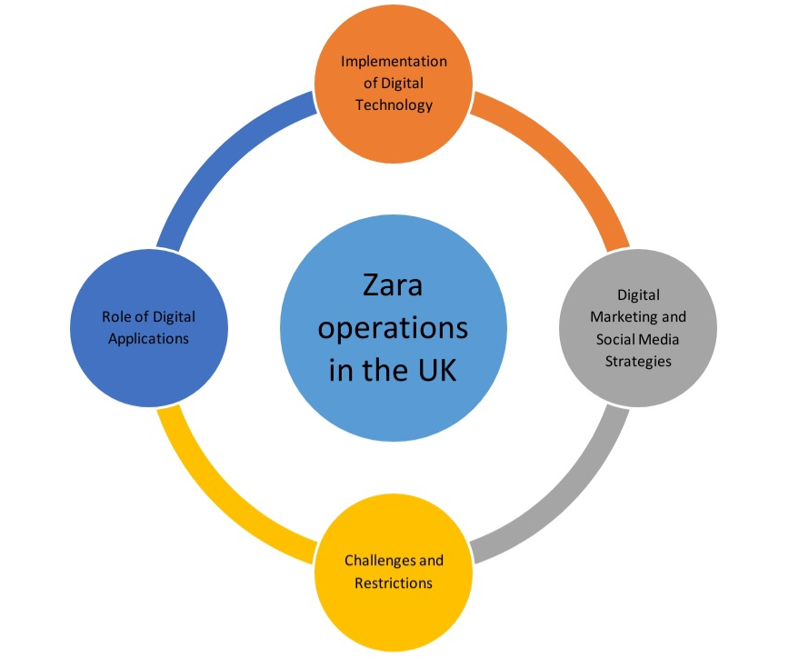
Figure 3 Conceptual Framework

Conclusion of Chapter
Zara has achieved remarkable results in improving customer experiences and streamlining processes by integrating digital applications strategically, and the company's dedication to using technology, from augmented reality to data analytics, has not only improved sales but also developed an enthusiastic base of patrons. After overcoming obstacles like antiquated systems, cultural resistance, and rivalry in the market, ZARA has effectively leveraged digitization to transform its industry. ZARA's journey illustrates the seamless integration of technology and fashion, underscoring the importance of embracing digital innovation in the modern retail industry. By prioritizing customer-centric approaches, data-driven decision-making, and agile strategies, ZARA has not only navigated the complexities of digital transformation but has emerged as a frontrunner in the competitive UK market. This chapter comprehensively explores the digital transformation journey of ZARA in the UK, emphasizing the transformative impact on various aspects of its business operations along with an in-depth analysis of ZARA's digital initiatives, shedding light on how the brand has utilized technology to enhance customer experiences both online and in-store.

CHAPTER 3: RESEARCH METHODOLOGY

Introduction
This chapter covers research theory, design, methodology, data collection, and analysis, in addition to ethical concerns. The process for obtaining and assessing the research's data is covered in this chapter.

Research Design
Research design refers to the overall structure or plan that guides an inquiry. It outlines the methods, procedures, and schedules for obtaining and analyzing data. According to Pham (2018), descriptive research designs focus on understanding and characterizing a phenomenon without altering or changing it. Meticulous observation, data collection, and analysis are required to provide a complete and accurate picture of the study issue (Ryan, 2018). The application of experimental and correlational research design in not effective for current research as these research design would not assist researcher to descriptively analyse the digitisation process and strategies of Zara rather it will assist researcher in correlational, cause and effect and experimental analysis of digitalisation in zara which is quite time consuming. The use of a descriptive research design is crucial in providing insight into Zara's digital transition in the United Kingdom. The researcher is able to completely and methodically detail all of the many aspects of Zara's digital transformation plan by using this design.
The researcher acquires extensive information on the brand's shift to digital platforms from secondary data sources, including newspapers, journals, articles, and websites. The descriptive design makes it possible to see Zara's modifications in a comprehensive way, including the precise actions taken, the technologies used, and the effects they have on the UK market. It makes it possible to illustrate in great detail how Zara uses technology, the evolution of e-commerce infrastructure, adjustments to supply chain operations, and digital consumer interaction tactics. Furthermore, by using a descriptive design, the researcher is able to provide an understandable and cohesive account of Zara's digital transition in the UK before and after. It contributes to the identification of patterns, trends, and significant aspects of Zara's journey, offering a deep and intricate comprehension of the company's tactics and their results in the UK market. With the use of this design, a thorough and organized study is made possible, providing insightful knowledge on Zara's digital transformation in the UK.

Research Philosophy
Research philosophy, as used in methodology, describes the fundamental beliefs and assumptions that guide a researcher's approach to doing research. There are many different types of research philosophies, including positivism, interpretivism, and pragmatism. Weligodapola and Darabi (2018) state that the interpretivism research philosophy strongly emphasizes the need to understand and interpret people's subjective meanings and experiences. It often uses qualitative methodologies to explore social phenomena in context and emphasizes the impact of culture and setting on human conduct.
By using an interpretative research philosophy in the analysis of Zara's digital transformation in the UK, the researcher is able to provide valuable data about the study subject. Using an interpretative method, the researcher acknowledges the significance of personal experiences, individual perspectives, and social constructs in understanding the phenomena of Zara's digital transition. This way of thinking makes it simpler to look at the many perspectives and reactions of consumers, industry experts, and stakeholders about Zara's digital activities. Thanks to interpretivism, the researcher is able to comprehend the intricate and context-specific details of Zara's shift in the UK market. It enables a comprehensive analysis of the effects of digital integration on culture, society, and consumer behavior in addition to its technical aspects. Using qualitative research methods, interpretivism enables deep, individualized insights, comprehension of social processes, and investigation of several points of view (Lowe, Farris, and Babbage, 2018). Positivist research philosophy will be rejected by the researcher as it creates possibility of weakness in theory and ineffective attempt to generalise the result lacking the specificness. Realism research philosophy does ot allow inclusion of intuition and mediation in the researcher which is the prime research of researcher for its rejection.
By accounting for factors including changing purchasing habits, technological preferences, and local fashion trends, the researcher is able to get a greater knowledge of how Zara's digital innovations interact with the UK client base. This mindset also encourages the researcher to look at a range of qualitative sources, such as journals, publications, and consumer feedback, to increase the study's breadth and depth. It simplifies the complex connections between Zara's digital initiatives and the changing UK market landscape. Consequently, the interpretive approach produces a comprehensive and impartial analysis that offers valuable insights into Zara's digital transformation inside the UK market.

Research Approach
Research approach refers to the methodical techniques employed to examine a study subject. A systematic approach to doing research and obtaining data to address a certain study subject or problem is referred to as a research strategy. There are two main approaches: the deductive approach and the inductive technique. The deductive approach seeks empirical evidence to validate or invalidate these hypotheses. According to Kosie and Lew-Williams (2022), the deductive approach promotes a systematic, methodical approach to data processing, laying the groundwork for organized, logically coherent research. According to Irshaidat (2022), this method is used in quantitative research and strives to show causal relationships based on recognized theories. Assisting in the generation of fresh ideas and hypotheses during exploratory research enhances our understanding of the problem.
The researcher's choice to investigate Zara's digital transformation in the UK using a deductive approach yields enlightening findings consistent with the study's focus. Using the deductive technique, the researcher builds a strong framework for their study by drawing on pre-existing ideas, concepts, and facts concerning digital transformation. This approach makes it easier to analyze the material that is accessible in an organized and methodical manner from a variety of sources, including journals, publications, websites, and newspapers. Inductive research philosophy isn't widely embraced due to its perceived subjectivity and reliance on specific cases. Many researchers prefer deductive approaches for their structured, theory-driven methods. Inductive methods can be viewed as less rigorous, potentially leading to biased interpretations. Personal biases may influence findings, making it a less favored choice in the research community.
Moreover, the researcher adapts well-established theories and models of digital transformation to the particular instance of Zara in the UK by using the deductive technique. With the use of this technique, patterns, trends, and possible causes that could be affecting Zara's digital transformation in the UK market are found. The researcher creates predictions and findings based on accepted theories by using deductive reasoning, which gives rise to a more thorough grasp of Zara's digital transformation strategy and its effects on the UK market. The researcher's ability to organize the analysis methodically using this methodology makes it possible for the results to be presented in a more logical and cogent manner, which greatly increases the validity and depth of the conclusions drawn from the study. The researcher will reject the application of the inductive research approach as it requires prior knowledge of the subject matter creating high chances of failure of research if the researcher does not have prior knowledge of the main research topic.

Research Strategy
A research strategy is a set of plan, procedure, policies that provides direction to research to perform research activity to achieve the predetermined research objectives. Morver, it has been mentioned in Giovannini et al. (2020) that there are primarily two categories of research strategy which are qualitative and quantitative research strategy. As the research is collecting data from secondary sources, qualitative research strategy will be highly effective to analyse the collected data. Qualitative research strategy will analyse the hidden meaning and emotion of collected data to effectively analyse the digital transformation of Zara in the UK market. Moreover, qualitative research strategy provides more in depth analysis of research phenomena (Gu et al. 2020).
The researcher will be analysing the factors related to digitalisation in the business environment of Zara in the market of the United Kingdom. Furthermore, qualitative research strategy will also allow researchers to include data related to human emotions and behaviours to analyse the research topic more accurately. Inclusion Of data possession information about human behaviours and emotions rejected under quantitative research strategy which is the prime research behind its rejection by the researcher to conduct current research strategy.

Data Collection Methods
Data collection is the systematic process of gathering facts and information to investigate a certain topic or address research issues. The main and secondary ways of data collection are the two basic categories. Rather than gathering new information, Carmichael and Cunningham (2018) contend that secondary data collection should include the analysis of pre-existing data. The use of a secondary data-gathering method by the researcher is crucial in obtaining significant results for the investigation of Zara's digital transformation in the United Kingdom.
By using pre-existing data from newspapers, journals, publications, and websites, the researcher is able to access a wealth of material that provides an in-depth understanding of Zara's digital transformation in the UK market. This method gives the researcher access to a multitude of reputable sources, providing a comprehensive understanding of Zara's digital tactics, consumer interaction, and market positioning. Through the process of amalgamating data from various media and platforms, the researcher acquires a range of views that enable an exhaustive examination of the brand's digital endeavors.
In addition, the secondary data gathering technique makes it easier to analyse long-term patterns and modifications in Zara's digital strategy by providing a historical framework that makes it easier to comprehend how the firm developed in the UK market. Data related to the digitalisation strategy, implementation and strategy and analysis of their business environment will be gathered from the peer reviewed articles in order to effectively analyse digitalisation in the setback of Zara. Data will be taken from peer reviewed articles published after 2019.
Furthermore, secondary data collecting methods allow for the efficient and economical gathering of large amounts of information without the need for primary data collection techniques, which sometimes need a large investment of time and money. Ultimately, the researcher's use of secondary data proves to be a very useful strategy that allows for a thorough examination of Zara's digital transition in the UK market.

Data analysis
The collected secondary data was deciphered using a thematic data analysis which will allow for the creation of themes using the secondary literature. The use of thematic data analysis allows for a comprehensive understanding of the secondary data through the different perspectives of themes. It has been mentioned in the study of Carmichael and Cunningham (2018) that the application of thematic data analysis is highly effective in order to dive deep into the different aspects of the main research question on the basis of creation of different themes reflecting different factors associated with the research questions. The cure research has also got benefits of deep analysis with heptics data analysis.

Ethical Considerations
The researcher considers many ethical principles while collecting data from secondary sources for the study on Zara's digital transformation in the UK. The sources of all the information the researcher gathers from books, journals, newspapers, and websites shall be duly acknowledged and recognized. This moral strategy protects the writers' intellectual property rights while promoting transparency and honouring the contributions of the original authors.
Additionally, the researcher prioritises the material's legitimacy and dependability by cross-referencing data from other trustworthy sources. They thoroughly evaluate the veracity of each source, removing those that include biassed or erroneous information. By drawing from a broad range of trustworthy publications and sources, the researchers reduce the likelihood of skewed data, enhancing the validity of the study's conclusions. Furthermore, confidentiality is preserved by not disclosing confidential or secret information obtained from the sources that would contravene agreements governing privacy or confidentiality. By taking this action, the study's ethical standards are respected, and the identity of the participants or organisations is kept private. To ensure that their study on Zara's digital transformation in the UK is legitimate and genuine, the researchers consider ethical considerations such as proper attribution, data integrity, and anonymity protection.

Limitations
The researcher uses the application of a descriptive research design that increases the possibility to make the research lengthy resulting in the loss of relevance and authenticity to the solutions to the predetermined research questions to analyze the digitalization in the working culture of ZARA. Moreover, the researcher selects the interpretivism philosophy followed by the deduction research approach that also poses a risk to make the research time-consuming, lack in-depth analysis, inclusion of biases, and limited research scope. Secondary data that is out-of-date or insufficient for examining digitization of Zara may not be specific enough to analyze the strategies of the company. It might miss confidential information or recent advancements, which could result in incomplete or erroneous conclusions.

Research Question
● What are the impacts of digital transformation on the business operation of Zara in the UK market?
● How has ZARA implemented digital applications in its business operations in the UK?
● What are the challenges and benefits of digital transformation witnessed by ZARA considering the UK market?

Research Hypothesis
Digital Transformation's Effect on Zara's UK Business Operations:
H0: Zara's business operations in the UK are not significantly impacted by digital transformation activities.
H1: Zara's business processes in the UK have been significantly impacted by digital transformation projects, which have increased overall performance, consumer engagement, and efficiency.
Zara's use of digital applications in the United Kingdom:
H0: Zara's business activities in the UK do not yet have a strategic integration of digital apps.
H1: In order to improve consumer experience and optimise internal procedures, Zara has proactively incorporated digital applications into its business operations in the UK. The company does this by utilising technology like data analytics, e-commerce platforms, and supply chain management systems.
Zara's digital transformation challenges in the UK:
H0: Zara's embrace of digital transformation in the UK market is not beset by major obstacles.
H1: Zara's adoption of digital transformation in the UK market is beset by difficulties, such as data security concerns, opposition from employees, and the requirement for ongoing technology updates, all of which might impede the smooth integration of digital solutions.
Advantages of Zara's Digital Transformation for the UK
H0: Zara's efforts to undergo a digital transformation in the UK have not yielded any noticeable results.
H1: As a result of its digital transformation initiatives in the UK, Zara has seen observable results including higher sales, improved inventory control, and a more responsive supply chain, all of which have improved the company's competitiveness and satisfied customers.

Conclusion
It can be deduced from the methodology chapter that the researcher will use interpretivism research prodigy backed by the implementation deductive research approach. The data will be collected by secondary sources that include research papers, studies and articles published in the synthetic sources. Data collection processes the authenticity of the research study selected for data extraction by aligning the abstract of the research with the current research questions, objectives and aims.

CHAPTER 4: FINDINGS / RESULTS, ANALYSIS AND DISCUSSION

Summary / Presentation of Findings / Results

4.1 Analysis and the impact of digitalization on the overall business performance of ZARA.
According to Megan (2019), to satisfy selective customers, Zara's "fast fashion" business model enables merchants to provide designer goods at competitive rates and in a flash. Because of lead times and seasonality, traditional fashion stores find it difficult to handle this. To meet the needs of these customers, Zara has created a flexible, quick-to-assemble supply chain that reduces the production cycle to under three weeks. To maintain its competitive edge, Zara has concentrated on leveraging digitalization and big-data analysis to boost sales turnover while utilising less working capital. Through the use of RFID microchips in clothing tags, Zara can offer its central data processing centre with real-time inventory tracking data. This enables twice-a-month product deliveries that are customized for each store. This reduces waste and removes fashion risk by enabling Zara to improve distribution, design, and inventory management. Long-term, Zara is putting more and more emphasis on digitizing every aspect of the shopping experience for customers, including online "click and collect" at its flagship stores. This might function as a supply chain that is just in time, eliminating inventory. Zara may be able to compete with online stores like Amazon and gather more sales data by creating an online presence as said by Megan, (2019).
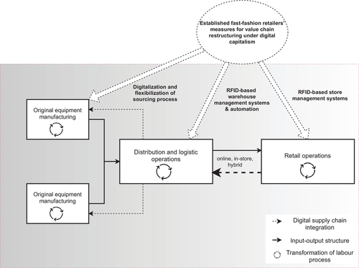
Figure 4 Linking digital value chain restructuring, governance, and labor process transformations in the fashion.
Source: López, (2022).
The above figure showcases the digital value chain restructuring, governance, and labor process transformations in the fast-fashion. According to Multinational retailers’ source from exporting nations in the Global South as part of the buyer-driven fashion value chain. In the 1990s and 2000s, new technology and the relocation of sourcing activities to industrializing nations gave rise to a particular kind of fashion value chain known as "fast fashion." Due to digital technologies like RFID, cloud computing, and robotic automation, the fast-fashion industry has undergone both technological and geographic disruption. Customer preferences migrating toward online channels and the emergence of ultra-fast pure online shops have been the main drivers of this transition. Fast-fashion chains with a long history, like Zara, have improved speed, flexibility, and cost-efficiency by restructuring their supplier networks, retail and logistical operations, and supply chain coordination. Along with strengthening regionalized sourcing, they have implemented digital supply chain management systems as well as digital store and warehouse management systems.
The construction of automated factories in consumer markets and an increase in clothing orders from EU brands are the results of these shifts. Near-source operations are predicted to persist in the upcoming years, even though these patterns do not point to a more significant geographic change in sourcing activities. For suppliers in well-known Asian production nations, like China or India, to be long-term partners in the supply chains of fast-fashion retailers, there is growing pressure on them to improve the cost-effectiveness and flexibility of their manufacturing operations through automated and digital production technologies.
Governance and labor in the fast-fashion GVC are being impacted by digitization. Improving information exchange between suppliers and retailers has the potential to move traditional governance models toward relational coordination. There is, however, little proof that suppliers adopt strategic inventory management practices. Aiming to improve supply chain speed, flexibility, and cost-efficiency, fast-fashion retailers' value chain power is being consolidated through digital supply chain integration, which has an impact on labor processes.
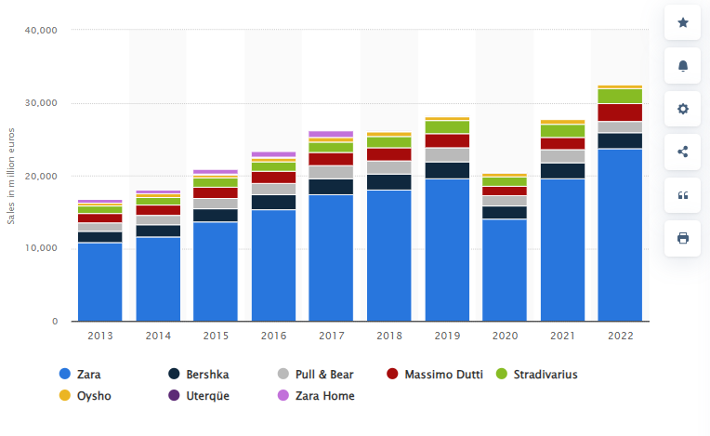
Figure: Zara Net Sales
Source: Smith, (2023)

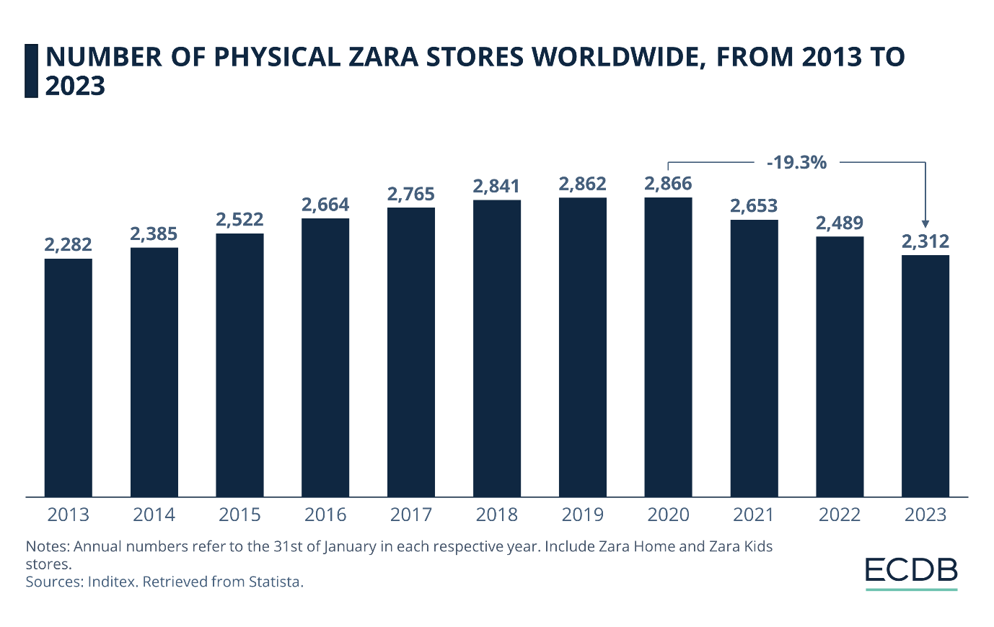
Figure: Zara Physical Stores
Source: ECDB (2023)
The fashion behemoth Zara expertly blends digital and physical sales channels in a mesmerising harmony that highlights both notable contrasts and fascinating connections. Although traditional stores continue to be the dominating force, accounting for 85% of revenue in 2022 (Inditex Annual Report 2022), a tech-savvy, convenience-seeking population is driving exponential growth in online sales. Zara's fundamental character remains intact despite this digital transformation. The same cutting-edge styles, alluring prices, and quick product cycles are provided by both channels, creating a unified brand experience.
Additionally, a smooth omnichannel approach makes it possible for customers to order for in-store pickup, explore online, and even return items they've made online to actual locations, completing a cohesive shopping experience. Despite these parallels, marketing approaches differ. Online campaigns use email marketing, social media, and customised advertising to reach a worldwide audience. On the other hand, physical retailers use in-store promotions, eye-catching window displays, and strategic positioning to draw in local customers. Each consumer category has specific demands and interests, which are reflected in this differentiation.
Although traditional stores are still more profitable than online ones because they have lower operating expenses and higher average order values, Zara's dedication to e-commerce infrastructure and creative online marketing techniques portends a time when the physical and digital worlds will coexist together. This omnichannel strategy will satisfy consumers' needs for both the ease and wider choices that come with online buying as well as their desire for real-world shopping experiences. With its sophisticated marketing and cohesive brand experience, Zara can likely manage this changing market and maintain its leadership in the fast-fashion sector.

According to Future Stores, (2023), the retail industry is changing as a result of AR and VR, which offer distinctive consumer experiences in real-world settings. According to a GlobalData research, people are embracing AR and VR due to the widespread use of smartphones and wearable devices. Fast fashion company Zara tested an augmented reality campaign in April, putting AR screens in 120 stores across the globe for two weeks. Lea Julian and Fran Summers were among the virtual models that appeared in the ad, posing, strutting, and conversing for short periods of seven to twelve seconds on customers' phone displays. Along with clothing displays, storefront displays, and AR-enabled packaging and promotional materials, Zara's augmented reality app (available for iOS and Android) was utilised. The experience featured brief 7–12 second spurts of augmented reality visuals of international models strutting, posing, and conversing on consumers' phone screens. On one of the largest stages in terms of square footage, measuring 170 square metres, customers could watch 12 distinct situations that were recorded by 68 cameras.
Following a number of other technological advances, including package-picking robots and a London pop-up shop devoted to digital sales, came the advertisement. A new first quarter revenue record of EUR5.7 billion ($6.6 billion) was announced by Zara and its parent company Inditex. This is a 2% increase over Q1 2017 as per Future Stores, (2023). Though in-store augmented reality is still relatively new, it is unclear if adding more permanent features will increase sales and create more consumer loyalty. The future of retail experiences is augmented and virtual reality, according to Andreas Olah, Lead Analyst at GlobalData. It was anticipated that AR and VR would be used in a variety of ways, such as virtual try-ons for clothing, in-store navigation, product demos, games, and communication with virtual shop assistants as stated in Future Stores, (2023).
According to Unmetric, (2019), one of the biggest names in fast fashion, Zara, is well-represented on social media sites including Facebook, Instagram, YouTube, Pinterest, and LinkedIn. Instagram and Facebook are the brand's primary social media channels, and they are their primary marketing channels. The most engaging content on Zara's Facebook page is provided by lookbook-style photographs that highlight their most recent collections. The company participated in 255 user interactions and promoted 236 posts, including 143 photographs, and got an 81% positive response from their audience.
Zara's approach to Twitter is to engage with customers and aggressively address their questions and problems. With 10,937 tweets answered, the brand maintains a 9.6% response rate. The best-performing content is new product announcements and arrivals, and Zara remains current by contributing to discussions about societal issues. Zara frequently appears in fashion publications, journals, and websites; Elle España has 241 @-mentions, British Vogue has 15, and InStyle and WWD have 6 @-mentions. High-profile influencers, such as celebrities like Danielle Peazer, Davina McCall, Nigella Lawson, Vicky Pattison, and Amanda Holden, have also @mentioned the company. To sum up, Zara's technologically advanced strategy, adaptable supply chain, and emphasis on content that is centred around products have been key factors in the fast fashion company's success. Leading clothing store Zara has grown its Instagram following by 8.5 million in the past year, to a total of 24.3 million. 340 images and 149 videos comprise the 469 postings that the brand has released. Integrated initiatives have also been introduced by Zara; one such campaign, the #joinlife sustainable apparel range, garnered over a million likes. For their 'Timeless' campaign, Zara garnered plaudits for its influencer marketing strategy, which featured models over 40.
Zara's social media strategy is based on visual components, regular updating, building relationships with customers, and getting support from bloggers and influencers that are interested in fashion. Despite bad press like the Pepe the Frog scandal, the brand has remained silent. The secret to Zara's success is its steady use of social media to interact with consumers and maintain brand loyalty. Every brand requires a solid social media marketing plan in order to expand and stay competitive in the modern business world.

4.2 Analyzing the challenges in the digital transformation of ZARA.
The most significant obstacle ZARA faced during its digital transformation process in the UK was the smooth incorporation of digital technologies into its pre-existing operation structure. Careful planning and strategic execution were necessary to modify legacy systems to accept cutting-edge digital technology without interfering with regular business operations and in order to ensure that their digital initiatives and their digital initiatives and their current infrastructure coexisted peacefully, ZARA had to manage a complex process.
For example, According to Zhang et al. (2023), RFID technology was incorporated by ZARA into their stores, allowing for real-time inventory tracking, and by 2016, 1,000 stores globally were equipped with RFID, demonstrating the complexity of integrating this technology across a vast retail network. The author also stated that RFID technology implementation led to a 10% increase in sales for ZARA due to improved inventory accuracy and reduced stockouts. Additionally, introducing digital transformation into any organization requires a fundamental shift in mindset and work culture, and employee opposition to ZARA’s change management practices was a result of their familiarity with the current situation. To ensure a seamless transition and promote a culture of digital literacy and adaptation, employee training programs were crucial in acquainting the workforce with new technology. Moreover, safeguarding client data became a top property as ZARA moved into the digital sphere and since online platforms are being used a lot of consumer data is being gathered, ZARA has made a large investment in strong cybersecurity protections. It was not just a technical problem in ensuring data security and privacy protection, it was also an issue of winning over clients by adhering strictly to UK data protection laws.
According to Alawida et al. (2022), 46% of businesses have identified at least one cybersecurity breach or attack in the last 12 Months, emphasising the prevalent landscape. Customers in the digital age demand quick delivery, personalised services, and flawless online experiences and for Zara, meeting these elevated expectations was a major problem. The business had to make significant investments to improve its user interfaces, internet platforms, and order fulfilment procedures and it became a sensitive but important challenge to strike a balance between satisfying client requests and maintaining operational efficiency. Zara's supply chain as a whole was included in its digital transformation, going beyond only online sales and managing inventories, real-time delivery logistics, and internet orders all have to be coordinated. The business wanted to optimize its supply chain procedures to guarantee a coordinated delivery of items from the point of production to the client's door and strong digital tools and creative solutions were needed to manage this complex network of operations.
According to Eslami et al. (2021), 79% of companies with high-performing supply chains achieve revenue growth significantly above the average within their industries. Furthermore, Zara had to negotiate a complex web of laws and regulations pertaining to e-commerce, data security, and consumer rights in order to operate in the UK market. The digital transformation process was further complicated by the fact that compliance with these laws was mandatory and in order to reduce the dangers associated with non-compliance, Zara had to invest in legal knowledge to make sure that all digital activities complied with UK legal requirements.

4.3 Benefits of adopting digital and social media marketing strategy at Zara
Zara has made significant investments in producing visually appealing content by often posting stunning photos and videos of their newest collections on social media. Their goal is to capture the audience's interest and persuade them to learn more about the company through their content. Popović-Šević, et al. (2021) states that Zara opened its online store in 2010. The website was first made available in Spain and the UK, and that same year, the online retailer Zaar extended its services to five other nations: Austria, Ireland, the Netherlands, Belgium, and Luxembourg. In addition, the business came in at number 35 on the same list in 2020, with an estimated brand worth of $14.862 billion, compared to nearly $17 billion in 2019 (KMPG 2019). Zara fell from 29th to 35th place in a single year as a result. The business is not the only clothing line to have reported lower sales in 2020 than in 2019. The brand is well-known and positioned in the international market since the COVID-19 epidemic has had a detrimental effect on the whole global fashion sector.

Skeldon, (2023) stated that social media expert Maybe performed the study and that, based on their observational data, Zara topped the list overall with 290,000 engagements over the course of the month, or around 9,400 interactions with its material each day. Its Instagram post featuring its women's capsule collection, which received close to 71,000 likes, was its most popular post. Additionally, New Look received the largest cut through 1.55% as opposed to Xara's 0.335 when overall engagement was measured as a percentage of total followers. Other merchants saw a higher percentage of interaction than their River Island scored 0.93%, while Jack Wills scored 1.17%.

As discussed by Shabir, and AlBishri, (2021), Inditex, the parent company of Zara, had a $299 million deficit in the first quarter of 2020, following a prosperous second quarter that significantly alleviated the adverse beginning of the year. Owing to the sudden effects of the COVID-19 pandemic, there was a massive $481 million loss in the first three months, but a $253 million profit was made in the second quarter.

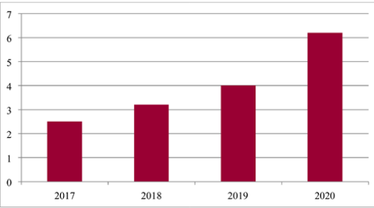
Figure 5 Zara online sales trends
Source: Shabir, and AlBishri, (2021)
The trend of Zara's online sales is seen in the above image. In contrast to other years, its internet sales in 2020 were very strong. During the same time frame, internet sales rose 74%, following other companies' experiences with customers shifting online during the COVID-19 epidemic.

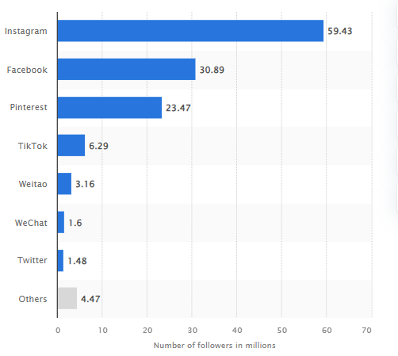
Figure 6 Number of social media followers worldwide 2022
Source: Statista (2023)
The above figure showcases the amount of Zara's social media followers worldwide in 2020, broken down by social media platform. Zara had about 59 million Instagram followers as of the fiscal year 2022. It also had over 15 million Twitter followers and 1.6 million WeChat followers, which is a popular platform among Chinese people. This suggests that Instagram has the most following, which influences buyers to buy their eye-catching product and apparel lines.
According to SwiftERM, (2023), Zara's eCommerce division has grown to operate in over 41 countries. Zara's strategy leverages automated methods and integrated stock management to tailor messaging to individual customers' online behaviour and purchasing demands while remaining on-target. Over 6,000 stores under parent company Inditex; 80% of investments for opening or renovating stores; 20% for developing technology capabilities; majority of business in China and Spain; 41% increase in eCommerce revenue in 2017; over 10 million daily visitors; ranking No. 390 in the Internet Retailer 2017 Top 500; and opening its first pop-up store in London are just a few of Zara's impressive statistics. With little to no promotion, investments in premium real estate, and the opening of flagship stores in well-known areas, Zara's eCommerce approach has flourished.

4.4 Comparative study of online and store sales of Zara
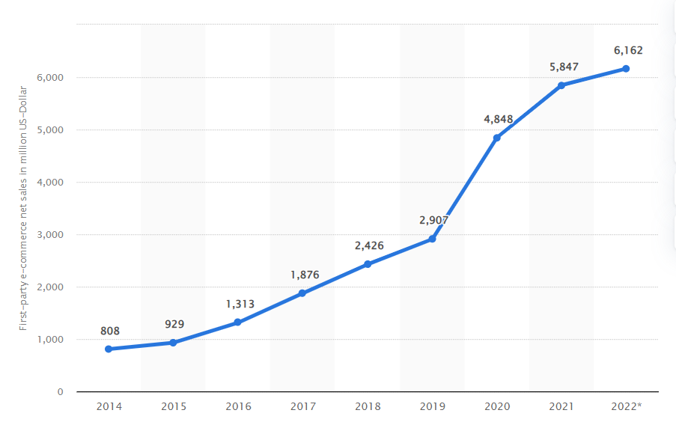
Figure 7: Increasing online sales of Zara
Source: Statista Research Department and 11, (2023)

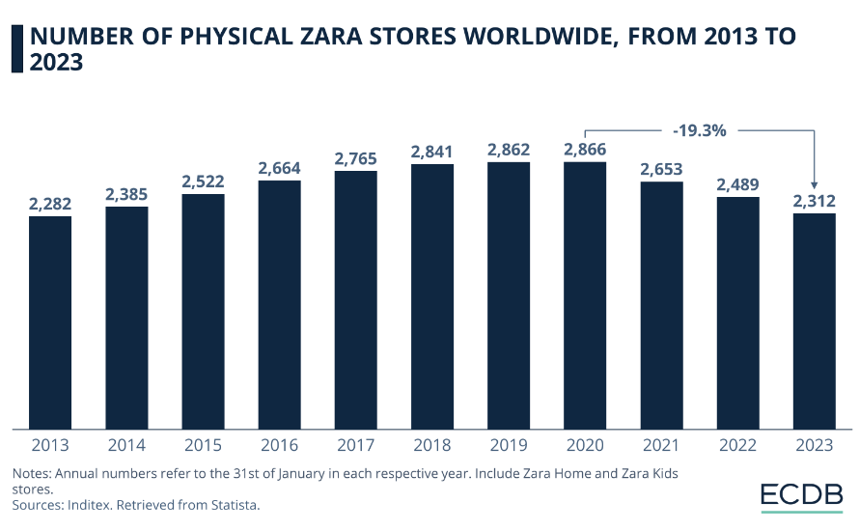
Figure 8: Decresign outlets of Zara from 2013 to 2023
Source: Statista Research Department and 11, (2023)
Inditex's flagship brand, Zara, passed a radical makeover in response to the COVID- 19 epidemic and other dynamic changes in the retail assiduity. The fashion empire endured a noteworthy 64% increase in net deals online onzara.com in 2020 as compared to the previous time, climaxing in a significant€5.9 billion (Statista Research Department and 11, 2023). This remarkable expansion comes after a record- breaking 2017 in which time year-over-year growth of 43 laid the root for unborn success up until the epidemic's inception. With an astounding 126 time year-over-year growth, Zara's home décor website,zarahome.com, surpassed the vesture section and reached total net deals of€ 322 million in 2020. Leading Functional adaptations in response to lesser online competition, changing consumer preferences, and rising company charges from affectation and high energy prices, Zara, as the face of Inditex, led the way. One significant change passed when physical stores were reduced by19.3 worldwide since 2020. The number of Zara stores, which includes Zara Kids and Zara Home, peaked at 2,866 in 2020 but fell to 2,312 by the morning of 2023 (Statista Research Department and 11, 2023). This is in line with further general trends in the sector, which emphasise closing underperforming locales to strengthen digital and cold-blooded immolations while growing and perfecting living bones . Zara's fidelity to a dynamic business model that embraces the changing retail geography is demonstrated by its purposeful drop of physical shops combined with strong online development. This approach eventually ensures adaptability and sustained success in a fast changing terrain.

Analysis of Results
According to MOSCHETTI and ZANABONI (2018), the goal of Zara's first London location, a "temporary concept store," is to combine physical and virtual shopping. A limited but well-chosen selection of the current collection for men and women is available at the pop-up store, which is situated on the first level of the Westfield Stratford retail centre. However, customers can peek at and touch items without trying them on or making a purchase. Payments are conducted through cell phones and Bluetooth. Customers can get styling advice and dress-matching accessory recommendations from the Zara app. Also, the Inditex plan, which wants to integrate more stores with the internet world, includes this new concept store as a significant step forward.
The new Zara megastore, which will almost double the size to 4,500 square meters on two stories, will remain open until the pop-up shop does. In contrast, a new store structure called Retail 2.0 was created with the idea of utilizing modern technologies to save money on monthly rent and store space. This layout does away with the necessity for stock rooms and fitting rooms by shrinking the store's physical space through the use of innovative technologies. In contrast to conventional retail practices, Zara's new store only offers a selection of items that match the most recent collection rather than the whole range of products.
Consumers can see and handle merchandise in-store, evaluate its features and calibre, and make payments using cash or credit cards. The store is significantly smaller than before, requiring a lot less area to set up to lower monthly rent and boost sales per square meter. The 1975-founded fast-fashion retailer Zara has had success with its business strategy, which emphasizes client satisfaction and technological innovation. According to Gosselin (2022), the company announced a 74% rise in online sales in 2020, underscoring the significance of its "integrated store and online" approach. However, as the eco-movement gains momentum, consumers' concerns about sustainability are growing. Zara can increase e-commerce sales and forecasting patterns of best-selling products by utilizing artificial intelligence.
On the other hand, with ambitions to reopen 98% of its locations by 2022, the company's digital transformation is essential for a brick-and-mortar retailer. Zara's online sales have increased by 74%, demonstrating the strength of its e-commerce strategy. However, Zara's end-to-end supply chain is under strain due to the growth of ultra-fast fashion, raising questions about sustainability. Zara has created its sustainable collection under the #joinlife monogram in response to these worries.
AI may enhance customer-focused strategies, increase e-commerce, and make business more sustainable. Zara is already measuring the number of apparel in boxes and enhancing stock inventories through partnerships with Jetlore, Intel, Fetch Robotics, and Tyco as per Gosselin, (2022). To safeguard product inventories and enhance supply chain traceability, they also used Tyco microchips. But Zara may utilize AI-powered trend forecasting to sharpen its trend sense and stay ahead of rivals and the latest players in ultra-fast fashion to stave off competition. The state-of-the-art technology offers direction for online merchandising photoshoots and lookbook by identifying and forecasting popular product and brand connections, styles, color, and textures.

According to Zhang et al. (2023), Zara’s digital transformation in the UK involved several complex challenges. The adoption of digital technologies into the existing operational structure required careful planning and execution. Notably, the successful adoption of RFID technology has highlighted the complexity of implementing innovation across a retail sector. The technological advancement not only enhanced inventory accuracy but also yielded a significant 10% increase in sales indicating the tangible benefits of resolving these significant challenges.
In addition, the challenges in terms of technology, Zara has addressed the need for a cultural transformation and faced resistance from employees. In order to address the challenge, the company implemented employee training programs, a significant factor in enhancing a culture of digital technology and adaptation. In contrast, the data security and privacy were obvious due to the prevalent cybersecurity environment. Zara’s significant investments in cybersecurity measures aligned with its commitment to safeguarding client data and ensuring compliance with strict UK data protection laws (Zhang et al. 2023). Moreover, meeting elevated customer expectations such as rapid delivery and personalised services has significant challenges.
The company has heavily invested in enhancing user interfaces, internet platforms and order fulfilment procedures highlighting the company’s commitment to enhancing the customer experiences while upholding operational efficiency. According to Alawida et al. (2022), the optimisation of the supply chain has expanded their online sales to encompass real time delivery logistics and inventory management. This required the utilisation of effective digital technology from production to the customer contributing to revenue growth.
According to Popović-Šević, et al. (2021) Zara’s strategic use of social media marketing and online presence has led to significant results and challenges. The company has leveraged visually appealing content representing posts and videos of their collection on social media with the aim of reporting the audience’s interest and engaging them with the brand. The online store was launched in 2010, initially in Spain and the UK, indicating the beginning of Zara's digital expansion. However, the covid 19 pandemic significantly impacted Zara’s sales contributing to a significant decline in its estimated brand worth from $17 billion in 2019 to $ 14.862 billion in 2020.
In contrast, Shabir and AlBishri (2021) discussed the financial performances of Zara’s parent company, Inditex during the covid 19 pandemic. The company faced a $ 299 million deficit in the first quarter of 2020 due to the pandemic’s significant impact but managed to recover with a $253 profit in the second quarter. Additionally, Zara’s online witnessed a significant 74% increase in 2020 meeting with the global shift towards online shopping during the pandemic. The findings of Statista (2022), have demonstrated that the brand’s significant presence on Instagram, Twitter and We chat indicated that Instagram has resulted in the highest number of followers. This signifies the influence of Instagram in engaging potential buyers with Zaara’s visually attractive products and apparel lines.

Discussion of Results

Impact of Digitalization on ZARA's Business Performance
ZARA’s digital transformation journey was distinguished by the integration of state-of-the-art technology, with an emphasis on optimising supply chain effectiveness. According to Park, Kim, and Lee (2020), Radio-frequency identification (RFID) was one of the key technologies that ZARA adopted and ZARA’s inventory management was replenished by RFID technology, which made it possible to track products in real-time throughout its extensive retail network. However, Guchhait, Pareek, and Sarkar (2019) stated that ZARA was able to obtain real-time inventory tracking information by carefully placing RFID microchips in clothing tags, which made supply chain coordination more effective and ZARA’s production cycle was improved to less than three weeks and lead times were decreased due to large part to this innovation. This nimble supply chain model allowed ZARA to meet the demands of its selective customers promptly, a feat that traditional fashion stores found challenging due to lead times and seasonality (Megan, 2019). Additionally, by implementing RFID technology, ZARA was able to save waste and minimise fashion risks by delivering products tailored to each store twice a month. Moreover, Shabir and AlBishri (2021), stated that ZARA’s digital endeavours encompassed the web domain, wherein the organisation utilized augmented reality and mobile platforms to boost client experiences and an important turning point in ZARA's digital history was the release of its mobile app in the middle of the decade. The app supported the expanding trend of mobile commerce by giving users a smooth browsing and buying experience on tablets and smartphones and the application’s incorporation of augmented reality (AR) technology was a fitting complement to this user-centric strategy. Customers may now virtually try on clothing due to ZARA's creative usage of augmented reality, which solves a major problem for online clothing retailers: the inability to try on clothing in person (Shabir and AlBishri, 2021). According to consumer surveys Shabir and AlBishri (2021),, 61% of customers preferred stores offering AR experiences, indicating the growing demand for immersive technologies in enhancing the shopping journey. ZARA digital transformation efforts encompassed not only these customer-facing advances but also data-driven tactics that prioritized individualized marketing and effective supply chain management.
ZARA used data analytics in a strategic way to learn about the interests of its customers, which helped the business create marketing plans that were specifically tailored to them these strategies focused on creating enduring customer relationships through tailored interactions and were based on relationship-oriented ideas such as the customer relationship management (CRM) model (Jovanović, 2022). ZARA optimized its product offers, costs, and customer support by analysing consumer data, product quality factors, product style, pricing, brand image, service quality, and retail environment. Na et al. (2022), stated that the application of machine learning algorithms for large-scale data analysis further streamlined inventory management and forecasted demand trends, ensuring products were accessible when and where customers desired, thus enhancing operational effectiveness and optimizing revenue. ZARA's business performance was visible through key measures that demonstrated the impact of these digitalization efforts and online sales increased significantly, indicating that consumers are increasingly favoring digital platforms for their purchases. Furthermore, statistics like average session duration, active users, and app downloads highlighted how well-received ZARA's user-focused features and design were and The company showcased the real impact of digital strategies on revenue generation in 2020 when it recorded a spectacular 36% rise in online sales, attributing the gain to its digital activities (Jovanović, 2022).

Challenges and Solutions in ZARA's Digital Transformation
ZARA had several major difficulties, one of which was incorporating state-of-the-art digital technology into its already-established organisational framework. The company's antiquated systems, created in a bygone period, presented a major challenge and it took careful planning and execution to move from old means to digital platforms with ease. Alawida et al. (2022), stated that ZARA had to make changes to these outdated systems without interfering with daily business operations and the use of Radio-Frequency Identification (RFID) technology, a pillar of ZARA's digital strategy, demonstrated the intricacy of this undertaking.
ZARA made real-time inventory tracking possible by using RFID tags, this achievement necessitated upgrading 1,000 stores worldwide. This complex procedure demonstrated the organization's commitment to resolving technological issues and guaranteeing that digital projects and current infrastructure live peacefully (Zhang et al. 2023). Digital transformation calls for a fundamental shift in work culture and philosophy, not just a technical one and employee resistance constituted a major obstacle for ZARA. According to Bryda and Costa (2023), The workers were first concerned about the upcoming changes because they were used to their routines and comprehensive employee training programmes were conducted by ZARA in order to lessen this opposition.

Chapter Conclusion
To sum up, ZARA's journey towards digital transformation illustrates the dual advantages and complex obstacles of adopting technology in the fashion retail industry. A notable increase in revenue and observable improvements in inventory accuracy were demonstrated by the effective implementation of RFID technology. But it was crucial to get beyond the obstacles of outdated technology, opposition from employees, data security, and regulatory compliance. ZARA's proactive approach is demonstrated by its dedication to personnel training, cybersecurity, and regulatory compliance. The company's skilful use of social media and internet channels helped to boost online sales and engagement, particularly in the face of the COVID-19 pandemic's difficulties. ZARA's endurance and leadership in the changing terrain of digital transformation in the fashion sector are highlighted by its ability to strike a balance between traditional and cutting-edge methods.

CHAPTER 5: CONCLUSIONS AND RECOMMENDATIONS

Summary of main findings
The results of the examination of social media marketing strategy of ZARA and digital transformation offer some important insights into the strategy of ZARA and how it affects corporate performance. By providing designer goods at cheap rates and with surprising speed, Zara has been able to meet the demands of a select group of clients thanks to its rapid fashion business model, which is defined by a flexible and quick-to-assemble supply chain. This has been made possible by the use of digital technology such as RFID (Radio-Frequency Identification), which allows for the automation of supply chain and shop operations as well as real-time inventory tracking.
By utilising digital technologies, Zara was able to drastically cut production cycle times to less than three weeks, which allowed them to react quickly to shifting consumer tastes and fashion trends. Using RFID technology allowed for real-time inventory tracking. Sales increased by 10% as a result of the incorporation of RFID technology, which allowed for real-time inventory tracking. Zara's digital transformation not only increased sales but also made inventory and supply chain management more effective. In order to improve the shopping experience for customers, Zara has embraced digitization and implemented augmented reality (AR) and virtual reality (VR) in its retail locations. Using augmented reality (AR) technology to create virtual models and interactive displays has helped create more engaging in-store experiences. Customers appear to be responding favourably to this strategy, which has increased sales and helped Zara set a new revenue record for the first quarter of 2023. Zara has made the most of its robust online presence on social media, especially on sites like Facebook and Instagram.

Conclusion based on the research questions

What are the impacts of digital transformation on the business operation of Zara in the UK market?
Digitalization has had a major impact on ZARA's business in the UK, affecting customer interactions, the effectiveness of the supply chain, and the growth of online shopping (Akhilendra & Aravindan, 2023). The company uses data analytics and digital tools to create eye-catching displays and follow consumer trends, which improves inventory control and boosts customer happiness (López et al., 2022). Digital technology in ZARA's supply chain helps the retailer fulfil its commitment to sustainability (Erhun et al., 2021). Automation increases manufacturing efficiency, and the brand's significant investment in its online presence has resulted in significant revenue growth (Statista, 2023). Online and offline platforms are seamlessly integrated with ZARA's omnichannel strategy, which maximises inventory management (Park, Kim, & Lee, 2020). By adopting cutting-edge technologies, the organisation maintains its competitiveness through its innovative and adaptable culture (Cooke et al., 2022).

How has ZARA implemented digital applications in its business operations in the UK?
In many areas, ZARA's operating efficiency in the UK has been greatly improved by digital technologies. In the apparel retail industry, efficient inventory management is essential. ZARA uses artificial intelligence (AI) algorithms and sophisticated data analytics to precisely forecast customer desires (Uddin & Alam, 2023). This data-driven strategy lowers waste and storage expenses by optimising inventory levels, minimising overstock, and guaranteeing that popular items are constantly available. ZARA tracks products from manufacturing to retail shelves using Radio Frequency Identification (RFID) technology. This allows for effective inventory management, which includes theft detection (Uddin & Alam, 2023; Guchhait, Pareek, & Sarkar, 2019). Real-time visibility is also made possible by ZARA. RFID technology improves overall efficiency by streamlining the supply chain and increasing inventory accuracy.

What are the challenges and benefits of digital transformation witnessed by ZARA considering the UK market?
The fast-paced fashion sector, market-specific issues, brand reputation, technological concerns, sustainability, employee reluctance, and data security are some of the challenges ZARA has when incorporating digital solutions (Rego et al., 2022; Ruan, Sang, & Zeng, 2022). An organised approach that takes into account technical aspects, ethical issues, and market dynamics is essential to overcoming these challenges (Sabanoglu, 2022). To avoid harming the brand, digital applications must be in line with the company's values (Sabanoglu, 2022). To be competitive, ZARA also needs to focus on omnichannel marketing, cybersecurity, and ongoing innovation (Rego et al., 2022). Scalable and secure apps are examples of technical elements that are essential for managing large amounts of data (Salim et al., 2023). In digital environments, ethical and sustainable practices are difficult to implement, and maintaining consumer trust requires data protection.

Recommendation (Practical and Theoretical)

Practical recommendation
It is highly recommended to Zara should focus on the implementation of strategies that keeps the organisations prone to use to applications of technology and innovations as it is mentioned in Cooke et al. (2022) that the Zara should focus on its e commerce presence in the market with the competitors including ASOS, H&M and mango. Moreover, It has been evident in Statista Research Department, (2023) that ZARA has produced 50% of its SKUs during the peak seasons in order to streamline its supply chain. ZARA should also focus on improving the efficiency of its supply chain. Zara also based its partnerships like partnership with Massachusetts Institute of Technology in order to digitise overall organisational works which is good in this initial phase but ZARA needs to develop itself so that it can implement digital application in core business strategies without involvement of partnerships.

Theoretical recommendation
It has been identified in the research that employees are reluctant to change in the Zara creating it a major challenge for effective digital implementation in organisational structure creating the need to formulate affecting employee evaluation techniques (Okazaki et al. 2020). As mentioned in Tőkés, (2022) that the employee reluctance creates the need to formulate effective employee evaluation techniques that will teach techniques to be followed in order to learn the updated and modern technology to the employees of Zara. Moreover, the employee evaluation technique should also focus on the education of working pressure while learning during the employee. Zara should also focus on the investment in the knowledge of leaves and regulation which is dynamic in nature. Implementation of digitization is done under the eye of certain laws and regulations formulated by government authorities. It has been emptied in MOSCHETTI, and ZANABONI, (2018) that it is curtail for ZARA to invest in knowledge of legal rules and regulation in order to prevent its business operation from the penalties or fines imposed by government or equivalent authorities for noncompliance.

Limitation of Research
The possible impacts of qualitative secondary research on the depth and scope of insights gained are significant. The lack of in-person interaction, such as during surveys and interviews, is one significant drawback. While primary research promotes connections between participants and researchers by posing pertinent questions and examining different aspects of responses, qualitative secondary research makes use of material that has already been gathered. This suggests that many points of view and personal histories are frequently not accurately recorded. In the same way, qualitative secondary research limits the researcher's authority over the information. Because the data was gathered for a variety of reasons, it may not have the necessary level of precision for this investigation. Reliability errors in data, such as those pertaining to consistency, accuracy, and relevance, can have an impact on researchers' work and lower the quality of their final product. This study's susceptibility to bias in its information sources is another drawback. The opinions and goals of the initial researchers or organisations may have influenced the data that was made available for the secondary evaluation. Consequently, the validity and impartiality of the research may be impacted by potential biases in both the primary data and secondary research.

Recommendation for Future Work
Future research can ensure making use of a Quantitative technique. Quantitative research offers potential advantages for examining Zara's transformation process beyond what can be discovered through the application of qualitative research approaches. This facilitates the supply of an organised, meticulous, and quantitative assessment of data with a more profound comprehension of the topic being researched. Researchers that conduct quantitative research obtain a large amount of data to derive judgements about the relevance of statistics. The ability to examine vast amounts of data on customer behaviour, sales patterns, and access to the internet is especially helpful in the context of a comprehensive research on the digital transformation of a global fashion retailer like Zara. In order to obtain data on consumer preferences, website traffic, current purchasing trends, and other relevant statistics, researchers employ surveys, questionnaires, and other data analysis approaches. From the aforementioned data-driven technique, which takes some time, qualitative methods might not be able to quickly identify any trend, connection, or pattern.

REFERENCES
Aftab, M.A., Yuanjian, Q., Kabir, N. and Barua, Z., 2018. Super responsive supply chain: The case of Spanish fast-fashion retailer Inditex-Zara. International Journal of Business and Management, 13(5), pp.212-227.Available at: https://doi.org/10.5539/ijbm.v13n5p212 (Accessed 28 October 2023)
Akhilendra, S.P. and Aravendan, M., 2023. A Review on Apparel Fashion Trends, Visual Merchandising and Fashion Branding. Intelligent Information Management, 15(3), pp.120-159.Available at: https://doi.org/10.4236/iim.2023.153007 (Accessed 27 October 2023)
Alavida, M., Omolara, A.E., Abiodun, O.I. and Al-Rajab, M., 2022. A deeper look into cybersecurity issues in the wake of Covid-19: A survey. Journal of King Saud University-Computer and Information Sciences. https://doi.org/10.1016/j.jksuci.2022.08.003
Amin, M.E.K., Nørgaard, L.S., Cavaco, A.M., Witry, M.J., Hillman, L., Cernasov, A. and Desselle, S.P., 2020. Establishing trustworthiness and authenticity in qualitative pharmacy research. Research in Social and Administrative Pharmacy, 16(10), pp.1472-1482. Available at: https://doi.org/10.1016/j.sapharm.2020.02.005 (Accessed 28 October 2023)
Anshari, M., Almunawar, M.N., Lim, S.A. and Al-Mudimigh, A., 2019. Customer relationship management and big data enabled: Personalization & customization of services. Applied Computing and Informatics, 15(2), pp.94-101.Available at: https://doi.org/10.1016/j.aci.2018.05.004 (Accessed 28 October 2023)
Arora, A., Bansal, S., Kandpal, C., Aswani, R. and Dwivedi, Y., 2019. Measuring social media influencer index-insights from Facebook, Twitter and Instagram. Journal of Retailing and Consumer Services, 49, pp.86-101.Available at: http://dx.doi.org/10.1016/j.jretconser.2019.03.012 (Accessed 28 October 2023)
Briguglio, M., Llorente-González, L.J., Meilak, C., Pereira, Á., Spiteri, J. and Vence, X., 2021. Born or grown: Enablers and barriers to circular business in europe. Sustainability, 13(24), p.13670. Available at: https://doi.org/10.3390/su132413670 (Accessed: 13 December 2023).
Smith, P. (2023) Inditex: Net Sales Worldwide by brand 2022, Statista. Available at: https://www.statista.com/statistics/456505/sales-inditex-group-worldwide-by-format/ (Accessed: 13 December 2023).
Bryda, G. and Costa, A.P., 2023. Qualitative Research in the Digital Era: Innovations, Methodologies and Collaborations. Social Sciences, 12(10), p.570.Available at: https://doi.org/10.3390/socsci12100570(Accessed 30 October 2023)
Brydges, T., Retamal, M. and Hanlon, M., 2020. Will COVID-19 support the transition to a more sustainable fashion industry? Sustainability: Science, Practice and Policy, 16(1), pp.298-308. Available at: https://doi.org/10.1080/15487733.2020.1829848(Accessed 27 October 2023)
Chen, S., Liu, X., Yan, J., Hu, G. and Shi, Y., 2021. Processes, benefits, and challenges for adoption of blockchain technologies in food supply chains: a thematic analysis. Information Systems and e-Business Management, 19, pp.909-935. Available at: https://doi.org/10.1007/s10257-020-00467-3 (Accessed 28 October 2023)
Chevalier, S., 2021. UK: Online revenue trend in fashion sector during COVID-19 2020, Statista. Available at: https://www.statista.com/statistics/1111036/fashion-weekly-online-revenue-growth-in-the-uk/ (Accessed: 28 October 2023).
Chowdhury, T., Adafin, J. and Wilkinson, S., 2019. Review of digital technologies to improve the productivity of the New Zealand construction industry. Available at: https://doi.org/10.36680/j.itcon.2019.032 (Accessed 28 October 2023)
Cooke, P., Nunes, S., Oliva, S. and Lazzeretti, L., 2022. Open innovation, soft branding, and green influencers: critiquing 'Fast Fashion ' and 'overtourism'. Journal of Open Innovation: Technology, Market, and Complexity, 8(1), p.52Available at:. https://doi.org/10.3390/joitmc8010052 (Accessed 28 October 2023)
Dewi, N.N.N.S., Suryaputra, R. and Sondakh, O., 2022. Analysis of the Effect of Product Quality Factors, Product Style, Product Price, Brand Image, Service Quality and Store Environment against Brand Loyalty of Zara Customers in Surabaya. Available at: https://doi.org/10.47191/jefms/v5-i3-14 (Accessed 03 November 2023)
Erhun, F., Kraft, T. and Wijnsma, S., 2021. Sustainable triple‐A supply chains. Production and Operations Management, 30(3), pp.644-655. Available at: https://doi.org/10.1111/poms.13306 (Accessed 27 October 2023)
ECDB (2023) Zara: Online sales 2023 and fashion trends: ECDB.com, Zara: Online Sales 2023 and Fashion Trends | ECDB.com. Available at: https://ecommercedb.com/insights/zara-rising-global-sales-zara-store-numbers-latest-fashion-trends/3098 (Accessed: 13 December 2023).
Eslami, M.H., Jafari, H., Achtenhagen, L., Carlbäck, J. and Wong, A., 2021. Financial performance and supply chain dynamic capabilities: The Moderating Role of Industry 4.0 technologies. International Journal of Production Research, pp.1-18. https://doi.org/10.1080/00207543.2021.1966850
Fiandra, C., Cattani, F., Leonardi, M.C., Comi, S., Zara, S., Rossi, L., Jereczek-Fossa, B.A., Fariselli, P., Ricardi, U. and Heijmen, B., 2023. Machine learning for predicting clinician approval of treatment plans for left-sided whole breast radiotherapy. Advances in Radiation Oncology, 8(5).Available at: https://doi.org/10.1016/j.adro.2023.101228 (Accessed 27 October 2023)
Future Stores, (2023). Zara’s augmented reality app brings virtual models to life in stores 2024. Available at: https://futurestoreseast.wbresearch.com/blog/zara-augmented-reality-app-virtual-model-strategy (Accessed: 03 November 2023).
Gosselin, V. (2022) How can Zara maintain its leadership thanks to AI?, Heuritech. Available at: https://www.heuritech.com/company-analysis/zara-leadership-artificial-intelligence/ (Accessed: 01 November 2023).
Guchhait, R., Pareek, S. and Sarkar, B., 2019. How does radio frequency identification optimise the profit in an unreliable supply chain management? Mathematics, 7(6), p.490. Available at:https://doi.org/10.3390/math7060490(Accessed 30 October 2023)
Jenkins, J. and Jerónimo, P., 2021. Changing the beat? Local online newsmaking in Finland, France, Germany, Portugal, and the UK. Journalism Practice, 15(9), pp.1222-1239. https://doi.org/10.1080/17512786.2021.1913626(Accessed 27 October 2023)
Jovanović, M., 2022. Overcoming the difficulties caused by the COVID-19 pandemic by using adapted marketing logistics in the" Zara" company. Tekstilna industrija, 70(4), pp.63-71. Available at:http://dx.doi.org/10.5937/tekstind2204063J (Accessed 28 October 2023)
Kim, Y. and Oh, K.W., 2020. Which consumer associations can build a sustainable fashion brand image? Evidence from fast fashion brands. Sustainability, 12(5), p.1703. Available at:http://dx.doi.org/10.3390/su12051703 (Accessed 28 October 2023)
KMPG (2019) Power to the people - KPMG. Available at: https://assets.kpmg.com/content/dam/kpmg/uk/pdf/2019/06/power-to-the-people-2019-uk-customer-experience-excellence-analysis.pdf (Accessed: 02 November 2023).
Lee, C.H., Liu, C.L., Trappey, AJ, Mo, JP and Desouza, KC, 2021. Understanding digital transformation in advanced manufacturing and engineering: A bibliometric analysis, topic modeling, and research trend discovery. Advanced Engineering Informatics, 50, p.101428. Available at: https://doi.org/10.1016/j.aei.2021.101428 (Accessed 28 October 2023)
López, T., Riedler, T., Köhnen, H. and Fütterer, M., 2022. Digital value chain restructuring and labor process transformations in the fast‐fashion sector: Evidence from the value chains of Zara & H&M. Global Networks, 22(4), pp.684-700.Available at: https://doi.org/10.1111/glob.12353 (Accessed 27 October 2023)
López, T., Riedler, T., Köhnen, H. and Fütterer, M., 2022. Digital value chain restructuring and labor process transformations in the fast‐fashion sector: Evidence from the value chains of Zara & H&M. Global Networks, 22(4), pp.684-700Available at: https://doi.org/10.1111/glob.12353 (Accessed 28 October 2023)
Malenkov, Y., Kapustina, I., Kudryavtseva, G., Shishkin, V.V. and Shishkin, V.I., 2021. Digitalization and strategic transformation of retail chain stores: Trends, impacts, prospects. Journal of Open Innovation: Technology, Market, and Complexity, 7(2), p.108. Available at: https://doi.org/10.3390/joitmc7020108 (Accessed 28 October 2023)
Martin, L., Hauret, L. and Fuhrer, C., 2022. Digitally transformed home office impacts on job satisfaction, job stress, and job productivity. COVID-19 findings. Plos one, 17(3), p.e0265131. Available at:https://doi.org/10.1371/journal.pone.0265131(Accessed 30 October 2023)
Megan (2019) Digitalization of Zara and fast fashion, Technology and Operations Management. Available at: https://d3.harvard.edu/platform-rctom/submission/digitalization-of-zara-and-fast-fashion/ (Accessed: 01 November 2023).
MOSCHETTI, N. and ZANABONI, N., 2018. Retail digitalization and urban rent. From standard retail to Retail 2.0.Available at:https://hdl.handle.net/10589/141967 (Accessed 27 October 2023)
Na, S., Heo, S., Han, S., Shin, Y. and Roh, Y., 2022. Acceptance model of artificial intelligence (AI)-based technologies in construction firms: Applying the Technology Acceptance Model (TAM) in combination with the Technology–Organisation–Environment (TOE) framework. Buildings, 12(2), p.90. Available at:https://doi.org/10.3390/buildings12020090 (Accessed 28 October 2023)
Nedra, B.A., Hadhri, W. and Mezrani, M., 2019. Determinants of customers' intentions to use hedonic networks: The case of Instagram. Journal of Retailing and C (Accessed 28 October 2023)onsumer Services, 46, pp.21-32. Available at:https://doi.org/10.1016/j.jretconser.2018.09.001
Okazaki, S., Eisend, M., Plangger, K., de Ruyter, K. and Grewal, D., 2020. Understanding the strategic consequences of customer privacy concerns: A meta-analytic review. Journal of Retailing, 96(4), pp.458-473. Available at:https://doi.org/10.1016/j.jretai.2020.05.007(Accessed 30 October 2023)
Oliveira-Dias, D., Maqueira-Marín, J.M. and Moyano-Fuentes, J., 2022. The link between information and digital technologies of industry 4.0 and agile supply chain: Mapping current research and establishing new research avenues. Computers & Industrial Engineering, 167, p.108000. Available at: https://doi.org/10.1016/j.cie.2022.108000(Accessed 27 October 2023)
Omar, Y.M., Minoufekr, M. and Plapper, P., 2019. Business analytics in manufacturing: Current trends, challenges and pathway to market leadership. Operations Research Perspectives, 6, p.100127. Available at: https://doi.org/10.1016/j.orp.2019.100127(Accessed 27 October 2023)
Park, J., Kim, Y.J. and Lee, B.K., 2020. Passive radio-frequency identification tag-based indoor localization in multi-stacking racks for warehousing. Applied Sciences, 10(10), p.3623. Available at:http://dx.doi.org/10.3390/app10103623 (Accessed 28 October 2023)
Popović-Šević, N., Jeremić, A., Slijepčević, M. and Ilić, M., 2021. Marketing focused on the online brand community: The example of Zara. Marketing, 52(1), pp.32-42. Available at: https://scindeks.ceon.rs/Article.aspx?artid=0354-34712101032P (Accessed: 02 November 2023).
Raji, I.D., Gebru, T., Mitchell, M., Buolamwini, J., Lee, J., and Denton, E., 2020, February. Saving face: Investigating the ethical concerns of facial recognition auditing. In Proceedings of the AAAI/ACM Conference on AI, Ethics, and Society (pp. 145-151). Available at: https://doi.org/10.1145/3375627.3375820 (Accessed 28 October 2023)
Rego, L., Brady, M., Leone, R., Roberts, J., Srivastava, C. and Srivastava, R., 2022. Brand response to environmental turbulence: A framework and propositions for resistance, recovery, and reinvention. International Journal of Research in Marketing, 39(2), pp.583-602.Available at: https://doi.org/10.1016/j.ijresmar.2021.10.006 (Accessed 27 October 2023)
Ruan, T., Sang, D. and Zeng, Q., 2022, July. Research on ZARA’s Business Environment and Marketing Strategies in China. In 2022 2nd International Conference on Enterprise Management and Economic Development (ICEMED 2022) (pp. 659-672). Atlantis Press. Available at: https://doi.org/10.2991/aebmr.k.220603.106 (Accessed 03 November 2023)
Sabanoglu, T. (2022) Zara: Brand value worldwide 2022, Statista. Available at: https://www.statista.com/statistics/980126/brand-value-of-zara-worldwide/ (Accessed 27 October 2023)
Sakas, D.P., Reklitis, D.P., Giannakopoulos, N.T. and Trivellas, P., 2023. The influence of website user engagement on the development of digital competitive advantage and digital brand name in logistics startups. European Research on Management and Business Economics, 29(2), p.100221.Available at: https://doi.org/10.1016/j.iedeen.2023.100221 (Accessed 28 October 2023)
Salim, A., Deiana, P., Fancello, F., Molinu, M.G., Santona, M. and Zara, S., 2023. Antimicrobial and Antibiofilm Activities of Pomegranate Peel Phenolic Compounds: Varietal Screening Through a Multivariate Approach. Journal of Bioresources and Bioproducts.Available at: https://doi.org/10.1016/j.jobab.2023.01.006 (Accessed 03 November 2023)
Shabir , S. and AlBishri, N.A. (2021) Sustainable retailing performance of Zara during COVID-19 pandemic, Scientific Research . Available at: https://www.scirp.org/journal/paperinformation.aspx?paperid=108440 (Accessed: 02 November 2023).
Shabir, S. and AlBishri, N.A., 2021. Sustainable retailing performance of Zara during the COVID-19 pandemic. Open Journal of Business and Management, 9(03), p.1013. Available at:http://www.scirp.org/journal/Paperabs.aspx?PaperID=108440 (Accessed 28 October 2023)
Sitaro, T.D., 2020. Fast Fashion and Sustainability Case of Inditex-Zara. Available at: https://www.doi.org/international_senior/46/ (Accessed 27 October 2023)
Skeldon, P. (2023) How zara and new look topped social media performance for fashion retailers over Christmas, Internet Retailing. Available at: https://internetretailing.net/how-zara-and-new-look-top-social-media-performance-for-fashion-retailers-over-christmas/ (Accessed: 02 November 2023).
Statista (2022) Zara: Brand value worldwide 2022, Statista. Available at: https://www.statista.com/statistics/980126/brand-value-of-zara-worldwide/ (Accessed 27 October 2023)
Statista (2023) Inditex: Net Sales Worldwide by brand 2022, Statista. Available at: https://www.statista.com/statistics/456505/sales-inditex-group-worldwide-by-format/ (Accessed 27 October 2023)
Statista (2023) Zara social media followers by platform 2022, Statista. Available at: https://www.statista.com/statistics/762313/worldwide-number-of-followers-of-zara-on-social-networks/ (Accessed: 02 November 2023).
Statista Research Department and 11, M. (2023) E-commerce net sales of Zara.com from 2014 to 2022, Statista. Available at: https://www.statista.com/forecasts/1218316/zara-revenue-development-ecommercedb (Accessed: 08 November 2023).
Statista Research Department, 2023. E-commerce net sales of Zara.com from 2014 to 2022, Statista. Available at: https://www.statista.com/forecasts/1218316/zara-revenue-development-ecommercedb (Accessed: 28 October 2023).
SwiftERM, (2023). The marketing and advertising strategy of Zara - SwiftERM AI product personalisation software. Predictive Analytics for Ecommerce. Available at: https://swifterm.com/the-marketing-and-advertising-strategy-of-zara/ (Accessed: 03 November 2023).
Taherdoost, H., 2021. Data Collection Methods and Tools for Research; A Step-by-Step Guide to Choose Data Collection Technique for Academic and Business Research Projects. International Journal of Academic Research in Management (IJARM), 10(1), pp.10-38. Available at: https://hal.science/hal-03741847/document (Accessed 28 October 2023)
Tőkés, G.E., 2022. The Digital Brand Identity of Fast-Fashion Brand Zara. A Case Study. Acta Universitatis Sapientiae, Social Analysis, (12), pp.131-154. Available at:https://doi.org/10.2478/aussoc-2022-0007 (Accessed 28 October 2023)
Tseng, S.Y., Chettih, S.N., Arlt, C., Barroso-Luque, R. and Harvey, C.D., 2022. Shared and specialized coding across posterior cortical areas for dynamic navigation decisions. Neuron, 110(15), pp.2484-2502. https://doi.org/10.1016/j.neuron.2022.05.012(Accessed 27 October 2023)
Uddin, M.M. and Alam, M.J., 2023. Inventory Management Techniques for Grocery Shops in Bangladesh: A Study on a Grocery Shop in Khulna City. International Journal of Science and Business, 29(1), pp.01-11.Available at: https://doi.org/10.58970/IJSB.2231(Accessed 30 October 2023)
Unmetric (2019), Zara’s social media strategy - how they delight their customers, Unmetric Social Media Analytics. Available at: https://blog.unmetric.com/social-media-strategy-zara (Accessed: 03 November 2023).
Vaidyanathan, N. and Henningsson, S., 2023. Designing augmented reality services for enhanced customer experiences in retail. Journal of Service Management, 34(1), pp.78-99. Available at:https://doi.org/10.1108/JOSM-01-2022-0004 (Accessed 30 October 2023)
Yu, Z., Razzaq, A., Rehman, A., Shah, A., Jameel, K. and Mor, R.S., 2021. Disruption in global supply chain and socio-economic shocks: a lesson from COVID-19 for sustainable production and consumption. Operations Management Research, pp.1-16. Available at:https://doi.org/10.1007/s12063-021-00179-y (Accessed 28 October 2023)
Zaki, M., 2019. Digital transformation: harnessing digital technologies for the next generation of services. Journal of Services Marketing, 33(4), pp.429-435. Available at: https://doi.org/10.1108/JSM-01-2019-0034 (Accessed 28 October 2023)
Zhang, D., Frei, R., Senyo, P.K., Bayer, S., Gerding, E., Wills, G. and Beck, A., 2023. Understanding fraudulent returns and mitigation strategies in multichannel retailing. Journal of retailing and consumer services, 70, p.103145. Available at: https://doi.org/10.1016/j.jretconser.2022.103145 (Accessed 28 October 2023)
Statista Research Department and 11, M. (2023) E-commerce net sales of Zara.com from 2014 to 2022, Statista. Available at: https://www.statista.com/forecasts/1218316/zara-revenue-development-ecommercedb (Accessed: 14 December 2023).
Gu, Y., Yu, L., Mou, J., Wu, D., Xu, M., Zhou, P. and Ren, Y., 2020. Research strategies to develop environmentally friendly marine antifouling coatings. Marine Drugs, 18(7), p.371. Available at: https://doi.org/10.3390/md18070371 (Accessed: 14 December 2023).
Giovannini, L., Palla, M., Agnolucci, M., Avio, L., Sbrana, C., Turrini, A. and Giovannetti, M., 2020. Arbuscular mycorrhizal fungi and associated microbiota as plant biostimulants: research strategies for the selection of the best performing inocula. Agronomy, 10(1), p.106. Available at: https://doi.org/10.3390/agronomy10010106 (Accessed: 14 December 2023).

