

Module Name: Learning in The Digital Era
Module Code: BMBM4008
Assignment Name: Video and Supporting Materials
Student Name: Jack Parsons
Student Number: 2502545
Lecturer: Ffion Cumberpatch
Deadline: 8th December 2025
Word Count: 602
Attachment Link: Recording-20251207_214555.webm
My understanding of digital and academic skills has developed by the understanding where more creditable information sources, using a deeper research approach by using tools such as google scholar and research tools on UWTSD library website. During the sessions we learned how to use the CRAAP test and how this can show the credibility and relevance of our sources found, this can be found in the appendices as figure 1.
During my working life I thought I was a good presenter as this was part of my current role, however, during this module as part of assignment one we were required to present before our classmates. When presenting to the group I found that being in front of people that I have gotten to know made me feel a bit anxious. Using the time to practice and perform a mock presentation eased the pressure and gave me a good understanding of what was expected from me in the real presentation. I have shown my first presentation in the appendices as figure 2.
Before becoming a student at UWTSD I worked from the age of 16 and the last 13 years has been spent outside of the education setting. The biggest skill I have had to develop from little to no knowledge was Harvard Referencing. The session with Lisa Ellis really interested me as she systematically explained how and why Harvard referencing is important in academic writing. Lisa also explained why it is important to reference sources and give the authors credit for the work that they do.
In one of our sessions with Ffion, we discovered the power and uses for AI in academic studies. During the session Ffion showed the group how to use AI in an ethical manor and how AI can be used to leverage our studies. When researching I use AI within the constraints laid out in the module handbook, where allowed I use AI to simplify academic literature into smaller more understandable context. The use of AI features such as creating podcast style audio of larger research papers has allowed myself to process information easier.
During the first six weeks of the course my family and I went on holiday for a two week period, this created a gap in the course content. When returning I felt that I was slowly slipping behind my peers but, using methods taught in the course content such as the pomodoro technique I was able to set aside time to catch up with content. Alongside this I was diagnosed with Dyslexia and ADHD, during the course we were shown methods to help with time management and how to combat procrastination. The Eisenhower Matrix has helped me time manage and plan my studies around my life. Kennedy and Porter (2021) allude that this matrix can help prioritise tasks when overloaded, this creates a good platform to overcome distraction.
My proudest achievement so far is following through with the application process and enrolling in university. Being a mature student created doubt in my mind that university was a viable option for me, this module and the course has created a sense of pride that I am sure will assist me in completing the full degree and the goal of graduating alongside my peers is firmly present.
My goals change over my time on the course. I initially enrolled simply to prove that my ethos in my own business was correct. However, this experience has encouraged me to embrace new opportunities and step outside my comfort zones. The course and its lecturers have made my time at university feel safe, engaging, and genuinely enjoyable.

Appendices
Figure 1
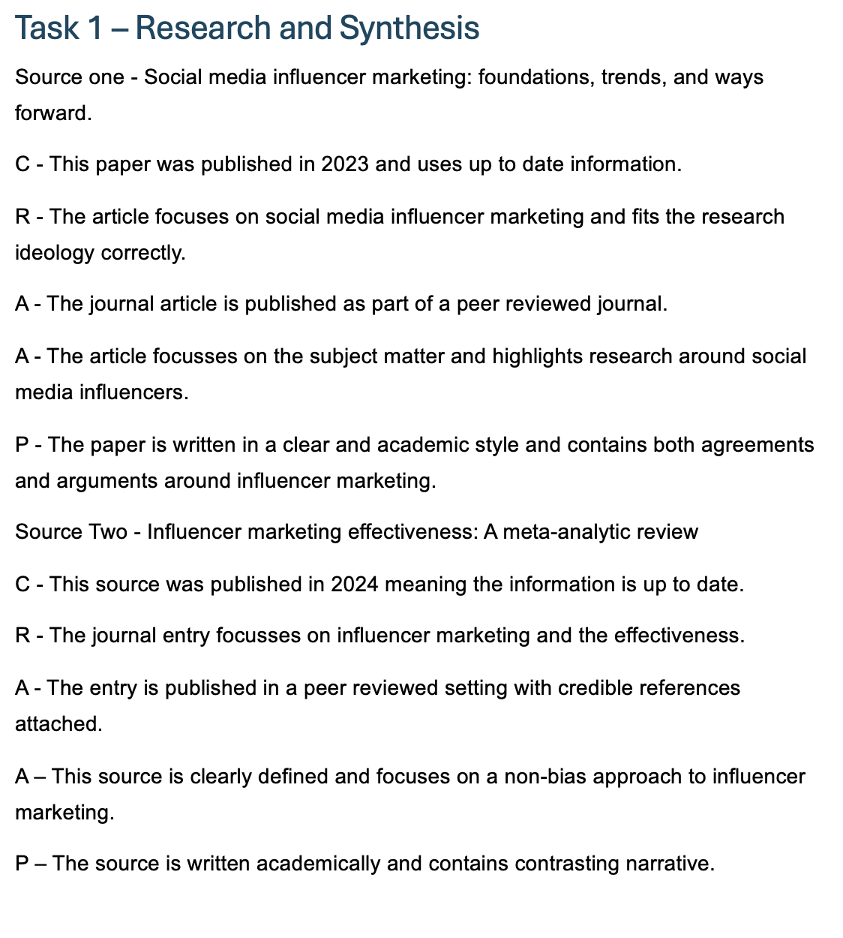

Figure 2

Kennedy, D.R. and Porter, A.L. (2021) ‘The Illusion of Urgency’, American Journal of Pharmaceutical Education, 86(7), p. 8914. Available at: https://doi.org/10.5688/ajpe8914.

