Intercultural communication
M5X02108
Business visits to China and Dubai
Steffan Treharne
1705128

Contents
Summary 3
Introduction 4
Preparation Information before the trip 4
Culture custom 5
China’s culture differences 6
Power distance 6
Masculine vs Feministic culture 7
Individualistic vs collective culture 7
Uncertainty Avoidance 8
Long Term Orientation 8
Indulgence 9
Chinese Gifts, Cards and Greetings. 9
Dubai 10
Power Distance 10
Masculinity 11
Individualism 11
Uncertainty Avoidance 12
Business or culture rituals In Dubai? 13
Conclusion 13
References 14
Bibliography 16
Appendix 19
1.1 The differences between Shia and Sunni Muslims 19

Summary

The report will be discussing the cultural difference between China, UAE and the US for potential business discussion and possible deals, mainly focusing on Hofstede and the cultural differences that occur in these nations and how the US will demonstrate the theory of Hofstede and how it is relevant for the report. Each part will play a role on how the outcome could will turn out potentially and what are the effects of these nations on business matters.

Introduction

This report will highlight relevant theoretical models of cultural awareness were utilised to produce a briefing paper highlighting the key challenges of intercultural communication key information to guide an American head of marketing for his trip to both China and the UAE (Dubai).

Preparation Information before the trip

Preparation for this visit for the American Business executive will consist of the Hofstede intercultural communication dimensions. This paper will be using figure 1 which is the graph below constantly to compare the 4 – 6 categories which are shown also below in figure 1.

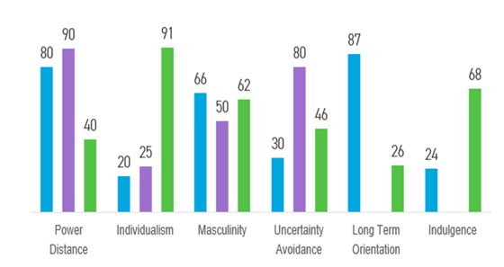

Code US = green, China = blue, UAE = purple

Figure 1 Comparison of US, UAE and China

Culture custom

Before visiting China and Dubai there needs to be an understanding that both Countries are different to the USA, that comes from the differences in diversity of culture. According to (Diehl & Prins, 2008) intercultural is when an individual is appropriately and effectively communicating with other individuals who have a different culture background. China is a very culturally diverse country, this includes being prestige as a nation, status which is very powerful, respectful of dignity to others according to Cardon (2009). While Dubai is a very religious country and plays a significant role in Dubai, whilst courtesy and hospitality is another significance in the culture (dubai.ae. 2018). This requires the Executive to go in with an open mind and be respectful with the language and believes that these countries hold.

China’s culture differences
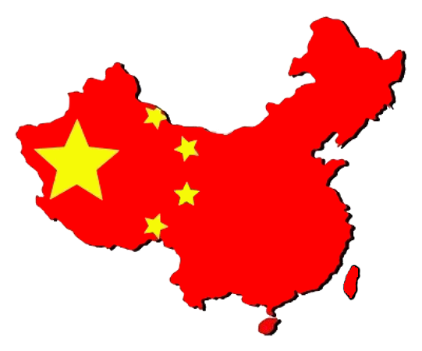

Power distance

As shown in figure 1, China and Dubai as two nations are very similar in power distance. According to (hofstede-insights.com, 2018) as china is rated 80 on the power distance graph, in terms this means that China is a nation that believes in inequality in society and is accepted, whilst there is no defending one with high powered individuals. This is where thriving and to do well, to be the best is vital to succeed in the business world. (hosted-insights, 2018) explains that as the USA is less power distant and generically based on uniqueness and that comes as inequality to everyone, in turn being unique and being able to exert over others on power could go one or two ways while meeting with the Chinese. While the USA are good at influencing this would be a great attribute to come to an agreement but also not showing signs of less power distance between the countries, in turn showing weakness.
Recommendation to overcome the power distance could be that the US executive shows individualism as a factor here to counter balance the high power of China simply showing a good knowledge of the culture and counter balance the negotiating back to neutral ground which would create a more positive business outcome by showing equal power balance shift.

Masculine vs Feministic culture

Masculinity and feministic is not referred as how lady like or how strong someone is it is how a nation is defined. In figure 1 both China and the USA are nearly equally high on the Masculinity graph but there is a difference of 4 which makes a significant change on how both nations work, China is higher which means it has a higher goal of achievement and thrive comparing to the US. (hostede-insights.com, 2018) explains that a high score will have an outcome as the countries will compete for success and in turn the “winner”. (marketmechina.com) explains that China’s society is defined by success and achievement, this is by working long hours even working in a different part of the country to where the family live, just to gain promotions or higher salary. These even ravels down to childhood such as the children of china thrive with high exam results this in turn shows how well china wants to do and how well they want to succeed.
Recommendations with the US Having a lower figure of Masculinity this could actually help the US by using a more feministic approach this will in turn great a compromise into a deal.

Individualistic vs collective culture

In figure 1 it shows Individualism is very low in China’s culture as referring to (Hofstede, G et al, 2005) it mentions that china is more collective which in term means that they will make a decision together as a group, and even when hiring they will use of knowing someone for a place in the organisation for a role it is also about coming together and helping each other out when in need, also look out after one another this is very important in Chinese tradition. According to (Hong, 2009) Individuals store knowledge of a culture and building on experiences direct or indirect which makes them cultural aware of the country. This could be effective as the US executive could sway the opposite by using individualism as a strong point and convince the Chinese. This could also have a negative effect as it is harder to convince more than one mind and as a nation who is as collective as China. With China thinking of their best interest this something that the US will really need to consider getting the best deal possible and sympathise and work on an agreement so both parties are happy for future business deals.
Recommendation for an agreement, As china is more collective than the US being more individualistic this could work more to the US once again as China is very family orientated and the US could adapt the communication skills to cater for this and turn this could work as a better business deal for the US if taken advantage of as the individualistic characteristic will motivate to potentially take advantage of the Chinese.

Uncertainty Avoidance

At a rating of 30 China has a low Uncertainty avoidance which means on how the society can handle the unforeseen future as it cannot predict it, and in return brings anxiety (Hofstede and Hofstede (2005). Compare the both Countries US scores a little higher of 46 this shows that the US are less aware than China. In turn this will make things more Uncertain for the US, and will react a little more than China, as China is very knowledgeable in their culture about these incidents and are very adaptable and entrepreneurial which the US is less adaptable to new ideas (Hofstede and Hofstede 2005). (Rashidi 2016) explains that as a low uncertainty avoidance country both China and US have a more relaxed approach China more so and this will help with a more suitable agreement for both as practise is more than principles in this case.
Recommendation for the US for this particular part is that as China has a low rating as shown in figure one it refers to the preparation of the Chinese in all aspects of life including business, the US could do the same by having smaller business meeting in China for the main business meeting, it will show that the US will be comfortable and knowledgeable against the Chinese business way.

Long Term Orientation

With a score of 87 China still holds tradition to its developing culture in reference to (hofstede-insights.com, 2018) “how every society has to maintain some links with its own past while dealing with the challenges of the present and future”. China is a very traditional pragmatic country and its population have a strong believe in three things which is situation, context and time (hofstede-insights.com, 2018). This is something that the US have to be aware of if there is any chance of making a business connection with China, as China will assess the situation of the deal the context and what intentions the US will have and what the time period would be for this business deal and in turn if it is a deal they would like to embrace. (Wang, Cheng Lu, 2008) explains that for the US to capture China’s desire for long term orientation there must be a long run of profitability and a concern of positive outcomes for the relationship to work for both parties.
Recommendation to help the US would be simple things as gifts to business executives or as simple as having the meeting in the restaurant and as the host will pay for everything, this shows generosity and makes for smoother and greater chance of transition of a deal.

Indulgence

With a low score china is very low indulging nation this is called a restrained nation, according to (hofstede-insights.com, 2018) as china is a restrained nation this means that societies in China has a tendency of cynicism and pessimism. According to (Kalagan and Guzeller, 2010) Cynicism in an organisation can consist of three priorities which are cognitive, affective and behavioural attributes. Even though cognitive relates to lack of honesty and could lead to problems with trust, this is something that the Chinese could be aware of the US and this is something that the US will have to be aware of and to be trusted so it can bring honesty and in return good partnership. (Norem & Illingworth, 1993) Believe that pessimism is built of both pessimism and reflectivity which lowers expectations and thinking of possibilities before considering action in return to lower failure. This is a case that many Chinese do for business which is to reduce the risks which in turn higher the possibility of financial gain in business.
The recommendation for this is that the US score higher which means they like to indulge more and in case becoming selfish and greedy by wanting more money from the business deal which could cause a breakdown as the Chinese are very low on the scale, the best way is communication and agree to a number or offer that benefits the both.

Chinese Gifts, Cards and Greetings.

In china is it tradition that in business according to (University Chinese students, 2018) say that, “men should greet women first. The people in lower position should give greetings higher position first.” Traditionally you would have a business meeting at a restaurant and you should pay for everything but let the potential business partner of the opposite make the decision on what everyone eats. Also giving money as a gift.

Dubai
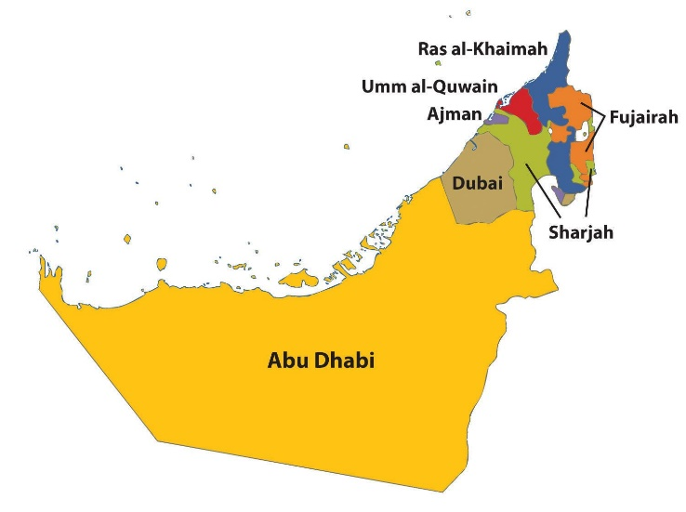

Power Distance

Power distance for the UAE is higher than China this means that there could be a power struggle as both the UAE and Chinese consider hierarchy to be important. According to (Salancik & Pfeffer, 1977) negotiators in this case UAE have power by bringing the ability of desirable outcomes by getting things done a certain way, in terms their way. (Kotter, 1979) explains this further by saying that a party that possess the most power can easily induce the other party in this case the US to do what it wants, even though the US do not want this, and this could affect the negotiations between both parties. This could cause trust issues not only for the UAE but China as well as both could adopt this way of thinking in return fail an agreement with the US as the US will show Lower Power distance and in turn show weakness which is not a trait that UAE and China tolerate.
Recommendation for the US for the UAE is to be patient stand ground and tolerate and in turn negotiate best possible outcome as the UAE have a higher power distant level as shown in figure 1.

Masculinity

As the graph shows UAE has less masculinity but it sits on the fence which according to (hofstede-insights.com. 2018) “Arab Emirates scores 50 on this dimension and can be considered to be neither Masculine or Feminine”, another way of thinking about this is that the UAE still believe motivation and to perform to be the best is important as a Nation. This is shown by the way the UAE is becoming one of the fastest growing nations. According to emirates247 website (2014) “Dubai is set to become the world’s fastest growing timeshare market in the world”, this will not only increase but the sector it’s in increasing is the Travel & Tourism market which is one the largest growing markets in the world. The facts of the US having the upper hand in this “masculinity” section is a cause of concern for the UAE as they need to compete for the best deals this will be hard as US is more masculine, but the Power distance will come into play with this and will level out in turn.
Recommendations, with a lower masculinity than the US this could be an advantage to the UAE against the US as their negotiation and communication skills are far better and this could easily use to create a deal or agreement that will suit both nations.

Individualism

As we know by figure 1 shows for the UAE it is also very low on individualism and this means they are a collectivist society according to (hofstede-insights.com. 2018). So how can UAE manage the individualism of the US, well they can adapt what has been mentioned in this report about how the Chinese would deal with the scenario, or the UAE could potentially create a new way of dealing with it. There are many ways of dealing with individualism such as wisdom, suppressing feelings, negative feedback and saying no are just some of many examples according to (mindtools.com. 2018).
Recommendations, like the Chinese the UAE could be taken advantage of as their beliefs and traditions are more meaningful which means the US could use this to trigger an emotional scenario, to counter balance the UAE could use the power distant they have over the US.

Uncertainty Avoidance

As a nation the UAE scored 80 comparing to the US score of 46 which relatively means that the UAE are a nation who maintain a strong belief in codes and behaviour but also, they do not tolerate unorthodox behaviour (hofstede-insights.com. 2018). This refers to the religious beliefs that the nation holds as being an Arabic nation and is also according to (globalsecurity.org. 2018) “estimated 89 percent of the country’s residents are noncitizens. Of the citizens, more than 85 percent are Sunni Muslim and an estimated 15 percent or fewer are Shia Muslims”, this shows that the UAE are a very religious nation and will hold as a benefit in the deal with the US. This is something that the US will need to consider when doing business in Dubai and would be of great help if they know on which religious part they are dealing with as it could either help or ruin the chance of a deal, as both see life in a slightly different way. Making background checks would lower the risk and could help in a deal and a relation.
Recommendations, The uncertain avoidance logically here is which Muslim the US are going to be negotiating with as Sunni and Shia have Similar but also different beliefs which all information is in the appendices 1.1. Baring this in mind the US will need to be aware of this and to adapt for the both beliefs of the nation.

Business or culture rituals In Dubai?

According to (kwintessential.co.uk. 2018) “The dress code for businesswomen makes it compulsory for women to cover their arms and legs and stay modest at all times in business environments. Skirts and low necklines should be avoided. Women should be well covered in rural areas of Dubai”.
Appointments made in advanced, offering tea and coffee as a gesture of hospitality and punctuality is respectful and is necessary. Also, handshakes should not be aggressive and not permitted with women. Always refer to Sayed which means MR or Sayeda which is MRS. Gift giving is allowed but not essential and is down to the person or business person themselves. Business cards are vital as usual in every business meeting.

Conclusion

For this to be a successful business meeting for the US they need to consider a few details which are vital. These details consist of knowledge of the beliefs, religion, and business curtesy and to be able to adjust to the cultural differences between each Nation by showing good skills of communication, body language and avoiding the stereotypical judgement of others, all this will show a true meaning of knowledge of both cultures and the respect they deserve before the meetings take place.

References

Cardon, P. W. (2009) ‘A model of face practices in Chinese business culture: Implications for western businesspersons’, Thunderbird International Business Review, 51(1), pp. 19–36. Available at: https://ezproxy.uwtsd.ac.uk/login?url=https://search.ebscohost.com/login.aspx?direct=true&db=bth&AN=35755473&site=ehost-live (Accessed: 19 November 2018).
Diehl, W.C. and Prins, E. (2008), ‘‘Unintended outcomes in second life: intercultural literacy and cultural identity in a virtual world’’, Language and Intercultural Communication
dubai.ae. (2018). Getting familiar with Dubai’s culture and etiquette. http://www.dubai.ae/en/Lists/Articles/DispForm.aspx?ID=147
emirates247.com. (2014) Dubai to be world’s fastest growing timeshare market. https://www.emirates247.com/business/dubai-to-be-world-s-fastest-growing-timeshare-market-2014-05-21-1.549816
globalsecurity.org. (2018). Religion. https://www.globalsecurity.org/military/world/gulf/uae-religion.htm
Hofstede, G and Hofstede, G. J. (2005) culture and organisations – software of the mind. 2nd ED. New York: Mc Graw. Hill.
hofstede-insights.com, (2018). Country comparison. https://www.hofstede-insights.com/country-comparison/china/
Hong, Y. (2009). A dynamic constructivist approach to culture: moving from describing culture to explain culture. Theory research and application. (pp.3 – 23)
Kalağan, G. And Gǜzeller, C. O. (2010) analysis of teachers levels of organisational cynicism. PP 83-97
Kotter, j. (1979). Power in management. New York, NY: Amacom.
kwintessential.co.uk. (2018). Business etiquette. https://www.kwintessential.co.uk/resources/guides/guide-to-dubai-the-uae-etiquette-customs-culture-business/
marketmechina.com, 2014. What Geert Hofstede tells us about Chinese business culture. https://www.marketmechina.com/geert-hofstede-tells-us-chinese-business-culture/
Mindtools.com. (2018) Hofstede's Cultural Dimensions. https://www.mindtools.com/pages/article/newLDR_66.htm
Norem, J. K & Illingworth, K (1993). Strategy - dependant effects of reflecting on self and tasks
Rashidi, A. (2016) ‘Sweden described by Hofstede’ {online} Available at: https://www.linkedin.com/pulse/sweden-described-hofstede-ali-rashidi. (accessed: 20th of November 2018)
Salancik, G. R. & Pfeffer, J. (1977). Who gets the power and how they hold on to it: a strategic- contingency model of power. Organisational dynamics 5, 3-21.
Wang, Cheng Lu, (2008). The significance of trust and renqing in the long-term orientation of Chinese business-to-business relationships. Industrial Marketing Management, 37(7), pp.819–825.

Bibliography

Anon, 2007. chapter 4: Business Environment. UAE Business Forecast Report, pp.24–33.
Asia link business, (2018). Chinese business culture and etiquette. https://asialinkbusiness.com.au/china/conducting-business-in-china/chinese-business-culture?doNothing=1
Bbc, (2009). Sunni and Shi'a. http://www.bbc.co.uk/religion/religions/islam/subdivisions/sunnishia_1.shtml
Businessinsider, (2015). The differences between Shia and Sunni Muslims. http://uk.businessinsider.com/the-differences-between-shia-and-sunni-muslims-2015-10
Cardon, P. W. (2009) ‘A model of face practices in Chinese business culture: Implications for western businesspersons’, Thunderbird International Business Review, 51(1), pp. 19–36. Available at: https://ezproxy.uwtsd.ac.uk/login?url=https://search.ebscohost.com/login.aspx?direct=true&db=bth&AN=35755473&site=ehost-live (Accessed: 19 November 2018).
Diehl, W.C. and Prins, E. (2008), ‘‘Unintended outcomes in second life: intercultural literacy and cultural identity in a virtual world’’, Language and Intercultural Communication
dubai.ae. (2018). Getting familiar with Dubai’s culture and etiquette. http://www.dubai.ae/en/Lists/Articles/DispForm.aspx?ID=147
emirates247.com. (2014) Dubai to be world’s fastest growing timeshare market. https://www.emirates247.com/business/dubai-to-be-world-s-fastest-growing-timeshare-market-2014-05-21-1.549816
globalsecurity.org. (2018). Religion. https://www.globalsecurity.org/military/world/gulf/uae-religion.htm
Ho, Radha Krishna & Yee, 2010. Chinese Familial Tradition and Western Influence: A Case Study in Singapore on Decision Making at the End of Life. Journal of Pain and Symptom Management, 40(6), pp.932–937.
Hofstede, G and Hofstede, G. J. (2005) culture and organisations – software of the mind. 2nd ED. New York: Mc Graw. Hill.
hofstede-insights.com, (2018). Country comparison. https://www.hofstede-insights.com/country-comparison/china/
Hong, Y. (2009). A dynamic constructivist approach to culture: moving from describing culture to explain culture. Theory research and application. (pp.3 – 23)
Kalağan, G. And Gǜzeller, C. O. (2010) analysis of teachers levels of organisational cynicism. PP 83-97
Kotter, j. (1979). Power in management. New York, NY: Amacom.
kwintessential.co.uk. (2018). Business etiquette. https://www.kwintessential.co.uk/resources/guides/guide-to-dubai-the-uae-etiquette-customs-culture-business/
Li Dong, 2007. National and corporate culture differences in international strategic alliances: Perceptions of Chinese partners. Asia Pacific Journal of Management, 24(2), pp.191–206.
Li Dong, 2009. Antecedents of perceived national and corporate culture differences: evidence from Chinese international strategic alliances. Asia Pacific Business Review, 15(2), pp.217–242.
marketmechina.com, 2014. What Geert Hofstede tells us about Chinese business culture. https://www.marketmechina.com/geert-hofstede-tells-us-chinese-business-culture/
Mindtools.com. (2018) Hofstede's Cultural Dimensions. https://www.mindtools.com/pages/article/newLDR_66.htm
Norem, J. K & Illingworth, K (1993). Strategy - dependant effects of reflecting on self and tasks
Rashidi, A. (2016) ‘Sweden described by Hofstede’ {online} Available at: https://www.linkedin.com/pulse/sweden-described-hofstede-ali-rashidi. (accessed: 20th of November 2018)
Ryan, Shane, 2017. Vanishing into Things: Knowledge in Chinese Tradition. Philosophy East & West, 67(4), pp.1299–1306.
Salancik, G. R. & Pfeffer, J. (1977). Who gets the power and how they hold on to it: a strategic- contingency model of power. Organisational dynamics 5, 3-21.
Santandertrade, (2018). United Arab Emirates: Business practices. https://en.portal.santandertrade.com/establish-overseas/united-arab-emirates/business-practices
Seidler, V.J., 2009. Embodying identities : culture, differences and social theory, Bristol: Policy.
Veeran, Vasintha, 2013. Reframing the Discourse on Social Work in the Arab World: Considerations for the Accreditation of Social Work in the UAE. Social Work Education, 32(8), pp.1075–1089
Wang, Cheng Lu, (2008). The significance of trust and renqing in the long-term orientation of Chinese business-to-business relationships. Industrial Marketing Management, 37(7), pp.819–825.

Appendix

1.1 The differences between Shia and Sunni Muslims

The conflicts between Shia and Sunni Muslims go back to the seventh century and the death of the Prophet Muhammad.

Yet a spotlight has been shone recently on the differences between the two branches of the religion as the number of clashes between both groups has intensified.

The vast majority of the 1.6 billion Muslims in the world are Sunni, according to a 2009study by the Pew Research center.

Between 10% and 13% are Shia Muslims, and 87% to 90% are Sunni Muslims. Sunni Muslims are also present in more countries and regions throughout the world, whereas most of Shia Muslims live in four countries: Iran, Pakistan, India, and Iraq.

sunni shia
The distribution as of 2005. Columbia.edu

The separation of the two groups started after the death of the Prophet Muhammad. The majority believed that his rightful successor was his father-in-law and close friend, Abu Bakr, but a small group believed the Prophet Muhammad's successor should be Ali ibn Abi Talib, his cousin and son-in-law and father of his grandchildren.

The Sunni majority got their way, as Abu Bakr became the first Muslim caliph and successor of the prophet. Although the divide was at first mostly political, as the minority group was a faction supporting the power of Ali, over time, the divide evolved into a religious movement.

One of the most crucial differences between Shia and Sunni Muslims is the importance that the Shiites give to Ali, whom the Sunni do not recognize as being the prophet's rightful successor.

One of the most important dates for Shia Muslims is the tenth day of the holy month of Muharram (the first month in the Islamic lunar calendar). Shia Muslims celebrate the anniversary of the death of Husayn ibn Ali, the grandson of the Prophet Muhammad and son of Ali.

U.S. President Barack Obama (not pictured) meets with Saudi King Salman bin Abdulaziz in the Oval Office of the White House in Washington September 4, 2015.
The Saudi King Salman bin Abdulaziz. Saudi Arabia is one of the countries in the world with the largest proportion of Sunni Muslims.Reuters

The occasion of “collective atonement through lamentation and self-flagellation” is called Ashoura. This practice is particular to the Shiites and often draws criticism and protests from Sunnis who do not celebrate that day nor view it as important.

Both groups, however, agree that Muhammad is God's messenger and follow the five ritualistic pillars of Islam, which include fasting during Ramadan, five daily prayers, and the Hajj, an annual pilgrimage to Mecca which devolved into a stampede this year, killing more than 700 people.

They also both share the holy book of the Quran. The primary difference in practice comes in that Sunni Muslims mainly rely on the Sunnah, a record of the teachings and sayings of the Prophet Muhammad to guide their actions while the Shiites more heavily on their ayatollahs, whom they see as a sign of God on earth.

Iran Supreme Leader Ayatollah Ali Khamenei
Iranian Supreme Leader Ayatollah Ali Khamenei addresses Iranian top officials in a mosque at his residence in Tehran, Iran. Office of the Iranian Supreme Leader via AP

Although many Shia and Sunni Muslims cohabit peacefully, a Pew Research Center survey from 2012 shows that 40% of Sunni Muslims from the Middle East and North Africa do not accept Shias as fellow Muslims .

The conflicts in Iraq and Syria are also show a divide between the two, as many Sunni men have joined rebel groups, while men from the Shia community are most often fighting for or with government forces, the BBC reports.

