How individuals Beliefs, Attitudes and Values impact on workplace behaviour



By Laura Morgan – 1811899
March 2020

Executive Summary
Contents Page – Page No.
Terms of Reference
Report requested by Shela Khan, by 27/03/2020. Report has been complied by Laura Morgan. Task is to critically analysis management theories and how these theories are implemented in the workplace.

Findings
This report looks at the different management theories and how these theories are implemented at the Phoenix Centre in Townhill.
The Phoenix Centre is a not for profit organisation and is the heart of the local community. The Phoenix has an on-site café, nursery, all weather pitch hire, IT suite and conference rooms.
Striving to make the area a wealthier, healthier, happier and safe place to live – a one stop-shop for the development of the local community.
(The Phoenix on the Hill 2019)
The three main theorists are Frederick Taylor, Max Webber and Henri Favol.
Frederick Taylor’s theory emphasizes efficiency. According to Taylor, rather than scolding employees for every minor mistake, employers should reward workers for increased productivity.
(Business.com 2020)
Max Webber was unlike most workplace leaders today. His theory of management, also called the bureaucratic theory, stressed strict rules and a firm distribution of power. He would've scolded today's managers, most of whom are open to new ideas and flexible work arrangements, for their leadership style.
(Business.com 2020)
Henri Favol management theory is a simple model of how management interacts with personnel. Fayol's management theory covers concepts in a broad way, so almost any business can apply his theory of management. Today the business community considers Fayol's classical management theory as a relevant guide to productively managing staff.
(Business.com 2020)

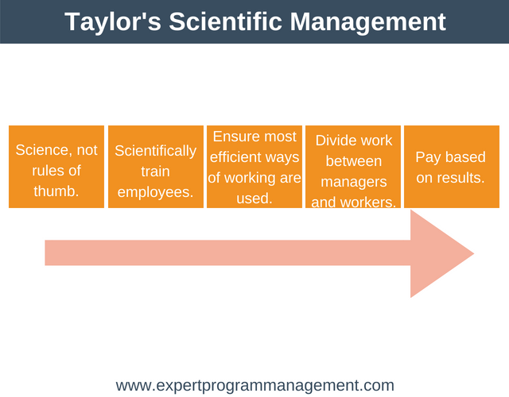

This report will discuss Taylor’s management theory at the Phoenix Centre. Taylor used time and motion in his theory. He used the most productive and efficient employees to put his theory to the test. This involved looking at the most efficient workers and why they were more efficient. He then believed that he would train all workers on this most efficient way so that every employee would complete the job the same way.
Because Taylor believed that workers were only motivated by pay and money, he thought workers don’t usually enjoy work. Because of this, they need to be monitored and controlled closely. Essentially, Taylor believed that employees had a natural tendency to take it easy or slack off whenever they could. He called this natural soldiering. To help with this, managers should break down each employee’s job into more manageable, bite-sized tasks. Training should be given so that all employees perform these tasks in a standard way. Workers should be paid based on how much they produce (piece rate). This will create a win-win situation. Workers are incentivized to work hard to earn more and the businesses production is as efficient as it can be (profits are maximized).
(Expert programme Management 2009-2018)
At the Phoenix Centre part of this could be implemented in the Café, the speed of food and a system of cooking would work well and if making more than one breakfast this would ensure fast and prompt service in a busy café. The same person would be cooking while one is serving. Having a system of work makes the flow easier. However, this theory wouldn’t be as practical in the main office. As members of the public walk through and come to reception, you cannot time the length of time that customer will you’re your assistance and due to this you couldn’t time an employee to do one invoice, because in a normal working day that employee could get interrupted several times by phone calls or customers at reception and the amount of time it takes to complete ten invoices could change every day due to attending to multiple tasks. Taylors theory could not be implemented in the office area.
Also, if an employee enjoys their job, they are more likely to achieve well standards of work, if employees are felt like they are being controlled this would cause a miserable place of work. At the Phoenix everyone knows their role and wants the best for the Centre, and everyone helps where possible even if it isn’t their job role. Taylor did not wan this, he did not want employees thinking for themselves, employees were to have one job and to only get paid for that one job.
Taylor didn’t want employees thinking for themselves, he simply wanted a simple task performed as quickly (as efficiently) as possible. In a nutshell, workers should be paid for doing, not thinking.
(Expert programme Management 2009-2018)
The Phoenix Centre works as one team not as individuals. All have their own job roles; the caretaker can’t complete invoicing but when needed can cover the reception area. Taylor didn’t believe in this way of working. With this way of working if a member of the team is on leave or sick someone else can cover the basics of the job. Who would cover in Taylor’s theory? The job would not be completed therefore making it less efficient and productive. It would be better to have the job done slower that day rather than not having the job done at all.
Taylor believed that managers should be responsible for developing the processes, ways of working and monitoring employees and employees should be responsible for executing a task as quickly as possible.
(Expert programme Management 2009-2018)
Taylor didn’t think that an employee and manager should work together. The manager should just monitor the employees work making sure that the employee was working efficiently. There would be a divide between the manager and employee. This however is not implemented at the Phoenix Centre in any department. The manager oversees all aspects but if needed she would help where needed. The manager in the Phoenix has helped in the café during extremely busy periods. Dropped all other work commitments to ensure the café runs smoothly to keep customers happy and not waiting too long for food. The Phoenix has a very much ‘all hands-on deck’ approach to working. Everyone helps where possible even if that goes outside their job description. If members of staff from other departments didn’t help when needed this would cause a bad atmosphere in the workplace.
Taylor also believed that workers should get paid based on their results or how much work they produced. He thought this would encourage employees to work to the best of their abilities.
Taylor’s Motivation Theory is premised on the fact that employees are motivated to be productive by one thing. Money. Because of this, Taylor believed that management should exercise close control over employees, to ensure that they were getting their money’s worth. He advocated using science to study jobs and break them down into manageable parts. These parts could then be described in an efficient, repeatable way. Every employee could then be trained to perform the task in this way.
(Expert programme Management 2009-2018)
This way of working wouldn’t work at the Phoenix Centre. Jobs would become very monotonous; this type of work ethic only benefits the management and is focused on money. The Phoenix Centre focuses on its community and staff, Taylors theory has no wellbeing for its staff, no Human Resources department, he just wants employees to complete task as quick as possible without workers having any input of thinking for themselves.
In conclusion to this management theory if implemented at the Phoenix Centre, they would lose staff, staff morale would drop considerably, and staff wouldn’t be motivated or enjoy their job. Although in every job the aim is to get work done as efficiently and productive as possible Taylor’s theory doesn’t give any incentive to do the best you can. It lacks job satisfaction.
Henri Fayol’s management theory would be more suited at the Phoenix Centre. This is because Henri Fayol has stressed on the specialization of jobs. He recommended that work of all kinds must be divided & subdivided and allotted to various persons according to their expertise in a particular area. Subdivision of work makes it simpler and results in efficiency. It also helps the individual in acquiring speed, accuracy in his performance. Specialization leads to efficiency & economy in spheres of business.
(Management Study Guide 2020)
Everyone at the Phoenix has their own specific job role. Even though all staff work as one team, there must be specific staff working in certain departments. There are staff that work in the nursery, café staff and office staff. This works as staff know each job role and have certain skills and qualifications to do that role.
Authority and responsibility are co-existing according to Fayol’s theory. There should be a balance between the two. Authority without responsibility leads to irresponsible behaviour whereas responsibility without authority makes the person ineffective.
(Management Study Guide 2020)
Fayol said Remuneration and method of payment should be fair and afford maximum satisfactions to both employees and employers. It-should provide enough incentive to the well-directed employee’s effort but over payment beyond reasonable limits is undesirable.
Unfortunately, at the Phoenix Centre this one does not apply. Due to the Phoenix being a non-for-profit organisation they can only pay their staff minimum wage. The Phoenix values are to provide for the community and all the staff have this same value.
According to Fayol there should be reasonable security of job. No employee should be removed unnecessarily within a short period. Stability of tenure is necessary to get an employee accustomed of doing a new work and to enable him in performing it well.
Managers should encourage their employees to take initiative within the limits of authority and discipline. Initiative is concerned with thinking and executing a plan.
(Preserve Articles 2020)
Fayol’s theory is far more thought out, it has more structure and Fayol cared about the workers. Taylor only focussed on the job. Which is why for most of the management theory Fayol’s theory would be more suited to be implemented at the Phoenix Centre.
The Phoenix values and beliefs are to make a difference in the community. To do this the manager at the Phoenix must have staff on side, staff need to be willing to go above and beyond to make it successful. The Phoenix provides training courses to help improve skills and to give motivation to staff. If the staff feel motivation and feel like they are needed they are more likely to put more into their job giving them greater job satisfaction. If the Phoenix only stuck to Taylors way of management, the staff would only be trained on one specific role, this would be boring, and staff would lose interest quickly. However, the incentive of extra pay in Taylor’s theory is good, everyone works for the money, but it would better to have a fulfilling enjoyable job. Fayol’s theory isn’t so black and white, there are lots of opportunities to progress and learn more.

Using Pearson’s RED model to assess the Phoenix Centre
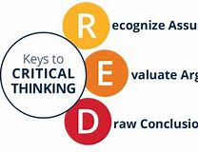
Recognise assumptions
- Ability to discern facts from opinions

Evaluate Arguments
- Ability to evaluate arguments that are intended to persuade you to believe or act a certain way
Draw conclusions
- Ability to arrive at conclusion that logically follow from the available evidence

The assumption is that the Phoenix Centre go above and beyond for the local community. On their website the headline states – making our hill a wealthier, healthier, happier and safer place to live – a one-stop shop for the development of our local community.
(The Phoenix on the Hill 2019)
After evaluating the pro’s and con’s on occasion due to funding or financial strains the Phoenix isn’t always able to reach out to the community as much as it would like to.
Overall to conclude if the staff didn’t have these values, they wouldn’t be making a difference to people’s lives, staff are aware of the impact and the need The Phoenix Centre has for the community. If staff didn’t have this value, they would risk the company making a loss and jobs would be lost which would eventually lead to the centre being closed.

Blooms Taxonomy

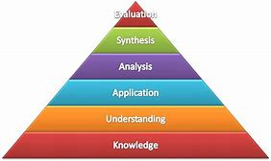

The 6 Levels of Bloom’s Taxonomy
1. The first level of Bloom’s Taxonomy is to Remember.
Example activities at the Remembering level: memorize a poem, recall state capitals, remember math formulas
2. The second level of Bloom’s Taxonomy is to Understand.
Example activities at the Understanding level: organize the animal kingdom based on a given framework, illustrate the difference between a rectangle and square, summarize the plot of a simple story
3. The third level of Bloom’s Taxonomy is to Apply.
Example activities at the Application level: use a formula to solve a problem, select a design to meet a purpose, reconstruct the passage of a new law through a given government/system
4. The fourth level of Bloom’s Taxonomy is to Analyse.
Example activities at the Analysis level: identify the ‘parts of’ democracy, explain how the steps of the scientific process work together, identify why a machine isn’t working
5. The fifth level of Bloom’s Taxonomy is to Evaluate.
Example activities at the Evaluation level: make a judgment regarding an ethical dilemma, interpret the significance of a given law of physics, illustrate the relative value of a technological innovation in a specific setting—farming, for example.
6. The sixth and final level of Bloom’s taxonomy is to Create.
Example activities at the Creation level: design a new solution to an ‘old’ problem that honours/acknowledges the previous failures, delete the least useful arguments in a persuasive essay, write a poem based on a given theme and tone.
(Teach Thought 2020)

References

Expert Programme Management (2009-2018) https://expertprogrammanagement.com/2018/05/taylors-scientific-management/ accessed on 23/03/2020
Management Study Guide (2020) https://www.managementstudyguide.com/management_principles.htm accessed on 25/03/2020
Management theory of Frederick Taylor (2020) https://www.business.com/articles/management-theory-of-frederick-taylor/ accessed on 18/03/2020
Preserve Articles (2020) http://www.preservearticles.com/management/henri-fayol-principles-of-management/31201 accessed on 25/03/2020
Teach Thought (2020) https://www.teachthought.com/learning/what-is-blooms-taxonomy-a-definition-for-teachers/ accessed on 26/03/2020
The Phoenix on the Hill (2019) https://thephoenixonthehill.com/ accessed on 18/03/2020

