
BSc (Hons) Health and Social Care
BMHP6030
Health, Wellbeing and Sustainable Development
Lecturer Name: Zakiyyah Ahmed
Component 2: Written Report Assignment
A critical examining current health, wellbeing and sustainability policies and initiatives that impact citizens on a global, national and local level.

Student Name: Dana Gabriela Zaharia
Student ID: 2241343
Date of Submission: 22/03/2026
Table of Contents
1. Introduction 2
2. Impact of SDG goals on citizens' health and well-being 2
2.1 SDG 3 2
2.1.1 About the sustainability goal 2
2.1.2 Impact on citizens’ health and well-being 3
2.2 SDG 17 4
2.2.1 About the sustainability goal 4
2.2.2 Impact on citizens’ health and well-being 5
3. Effectiveness of health, wellbeing and sustainable development initiatives 5
3.1 At the national level 5
3.1.1 Greener NHS Program 5
3.1.2 Public Health and Prevention 6
3.1.3 Health Inequalities and Obesity 7
3.1.4 Environmental Health 7
3.2 At the local level 7
3.2.1 Integrated Neighbourhood Health Centres 7
3.2.2 Travel Well and Active Travel 7
3.2.3 Community Food Projects 8
3.2.4 Workplace Health and Wellbeing 8
4. Recommendations 8
4.1 Implementation of the cross-government sustainable wellbeing framework 8
4.2 Increase investment in community and mental health care 8
4.3 Strengthen independent oversight 9
5. Conclusion 9
References 10

1. Introduction
Health, well-being, and sustainability policies are considered as one of the most crucial aspects for the sustainable development of the entire globe. In the report of the World Health Organisation (2025), it has been stated that advancement in health and well-being at the local, national, and international levels must be equally prioritised. The present report aims to analyse the influences of the United Nations Sustainable Development Goals (SDG) on health, well-being, and sustainable development at the local and national levels. The study has selected SDG 17, ‘Partnerships for the Goals’, along with SDG 3, ‘Good Health and Well-being’, to understand their influence on the health and well-being of citizens. The report has also discussed different health, well-being, and sustainability development-related policies and initiatives of the UK at both the national and local levels. The main purpose of this critical evaluation is to understand the drawbacks of current policies and initiatives and propose solutions for further improvements.

2. Impact of SDG goals on citizens' health and well-being

2.1 SDG 3

2.1.1 About the sustainability goal
‘Good Health and Well-being’, the SDG 3 of the UN, has been designed to improve the health of the global population. The main agenda of this sustainability goal is to make better health accessible for everyone all over the world, not only for a few, elite, or affluent populations (United Nations, 2025a) (Refer to figure 1). The key targets of Goal 3 involve reduction of the ratio of maternal mortality on a global scale to less than 70/100000 live births by 2030 (United Nations, 2025a). The goals also target to mitigate the preventable deaths of newborns, children under the age of 5, and end the epidemic of malaria, AIDS, and tuberculosis by 2030. The purpose of SDG 3 also includes ensuring universal access to services for reproductive and sexual health care. All these targets are directly linked to the health and well-being of global citizens as it seeks to achieve universal health coverage and ensure access of affordable and safe medicines for all.
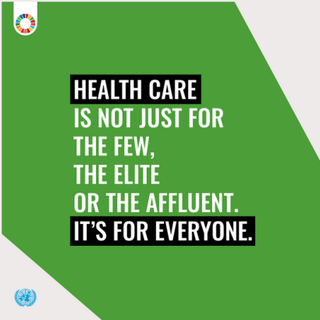
Figure 1: Main agenda of SDG 3
(Source: United Nations, 2025a)

2.1.2 Impact on citizens’ health and well-being
As per the data of 2023, approximately 133 countries all over the world became able to address the targets of SDG 3. That resulted in a decrease of 14% in the maternal mortality ratio and 16% in under 5 mortality rates (United Nations, 2025a) (Refer to figure 2). By ensuring everyone equal access to healthcare, SDG 3 significantly contributes in improvement of citizens’ health and well-being.
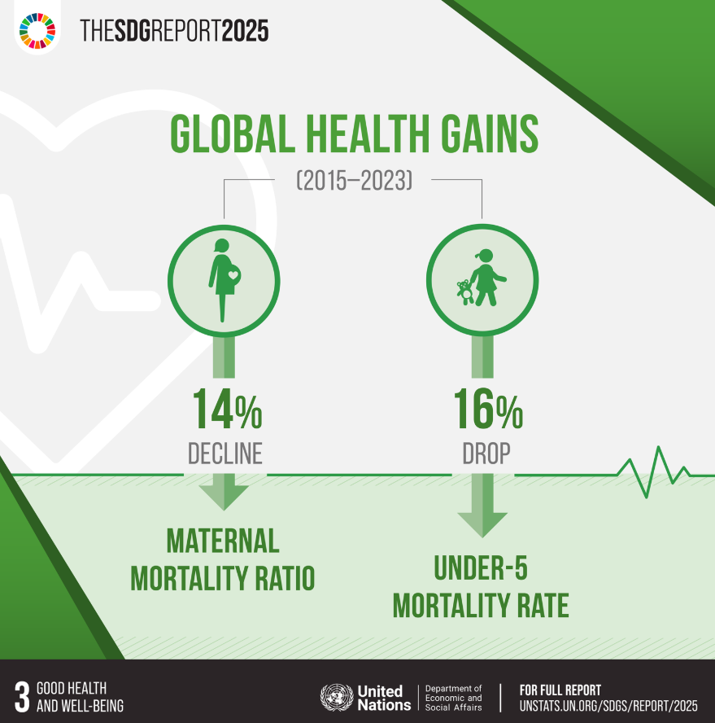
Figure: Impact of SDG 3 on citizens’ health and well-being
(Source: United Nations, 2025a)

2.2 SDG 17

2.2.1 About the sustainability goal
‘Partnerships for the Goals’, the SDG 17 of the UN, is mainly focused on revitalising the international collaboration for the sustainable development of the world. The key targets of SDG 17 involve the strengthening of finance, tech, capacity, and trade among the countries. The main purpose of this collaborative goal is to advance the global finance system and use it to support the developing countries, not against them (United Nations, 2025b) (Refer to figure 3). Through strengthening partnerships between international organisations and the private sector, SDG 17 accelerates the infrastructure development of healthcare, especially in developing countries.
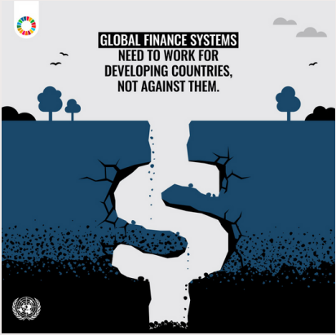
Figure 3: Main agenda of SDG 17
(Source: United Nations, 2025b)

2.2.2 Impact on citizens’ health and well-being
Advancements in global collaboration allow countries to foster the sharing of medical expertise and technology. The study of Yun and Zhang (2025) mentioned that international collaboration on AI-driven healthcare plays a significant role in advancing the health and well-being of different countries and fosters equal access to advanced healthcare for all. Considering this fact, it can be stated that SDG 17 indirectly contributes to enhancing health and well-being for global citizens.
Therefore, both SDGs 3 and 17 have a direct and indirect influence on the health and well-being of the global population, respectively. SDG 3 directly aims to ensure equal access to healthcare for all, and SDG 17 accelerates the progress of SDG 3 by supporting international partnerships.

3. Effectiveness of health, wellbeing and sustainable development initiatives

3.1 At the national level

3.1.1 Greener NHS Program
Greener NHS is a national sustainability program that aims to support the ambition of the NHS to achieve the position of a net-zero national health service (NHS England, n.d. a). Through this program, the NHS targets to achieve net zero emissions by the year 2040 by fostering 80% of the reduction in the carbon footprint of the organisation by 2028. To achieve these targets, the NHS will consider different tactics as highlighted in the figure 4 below. This program also aims to improve patient care at the national level by delivering financial savings along with the reduction in emissions.
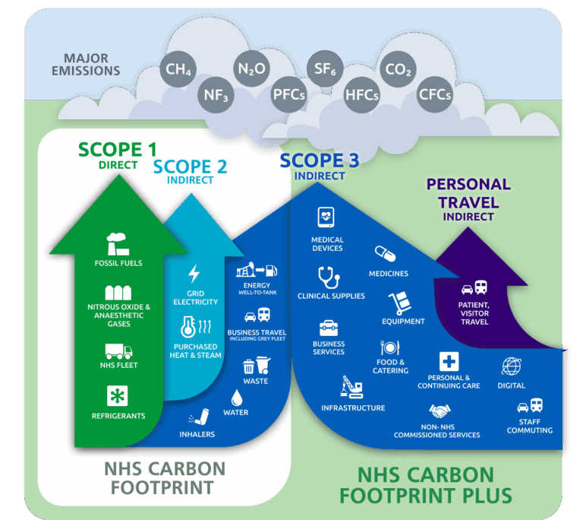
Figure 4: Key targets of the Greener NHS Program
(Source: NHS England, n.d. a)

3.1.2 Public Health and Prevention
The UK Health Security Agency (UKHSA), a government agency of the UK, is responsible for the health security of the nation (UK Health Security Agency, n.d.). The key purpose behind the development of this agency is to ensure the health protection of the country, by early response to external threats and driving innovation. The agency works with the NHS organisations, local authorities, industry, and academic institutions in terms of ensuring impactful policy responses and effective implementation.

3.1.3 Health Inequalities and Obesity
The Healthy Start policy of the UK has been especially designed for women who are more than 10 weeks pregnant and have a baby under the age of 4 years (Government of the UK, n.d. a). This policy will help these women to buy healthy foods like fruits and milk. Under this policy, the government of the UK also provides free vitamins to those pregnant women and the mothers of 4 years.

3.1.4 Environmental Health
The Natural Environment Research Council (NERC) of the UK supports all the policy action and delivery that contributes to the improvement of environmental quality, human health, and the economy of the country (UK Research and Innovation, n.d.). This institution contributes to identifying and tackling environmental challenges, with a priority on human health protection and achieving net-zero emissions for the entire country by 2050.
From all these health, well-being, and sustainable development initiatives of the UK, it can be stated that the government of the country is significantly dedicated to advancing the position of the nation. Hence, in national level, the UK government designed several impactful policies and initiatives related to citizen health, well-being, and the environmental sustainability.

3.2 At the local level

3.2.1 Integrated Neighbourhood Health Centres
‘Fit for the Future’, a 10-year health plan of the NHS for England (NHS England, n.d. b). This plan has been designed to deliver better patient care by harnessing the opportunities of new and advanced medicines, technologies, and innovations. This initiative of the NHS operates at the local level of England for all the taxpayer beyond their socio-economic status. Through this initiative, NHS healthcare services shift from hospital to community, sickness to prevention, and analogue to digital.

3.2.2 Travel Well and Active Travel
‘Active Travel’, a well-being initiative of Sport England that promotes healthy habits, like walking to reach school and cycling to reach the workplace (Sport England, n.d.). Promotion of active travel acts as an affordable, accessible, and convenient way to achieve fitness by moving more in daily activities. This initiative fosters a link between physical activity and active travel to ensure physical activity among the local population of England.

3.2.3 Community Food Projects
At the local level in London and England, there are several community food projects, which are dedicated to develop circular food community. For example, the report of ReLondon (2026), the London Borough of Islington, and ReLondon collaborated with a climate-vulnerable community of North London to redesign an advanced circular food community. This model will replicate the traditional community, which will deliver measurable socio-economic and environmental benefits to the local population.

3.2.4 Workplace Health and Wellbeing
‘Work, health and growth’, a local-level government initiative of the UK, that aims to foster work, health, and economic growth (Local Government Association, 2023). As per this local council guideline, at the local government level, it is essential to take effective actions for improving work and health outcomes of the local communities. In that case, the local government plays the role of major employers, commissioners, providers, and leaders of local economic development.
Hence, at the local level, there are also several significant initiatives to uphold environmental sustainability and community well-being. All these initiatives are directly linked to the health, well-being, and sustainable development of the country, which operates on both small and large scales.

4. Recommendations

4.1 Implementation of the cross-government sustainable wellbeing framework
Development of a cross-government sustainable framework for human well-being, to connect the NHS goals with the local healthcare initiatives of the country. According to the study of Kshatriya et al. (2026), cross-government sustainable well-being helps a country to foster a unified mission of healthcare. Considering this fact, it can be suggested to the government of the UK to foster a significant connection between its national and local level initiatives to accelerate the progress of its healthcare policies/frameworks. In that context, the development of an all-in-one healthcare policy may help the government of the country to advance its community health and well-being.

4.2 Increase investment in community and mental health care
The government of the UK invests nearly £1 billion in its mental health care initiatives (Government of the UK, n.d. b), which needs to be expanded to address the increasing number of mental health cases in the country. As per the research outcomes of Gennaro and Colizzi (2023), the government of the UK needs to increase its priorities for addressing the community's mental health and well-being. The government must increase investment to shift its care focus from an acute hospital service to preventive care. This strategy will allow the care staff to reach more people with mental health issues and ensure their well-being with advanced care services.

4.3 Strengthen independent oversight
In the context of sustainable development, it might be helpful to empower environmental bodies to take action when the national sustainable targets are not met. Bergougui and Ben-Salha (2025) mentioned that empowering environmental governance bodies helps a nation to better monitor its sustainable development progress. Therefore, it is recommended that the government of the UK empower its local environmental governance bodies to take suitable actions against environmental pollution/degradation.
Integration of all these strategies might help the government of the country to advance its progress towards achieving its broader targets in healthcare and sustainable development. Interconnection between national and local initiatives with increased investment and empowerments will significantly contribute to further improve the citizens’ health and well-being of the country and accelerate its progress towards achieving net zero.

5. Conclusion
Overall, human health, well-being, and sustainable development are significantly depending on the government initiatives at the local, national, and global levels. In the context of the global level, it has been found that the UN SDG goals play a significant role in advancing citizens’ health and well-being. For instance, the SDGs 3 and 17 aim to improve international access of equal healthcare in a direct and indirect manner, respectively. Furthermore, in national level, the government of the UK has fostered several initiatives, such as Greener NHS, UKHSA, Healthy Start policy, and NERC. All these policies/initiatives are dedicated to improving the healthcare and sustainable development of the country. Moreover, at the local level, Fit for the Future, Active Travel, circular food community development, and ‘Work, health and growth’ have been found as key initiatives. All these national and local-level initiatives allow the UK government to advance its citizen health and well-being, along with progressing its sustainable development. In the context of further improvement, it will be helpful for the country to foster a cross-government well-being framework, increase investment for mental health care, and strengthen independent oversight of national sustainability progress. Altogether, it is the first responsibility of the government of a country to take impactful initiatives in fostering human health, well-being, and sustainable development.

References
Bergougui, B. and Ben-Salha, O. (2025) ‘The Impact of Environmental Governance on Energy Transitions: Evidence from a Global Perspective’, Sustainability, 17(19), pp. 1–24.
Gennaro, G.D. and Colizzi, M. (2023) ‘Can we interrogate public databases to fill critical gaps in mental health epidemiology? Testing the association between cannabis and psychosis in the UK as an example’, Epidemiology and Psychiatric Sciences, 32, pp. 1–4.
Government of the UK (n.d. a) Healthy Start, Government of the UK. Available at: https://www.gov.uk/healthy-start (Accessed: 21 March 2026).
Government of the UK (n.d. b) New investment in mental health services, Government of the UK. Available at: https://www.gov.uk/government/news/new-investment-in-mental-health-services (Accessed: 21 March 2026).
Kshatriya, M., Syal, R., Als, D., Muralidharan, O., Akindole, B., Padhani, Z.A., Das, J. and Bhutta, Z.A. (2026) ‘Implementation of health and health-related sustainable development goals: progress, challenges and opportunities—a systematic literature review update’, BMJ Global Health, 11(2), pp. 1–15.
Local Government Association (2023) Work, health and growth: A guide for local councils | Local Government Association, Local Government Association. Available at: https://www.local.gov.uk/publications/work-health-and-growth-guide-local-councils (Accessed: 21 March 2026).
NHS England (n.d. a) Greener NHS, www.england.nhs.uk. Available at: https://www.england.nhs.uk/greenernhs/ (Accessed: 21 March 2026).
NHS England (n.d. b) Fit for the Future, NHS England. Available at: https://webarchive.nationalarchives.gov.uk/ukgwa/20250707103655/https://www.longtermplan.nhs.uk/ (Accessed: 21 March 2026).
ReLondon (2026) Report - Building a circular food community: a case study from London - ReLondon, ReLondon. Available at: https://relondon.gov.uk/resources/report-building-a-circular-food-community (Accessed: 21 March 2026).
Sport England (n.d.) Active travel, Sport England. Available at: https://www.sportengland.org/research-and-data/research/active-travel (Accessed: 21 March 2026).
UK Health Security Agency (n.d.) UK Health Security Agency, Government of the UK. Available at: https://www.gov.uk/government/organisations/uk-health-security-agency (Accessed: 21 March 2026).
UK Research and Innovation (n.d.) Healthy environment, healthy people, UK Research and Innovation. Available at: https://www.ukri.org/who-we-are/how-we-are-doing/research-outcomes-and-impact/nerc/healthy-environment-healthy-people/ (Accessed: 21 March 2026).
United Nations (2025a) Goal 3: Ensure healthy lives and promote well-being for all at all ages, United Nations Sustainable Development Goals. Available at: https://www.un.org/sustainabledevelopment/health/ (Accessed: 21 March 2026).
United Nations (2025b) Goal 17: Revitalize the global partnership for sustainable development, United Nations Sustainable Development. Available at: https://www.un.org/sustainabledevelopment/globalpartnerships/ (Accessed: 21 March 2026).
World Health Organisation (2025) A Global Health Strategy for 2025–2028. Available at: https://cdn.who.int/media/docs/default-source/documents/about-us/general-programme-of-work/global-health-strategy-2025-2028.pdf (Accessed: 21 March 2026).
Yun, T. and Zhang, L. (2025) ‘International Partnerships in AI-Driven Healthcare: Opportunities and Challenges for Advancing the UN Sustainable Development Goals—A Perspective’, Healthcare, 13(16), pp. 1–14.

