

Discuss whether the prison system in England and Wales is fit for purpose or in need of reform

By

Morgan Owen Sims

Submitted to the University of Wales Trinty Saint David Swansea Business Campus
Criminology & Policing

May 2024

Abstract
This research project dives into the issues surrounding the prison system within England and Wales, and through the primary data collected asks the question of whether the prison system in England and Wales is fit for service or in need of reform. It addresses issues such as overcrowding and recidivism and more and compares the findings against the publics thoughts and other countries prison systems.
This research project came to the conclusion that the prison system is not fit for purpose and is in need for reform due to the fact that the government is reacting to issues and not preventing them from happening which if left unanswered will lead to more issues arising for the inmates, staff, and the UK financially.

Declaration
This work has not previously been accepted in substance for any degree and is not being concurrently submitted in candidature for any degree.
STATEMENT 1
This dissertation is being submitted in partial fulfilment of the requirements for the degree of BSC Criminology and Policing.
STATEMENT 2
This dissertation is the result of my own independent work/investigation, except where otherwise stated.
Other sources are acknowledged in the Reference Section.
STATEMENT 3
I hereby give consent for my dissertation, if accepted, to be available for photocopying and for interlibrary loan, and for the title and summary to be made available to outside organisations.
STATEMENT 4
I hereby give consent for my dissertation, if accepted, to be available on the university’s IT system to those who have consent to use the system.

Student’s Name: Morgan Owen Sims

Signed: Sims M

Date: 07/05/24

Acknowledgments
I would like to thank my mother and gran for boosting and pushing me to apply for University in the first place, and I would not be here writing this paper without them. I would also like to thank my father for always reassuring me and checking in on me to keep me on track and make sure this opportunity did not slip through my fingers.
Additionally, I would like to thank some of my lecturers Mike Durke, Sadie France, Laura Knight, and Jane Davies for always doing their best for me in and outside of lectures, by responding to my emails and giving me guidance and comments to the best of their ability to give me the knowledge to get through this year.

Table of Contents
Table of Figures 6
Section 1: Introduction 7
1.2 Objectives 10
Section 2: Literature Review 12
2.1 Identify some important issues that are happening in the prison system of England and Wales. 12
2.2 Propose ideas for change to the current system and alternatives to incarceration. 17
Section 3: Methodology 20
3.1 Research Onion 20
3.2 Research Philosophy 21
3.3 Research Approach 21
3.4 Methodological Choice 22
3.5 Research Strategy 22
3.6 Time Horizon 23
3.7 Techniques & Procedures 23
3.7.1 Data Collection, Processes and Analysis 23
3.7.2 Sampling 24
3.7.3 Reliability and Validity 24
3.7.4 Limitations or Ethical Issues 25
Section 4: Findings 26
4.1 Consent and Anonymity 26
4.1.1 26
4.1.2 27
4.2 Findings: Description of analysis and results 27
4.2.1 27
4.2.2 28
4.2.3 28
4.2.4 29
4.2.5 29
4.2.6 30
4.2.7 If yes, what do you think would be a good alternative to assist or replace prisons? 31
4.2.8 31
4.2.9 32
4.2.10 32
Section 5: Conclusion 34
References 36

Table of Figures
Figure 1 - Research Onion by Saunders et al. 20
Figure 2 – Questionnaire Survey 26
Figure 3 - Questionnaire Survey 27
Figure 4 - Questionnaire Survey 27
Figure 5 - Questionnaire Survey 28
Figure 6 - Questionnaire Survey 28
Figure 7 -Questionnaire Survey 29
Figure 8 - Questionnaire Survey 29
Figure 9 - Questionnaire Survey 30
Figure 10 - Questionnaire Survey 31
Figure 11 - Questionnaire Survey 32
Figure 12 - Questionnaire Survey 32

Section 1: Introduction
The conversation that needs to be had about the prison system within England and Wales, is whether it is fit for service in today's society or is in need of reform. This topic has been chosen due to not only its importance but its relevance as well. Shown by the UK having the highest imprisonment rate in Western Europe with 88,225 inmates in England and Wales at the end of 2023 (UK Parliament, 2023c), leading to two-thirds of prisons being officially overcrowded. This is just one of many issues, however it shows how important this research topic is (Prison Reform Trust, 2023., & Pidd, 2023).
Overcrowding has had a chain reaction and allowed a multitude of other issues to arise, such as the deteriorating living conditions for inmates and strains on financial resources allocated to the prison system to support the overwhelming number of inmates. Furthermore, questions are being raised about the government and police, since one of the main uses for prison, which is reform, is failing.
Prison is supposed to provide offenders with the opportunity to reflect on, and take responsibility for their crimes, and when prioritizing rehabilitation, it is implied that they can reduce reoffending rates (Gauke, 2018). However, the current rehabilitation within England and Wales is shown to be ineffective because in 2021, the reoffending rate within the UK was 25.4%, and in all accounts from adults to juvenile offenders, all reoffending rates have increased since 2020 (Ministry of Justice, 2023b).
From this information alone, it is clear that the prison system needs urgent action because the issues that can stem from the previously discussed challenges involves safety risks to both inmates and staff. This is evident from April 2022 to March 2023, where there were 733 self-harm incidents per 1000 inmates, including overdose, self-harm, and hanging (Home Office, 2023b). Furthermore, per 1000 prisoners there are 92 assaults on staff which has been on the rise over the past two years (Home Office, 2023a., & Prison Reform Trust, 2023), indicating that changes need to be made otherwise, further risks will arise, endangering more lives.
These are just some of the issues why the prison system within England and Wales needs change, whether that is minor or major adjustments. Through research and critical analysis of the prison system within England and Wales, key issues as previously mentioned will be identified, and suggestions will be made so that change can be achieved.
Times have changed over the years, and so has the punishment and imprisonment system within England and Wales as well as how we perceive criminals, for example criminals would be transported to colonies in America when the sentence of death was not applicable (UK Parliament, 2024a). At the end of the 19th century, prisons were not just seen as places of punishment but also as institutions aimed at understanding why an inmate committed a crime and how to assist them (UK Parliament, 2024b). The criminal justice system’s views and approach towards mental illness has also changed over the years, with the current system in place having developed appropriate responses for rehabilitation and punishment toward those with mental health issues. Whereas in the 1800s and 1900s, individuals were admitted to the insane asylum or psychiatric institute for effectively any crisis of behaviour or personal circumstance (Kelly, 2024).
On the other hand, the evidence provided by the Prison Reform Trust (2023), and Pidd (2023) alone shows that the prison system within England and Wales is crumbling. The reasons the prison system is crumbling vary from overcrowding to rehabilitation not yielding results. The challenges that come with these issues can be that England and Wales prison system and government are reacting instead of preventing the increase of inmates and the extended issues that arise, such as the safety of inmates and staff not being guaranteed, as well as funds for the system continuously growing to support the need for more prison space. One way they could tackle these issues is through rehabilitation so that the reoffending rate decreases with proper support, as well as targeting areas with the most drug use and crime and investing more money into these hotspots for more help and youth centres.
The benefits of this research hope that the suggestions that can be put in place can alleviate some unease the public might have about convicts being released without having had the support they need to successfully reintegrate back into the community, which is potentially resulting in them committing more crime (Home Office, 2024a).
Alongside this, the research in place will suggest actions to improve the situation for convicts and staff within the system currently and in the future, creating a safer environment for them, and reducing the current and future convicts reoffending rate through rehabilitation. Through these benefits, it also assists the UK government as a whole, as public perception of them will be improved by seeing positive results.
Crime and living conditions in the prisons are ongoing issues that affect not just the prisoners but staff as well. For instance, in 2022 20% of self-inflicted deaths occurred within the first 30 days of custody (HM Prison and Probation Service, 2023), showing that this research is necessary so issues such as these can be addressed, and solutions formed.
A questionnaire has also been compiled, and the participants involved in this research are a variety of over 100 individuals who have chosen to volunteer in the questionnaire that was posted on social media. This survey questions their opinion on the current state of the prison system within England and Wales, alongside a variety of other questions to provide the best possible results to analyse, taking 5 to 10 minutes to complete. The individuals are required to be 18 years old or older to participate, giving this questionnaire a wider variety of answers and knowledge. This survey will be open to any gender to ensure no one is left out and everyone can feel included.
These research methods have provided more qualitative data through case studies and the questionnaire. However, it has also yielded quantitative data by showing statistics on the prison system that are important to the overall research. This variety of data will assist this research in finding a solution to the ongoing crisis of overcrowding within the prisons of England and Wales (Pidd, 2023).
When talking about changing something with as much history as the prison system has (UK Parliament, 2024a), it could be controversial due to strong opinions towards either the government, prison system, or even the inmates themselves. This is due to either the belief that the government is not fulfilling its duties properly or the strong opinions toward the inmates, because there those in prison for crimes such as homicide and rape (Allen, & Mansfield, 2023), which are felonies some believe are worthy of the death penalty and therefore, should not have taxpayers’ money paying to feed and shelter these criminals.

1.2 Objectives
The aim of this research is to explore whether the prison system in England and Wales is fit for purpose or in need of reform. To achieve this, two key objectives have been identified and assessed within this research project, highlighting key areas of the chosen topic, and suggesting ways to change or improve based on the evidence and information gathered.
The first objective is to identify important issues in the prison system of England and Wales. This is crucial for drawing conclusions because the research must examine what aspects of the system are failing and in what ways. To achieve this themes such as overcrowding, corruption within prisons, recidivism, and living conditions have been chosen. Additionally, a comparison to other countries will also be made to see how they are dealing with similar issues. For instance, the Bastoy Prison in Norway, described as the world’s most humane prison system (Berger, 2016) will be examined. Through these comparisons, suggestions could be made to implement some of their ideas and structures into our prison system.
The second objective is to propose ideas for changing the current system and explore alternatives to incarceration. This objective is intended to support the conclusion after assessing and discussing all the information gathered about the prison system within England and Wales from the previous objectives and suggest actions and improvements that can be made to improve the system as well as new ideas that could also help.
These objectives are achieved by mainly looking at the past five years and if anything has changed, to keep the information relevant, as well as discuss how things could change if things continue the way they are now and what repercussions it will have on the future. Along with this, the foundations of the prison system within England and Wales will be addressed such as the Transportation Act 1718 which allowed the transportation of prisoners to American Colonies as an alternative form of punishment (UK Parliament, 2013., & UK Parliament, 2024a).
This research is carried out by discussing current information about the prison system within England and Wales and using this information to come to a conclusion that could help improve the current system. This research has been done using a range of opinions, alongside the use of reliable sources that range from books to speeches.

Section 2: Literature Review

2.1 Identify some important issues that are happening in the prison system of England and Wales.
The question of whether the prison system in England and Wales is fit for purpose or in need of reform has been a subject of importance within academics, and policy. The importance of reassessing the efficacy of the penal system comes from how vital the prisons are within the criminal justice system, to not only punish but rehabilitate offenders of serious or minor crimes. Due to how important the prison system is, it is imperative to all parties from the lords and ladies to people on the street that this system is constantly being checked and improved for the better. The UK Parliament held a ‘special debate’ about the ‘capacity crisis’ and involves some ways they plan on tackling the issue like reducing magistrates’ sentencing powers to stem the flow of prisoners into jails (UK Parliament, 2023a).
The prison system within England and Wales has gone through a multitude of challenges and difficulties. These issues are related to overcrowding, recidivism, and much more. Due to this, questions about the adequacy of rehabilitation programs and other methods that the government is implementing or taking away to solve these ongoing issues are raised. One example of the government attempting to solve this was the 2010 to 2015 government policy towards reoffending and rehabilitation, which is aimed to reduce the rate of reoffending (Home Office, 2015).
To achieve this, they planned to change numerous details about reoffending through rehabilitation through this policy some of which being that they provide more meaningful and valuable work for individuals while in prison as well as, supporting offenders to transfer to their communities and assist those being released with finding work (Home Office, 2015). The statistics from 2008 to 2022 relating to reoffending within England and Wales would suggest that the actions taken through this policy may have had an effect due to the rate of reoffending slowly reducing throughout these years, from 31.6% in 2008 to an all-time low in 2021 of 24% (Clark, 2024).
However, the system is not the only thing that has seen change over the years. Crime itself has changed and adapted over time, with crimes such as burglary, car theft, or low-level assaults all seeing a decrease of 75% from 1995. Crime has adapted because although these ‘traditional’ crimes have decreased others have seen inflation such as cybercrime and fraud, showing that the system and crime and constantly changing and adapting to each other (The Police Foundation, 2022).
While there has been a decrease in some areas, it is crucial to note that certain trends, like drug use, have shown slight increases and if left could become an even larger issue. This issue is just one among many serious concerns within the prison system in England and Wales. These concerns include overcrowding, corruption, reoffending rates, and the living conditions some inmates endure.
The prison system faces new challenges every day due to potential corruption. This can include smuggling items into prison, such as cigarettes, and drugs. Corruption can also be seen through bribery or guards and staff, however, measures such as the Bribery Act 2010 (Home Office, 2012) and the implementation of X-ray body scanners have shown some success and have revealed 46,900 or more suspected items such as cigarettes and drugs since being implemented in 2020 (Ministry of Justice, 2023a). On the other hand, stated by the HM Probation and Prison Service (2019), between 2012 and 2018 saw a rise in drug use within UK prisons by 50% and shows the need for a broader range of strategies to deal with the smuggling and potential corruption that is happening inside the UK correctional facilities.
As seen through previous examples smuggling contraband cannot be stopped easily especially if there is corruption among prison staff. This corruption can be seen through inappropriate relations between colleagues or staff and inmates as well. Stated by Ministry of Justice (2020) the number of reported inappropriate relationships between staff and inmates between 2015 and 2019 is 32, however on the table it only adds up to 26 showing that 6 individuals are unaccounted for raising questions about the integrity of the system and whether they are actually showing the full truth.
The impact that drugs can have within a prison cannot be overstated, as drugs and crime for many years have been known to go hand in hand, with those reliant on drugs being said to be particularly involved in crime for financial gain (Pierce et al. 2015). Drugs are also known to make an individual more aggressive in some cases when on drugs or in need of them by altering the individual's dopamine or serotonin levels (Anderson., & Bokor, 2012). This easier access to drugs within prisons and environment where the inmates have a roof over their heads with a bed and three meals a day all of which will have the nutrients a person needs to get through each day under the Prison Rule 24 (Prison Reform Trust, 2024b), could massively affect the reoffending rates due to fact that if life is better in prison why would anyone want to leave leading to people purposefully committing crimes varying in seriousness. This is supported by Parliament (2024) identified that in 2020, after 12 months 17% of prison leavers would remain homeless and 79% went on to re-offend. This shows a clear link between homelessness and reoffending proving more needs to be done for these individuals which will also help other issues the Prison System within England and Wales is suffering from such as overcrowding which will be affected by fewer people reoffending.
The prison system within England and Wales can be referred to as a ‘revolving door’ due to the reoffending rates and overcrowding. The 'revolving door' refers to the experiences of people who are caught in a cycle of crisis, crime, and mental illness, whereby they are repeatedly in contact with the police and often detained in prison (Revolving doors agency, 2008). To change this the Howard League for Penal Reform (2024), suggests for a five-year strategy that focuses on the issues inside English and Welsh prisons. This strategy includes a complete overhaul to the system currently in place and move the dial on punishment away from cruelty and towards building a more humane and effective response to crime that provides justice and helps to lower levels of reoffending.
The incarceration rates have also been increasing since 1990-2000 within England and Wales (UK Parliament, 2023b) which can be blamed on a multitude of reasons such as the ones previously mentioned or the drastic changes in price for living costs leading to more crime being committed especially by the youth due to grooming (The Childrens Society, 2023).
The Prison Reform Trust forecasted that by 2026, the inmate population in English and Welsh prisons would almost hit 100,000, with over 85,851 inmates reported by the end of 2023 (Prison Reform Trust, 2021., & Home Office, 2023a). This rapid increase poses serious concerns, including overcrowding-related issues like compromised living conditions and heightened risks of crime and contraband exchange. Furthermore, the cost to house an inmate has increased by approximately £11,500 per prisoner over a six-year period from 2015/2016, reaching an average of £46,696 annually in 2021/2022 (Clark, 2023).
Excluding the pay for staff and other bills separate from what are needed to not violate any human rights of the 80,798 inmates in 2021 within English and Welsh prisons (UK Parliament, 2023b), it would have roughly cost an estimated £3,772,943,408 in 2021, which is an unbelievably high amount of money especially when considering this was during covid-19, which is important because prison population across the whole UK decreased slightly (UK Parliament, 2023b). Meaning as the prison population continues to increase and overcrowd the prisons in place more prisons will be needed, and more money will also be needed to be pumped into the system for the increase in staff and prisons, leading to a repetitive cycle that needs to stop.
Overcrowding is the biggest issue of today and possibly the foreseeable future. As previously mentioned, the incarceration rates within England and Wales are the highest in Western Europe (Prison Reform Trust, 2023) and as shown are predicted to only increase if nothing is done.
With overcrowding becoming such a serious issue within UK prisons (Prison Reform Trust, 2023), questions about sanitation and living conditions have to be raised and compared to how other countries are dealing with similar issues. As stated by the Prison Reform Trust (2024a), a prisoner is entitled to be of adequate size for the maximum number of prisoners it will hold. The cell must also have lighting, heating, ventilation as well as access to water and sanitation at all times.
However, these promises are not always upheld, through several prison inspections made by the HM Chief Inspectorate of Prisons (2023b), it was found that in HMP Woodhill, when repairs were happening for the cells, there was a lack of accommodation to move them elsewhere and found that some prisoners were moved to cells in unacceptable conditions. An example of this was when a vulnerable individual in prison did not have access to a call bell. Another example was when a prisoner was put in a cell for two days without running water or a toilet. This is not a one-off as well it was also reported that lots of cells within HMP Grendon had no toilet or running water (HM Chief Inspectorate of Prisons, 2023a).
This is breaking the prisoner's right to basic hygiene and healthcare, therefore is not acceptable no matter the circumstances happening inside the prison (Home Office, 2024b). With incidences such as these being publicly reported and for the world to see the people of England and Wales, the public will start to question that with the estimated billions being put into the prison system how is it that these situations can even occur when other foreign prisons do not seem to share the same troubles.
In contrast, Champ-Dollen in Geneva also had overcrowding issues, however, this issue was dealt with swiftly as the problem arose in 2011 and was solved in the same year, showing efficiency in addressing the issue at hand. They solved this issue of overcrowding by adding 100 extra cells but shows that they are on top of the situation (Jaberg, 2011).
On the other hand, in England and Wales, the government is undertaking a similar prison-building program to build 20,000 new prison places by the middle of the 2020s (UK Parliament, 2023c) due to the constant rapid inflation of inmates and to deal with the predictions of there being around 100,000 inmates within England and Wales by 2026 (Prison Reform Trust, 2021). This plan was started in 2021 and by June 2023 only 5,400 places are said to have been delivered (UK Parliament, 2023c). At this rate, England and Wales will constantly be making more and more space to catch up with the number of inmates they need to house, and have reached the point that they are trying to make a deal with these other countries to transfer prisoners from England and Wales there (Prison Reform Trust, 2024c), even though it is said to be a very expensive way of increasing capacity (House of Commons, 2024).
Rehabilitation is constantly trying to be improved within England and Wales with the introduction of new programs (Home Office, 2015), so far with the increasing numbers and overcrowding in English and Welsh prisons suggest that it is not working. However, a country that excels in rehabilitation and is known to have the world's most humane prison system is Norway (Berger, 2016).
One of these prisons is Bastoy Prison, which is known for its lavish amenities and services, prisons such as Bastoy, Norway push their idea of rehabilitation which is to keep life in prison as similar as possible to life on the outside (Berger, 2016). This has produced results with Norway having one of the lowest recidivism rates among Western nations, at approximately 20 percent (Denny, 2016). On the other hand, if England and Wales were to implement this type of rehabilitation would the general public take kindly to killers or worse being treated like they have committed no crime and still getting luxuries even though they are in prison.

2.2 Propose ideas for change to the current system and alternatives to incarceration.
So how can England and Wales address this issue, or what could be put in place for a positive change instead of sending individuals to prison. As mentioned so far England and Wales have looked at several different options such as building new programs to increase the number of prison places by 20,000 (UK Parliament, 2023c). As well as the idea to ship prisoners away to foreign countries (Prison Reform Trust, 2024c), however, both options do not seem to fix the problem due to England and Wales constantly trying to catch up with the overcrowding issue by increasing the prison space, and secondly shipping off inmates is deemed expensive (House of Commons, 2024) and could be argued to be unethical as they will be moved away from family and friends.
A potential way to fix the prison system and make it a more reliable structure within England and Wales would be to deal with the overcrowding that has become such a serious issue within England and Wales and caused other problems such as drug and violence in prisons to increase (Ruderman et al. 2015), to do this a focus on rehabilitation is needed. Rehabilitation is important as it could lead to offending and reoffending rates to decrease.
This is shown through the prison systems in foreign countries such as Norway which focuses on rehabilitation and has one of the lowest reoffending rates in the world (Jones, 2021), this is due to the assistance Norway provides prisoners in and out of prison, by providing education and employment skills within prison to better assimilate them when they are released (Jones, 2021). Compared to England and Wales who provide universal credit and jobseekers allowance when they leave which individuals who have been inside prison for a longer duration of time will not know how to make the most out of it and could be the reason the UK reoffending rate is 25.4% (Ministry of Justice, 2023b), therefore England and Wales could look at the way Norway run their prisons and try implement it.
However, this can only be done after the number of prisoners within England and Wales is reduced and under control, because Norway seemingly can only run this program of allowing their prisoners to have a set amount of freedom and luxuries due to Norway having the space in prisons to do so with them having only 54 prisoners per 100,000 people (World Prison Brief, 2024), compared to England and Wales having 159 prisoners per 100,000 people (UK Parliament, 2023b).
The number of prisoners per 100,000 people is important because with having a lower imprisonment rate of 2,932 inmates in 2020 (World Prison Brief, 2024) they have more space within prisons to add luxuries and activities, and due to the low incarceration rate if Norway had the same amount of prisoners in 2021 and spent the same amount of money per prisoner as the UK does at £46,696 (Clark, 2023), it would cost Norway an estimated £136,912,672 per year compared to the UK’s estimate spending of £3,772,943,408 per year. This shows how big of an impact having a low incarceration rate is financially.
Places such as rehabilitation and youth centres could play a big role in England and Wales, because youth centres give teenagers and children a place to socialize and play in a safe environment outside of school teachings a place to learn about what is right and wrong. It takes kids from all kinds of areas and keeps them off the streets or away from harmful individuals who may want to take advantage of them and is found that in London youth interventions through sport can reduce youth violence and crime (McMahon, Belur, 2013).
However, even though youth and rehabilitation centres show positives towards getting kids and adults off the street and out of jail, councils in 2014, cut £259 million from youth service spending and at least 35,000 hours of outreach work by youth workers had been removed (Tickle, 2018). On top of this rehabilitation centres for drug and alcohol treatment has also seen a steady decline since the introduction of the Health and Social Care Act 2012 (Rehabs UK, 2022).
So how did these cuts affect youth crime rates? This can be seen through the statistics posted by the Ministry of Justice (2016), in the year 2014 to 2015 it was shown that they saw a decrease from March 2010 in first-time entries by 67%, and 65% fewer young people who received a youth caution or court, as well as 57% of those under 18 within custody in the youth secure estate. This clearly shows positive change even though it was previously stated that youth interventions through sport can reduce youth violence and crime (McMahon., & Belur, 2013). Furthermore, this could be due to the fact that the government has shown an increased tolerance towards children who offend, on top of increased diversion and substantial reductions in child imprisonment (Bateman, 2014). This could be seen as avoiding the issues and letting youth offenders off easily instead of putting them in prison or giving first-time offenders cautions, leading to a decrease in statistics such as 65% fewer young people who received a youth caution or court. Due to this the youth offenders may potentially think they can get away with crimes and be let off, this is shown through the reoffending rate for youth offenders has increased by 5.6 percentage points since March 2008, to 38.0% in the year ending March 2014 (Ministry of Justice, 2016).
Reintroducing the death penalty is another potential way to assist the prison system within England and Wales. The death penalty was abolished under the Human Rights Act 1998, due to the UK government believing that it undermines human dignity and that it is an irreparable punishment (Home Office, 2019). While this is true if an individual was falsely charged, the death penalty also brings about a way of immediate change to overcrowding, and also if applied to all individuals who have been charged with crimes as serious as murder or terrorism it could increase the safety of other inmates and staff inside the prison system. The governments thoughts on the death penalty however may not align with what the public wants with petitions being posted online for the death penalty to be reintroduced for convicted terrorists, mass murderers, serial rapists, paedophiles, and child killers, receiving 12,691 signatures (Petitions, 2020).

Section 3: Methodology
The methodology section of this dissertation outlines and assesses the approaches and methods used to investigate whether the prison system is fit for service within England and Wales, focusing on overcrowding, corruption, rehabilitation, and alternatives to incarceration. This chapter will also explain why certain research methods were used, as well as the strengths and weaknesses they possess. Furthermore, this chapter will assess and prove how ethical considerations were always considered and adhered to throughout the process of this research.

3.1 Research Onion
Saunders et al. (2009) stated that the research onion illustrates the different sections necessary for the methodology chapter and shows how each layer of the onion describes a more detailed stage of the research process. This study will follow the research onion to make sure that all research and data are important to the study and to be able to show and produce accurate and detailed results.
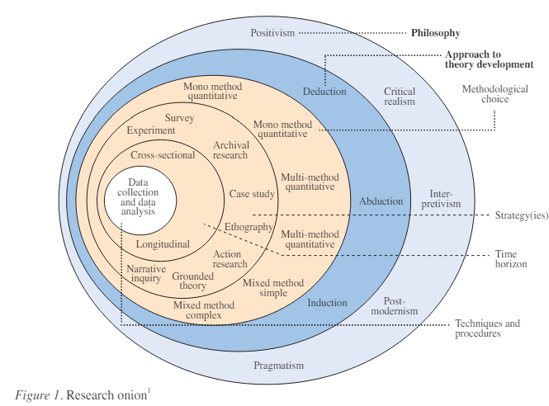

Figure 1 - Research Onion by Saunders et al.

3.2 Research Philosophy
Galliers (1991), asserts that the research philosophy is a belief in the way in which data about a phenomenon should be gathered, analysed, and used. He also mentions that there are two types of research philosophy, these being positivist and interpretivist. Ryan (2018), states that the positivist research philosophy is based on being able to prove or disprove a hypothesis and believes in the use of objectivity. On the other hand, the interpretivist research philosophy is completely different and values subjectivity instead. This research focuses on the positivist research philosophy. This research philosophy is beneficial to this research because of the subject nature of this dissertation looks closely at government-run institutes, therefore relying heavily on empirical as well as quantitative data which will be studied to draw hypotheses through patterns and correlations that will lead towards a conclusion. According to Pham (2018), the advantages of adopting a positivist approach can lead to research having high-quality standards of validity and reliability. However, positivism relies on objectivity and disregards subjectivity, this research philosophy is also based on assumptions that what happens in one social environment can be generalized to other social situations (Velez, 2008). Due to this, it will be important to compare and contrast other sources and information so that the research can be accurate and not generalized. This way of thinking will also be applied to the questionnaire survey to ensure that there is no bias in the questions and that all participant's answers are thoroughly examined and not generalized.

3.3 Research Approach
After determining that the research philosophy will follow the positivist philosophy, therefore leads to the deduction that the inductive research approach will assist this study the most. Thomas (2003) explains that the inductive research approach establishes clear links between the research objectives and the summary findings derived from the raw data, on top of this it is apparent that the raw data can be used to develop a model or theory about the underlying structure of experiences or processes. The benefits of the inductive research approach are that through flexibility and staying accurate to content a new theory can be supported (Warwick, 2016). By allowing that flexibility and staying true and accurate to the results that will come from the questionnaire survey, alongside the positivist research philosophy and the inductive research approach, it will produce a new theory or conclusion that is insightful and well-resourced.

3.4 Methodological Choice
Tharsika (2022), states that the methodological choice is where the researcher will choose whether to use qualitative, quantitative data, or a mixed method for their research. LeCompte (2000) explains that qualitative data can be retrieved from a variety of sources ranging from interviews, observations, and documents and can produce a vast amount of data (Pope et al. 2000). This data can be used to delve deeper into an individual’s emotions and thought process, showing that qualitative research will reveal insight to a person true nature and behaviour (Sutton & Austin, 2015). On the other hand, quantitative data is represented numerically, alongside anything that can be measured, counted, or given a numerical statistic such as the gender percentages of those who submitted a survey and then analysed statistically (National Library of Medicine, 2024). Halcomb & Hickman (2015) explain that when both quantitative and qualitative data are used within a singular research project it is referred to as mixed methods research and allows the researcher to examine and explore their chosen topic in more detail. The advantages that mixed method research brings will be used within this research project. This is because this project will collect public opinions through questions about ongoing issues within the prison system in England and Wales, and through this will collect qualitative data but to ensure this research project is reliable it will base the questions from well research quantitative data so there is no bias.

3.5 Research Strategy
The research strategy used within this project is a questionnaire survey. According to Jones et al. (2013) a survey is an important tool that allows a researcher to gather meaningful results from a large population with relative ease. Wright (2005), mentions that the advantages of using an online survey can include that individuals who are in very distant locations can still access the survey and give their input, alongside having the benefit of having automated data collection, reducing the time and effort a researcher needs to analyse their findings. However, Wright (2005) also says that an online survey can lead to uncertainty over the validity of data. To avoid this the questions and answers received will be carefully studied and accessed to ensure quality control and accurate data collection and analysis (Patino & Ferreira, 2018).

3.6 Time Horizon
As shown in the research onion provided by Saunders et al. (2009), the time horizon layer is one of the innermost sections and is addressed after the other layers of the research onion have been identified. Melnikovas (2018) describes this layer as the point at which the researcher must confirm a time frame for their research. This can be done through one of two studies the cross-sectional or longitudinal. Cross-sectional studies are said by Wang & Cheng (2020) to be observational studies that focus on a singular or specific point in time and analyse the data retrieved. Whereas Caruana et al. (2015) states that longitudinal studies engage in constant measures to follow a particular individual over an extended time frame with no external influence affecting the results. Based on these findings and time factors, this research will use a cross-sectional study to ensure that the research can be completed within the time frame given by an academic institute and not result in going over the deadline. The survey will be accessible to anyone who wishes to participate for a week-long period of time. Once this time is over the survey will be closed, no more answers will be accepted, and the results will be reviewed and analysed.

3.7 Techniques & Procedures

3.7.1 Data Collection, Processes and Analysis
The primary data will be collected through a survey. This will collect qualitative and quantitative data by using open and closed questions based on the Literature Review. Open-ended questions allow those who choose to participate in the chosen survey the freedom to write or say as they wish in text form. Compared to closed-ended questions restrict the participant from choosing between a limited set of answers, such as ‘yes’ or ‘no’ (Rosala, 2024). This questionnaire survey will made through the use of Google Forms, and for the specified time period of a week will be made available at all times to anyone who wishes to share their insight and participate. When this data is collected the researcher will analyse the results through thematic analysis. Thematic analysis is described by Braun & Clarke (2012) as an accessible, flexible method of qualitative data analysis.

3.7.2 Sampling
Sampling is a method that allows a researcher to collect data from a group of participants, without having to investigate and question each individual of a large population as that can be impractical and allow for high-quality research to be received with less effort (Health Knowledge, 2024). Specifically, this research will adopt the non-probability sampling method for this research. According to Elfil & Negida (2017), this sampling method is also known as convenient sampling due to its quick and convenient way of retrieving data, this is due to the participants having access to choose whether they want to be a participant after the researcher announces the study to a large group of individuals.

3.7.3 Reliability and Validity
According to Roberts & Priest (2006), reliability and validity are ways researchers use to demonstrate the research processes and the trustworthiness of research findings. They also go on into more depth explaining that reliability shows how far a researcher's tools or procedures can produce similar results under different circumstances, with the assumption that nothing has changed therefore leading to the ability of repeatability. To ensure that the research is reliable it must be repeatable, this is accomplished through finding research through similar means and being clear and direct with questions in the survey so that if redone the answers will be the same. Whereas validity refers to whether a test measures what it aims to measure. For example, if an individual is taking a driving test it should not be all theory but must require some practical driving to accurately assess the individual’s skills (Cambridge, 2024). Alwin (2010) states that surveys routinely have high reliability and validity, however, a variable that can affect this is the survey being improperly designed and having possible survey errors leading to the research not being reproducible (Rickards et al. 2012). The researcher can avoid this to ensure the reliability and validity of their research is not harmed by making sure that all questions that are released to the public are beneficial to the research and have no errors or bias in them.

3.7.4 Limitations or Ethical Issues
The limitations of a research study are the impacts or influences that the chosen research could have on the researcher's findings (University of Southern California, 2023). A limitation that could be an issue during this research is in the sampling section, this is due to the fact that the survey is published and shared between individuals only the researcher knows which sets the limitation that others cannot access the survey. Another limitation that could affect the researcher's results is the time limit used in the cross-sectional study, due to its shorter time frame than other studies potentially leading to fewer individuals participating in the survey, therefore there being less data to compare and analyse for the researcher.

Section 4: Findings
This chapter focuses on showing and analysing in detail the findings from the primary data collected from the survey. This survey was created on Google Forms and posted online for anyone to access if they choose to participate. This survey across a week-long period asked the public ten questions relating to this research study and managed to accumulate 117 responses. Before participants could access the survey, they were made to understand that their anonymity would be ensured as well as if they agreed for their answers to be used for this research. This was to make sure they were comfortable with giving their responses as well as full consent. They also could leave the survey at any point in case they were not comfortable with answering any more questions or if it took too long. As previously mentioned, this chapter is to analyse the data gathered from the survey based on public opinions around whether the prison system within England and Wales is fit for service and compared against the secondary research within the literature review.

4.1 Consent and Anonymity
Before the participants could enter the survey there were two questions that they were required to answer if they wished to continue with the survey. Firstly, was required so that they knew their anonymity was guaranteed (See 4.2.1). As well as if they consented to their answers being used in this research (See 4.2.2). This was to ensure that all answers given were honest and accurate, as the potential risk of a break in confidentiality could lead to participants not giving their honest opinions (Hoft, 2021), resulting in a research study that isn’t reproducible. However, as seen all 117 participants gave their consent.

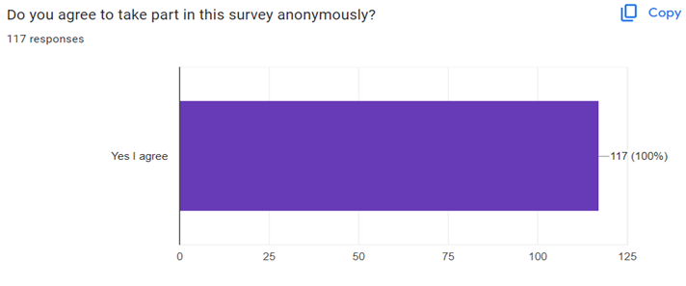
4.1.1

Figure 2 – Questionnaire Survey

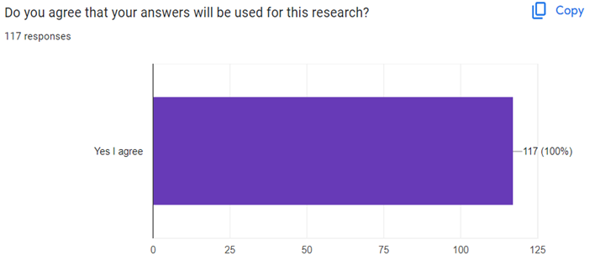
4.1.2

Figure 3 - Questionnaire Survey

4.2 Findings: Description of analysis and results
The first question of the survey released to the public after they had given their consent, was to identify what gender they identified as. As seen in photo 4.3.1 the participants were given options that tried to be as inclusive as possible so that anyone who wished to participate could be involved. The finding resulted in 48.7% female (57 participants), 46.2% male (54 participants), and 5.1% non-binary (6 participants).

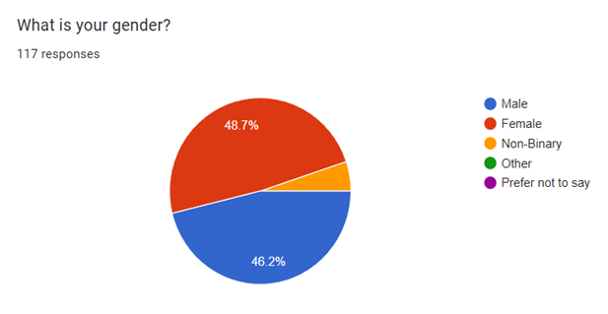
4.2.1

Figure 4 - Questionnaire Survey

The following question was a follow-up question so that the researcher could truly identify the diversity within this survey. This was to identify the participant's age they were given options from different age groups starting at 18-25 up to 66 plus. As seen in photo 4.3.2, the age group that had the majority of participants was 18-25 with 43.6%.

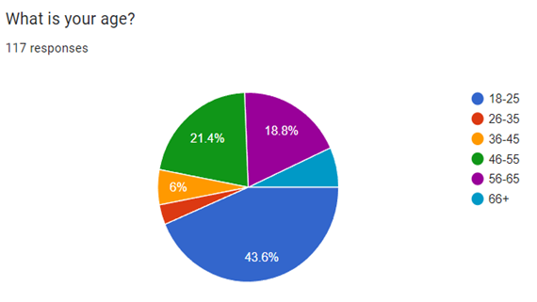
4.2.2

Figure 5 - Questionnaire Survey

The question that was addressed next was to identify how many of those participating in this survey lived in England and Wales (See 4.3.3). It was found that 94.9% (111 participants) of those who took part currently live in England or Wales. This was important to address because those who live in England and Wales have a more vested interest in what is going on in their prisons. on top of this, they may be able to give more detailed answers to the open question later in the survey because they live in the country that is being discussed in this research.

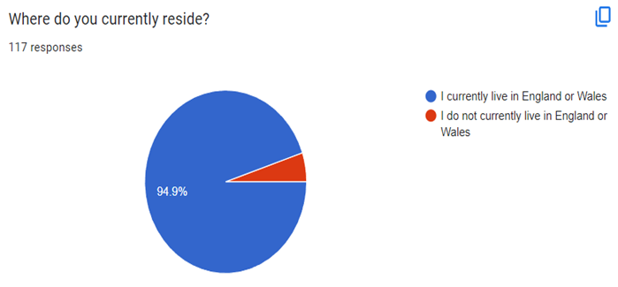
4.2.3

Figure 6 - Questionnaire Survey

The purpose of the fourth question was to identify how well-informed this group of participants considered themselves to be about the prison system itself. This was done to compare against a later question's results. These results (see 4.3.4) show that of the individuals who participated in this survey the most common answer was not informed at all at 27.4%, however, the answers were spread evenly across the data apart from the in the very well-informed section with only 4.3% of participants choosing that option.

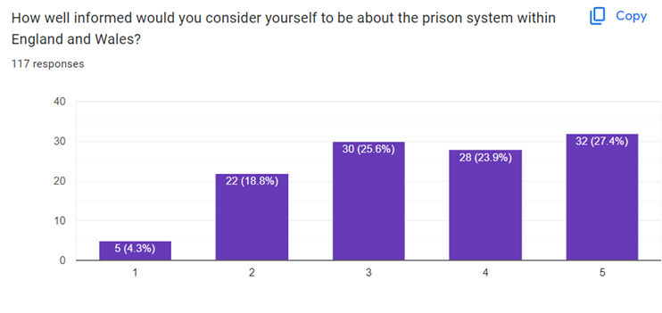
4.2.4

Figure 7 -Questionnaire Survey

The fifth question was to compare the previous question’s data to this and analyse what the public thought about the prison system (see 4.3.5) and whether they were well-informed or not informed at all. The results show that a majority of the participants believed that the prison system was being run okay with 56.4% choosing this option. This survey also shows that more individuals believed the prison system within England and Wales was being poorly run compared to being a well-run institute.

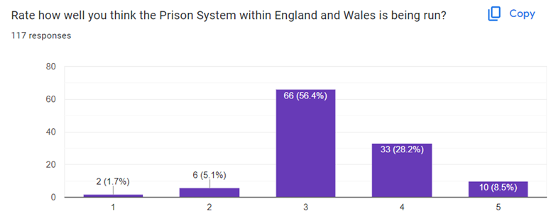
4.2.5

Figure 8 - Questionnaire Survey
Based on the previous data, this leads to the closed question of whether the participant believes the prison system needs to change. The data in chart 4.3.6 shows nearly an even split with it favouring yes at 53.8% (63 participants) and I do not know at 38.5% (45 participants). However, the important data from this is that only 7.7% (9 participants) of participants believed the prison system did not need any change.

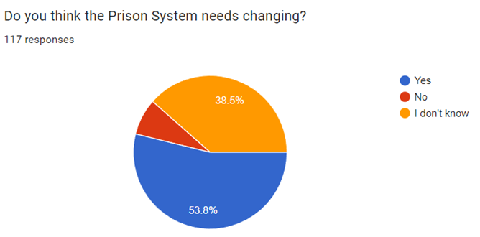
4.2.6

Figure 9 - Questionnaire Survey

With a larger portion of the participants choosing the option that the prison system within England and Wales needs changing, branches off into the following question (see 4.3.7). With this question, it could be analysed how the public who believed in change thinks it needs to happen. The data showed that 54 individuals chose to give a response and the most commonly seen answer was the death penalty or improvements to rehabilitation. Other answers included improvements to the prison such as more capacity or improvements to how they are run such as increasing staff as well as how they treat the prisoners. Based on what the literature review states with groups like the Howard League for Penal Reform (2024) wanting a change in how the penal system operates it can be seen through the data gathered that the public agree with the prison system changing.

4.2.7 If yes, what do you think would be a good alternative to assist or replace prisons?
This open question gave the participants an opportunity to voice their opinion on what they believed could make a difference to the prison system in England and Wales. 54 responses were recorded and from this data a variety of answers were given from increasing the number of staff and their pay, community service, as well as the idea to only put violent criminals in jail. However, two answers were the most apparent in the data, these being improved rehabilitation roots and reform, and the death penalty to be reintroduced. This is important data because in the literature review the key point covered is the need for improved rehabilitation methods inside the penal system for England and Wales which the participants of this survey agree with.

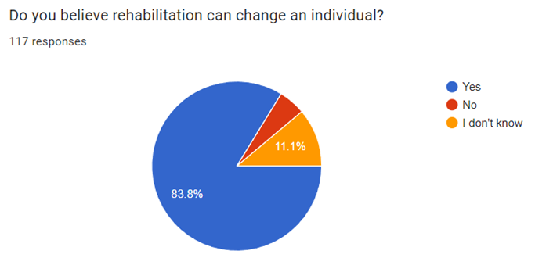
4.2.8

Figure 10 - Questionnaire Survey

The data shown in chart 4.2.8 shows if the public thinks rehabilitation can change an individual, this question was of utmost importance as it is one of the main focuses of this research study. This data shows that those who chose no or I do not know were in the minority, with 83.8% (98 participants) choosing yes and believing that rehabilitation can make a difference and change an individual. As previously mentioned, reform is key topic within the literature review as well as one of the most suggested alternatives made by the participants of this survey. This data shows that not only does the public believe that improved efforts towards rehabilitation are important but also that if this change is made it can have a serious impact and be effective.

The next two questions were to compare data gathered in the literature review from academic sources to what to public thinks as seen in pie charts 4.2.9 and 4.2.10.

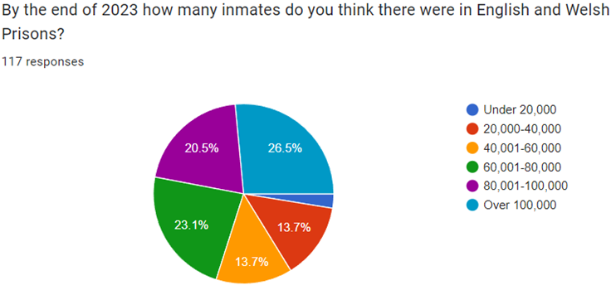
4.2.9

Figure 11 - Questionnaire Survey

It can be seen in this graph that the participants were given a multitude of choices for many inmates they believed were in prison by the end of 2023, these choices ranged from under 20,000 to over 100,000. This data shows that the most and least chosen options were at opposite sides of the spectrum with under 20,000 receiving 2.6% (3 participants), and over 100,000 receiving 26.5% (31 participants).

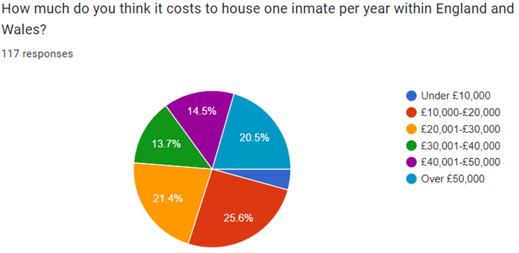
4.2.10

Figure 12 - Questionnaire Survey

This data chart was the last question for participants asked how much they thought it cost to house one inmate per year within England and Wales. They were given six options to choose from ranging from under £10,000 to over £50,000. Out of these options, most participants believed that it cost £10,000-£20,00 to house an inmate for a year at 25.6% (30 participants), whereas under £10,000 was chosen the least with 4.3% (5 participants).
4.2.9 and 4.2.10 show that participants knowledge on the criminal justice systems spending is varied with no answer in either graph getting an overwhelming majority. In the literature review it states that there were 88,225 inmates in England and Wales at the end of 2023 (UK Parliament, 2023c) and to one of these inmates per year in 2021/2022 it cost £46,696 annually (Clark, 2023). Comparing this information against the data gathered from the survey shows through the most chosen option in each graph that not only did participants believe that there were more inmates than there is but they also believed that it cost a lot less to house one inmate per year.

Section 5: Conclusion
In summary, this research project set the scene by giving details about what would be covered as well as giving brief information regarding the chosen subject, which is whether the prison system within England and Wales is fit for purpose or in need for reform. To achieve two objectives were laid out, the first being to identify some important issues that are happening in the prison system of England and Wales, and secondly to propose ideas for change to the current system and alternatives to incarceration. These two objectives cover the research question by first laying out the information, as well as past, current and future issues that are happening with the prison system, and then using this information to build possible solutions by comparing how other countries deal with similar issues, as well as researching areas that could show results.
The key information gained through these two objectives in the literature review was that some of the current issues within the prison system in England and Wales includes overcrowding, recidivism, corruption and failing rehabilitation efforts (Pidd 2023., & Ministry of Justice, 2023b., & Home Office, 2012., & Gauke, 2018). From the information gathered on these key issues research was collected on how to address and potential solve these ongoing issues within the second objective. It was concluded that the efforts to expand capacity and explore alternatives like sending them to foreign prisons have fallen short (Prison Reform Trust, 2024c., & UK Parliament, 2023c). However, rehabilitation emerged as a key issue that could be changed, with countries such as Norway, where recidivism rates are notably lower shows that finding a solution to recidivism is beneficial (Berger, 2016). It was also discovered that youth centres could be crucial however due to the lack of funding from the government, these institutions have not shown the desired results (McMahon, Belur, 2013). On the other hand, the death penalty being reintroduced was also researched however, this approach raises ethical and legal concerns (Home Office, 2019., & Petitions, 2020).
The Methodology chapter explained that this research would follow to research onion model (Saunders et al. 2009), after this it was discussed in detail what methods and approaches would be most successful and linked to this research with the data gathered. It was also mentioned what time horizon study would be applicable alongside how data would be collected with the reliability and validity not being harmed and how. The findings chapter shows the results gathered from the questionnaire survey posted online, it then used the data gathered to compare against the literature review. The data gathered showed that the participants believed that the death penalty could be an option to solve issues within the prison system within England and Wales. The other option was improving efforts towards rehabilitation, this response was important for this research with it being heavily mentioned in the literature review alongside the fact that 83.8% (93 participants) said they believed that rehabilitation could change an individual.
With all of this information gathered it can be concluded that the prison system within England and Wales is currently not fit for purpose and is in desperate need of reform. The current system approach is not fit for purpose due to the overwhelming number of issues currently within the prison system such as overcrowding, rising recidivism rates, corruption, and substandard living conditions. The need of reform is imperative because of the predictions made for the future years on the population of inmates mixed with the failing suggestions of the government, and the failure to act poses serious risks to the safety and well-being of inmates and staff, as well as financial burdens on taxpayers. Through comparisons made to Norway and what it can do for individuals when used effectively it is made clear that rehabilitation will play a vital role regarding reform, with other countries showing its effectiveness and the public agreeing that it is important, there should be more investment and assets targeted at this to see if it will show improvement. This can be done through institutions such as youth centres that assist young impressionable individuals from getting involved in a life of crime, as well as investing money into teaching inmates’ valuable life skills they can use on the outside to aid them in finding a job therefore keeping them off the streets and decreasing recidivism rates.

References
Allen G., & Mansfield, Z. (2023). Homicide statistics. House of Commons Library. Available at: https://researchbriefings.files.parliament.uk/documents/CBP-8224/CBP-8224.pdf (Accessed 5th January 2024)

Alwin, D.F. (2010). How good is survey measurement? Assessing the reliability and validity of survey measures. Handbook of survey research., 2, pp.405-434.

Anderson, P.D., & Bokor, G. (2012). Forensic aspects of drug-induced violence. Journal of pharmacy practice, 25(1), pp.41-49.

Bateman, T. (2014). Where has all the youth crime gone? Youth justice in an age of austerity. Children & Society, 28(5), pp.416-424

Berger, R. (2016). Kriminalomsorgen: a look at the world's most humane prison system in Norway. Available at: https://papers.ssrn.com/sol3/papers.cfm?Abstract_id=2883512 (Accessed 8th January 2024)

Braun, V., & Clarke, V. (2012). Thematic analysis. American Psychological Association.

Cambridge (2024). What is Validity? Available at: https://www.cambridgeenglish.org/blog/what-is-validity/#:~:text=Validity%20refers%20to%20whether%20a,of%20the%20rules%20of%20driving. (Accessed 25th April 2024)

Caruana, E.J. Roman, M. Hernández-Sánchez, J., & Solli, P. (2015). Longitudinal studies. Journal of thoracic disease. 7(11), p.537.

Clark. D. (2023). Average annual overall resource expenditure per prison place in England and Wales from 2015 to 2022. Statista. Available at: https://www.statista.com/statistics/1202172/cost-per-prisoner-england-and-wales/ (Accessed 4th April 2024)

Clark. D. (2024). Proportion of offenders who re-offend in England and Wales from 2008/09 to 2021/22. Statista. Available at: https://www.statista.com/statistics/317299/re-offending-in-england-and-wales/#:~:text=In%202021%2F22%2C%2024.9%20percent,24%20percent%20in%202020%2F21 (Accessed 10th February 2024)

Denny, M. (2016). Norway's Prison System: Investigating Recidivism and Reintegration. Available at: https://digitalcommons.coastal.edu/cgi/viewcontent.cgi?article=1032&context=bridges (Accessed 15th April 2024)

Elfil, M., & Negida, A. (2017). Sampling methods in clinical research; an educational review. Emergency, 5(1).

Galliers, R.D. (1991). Choosing Appropriate Information Systems Research Approaches: A Revised Taxonomy. Available at: https://www.researchgate.net/publication/236143992_Choosing_Appropriate_Information_Systems_Research_Approaches_A_Revised_Taxonomy (Accessed 26th April 2024)

Gauke, D. (2018). Prisons reform speech. Royal Society of Arts, London. Available at: https://www.gov.uk/government/speeches/prisons-reform-speech (Accessed 2nd December)

Halcomb, E.J., & Hickman, L. (2015). Mixed methods research. Nursing Standard. 29(32), 41-47.

Health Knowledge (2024). Methods of sampling from a population. Available at: https://www.healthknowledge.org.uk/public-health-textbook/research-methods/1a-epidemiology/methods-of-sampling-population#:~:text=Sampling%20is%20a%20method%20that,having%20to%20investigate%20every%20individual. (Accessed 25th April 2024)

HM Chief Inspectorate of Prisons (2023a). Report on an unannounced inspection of HMP Grendon. pp.11. Available at: https://www.justiceinspectorates.gov.uk/hmiprisons/wp-content/uploads/sites/4/2023/08/Grendon-web-2023.pdf (Accessed 7th April 2024)

HM Chief Inspectorate of Prisons (2023b). Report on an unannounced inspection of HMP Woodhill. pp.27. Available at: https://www.justiceinspectorates.gov.uk/hmiprisons/wp-content/uploads/sites/4/2023/11/Woodhill-web-2023.pdf (Accessed 7th April 2024)

HM Prison and Probation Service (2019). Prison and Drug Strategy. pp.1. Available at: https://assets.publishing.service.gov.uk/media/5ca4844b40f0b625e7f496aa/prison-drugs-strategy.pdf (Accessed 15th March 2024)

HM Prison and Probation Service (2023). Safety in Custody Statistics, England and Wales: Deaths in Prison Custody to December 2022 Assaults and Self-harm to September 2022. Available at: https://www.gov.uk/government/statistics/safety-in-custody-quarterly-update-to-september-2022/safety-in-custody-statistics-england-and-wales-deaths-in-prison-custody-to-december-2022-assaults-and-self-harm-to-september-2022 (Accessed 6th May 2024)

Hoft, J. (2021). Anonymity and confidentiality. The Encyclopedia of Research Methods in Criminology and Criminal Justice. 1, pp.223-227.

Home Office (2012). Bribery Act 2010 guidance. Available at: https://www.gov.uk/government/publications/bribery-act-2010-guidance (Accessed 4th March 2024)

Home Office (2015). 2010 to 2015 government policy: reoffending and rehabilitation. Available at: https://www.gov.uk/government/publications/2010-to-2015-government-policy-reoffending-and-rehabilitation/2010-to-2015-government-policy-reoffending-and-rehabilitation#:~:text=The%20programme%20aims%20to%20bring,21%20Community%20Rehabilitation%20Companies%20(CRCs) (Accessed 6th May 2024)

Home Office (2019). HRC40: UK Statement on the use of the Death Penalty. Available at: https://www.gov.uk/government/news/hrc40-uk-statement-on-the-use-of-the-death-penalty (Accessed 1st May 2024)

Home Office (2023a). Prisons data. Available at: https://data.justice.gov.uk/prisons (Accessed 16th December 2023)

Home Office (2023b). Safety and order. Available at: https://data.justice.gov.uk/prisons/safety-and-order#table-tab-assaults-rate-staff (Accessed 13th December 2023)

Home Office (2024a). Leaving Prison. Available at: https://www.gov.uk/leaving-prison/support-when-someone-leaves-prison#:~:text=A%20person%20leaving%20prison%20may,help%20from%20your%20local%20council (Accessed 24th December 2023)

Home Office (2024b). Prison life. Available at: https://www.gov.uk/life-in-prison/prisoner-privileges-and-rights (Accessed 9th April 2024)

House of Commons (2024). Oral evidence: Future prison population and estate capacity. Mark Day. Available at: https://committees.parliament.uk/oralevidence/14074/pdf/ (13th April 2024)

Howard League for Penal Reform (2024). Our approach. Available at: https://howardleague.org/our-approach/ (Accessed 4th May 2024)

Human Rights Act (1998). Available at: https://www.legislation.gov.uk/ukpga/1998/42/schedule/1 (Accessed 3rd May 2024)

Jaberg, S. (2011). Geneva tackles prison overcrowding. Available at: https://www.swissinfo.ch/eng/swiss-politics/geneva-tackles-prison-overcrowding/30793474 (Accessed 11th April 2024)

Jones, T.L. Baxter, M.A.J., & Khanduja, V. (2013). A quick guide to survey research. The annals of the Royal College of surgeons of England. 95(1), pp.5-7.

Jones, I. (2021). Prisons in Paradise or Purgatory: A Comparative Analysis Between Criminal Justice Systems and Recidivism Rates in Norway and the United States.

Kelly, S. (2024). Past, Present, Prison. Available at: https://sites.coloradocollege.edu/hip/mentally-ill-and-the-penal-system/ (Accessed 30th April 2024)

LeCompte, M.D. (2000). Analyzing qualitative data. Theory into practice. 39(3), pp.146-154.

McMahon, S., & Belur, J. (2013). Sports-based programmes and reducing youth violence and crime. London: Project Oracle. pp.1012-1023.

Melnikovas, A. (2018). Towards an Explicit Research Methodology: Adapting Research Onion Model for Futures Studies. Journal of futures Studies. 23(2).

Ministry Of Justice (2016). Youth Justice Statistics 2014/15. pp. 5. Available at: https://assets.publishing.service.gov.uk/media/5a749bfc40f0b616bcb17e04/youth-justice-statistics-2014-to-2015.pdf (Accessed 21th April 2024)

Ministry of Justice (2020). Freedom of Information Act. pp.1. Available at: https://assets.publishing.service.gov.uk/media/6048b209d3bf7f1d0fdfd4a9/FOI_200915034_prison_staff_dismissals_-_inappropriate_sexual_relationships_with_prisoners.odt (Accessed 6th May 2024)

Ministry of Justice (2023a). Prison Security Investment Programme: X-ray Body Scanners. pp.2. Available at: https://assets.publishing.service.gov.uk/media/656714a175007400131dedc3/Prison_Security_Investment_Programme_X-ray_Body_Scanner_Management_Information_December_2023.pdf (Accessed 6th May 2024)

Ministry of Justice (2023b). Proven reoffending statistics: October to December 2021. Available at: https://www.gov.uk/government/statistics/proven-reoffending-statistics-october-to-december-2021/proven-reoffending-statistics-october-to-december-2021 (Accessed 8th December 2023)

National Library of Medicine (2024). Quantitative Data. Available at: https://www.nnlm.gov/guides/data-glossary/quantitative-data (Accessed 24th April 2024)

Patino, C.M., & Ferreira, J.C. (2018). Internal and external validity: can you apply research study results to your patients?. Jornal brasileiro de pneumologia. 44, pp.183-183.

Parliament (2024). Criminal Justice Bill. Available at: https://publications.parliament.uk/pa/cm5804/cmpublic/CriminalJustice/memo/CJB64.htm#:~:text=68%25%20of%20people%20released%20to,within%20a%20year%20of%20release (Accessed 26th April 2024)

Petitions (2020). Bring back the death penalty. UK Government and Parliament. Available at: https://petition.parliament.uk/petitions/304809 (Accessed 1st May 2024)

Pham, L.T.M. (2018). Qualitative approach to research a review of advantages and disadvantages of three paradigms: Positivism, interpretivism and critical inquiry. University of Adelaide. pp.2

Pidd. H. (2023). Two-thirds of prisons officially overcrowded in England and Wales. The Guardian. Available at: https://www.theguardian.com/society/2023/oct/15/two-thirds-prisons-officially-overcrowded-england-wales (Accessed 1st December 2023)

Pierce, M., Hayhurst, K., Bird, S.M., Hickman, M., Seddon, T., Dunn, G., & Millar, T. (2015). Quantifying crime associated with drug use among a large cohort of sanctioned offenders in England and Wales. Drug and alcohol dependence. 155, pp.52-59.

Pope, C. Ziebland, S., & Mays, N. (2000). Analysing qualitative data. BMJ. 320(7227), pp.114-116.

Prison Reform Trust (2021). Overcrowding. Available at: https://prisonreformtrust.org.uk/category/overcrowding/ (Accessed 2nd April 2024)

Prison Reform Trust (2023). Prison: the facts. pp.2-4. Available at: https://prisonreformtrust.org.uk/wp-content/uploads/2022/07/Prison-the-facts-2022.pdf (Accessed 1st December 2023)

Prison Reform Trust (2024a). Accommodation and living conditions in prison. Available at: https://prisonreformtrust.org.uk/adviceguide/accommodation-and-living-conditions-in-prison/ (Accessed 5th April 2024)

Prison Reform Trust (2024b). Food in prison. Available at: https://prisonreformtrust.org.uk/adviceguide/food-in-prison/ (Accessed 26th March 2024)

Prison Reform Trust (2024c). Transferring UK prisoners to foreign prisons a “very expensive and a very complicated way” of increasing capacity. Available at: https://prisonreformtrust.org.uk/transferring-uk-prisoners-to-foreign-prisons-a-very-expensive-and-a-very-complicated-way-of-increasing-capacity/ (Accessed 13th April 2024)

Rehabs UK (2022). The Impact of 10 Years of Cuts to Addiction Services. Available at: https://rehabsuk.com/blog/the-impact-of-10-years-of-cuts-to-addiction-services/ (Accessed 20th April 2024)

Revolving doors agency (2008). Justice Reinvestment in the UK: Evidence for the Justice Select Committee. pp.1. Available at: https://revolving-doors.org.uk/wp-content/uploads/2022/02/2008-06-Evidence-submitted-to-Justice-Select-Committee-on-Justice-Reinvestment-in-the-UK-3.pdf (Accessed 4th May 2024)

Rickards, G. Magee, C., & Artino Jr, A.R. (2012). You can't fix by analysis what you've spoiled by design: developing survey instruments and collecting validity evidence. Journal of graduate medical education. 4(4), pp.407-410.

Roberts, P., & Priest, H. (2006). Reliability and validity in research. Nursing standard. 20(44), pp.41-46.

Rosala, M. (2024). Open-Ended vs. Closed Questions in User Research. Nielsen Norman Group. Available at: https://www.nngroup.com/articles/open-ended-questions/#:~:text=There%20are%20two%20types%20of,limited%20set%20of%20possible%20answers (Accessed 21st April 2024)

Ruderman, M.A., Wilson, D.F., & Reid, S. (2015). Does prison crowding predict higher rates of substance use related parole violations? A recurrent events multi-level survival analysis. PloS one. 10(10)

Ryan, G. (2018). Introduction to positivism, interpretivism and critical theory. Nurse researcher. 25(4), pp.41-49.

Saunders, M. Lewis, P., & Thornhill, A. (2009). Research methods for business students. Pearson education.

Sutton, J., & Austin, Z. (2015). Qualitative research: Data collection, analysis, and management. The Canadian journal of hospital pharmacy. 68(3), p.226.

Tharsika, K. (2022). A review of methodological choice: Research paradigm underpins. Available at: https://www.researchgate.net/publication/361119109_A_review_of_methodological_choice_Research_paradigm_underpins (Accessed 26th April 2024)

The Childrens Society (2023). Criminals capitalising on a cost of living crisis. Available at: https://www.childrenssociety.org.uk/what-we-do/blogs/criminals-capitalising-cost-living-crisis#:~:text=The%20cost%20of%20living%20crisis,promise%20of%20'easy%20money (Accessed 29th March 2024)

The Police Foundation (2022). A New Mode of Protection. Available at: https://www.policingreview.org.uk/wp-content/uploads/srpew_final_report.pdf (Accessed 26th February 2024)

Tickle, S.J. (2018). The impact of austerity on children and young people’s health and well-being in England and Wales. pp.1

Thomas, D.R. (2003). A general inductive approach for qualitative data analysis. pp.1

UK Parliament (2013). Key dates. Avaialble at: https://www.parliament.uk/about/living-heritage/transformingsociety/laworder/policeprisons/keydates/ (Accessed 3rd February 2024)

UK Parliament (2023a). Capacity crisis in jails leads to special parliamentary debate. Available at: https://committees.parliament.uk/committee/102/justice-committee/news/196138/capacity-crisis-in-jails-leads-to-special-parliamentary-debate/ (Accessed 30th January 2024)

UK Parliament (2023b). UK Prison Population Statistics. Available at: https://commonslibrary.parliament.uk/research-briefings/sn04334/#:~:text=It%20has%20steadily%20grown%20since,Northern%20Ireland%20in%202021%2F22 (Accessed 28th March 2024)

UK Parliament (2023c). What is the Government doing to reduce pressure on prison capacity? Available at: https://commonslibrary.parliament.uk/what-is-the-government-doing-to-reduce-pressure-on-prison-capacity/ (Accessed 30th November 2023)

UK Parliament (2024a). Early prisons and imprisonment. Available at: https://www.parliament.uk/about/living-heritage/transformingsociety/laworder/policeprisons/overview/earlyprisons/ (Accessed 19th December 2023)

UK Parliament (2024b). Reforming prisons, reforming prisoners. Available at: https://www.parliament.uk/business/publications/research/olympic-britain/crime-and-defence/reforming-prisons-reforming-prisoners/ (Accessed 30th April 2024)

University of Southern California (2023). Research Guides: Organizing Your Social Sciences Research Paper. Available at: https://libguides.usc.edu/writingguide/limitations (Accessed 21st April 2024)

Velez, A.M. (2008). Evaluating research methods: Assumptions, strengths, and weaknesses of three educational research paradigms. Academic Exchange Extra. 9, pp.1-9.

Wang, X., & Cheng, Z. (2020). Cross-sectional studies: strengths, weaknesses, and recommendations. Chest. 158(1), pp.65-71.

Warwick (2016). Inductive or deductive approaches. Available at: https://warwick.ac.uk/fac/soc/ces/research/current/socialtheory/maps/when/#:~:text=The%20benefits%20of%20an%20inductive,on%20social%20loss%20as%20example%5D. (Accessed 24th April 2024)

World Prison Brief (2024). Norway. Available at: https://www.prisonstudies.org/country/norway (Accessed 19th April 2024)

Wright, K.B. (2005). Researching Internet-based populations: Advantages and disadvantages of online survey research, online questionnaire authoring software packages, and web survey services. Journal of computer-mediated communication, 10(3).

