

LOCATION: Swansea | LLEOLIAD: abertawe
LEVEL 5 | LEFEL 5
EXAMINATION PERIOD | CYFNOD ARHOLIADAU
MAY 2023 | 2023

MODULE CODE: ACDC5009
Electromagnetic Radiation
Programme:
B.Eng.(Hons.) iN Embedded Electronic Systems

TIME: 2 HOURS
answer Any five questions

Equipment or materials required – Calculator
Adnoddau neu ddefnyddiau sydd eu hangen - Cyfrifiannell

ANSWER ANY 5 QUESTIONS

Question 1 [20 marks]
- Define an Electromagnetic wave. [2 marks]
Answer: Electromagnetic radiation can be defined as a form of energy that is produced by the movement of electrically charged particles travelling through a matter or vacuum or by oscillating magnetic and electric disturbances. [2 marks]
- Describe the properties of Electromagnetic waves. [6 marks]
Answer:
- They does not require any medium for propagation.
- Electromagnetic waves can be reflected, refracted, absorbed, diffracted, scattered and produce interference patterns.
- They are transverse in nature.
- Electromagnetic waves travel with a constant velocity in vacuum. The speed of the waves is 3x10⁸m/s.
- They obey the equation c = fλ. Here, f is the frequency in Hertz and λ is the wavelength in metres. C= 3 x 10⁸ m/s. From this relation, the electromagnetic waves will travel with the speed of light regardless of wavelength and frequency.
- The oscillating electric field and magnetic field are in the same phase.
- They may be polarized. [ Each point 1 mark, maximum of 6 marks]
- How does an Electromagnetic wave propagate. [2 marks]
Answer: Electromagnetic waves are Self Propagating in nature. The magnetic and the electric fields come at 90° to each other, and the combined waves move perpendicular to both electric and magnetic oscillating fields occurring during the disturbance. [2 marks]
- What is an Electromagnetic Spectrum? Describe the features and applications of Radio Frequency waves. [8 marks]
Answer: The electromagnetic (EM) spectrum is the range of all types of EM radiation, which travels and spreads out as it goes. Electromagnetic energy travels in waves and spans a broad spectrum from very long radio waves to very short gamma rays. EM waves are in order of increasing frequency and decreasing wavelength. [2 marks]
- Radio waves have the longest wavelengths and lowest frequency in the electromagnetic spectrum.
- Frequency - 300 gigahertz (GHz) and below.
- Wavelength – 1mm to 10,000 kilometers
- AM – Frequency range - 535-1605 kHz.
- FM – Frequency range - 88 to 108 MHz
- At 300 GHz, the corresponding wavelength is 1 mm (shorter than a grain of rice); at 30 Hz the corresponding wavelength is 10,000 kilometers (6,200 miles) (longer than the radius of the Earth).
- Radio waves are very widely used in modern technology for fixed and mobile radio communication, broadcasting, radar and radio navigation systems, communications satellites, wireless computer networks and many other applications.
- The radio "receives" these electromagnetic radio waves and converts them to mechanical vibrations in the speaker to create the sound waves you can hear.
[ 6 marks]
e) Define a TE mode. [2 marks]
Answer: These are sometimes called H modes because there is only a magnetic field along the direction of propagation (H is the conventional symbol for magnetic field). Electric Field (E) vector is transverse or perpendicular to the Waveguide’s axis. No electric field in the direction of propagation. [2 marks]
Question 2 [20 marks]
- Define Polarisation. Describe the types of Polarisation with the aid of necessary diagram. [10 marks]
Answer: The polarisation of an electromagnetic wave indicates the plane in which it is vibrating. As electromagnetic waves consist of an electric and a magnetic field vibrating at right angles to each other. It is necessary to adopt a convention to determine the polarisation of the signal. [2 marks]
- Linear polarization.
- Circular polarization.
- Elliptical polarization [1 mark]
Linear polarization
- Linear polarization or plane polarization of electromagnetic radiation is a confinement of the electric field vector or magnetic field vector to a given plane along the direction of propagation.
- The orientation of a linearly polarized electromagnetic wave is defined by the direction of the electric field vector.
- For example, if the electric field vector is vertical the radiation is said to be vertically polarized.
- If the electric field vector is horizontal the radiation is said to be horizontally polarized.
[2 marks]
Circular polarization.
Circular polarization of an electromagnetic wave is a polarization state in which, at each point, the electromagnetic field of the wave has a constant magnitude and rotates at a constant rate in a plane perpendicular to the direction of the wave. [1 mark]
Elliptical polarization.
Elliptical polarization is the polarization of electromagnetic radiation such that the tip of the electric field vector describes an ellipse in any fixed plane intersecting, and normal to, the direction of propagation. [1 mark]
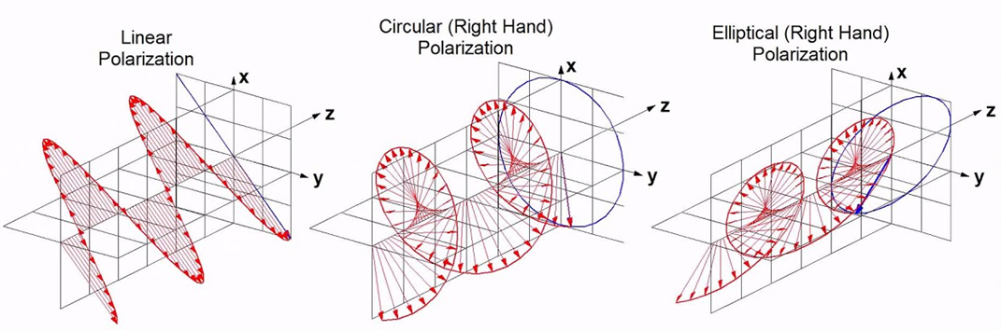[3 mark]

- A Charge $Q_{1}= -20μC$ is located at P(-6,4,6) and a charge $Q_{2}= 50μC$ is located at R (5,8,-2) in a free space. Find the force exerted on $Q_{2}$ by $Q_{1}$. The distance given are in meters. [10 marks]
Answer:
${\overline{F}}_{Q_{1}Q_{2}}=\frac{Q_{1}Q_{2}}{4πε_{0}d_{12}^{2}}{\overline{a}}_{12}$
$\overline{P}=-6{\overline{a}}_{x}+4{\overline{a}}_{y}+6{\overline{a}}_{z}$
$\overline{P}=5{\overline{a}}_{x}+8-2{\overline{a}}_{z}$ [2 marks]
${\overline{d}}_{PR}=\overline{R}-\overline{P}=11{\overline{a}}_{x}+4{\overline{a}}_{y}-8{\overline{a}}_{z}$ [1 mark]
$\left|{\overline{d}}_{PR}\right|=\sqrt{{11}^{2}+4^{2}+{(-8)}^{2}}=14.177$ [1 mark]
${\overline{a}}_{12}=\frac{{\overline{d}}_{PR}}{\left|{\overline{d}}_{PR}\right|}=\frac{11{\overline{a}}_{x}+4{\overline{a}}_{y}-8{\overline{a}}_{z}}{14.177}=0.776{\overline{a}}_{x}+0.28{\overline{a}}_{y}-0.564{\overline{a}}_{z}$ [2 mark]
${\overline{F}}_{Q_{1}Q_{2}}=\frac{-20×{10}^{-6}×50×{10}^{-6}}{4π×8.85×{10}^{-12}×{14.177}^{2}}[0.776{\overline{a}}_{x}+0.28{\overline{a}}_{y}-0.564{\overline{a}}_{z}]$
${\overline{F}}_{Q_{1}Q_{2}}=-0.0447[0.776{\overline{a}}_{x}+0.28{\overline{a}}_{y}-0.564{\overline{a}}_{z}]$ [2 marks]
${\overline{F}}_{Q_{1}Q_{2}}=-0.0346{\overline{a}}_{x}-0.0126{\overline{a}}_{y}+00.2522{\overline{a}}_{z}]$ N
$\left\lceil {\overline{F}}_{Q_{1}Q_{2}}\right\rceil =\sqrt{{(-0.0346)}^{2}+{(-0.0126)}^{2}+{(-0.02522)}^{2}}=44634mN$ [2 marks]
Question 3 [20 marks]
- Describe the following terms used in Electromagnetic Radiation with necessary diagram,
- Diffraction, [2 marks]
- Total Internal Reflection, [2 marks]
- Scattering [2 marks]
- Interference [2 marks]
- Refraction [2 marks]
Answer:
- Diffraction,
Diffraction is defined as the interference or bending of waves around the corners of an obstacle or through an aperture into the region of geometrical shadow of the obstacle/aperture. The diffracting object or aperture effectively becomes a secondary source of the propagating wave. [1 mark]
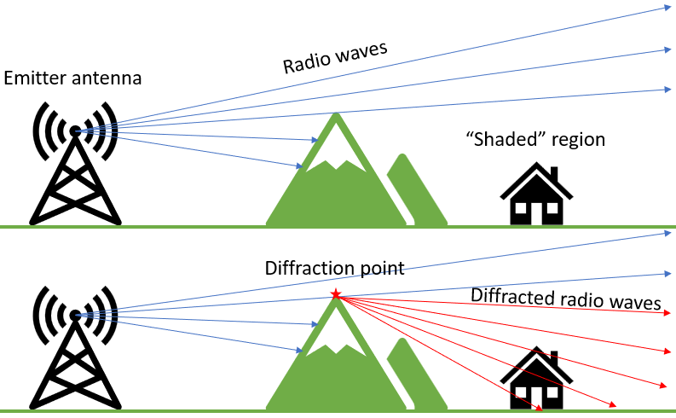 [1 mark]
- Total Internal Reflection,
Total internal reflection is the phenomenon that involves the reflection of all the incident light off the boundary. [1 mark]
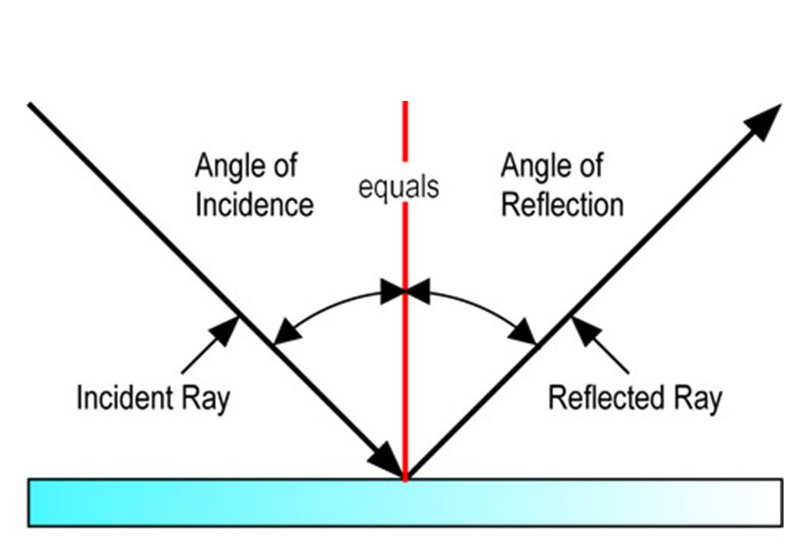 [1 mark]
- Scattering
Scattering is the process by which a particle in the path of an electromagnetic wave continuously removes energy from the incident wave and re-radiates the energy into the total solid angle centred at the particle. [1 mark]
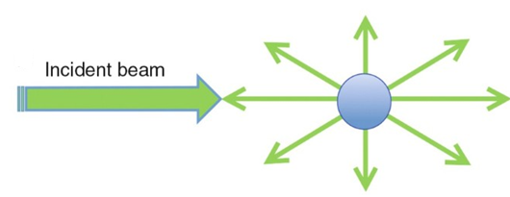 [1 mark]
- Interference
Electromagnetic interference (EMI) is unwanted noise or interference in an electrical path or circuit caused by an outside source. EMI can cause electronics to operate poorly, malfunction or stop working completely.
Interference is a phenomenon in which two waves combine by adding their displacement together at every single point in space and time, to form a resultant wave of greater, lower, or the same amplitude. [2 marks]
- Refraction
Refraction is the change in the direction of a wave passing from one medium to another. Refraction is the bending of light (it also happens with sound, water and other waves) as it passes from one transparent substance into another. [1 mark] 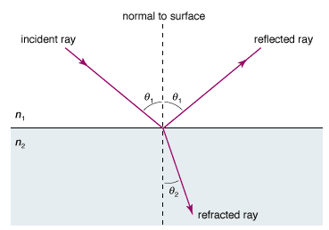 [1 mark]

- What is a waveguide? Describe the types of optic fibre waveguide with necessary diagrams. [10 marks]
Answer: A waveguide is a structure that guides waves, such as electromagnetic waves or sound, with minimal loss of energy by restricting the transmission of energy to one direction. Waveguide helps in the propagation of high frequency Electromagnetic waves like Microwaves, Radio waves, and Infrared Rays. [2 marks]
Optic fiber waveguides are classified as follows
- Single mode optic fiber,
- Multimode graded index optic fiber,
- Multimode step-index optic fiber. [1 mark]
single mode optic fiber,
single-mode optical fiber (SMF), also known as fundamental- or mono-mode is an optical fiber designed to carry only a single mode of light in the transverse mode.
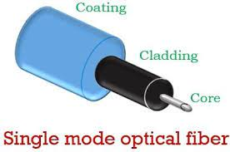 [2 marks]
Multimode step index optic fiber :
- step-index fiber, where a uniform refractive index exists within the core and a sharply decreased refractive index exists in the core-cladding interface because of the lower refractive index in cladding.
- For step-index multimode fiber, the light propagates in the shape of a zigzag along the fiber/core axis according to the principle of total reflection.
- Light entering the fiber at different angles of incidence will go through different paths.
- Although the incident lights propagate at the same speed simultaneously at the input, the time to reach the output of the fiber is different, resulting in a temporal dispersion called modal dispersion. [1 mark]
Multimode graded index optic fiber
- Graded index multimode fiber is a type of optical fiber where the refractive index is higher at the axis of the core and then it decreases gradually towards the core-cladding interface.
- That is to say, the refractive index of a graded-index fiber gradually decreases from its center, and eventually decreases to the same value as the cladding at the core edge.
- The change in refractive index causes refraction rather than total internal reflection.
- When light passes through a layer with a lower refractive index, the light will fold back to the fiber axis. Total internal reflection does not occur because refraction folds the light back into the fiber axis before it reaches the cladding boundary. ` [2 mark]
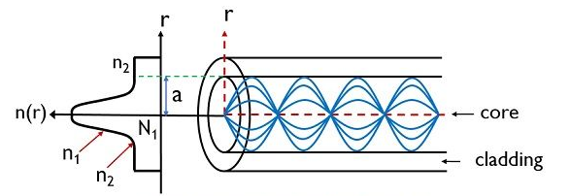
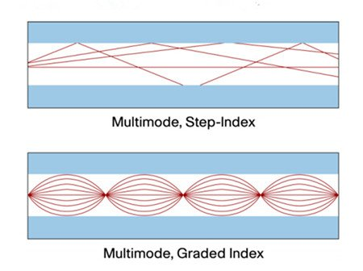 [2 mark]

Question 4 [20 marks]
- A Volume charge density is expressed as $ρ_{v}=10Z^{2}xsinπy$. Find the total charge inside the volume (-1$≤x≤2), (0≤y≤1)$and$(3≤Z≤3.6)$ [6 marks]
Answer:
$ρ_{v}=10Z^{2}xsinπy$
$Q=\int_{Vol}{ρ_{v}dv}$ [1 mark]
$Q=\int_{-1}^{2}{\int_{0}^{1}{\int_{3}^{3.6}{10Z^{2}xsinπy}dxdydz}}$ [1 mark]
$Q=10\left[{\left[\frac{x^{2}}{2}\right]}_{-1}^{2}{\left[\frac{Z^{3}}{3}\right]}_{3}^{3.6}{\left[\frac{-cosπy}{π}\right]}_{0}^{1}\right]$ [2 marks]
$Q=62.57C$ [2 marks]
- A silica optical fiber with a core diameter large enough to be considered by ray theory analysis has a core refractive index of 1.50 and a cladding refractive index of 1.47. Determine the critical angle at the core–cladding interface and the acceptance angle in air for the fiber. [4 marks]
Answer:
Critical angle:
$ϕ_{c}={Sin}^{-1}\frac{n_{2}}{n_{1}}={Sin}^{-1}\frac{1.47}{1.50}={78.5}^{o}$ [2 marks]
$NA={(n_{2}^{2}-n_{1}^{1})}^{1/2}$ =0.3 [1 mark]
$Acceptance angle$
$ϕ_{c}={Sin}^{-1}NA={Sin}^{-1}\left(0.30\right)= {17.4}^{o}$ [1 mark]
- Describe the construction and working of a laser with the aid of necessary diagrams. [8 marks]
Answer:
- Fabrication of multimode injection lasers with a single or small number of lateral modes is achieved by the use of stripe geometry.
- These devices are often called gain-guided lasers. The constriction of the current flow to the stripe is realized in the structure either by implanting the regions outside the stripe with protons (proton - isolated stripe) to make them highly resistive, or by oxide or p–n junction isolation.
- The structure for an aluminum gallium arsenide oxide isolated stripe DH laser. It has an active region of gallium arsenide bounded on both sides by aluminum gallium arsenide regions.
- This technique has been widely applied, especially for multimode laser structures used in the shorter wavelength region. The current is confined by etching a narrow stripe in silicon dioxide film.
- The resistive region formed by the proton bombardment gives better current confinement than the simple oxide stripe and has superior thermal properties due to the absence of the silicon dioxide layer; p–n junction isolation involves a selective diffusion through the n-type surface region in order to reach the p-type layers. None of these structures confines all the radiation and current to the stripe region and spreading occurs on both sides of the stripe. With stripe widths of 10 µm or less, such planar stripe lasers provide highly efficient coupling into multimode fibers,
- Some injection laser structures characteristic is not linear in the simulated emission region, but exhibits kinks. This phenomenon is particularly prevalent with gain-guided injection laser devices.
- The kinks may be classified into two broad categories. The first type of kink results from changes in the dominant lateral mode of the laser as the current is changed. The second type of kink involves a ‘spike’, as observed for laser B.
- Gain-guided lasers are commercially available for operation in both the shorter wavelength range (using GaAs active regions) and the longer wavelength range
[6 marks]
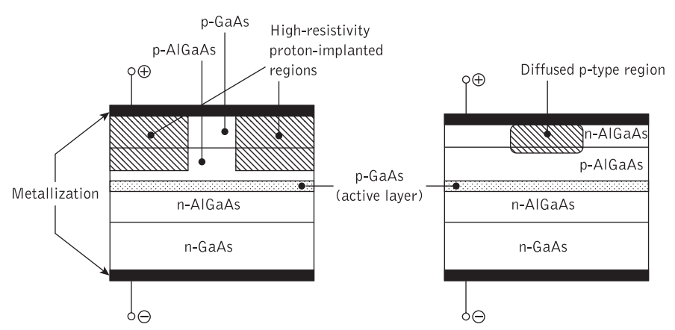 [2 marks]
- Describe the function of an isolator in a waveguide. [2 marks]
Answer: An isolator is a two-port device that transmits microwave or radio frequency power in one direction. It isolates the unwanted reflected signals which may cause damage to the RF transmitter and other units. [2 marks]
Question 5 [20 marks]

- Find the inductance per unit length of a co-axial cable radius of inner and outer conductors are 1mm and 3mm respectively. Assume relative permeability as unity.
[4 marks]
Answer:
$\frac{L}{d}=\frac{μ}{2π}ln\left(b/a\right)$ [2 marks]
$=\frac{μ_{o}μ_{r}}{2π}ln\left(b/a\right)$
$=\frac{4π×{10}^{-7}×1}{2π}ln\left({3×{10}^{-3}}/{1×{10}^{-3}}\right)$
$=0.2197μH/m$ [2 marks]
- Calculate the characteristic impedance , the attenuation constant and phase constant of a transmission line if the following measurements have been made on the line as, $Z_{OC}=550Ω∠{-60}^{o}Ω and Z_{SC}=500Ω∠-{14}^{o}Ω$. [16 marks]
Answer:
For a Transmission line
$Z_{0}=\sqrt{Z_{OC}Z_{SC}}=\sqrt{550×500∠-{60}^{o}-{14}^{o}}$
$=524.404∠\frac{{74}^{o}}{2}=524.404∠{37}^{o}Ω$
$=414.807-j315594Ω$ [3 marks]
$tanh γ=\sqrt{\frac{Z_{SC}}{Z_{OC}}}=\sqrt{\frac{500∠-{14}^{o}}{500∠-{60}^{o}}}=0.9534∠\frac{-{14}^{o}+{60}^{o}}{2}$ [3 marks]
$=0.9534∠{23}^{o}=0.877+j0.3725$
$tanh γ=\frac{e^{2γ}-1}{e^{2γ}+1}=0.877+j0.3725$
${(e}^{2γ}-1)=(0.877+j0.3725)(e^{2γ}+1)$
$e^{2γ}-1=0.877e^{2γ}+j0.3725e^{2γ}+0.877+ j0.3725$
$e^{2γ}\left[1-0.877+j0.3725\right]=1+0.877+j0.3725$ [2 marks]
$e^{2γ}\left[0.123+j0.3725\right]=1.877+j0.3725$
$e^{2γ}=\frac{1.877+j0.3725}{0.123+j0.3725}=\frac{1.9136∠{11.22}^{o}}{0.3922∠{71.72}^{o}}$
$e^{2γ}=4.8791∠{82.94}^{o}$
$2γ=ln\left[4.8791∠{82.94}^{o}\right]$
$γ=\frac{1}{2}[ln4.8791+j{82.94}^{o}]$ [4 marks]
$w.k.t$,
$γ=α+jβ$
$α+jβ=\frac{1}{2} ln4.8791+j\frac{{82.94}^{o}}{2}$
$α= 0.7924 Nepers/Km$
Attenuation Constant = $0.7924 Nepers/Km$ [2 marks]
$β={\left(\frac{82.94}{2}\right)}^{o}=\frac{{41.47}^{o}}{Km}$
Phase Constant $β=0.7237 rad/km$ [2 marks]
Question 6 [20 marks]
- A plane TEM wave has a power density of 12$ω/m^{2}$ in a medium with $ε_{r}=3$,${ μ}_{r}=1$. Find $E_{max}$ and $H_{max}$. [6 marks]
Answer:
$Power=\frac{E_{max}^{2}}{2η_{o}}=1.2ω/m^{2}$
$η_{o}=\sqrt{\frac{μ_{o}μ_{r}}{ε_{o}ε_{r}}}=120π\sqrt{\frac{μ_{r}}{ε_{r}}}= 120π\sqrt{\frac{1}{3}}$ [1 mark]
$\frac{E_{max}^{2}}{2η_{o}}=1.2$
$E_{max}^{2}=1.2×2η_{o}$
$E_{max}^{2}=1.2×2×120π\sqrt{\frac{1}{3}}$
$E_{max}=22.85 V/m$ [2 marks]
$\frac{E_{max}}{H_{max}}=η$ [1 mark]
$H_{max}=\frac{22.85 }{η}$
$H_{max}=\frac{22.85 }{120π\sqrt{\frac{1}{3}}}$
$H_{max}=0.105AT/m$ [2 marks]

- Define Doppler Effect, with an example. [4 marks]
Answer: Doppler effect is defined as the increase (or decrease) in the frequency of sound, light, or other waves as the source and observer move towards (or away from) each other. [2 marks]
The drop in pitch of ambulance sirens as they pass by and the shift in red light are common examples of the Doppler Effect. [2 marks]
- Describe the working of a Pulse radar, with the aid of a functional Block diagram. [10 marks]
Answer:
- Pulse Modulator − It produces a pulse-modulated signal and it is applied to the Transmitter.
- Transmitter − It transmits the pulse-modulated signal, which is a train of repetitive pulses.
- Duplexer − It is a microwave switch, which connects the Antenna to both transmitter section and receiver section alternately. Antenna transmits the pulse-modulated signal, when the duplexer connects the Antenna to the transmitter. Similarly, the signal, which is received by Antenna will be given to Low Noise RF Amplifier, when the duplexer connects the Antenna to Low Noise RF Amplifier.
- Low Noise RF Amplifier − It amplifies the weak RF signal, which is received by Antenna. The output of this amplifier is connected to Mixer.
- Local Oscillator − It produces a signal having stable frequency. The output of Local Oscillator is connected to Mixer.
- Mixer − We know that Mixer can produce both sum and difference of the frequencies that are applied to it. Among which, the difference of the frequencies will be of Intermediate Frequency (IF) type.
- IF Amplifier − IF amplifier amplifies the Intermediate Frequency (IF) signal. The IF amplifier shown in the figure allows only the Intermediate Frequency, which is obtained from Mixer and amplifies it. It improves the Signal to Noise Ratio at output.
- Detector − It demodulates the signal, which is obtained at the output of the IF Amplifier.
- Video Amplifier − As the name suggests, it amplifies the video signal, which is obtained at the output of detector.
- Display − In general, it displays the amplified video signal on CRT screen.
[7 marks]
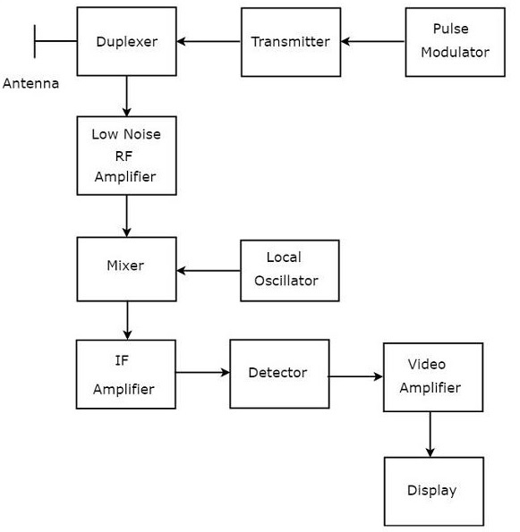
[3 marks]

Diwedd/End

