Employability Skills

Task 1
Student’s Name: Edna Green-Akafou
Student’s #: 1814551
Module #: BMSW 4001
Module Title: Academic and Employability Skills
Lecturer’s Name: Mr. Peter Allen
Date of Submission: August 26, 2019
Term 1

Table of Contents
Chapter Pages
Introduction 3
Significance of Study 4
Literature Review 5-6
Discussion 7-9
Conclusion 10
References 11-12
Appendices 13-17

Title: Analysing Academic and Employability Skills
Introduction
Employment is a critical phase of a person's life. Much of the time people miss the opportunity to get a conventional position or occupation, since they are not set ready for being used. Notwithstanding the way that it is agreed that movement express scope of capacities is basic to have, anyway there are other social aptitudes additionally which are essential in finding a perfect profession and a short time later supporting it in future. For us to win their adversaries in the angry test, organizations need graduates who have a wide extent of aptitudes to bring to the working environment and need the agents with multi-gifted to fulfill a wide scope of employments.
The purpose of this report is to analyse the skills that I have developed during Academic and Employability Skills course. Employability skills can be defined as the skills persons own or developed to make them employable in their field of studies or career. Employability skills include communication, Teamworking, time management, decision making, problem solving and organising and planning. Academic skills on the other hand are the skills that provide the foundation that will help you to be an effective learner in school. Academic Skills include paraphrasing, Harvard referencing, report writing, summarising and presentation skills.

Significance of Report
This report is important as it will benefit both employers, employee and students that ae studying. It will help employers to be aware of the skills that their employee must have for them to be employable and it will educate employee and students that are studying about the skills they need to have to make them employable in the future.

Literature Review
There is a significant connection between skills require for school and your place of employment. Everyone possesses different skills and ability yet our overall abilities in relation to critical thinking and our knowledge in a particular discipline will be basically the same (Morgan, 2017, p. 177).
Employability skills are crucial for both employers and employees. Persons that possessed or have developed effective employability skills are more marketable or employable. Bennet (2006) stated that for persons to survive in this workforce era employability skills are necessary. An examination that was completed by Fitrisehara et al. (2009) demonstrated that understudies have a moderate degree of employability aptitudes. Data abilities were observed to be the most minimal score and individual quality the maximum score. They found that there were noteworthy contrasts between employability abilities and the understudies' field of studies. The discoveries likewise demonstrated employability aptitudes obtained from various field of studies changes essentially. The discoveries demonstrated that understudies in the electronic field have the most employability abilities contrasted with others. Another, investigation on specialized alumni done by Ahmad Zaini (2005) found that 80.000 were still
jobless, and these alumni are to a great extent rely upon scholastic capabilities to find a new line of work yet with less nontechnical abilities or conventional aptitudes expected of businesses. Managers will in general find capable laborers from abroad in view of nearby graduates’ absence of employability. Information from the Economic Planning Unit (2006) expressed that the joblessness rate ascends from 3.1% (2000) to 3.5% (2010).
When you are working in the Health and Social care industry it very important to have employability skills especially communication, team work and problem-solving skills. Blaxell and Moore (2012) explained that communication skills, team work and problem-solving skills are very important skills that one must have or develop. When you have good communication skills it adds to profitable and agreeable relations between the worker and the clients. In addition, when you can work in a team the outcome will be more productive and the working relationships will be more effective and finally problem-solving add to profitable results. These skills can help medicinal services laborers to all the more likely serve quiet populaces and improve the effectiveness of the social insurance practice. It is with these employability skills that make graduates most appealing to potential bosses. The challenge for employments for graduating understudies can be exceptionally serious. Understudies should display these abilities in a manner that is important to the business so as to be fruitful in getting work and encouraging their vocation.
Employability skills are connected to Academic skills. It is very important that pupils, employers and employee master academic skills. All students need to have or develop academic skills in today’s world. However, to truly be career ready students also need to be able to apply academics in context all understudies need essential scholarly information, particularly in math and English language expressions, and, in the present monetary condition, all secondary school understudies need the scholastic abilities important to seek after postsecondary training without remediation the measure many consider "school preparation." Notwithstanding, to really be vocation prepared, understudies additionally should probably apply scholastics in setting, and some scholarly aptitudes need more consideration and improvement. For instance, managers frequently refer to lacks in English and composed correspondences, for example, memos, letters and complex specialized reports. This backing that the vast majority of the composed material understudies will experience in their vocations is educational in nature, for example, specialized manuals and research articles, and they should be prepared scholastically to break down and utilize these materials. Time and again, these abilities are not underlined in customary scholastic homerooms. Work environment lacks in math are likewise ordinarily noted, with more consideration required on territories, for example, information investigation and measurements, thinking, and understanding numerical issues.

Discussion
I will be discussing three employability skills (communication, teamwork and time management) and three academic skills (paraphrasing, summarising and referencing) that I have developed in class. From studying this course, I have learnt how important employability skills are. I can say I have become a more effective communicator since taking this course. I have studied Shannon and Weaver Model of communication. Communication is the transfer of information from one person to another either written or verbally (Shannon and Weaver, 1949). From studying their model, I know what it takes to be an effective communicator. This is a key skill that employers are looking for. I have always been an effective communicator because of the line of work (Working with stroke patients) I am in. It is very important that I am an effective communicator in my field of work and outside as I am working with sick patients and if I do not relay messages effectively then it can be detrimental. Effective communication skills are fundamental for people in any social insurance setting, from a doctor examining an unpredictable conclusion with a patient, to therapeutic charging staff cooperating with insurance agencies to appropriately accommodate solicitations. Forthcoming competitors should show ability in successfully interfacing with different hierarchical levels and correspondence styles and should be open to talking about a wide scope of profoundly touchy data in an expert way. Moreover, in circumstances including restorative crises, the requirement for clear, concise communication is principal, as time is of the pith in numerous occasions (iCIMS, 2015).
Another important employability skills that I developed is team working. Working with strokes patient we must work in teams for our work to be easier and more productive. Since I have been working in teams, I have been less stress and more productive at work and home. If we fail to work in team then we cannot reach our goals that we have set. Working in a team has increase my growth. A significant part of the work in the Health and social care industry is communitarian, with numerous people associating in groups nearby others, for example, specialists and medical caretakers. Having the option to viably work in gatherings and add to a more noteworthy objective is fundamental for effective execution, and furthermore improves the degree of consideration and wellbeing for patients (iCIMS, 2015).
The final employability skill that I have is Time Management. Working with strokes patient you must always be on time. Time management is very important in our everyday lives as well as for the work organization. When you are good at managing your time, it will make your more employable. Employers are looking for this skill as well as time is money. Health and Social care experts must show competency in time the board aptitudes to effectively deal with position obligations and keep up an expert domain when associating with patients and partners. Being able to organize day by day remaining burden and viably execute numerous assignments all the while is fundamental for all positions. Also, identified with flexibility, laborers in this industry must almost certainly rapidly reprioritize and deal with their assignments because of a minute ago booking alterations, therapeutic crises, and regularly changing hierarchical needs (iCIMS, 2015).
In addition to these skills I have developed paraphrasing skills (see appendices) from doing this course. Paraphrasing is when you rewrite a text using your own words without altering the meaning of the original text. I have learnt that this skill is very important when studying and also in my line of work. This skill helps to prevent plagiarism (using someone’s information as your own without giving the original author or source any credit). Plagiarism is considered a serious issue in Academic writing. I have developed this skill from reading different books, journals and websites and trying to paraphrase what I read and from my job. From my job I have noticed that paraphrasing helps the patient to know their information has been received clearly. We use paraphrasing with our patient, we listen to them feeding back briefly what we have heard to show them we are listening. For example, when having a face to face discussion or supervision. Paraphrasing encourages the individual to realize that their message was heard plainly. Once more, the speaker gets explanation that what they were attempting to state was gotten. With regards to working with strokes patient, this is significant. I know for a fact, that not explaining what to do can make for a troublesome day (Craft, 2017).
Summarising (see appendices) is giving a short version of what a text is talking about using your own words. In the health and Social Care industry it is significant to display that you comprehend what the other person is saying. What we do in my field of work is summarise what the patient said to check our understanding. Health and Social Care workers should help individuals talk about and express their worries by checking their comprehension of what the individual says to them by recapping, summarising or simply posing inquiries like, 'Can I simply watch that you implied … ' (BTEC First Health and Social Care - Student Textbook, 2017).
The final academic skill that I have developed from studying this course is referencing. Before starting this course, I never knew how to reference sources properly or the different formats (Harvard, MLA, APA) that they use. Now I know how to references sources which I received my information from. Referencing is providing information about the sources you used when carrying out your research. Academic referencing offers believability to the data introduced, empowering sources to be followed, confirmed, and used to associate and integrate thoughts. Roberts (2008) recommends the main source of counterfeiting is vulnerability about how to refer to sources and misguided judgments about referencing wording.

Conclusion
From completing this course, I learnt that employability and academic skills are connected. For me or anyone to be employable we must have or developed effective employability and academic skills. In today’s society employability skills are very important to employers. The more effective employability skills you have the more likely you are to get a job. Academic skills on the other hand are just as important as employability skills. You must know how to paraphrase, summarise and present before an audience.

References
Ahmad Zaini. (2005). Students and Employers as Customers of Multimedia College. Proceedings of National Seminar “The development of Technology And Technical-Vocational Education And Training In An Era of Globalization: Trend and Issues”. Kuala Lumpur.
Bennett, T. M. (2006). Defining The Importance Of Employability Skills In Technical Education. Dissertation Auburn University.
Blaxell, R. & Moore, C. (2012). Connecting academic and employability skills and attributes. In Developing student skills for the next decade. Proceedings of the 21st Annual Teaching Learning Forum, 2-3 February 2012. Perth: Murdoch University.
BTEC First Health and Social Care - Student Textbook (2017). BTEC First Health and Social Care - Student Textbook. [online] Collins. Available at: https://collins.co.uk/products/9780007342655 [Accessed 26 Aug. 2019].
Craft, C., (2017) Why Reflecting and Paraphrasing are Important Communication tools [Online] Available at https://www.liveabout.com/reflecting-paraphrasing-communication-tools-27013 [Accessed 26 Aug.2019]
Fitrisehara, K., Ramlah, H., and Rahim, A. B. (2009). Employability Skills Among the Students of Technical and Vocational Training Centers in Malaysia. European Journal of Social Sciences, 9(1), 147-160.
iCIMS (2015). The Importance of Soft Skills in the Healthcare Profession - White Paper - iCIMS. [online] Icims.com. Available at: https://www.icims.com/resources/the-importance-of-soft-skills-in-the-healthcare-profession/ [Accessed 26 Aug. 2019].

Morgan, P. ( 2017). The Business Student's Guide to Study and Employability. SAGE Publisher: London.

Shannon, C. E. and Warren, W. (1949). A Mathematical Model of Communication.

Urbana, IL: University of Illinois Press
RMIT University, Study and Learning Centre, Paraphrasing, Summarising, Quoting [Online] Available at http://emedia.rmit.edu.au/learninglab/sites/emedia.rmit.edu.au.learninglab/files/parap hrasing.pdf [Accessed 26 Aug.2019]

Roberts, D., (2006). Plagiarism within higher education has risen substantially over the past decade. [Online] Available at https://www.qub.ac.uk/cite2write/harvard.pdf. [Accessed 26 Aug.2019]

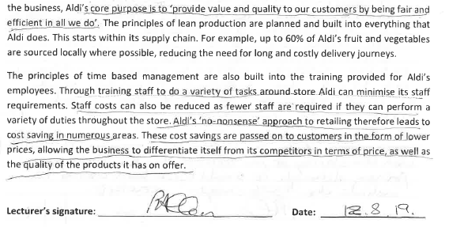
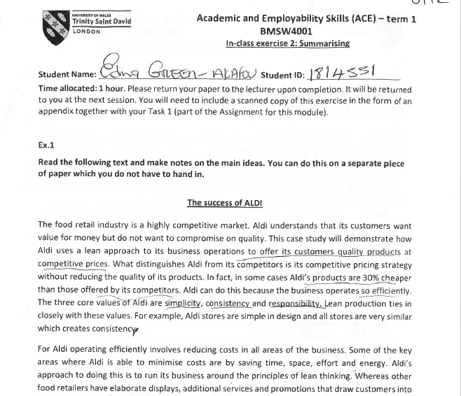
Appendices (Evidences of work done in class)



