M2X9399 – Supply Chain Management

PD02 - Assignment 2

Is your organisation more Lean or more Agile? Discuss the extent to which either concept applies to your place of work and draw a conclusion based the arguments you present.

Student Number – 1708503

Word Count – 2088

- Introduction
The following assignment aims to introduce the concepts of Lean and Agile and how they influence the management of supply chains. Furthering this, the report will also identify and discuss these concepts in the context of Biotage’s GB Ltd’s supply chain management activities and enable a conclusion on whether the organisation is Lean, Agile, or potentially a combination of both.
Biotage is a multinational organisation, specialising in the manufacture and distribution of consumables and instruments for analytical chemistry. Biotage currently employees 330 people, manufacturing its products in South Wales and operating sales and distribution hubs in Sweden, Asia and the USA. Key customers include food and beverage manufacturers, drug testers, contract laboratories, academic institutes and health service providers (Biotage, 2018).

- Introduction to Lean thinking
Lean practice is described by Womack et al cited in Lysons and Farrington (2005), as the removal of any waste (‘Muda’ in Japanese) that creates no value but uses resources within an organisation. Building on this, Scott (2014), identifies such wastes as defects, overproduction, waiting, non-utilized talent, transportation, inventory, motion, and extra/over-Processing. As a result, Rushton et al (2010), identifies the following five principles to lean thinking:
1. Specify what does and does not create value from the customers’ perspective and not from the perspective of individual firms, functions and departments.
2. Identify all the steps necessary to design, order and produce the product across the whole value stream to highlight non-value-adding waste.
3. Make actions that create value flow without interruption, detours, back flow’s waiting or scrap.
4. Only make what is pulled by the customer order just in time.
5. Strive for perfection by continually removing successive layers of waste as they are uncovered.
Identifying the advantage of integrating Lean thinking, Lysons and Farrington (2005) propose that an organisation is able to benefit from increased supply chain flexibility, reduced waste, reduced lead times, reduced inventory and improved quality. Concurring, Kumar and Kumar (2012), suggest that by attaining the benefits of Lean, modern organisations are better equipped to ensure customer satisfaction and generate competitive advantage through a strengthened supply chain performance.

2.1 Lean supply chain management at Biotage
In order to fulfil the principles of Lean identified by Rushton (2010), Biotage implements a variety of initiatives in to its supply chain strategy. Firstly, Biotage has developed a highly trained, cross-functional Business Process Engineering (BPR) project team who are tasked with identifying and managing the removal of resources and activities (aforementioned wastes) in its internal processes that do not add any value to Biotage’s customers. Supporting this, Slack et al (2013) suggests that BPR can enable organisations to become ‘Lean’ by redesigning supply chain processes to eliminate unnecessary non-value adding work (wastes), improve speed and cost efficiency.
One example of Lean BPR at Biotage concerns the re-design of its ‘Filling’ production processes, which are applicable to the organisation’s entire consumable product range. The project consisted of reducing production wastes (time and motion), by re-positioning employee workstations closer to components in cellular formats (see appendix 1). Supporting this, Kumar and Kumar (2012) argue that cellular layouts are an effective enabler of lean, not only by eliminating wastes, but also by improving quality through empowering workers with responsibility for their cell output. In addition to cellular production BPR, for some highly intricate filling processes associated with Biotage’s smaller consumable products, the organisation has also conducted BPR to implement automated robotics. Through this programme, Biotage has installed filling machines (see appendix 2), which in line with the findings of Gingerich (2013), have enabled the organisation to achieve shorter production times, reduced quality defects and material waste, which were previously associated with manual filling processes. In addition to Biotage reducing wastes, this report has also identified quality improvement as an outcome of BPR. Indeed, Lysons and Farrington (2012) suggests quality as a fundamental trait of Lean, whilst Kumar and Kumar (2012) identify the positive correlation between lean processes and a firm’s quality competency.
Further to its production processes, Biotage also utilises IT-driven Enterprise Resource Planning (ERP) software to optimise the lean management of its supply chain, with the aim of ensuring a smooth process flow and that products are only produced when pulled by customers. Biotage’s ERP system (Dynamics 365) links together all operational functions at its Cardiff manufacturing facility (Materials, Production and Finance) and the organisation’s distribution hubs located in the USA, Japan and Sweden. By integrating its point of sales (Customer Services) into its ERP, Biotage is able to generate a strong Demand Management Capability, which is identified by Vitasek et al (2005) as a key element of a lean supply chain. This is achieved by utilising Electronic Data Interchange (EDI), which enables Biotage’s hubs to rapidly and accurately communicate demand-pulls, resulting in the immediate initiation of upstream supply chain processes including manufacturing based on consumption (instead of forecasts), purchasing and logistics. Furthermore, Powell et al (2012) propose additional lean advantages through ERP, including the ability for Biotage to automate non-value adding processes and to provide a comprehensive statistical record base, for which organisations can conduct analysis and support process improvement, such as BPR.
In addition to its activities relating to waste elimination and smooth process management, Biotage also conducts measures to achieve continuous improvement, identified by Rushton (2010) as the fifth fundamental principle of lean. In order to sustain its previous efforts and identify new opportunities to reduce waste and improve production efficiency, Biotage has integrated a 5S visual improvement program into all functions of the business concerned with supply chain management (warehousing and production). Biotage’s 5S process consists of systematically implementing the following stages (translated from Japanese):
- Sort (Seiri) – Employees remove unnecessary resources from the work place.
- Set in order (Seiton) – The organisation positions tools and materials in locations that are easy to access, therefore eliminating time wasted retrieving resources required for an operation.
- Shine (Seiso) – Machinery, equipment and tools are cleaned and maintained regularly, enabling the organisation to identify and/or proactively prevent issues such as production (quality) defects, equipment failure or safety hazards. Materials are also returned to their set locations at the end of every workday, in order to sustain the achievements of sorting and setting in order.
- Standardize (Seiketsu) – Biotage standardises its operational tasks and procedures for each functional area through work instructions – to ensure process consistency.
- Sustain (Shitsuke) – Biotage ensures that aforementioned 5S efforts are sustained.
Appendix 1 illustrates an example 5S audit within the Warehousing function of Biotage. By conducting 5s visual management and auditing, Slack et al (2013) proposes that Biotage is able to generate the continuous improvement of lean elements, including the elimination of wastes identified by Scott (2014), increased organisation and standardization. Concurring, Lysons and Farrington (2012) underline continuous efforts for perfection as a fundamental lean philosophy; it can therefore be suggested that 5S Visual Management provides Biotage with a progressive platform to achieve this.

- Introduction to Agile thinking
Agile supply chain management can be described as an organisation’s proficiency in responding to changes in demand and variety by customers (Murphy and Knemeyer, 2015). Concurring, Rushton et al (2010) propose that an Agile supply chain is strategically developed for organisations to be able to respond rapidly to volatile market changes and shifting customer demands. Building on this, Lysons and Farrington (2005), suggest a number of factors that drive the need for Agile supply chain management. These include the opportunities to generate competitive advantage through responsiveness, technological developments and innovations, shorter product lifecycles and a shift in customer demands towards customisable products and services.
As a result, Goldman et al cited by Lysons and Farrington (2005), propose the following attributes that contribute to an Agile organisation:
- An ability to deliver value to customers
- Being prepared to quickly and efficiently respond to customer and market changes
- Placing value on human knowledge
- Forming virtual partnerships
Should Agile be effectively into supply chain management, Naylor et al (1999) suggest that an organisation will be positioned ‘to exploit profitable opportunities in a volatile marketplace’.

3.1 Agile supply chain management at Biotage
Whilst the advantages of Biotage’s lean supply chain efforts have been discussed in sections 2.0 and 2.1, a number of disadvantages can also be identified. Slack et al (2013) suggests that a lean synchronised supply chain is vulnerable to disruption from market volatility and fluctuations in demand. Concurring, Lysons and Farrington (2005) add that as a lean strategy depends on a stable market environment, it is therefore most appropriate for a mass production environment. This is particularly concerning, given Day’s (2013) argument that modern markets are moving away from mass production, to highly customised products driven by evolving customer requirements. This is indeed true of Biotage, whose consumable product portfolio is highly customised depending on the analytical chemistry needs of its customers (Biotage, 2018); most specifically the specification of medias/powders.
As a result, Biotage implements a number of activities that are Agile in nature to ensure that the organisation is able to respond quickly to demands and remain flexible to the uncertain needs of its customers (Slack 2013). Firstly, in the design of its production processes, Biotage has configured a number of its manufacturing machines to be interchangeable. These include modular tube-filling machines, which can be quickly re-configured to process any of the five different tubes sizes in the organisations product range. In addition, Biotage has also invested in multiple chemistry workstations and vessels, which if required, enable the organisation to produce a wide range of powders simultaneously; thereby significantly reducing the production lead times of a diverse order book.
Another Agile-focused provision in Biotage’s supply chain is ‘Postponement’, which Lysons and Farrington (2005) describe as the practice of delaying the customisation of manufactured products as close as possible to point of purchase. One example of Biotage implementing this in its upstream supply chain relates to its outsourced production of three plungers, which are used in conjunction with the organisation’s consumable cartridges. Through joint supplier collaboration and information exchange (Kant et al, 2016), Biotage has designed the three plungers to share common components and assembly processes to 75% without configuration. By delaying differentiation, Biotage is able to quickly make-to-order through via rapid customer configuration once demand is pulled from the downstream supply chain (Diwakar and Saif, 2003). Biotage also applies this practice in its internal operations, by implementing a small buffer inventory of key sub-components at the latest stage of pre-configuration, which can then be differentiated quickly once firm customer orders are received; such as pre-printed clean tubes and cleaned frits. Supporting Biotage’s deployment of postponement, Faisal et al (2006) propose that it is is a fundamental element of an effective Agile supply chain, whilst Lysons and Farrington (2005) suggest that effective postponement enables supply chain efficiency through reduced inventory and processing.

- Is Biotage more Lean or Agile
In determining whether Biotage is more Lean or Agile, this report has identified firm evidence of both concepts in the management of its supply chain. Therefore, as an alternative to concluding whether Biotage is either Lean or Agile, it can be argued that both philosophies are used in conjunction in its supply chain strategy. Naylor cited in Lysons and Farrington (2005), who propose the concept of ‘Leagility’, confirm the validity of such a ‘hybrid’ approach, suggesting that an organisation is able to compliment the use of both Lean and Agile practices to achieve a reactive, efficient and cost-effective supply chain strategy. Underlining this, Kant et al (2016) advises that the harmonious application of both Lean and Agile can indeed support the generation of competitive advantage.
Identifying the boundary between Lean and Agile activities in Biotage’s supply chain activities, Christopher (2005) defines this as the ‘de-coupling point’ and the point where customer demand penetrates the supply chain. Managing its de-coupling point, Biotage primarily implements Lean manufacturing based on low material variation until the point of final product assembly. By doing so, the organisation is able to ensure a stable demand for ‘platform materials’ (Kant et al, 2016), such as clean tubes, clean filtration frits and base media/powder; thereby benefitting from the advantages of Lean (discussed in sections 2.0 and 2.1) including waste elimination and efficiency improvements. Once customer demand has been established through order placement, Biotage is then able to ‘make-to-order’ (Gupta et al, 2003) and feed the aforementioned platform materials into its Agile activities. It is through the utilisation of highly configurable manufacturing processes (discussed in section 3.1 – concerning chemistry, printing and filling) that the organisation is able to react quickly to firm customer requirements and execute the final configuration of platform materials in to finished product.

6.0 References
Biotage GB Ltd, About Biotage, retrieved from http://www.biotage.com/page/about-biotage on 18 July 2018 at 14:50
Lean thinking and methods – 5S, United States Environmental Protection Agency, retrieved from https://www.epa.gov/lean/lean-thinking-and-methods-5s on 20 July 2018 at 15:07
Rushton A., Croucher P., Baker P. (2010) The handbook of logistics and distribution management (4th edition), Kogan Page
Lysons K., Farrington B. (2012), Purchasing and supply chain management (8th edition), Pearson
Murphy P., Knemeyer M. (2015), Contemporary logistics (11th edition), Pearson
Naylor J., Naim M., Berry D. (1999), Leagility: interfacing the lean and agile manufacturing paradigm in the total supply chain, International Journal of Production Economics, Volume 62 pp107-118
Day P. (11/10/2013), Imagine a world without shops or factories, BBC News (online), accessed 26/06/2018, Available at: https://www.bbc.co.uk/news/magazine-23990211
Scott S. (2010), Muda, Muri and Mura, ASQ Six Sigma Forum Magazine, Volume 13 (Issue 2) pp 36-37
Christopher M. (2005), Logistics and supply chain management – creating value-adding networks (3rd Edition), FT Prentice Hall
Powell D., Strandhagen J.O., Dreyer H. (2012), 025-0984: Revisiting the lean-ERP Paradox: ERP support for the respect-for-human system, Department of Production and Quality Engineering, Norwegian University of Science and Technology
Vitasek K., Manrodt K., Abott J. (2005), What makes a lean supply chain, Supply Chain Management Review, Volume 9 (Issue 7) pp39-45
Slack M., Brandon Jones A., Johnston A. (2013), Operations Management (7th Edition), Pearson
Faisal M.N., Banwet D.K., Shankar R. (2006) Mapping supply chains risk and customer sensitivity dimensions, Industrial Management & Data Systems, Volume 106 (Issue 6), pp.886
Kumar R., Kumar V, (2012), Lean Manufacturing: Elements and its benefits for manufacturing industry, Proceedings of the National Conference on Trends and Advances in Mechanical Engineering, YMCA University of Science & Technology, Faridabad, pp748-755
Biotage GB Ltd, Products and Services, retrieved from http://www.biotage.com/page/products-and-services on 20 August 2018 at 15:30
Gingerich K. (2015), Automation solutions – Lean production and automation, Plant Engineering, June 2015, Volume 69 (Issue 5), pp51-55
Diwakar G., Saif B. (2003), Make-to-order, make-to-stock, or delay product differentiation? A common framework for modelling and analysis, Department of Mechanical Engineering, University of Minnesota
Kant R., Pandey., Pattanaik L. (2016) Lean, agile & leagile supply chain: a comparative study, ELK Asia Pacific Journals – Special Issue, International Conference on Advancements and Recent Innovations in Mechanical, Production and Industrial Engineering (ARIMPIE - 2016)
- Appendices

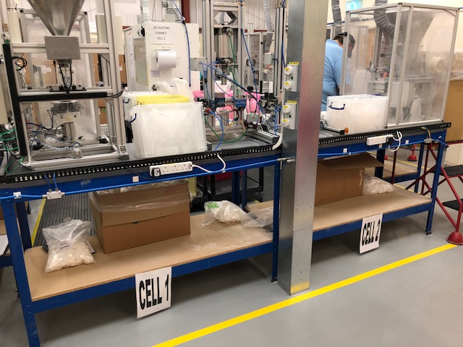
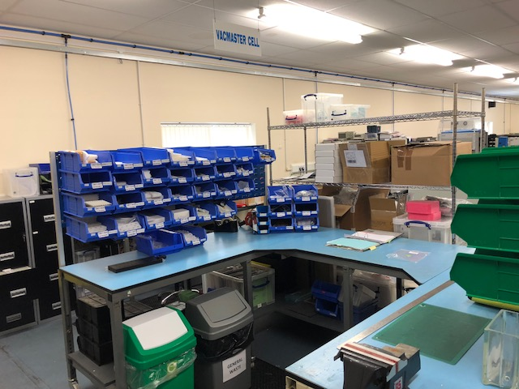
7.1 Appendix 1 – Photos of BPR - manufacturing processes to cell-based format

Appendix 2 – Photos of BPR – installation of ‘autofill machines’

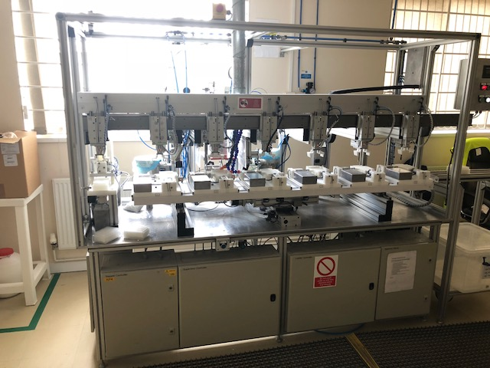

7.2 Appendix 3 – Example 5S Biotage visual and continuous improvement audit
 |  | Audit Area: | Unit 9 Warehouse |  |  |  |  |  |  |  |  |  |  |  |  |  |  |  |  |  |  |  | Scoring Key
Completed By: |  |  | JW and DW |  |  |  |  |  |  |  |  |  |  |  |  |  |  |  |  |  |  |  | 0 |  | = |  | No Compliance
This Score: |  |  | 81 |  | Prev Score: |  |  |  |  |  |  |  |  |  |  |  |  |  |  |  |  |  | 2 |  | = |  | Some Compliance
 |  |  |  |  | Difference: |  |  |  |  |  | 81 |  |  |  |  |  |  |  |  |  |  |  | 3 |  | = |  | Significant Compliance
 |  |  |  |  |  |  |  |  |  |  |  |  |  |  |  |  |  |  |  |  |  |  | 4 |  | = |  | TotalCompliance
Step |  | No | Check Item |  |  |  |  |  |  |  | Description |  |  |  |  |  |  |  |  |  |  |  |  |  |  |  |  |  |  |  |  |  |  |  |  | Score
Sort |  | 1 | Materials or parts |  |  |  |  |  |  |  | Does the inventory or in-process inventory include any unneeded materials or parts? |  |  |  |  |  |  |  |  |  |  |  |  |  |  |  |  |  |  |  |  |  |  |  |  | 4
 |  | 2 | Machines/equipment |  |  |  |  |  |  |  | Are there any unused machines or other equipment around? |  |  |  |  |  |  |  |  |  |  |  |  |  |  |  |  |  |  |  |  |  |  |  |  | 4
 |  | 3 | Jigs, tools or dies |  |  |  |  |  |  |  | Are there any jigs, tools or similar items around (e.g. boards, tampers etc.)? |  |  |  |  |  |  |  |  |  |  |  |  |  |  |  |  |  |  |  |  |  |  |  |  | 4
 |  | 4 | Visual control |  |  |  |  |  |  |  | Is it obvious which items have been marked as necessary and unnecessary (red tagging)? |  |  |  |  |  |  |  |  |  |  |  |  |  |  |  |  |  |  |  |  |  |  |  |  | 4
 |  | 5 | Written standards |  |  |  |  |  |  |  | Has establishing 5S left any useless standards (e.g. out of date paperwork, labelling etc.)? |  |  |  |  |  |  |  |  |  |  |  |  |  |  |  |  |  |  |  |  |  |  |  |  | 4
 |  | Notes: |  |  |  |  |  |  |  |  |  |  |  |  |  |  |  |  |  |  |  |  |  |  |  |  |  |  |  |  | SUB TOTAL |  |  |  |  | 20
Set |  | 6 | Location indicators |  |  |  |  |  |  |  | Are shelves, racking, cupboards and other storage areas marked with location indicators? |  |  |  |  |  |  |  |  |  |  |  |  |  |  |  |  |  |  |  |  |  |  |  |  | 4
 |  | 7 | Item indicators |  |  |  |  |  |  |  | Are items clearly identifiable and linked to corresponding location indicators? |  |  |  |  |  |  |  |  |  |  |  |  |  |  |  |  |  |  |  |  |  |  |  |  | 3
 |  | 8 | Quantity indicators |  |  |  |  |  |  |  | Are the maximum and minimum allowable quantities of items/materials indicated? |  |  |  |  |  |  |  |  |  |  |  |  |  |  |  |  |  |  |  |  |  |  |  |  | 4
 |  | 9 | Walkways and storage areas |  |  |  |  |  |  |  | Are markings used to clearly indicate where walkways and storage areas begin and end? |  |  |  |  |  |  |  |  |  |  |  |  |  |  |  |  |  |  |  |  |  |  |  |  | 4
 |  | 10 | Jigs and tools |  |  |  |  |  |  |  | Are jigs and tools arranged more rationally to facilitate picking them up and returning them? E.g. Heavier items stored closer to the ground. |  |  |  |  |  |  |  |  |  |  |  |  |  |  |  |  |  |  |  |  |  |  |  |  | 3
 |  | Notes: | There are a few items that do not correspond to location - e.g. a crate labelled R&D + a returned 400L. No contents/standard inventory listed for tool cupboard – needs addressing |  |  |  |  |  |  |  |  |  |  |  |  |  |  |  |  |  |  |  |  |  |  |  |  |  |  |  | SUB TOTAL |  |  |  |  | 18
Shine |  | 11 | Floors/Work surfaces |  |  |  |  |  |  |  | Are floors/work stations/machines clean and free of waste (e.g. powder, oil, shavings etc.)? |  |  |  |  |  |  |  |  |  |  |  |  |  |  |  |  |  |  |  |  |  |  |  |  | 4
 |  | 12 | 5S check sheets 1 |  |  |  |  |  |  |  | Are area specific daily and weekly 5S check sheets in place? |  |  |  |  |  |  |  |  |  |  |  |  |  |  |  |  |  |  |  |  |  |  |  |  | 4
 |  | 13 | 5S check sheets 2 |  |  |  |  |  |  |  | Are daily and weekly 5S check sheets being followed? |  |  |  |  |  |  |  |  |  |  |  |  |  |  |  |  |  |  |  |  |  |  |  |  | 2
 |  | 14 | Walkways and entrances |  |  |  |  |  |  |  | Are walkways, entrances and corridors free of obstructions? |  |  |  |  |  |  |  |  |  |  |  |  |  |  |  |  |  |  |  |  |  |  |  |  | 4
 |  | 15 | Habitual cleanliness |  |  |  |  |  |  |  | Do operators routinely sweep floors and wipe equipment without prompt? |  |  |  |  |  |  |  |  |  |  |  |  |  |  |  |  |  |  |  |  |  |  |  |  | 4
 |  | Notes: | All documentation present, however, last 5S check sheet completed in December 2017. Out of date. |  |  |  |  |  |  |  |  |  |  |  |  |  |  |  |  |  |  |  |  |  |  |  |  |  |  |  | SUB TOTAL |  |  |  |  | 18
Standardise |  | 16 | Improvement ideas 1 |  |  |  |  |  |  |  | Are improvement ideas regularly being generated and recorded on the area's Continuous Improvement Suggestion Sheet (CISS)? |  |  |  |  |  |  |  |  |  |  |  |  |  |  |  |  |  |  |  |  |  |  |  |  | 1
 |  | 17 | Improvement ideas 2 |  |  |  |  |  |  |  | Is there evidence that suggested improvement ideas are being responded to and where relevant acted on? |  |  |  |  |  |  |  |  |  |  |  |  |  |  |  |  |  |  |  |  |  |  |  |  | 1
 |  | 18 | Key procedures 1 |  |  |  |  |  |  |  | Are standard procedures written, clear and actively used for all processes? |  |  |  |  |  |  |  |  |  |  |  |  |  |  |  |  |  |  |  |  |  |  |  |  | 4
 |  | 19 | Improvement plan |  |  |  |  |  |  |  | Are the future standards being considered with a clear improvement plan for the area? |  |  |  |  |  |  |  |  |  |  |  |  |  |  |  |  |  |  |  |  |  |  |  |  | 1
 |  | 20 | Visual display boards 1 |  |  |  |  |  |  |  | Visual display boards are in place and contain all required information elements (i.e. 5S scores, CISS, Quality Indicies etc.)? |  |  |  |  |  |  |  |  |  |  |  |  |  |  |  |  |  |  |  |  |  |  |  |  | 3
 |  | Notes: | CISS + Improvement Plan present, but last updated 2016. In addition, visual display board includes all documents, but again not up to date. |  |  |  |  |  |  |  |  |  |  |  |  |  |  |  |  |  |  |  |  |  |  |  |  |  |  |  | SUB TOTAL |  |  |  |  | 10
Sustain |  | 21 | Training |  |  |  |  |  |  |  | Is everyone adequately trained in standard procedures (e.g. skills matrix)? |  |  |  |  |  |  |  |  |  |  |  |  |  |  |  |  |  |  |  |  |  |  |  |  | 2
 |  | 22 | Tools and parts |  |  |  |  |  |  |  | Are tools and parts being stored correctly? |  |  |  |  |  |  |  |  |  |  |  |  |  |  |  |  |  |  |  |  |  |  |  |  | 3
 |  | 23 | Stock controls |  |  |  |  |  |  |  | Are stock controls being adhered to? |  |  |  |  |  |  |  |  |  |  |  |  |  |  |  |  |  |  |  |  |  |  |  |  | 4
 |  | 24 | Key Procedures 2 |  |  |  |  |  |  |  | Are procedures up to date and regularly reviewed? |  |  |  |  |  |  |  |  |  |  |  |  |  |  |  |  |  |  |  |  |  |  |  |  | 4
 |  | 25 | Visual display boards 2 |  |  |  |  |  |  |  | Are visual display boards up to date and regularly reviewed? |  |  |  |  |  |  |  |  |  |  |  |  |  |  |  |  |  |  |  |  |  |  |  |  | 2
 |  | Notes: | Fork truck matrix out of date. Visual display board includes all documents, but not up to date. Items being stored in fork truck charging area against standard operating procedure. |  |  |  |  |  |  |  |  |  |  |  |  |  |  |  |  |  |  |  |  |  |  |  |  |  |  |  | SUB TOTAL |  |  |  |  | 15

 |  | Items for Corrective Action
Audit Area: | Unit 9 Warehouse |  | Auditors: | DW + JW
Date of Audit: | 21/06/2018 |  | Responsibility: | CL
No | Problem | Solution | Target | Date
No | Problem | Solution | Date | Implemented
1 | Items which do not correspond with location – R&D SPE drum and packing crate | Relocate and prevent future occurrence. | 05/07/18
2 | Items being stored in fork truck charging area, whilst charger is being used. This is against standard procedure and a H+S hazard | Clear up area as a priority and prevent future occurrences | 25/06/18
3 | No list of standard contents /inventory on tool cupboard - standard kit list would ensure that correct items are available and maintained | Implement list to be maintained | 27/07/18
4 | 5S display board - Following are not kept up to date: 1) Improvement sheet 2) Daily checklists 3) Suggestion sheet | Keep up to date and sustain | 20/07/18
5 | Fork truck skills matrix not up to date - some users licence dates have expired, although refresher training has already been completed | Update with urgency | 25/06/18

