Assignment 1 – Construction Management

Productivity Incentives Page 2
Programme Delay Page 3
References Page 5

Productivity Incentives

There are many ways that people can be motivated in both ways to improve the speed and quality of the works that are being undertaken. Below will discuss various ways to motivate individuals and contractors to aid in the completion of the project.

Contractors can be motivated in different ways to help improve performance, one way motivation can be achieved is through target based performance measures. One method used, is having a goal for work to reach on a specific agreed date, hitting this date can give contractors incentives such as reduced payment delay. If the standard agreed payment terms is 30 days, this can be reduced to 15 days if the measureable targets are met.

Another form of motivation tool used, typically with in house staff would be the use of target based bonuses. If a Team or gang on site are given jobs they may be given targeted goals to carry out tasks, such as five weeks to complete. To incentivise efficiency on site the company may have a policy that if the work is completed ahead of time they can earn a bonus. For example if the five weeks work are complete in four weeks, they could still be paid for five.

Alternatively, if a team or gang on site are given a target such as to complete a particular activity by the end of a working week. They may be given the option that if they complete the work ahead of the target set, they can take the time in luei. They may be able to leave early, or take the time back. This helps to motivate staff work efficiently to complete a task.

Another way to improve performance can go be improved which may mean quality is improved reducing snagging problems or being called back to site is career progression incentives. If staff are achieving high quality work there may be options for additional training or career improvement, which can help staffs responsibility around site. Maturity from staff involved around keeping sites clean as well as working to a high quality leading to more responsibility as well as higher pay. This increased responsibility can help to give job satisfaction to the employees as well as the company benefitting from devoted workforce. This can be seen where the Senior Ground Worker is the site manager.

Staff may be awarded with a reward schemes for staff to help achieve motivated staff, this tends to be a similar system to a financial bonus, and contractors can be motivated with tickets as a gift for cooperation on site. This can be used with contractors when management of contractors ensure key dates are met, these can be given as thank you for efficient and cooperation on site. This is relevant to the Concrete Contractor undertaken the concrete pours.

Finally, there is the use of contractual punishments for not achieving specific dates. This will be damages for not hitting targeted dates, this will be punishments to cover the financial burden put onto the main contractor or client for the delays caused. This may be used to compensate members of the public due to the disturbances.

Delay

There has been a delay to the progress on the project due to a five week delay to the concrete works starting due to strike action within the industry. This is shown through diagram 1 below, this is a critical path item which means that the whole project is affect. Some time is recovered due to the slack that is achieved from other items of work, this means that the overall project is delayed for four weeks shown in diagram 2.

Diagram1

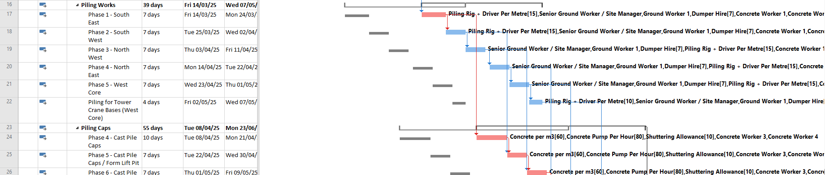
Diagram 2

The critical path of the project (Shown below in Diagram 3), critical items are highlighted red to stress the importance of these items not moving. Where these items are delayed it affects the project as a whole.

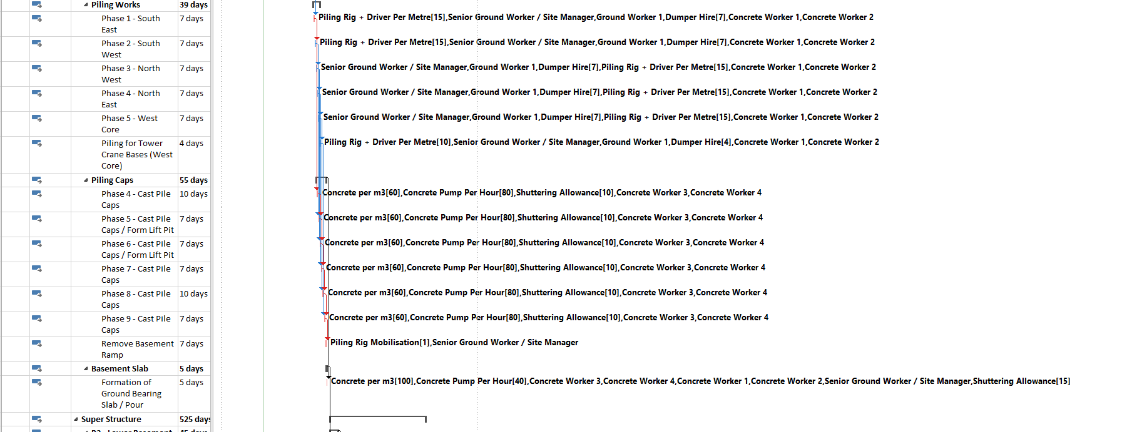
Diagram 3

As this affects the completion date of the project this will have cost implication for the contractor as agreed dates will be set out within the contract. Therefore the option of weekend working should be introduced to allow the concrete work to be brought back in line with the original program. However, where piling works are to be undertaken there may be limitations on the hours that ‘loud’ works can be carried out. As the primary concreting works is dependant on the use of a piling rig, there is little scope for additional workforce on site speeding up the process.

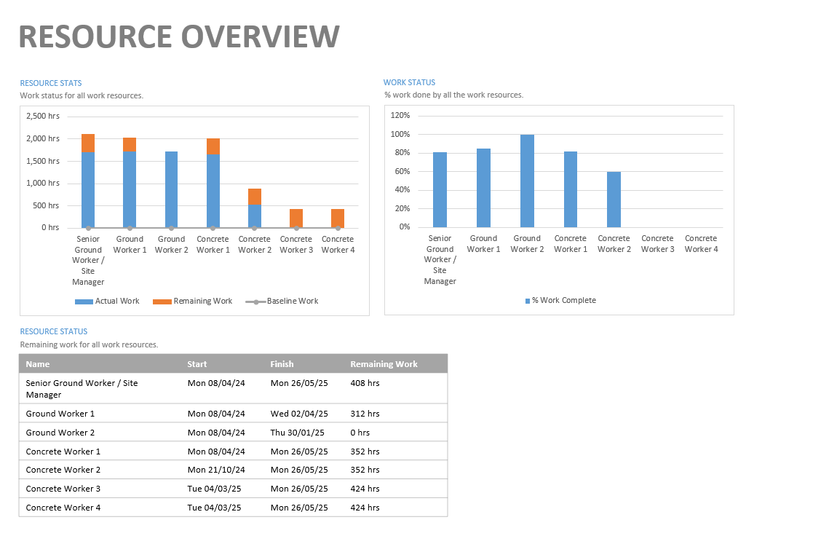
Diagram four below shows the allocated resources and how they are much has been used along with the remaining works. This gives the client a clear view of how to much labour has been used on site as well as how much remains for the duration of the works. This figures are an extract showing the substructure element of the project, for an in-depth report for the resources a full project report can be produced.
Diagram 4

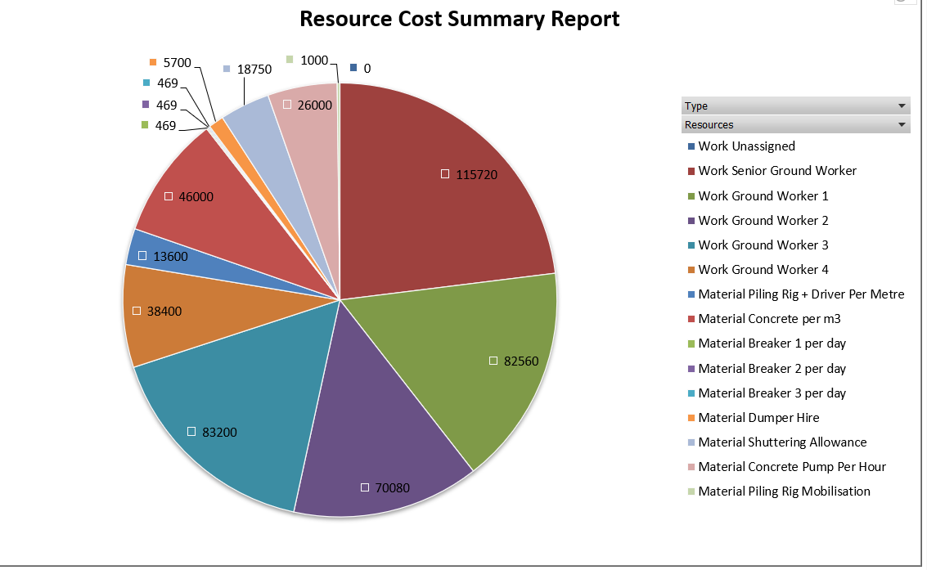
The Next Diagram (diagram 5) shows how the spend for this element of the project is spilt for each resource on the project, this shows the total cost associated for each element of the scheme, this includes both contractors/staff as well as the materials being used. Rates used for the resource sheet were taken where possible from Spons Architect 2020, where these could not be used sensible figures have been used from commercial experience.

Diagram 5
The Sixth Diagram shows the overall time frame of the project, this gives the overall completion of the job as well as being spilt down into the completion of each element on the project, this makes it clear that there the substructure is currently 69% complete with the overall project being on 35% complete. This is useful tool for progress meetings to assess the productivity of the scheme.
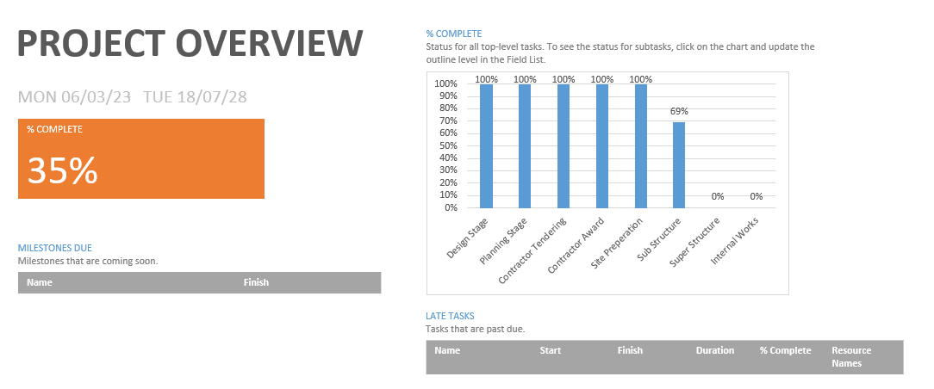
Diagram 6

This report has been produced to help aid the project as it runs for the works being undertaken to Swansea Kingsway. All figures stated above should be read in combination with the Gantt Chart provided, this chart gives an in depth view at programme as well as delays referred to above. As this scheme has now been opened up to delays due to the strike action it is important for contractors to work together to both try and recover as well as minimalise any further delays.

References

Spons Architects’ and Builders’ Price Book (2020)

