Explore How the Amalgamation of Gestalt Psychology and Art has Impacted the Creation and Interpretation of Art and the Mental Health System.

Sophie Harding
P149845

Submitted in partial fulfillment of the requirements for the degree of BA (Hons) University of Wales Trinity Saint David, Swansea, 12th December 2018

Word count: 5960

Table of contents

Image List_________________________________________________________3
Summary__________________________________________________________4
Introduction________________________________________________________4

Chapter 1 – The Origin and Growth of Gestalt Psychology________________13
The Integration of Gestalt Psychology and Video Art________________________16

Chapter 2 - Gestalt Theory within Painting_____________________________13
How Artists Have Explored Gestalt’s Perceptual Laws within their Practice______16

Chapter 3 - How Gestalt theories were received at the time_______________21
How Gestalt Theories Have Enriched the Contemporary Mental Health System__ 23

Conclusion_______________________________________________________26

Bibliography______________________________________________________29
Image References__________________________________________________34

Word count: 5960

Image List

Figure 1- Bill Viola. Ascension. 2000 8
Figure 2 -Pipilotti Rist. Sip My Ocean. 2017-18 12
Figure 3 - Jackson Pollock. Number 23. 1948 ……………………………………………………………………
Figure 4- Josef Albers. Steps. 1932 18
Figure 5- Naum Gabo. Two Cubes. 1930 20
Figure 6- Magdalenian parietal art. Cave Painting of a Bison Head. 15,000 BCE 26

Summary
This dissertation will be discussing the origin and expansion of one of the first theories to amalgamate Psychology and Art - Gestalt psychology. It will be focusing on how Gestalt psychology and art have become entwined, leading to the development of Gestalt art therapy methods that have enriched the mental health system.

Introduction
Discussion will develop around the origin and expansion of one of the first theories to amalgamate Psychology and Art - Gestalt psychology, a school of thought focused on human perception. The conversation will emphasise key theorists, artists and psychologists who have added to the fundamental ideas and progression of Gestalt Psychology. Including what and who influenced arising concepts during its development and how such Avant- Garde theories of human perception were received at the time, in comparison to the already existing ones. Further debate will reveal other links that have been made between Gestalt psychology and the different art forms/movements. Examining how these revolutionary ideologies have encouraged the explorations of perception within several artist’s works, such as; video artists; Bill Viola and Pipilotti Rist, Painters; Jackson Pollock and Josef Albers and Sculpture; Naum Gabo. Illustrating the viewpoint that Psychological qualities are saturated within everything and thus everything contains the ability to effect one’s perceptions and inner being. The discussion will proceed by exploring the ways in which the integration of Gestalt psychology within the Art world has expanded our ability to perceive and interpret visual information. Finally, examining how these growing notions have contributed to the advancement of our contemporary mental health system. Allowing art to be used as an insight into a person’s mind.
The reasoning behind this dissertation is personal. Through research conducted within my practice, I have become interested in the notion of art containing a link to our psychologies. From a young age, art has proven itself to be an outlet for my psychological wellbeing. As a child with ADHD and behavioural issues, art supplied a means to express and transpose my energy. For me, the process of painting is exceptionally therapeutic. I believe that the utilisation of art as a healing process or ‘outlet’ is not being fully recognised within contemporary society. The researching and evaluation of psychological links within art and how these have created an impact on how we make and view art today, is crucial to the creative exploration within my own practice.

Chapter 1 – The Origin and Growth of Gestalt Psychology
Before officially being formed as a school of psychology, the idea of Gestalt formed its roots of thought in theories by Ernst Mach (1838-1916) and Christian von Ehrenfel’s (1859-1932). (Boeree, 2000) During the early twentieth century Mach began to consider the connection of one’s innate sensations with external provocations. Time, colour, space and sound, once seen as the sphere of physics, became a study within psychology. Mach began to see these elements not only as the stuff of the physical exterior world that surrounds us, but also as the foundations of our internal experiences. (pojman, 2008) Mach elaborates on these views within his 1886 Beiträge zur Analyse der Empfindungen, (Contributions to the Analysis of Sensation) whereby, he suggests that all information is obtained from consciousness; thus, meaning that singularities under methodical examination can be understood only in terms of experiences, or “sensations,” existing in the observation of the singularities. (Harding, 2018) According to Mach, Sensations are not merely fresh experiences, but the interaction of experience with a pre-formed mental construction. (Mach, 1897) For example, when listening to a known rhythm, we identify it no matter what key the rhythm is played in. It can be sung, hummed or played using various instruments and our brain will still recognise the melody, even if numerous notes or keys are incorrect. In this sense Mach questions how this works, “what constitutes a melody?”. (Mach, 1897) It appears unfitting to say that it’s the actual sound vibrations that create the melody as we have just established that the same melody can be made with multiple different sounds. However, at the same time it seems strange to claim that a melody is not established from its sound. The melody must therefore exist in our capability to identify it. It is formed by our experiences and is an idealism of those experiences. The idealisation captures the relationship of sounds or notes from one to another, rather than the actual sounds heard. This means that regardless of pitch, speed and tone etc if the relationship between the notes remain the same, we recognise it as the same melody. For Mach this notion is the basis of all human perception. Experience needs a priori, and a priori is itself formed by experience. (King, 2002),

This initial explanation of human perception by Mach is one of the primary originators of Gestalt thought, before it became officialised. This notion is one that is now very well heard of within modern society, particularly the art world. With many artists holding the view that art, experience and perception go hand in hand. Like perception art is influenced greatly by experience but also needs “a priori” as Mach suggested. In other word’s we create with our own assumptions, thoughts, intentions and expectations, but these are in fact made up and projected in part by our experiences and relationships with the world, as well as also having a role in how we experience. Everything is interlinked. (Mach, 1897)The ideas above were the first theories to unify such features in a psychological manner rather than merely scientific. The at the time contemporary ideas expressed by Mach, such as his theories on how the exterior world affects us internally and thus influences how we perceive, can be seen within any creative field.

The Integration of Gestalt Psychology and Video Art
Using contemporary examples, we can see that these notion influence and feed into various artists work. Video Artist, Bill Viola (1951-present) explores human experience and our link to the external world within his work. Confronting the human condition and consciousness. The videos Viola creates capture beautifully the essence of our relationship to the world. How we imprint or mark the world in a way and how the external world imprints or leaves marks on us. He conveys and presents the world as it is. Exploring his personal perceptions of existence, captured with the camera, while also leaving space for the spectator to conjure up their own interpretations. Viola’s work often concentrates on the philosophies behind vital and inevitable human experiences like birth, love, emotion, death and the theoretical characteristics of consciousness. Through the notion of being present in the moment, he reflects a sort of humanist spirituality. (Viola, n.d.)

Kira Perov, Viola’s executive producer, collaborator and partner, in her introduction to one of Viola’s exhibitions describes his work as a "journey of the soul" and goes on to make the following declaration; "Bill’s work came from a place that was part of the invisible world, a place of inner landscapes… Landscapes where time is stretched to infinity, where subtle changes of light create an eternity, and where sound is extended beyond hearing… a space for meditation, contemplation, and perhaps, even epiphany." (Gosling, 2017) This supports the idea that art taps into our psychology or as Perov puts it our souls. Perception is illustrated and altered by our experiences. An example of violas work is seen below. (Fig 1)

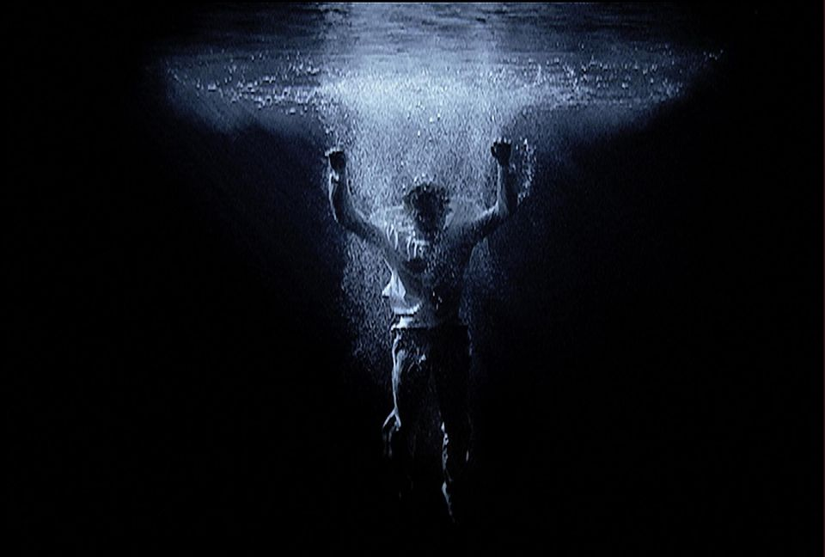
Figure 1- Bill Viola. Ascension (2000) (Photo Kira Perov)

Every second we are generating our experience. Our words, our thoughts, our actions our perceptions are all occurrences and examples of our capacity to bring forth something in the space where nothing existed before but also these incidences are affected by the external spaces that surround us. Life is the canvas, our experiences are the canvas, conversations are the canvas, relationships are the canvas. Time, space, our existence and our relationship with what exists shape or perceptions and shape what we project into the world. Viola evokes such values insisting “Time makes my art possible,” He expresses his art as “sculpting time”, (Mun-Delsalle, 2015) where time is the rudimentary factor within film and video. As the artist creates experiences or events that will unfold, apprehended on a band of celluloid or tape. In Violas hands, time may be repeated, Stretched, layered, condensed, reversed, decelerated, accelerated or interlinked to reveal to the observer all its facades. Time, existence and perception become dishevelled and all assimilate within Art. “Art is life and life is art” (TANNER, 2015)

Similar to the ideas discussed, Mach’s physical principle also examined one’s relationship to the world. Holding precedents of early notions that formed as influences within Gestalt psychology. As well as having an impact on various artists at the time. Quoted by Einstein as one of the vital inspirations for his theories of relativity, Mach's physical principle claimed that the inclination of a body in motion to continue in motion, in the same direction and of a body at rest to remain at rest (inertia) results from a relationship of that object with all the rest of the matter in the cosmos. Mach argued that even at great detachment, inertia applies only as a function of the interaction between one body and other bodies in the universe. (Pfister, 1995) (Harding, 2018) This rejected such conjectural concepts as absolute time and space. (Gardner, 1977) Although this notion was initially applied to the human body, the introduction of such philosophies fuelled ensuing theories that began to connect these same impressions with the relationship of object/experience and space.

Christian von Ehrenfels (1859-1932) expanded Mach’s ideas when he announced the concept of Gestalt (shape/form) psychology within his renowned Über Gestaltqualitäten (On the Qualities of Form, 1890). Like Mach, when using a melody as an example, Ehrenfels described that although melodies consist of individual sounds, there is more to how we perceive them than the individual notes. This led to the at the time Avant-Garde idea of separating “perception of the whole” in comparison with its “parts”. Something Ehrenfels called Gestaltqualitäten. (gestalt qualities). (Goldstein, 2010) (Harding, 2018)

Austro-Hungarian-born psychologist, Max Wertheimer advanced these concepts even further in Germany, 1912. Creating the official Gestalt school of thought, along with Kurt Koffka and Wolfgang Köhler. Wertheimer’s unique contribution was to disagree with Von Ehrenfel’s impression of the Gestalt and insist that it is perceptually primary, defining the fragments it was composed from, rather than being a secondary value that arises from those parts, as Von Ehrenfels had earlier suggested. (Wertheimer, 1961) (Harding, 2018) The development of Gestalt psychology was influenced in part by Wertheimer's experience whilst waiting at a train station. He obtained a model stroboscope which presented images in a fast-paced sequence, creating an appearance of movement. This led to the later assertion of the notion of Phi phenomenon, in which flickering lights in arrangement can lead to what is known as deceptive motion. (Cherry, 2018) In other words, we falsely perceive movement even though there is none. According to Gestalt psychology, this deceptive movement occurs because our minds fill in absent information. Gestalt psychology, therefore, is a particular way of understanding how objects embody certain psychologic principles, by attempting to comprehend the laws behind the ability to attain and uphold meaningful observations in a chaotic universe. (Kohler, 1992) (Harding, 2018)

Wertheimer’s "Experimental Studies on the Perception of Movement". Explains how this illusion of motion which underlies our perception of smooth motion cannot be reduced to its underlying elemental light flashes. Wertheimer represented this phenomenon on a device he constructed that contained two separate lights in different locations. Although these lights were immobile, flashing the lights at ensuing time intermissions causes the retina (the light sensitive part of the eye) to perceive the light as being in motion. (Das, 2009) Their findings further demonstrated that the quality of the whole is different from the summation of the parts. Movement is assumed because of the reaction or feedback from the moving eye to these flashes, eluding the mind to process this as actual movement.

Films and the moving image are one occurrence of this ostensible superficial motion. Through sequentially displaying numerous transitioning still images, the illusion of movement or continuity is created. The camera is such a powerful tool in creating an experience for the viewer within art. We have used this knowledge of how our brains take in information to help us develop such areas of art. These notions of perception as well as Mach’s ideologies of experience linking in with perception can be seen within artist Pipilotti Rists work. Rist’s work embodies human experience. The compositions created within her works when exhibited create a complete sensory experience, captured through numerous different elements that are manipulated and staged to create the atmosphere or experience for the viewer, but once again in the same way, allows the space to offer itself up to interpretation. (Gioni, 2016) As seen in Rist’s installation; Sip my ocean (1 November 2017 – 18 February 2018) held at the museum of contemporary art Australia in Sydney.

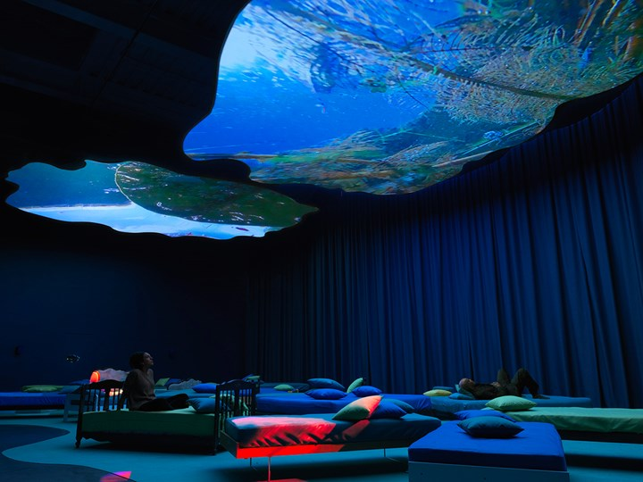
Figure 2 -Pipilotti Rist. Sip My Ocean. (2017-18)

Rist constructs colour-saturated sensory creations that transport the observer into vivid arrangements of film, moving image and objects. Natasha Bullock proclaims that the artist; “brings ideas and feelings together, and does so through the prism of video”. (King, 2018) The installation is a prime example of how these ideas of perception can be used when creating art, highlighted by the range of the artists practice. From her early ventures into single-channel videos of the 1980s to large-scale immersive atmospheres. Rist creates a mystical spatial experience, consumed with strategically placed furnishings and vibrant captivating projections. Her work encompasses the discussed ideas of perception and experience, through a profusion of energetic elements that are all taking in and processed simultaneously as a whole sensory experience. (Gioni, 2016)

Chapter 2 – Gestalt Psychology within Painting.
In addition to video art, Gestalt theories can also be applied to painting. The early suggestions made by Mach; that we form perception from experience and experience from perceptions, along with the minds nature to organise numerous components into a sequence or perceptual whole, has influenced the way in which we think about the process of creating and viewing art. This can be seen within various art forms, but particularly when looking at action painters such as Jackson Pollock. Where in many ways the process of creation, the “action”, becomes one of the most fundamental features of the work. An example of this is, Jackson Pollocks “number 23” (Fig 3)

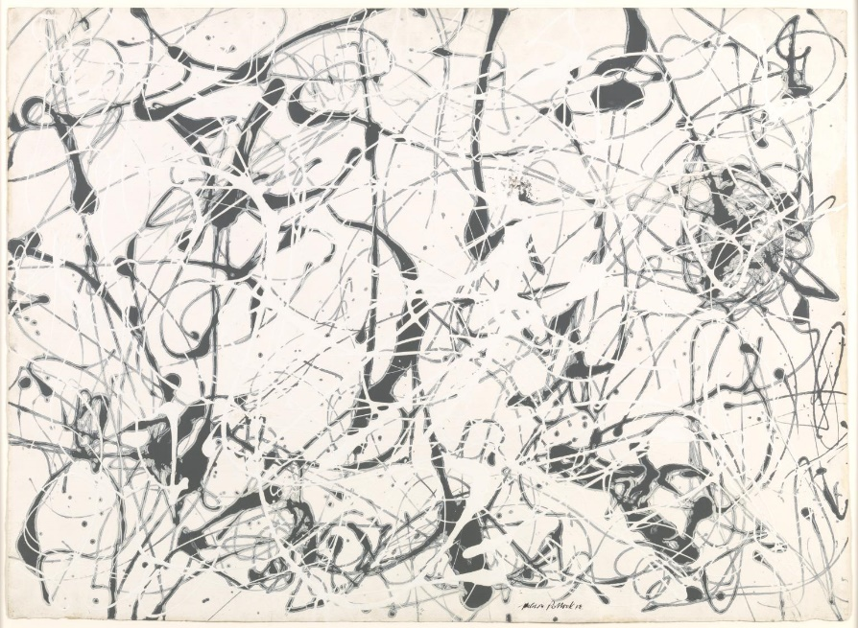

Figure 3 - Jackson Pollock, Number 23. (1948)

Created during a period, in which Pollock worked with whatever commercially available materials he could get his hands on. “Number 23” was formed by watering down black manufactured enamel to a thinner consistency that Pollock could apply capably and in abundance. The paint was either dribbled onto the surface by hand (the dripping technique) or applied a little less loosely with a syringe full of paint. As Fellow Artist Lee Krasner 1969 claimed; “An instrument Pollock handled like a giant fountain pen”. (Karmel, 1999) The work was done completely spontaneously and is concerned more with the movement and action rather than the composition or context of the piece. (Tate, n.d.) Pollock states; “The painting has a life of its own. I try to let it come through”. Supporting the importance of the artists psychological and physical relationship with the work. Like the ideas of Gestalt, this form of expressionist and performative painting, was also a visionary notion within the artworld and society at the time. In pollocks words “The modern artist is working with space and time and expressing his feelings rather than illustrating… Painting is self-discovery. Every good artist paints what he is.” (Olmedo, 2017) Supporting such assumptions, Gestalt thought would argue that the different constituents are not completely separate from the finished painted outcome. Instead, they are a sum of parts that make it what it is. The experience, process, action and outcome work together in creating the expression and all tie in hand in hand. (Elizabeth Frank, 1983) The marks, motions, colour atmosphere and mood of the piece is viewed holistically. We don’t investigate each distinctive element. Our mind innately self-organises the visual information we receive into an overall perception of the piece. Expressionism especially is hard to separate and view as a variety of component. Thus, is a perfect example of the minds tendency to create a self-organised whole.

When creating Number 23, Pollock applied the paint from above, circling around the paper’s surface, which he dubbed ‘the arena’. This technique created thin, sweeping arcs of paint, with no central point of focus or hierarchy of elements, imbuing the work with a rhythmic and energetic quality. (Elizabeth Frank, 1983)Like Mach and Ehrenfels notions of a melody being recognised from its relationship or rhythm of notes, this also applies here. The relationship and overall perception of the piece is stronger than the analysis of each small mark. We can instantly recognise a Pollock even if different colours, compositions and grounds are used. The action of the gestures and mark demonstrate the perceptual laws that Gestalt psychology began to examine. Through this we can see that the Gestalt theory of perception can be applied visually and auditorily.

In addition to exploring the role these psychological theories have had on our ability to realise and create numerous art forms. We can also analytically and methodologically examine what makes up the specifications of how we perceive visual information, from a Gestalt view point. We already know that gestalt psychology seeks to explain perceptions in terms of gestalts (organised wholes) rather than by analysing their constituents, attempting to explicate how the brain makes sense of what otherwise could be considered disorder. When looking at how this occurs, the theory purposes that the mind does this by forming a universal whole with self-organising propensities when perceiving or taking in information. (Jacquette, 2001) (Harding, 2018) In other words when trying to make sense of the world around us, our minds observe things we see as portions of a larger whole, as well as the foundations of more complex arrangements. (Koffka, 2014) This opposed the previous ideas of the mind concentrating on each small element separately. Ultimately suggesting that perception is determined greatly by a set of mental responses or laws such as; similarity, continuation, closure and symmetry that unite different elements within a larger visual context. Creating an overall awareness of what we see or experience. (Ash, 1998)

How Artists Have Explored Gestalt’s Perceptual Laws within their practice.
In order to better understand how this type of human perception works in relations to art we can further examine what Gestalt psychologists proposed to be the laws of perceptual organisation. For example, the law of similarity. Gestalt suggests that when observing and processing visual information, similar items tend to be grouped together. If a variety of items in a section are similar, our brains naturally assemble them together to be perceived as a whole image, rather than separate items. An example of this is when we see a series of circles grouped together, our brains will process the image as a series of columns or clusters rather than just individual shapes. Gestalt claims that as humans we automatically do this in our day to day life. When it comes to the law of proximity, much like similarity, if numerous different people are standing close together, you may instantly assume that they are all part of the same social group. (Ellis, 1999) When applying these notions to visual art, we can see that these organisational laws are present. Referring to Pollocks, Number 23, we can see the marks, splatters and drips are all placed in relatively close proximity, thus, we automatically view the piece as fluid and in unison. Furthermore, we can see the integration of Gestalt Theory and art more vividly when looking at Painter, Josef Albers (1888-1976).

Albers felt that art could provide challenges to our visual perception and began to examine the perceptual laws mentioned above within his practice. Influenced by Gestalt theories, Albers believed that, although all visual stimuli are theoretically ambiguous, we are typically able to grasp and organise an excessive sum of visual clues or cues in order to make sense of the many objects around us. Albers was enchanted by the formation of abstruse figures or images that could be understood in more than one way. (Rosenthal, 2006) An example of this investigation of perception can be seen within Albers, Steps (Fig 4) the first exertion in his Formulation: Articulation portfolio. The image on the right resembles a kind of staircase shape or structure, hence the name steps. Since the bottom step is the broadest, we see it first and perceive the steps as moving upward and further from us. But the smaller image on the left is equivocal. We can perceive the set of steps as moving toward or away from us, we can perceive it as a set in which only the middle step is receding, or in five alternative ways. When viewing a real-life staircase, we gather information or visual cues from various rudiments such as size, stereo vision, shadow, perspective, and its changing appearance as we move around it or oscillate within the proximity of it. By eliminating these clues in the small depiction in Steps, Albers forces the viewer to focus on the basic elements of the drawing - the lines and their interactions. (Barry, 2015) Although there are many simplistic lines, we don’t see the lines as separate even without the visual clues taken away by Albers. Instead we continue to associate a context or structure with the line drawing. We recognise the relationship of lines as being those representing steps just as Ehrenfel’s established we may recognise an incomplete melody.
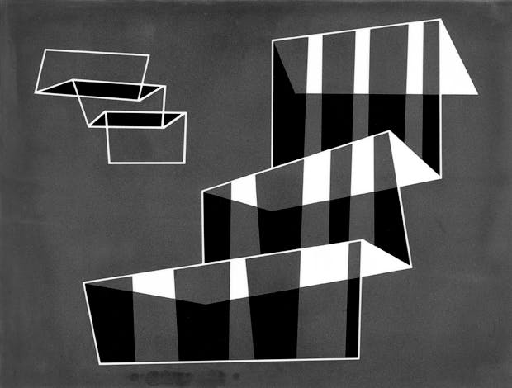

Figure 4- Josef Albers. Steps. (1932)

The laws of proximity and similarity offer up some form of explanation to why this phenomenon takes place. Albers wrote in 1928: “Adding one element to another element should yield at least one interesting relation that is more than just the sum of those elements. The more variable and intensive the relations that arise, the more valuable the result, the more productive the work.” (KOEHLER, 2015) Not only was Albers recitation his own teaching technique here, he was also evidently reverberating the philosophies of Gestalt as he comprehended them.

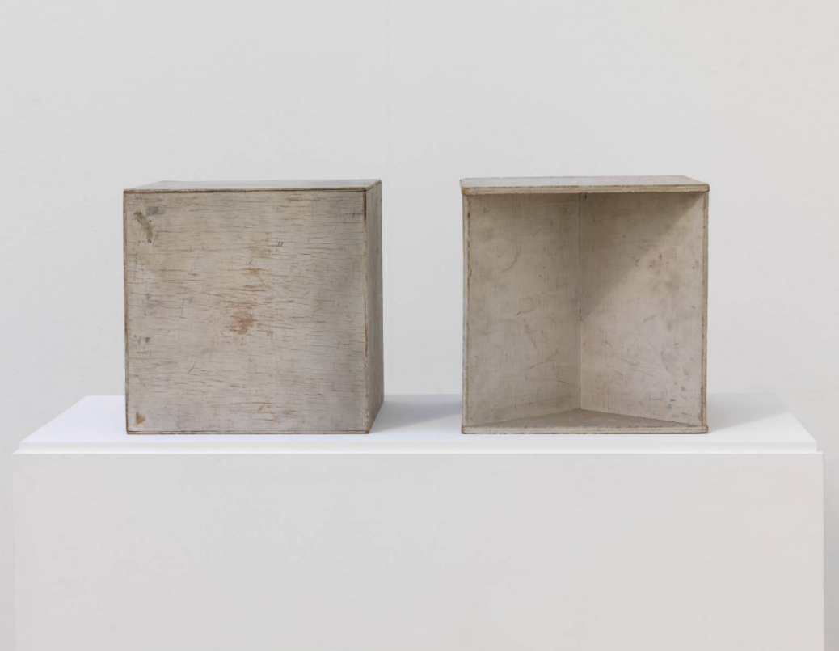
The work of Munich-based research psychologist Theodor Lipps (1851-1914), also played a central role in the evolution of Gestalt psychology during the twentieth century. One of the earliest to amalgamate art history with psychology, Lipp's most critical involvement was his attempt to hypothesise the question of Einfuehlung (empathy), which Lipps expressed as the act of projecting oneself into the object of a perception (Weigel, 2017) (Harding, 2018) An idiom that would become an important feature in many ensuing theories of Art Psychology. Lipp's exploratory study of optical illusions within Raumästhetik und geometrisch-optische Täuschungen (1897), guided much contemporary research surrounding this subject. He suggested that all appreciation of Art is be dependent upon a similar self-projection into the object. (Titchener, 1909) Thus, connecting perception of external aesthetics with the innate psychological interpretations and relationship between object and self. (Mandler, 2007) (Harding, 2018) Swiss historian and Art critic, Heinrich Woelfflin (1864–1945) also supported such ideas. Now considered to be one of the founding texts of emerging psychological direction of art history, Woelfflin's (1886) Prolegomena zu einer Psychologie der Architektur intended to show that architecture and the spaces around us could be comprehended merely from a psychological view point rather than a progressivist one. Like Lipp, Wolfflin suggests that architecture has a foundation in form through the empathetic response of human form. (Woelfflin, 2016) (Harding, 2018) These concepts had a major impact on the art world at the time and several artists in the twentieth century began to be influenced by the theories discussed. Influential theorist, sculptor, and crucial figure within Russia's post-Revolution avant-garde Art world; Naum Gabo (1890 -1977), encouraged by Wolfflin's lectures, experimented with how we psychologically perceive objects, through his theory and practice. (Sidlina, 2012) Enormously captivated with the early Gestalt ideas of perception and an objects relationship to space, Gabo's "two cubes" 1930 (Fig 5) Demonstrated ideas within his thesis ‘Sculpture: Carving and Construction in Space’. (Vinzent, 1930) (Harding, 2018)
Figure 5- Naum Gabo - Two Cubes. (1930)
One cube uses solid mass to expound the space within the sculpture while the other communicates the form’s inner space. Gabo sought to make the space inhabited by an object visible without surrounding it. Inner space was a sample of what Gabo called the constructive idea, where the partition between the artist’s perceptions of an object and the object itself were dissolved, therefore; art becomes reality. (The Art Story, n.d.) (Harding, 2018)

Chapter 3 – How Gestalt Theories Have Been Received Within Society.
At the time of emergence Gestalt psychology juxtaposed the alternative psychological theories of perception and behaviour. Its ideas challenged the structuralism of German philosopher, and professor, Wilhelm Wundt. While Wundt was interested in breaking down psychological matters into their smallest possible parts, (McLeod, 2008) Gestalt psychologists were instead interested in looking at the totality of the mind and behaviour. Structuralism aimed to examine the human mind in relation to the most basic definable components. Proceeding to find the way in which these constituents merge together into complex forms. (McLeod, 2008) British psychologist, Edward Titchener, who studied under Wundt for several years, disagreed with the Gestalt theory. Claiming that experiences should be assessed as facts, as they exist. Without analysing the value or implications of the experiences on our perception. In his dissertation, A Textbook of Psychology (1909–10), Titchener quantified that the only foundations required to define the conscious experience are affection (feeling) and sensation. Personality and behaviour were outside the scope measured by structuralism. (Wallis, 2018) By untying meaning from the facts of experience, structuralism therefore conflicted with the phenomenological Gestalt psychology. The ideas discussed throughout this dissertation also opposed those of atomism, another hypothetical methodology that esteems a thing as interpretable through examination into it’s detachable, independent and distinct basic components. (Chalmers, 2014) However, despite these conflicting views Gestalt theory has adapted and advanced the way in which we approach cognitive issues, introducing Psychotherapy methods such as Gestalt therapy, that focuses on changing one’s perceptions of themselves and their relationship to the world around them. (Wertheimer, 2007)

Gestalt therapy is a client-focused method of psychotherapy that aids clients to concentrate on the existing moment and comprehend what is really occurring in their lives at present, rather than what they may believe to be happening constructed by previous experiences. (Psychology Today, 2018) Developed by Fritz Perls (1893–1970). Instead of discussing past conditions, the individual is encouraged to experience them, through processes such as re-enactment. As the patient may not understand the role they play in their own unhappiness and discomfort the gestalt process aims to help patients attain the ability of being conscious of how their self-inflicting damaging behaviours and thought patterns are delaying self-awareness, resulting in discontentment. Inspired by the Gestalt theories examined, Perl’s developed these methods on the principle that humans are best viewed as a whole entity, consisting of body, mind, and soul, and are best understood when viewed through their own eyes, transferring their past into their present. (Yontef, 1993) Gestalt psychotherapist, Dave Mann, in his book; Gestalt Therapy (100 Key Points), 2010. Discusses how Gestalt therapy offers a relational, present-focused method that exerts the central belief, that the client knows the best way of altering to their conditions. He commends how, by aiming to amplify awareness through artistic investigation and analogue, Gestalt therapists generate the circumstances for a client's individual expedition to health. (Mann, 2010)

How Gestalt Theories Have Enriched the Mental Health System
Furthermore, this psychotherapeutic approach has induced revolutionary methods that have been amalgamated not only with art, but with dance, drama, body work, and other therapies. (Perls, 1994) Painter and teacher Janie Rhyne (1913-1995) was a crucial pioneer in art therapy as well as Gestalt art therapy, which integrated the methods of Gestalt therapy with art therapy. Rhyne used art as an expression and communication, encouraging individuals to construe and express their emotions from pieces of art. (Junge, 2010) Rhyne recognised the therapeutically healing characteristics art contains, working with both adults and children in several hospitals and schools. This opposed the conventional approach to psychotherapy at the time, which echoed a more formal structure, where elucidations are made by the art therapists rather than the client. (Rhyne, 1996)

As identified, Gestalt theories of perception pronounce that entities must holistically be comprehended in the framework of their ongoing relationship with the world. Avowing that the source of human anguish is that individuals do not assimilate the fragmented aspects of their personality at the current time, due to the lack awareness of their environment and themselves, as well as holding onto incomplete business from the past. (Smith, 1998) The focus of Gestalt art therapy aims to help clients eventually experience the amalgamation of their disjointed parts of personality, in the moment, through experiencing art work. Rhyne urged that the most imperative feature of the therapist's duty in the Gestalt art experience is his or her expertise in transferring the acumens of the complete process onto the way the individual experiences the world and their relationship to it. (Rhyne, 1996)

Gestalt art therapy emphasises that the human mind tends to classify similar colours, lines, and shapes as a unification, so individuals perceive these elements as generating a visual group and then construct a figure that stands out in consciousness from a less figural ground. Illustrating the human tendency to recognise their own inclination toward the implementation of creating wholes and the completing of unfinished parts of wholes. With these philosophies, Rhyne was adamant that clients could increase insight into how they commonly perceive, through their art experiences. In other words, she supposed that it is probable for how an individual perceives visually to have a direct correlation with how they feel and think. For example, the way an individual uses shapes, colours and lines in affiliation to each other may specify something about their patterns in life. In addition, the structure, or the lack of, in the persons painting or drawing may be connected to their behaviour in various other aspects of their life. (Rhyne, 1996) Although Rhyne used an extensive assortment of non-conventional and conventional art materials when inspiring individuals to express their experiences and emotions, she usually favoured painting and drawing as the means for effective therapy, since she believed that both expressive practices produce various clues, that through the principles of Gestalt perception become easily comprehensible. (Rhyne, 1974)

In her book, The Gestalt Art Experience: Patterns That Connect, 1996, Rhyne’s Discusses how Gestalt art therapy has developed in alignment with various theories and practices underlying broader-based disciplines. Acclaiming Gestalt psychology and the many ensuing theories highlighted as a fundamental innovator of Gestalt Art therapy. Rhyne discusses how Gestalt therapy is predominantly based on the theories of Gestalt psychology, but they have been adapted to support therapeutic interpositions. Whereas the Gestalt art experience incorporates ideas from both fields. (Rhyne, 1974) Integrating the perceptual laws and conceptions of one’s relationship to the world introduced by theorists like Mach, Von Ehrenfels and Wertheimer, in addition to Perls Gestalt therapy methods with art. Rhyne believed that using the Gestalt methods of art therapy as a means of expressing and communicating their ‘inner world’ could assist people efficiently trigger their sensory memories. She was obstinate that artistic media and expression acted as a bridge between the external world and our internal worlds. (Rhyne, 1996)

The idea that art acts as a bridge between our inner selves or psychologies and the exterior world is a notion that is evident when looking at prehistoric art such as cave painting or parietal art.(Fig 6) A 2018 study states the existence of a 64,000-year-old non-figurative cave petroglyph in Iberia as the oldest piece of cave art documented so far. (Greshko, 2018) Implying that it was produced by Neanderthals rather than modern humans as we know them. This astonishingly solidifies the postulation that as humans we have the innate disposition to want to visualise and create what we feel or perceive. As artist, Nam June Paik articulates; “The human condition is so powerful and so necessary. The most important thing human beings can do in their lives is to leave something behind. People who came before have left behind something that gives us knowledge. Creativity exists in all human beings; it transcends time and place and it arises from the practice of making something new from something old. Art is the universal language of mankind.” (Art, 2018)
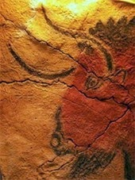

Figure 6- Cave painting of a bison head, Magdalenian parietal art. (15,000 BCE)

Conclusion
It is clear that Gestalt psychology has impacted the art world. Encouraging an abundance of artists to explore the relationships of objects within a space, perceptual laws and other Gestalt theories within their practice, as exemplified by artists Albers and Gabo. The links made by Mach, between our experiences and perceptions of the external world with our internal emotions or sensations has become a crucial component within art practice. Meaning that emerging and existing artists have a much clearer and more advanced appreciation of the psychological and perceptual elements of the making and interpreting of art. Such principles have moulded the foundation of much further research into the perception of designs and objects (Carlson et al. 2000), and of exploration into thinking, problem solving and psychopathology. (Mandler, 2007) Through them we can examine the psychological effect that our surroundings could have on us, becoming an agency for certain psychological manipulations. (Harding, 2018) Although Gestalt psychology conflicted with the adjacent theories around the time of its emergence and has faced condemnation, predominantly in that many of its vital concepts can be problematic to define and examine experimentally. It has helped familiarise the awareness that human perception is not just about seeing what is present in the world around us. Much of what we perceive is also profoundly influenced by our motivations and expectations. (Tarry, n.d.) Its essential philosophies have had an excessive influence on the field of psychology as a whole. (Kohler, 1992) In addition, gestalt theories have been supported by One of the most significant figures in Western history, ancient Greek philosopher and scientist Aristotle (384 BC - 322 BC). The first great mind to conceive the view of the whole as more than the sum of its parts. Aristotle himself affirmed that “In the case of all things that have several parts and in which the whole is not like a heap, but is a particular something besides the parts, there must be some such uniting factor”. (Sturmberg, 2016) An assemblage of his treatise; Metaphysics, investigates the associations of objects and their features, in addition to a multitude of other ontological impressions. The text articulates accounts of an elementary edifice of experience of various "objects" that exist in some form or another, but which need to be distinguished from the most fundamental objects of reality. Providing insight into what exists and what merely holds a relationship to what exists, much like the ideologies that fortify Gestalt psychology. (Aristotle, 1952)

Furthermore, the unification of Gestalt psychology and art has not only lead to the advancement and development of numerous art styles, it has helped us better understand human behaviour, using artwork as a tool in doing so. With art now, becoming not just something visual but something psychological, an outlet. Providing an insight into a person’s mind. (Behrens, 1998) The development of Gestalt art therapy through this has set the guidelines for individuals, to explore one's own exclusively unique abilities, expand one's array of perception through the expression of forms, and help learn to recognise the visual communications forms convey. Becoming quintessentially successful in helping younger individuals or those who may have problems communicating verbally. (Rhyne, 1996) Gestalt psychology and the introduction of Gestalt art therapy has contributed to the broad understanding of the methodology of art therapy the mental health sector maintains today. With mental health issues becoming more common, contemporary society is a lot more aware of the ramifications of mental illness, and the need for such methods are crucial in supporting these individuals. This dissertation demonstrates how art and psychology has become deeply entwined within society, becoming an essential component in how we can utilise art as something psychologically beneficial.

Bibliography
Allesch C.G. (2017) Einfühlung – A Key Concept of Psychological Aesthetics. In: Lux V., Weigel S. (eds) Empathy. Palgrave Studies in the Theory and History of Psychology. Palgrave Macmillan, London
Aristotle, 1952. Metaphysics (Ann Arbor Paperbacks). s.l.:University of Michigan Press.
Art, W. M. o. A., 2018. Conserving Nam June Paik’s Fin de Siècle II, 1989. [Online]
Available at: https://whitney.org/WatchAndListen
[Accessed 1 December 2018].
Ash, M. G., 1998. Gestalt psychology in German culture, 1890-1967. s.l.:Cambridge University Press.
Barry, S. R., 2015. Josef Albers and the Science of Seeing. In: V. Malloy, ed. Intersecting Colors: Josef Albers and His Contemporaries. s.l.:Amherst College.
Behrens, R. R., 1998. Art, Design and Gestalt Theory. Leonardo, 31(4), pp. 299-303.
Boeree, G., 2000. webspace; Gestalt Psychology. [Online]
Available at: https://webspace.ship.edu/cgboer/gestalt.html
[Accessed 4 August 2018].
Chalmers, A., 2014. Stanford Encyclopedia of Philosophy - Atomism from the 17th to the 20th Century. [Online]
Available at: https://plato.stanford.edu/entries/atomism-modern/
[Accessed 19 November 2018].
Cherry, K., 2018. Very Well Mind. [Online]
Available at: https://www.verywellmind.com/gestalt-laws-of-perceptual-organization-2795835
[Accessed 20 November 2018].
Das, A., 2009. Contextual Interactions in Visual Processing. s.l.:ACADEMIC PRESS.
Elizabeth Frank, J. P., 1983. Jackson Pollock Volume 3 of Modern Masters Series. s.l.:Abbeville Press.
Ellis, W. D., 1999. A source book of gestalt psychology. s.l.:Psychology Press.
Harding, S., 2018. Dissertation Proposal - The Unification of Psychology and Art. Swansea: s.n.
Hardy, A. (2011). The Expression of movement in Architecture. 471-497. Retrieved from https://www.tandfonline.com/doi/abs/10.1080/13602365.2011.598698?src=recsys&journalCode=rjar20
Gardner, M. R., 1977. Relationism and Relativity. The British Journal for the Philosophy of Science, 28(3), pp. 215-233.
Gioni, M., 2016. Pipilotti Rist: Pixel Forest. s.l.:Phaidon Press.
Goldstein, E. B., 2010. Encyclopedia of perception. Volume 1 ed. London: Sage Publications.
Gosling, E., 2017. Creative boom: Bill Viola: When video art becomes life, death, and transcendence. [Online]
Available at: https://www.creativeboom.com/inspiration/bill-viola/
[Accessed 1 September 2018].
Greshko, M., 2018. National Geographic, World's Oldest Cave Art Found—And Neanderthals Made It. [Online]
Available at: https://news.nationalgeographic.com/2018/02/neanderthals-cave-art-humans-evolution-science/
[Accessed 23 November 2018].
Jacquette, L. A. a. D., 2001. The school of Alexius Meinong(western Philosophy series). 1 edition ed. s.l.:Routledge.
Junge, M. B., 2010. The Modern History of Art Therapy in the United States. s.l.:Charles C Thomas Publisher.
Josef Albers, “Teaching Form Through Practice,” AA Files 67 (2013), 129.

Karmel, K. V. a. P., 1999. Jackson Pollock. Paperback edition ed. S.l.:Tate Publishing.
King, M., 2002. From Max Ernst to Ernst Mach: epistemology in art and science. Working Papers in Art and Design, Volume 2, pp. 1-13.
King, N., 2018. Pipilotti Rist in Conversation, Ocula. [Online]. Available at: https//ocula.com/magazine/conversations/pipilotti-rist/ [Accessed: 23 November 2018].
KOEHLER, K., 2015. MORE THAN PARALLEL LINES: THOUGHTS ON GESTALT, ALBERS, AND THE BAUHAUS. In: V. MALLOY, ed. Intersecting Colors: Josef Albers and His Contemporaries. s.l.:Amherst College.
Koffka, K., 2014. Principles of Gestalt Psychology. s.l.:Mimesis International.
Kohler, W., 1992. Gestalt Psychology: An Introduction to New Concepts in Modern Psychology. 2rev Ed edition ed. s.l.:Liveright Publishing Corporation.
Mach, E., 1897. Contributions to the Analyses of the Sensations. Michigan: Open court pub co.
Mandler, G., 2007. A History of Modern Experimental Psychology. Cambridge: MIT Press.
Mann, D., 2010. Gestalt Therapy (100 Key Points). 1st ed. s.l.: Routledge.
McLeod, S., 2008. Simply Psychology, Wilhelm Wundt. [Online]
Available at: https://www.simplypsychology.org/wundt.html
[Accessed 4 September 2018].
Mun-Delsalle, Y.-J., 2015. Forbes: American Video Artist Bill Viola Has Been Reinventing Reality For The Past 40 Years. [Online]
Available at: https://www.forbes.com/sites/yjeanmundelsalle/2015/01/01/american-video-artist-bill-viola-has-been-reinventing-reality-for-the-past-40-years/#7ac913b74805
[Accessed 1 September 2018].
Olmedo, K., 2017. Artnet news. [Online]
Available at: https://news.artnet.com/art-world/jackson-pollock-quotes-836450
[Accessed 5 September 2018].
Perls, F. S., 1994. Gestalt Therapy: Excitement and Growth in the Human Personality. Reprint edition ed. s.l.:Souvenir Press Ltd.
Pfister, J. B., 1995. Mach's Principle;From Newton's Bucket to Quantum Gravity (Einstein Studies). s.l.:Birkauser.
pojman, p., 2008. Stanford encyclopedia of philosophy. [Online]
Available at: https://plato.stanford.edu/entries/ernst-mach/
[Accessed 1 August 2018].
Psychology Today, S. P., 2018. Psychology today- Gestalt Therapy. [Online]
Available at: https://www.psychologytoday.com/gb/therapy-types/gestalt-therapy
[Accessed 20 Novemeber 2018].
Rhyne, J., 1974. The Gestalt Art Experience. s.l.:Brooks/Cole.
Rhyne, J., 1996. The Gestalt Art Experience: Patterns that Connect. s.l.:Magnolia Street Publishers.
Rosenthal, J. A. a. T. G., 2006. Josef Albers: Formulation : Articulation. New Ed edition ed. s.l.:Thames and Hudson Ltd.
Sidlina, N., 2012. Naum Gabo. 1st ed. s.l.:Tate Publishing.
Smith, B., 1998. Foundations of Gestalt Theory. s.l.:Philosophia.
Sturmberg, J. P., 2016. "Returning to Holism": An Imperative for the Twenty-First Century. In: J. P. Sturmberg, ed. The Value of Systems and Complexity Science for Healthcare. 1st ed. 2016 edition ed. s.l.:Springer, pp. 3-19.
TANNER, E., 2015. SchirnMag:Art is life and life is art - Wolf Vostell. [Online]
Available at: https://www.schirn.de/en/magazine/context/art_is_lifelife_is_art_wolf_vostell/
[Accessed 1 September 2018].
Tarry, D. R. J. a. D. H., n.d. Defining social Psychology: History and Principles. [Online]. Available at: https://opentextbc.ca/socialpsychology/chapter/defining-social-psychology-history-and-principles/ (Accessed: 6 November 2018)
Tate, n.d. tate: Art and Artwork, Jackson Pollock. [Online]
Available at: https://www.tate.org.uk/art/artworks/pollock-number-23-t00384
[Accessed September 2018].
The Art Story, M. A. I., n.d. Naum Gabo, Russian-American Sculptor, Designer, And Architect. [Online]
Available at: https://www.theartstory.org/artist-gabo-naum.htm
Theodore Lipps, (Leipzig j a barth. 1897)
Titchener, E., 1909. Lectures on the Experimental Psychology of the Thought-Processes. New York: Macmillan.
Vinzent, J (1930). Challenging the abstract in late 1930s Britain; Encounters with the 1930s, ed. Mendelson, J. exhibition catalogue, Museo Nacional Centro de Arte Reina Sofía, Madrid, 3 October2012-7 January 2013, 140-147
Viola, B., n.d. Bill Viola: Artist Biography. [Online]
Available at: https://www.billviola.com/biograph.htm
[Accessed 4 August 2018].
Wallis, D. C., 2018. The History and Science of Cognitive Science: Introductory Lectures. [Online]
Available at: http://web.csulb.edu/~cwallis/382/readings/482/text/psychology.pdf
[Accessed 10 November 2018].
Weigel, V. L. a. S., 2017. Empathy. Palgrave Studies in the Theory and History of Psychology. London: Palgrave Mcmillan.
Wertheimer, D. B. K. a. M., 2007. Max Wertheimer and Gestalt Theory. s.l.:Transaction Publishers.
Wertheimer M. Experimentelle Studien über das Sehen von Bewegung. Zeitschrift für Psychologie. 1912;61:161–265.(Translated extract reprinted as “Experimental studies on the seeing of motion”. In T. Shipley (Ed.), (1961). Classics in psychology (pp. 1032–1089). New York, NY: Philosophical Library.)
Wertheimer M. Über Gestalttheorie. Lecture delivered to the Kant-Gesellschaft, Berlin, December 1924. 1924 (Translated extract reprinted as “Gestalt theory”. In W. D. Ellis (Ed.), (1938). A source book of Gestalt psychology (pp. 1–11). London, U. K.: Routledge & Kegan Paul Ltd.)
Wertheimer M. Untersuchungen zur Lehre von der Gestalt, II. Psychologische Forschung. 1923;4:301–350. (Translated extract reprinted as “Laws of organization in perceptual forms.” In W. D. Ellis (Ed.), (1938). A source book of Gestalt psychology (pp. 71–94). London, U. K.: Routledge & Kegan Paul Ltd.).
Woelfflin, H., 2016. Prolegomena to a Psychology of Architecture:Translated by Michael Selzer (keepAhead Press Architectural Theory Texts). First Edition ed. s.l.:CreateSpace Independent Publishing Platform.
Yontef, P. G., 1993. Awareness, Dialogue, and Process. s.l.:The Gestalt Journal Press.

Images
Figure 1: Viola,B. (2000) Ascension [video/sound installation].Available at: https://www.forbes.com/sites/yjeanmundelsalle/2015/01/01/american-video-artist-bill-viola-has-been-reinventing-reality-for-the-past-40-years/#5e336bb94805 (Accessed: 1 December 2018). 10 minutes, performer: John Coxx (Photo Kira Perov)
Figure 2: Rist,P. (2012-18) Sip My Ocean [Video/Installation].Available at: https://www.mca.com.au/about-us/media-releases/media-releases/dive-mcas-summer-exhibition-pipilotti-rist-sip-my-ocean/ (Accessed: 1 December 2018)
Figure 3: Pollock,J. (1948) Number 23 [Enamel on Gesso on Paper].Available at: https://www.tate.org.uk/art/artworks/pollock-number-23-t00384 (Accessed: 17 November 2018)
Figure 4: Albers,J. (1932) Steps [Casein on Masonite]. Available at: https://www.nicholasfoxweber.com/josef-albers-steps/ (Accessed: 17 November 2018)
Figure 5: Gabo, N. (1930) Two Cubes [Painted Wood]. Available at: https://www.tate.org.uk/art/artworks/gabo-two-cubes-demonstrated-stereometic-method-t02166 (Accessed: 15 November 2018)
Figure 6: n.d. (15,000 BCE) Cave painting of a bison head, Magdalenian parietal art [Painting]. Available at: http://www.visual-arts-cork.com/prehistoric/parietal-art.htm (Accessed: 16 December 2018)

