Effective Team Work and Communication
Robbie Paul Moore
I.D - 2027448
Module - BMSW4002
Lecturer – Saqib shaman
University of Wales Trinity saint David
05/01/2022
Table of Contents

COMMUNICATION IMPORTANCE IN A WORKPLACE: 3
WORKPLACE COMMUNICATION RELATED CONFLICTS: 4
COMMUNICATION THEORIES AT WORKPLACE: 5
INTERPERSONAL SKILLS: 6
COMMUNICATION MODELS: 7
FORMATS OF WRITTEN COMMUNICATION: 9
References 11

COMMUNICATION IMPORTANCE IN A WORKPLACE:

(Belbin, M.R., 2012) stated that communication has become critical in the modern-day. Human action will come to a grinding halt if there is no dispatch. Each human interaction occurs as naturally as possible through letters. It is by far the most vital aspect of any commercial partnership. In particular, in today's international market economy, effective communication is critical to the success and survival of any organisation.
Businesses demand individuals with superior report abilities, as communication is a critical component of the type of job performed in large company organisations. It pervades every sector of business, including administrative, specialised, administrative, and social positions. Business dispatch is the term used to describe a company's efforts to communicate with the goal of achieving specified goals. In reality, corporate communication is an exceptional form of communication that is aimed at meeting the needs of the organisation. Correspondence is at the heart of cutting-edge control standards like cooperation, inspiration, and inclusion.
(Morgan, 2016) studied that company's communication system is based on the exchange of knowledge and expertise among several notable members and members of the company as a whole. Different modes and media are emphasised in verbal trade transactions as part of it.
Business communication is essential for a variety of reasons, such as the following:
- Strong bonding: Developing, maintaining, and expanding relationships with key partners requires a different set of skills. Using it, anyone might increase their compassion and strengthen their relationships with critical coworkers.
- Competitive advantage: Managers will want representatives who can communicate successfully with all sections of the organisation as communication technology advances.
- Trust Building: In cooperation and system administration, correct communication may be helpful since it encourages people to put greater effort into their happiness. If a person has gained the respect of others with whom they have worked, they will be in a better position to deal with unexpected events and difficult requests.
- Goal Achievement: Communication brings people together, allowing them to pursue ambitions that aren't all that outlandish. In addition, it is essential to preserve the most open members of the family. Additionally, administrators are frequently expected to engage with the media with the hope of portraying a positive image of the company.

WORKPLACE COMMUNICATION RELATED CONFLICTS:

- Communication Gap: It occurs when individuals exchange measures without physically meeting. This results in erroneous data and information that enables one colleague to operate from one arrangement of saw data and information while another works in an entirely different manner (Collins, 2001).
- False impression: As a result of a lack of communication, misunderstandings can lead to mistakes, missed deadlines, and a rethinking of work guidelines. Dissatisfaction might result if a staff member believes her labour or time has been wasted or if a partner is accused of not passing on the proper facts in a coordinated manner. Due to a lack of clear direction, updates and status surveys may not be given quickly, or there may be no one in charge of an initiative or task.
- Non-responsiveness: Any other source of conflict is companions' or leaders' inaction in response to a demand for documents, defence, or speculation. The representative anticipating a reaction may also notice that the opposite birthday celebration is generally purposefully not communicative and interferes with her capacity to accomplish her unique activity. This creates a detrimental, non-collaborative environment, regardless of whether the non-responsiveness is the direct result of an overlook or another type of cause.
- Unorganised System of Communication: Organisations that are afflicted by discussion difficulties almost certainly lack defined, organisation-wide discussion procedures in their zone. Enhancing work environment communication entails developing a correspondence instructors are needed to adhere to a set of guidelines. This may incorporate to acquire and communicate character traits, to provide standard notoriety reports to whole works of art organisations, and to conduct standard up close and personal testing.
- Different Communication Style: As there are no established dispatch systems in the region, people's forms of communication might clash and cause conflict. As an example, one worker may prefer face-to-face interactions while another prefers technological communication, such as e-mail. Each meeting may come across an extreme alternative, and this might lead to a breakdown in verbal communication.
- Technical Issues: A variety of computerised report formats such as electronic mail and content informing and certain types of computerised reports have accelerated and enhanced communication, but they have their limitations. Messages might be misplaced or sent to junk mail, and they don't always get them to their intended destination.

COMMUNICATION THEORIES AT THE WORKPLACE:

- Critical Theory:
People in the workplace can use this notion to communicate with their coworkers and with everyone else to handle all the challenges of the workplace. Administrative divisions of an office, which are responsible for coming up with ideas and making plans, and representatives, who are responsible for making those plans a reality. It's a good idea for higher management to be in touch with businesses on a regular basis so they can motivate them and reduce the differences between all of them, according to this theory (Tuckman and Harper, 2012).
- Post-positive theory:
Several organisations employ the tyranny model, in which one member initiates the request and another follows up. In any matter, this may pave the way for confrontations if the ideas are not thoroughly explored with companies. Along these lines, any plans established by the higher management are evaluated in the form of a meeting or by different ways, and then an appeal is made for the work or activity to be completed. This instils a sense of justice in firms and motivates them to make a gallant attempt.
- Groupware theory:
People thousands of kilometres distant may now communicate instantly via text messaging because of rapid advances in technology. In addition, these new developments in teaching may also be observed in the workplace. However, this might also lead to problems, such as the instantaneous leakage of private data through new forms of contact. This notion has been developed in order to better direct an organisation's inventive correspondence.
- Information Theory:
Occasionally, the content you need to convey your customer's perception of your product alters when it reaches them. As a result, this correspondence theory assures that no misinterpretation occurs and that the right message is conveyed to the recipient.

INTERPERSONAL SKILLS:

(Ercegovac, 2008) explained that every day, we employ interpersonal communication skills when we interact with people, both individually and across organisations. People who have strong interpersonal skills are successful in many walks of life, including business and politics. Listening, pondering, and knowing framing language are only a few of the skills needed for effective interpersonal communication. Being able to recognise your own emotions and those of others is also a part of this set of skills.
Body Language:
A person's nonverbal communication includes things like their body language and facial expressions. The term "body language" refers to how we communicate without using any words in the workplace.
Active Listening:
We can't have a meaningful conversation without paying attention to the other person. Of the sentences we use and their meanings, but also of our tone of voice is built up (gentle, restful, moved, etc.). In the workplace, we pay attention to one another; a phone call is a kind of communication.
Team Working:
Formal or informal communication is an important part of teamwork in the workplace. It aids in completing any crucial job in the smallest amount of time feasible (Belbin, 2010).
Personal Presentation:
It is tasked with the responsibility of transmitting proper signs for the circumstance and the alternate persons concerned. Individuals who lack self-esteem and vanity may also struggle to properly communicate their message/content or fully utilise their skills and abilities as a result of their presentation.

Context Awareness:
Area awareness is characterised as a complementary feature of mobile devices. Mobile phone users, in particular those with smartphones, may be able to make more flexible use of context than those with fixed-line devices.

Problem Solving & Decision Making:
Working as part of a team facilitates problem-solving and decision-making on a wide range of significant challenges. Concord may be created in society by making decisions that assist relationships flourish, while difficulties can devastate them.

COMMUNICATION MODELS:

Linear Model:
In this paradigm, the receiver does not participate in the transformation procedure enthusiastically. The beneficiary receives the message subtly and proceeds as instructed or desired by the sender.
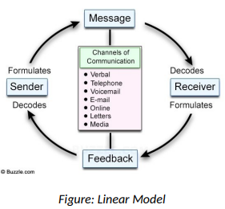

Shannon-Weaver Model:
Once a message is received by a receiver, it is sent by a transmitter and then conveyed closer to the collector via a sign in this model. Prior to reaching its intended target, the message must clear "resources of impedance," which is commotion. As a result of this, it eventually ends up at its destination via the recipient.
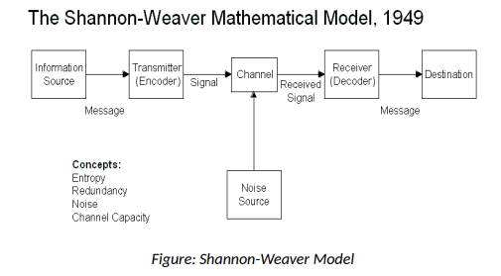
Berlo's Model:
Each encoder and decoder in this approach has five elements that impact and determine the consistency of correspondence. As a result, Berlo emphasises the importance of the message. The Message's Origin Sender and message are equally important to correspondence, but without the recipient, there is no verbal commerce.
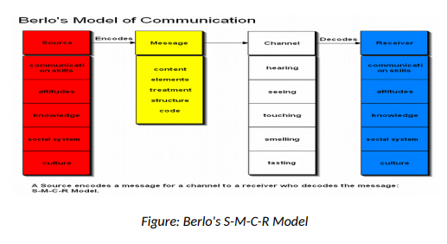

FORMATS OF WRITTEN COMMUNICATION:

- Memos and Letters:
Traditional corporate communication methods such as letters and memos are the oldest and most common. A business letter is typically sent to other organisations, persons, or stakeholders in the firm to provide reliable information. Letters can also be used to discuss commercial agreements or to create professional connections inside the corporate environment with other firms. Memos are a type of internal written communication used by managers and staff to convey information. Companies can reduce their usage of memos in today's corporate climate because of the surge in email use (Adair, 2009).
- Online Chat:
Web-based communication is another relatively new feature that several trademark groups include in their websites. Visit permits companies to exploit people who visit the venture's website and to provide a response framework for clients who have inquiries about the partnership or its goods. Instead of having clients scan for contact information, such as mobile phone numbers or email addresses, offices may alternatively use a web visit interface on their web website landing page to assign customers to a client support delegate.
- Electronic Mail:
Email is a kind of textual communication that is transmitted electronically. In recent years, organisations that use non-open PC frameworks in their company operations have grown to appreciate this correspondence architecture more and more. Sending messages or data updates to people inside or outside of a firm may now be done in a much faster and more efficient manner, thanks to email. The email was once considered as a less formal manner of doing business in its early days, but many firms have now adopted a more official approach for business activity discussion in order to maintain a consistent level of professionalism. Small businesses frequently use email because it is a cost-effective method of communicating with both internal and external business partners.

- Business Proposals:
A firm must produce several proposals to address a variety of issues and concerns. Business suggestions are typically referred to by a variety of terms, including "business plans," "marketing plans," "white papers," "budgetary plans," "vital plans," and "project proposal," but they all extend standard reasoning or superstructure.
Creating a proposal might be difficult due to the fact that recommendations based on nature's techniques are always expected. It is common practice for academics to begin by devising a system for describing a clear problem, necessity, or possibility within a company, but they then question the best approach to solving this problem and possible solutions. Explanatory as well as creative abilities are required for the search and organisation of something that has not yet been created but is being sought after. Despite the fact that it is essential to maintain the legitimacy of your business by delivering an item or service that looks exactly like what you originally planned, plans seldom come out precisely as expected.

References

Ercegovac, Z., 2008. Information literacy: search strategies, tools & resources for high school students and college freshmen. ABC-CLIO.
Maginn, M., 2004. Making teams work 24 lessons for working together successfully. McGraw Hill Professional.
Morgan, P., 2020. The Business Student′ s Guide to Study and Employability. Sage.
Belbin, R.M., 2010. Team Roles at Work, Burlington, MA.
Belbin, R.M., 2012. Beyond the team. Routledge.
Adair, J., 2009. Effective teambuilding: How to make a winning team. Pan Macmillan.
Tuckman, B.W. and Harper, B.E., 2012. Conducting educational research. Rowman & Littlefield Publishers.

