Report : Cloud Computing Architecture
[Student Name] Marios Soulka
[Student ID] 1907844

Table of Contents
1. Introduction 3
2. Background 3
3. Problem statement 4
4. Aim and objectives 5
5. Proposed solution 6
6. Evaluation 8
7. Conclusion 10
8. References 12

Introduction
In cloud computing architecture, a virtual machine (VM) is a software emulation of a physical computer system, which allows multiple operating systems to run on a single physical machine. Each VM consists of virtual hardware resources, including virtual processors, memory, virtual hard drives, and network interfaces. Virtual hard drives are storage resources used by VMs to store data and operating systems. They are created and managed by the hypervisor software, which manages the VMs and their associated resources. VMs are created by deploying a virtual machine image onto a physical machine, which includes the operating system and applications required to run the virtual machine. vNets, or virtual networks, are the virtual equivalents of physical networks (Zolfaghari et al. 2021). They allow multiple VMs to communicate with each other and with external networks over a virtual network infrastructure. vNets can be created and managed through cloud computing platforms such as Microsoft Azure, Amazon Web Services (AWS), or Google Cloud Platform. Network security groups (NSGs) are a type of firewall that provides network security for vNets. NSGs allow administrators to create rules to control inbound and outbound traffic to and from a vNet. These rules can be based on IP addresses, protocols, and ports. NSGs are used to enforce network security policies, such as restricting access to specific resources or applications (Zolfaghari and Rahmani, 2020).

Background
Cloud computing is a model for delivering computing resources as a service over the internet. It allows users to access on-demand computing resources such as servers, storage, applications, and services from anywhere in the world with an internet connection. Cloud computing has transformed the way businesses operate by providing greater flexibility, scalability, and cost-effectiveness compared to traditional on-premises computing. Cloud computing architecture is the underlying structure of a cloud computing system that defines its components, subsystems, and their relationships. It comprises two main components: the front end and the back end. The front end is the user-facing component that includes the client devices, such as computers, tablets, and smartphones. The back end is the cloud-based infrastructure that includes servers, storage, and networks managed by cloud service providers (Aldossary et al. 2019).
Virtual machines (VMs) are a critical component of cloud computing architecture. A virtual machine is a software emulation of a physical computer system that runs on a physical machine. It allows multiple operating systems to run on a single physical machine, making it an efficient way to utilize computing resources. Each VM has its own virtual hardware resources, including virtual processors, memory, virtual hard drives, and network interfaces (Alharbi et al. 2019). Virtual hard drives are the storage resources used by VMs to store data and operating systems. They are created and managed by the hypervisor software, which manages the VMs and their associated resources. The hypervisor is responsible for allocating and de-allocating computing resources as needed, ensuring that VMs have access to the resources required to run their applications (Aldossary et al. 2019).
Virtual networks (vNets) are the virtual equivalent of physical networks. They allow multiple VMs to communicate with each other and with external networks over a virtual network infrastructure. vNets can be created and managed through cloud computing platforms such as Microsoft Azure, Amazon Web Services (AWS), or Google Cloud Platform. Virtual networks can be customized to meet the needs of specific applications or workloads, and they can be configured to provide secure connectivity between different network segments. Network security groups (NSGs) are a critical component of cloud computing security (Zolfaghari et al. 2021). They provide firewall protection for vNets by controlling inbound and outbound traffic to and from a vNet. NSGs allow administrators to create rules to control traffic based on IP addresses, protocols, and ports. NSGs are used to enforce network security policies, such as restricting access to specific resources or applications (Aldossary et al. 2019).

Problem statement
Cloud computing architecture is multifaceted, with different organizations and individuals facing unique challenges. However, some common themes emerge that illustrate the complexity and importance of cloud computing architecture design. Scalability is one of the most significant challenges facing cloud computing architecture. The ability to handle varying levels of demand is critical for organizations to ensure they can meet the needs of their customers while maintaining operational efficiency. Cloud computing architecture needs to be designed to enable organizations to scale up or down quickly and seamlessly in response to changing demand. As organizations increasingly rely on cloud computing to store and process sensitive data, the risk of data breaches and cyber-attacks becomes a major concern (Mavridis and Karatza, 2019). Cloud computing architecture needs to be designed with robust security features, such as encryption, access controls, and network segmentation, to mitigate these risks. Organizations need to ensure that they are not only protecting their own data but also adhering to compliance and regulatory requirements (Hussein et al. 2019).
Cost optimization is also an essential consideration in cloud computing architecture. While cloud computing offers many cost-saving benefits, such as pay-as-you-go pricing and reduced infrastructure requirements, it can also be a complex and challenging environment to manage. Organizations need to ensure that their cloud architecture is designed to optimize costs and minimize wasteful spending. This requires careful consideration of resource allocation, usage monitoring, and cost analysis. Interoperability is another significant challenge in cloud computing architecture. As more organizations use multiple cloud providers and services, there is an increasing need for interoperability between different cloud environments. However, interoperability can be challenging, particularly when different cloud providers use different protocols and standards (Mavridis and Karatza, 2019). Cloud computing architecture needs to be designed to enable the seamless integration of different cloud environments, allowing organizations to move workloads and data between systems. Performance is also critical in cloud computing architecture. The performance of cloud-based applications and services is essential to the success of many organizations. Cloud computing architecture needs to be designed with performance in mind, ensuring that workloads are distributed effectively and that resources are allocated appropriately to meet demand. This requires careful consideration of resource availability, network latency, and workload distribution (Hussein et al. 2019).

Objectives
The aim of this project is to develop a practical understanding of cloud computing architecture using Microsoft Azure, by creating and managing virtual machines (VMs) to host a web server and a database server.
- To create two VMs, one for the Nginx webserver and the other for a database server.
- To install and configure the Nginx webserver on the first VM, and an image of a database server on the second VM.
- To ensure that the web server is publicly accessible, while the database server is kept private and secured within the vNet.
- To implement network security groups (NSGs) to restrict access to the database server VM from outside the vNet, ensuring that only authorized traffic is allowed.
- To test the connectivity between the two VMs, and ensure that the NSG rules are working correctly, to guarantee secure communication between the webserver and the database server.

Proposed solution
Cloud computing has revolutionized the way businesses approach computing infrastructure, providing on-demand access to a wide range of computing resources and services. Virtualization plays a critical role in cloud computing architecture, allowing organizations to create and manage virtual machines (VMs) that can be scaled up or down as required. In this context, it is important to understand the resources associated with a VM, such as virtual hard drives, and how VMs are created and managed. It is also important to ensure the security of these resources and to implement appropriate measures to protect them. This includes configuring virtual networks and network security groups (NSGs) to ensure secure communication between VMs (Fantacci, R. and Picano, B., 2020). One way to gain practical experience with cloud computing architecture is to create and manage VMs using a cloud service provider such as Microsoft Azure. To demonstrate this, an individual or organization can create two VMs on Azure, one for the Nginx webserver and the other for a database server. The first step is to create the VMs, which can be done using the Azure portal or the Azure command-line interface. They can choose the operating system and the size of the VM based on their requirements, and Azure will provision the VM with the required resources (Hussein et al. 2019).
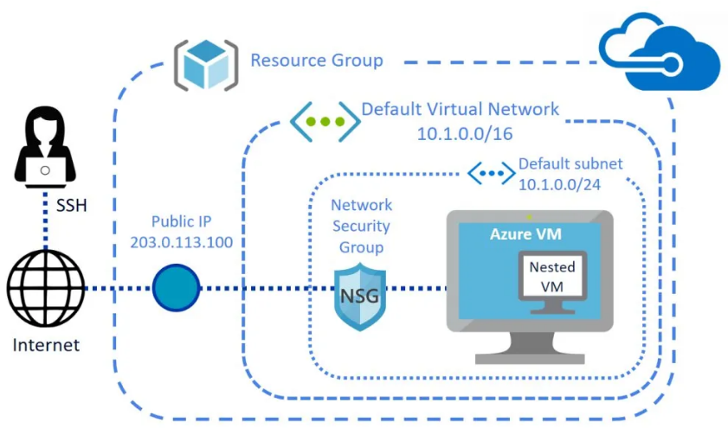
Figure 1: virtual machine inside the Azure virtual machine
Once the VMs are created, it is necessary to install and configure the necessary software on each VM. For the Nginx webserver, the Nginx web server software can be installed and configured. For the database server, an image of a database server such as PostgreSQL or MySQL can be installed. Client software can also be installed on the webserver VM that can talk to the database server VM, such as postgresql-client. Next, the virtual network needs to be configured to ensure that the database server VM is not publicly accessible, and is only accessible within the vNet. The NSGs can also be configured to restrict access to the database server VM and allow authorized traffic only (Kristiani et al. 2021). For the webserver VM, a new inbound security rule can be created in the NSG to allow incoming traffic on port 80 for HTTP communication. For the database server VM, a new inbound security rule can be created in the NSG to allow incoming traffic only from the IP address of the webserver VM, and for the port used by the database server. With the VMs and network configured, the connectivity between the two VMs can be tested by attempting to access the database server VM from the webserver VM using the client software. The NSG rules can be verified to ensure they are working correctly by attempting to access the database server VM from outside the vNet and ensuring that access is denied, while still allowing authorized traffic from the webserver VM (Mavridis and Karatza, 2019).
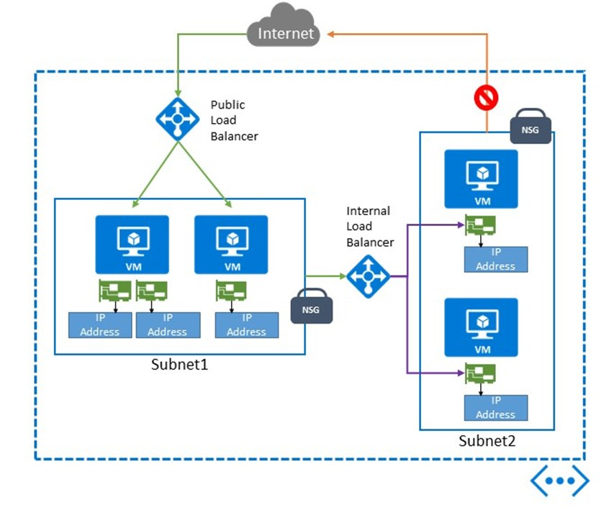
Figure 2: Azure Virtual Machines Network

Evaluation
The evaluation of the proposed solution involves assessing its effectiveness in meeting the objectives outlined in the previous section. Specifically, we need to evaluate how well the solution addresses the problem of providing a scalable and secure infrastructure using cloud computing architecture. We also need to evaluate the effectiveness of the VM creation and management process, as well as the configuration of the virtual network and NSGs. To evaluate the proposed solution, we can consider several factors, including ease of use, scalability, security, and cost. In terms of ease of use, the solution is relatively straightforward and can be implemented using the Azure portal or the Azure command-line interface. This makes it accessible to a wide range of users with different levels of technical expertise (Aldossary et al. 2019). Additionally, Azure provides extensive documentation and support, which further facilitates the implementation of the proposed solution.
Scalability is a key feature of cloud computing architecture, and the proposed solution is designed to leverage this scalability. The ability to create and manage VMs on demand allows us to scale up or down based on our requirements. This flexibility is particularly useful for organizations with varying workloads or for those who require additional computing resources for short-term projects. Furthermore, the use of NSGs allows us to easily configure and manage the security of the VMs, which can be scaled up or down as required. Security is a critical factor in any infrastructure, and the proposed solution addresses this by implementing appropriate security measures. The use of NSGs ensures that only authorized traffic is allowed between VMs, reducing the risk of unauthorized access or data breaches. Additionally, the use of a private virtual network ensures that the database server VM is not publicly accessible, further enhancing the security of the infrastructure. Overall, the proposed solution provides a secure and scalable infrastructure for organizations looking to leverage cloud computing architecture (Rahman et al. 2019).
Cost is another important factor to consider, as cloud computing services can quickly become expensive if not properly managed. The cost of using Azure depends on several factors, including the size and configuration of the VMs, the storage requirements, and the level of usage. However, by leveraging the scalability of cloud computing, organizations can reduce their costs by only paying for the resources they use. Additionally, Azure provides cost management tools and services to help organizations monitor and optimize their usage, further reducing costs. In terms of the VM creation and management process, the proposed solution is relatively straightforward and can be accomplished using the Azure portal or the Azure command-line interface. However, there are some potential challenges that may arise when creating and managing VMs. For example, configuring the virtual hard drives and storage requirements can be complex, particularly for organizations with large data storage requirements (Aldossary et al. 2019). Additionally, managing VMs can be time-consuming, particularly for organizations with a large number of VMs. Configuring the virtual network and NSGs can also be complex, particularly for organizations with complex network requirements. There are several factors to consider, including IP addressing, routing, and security rules. Additionally, managing NSGs can be time-consuming, particularly for organizations with a large number of NSGs or complex security requirements (Zolfaghari et al. 2021).
Overall, the proposed solution is effective in meeting the objectives outlined in the previous section. By leveraging cloud computing architecture and implementing appropriate security measures, the solution provides a secure and scalable infrastructure for organizations looking to build and manage VMs. However, there are some potential challenges associated with VM creation and management, as well as configuring the virtual network and NSGs. Organizations should carefully consider these factors when implementing the proposed solution.

Conclusion
The adoption of cloud computing architecture has revolutionized the way organizations store, manage, and access their data and applications. Cloud computing offers numerous advantages, such as scalability, flexibility, cost-effectiveness, and enhanced security. The use of virtual machines, vNets, and network security groups are essential components of cloud computing architecture that provide users with the ability to create, manage, and secure their virtual infrastructure. Virtual machines provide a cost-effective and scalable way for organizations to run multiple instances of an operating system on a single physical server. The resources associated with a virtual machine, such as virtual hard drives, can be easily managed, and allocation of resources can be adjusted on the fly. This allows for more efficient resource utilization and helps reduce hardware costs for organizations.
vNets and network security groups are crucial components of cloud computing architecture, providing network isolation and access control. vNets allow administrators to segment their network and create virtual private networks, while network security groups provide granular control over inbound and outbound network traffic. This helps prevent unauthorized access to sensitive resources and ensures that only authorized users are able to access specific resources. The exercise conducted in this paper demonstrated the importance of vNets and network security groups in cloud computing. By creating two virtual machines, one with a public-facing web server and another with a private database server, we were able to demonstrate how network security groups can be used to control access to resources. By configuring the network security group to only allow traffic from the web server to the database server, we ensured that the private database server remained secure and was not accessible from the internet. As cloud computing continues to evolve, it is important for organizations to stay up-to-date with the latest technologies and best practices. This includes proper configuration of virtual machines, vNets, and network security groups, as well as ongoing monitoring and management of cloud resources. Additionally, organizations should also ensure that they are in compliance with any relevant regulatory requirements and have appropriate disaster recovery and business continuity plans in place.

References
Aldossary, M., Djemame, K., Alzamil, I., Kostopoulos, A., Dimakis, A. and Agiatzidou, E., 2019. Energy-aware cost prediction and pricing of virtual machines in cloud computing environments. Future Generation Computer Systems, 93, pp.442-459.
Alharbi, H.A., El-Gorashi, T.E. and Elmirghani, J.M., 2019, July. Energy efficient virtual machine services placement in cloud-fog architecture. In 2019 21st International Conference on Transparent Optical Networks (ICTON) (pp. 1-6). IEEE.
Fantacci, R. and Picano, B., 2020. A matching game with discard policy for virtual machines placement in hybrid cloud-edge architecture for industrial IoT systems. IEEE Transactions on Industrial Informatics, 16(11), pp.7046-7055.
Hussein, M.K., Mousa, M.H. and Alqarni, M.A., 2019. A placement architecture for a container as a service (CaaS) in a cloud environment. Journal of Cloud Computing, 8, pp.1-15.
Kristiani, E., Yang, C.T., Huang, C.Y., Wang, Y.T. and Ko, P.C., 2021. The implementation of a cloud-edge computing architecture using OpenStack and Kubernetes for air quality monitoring application. Mobile Networks and Applications, 26, pp.1070-1092.
Mavridis, I. and Karatza, H., 2019. Combining containers and virtual machines to enhance isolation and extend functionality on cloud computing. Future Generation Computer Systems, 94, pp.674-696.
Rahman, U.U., Bilal, K., Erbad, A., Khalid, O. and Khan, S.U., 2019. Nutshell—simulation toolkit for modeling data center networks and cloud computing. IEEE Access, 7, pp.19922-19942.
Zolfaghari, R. and Rahmani, A.M., 2020. Virtual machine consolidation in cloud computing systems: Challenges and future trends. Wireless Personal Communications, 115(3), pp.2289-2326.
Zolfaghari, R., Sahafi, A., Rahmani, A.M. and Rezaei, R., 2021. Application of virtual machine consolidation in cloud computing systems. Sustainable Computing: Informatics and Systems, 30, p.100524.

