What is ‘community heritage’ and how is it practised in Britain today? Discuss in relation to the Carew Cheriton Control Tower project.

Community heritage has become increasingly significant within contemporary heritage practice in Britain. It is seen as voluntary, locally rooted efforts to preserve and interpret the past, which can challenge conventional top-down approaches to heritage management while fostering a sense of place, identity, and belonging (MGCI, 2025). The concept remains dynamic, shaped by who defines it, the context in which it is practised, and the diversity of the participants involved (Crooke, 2010). In Britain, community heritage is achieved through participatory methods, where local groups with historical or emotional ties to a site work together to preserve and transmit its knowledge. While such efforts may receive institutional support, they are fundamentally driven by local communities themselves.

This essay argues that community heritage in Britain is best understood as a participatory, negotiated process shaped by both grassroots initiatives and institutional frameworks. The Carew Cheriton Control Tower project (hereafter Carew) in South Pembrokeshire is a community-led heritage project centred on the restoration of a Second World War RAF control tower, providing a clear illustration of how restoration, education, and commemoration can sustain tangible and intangible heritage while promoting social cohesion and intergenerational knowledge transfer. The analysis first distinguishes community heritage from official heritage, then explores contemporary practices in Britain, and finally examines the Carew project as a detailed case study.

Community heritage contrasts with traditional ‘official’ heritage, which typically prioritises institutional preservation and top-down decision-making. Heritage encompasses the practices and activities through which objects, sites, and traditions are preserved for future generations, physically, symbolically, or institutionally. In contrast, community heritage foregrounds local agency, empowering communities to define what is significant and decide how it should be preserved (Waterton and Smith, 2010). At Carew, volunteers select narratives, oversee restoration, and curate artefacts, balancing historical accuracy with funding and regulatory constraints. This demonstrates how community heritage can challenge or expand upon the assumptions within the Authorised Heritage Discourse (AHD), which has traditionally privileged white, middle-class perspectives (Smith, 2006, p. 4). It does not replace the AHD entirely but illustrates how local decision-making can reshape power dynamics within heritage contexts.

Living heritage highlights the role communities play in maintaining both tangible and intangible elements: sites, objects, memories, traditions, and stories (UNESCO, 2025; Poulios, 2014). At Carew, volunteer-led tours and projects combine the Control Tower and museum with storytelling, actively shaping local identity and preserving wartime memory rather than leaving it to passive reception (Waterton and Smith, 2010). Given its ongoing restoration efforts, educational programmes, storytelling, and intergenerational engagement, Carew can be regarded as a living heritage site, demonstrating how communities actively maintain both tangible and intangible aspects of historical memory while negotiating meaning and authority. (UNESCO, 2025; Poulios, 2014). Contemporary heritage management increasingly frames such practice as co-creation, involving communities in interpretation and maintenance to ensure heritage remains socially, culturally, and historically relevant (AHRC, 2024). Community heritage is further shaped by local priorities and ongoing negotiations over authority, meaning, and representation (Crooke, 2010).

Local groups preserve heritage to safeguard objects, maintain social practices, and reinforce collective identity (Mydland and Grahn, 2012). This participatory approach prioritises engagement and local decision-making, even when it diverges from national criteria. In Britain, community heritage is increasingly recognised as vital for both individual and community wellbeing (Historic England, 2025; Clark, 2019). Alongside tangible heritage, intangible cultural heritage is gaining recognition across the UK as an important aspect of community identity and wellbeing (MGCI, 2025; UNESCO, 2003). Guided tours, commemorative events, and school workshops enable communities to transmit collective memory while adapting heritage to contemporary needs. Carew exemplifies this by transmitting stories of military and civilian life and fostering intergenerational engagement. While the UK has not ratified the Faro Convention, its framework offers a valuable lens for understanding community-led heritage, particularly the role of ‘heritage communities’ in shaping meaning and practice (Council of Europe, 2005; Moss, 2005). Across Britain, volunteers negotiate conservation, interpretation, and storytelling within professional heritage frameworks, highlighting the interplay between local agency and institutional governance (Waterton and Smith, 2010).

Community heritage is increasingly recognised as a social process, not merely the preservation of objects. Conservation and interpretation efforts frequently aim to bring people together, cultivate social bonds, and strengthen a sense of belonging (Mydland and Grahn, 2012). Volunteering plays a central role, sustaining social connections, practical skills, and civic engagement (Historic England, 2025). At Carew, volunteers of all ages participate in restoration, curate exhibitions, and support educational work, illustrating how intergenerational exchange can preserve both skills and memory.

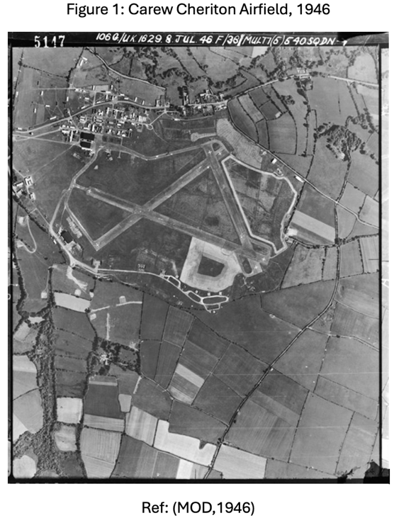
Effective community heritage relies on cross-sector collaboration. Partnerships among arts and heritage organisations, local authorities, voluntary groups, and private actors enhance sustainability, inclusivity, and impact (AHRC, 2024). Volunteers’ work is influenced by institutional policies and funding frameworks, which both enable and constrain initiatives. Since 1994, the National Lottery Heritage Fund has allocated over £460 million to more than 24,100 community heritage projects in the UK (Heritage Fund, 2025). Organisations such as the National Trust facilitate public access to heritage buildings and monuments (Hodges and Watson, 2000), while in Wales, Cadw provides policies, resources, and management structures to support inclusive heritage (Cadw, 2023). Together, these mechanisms show how grassroots participation and institutional support interact to sustain meaningful heritage practice, even under resource constraints.

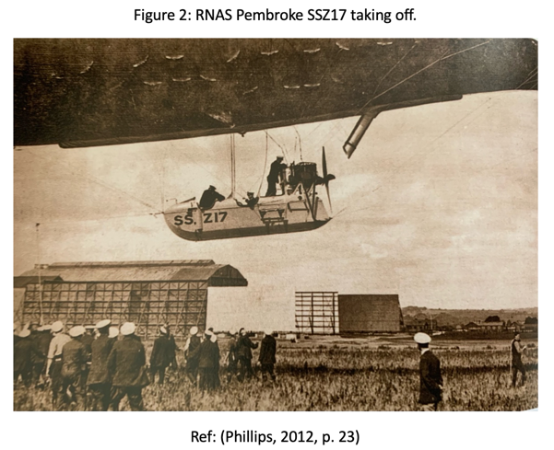
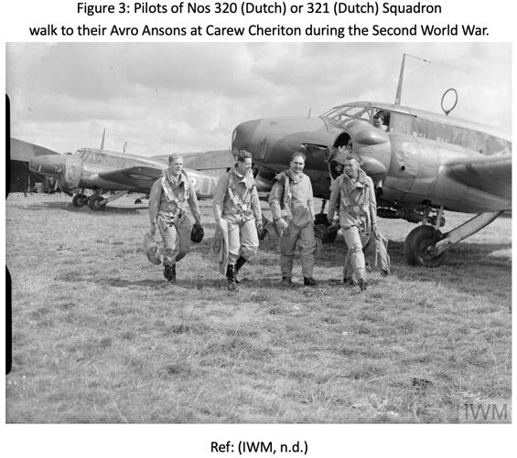
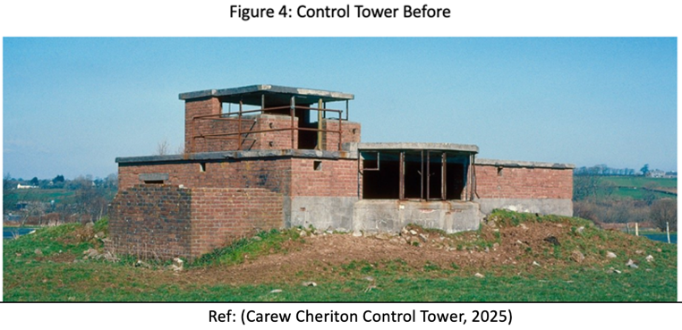
Carew Cheriton Airfield (See Figure 1) was established in January 1916 as RNAS Pembroke (Milton), serving as a First World War airship station patrolling the Irish Sea (See Figure 2). After a fire in 1918 and post-war decommissioning in 1920, it reopened in April 1939 as RAF Carew Cheriton to distinguish it from nearby Pembroke Dock. During the Second World War, the airfield operated as a Coastal Command station, hosting international personnel, including Dutch airmen (See Figure 3), and endured several bombing raids, notably in April 1941, resulting in military casualties. It later shifted from operational use to training and technical functions, reflecting wartime needs (ABCT, 2025). The airfield included three concrete runways, a northern technical site, accommodation, bomb stores, and a uniquely designed control tower. While post-war development removed much of the northern area, the restored control tower, turret training building, bomb store complex, and fragments of runways survive. Its inclusion in the national registry recognises its historical significance, although it does not provide statutory protection equivalent to that afforded to listed buildings or scheduled monuments (Pyper and Page, 2012). The key surviving feature is the Control Tower (NPRN 309962/Grid Reference: SN0529702991), built in the early 1940s. The single-storey structure, with a rooftop observation room and bay window, became a landmark. Most ancillary buildings were demolished in the 1960s, leaving the tower derelict (See Figure 4) while the site was repurposed for agriculture, markets, and leisure activities (ABCT, 2025; Coflein, 2011).

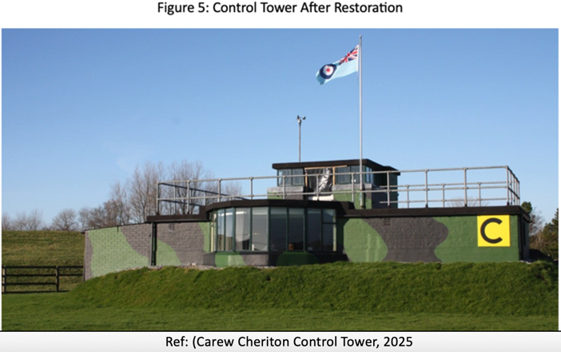
In 2000, the landowner granted a long-term lease to the Carew Historical Society, preventing the Control Tower’s demolition. Local volunteers established the Carew Cheriton Control Tower Group, comprising approximately 35 individuals aged 13 to 80 from diverse backgrounds. Their objectives included restoring the tower to its wartime condition, creating a memorial for airfield personnel from both world wars, developing an educational resource, and establishing a tourist site offering an immersive wartime experience. Supported by local businesses, Pembroke County Council, The Welsh Office, PLANED, and a 99-year lease at minimal rent, the restoration demonstrates the capacity of community initiative and volunteer expertise to safeguard heritage (Carew Cheriton Control Tower, 2025a).

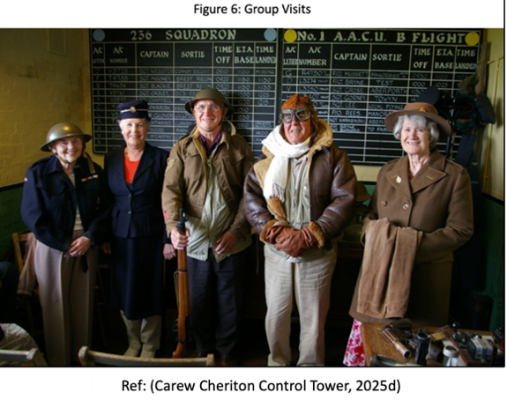
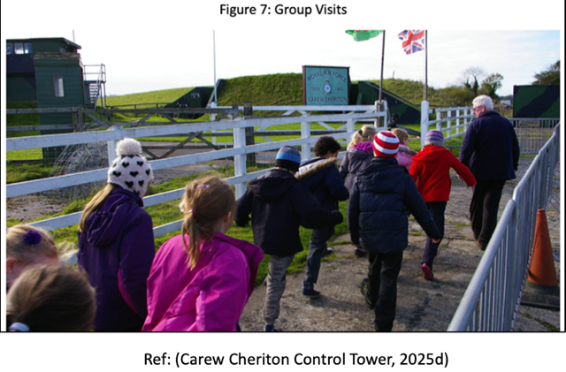
The restored Control Tower (See Figure 5) now functions as a museum, community heritage site, and educational centre, maintained entirely by volunteers who interpret local military history for visitors, schools, and community groups (Carew Cheriton Control Tower, 2025b). Visitor reviews emphasise the immersive experience of exploring the restored Control Tower and Air Raid Shelter and engaging with wartime exhibits. Visitors especially appreciate the personal testimonies and local stories shared by two very active members of the project, now in their 80s, which vividly bring Carew's history to life (TripAdvisor, 2025). It is open to the public two days a week between May and October, with an admission fee for adults. Volunteers provide guided tours (See Figure 6), organise school visits (See Figure 7), and guide visitors through a reconstructed air-raid shelter, wartime artefacts, and a hangar containing historic vehicles and aircraft. Visits offer participatory experiences that engage both local residents and visitors (Carew Cheriton Control Tower, 2025c). These activities encourage intergenerational learning and support active, community-led heritage preservation.

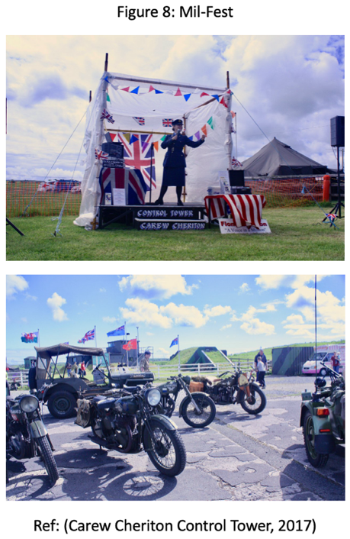
The project exemplifies community heritage in practice, blending tangible heritage with living or intangible heritage through storytelling, re-enactments, commemorations, and events such as Mil-Fest (See Figure 8) (Carew Cheriton Control Tower, 2017). Volunteers serve as interpreters, educators, fundraisers, and custodians, actively sharing wartime knowledge. This participatory approach challenges top-down heritage models by centring community voices and local practices (Smith, 2006, p. 4). Digital tools significantly extend the project’s reach; the website documents events, restoration progress, and school visits, reflecting contemporary best practices in museum digitalisation (Yap et al., 2024). The site’s blog highlights grassroots participation, featuring posts on major heritage events, community gatherings, and fundraising activities such as bingo nights (Carew Cheriton Control Tower, 2025e). These posts demonstrate that the project’s heritage practice relies on strong social networks, local support, collective fundraising, and the interpretation of wartime history. Regular updates on school visits, restoration work, and public open days further illustrate that Carew is a living community heritage project, actively sustained by volunteer effort and ongoing public engagement.

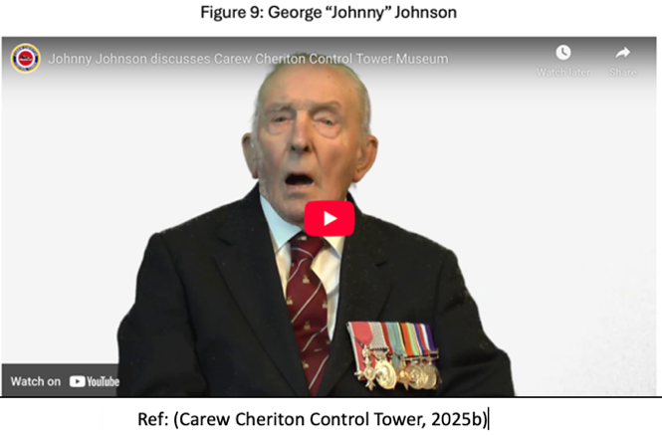
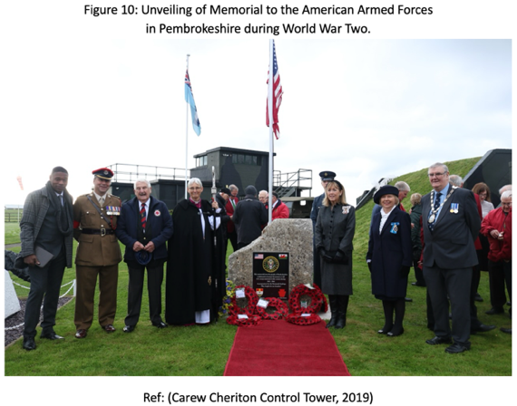
Central to the project is the transmission of memory. The museum displays a commemorative message from George ‘Johnny’ Johnson (See Figure 9), the last surviving Dambuster, underscoring the importance of preserving personal stories of those who served (BBC, 2022). First-hand accounts, oral, written, or digital, are recognised as vital for maintaining intangible memories and community identity (Heritage Fund, 2024). A particularly significant aspect of the project is the voluntary maintenance of 15 Second World War Commonwealth war graves. Deric Brock, the group’s chairman and a local resident, has cared for these graves for over four decades, compiling photographs and biographies and maintaining contact with families and authorities (Hill, 2025). The unveiling of a memorial in 2019 to American soldiers of the 110th Regiment stationed in Pembrokeshire before D-Day (See Figure 10) further emphasises the site’s role as a ‘lieu de memoire’ (Nora, 1989) (Carew Cheriton Control Tower, 2019). Such work ensures the intergenerational transmission of historical knowledge as the generation with direct wartime experience passes away (Finney, 2017). Media coverage, such as ITV’s Vanished Wales (2024), highlights Carew’s deep embedding in local memory. Many current volunteers are descendants of families who supported airmen, reflecting continuity of care and responsibility. Interviews with former personnel enrich wartime interpretation, demonstrating how community heritage is sustained through lived experience. Collaboration with other museums and heritage organisations, such as Tenby Museum, and participation in regional forums and heritage showcases organised by PLANED and the Heritage Forum in Pembroke Dock, demonstrate the project’s integration into broader social and cultural networks (Sinclair, 2014; Tenby Observer, 2018). These partnerships enhance resilience, adaptability, and a sense of shared purpose across a wider heritage community.

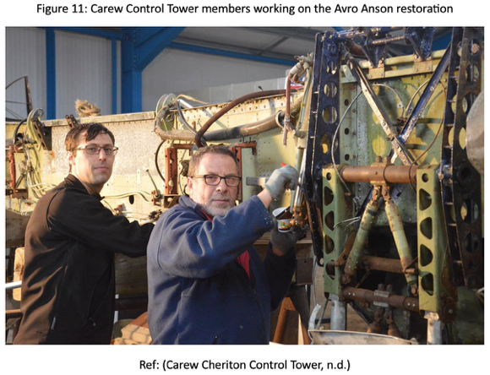
As the airfield and Control Tower are located outside conservation zones, their preservation relies primarily on community stewardship (Pembrokeshire CC, 2023; DataMap Wales, 2025). The project’s charitable status facilitates fundraising, attracts volunteers, and fosters public trust (Resource Centre, 2025). Grants such as a £47,400 National Lottery Heritage Fund award in 2008 (Heritage Fund, 2008), and earlier support for restoring a Second World War Avro Anson aircraft (See Figure 11) (Heritage Fund, 2005a) and commemorative community events (Heritage Fund, 2005b). However, ongoing work depends on volunteer effort and modest local support.

As an unlisted site, Carew has therefore depended on alternative funding streams and locally driven decision-making, illustrating how community heritage initiatives in Britain can operate effectively beyond formal heritage frameworks. The Carew project exemplifies key characteristics of community heritage: it is participatory, locally led, and socially embedded, integrating both tangible and intangible forms of heritage. Volunteer-led restoration, education, and commemoration foster intergenerational dialogue, strengthen community cohesion, and reinforce shared identity.

While Carew challenges top-down models of heritage management, it also faces ongoing sustainability pressures and the need to represent a diversity of historical experiences. Continued adaptability, collaboration, and digital engagement will be essential to its long-term success. More broadly, Carew demonstrates how community heritage in Britain not only preserves the past but also creates dynamic spaces for negotiating memory, meaning, and social value, exemplifying the participatory and socially transformative character of contemporary heritage practice.

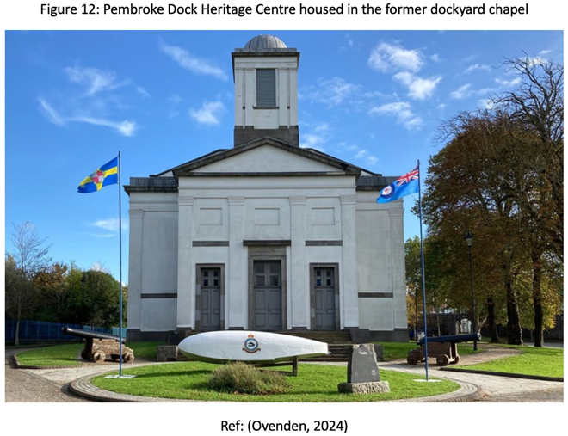
Community heritage initiatives encounter several criticisms and limitations related to participation dynamics, resource allocation, and institutional frameworks. A significant challenge is the persistence of top-down models in heritage engagement, where community involvement may be more symbolic than substantive. Projects risk conforming to established authoritative discourses and institutional agendas, which can limit genuine community-driven participation and reduce the potential for sustainable and relevant outcomes (Perkin, 2010). A comparison can be made with the nearby Pembroke Dock Heritage Centre (PDHC, 2025), which, like Carew, focuses on military and aviation heritage and relies heavily on volunteers and community support, but is in a small town. However, Pembroke Dock, being a larger museum situated in a Grade II-listed former military chapel (See Figure 12), enjoys statutory protection, potential access to additional funding, longer opening hours, and a more central urban setting. These factors can help increase institutional backing and attract more visitors. Comparing the two sites highlights how differences in legal status, resources, and operational models shape both sustainability and the scope of community participation, suggesting that while Carew exemplifies the typical characteristics of grassroots heritage work, its trajectory is shaped by site-specific constraints and opportunities.

While Carew demonstrates successful volunteer-led restoration and public engagement, meaningful ‘success’ in community heritage goes beyond tangible outcomes such as restored buildings or visitor numbers. Participation can also enhance well-being, self-efficacy, and perceptions of community support, highlighting the social and psychological impact of heritage work (Brizi, Rabinovich and Lewis, 2023). These outcomes show that community heritage strengthens local identity, social cohesion, and resident empowerment. Unlike rural initiatives like Carew, urban community heritage practice in Wales takes various forms. For example, the CAER Heritage Project in Cardiff involves residents in co-produced heritage activities, including community archaeology, heritage trails, and exhibitions, that highlight local voices in an urban setting. This demonstrates how community heritage can function as a participatory and socially embedded process that goes beyond restoring a single site, engages diverse stakeholders, and addresses socio-economic challenges within urban communities. The CAER example demonstrates how community heritage in Britain varies not only by resource and scale but also by how communities negotiate authority, meaning, and representation within heritage practice (NCCPE, 2025; Caer Heritage, 2025). While the Carew project exemplifies successful community heritage in a rural Welsh context, it is important to recognise that not all community heritage projects share the same resources, volunteer base, or social dynamics. The lessons from Carew, while instructive, should be considered within their specific social and historical context, rather than assumed to apply universally. Nonetheless, the principles demonstrated at Carew, volunteer leadership, negotiated authority, integration of tangible and intangible heritage, and networked support, offer a valuable framework for other communities seeking to preserve and reinterpret their own heritage.

Despite the substantial social and cultural benefits of community heritage, significant challenges persist. The need for institutional support, whether through funding, access, or expertise, can create tensions between grassroots initiatives and structural reliance. The dominance of the AHD means that local communities must negotiate the boundaries set by professional heritage practice, which can limit the representation of diverse histories (Waterton and Smith, 2010). As seen at Carew, volunteer involvement often shapes which stories are highlighted in museums. This focus, such as Carew’s emphasis on wartime narratives, can sideline other community voices and introduce historical bias, as volunteer-curated displays tend to reflect selective perspectives (Stefano, 2009). Sustainability also remains a concern, as initiatives often rely on a small, ageing volunteer base. Volunteer-led interpretation, though empowering, can unintentionally prioritise some narratives over others, highlighting the need for inclusivity. Ensuring the transmission of knowledge and memory to younger generations is essential for the long-term survival of such projects (Finney, 2017). Alexander and Hamilton (2016) demonstrate that community-led heritage projects succeed when local residents are granted autonomy and responsibility, enabling them to actively preserve, interpret, and promote their heritage while strengthening place identity. The Carew volunteers exemplify this, leading restoration and public engagement within the frameworks of council guidance and grant conditions. Effective community heritage depends on balancing volunteer initiative with supportive facilitation to ensure projects remain meaningful, sustainable, and connected to the local community. Local and community heritage in the UK, particularly in Wales, faces increasing threats from budgetary constraints, socio-economic changes, and environmental pressures, which, without active intervention, risk rendering heritage assets neglected or burdensome to local authorities (AHRC, 2024). The use of digital platforms and educational outreach can help address challenges in preserving historical memory, but ensuring meaningful ongoing public engagement, especially with younger generations, remains a significant challenge in heritage conservation (Boccacci et al., 2025). Balancing the preservation of physical remains of Second World War heritage sites with the transmission of their historical narratives remains an ongoing challenge that requires both tangible conservation efforts and active initiatives to sustain collective memory (Boccacci et al., 2025). Ultimately, Carew's resilience relies on its ability to handle these pressures while staying true to its core values. Community heritage projects need to continually adjust to evolving community needs and interests, as well as changes in policy, funding, and cultural trends, to stay relevant, sustainable, and socially meaningful. Together, these case studies highlight the various challenges and opportunities faced by rural and urban heritage initiatives, emphasising the need for strategies tailored to specific contexts to preserve community heritage.

In conclusion, community heritage in Britain is a participatory and socially embedded practice that extends beyond the preservation of physical sites to include storytelling, education, and collective memory. The Carew project exemplifies how volunteer-led stewardship, intergenerational engagement, and local interpretation sustain both tangible heritage and intangible values such as identity, memory, and belonging. While Carew illustrates the strengths of community heritage, it also faces persistent challenges, such as an ageing volunteer base, the loss of lived memory, limited funding, and dependence on institutional support. Its negotiation with the AHD shows that community initiatives can both align with and challenge dominant narratives. At the same time, comparison with urban projects like the CAER Heritage Project highlights the importance of context in shaping practice. Ultimately, successful community heritage depends on balancing grassroots participation with institutional support, embracing digital innovation, and fostering diverse, intergenerational involvement. Projects like Carew demonstrate that the past can be preserved not only as static memory but also as a living, inclusive resource that remains meaningful to contemporary and future communities.

BIBLIOGRAPHY
ABCT (2025) Carew Cheriton (Milton) (Pembroke). Available at: https://www.abct.org.uk/airfields/carew-cheriton-milton-pembroke/ (Accessed: 5 December 2025).

AHRC (2024) Wales Place-Making and Community Heritage. Available at: https://creativecommunities.uk/wp-content/uploads/2024/09/Alexander-Langlands_CIP-Policy-Paper_AHRC-Creative-Communities.pdf (Accessed 9 Dec. 2025).

Alexander, M. and Hamilton, K. (2016) ‘Recapturing place identification through community heritage marketing’, European Journal of Marketing, 50(7/8), pp. 1118–1136. Available at: https://doi.org/10.1108/EJM-05-2013-0235

Amar, J.H.N. and Armitage, L. (2019) ‘Community heritage discourse (CHD): a multidisciplinary perspective in understanding built heritage conservation’, Pacific Rim Property Research Journal, 25(3), pp. 229-244. Available at: https://doi.org/10.1080/14445921.2019.1693324

BBC (2019) D-Day: Pembrokeshire memorial unveiled for US soldiers. Available at: https://www.bbc.co.uk/news/uk-wales-50143333 (Accessed: 5 December 2025).

BBC (2022) Obituary: Sqn Ldr George ‘Johnny’ Johnson. Available at: https://www.bbc.co.uk/news/uk-40497471 (Accessed: 5 December 2025).

Blake, J. (2000) ‘On Defining the Cultural Heritage’, The International and Comparative Law Quarterly, 49(1), pp. 61–85. Available at: https://doi.org/10.1017/S002058930006396X

Boccacci, G. et al. (2025) ‘Ten questions concerning challenges in preserving the materiality and memory of WWII heritage sites: the case study of Trondheim (Norway)’, Built Heritage, 9(1). Available at: https://doi.org/10.1186/s43238-025-00215-x

Braber, N. and Howard, V. (2024) ‘Language Heritage and the UK Public: Successes and Challenges of the UK Heritage Sector’, Heritage and Society, pp. 1–20. Available at: https://doi.org/10.1080/2159032X.2024.2382625

Brizi, A., Rabinovich, A. and Lewis, C. (2023) ‘Psychological outcomes of local heritage engagement: Participation in community archaeological excavations increases well‐being, self‐efficacy, and perceived community support’, Journal of Applied Social Psychology, 53(9), pp. 850–861. Available at: https://doi.org/10.1111/jasp.1297

Cadw (2023) A review of Cadw’s governance arrangements. Cardiff: Welsh Government. Available at: https://www.gov.wales/sites/default/files/publications/2023-12/a-review-of-cadws-governance-arrangements.pdf (Accessed 5 December 2025).

Cadw (2025) Listed Building Regeneration Grant Scheme. Cadw. Available at: https://cadw.gov.wales/advice-support/historic-assets/listed-buildings/historic-buildings-grant/listed-building (Accessed: 7 December 2025).
Caer Heritage (2025) About us. Available at: https://www.caerheritage.org/about-us (Accessed: 11 December 2025).

Carew Cheriton Control Tower (2017) First Carew Mil-Fest Great Success. Available at: https://www.carewcheritoncontroltower.co.uk/blog/first-carew-mil-fest-outstanding-success/ (Accessed: 9 December 2025).

Carew Cheriton Control Tower (2019) Unveiling of memorial to the American Armed Forces in Pembrokeshire during World War Two. Available at: https://www.carewcheritoncontroltower.co.uk/blog/unveiling-of-memorial-to-the-american-armed-forces-in-pembrokeshire-during-world-war-two/ (Accessed: 9 December 2025).

Carew Cheriton Control Tower (2025) The Control Tower. Available at: https://www.carewcheritoncontroltower.co.uk/visit/control-tower/ (Accessed: 13 December 2025).

Carew Cheriton Control Tower (2025a) About us. Available at: https://www.carewcheritoncontroltower.co.uk/about/ (Accessed: 14 December 2025).

Carew Cheriton Control Tower (2025b) Experience a unique Pembrokeshire museum. Available at: https://www.carewcheritoncontroltower.co.uk/ (Accessed: 14 December 2025).

Carew Cheriton Control Tower (2025c) Visit. Available at: https://www.carewcheritoncontroltower.co.uk/visit/ (Accessed: 14 December 2025).

Carew Cheriton Control Tower (2025d) Group Visits. Available at: https://www.carewcheritoncontroltower.co.uk/visit/group-visits/ (Accessed: 13 December 2025).

Carew Cheriton Control Tower (2025e) Blog. Available at: https://www.carewcheritoncontroltower.co.uk/category/blog/ (Accessed: 14 December 2025).

Carew Cheriton Control Tower (n.d.) Carew Control Tower members working on the Avro Anson restoration. Available at: https://www.carewcheritoncontroltower.co.uk/blog/avro-anson-restoration-project-gets-underway/ (Accessed: 13 December 2025).

Cerreta, M. and Giovene di Girasole, E. (2020) ‘Towards Heritage Community Assessment: Indicators Proposal for the Self-Evaluation in Faro Convention Network Process’, Sustainability, 12(23), p. 9862. Available at: https://doi.org/10.3390/su12239862

Charity Commission (2025) Carew Cheriton Control Tower Group. Available at: https://register-of-charities.charitycommission.gov.uk/en/charity-search/-/charity-details/5012915?_uk_gov_ccew_onereg_charitydetails_web_portlet_CharityDetailsPortlet_organisationNumber=5012915 (Accessed: 4 December 2025).

Clark, K. (2019) ‘The Shift toward Values in UK Heritage Practice’, in Avrami, E., Macdonald, S., Mason, R. and Myers, D. (eds.) Values in Heritage Management: Emerging Approaches and Research Directions. Los Angeles: The Getty Conservation Institute. Available at: http://www.getty.edu/publications/occasional-papers-3/part-two/5/ (Accessed: 6 December 2025).

Clark, K. and Maeer, G. (2008) ‘The cultural value of heritage: evidence from the Heritage Lottery Fund’, Cultural Trends, 17(1), pp. 23–56. Available at: https://doi.org/10.1080/09548960801920302

Coflein (2011) Carew Cheriton Control Tower. Available at: https://coflein.gov.uk/en/site/413171/ (Accessed: 5 December 2025).

Council of Europe (2005) Framework Convention on the Value of Cultural Heritage for Society (Faro Convention). Available at: https://rm.coe.int/090000168071aabc (Accessed 5 December 2025).

Crooke, E. (2010) ‘The politics of community heritage: motivations, authority and control’, International Journal of Heritage Studies: IJHS, 16(1–2), pp. 16–29. Available at: https://doi.org/10.1080/13527250903441705

DataMapWales (2025) Pembrokeshire Coast National Park. Available at: https://datamap.gov.wales/maps/pembrokeshire-coast-national-park/ (Accessed: 9 December 2025).

Drozdzewski, D., Waterton, E. and Sumartojo, S. (2019) ‘Cultural memory and identity in the context of war: Experiential, place-based and political concerns’, International Review of the Red Cross, 101(910), pp. 251–272. Available at: https://doi.org/10.1017/S1816383119000110

Finney, P. (2017) ‘Politics and technologies of authenticity: the Second World War at the close of living memory’, Rethinking History, 21(2), pp. 154–170. Available at: https://doi.org/10.1080/13642529.2017.1315967

Gillies, C. (n.d.) What is community heritage? Available at: https://www.scottishcommunityalliance.org.uk/briefings/connecting-community-heritage#:~:text=The%20term%20%E2%80%9Ccommunity%20heritage%E2%80%9D%20encompasses,project%20determined%20by%20outside%20entities (Accessed: 4 December 2025).

Gravagnuolo, A., Micheletti, S. and Bosone, M. (2021) ‘A Participatory Approach for “Circular” Adaptive Reuse of Cultural Heritage. Building a Heritage Community in Salerno, Italy’, Sustainability, 13(9), p. 4812. Available at: https://doi.org/10.3390/su13094812

Harrison, R. (2013) Heritage: critical approaches. Milton Park, Abingdon; Routledge.
Heritage Fund (2008) Wings over Carew. Available at: https://www.heritagefund.org.uk/projects/wings-over-carew (Accessed: 4 December 2025).

Heritage Fund (2024) Oral history good practice guidance. Available at: https://www.heritagefund.org.uk/funding/good-practice-guidance/oral-history (Accessed: 7 December 2025).

Heritage Fund (2025) Community Heritage. Available at: https://www.heritagefund.org.uk/our-work/community-heritage (Accessed: 4 December 2025).

Heritage Fund (2005a) Project: Restore historical aircraft – Avro Anson. Available at: https://www.heritagefund.org.uk/projects/project-restore-historical-aircraft-money-cost-and-transport-second-world-war-avro-anson (Accessed: 9 December 2025).

Heritage Fund (2005b) Project: Commemorate 60th anniversary of end of WWII. Available at: https://www.heritagefund.org.uk/projects/project-commemorate-60th-anniversary-end-ww2-provision-street-party-social-evening-and (Accessed: 9 December 2025).

Heritage Fund (2008) Project: Wings Over Carew. Available at: https://www.heritagefund.org.uk/projects/wings-over-carew (Accessed: 9 December 2025).

Hill, J. (2025) For 42 years one man has tended a set of 15 graves for free and his reason might surprise you. Available at: https://www.walesonline.co.uk/news/wales-news/gallery/42-years-one-man-tended-32534483 (Accessed: 5 December 2025).

Historic England (2025) Research Evidence for the Social Impact of Heritage. Available at: https://historicengland.org.uk/advice/caring-for-heritage/social-impact/indicators/research-evidence/ (Accessed: 2 December 2025).

Hodges, A. and Watson, S. (2000) ‘Community-based Heritage Management: a case study and agenda for research’, International Journal of Heritage Studies: IJHS, 6(3), pp. 231–243. Available at: https://doi.org/10.1080/13527250050148214

ITV (2024) Vanished Wales. Available at: https://www.itv.com/walesprogrammes/articles/vanished-wales-series-3-episode-6 (Accessed: 9 December 2025).

IWM (n.d.) Pilots of Nos 320 (Dutch) or 321 (Dutch) Squadron walk to their Avro Ansons at Carew Cheriton during the Second World War. Available at: https://www.iwm.org.uk/collections/item/object/205208700 (Accessed: 13 December 2025).

MGCI (2025) Community Heritage Scotland. Available at: https://mgci.wp.st-andrews.ac.uk/community-heritage-scotland/ (Accessed: 6 December 2025).

MOD (1946) Aerial view of Carew Cheriton Airfield, 1946. Available at: https://www.abct.org.uk/airfields/carew-cheriton-milton-pembroke/ (Accessed: 13 December 2025).

Moss, S. (2005) Why the United Kingdom Has Not Ratified the CISG. Available at: https://uncitral.un.org/sites/uncitral.un.org/files/media-documents/uncitral/en/moss.pdf (Accessed: 5 December 2025).

Mullan, P. (2021) ‘Community archaeology and the Heritage Fund in Northern Ireland’, Journal of Community Archaeology and Heritage, 8(4), pp. 245–255. Available at: https://doi.org/10.1080/20518196.2021.1966171

Mydland, L. and Grahn, W. (2012) ‘Identifying heritage values in local communities’, International Journal of Heritage Studies: IJHS, 18(6), pp. 564–587. Available at: https://doi.org/10.1080/13527258.2011.619554

NCCPE (2023) CAER Heritage Project (Caerau and Ely Rediscovering). Available at: https://www.publicengagement.ac.uk/learn-others/case-studies/caer-heritage-project-caerau-and-ely-rediscovering (Accessed: 11 December 2025).

Nora, P. (1989) ‘Between Memory and History: Les Lieux de Mémoire’, Representations, 26, pp. 7–24. Available at: https://doi.org/10.2307/2928520

Ovenden, P. (2024) Pembroke Dock Heritage Centre Museum Star Wars collections are out of this world! Available at: https://www.tenby-today.co.uk/news/pembroke-dock-heritage-centre-museum-star-wars-collections-are-out-of-this-world-715853 (Accessed: 13 December 2025).

PDHC (2025) Pembroke Dock Heritage Centre. Available at: https://pdht.org/ (Accessed: 11 December 2025).

Pembrokeshire CC (2023) Listed Buildings and Conservation Area. Available at: https://www.pembrokeshire.gov.uk/listed-buildings-and-conservation-area/conservation-of-the-built-environment (Accessed: 9 December 2025).

Pembrokeshire County Council. (2025) Conservation. Available at: https://www.pembrokeshire.gov.uk/conservation (Accessed: 9 December 2025).

Perkin, C. (2010) ‘Beyond the rhetoric: negotiating the politics and realising the potential of community-driven heritage engagement’, International Journal of Heritage Studies: IJHS, 16(1–2), pp. 107–122. Available at: https://doi.org/10.1080/13527250903441812

Phillips, A. (2012) Welsh Military Airfields through time. 1st edn. Stroud: Amberley Publishing.

Poulios, I. (2014) ‘Defining and managing ‘living heritage’, in The Past in the Present: A Living Heritage Approach - Meteora, Greece, pp. 25–30. Available at: http://www.jstor.org/stable/j.ctv3s8tpq.9 (Accessed: 6 December 2025).

Poulios, I. (2014a) ‘Conclusion: The Contribution of a Living Heritage Approach to the Discipline of Conservation’, in The Past in the Present: A Living Heritage Approach - Meteora, Greece, pp. 139–144. Available at: http://www.jstor.org/stable/j.ctv3s8tpq.21 (Accessed: 6 December 2025).

Power, A. and Smyth, K. (2016) ‘Heritage, health and place: The legacies of local community-based heritage conservation on social wellbeing’, Health and Place, 39, pp. 160–167. Available at: https://doi.org/10.1016/j.healthplace.2016.04.005

Pyper, A. and Page, M. (2012) Twentieth Century military sites: Airfields. Available at: https://coflein.gov.uk/media/86/47/dat21_02.pdf (Accessed: 9 December 2025).

Resource Centre (2025) Charity Registration. Available at: https://www.resourcecentre.org.uk/information/charity-registration/ (Accessed: 9 December 2025).

Sinclair, T. (2014) Community heritage showcased. Available at: https://pembrokeshire-herald.com/5987/community-heritage-showcased/?utm (Accessed: 5 December 2025).

Smith, L. (2006) Uses of heritage. London; Routledge. Available at: https://doi.org/10.4324/9780203602263

Smith, L. (2007) ‘Heritage as a cultural process’, in Uses of Heritage. Routledge, pp. 58–98. Available at: https://doi.org/10.4324/9780203602263-12

Smith, L. (2021) Emotional heritage: visitor engagement at museums and heritage sites. London; Routledge.

Smith, L. and Waterton, E. (2012) Heritage, communities and archaeology. London: Bristol Classical Press.

Stefano, M. (2009) Safeguarding intangible heritage: five key obstacles facing museums of the North East of England. Available at: https://www.ijih.org/volumes/article/50 (Accessed: 14 December 2025).

Tenby Museum (2024) RAF Carew Cheriton: A moment in time. Available at: https://tenbymuseum.org.uk/raf-carew-cheriton-a-moment-in-time/ (Accessed: 5 December 2025).

Tenby Observer (2018) Heritage Groups Start Working Together. Available at: https://www.pembroke-today.co.uk/news/heritage-groups-start-working-together-473045?utm (Accessed: 5 December 2025).

UNESCO (2003) Convention for the Safeguarding of the Intangible Cultural Heritage. Available at: https://ich.unesco.org/en/convention (Accessed: 5 December 2025).

Trip Advisor (2025) Carew Cheriton Control Tower. Available at: https://www.tripadvisor.co.uk/Attraction_Review-g7143272-d4352116-Reviews-Carew_Cheriton_Control_Tower-Sageston_Tenby_Pembrokeshire_Wales.html (Accessed: 14 December 2025).

UNESCO (2025) What is Living Heritage? Available at: https://livingheritage.unesco.org.uk/info/guidance/what (Accessed: 6 December 2025).

Van Knippenberg, K., Boonstra, B. and Boelens, L. (2022) ‘Communities, Heritage and Planning: Towards a Co-Evolutionary Heritage Approach’, Planning Theory and Practice, 23(1), pp. 26–42. Available at: https://doi.org/10.1080/14649357.2021.1998584

Waterton, E. and Smith, L. (2010) ‘The recognition and misrecognition of community heritage’, International Journal of Heritage Studies: IJHS, 16(1–2), pp. 4–15. Available at: https://doi.org/10.1080/13527250903441671

Waterton, E. and Watson, S. (2013) Heritage and community engagement: collaboration or contestation? S.l: Routledge.

Yap, J.Q.H. et al. (2024) ‘The impact of digitalisation and digitisation in museums on memory-making’, Current issues in tourism, 27(16), pp. 2538–2560. Available at: https://doi.org/10.1080/13683500.2024.2317912F

