Student Name: Katerina Hristova  Student ID: 2232205  Module Title: Foreign Languages and Cultural Awareness  Module Code: BMIH5003  Lecturer: Lisa Bassler and Heidi Prosser  Date: 09/02/2024 | 
ASSIGNMENT 1: PORTFOLIO
(4 Components)

Component 1: Professional Reflection (500 words +/- 10%)

Weighting: 25%

Introduction

Culture defines the group of knowledge which implies experience, beliefs, values, behaviour and meaning obtained by several people in the itinerary of generation. Cultures play an important part in the lives of several people in a community and provide a sense of possession when all speak the identical language. In the following professional reflection, I will discuss the importance of culture in language and how it helps in effective communication. In the following essay I have chosen Kimpton Hotel and Restaurant and I will also discuss the conflict that occurs due to diverse language communication and how it leads to cultural misunderstandings. Succeeding the essay, I will further discuss the behavioural changes needed to make, to prevent cultural misunderstanding in future. Lastly, I will end the discussion with a relevant conclusion to all of it.

Discussion

Culture and language play a crucial part in my life and due to the diverse languages of various countries, I have faced a severe cultural understanding once. Being an F&B employee at Kimpton Hotel and Restaurant, I had once faced language and cultural conflict in the hotel where I work. Cultural misunderstanding can take place when more than one person articulates identical language, however they imply or acknowledge contrasting things. Culture is crucial when learning languages since understanding the cultural history, art, and habits will help me to outreach native tongue expertise (commisceo, 2024). This will also enable me to live the language while I am learning. Though I have good communication and understanding skills, it is often troubling for me to understand various languages when providing hospitality to people of diverse cultures. I often fail to make people understand what I am trying to say and vice-versa what they are trying to say. This especially happens with me when I am asking or suggesting to them the food, having them for breakfast and offering them service. All these establish miscommunications and misunderstandings regarding cultures and languages. The tone, the way of speaking and the language action of some visitors of non-English speaking sometimes become back-breaking for me to recognise. To get rid of these cultural misunderstandings I must take part in various courses offering the knowledge and information of various cultures. This will enhance my skills further to actively understand the various cultures different guests possess. I should also take part in several foreign language and cultural courses so that I can avoid any misunderstandings or conflicts in future. This will also help me to provide the service that hotel guests demand and have a healthy culture and communication with them.

Conclusion

While esteem and tolerance can go a long way in shortening differences of opinion between people from diverse languages and cultural hereditary, misunderstanding can still lead to extreme conflict. This often leads to diversification globally and communication patterns. In the above professional reflection, being an F&B employee of Kimpton Hotel and Restaurant, I have discussed the personal experience I have faced in providing hospitality to people of different cultures. I have also explained the lack of skill I possess which led to the cultural conflict. Lastly, I have discussed the courses such as various foreign cultural and language educational training I am taking part in to improve the lack to avoid conflict in future.

References:
commisceo, (2024). 3 Real-life Examples of Cultural Misunderstandings in Business. [Online] Available at: https://www.commisceo-global.com/blog/3-real-life-examples-of-cultural-misunderstandings-in-business [Accessed 5 1 2024].

Component 2: Training Plan (500 words +/- 10%)
Weighting: 25%
Identified cultural misunderstanding (in a few words):
Cultural misapprehension takes place when more than two people vocalise identical language, although they indicate or understand non-identical things. The cause is initially that cultures are featured by various attitudes, communication patterns and regulations. Due to this, when working out across cultures, this brings a diverse viewpoint to the negotiating table, which leads to probable misunderstanding. It is important for hotels to effectively address cultural misunderstandings as discussed in component 1 in order to maintain productive workplace environment. The following section is going to highlight a training plan that is dedicated to address any such issues for avoiding future cultural misunderstandings in Kimpton Hotel and Restaurant.
Training plan (Why/What//Who/Where/When):
Skills to improve | Training format | Important stakeholder | Training partner | Allocated Budget
Communication skill | There are several types of communication skills such as oral, written, nonverbal and contextual communication skills. In my training period, I have learnt to keep my listeners in mind by engaging them in interesting communication by providing them with valuable information. Secondly, I have been trained to consider the finest method to convey my message. This is especially crucial when communicating anticipation. Thirdly, I have learnt to reduce distraction by keeping eye contact with the opposite person I am communicating with (Gattig, 2023). | Employee | Human resource manager | 1000 pounds
Cultural diversity teamwork | To improve cultural diversity teamwork there are different ways to enhance to reduce cultural and language conflicts. Firstly, it is important to understand and consider cultural diversification. Conveying the existence of different cultural histories within the team will help to necessitate and locate the differences to enhance team performance. Secondly, developing a team specification and allocating roles and responsibilities can improve cultural diversity teamwork. Through breaking roles and responsibilities to reach general aims can shorten the probability of misunderstanding among various cultures and language groups. | Customers | Suppliers | 500 pounds
Language | Language skills can be improved through various ways by improving speaking skills in foreign languages as well as listening skills in foreign languages. Similarly, these significant skills can be made better by enhancing grammar and vocabulary skills. The training will provide confidence as it is the key to learning new skills. Only being confident to communicate with the locals and having enough courage to learn from the mistakes to improve the diverse language skills. Language skills can be improved by reading magazines since they are written in an understandable style and sometimes talk about the topic which has a common recognition of the subject area (Pardede, et al 2020). Another way is analysing and evaluating the country in which foreign languages need to be practised and increase understanding to improve the mentioned skill. | Customer service holder | Service Manager | 1500 pounds
Cultural awareness | During my training period I have learnt that to improve cultural awareness it is important to learn from others, acknowledge the history as well as visit cultural institutions. Firstly, learning from others will help me to understand the multicultural characteristics that every habitat possesses. Secondly, understanding the histories of various cultures can help me to enhance my knowledge by collecting information on different roots of cultural development (Diaz, 2022). Thirdly, it is essential to visit cultural institutions in my community which will provide huge resources to have extensive awareness of the rich cultures of others. | Tourism manager | customers | 1000 pounds

References:
Gattig, N., (2023). 18 effective strategies to improve your communication skills. [Online] Available at: https://www.betterup.com/blog/effective-strategies-to-improve-your-communication-skills [Accessed 9 1 2024].
Pardede, P., (2020). Integrating the 4Cs into EFL Integrated Skills Learning. Journal of English Teaching, 6(1), pp.71-85.
Diaz, T. I., (2022). How to Improve Cultural Awareness with Intercultural Communication Skills. [Online] Available at: https://globisinsights.com/career-skills/communication/intercultural-communication/ [Accessed 9 1 2024].

Component 3: Student Self-Reflection (500 words +/- 10%)
Weighting: 25%
Gibbs’ Reflective Cycle is a pronominal model for reflection, intervening as an organised method to permit individuals to think constructively about their own experiences. This model was first developed by Grahams Gibbs in 1988 offering six stages such as description, feelings, evaluation, analysis, conclusion and an action plan.
Description: The experience I will be reflecting on occurred in the hotel Kimpton and Restaurant while providing breakfast to tourists. While the customers were ordering their breakfast and were asking about the method of preparation in their native language, I was very confused in understanding their language. Since the customers were non-English speakers, this led to significant issues in understanding each other's languages. Sometimes it is becoming a huge misunderstanding of cultures and languages for me to acknowledge their priorities. My failure to act as a service provider by understanding their language and culture created a huge communication and cultural awareness gap.
Feelings: Due to this misunderstanding, I was quite embarrassed, confused as well as nervous. It was my responsibility and duty to provide my customers with the ultimate satisfaction which I failed and even felt guilty for not responding to their requirements effectively. I felt I did not succeed in maintaining my responsibilities and duties towards my customers and causing chaos in the situation. Moreover, the everyday conversation with my customers with language and cultural difficulties comprises verbal and non-verbal communication (Pieper et al., 2021). Therefore, professionals should make face to face conversations to avoid such trouble in future.
Evaluation: The experience I had mostly had negative elements which have led to a huge understanding of the hospitality user experience following my role to provide satisfaction. I have realised that with my poor foreign language skill power I could not produce effective customer service to my clients. Secondly, this had two effects on my career, firstly it had a huge impact on my reputation in provisioning service to my customers. The important thing is that it made me learn various foreign languages and cultures to avoid such misunderstandings in future.
Analysis: From the above experience I faced in life regarding language and communication I have learnt that every person should learn two foreign languages apart from English. Before entry into the hospitality industry, professionals go through the customers’ communication and their likes and dislikes; and locate any potential fears either through conversation or by permitting the client to visit the higher authority for better service (Ezezika et al., 2023).
Conclusion: From the experience, I am now very sensible of the significance of being confident and exercising professionalism in practice. I am also determined to learn various foreign languages to ignore such difficulties regarding cultural and language conflict in future. The observation I have obtained from this experience while working in Kimpton Hotel and Restaurant means that I am now away much more aware of the consequences of not acting instantly and the significance of rolling in the best interests of the clients, even when this may take bravery.
Action Plan: I will be more fluent in foreign languages in future and offer the best service to my customers regarding their queries in their language. Similarly, I will also try my best to join immediately in various courses offered to improve the skills I lack. I will set a budget for my course and will fill all the drawbacks with all my positive learning and will increase cultural awareness through communication with diverse people (Williams et al., 2020).
References:
Pieper, M., Roelle, J., vom Hofe, R., Salle, A. and Berthold, K., (2021). Feedback in reflective journals fosters reflection skills of student teachers. Psychology Learning & Teaching, 20(1), pp.107-127.
Ezezika, O. and Johnston, N., (2023). Development and implementation of a reflective writing assignment for undergraduate students in a large public health biology course. Pedagogy in Health Promotion, 9(2), pp.101-115.
Williams, K., Woolliams, M. and Spiro, J., (2020). Reflective writing. Bloomsbury Publishing.

Component 4: Training Presentation (6 Slides)
Weighting: 25%
Slide 1:
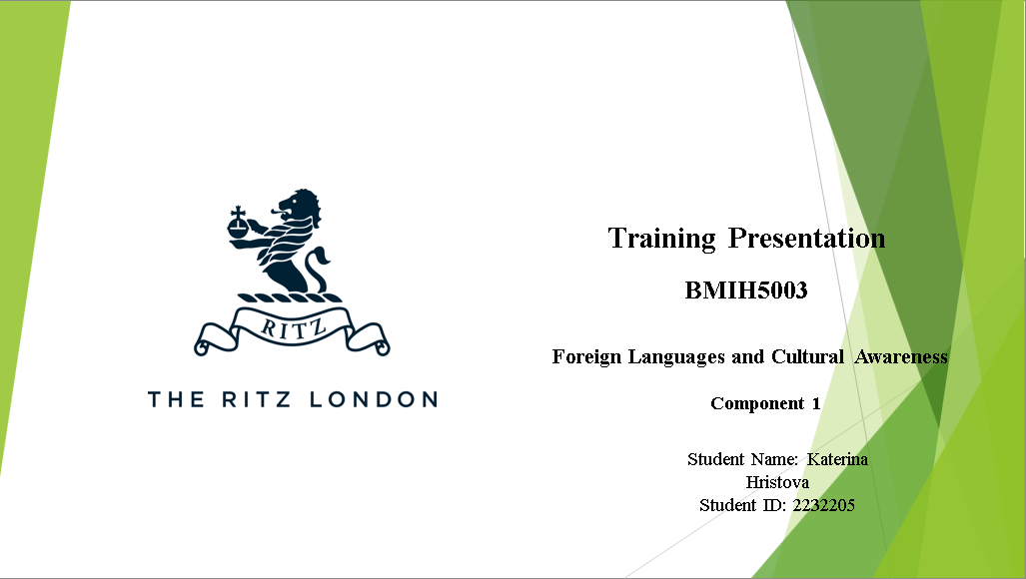
Slide 2:
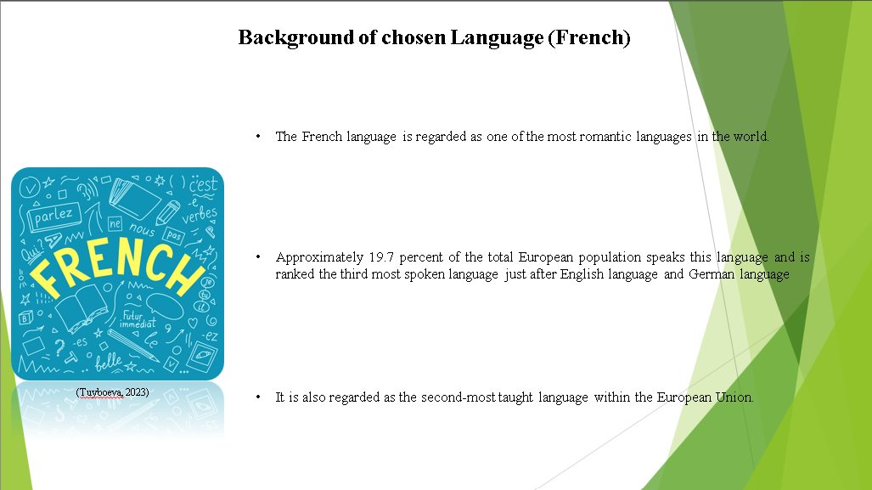
Notes:
Background of chosen Language (French)
The French language is regarded as one of the most romantic languages in the world. Approximately 19.7 percent of the total European population speaks this language and is ranked the third most spoken language just after English language and German language (Tuyboeva, 2023). It is also regarded as the second-most taught language within the European Union
Slide 3:
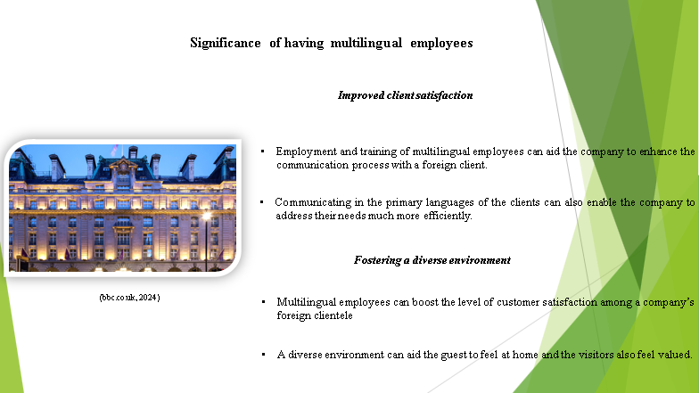
Notes:
Significance of having multilingual employees
Improved client satisfaction
Employment and training of multilingual employees can aid the company to enhance the communication process with a foreign client. This high level of interactivity can aid the company to gain profits in a long-term period. The company can also develop a good reputation among their foreign clients. Communicating in the primary languages of the clients can also enable the company to address their needs much more efficiently.
Fostering a diverse environment
Multilingual employees can boost the level of customer satisfaction among a company’s foreign clientele. A diverse environment can aid the guest to feel at home and the visitors also feel valued. This can also increase the level of quality of services provided by the company and establish a trustworthy reputation within the market.

Slide 4:
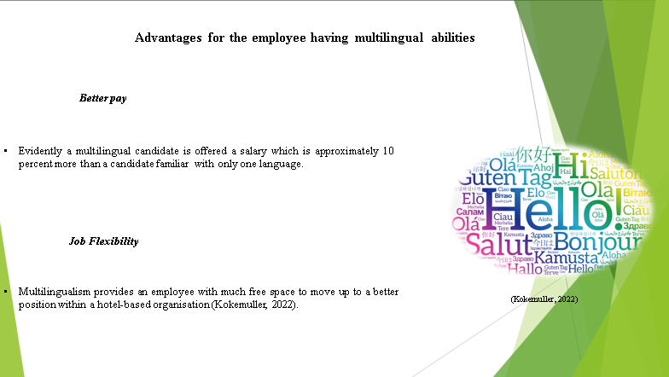
Notes:
Advantages for the employee having multilingual abilities
Better pay
A multilingual employee is provided with better opportunities to earn a lucrative salary than a unilingual employee. Evidently a multilingual candidate is offered a salary which is approximately 10 percent more than a candidate familiar with only one language. In recent times hospitality-based companies are focusing on hiring multilingual employees to reduce the cost of training of the employees.
Job Flexibility
Multilingualism provides an employee with much free space to move up to a better position within a hotel-based organisation (Kokemuller, 2022). Due to the emerging importance of diversity within the tourism industry, most of the candidates employed at managerial roles are often required to be bilingual or multilingual.

Slide 5:
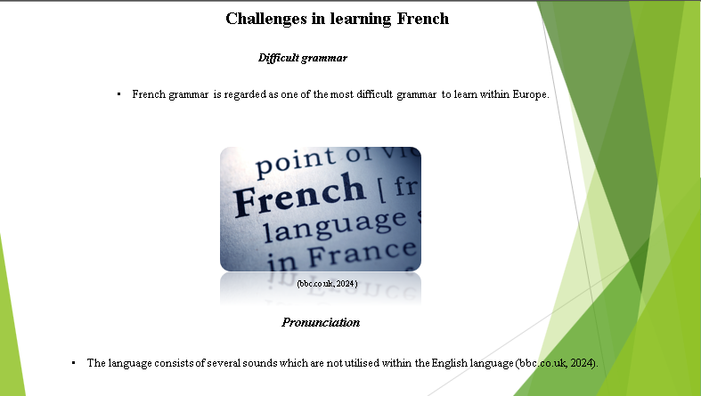
Notes:
Challenges in learning French
Difficult grammar
French grammar is regarded as one of the most difficult grammars to learn within Europe. There are a vast number of rules and norms which are quite unfamiliar for English speaking learners. The concept of subjunctive mood is quite difficult to grasp and makes it quite challenging for the learner.
Pronunciation
It can be quite difficult for an English-speaking individual to pronounce French words. The language consists of several sounds which are not utilised within the English language (bbc.co.uk, 2024). A person familiar with the British accent can face certain challenges to master the French accent as there are negligible similarities between the two languages

Slide 7:
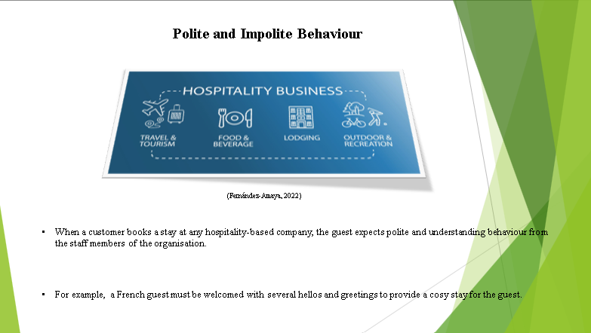
Notes:
Polite and Impolite Behaviour
When a customer books a stay at any hospitality-based company, the guest expects polite and understanding behaviour from the staff members of the organisation. For example, a French guest must be welcomed with several hellos and greetings to provide a cosy stay for the guest (Fernández-Amaya, 2022). This can also enhance the customer satisfaction levels of the foreign guests and increase the rate of customer retention of the company. An impolite staff can negatively impact on the reputation of the company and decrease the credibility of the company within the hospitality industry
References (no screenshots):
Christiansen, B., Branch, J.D. and Karmowska, J. (2020) Cultural Factors and Performance in 21st Century Businesses. Hershey: IGI Global.
Deresky, H. (2017) International Management: Managing Across Borders and Cultures: Text and Cases. 9th Ed. Harlow: Pearson Education Ltd.
Gregor, M.A., Weigold, I.K., Wolfe, G., Campbell-Halfaker, D., Martin-Fernandez, J. and Pino, H.V.G.D., (2021). Positive predictors of career adaptability among diverse community college students. Journal of Career Assessment, 29(1), pp.115-128.
Tuyboeva, S., (2023). THE INTERPRETATION OF UNUSUAL CASES IN SENTENCE CONSTRUCTION IN THE FRENCH LANGUAGE. Innovative Development in Educational Activities, 2(6), pp.344-347.
Fernández-Amaya, L., (2022). Politeness in hotel service encounter interactions in Spain: The receptionist’s point of view. Pragmatics and Society, 13(2), pp.224-249.
bbc.co.uk, (2024). Pronouncing words in French: Vowels. [Online] Available at: https://www.bbc.co.uk/bitesize/articles/zbwq96f [Accessed 28 January 2024].
Kokemuller, N., (2022). What Are the Benefits of Multilingualism in the Workplace? [Online] Available at: https://work.chron.com/benefits-multilingualism-workplace-6178.html [Accessed 26 January 2024].

